**Computer Vision**

**Programming Assignment 1**

**Name:** Mohammad Al Fahim K **Roll No.:**EE17B021

1. **Brief Description:**

To convolve the given noisy image with the best Gaussian kernel achievable and to compare the results with the mean filtered image.

**Images:**

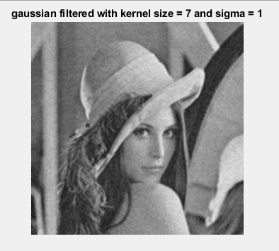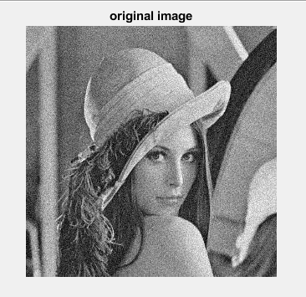

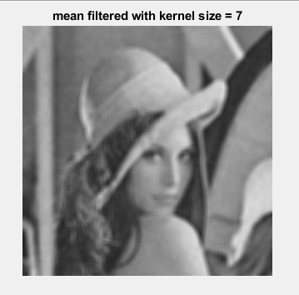

**Parameters:**

Gaussian Filter : kernel size = 7 , sigma = 1

Mean Filter : kernel size = 7

**Inferences:**

As the Kernel size increases for the filters, the edges get smoother with decreasing noise. The Sigma value is directly proportional to amount of noise reduction and edges smoothening. When the kernel sizes of the Gaussian and mean filters are the same, the more the sigma value, the more both filters become similar.

1. **Brief Description:**

To find waldo in the ‘where-is-waldo’ image using template matching by performing normalized cross correlation between the template and the target image.

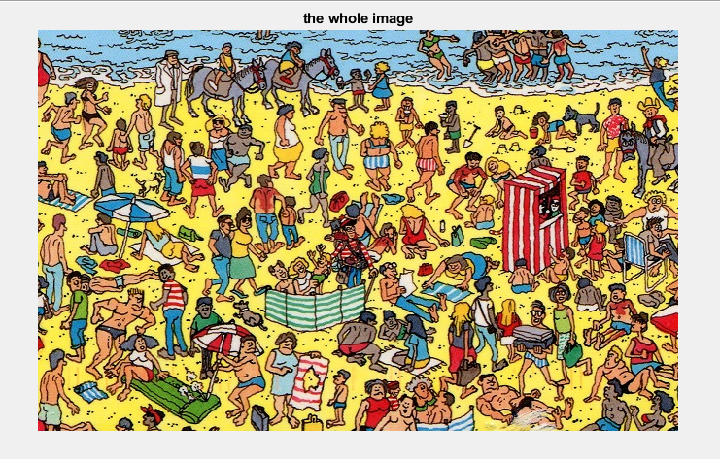**Images:**

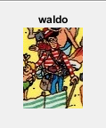

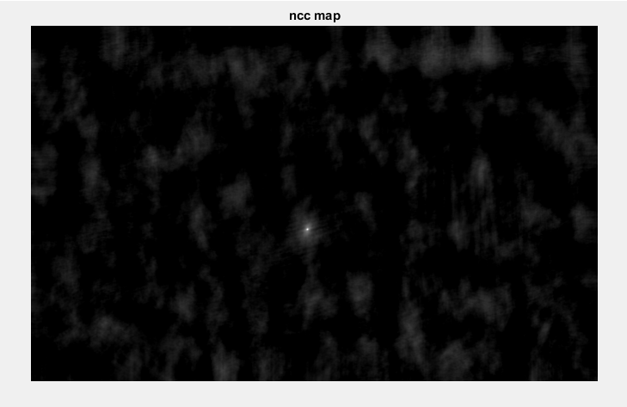

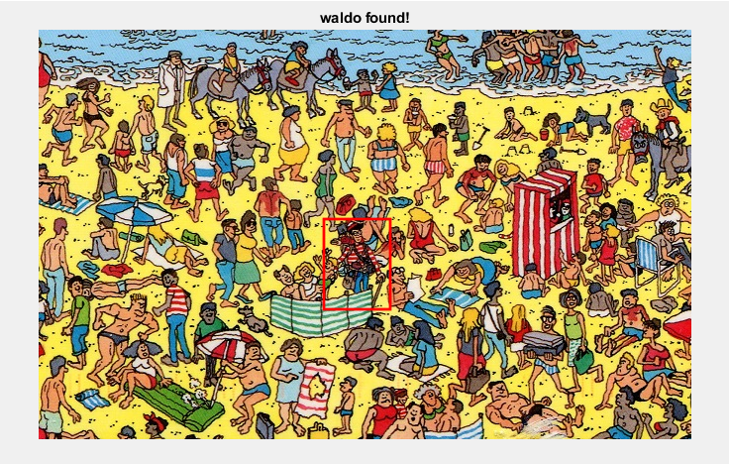

**Interferences:**

The brightest spot in the NCC map indicates the position of ‘waldo’ in the template image

1. **Brief Description:**

To obtain the x, y and the gradients of the given image using the sobel operator and to threshold the absolute gradient to keep only the dominant edges.

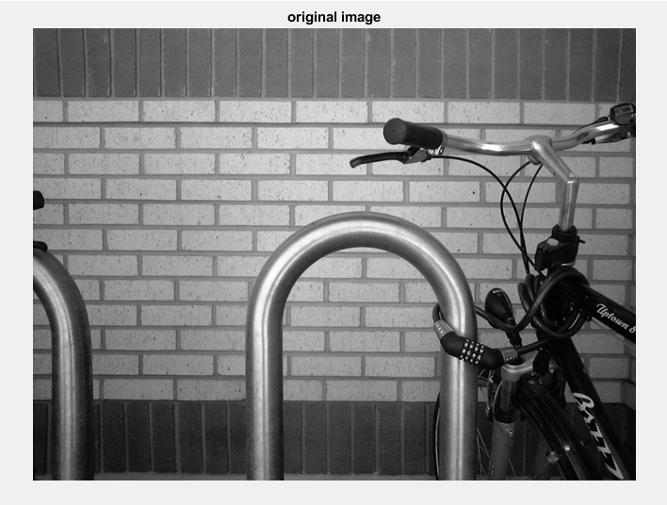**Images:**

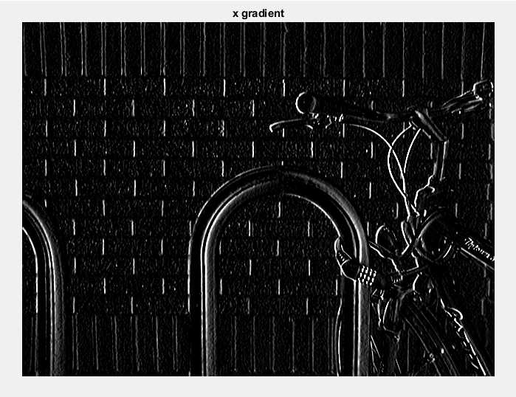

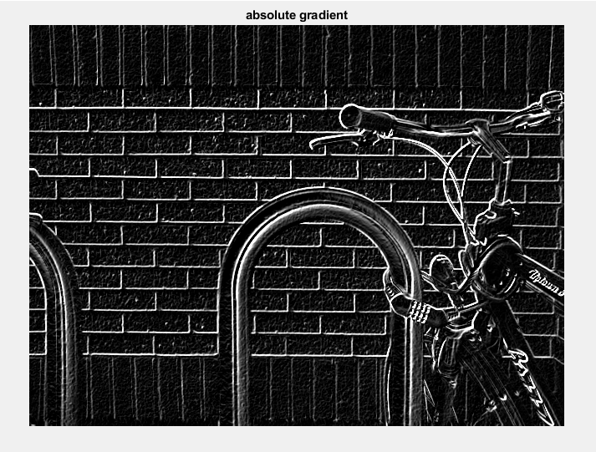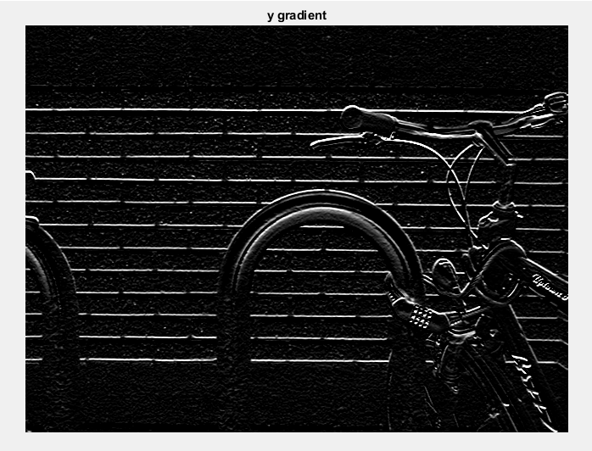

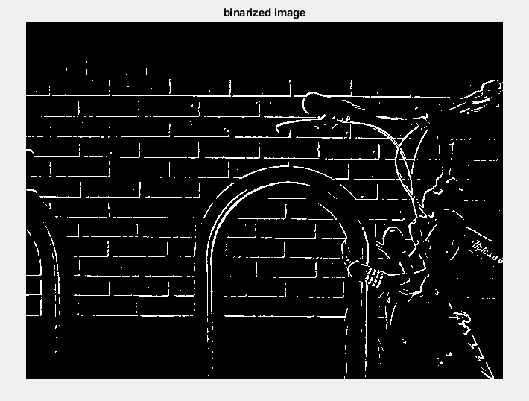

**Parameters:**

Threshold value: 0.75

Sobel Kernel size: 3X3

**Interferences:**

The bright lines in the x and y gradient images represent the detected vertical and horizontal edges respectively. With a threshold value of 0.75, I was able to keep only the dominant edges and erode the faint edges.