**Computer Vision**

**Programming Assignment 1**

**Name:** Mohammad Al Fahim K **Roll No.:**EE17B021

1. **Brief Description:**

To detect the lines in the given images (image1.png, image2.png, image3.png and image4.png) using the custom built Hough transform program. The parameter space is rescaled so that the values range from 0 to 1.

**Images:**

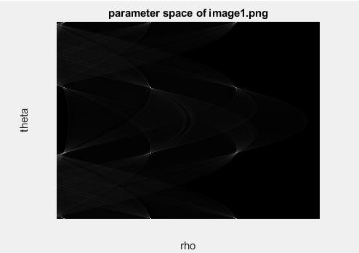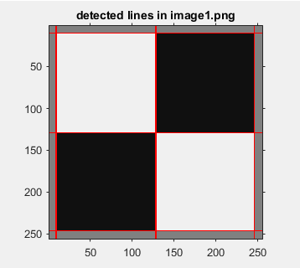

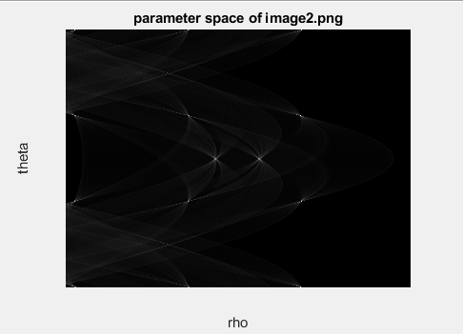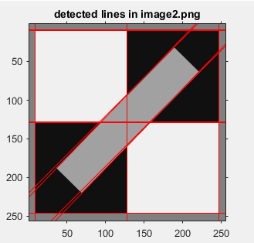

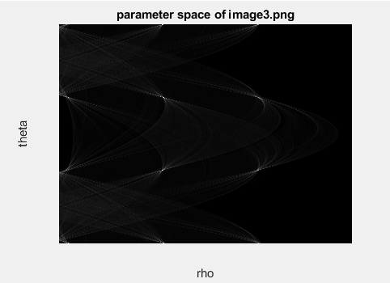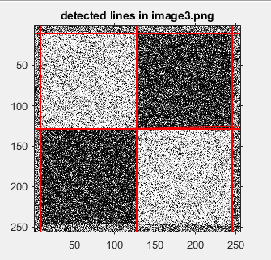

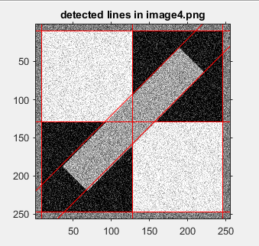

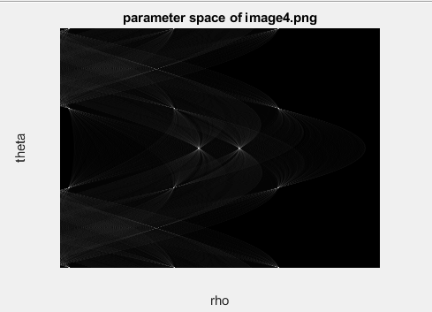

**Parameters:**

Image1.png , gaussian filter’s sigma : 4, threshold : 0.5

Image2.png , gaussian filter’s sigma : 6, threshold : 0.5

Image3.png , gaussian filter’s sigma : 6, threshold : 0.5

Image4.png , gaussian filter’s sigma : 4, threshold : 0.7

Rho ranges from 0 to 362 ( floor(1.414*N) ) and theta ranges from -180 degrees to 90 degrees. The bin sizes for both rho and theta are 1.

**Inferences:**

The small lines angled at 45 degrees and -135 degrees in the images ‘imge2.png’ and it’s noisy image, were not detected because the number of votes it gets is very low since they are so small when compared to the other lines in the image. To get those lines, the threshold should be reduced to as low as 0.3, which results in an image filled with many superimposed lines.

1. **Brief Description:**

To detect the lines and circles in the images, image5.jpg, image5.jpg and image7.jpg using the custom built hough transform program.

**Images:**

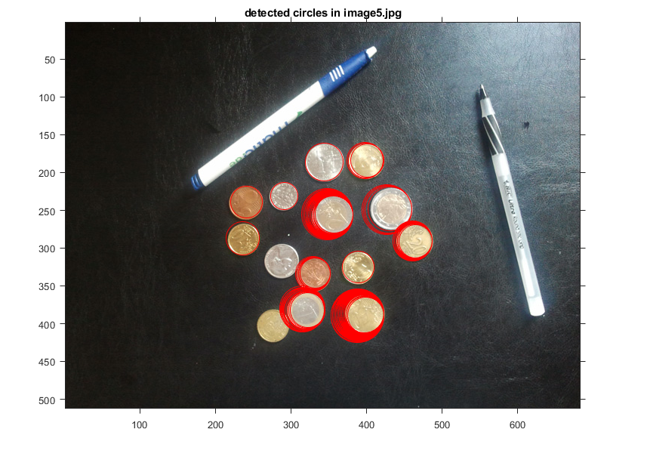

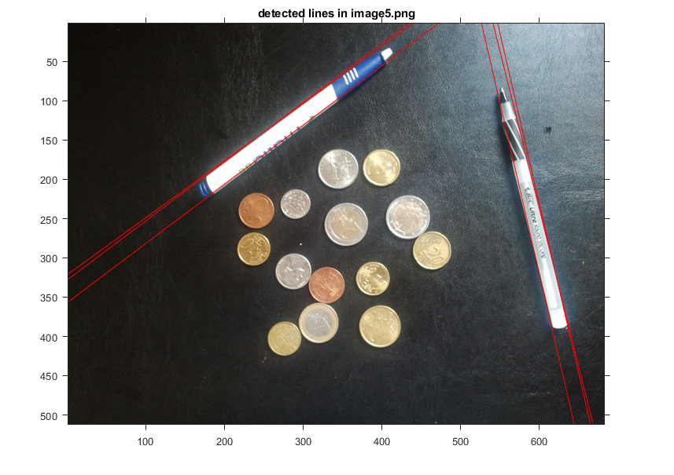

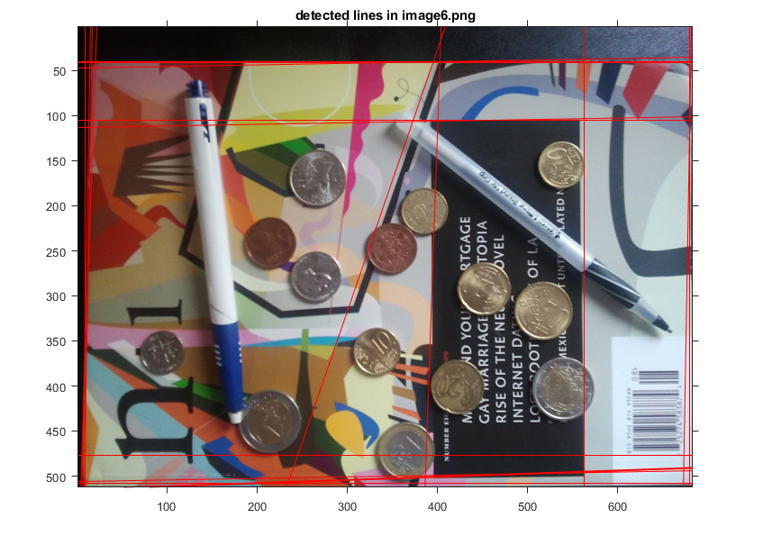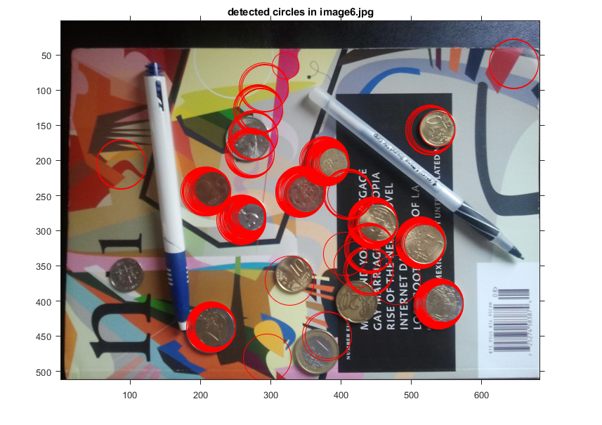

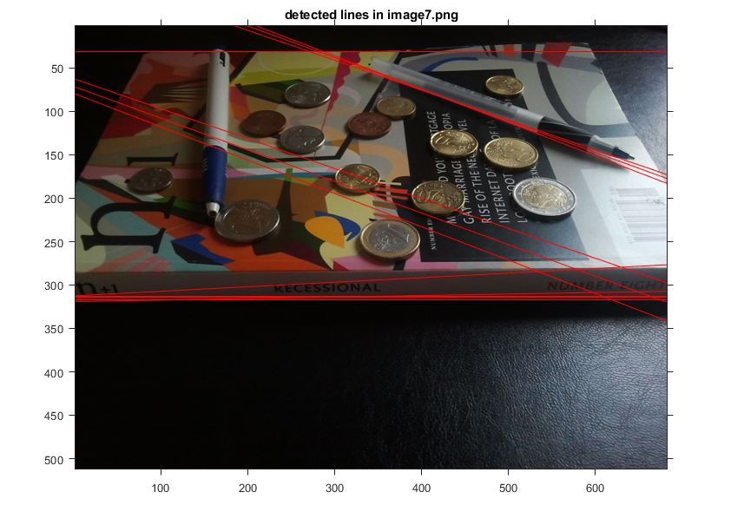

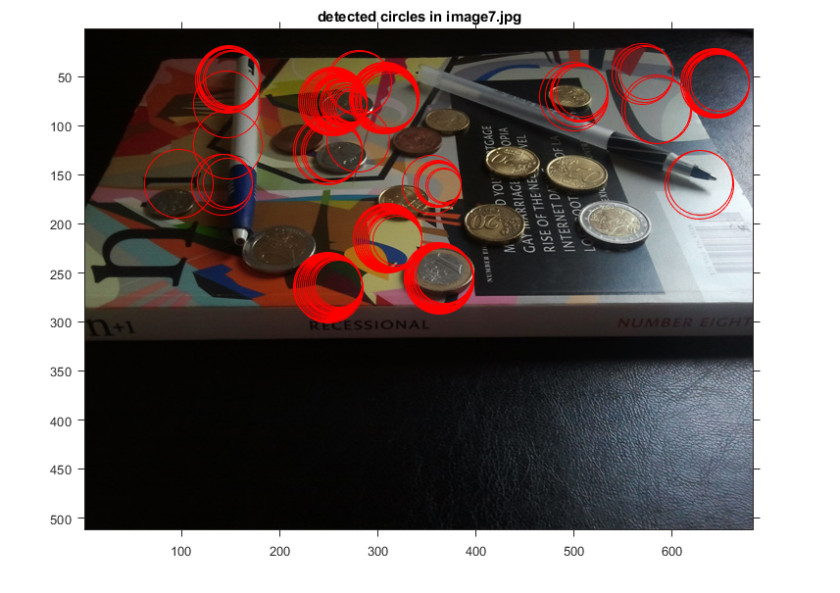

**Parameters:**

Image5.jpg, Gaussian filter’s sigma: 7 (lines) and 5 (circles), threshold: 0.7 (lines) and 0.6 (circles)

Image6.jpg, Gaussian filter’s sigma: 9 (lines) and 4.5 (circles), threshold: 0.4 (lines) and 0.5 (circles)

Image7.jpg, Gaussian filter’s sigma: 8 (lines) and 7 (circles), threshold: 0.75 (lines) and 0.6 (circles)

The ‘a’ and ‘b’ [considering circle centres are (a,b)], ranges from 0 to 3 times the length of the image and 0 to 3 times the breadth of the image respectively. The reason why the ranges of ‘a’ and ‘b’ are so large is because the circle arcs at the edges and corners have to be considered which will have centres outside the image. For a fixed radius, the (a,b) parameter space can be considered to be the same size of the image and a zero padding to both; the top and bottom for a length of the height of the image, and the left and right of the image for a length of the length of the image.

The radius ranges for 1 to 35. The dimensions of the parameter space is [3*(image length), 3*(image breadth), radius]. The bin sizes in all dimensions is 1.

**Interferences:**

The lines and circles detected in the images, image6.jpg and image7.jpg, are not as perfect as those detected in image5.jpg due to change in viewpoints, overlying object shapes and image shadows. To detect all the pen’s and books’ edges in the image7.jpg, its threshold was reduced to 0.5 and the following was obtained.

