**ED6001: Medical Image Analysis**

**Programming Assignment 1**

**Name:** Mohammad Al Fahim K **Roll No.:**EE21S050

1. **Brief Description:**

Denoising: A gaussian noise of standard deviation 3 and 5 for the first and second images respectively was introduced to the image so as to get a proper comparison between the input image and resulting denoised image. The noisy images were filtered using mean, median, and gaussian filters, and their performances are compared using residuals and PSNR.

**Results:**

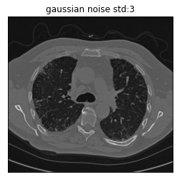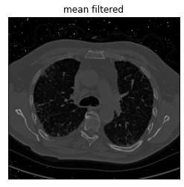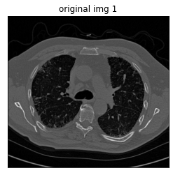

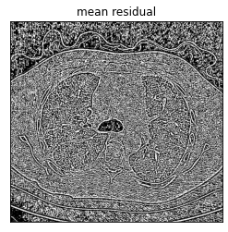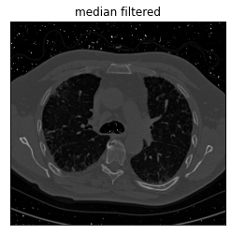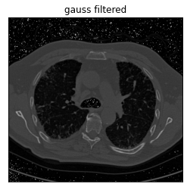

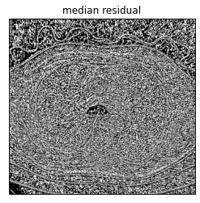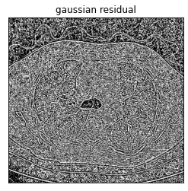

|  |  |  |  |  |
| --- | --- | --- | --- | --- |
| PSNR | Noisy image | Mean filtered | Gaussian filtered | Median filtered |
| Image 1 | 19.003 | 27.944 | 21.909 | 25.747 |
| Image 2 | 17.914 | 41.819 | 42.913 | 41.244 |

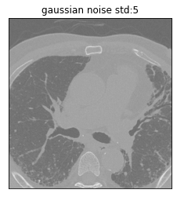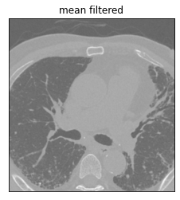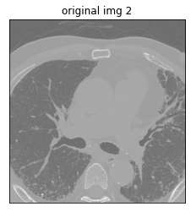

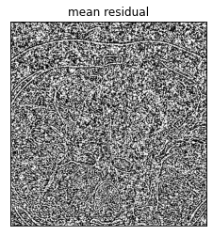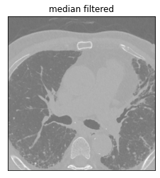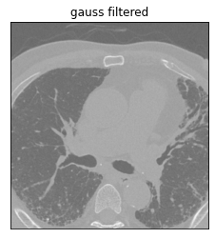

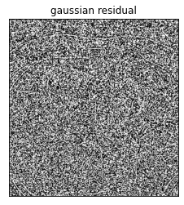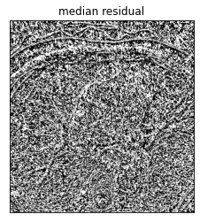

**Observations:**

In the 1st set of images, it is evident by looking at the filtered images, the mean and median filtered images have the least noise when compared to the gaussian filtered image. When seeing the residuals, the mean and gaussian residual seem to retain most of the edges with fine detail, with the mean residual having the highest edge information, whereas the median residual, although has a higher contrast between edges and noise, seems to lose edge information in the centre and lower mid region of it.

In the 2nd set of images, since the original image has a higher overall intensity, the noise is not much visible in the noisy image, and there is not much difference between the filtered images visibly. Although the PSNR values show a huge improvement in filtering. Looking at the residuals, the mean residual has the highest edge detail over them all. The median residual has the thickest edge information of them all and the gaussian residual has some edge detail in the corners but not in the middle.

1. **Brief Description**
2. Image contrast enhancement by various methods and comparing using their histograms
3. Edge detection using various filters and their comparison

**Results:**



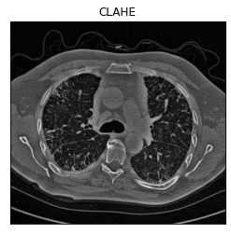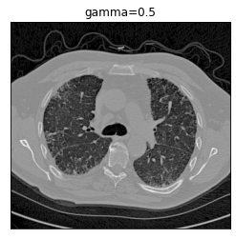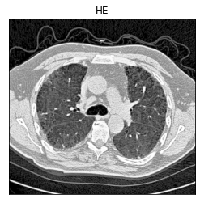

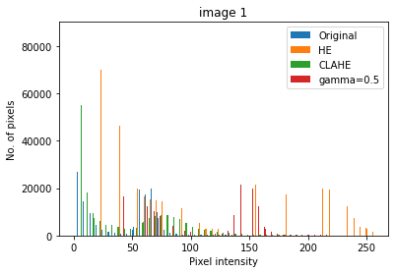

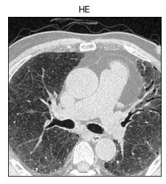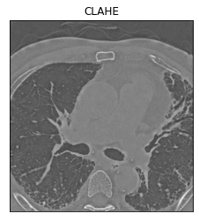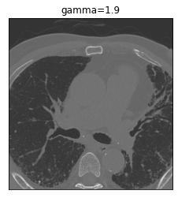

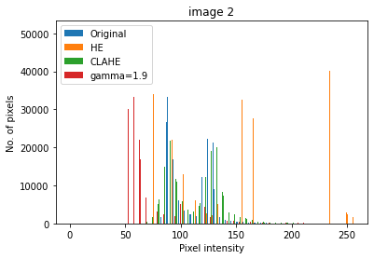

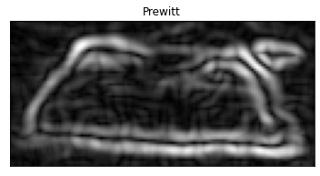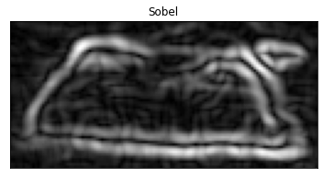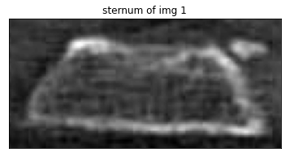

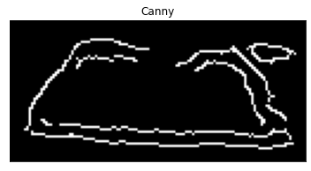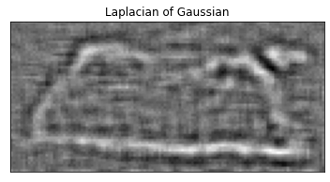

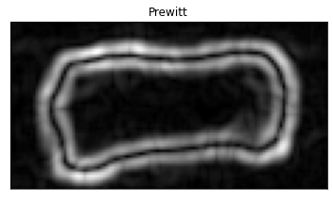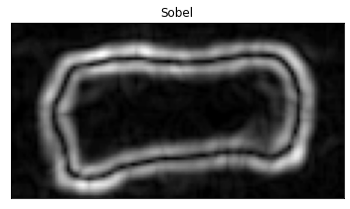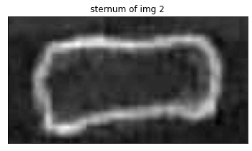

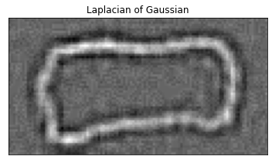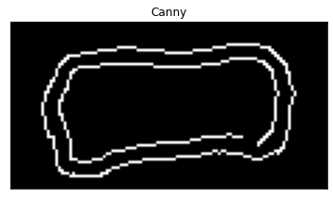

**Observations:**

1. In the 1st set of images, although HE seems to produce the best overall contrast, CLAHE(CL:2, (25,25)) gives the best contrast between the edges of the sternum and its surrounding region. The noise is also enhanced in HE which makes CLAHE more favourable.

In the 2nd set of images, HE again produces the best overall contrast but for sternum edge detection, it is favourable to go with the gamma enhanced image than CLAHE(CL:2, (50,50)), because the overall intensity in CLAHE is higher than that in gamma because of which there is a higher contrast between the sternum’s edges and its surrounding region.

1. All the sternum images underwent gaussian filtering before edge detection. In both set of images, there is almost no difference between the results of Sobel and Prewitt edge detector. This can be attributed to the only difference between them which is the middle layer in their filters. The LOG looks similar to the original image albeit with enhanced noise, because it basically is the differentiation of the edge detected images. The edges are thicker because of the gaussian smoothening done to remove the noise. Applying gaussian smoothening with lower sigma values or window sizes gives finer edges but with more noise. The canny edge detected images are the best among them all. For the sternum from image 1, the CLAHE result was cropped for edge detection and for the sternum from image 2, the gamma enhanced image was cropped for edge detection.
2. **Brief Description:**

To apply Hough transform for super ellipse detection to locate the sternums in the sternum cropped images. The following equations were taken into account for the parameter plane voting. ‘n’ is the blend parameter

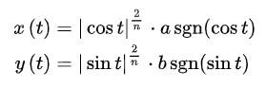

**Results:**

**Observations:**

The ‘m’ in the image titles is the blend parameter. A threshold of 0.8 was applied for Hough transform of the 1st sternum and 0.7 for the Hough transform of the 2nd sternum. The centre points of the ellipses were manually set by trial and error. Along with the ellipses that coincide with the longer edges, there are also some random ellipses (the 2 vertical lines in the 1st Hough transform and 4 in the 2nd Hough transform). One reason why the ellipses do not mostly coincide with the sternums are because the sternums do not exactly fit the super ellipses with any blend parameter, although if the most of the edges were eroded and parts of the curvatures were kept intact, the ellipses might coincide with the sternums’ shapes.

