CONTENTS
Chapter 1: Introduction
Chapter 2: Literature Survey
Chapter 3: Scope of the Project
Chapter 4: Methodology
Chapter 5: Details of Design, Working and Processes
Chapter 6: Results and Applications
References

CHAPTER 1: INTRODUCTION

1.1 Introduction
The skin is the largest organ of the human body and plays a crucial role in protecting internal organs from external pathogens, regulation of body temperature, and sensation. However, it is susceptible to a wide variety of diseases ranging from common infections like eczema and ringworm to life-threatening conditions such as melanoma (skin cancer). According to the World Health Organization (WHO), skin diseases are among the most common human health afflictions, affecting roughly 900 million people at any given time.
In many developing regions, access to dermatologists is limited, and appointments can be expensive or delayed. Misdiagnosis or delayed diagnosis of conditions like melanoma can lead to severe consequences. With the advent of Artificial Intelligence (AI) and Computer Vision, specifically Deep Learning, it has become possible to analyze medical images with high accuracy. This project, the 'AI-Based Skin Disease Detection System', aims to bridge the gap between patients and specialized dermatological care by providing an accessible, automated tool for early screening of skin conditions using a smartphone.
The integration of artificial intelligence into healthcare systems has transformed diagnostic procedures across multiple medical domains. In dermatology, image-based diagnosis makes it particularly suitable for computer vision applications. Deep learning models, especially convolutional neural networks, have demonstrated the ability to extract complex visual patterns that are often difficult to quantify manually. This enables automated systems to assist in identifying subtle variations in skin texture, color, and lesion structure.
Early screening plays a crucial role in reducing morbidity and mortality associated with severe skin conditions. For example, melanoma survival rates significantly improve when detected at an early stage. An automated system accessible through smartphones increases the likelihood of early detection by reducing dependency on physical consultations for initial screening. Such systems act as preliminary diagnostic tools that guide users toward appropriate medical decisions.
Furthermore, the widespread availability of smartphones equipped with high-resolution cameras makes this solution scalable and practical. The proposed system leverages this accessibility to provide an inclusive healthcare support mechanism. By combining mobile technology with deep learning algorithms, the project demonstrates how computational intelligence can be embedded into daily life to improve health awareness and proactive care.
1.2 Background of the Domain
Dermatology relies heavily on visual inspection. Traditionally, dermatologists use dermoscopy—a non-invasive skin imaging technique—to examine lesions. However, visual interpretation is subjective and dependent on the clinician's experience. Computer-Aided Diagnosis (CAD) systems have evolved to support doctors. Recent advancements in Convolutional Neural Networks (CNNs) have shown performance comparable to human experts in classifying skin lesions.
Computer-Aided Diagnosis systems have evolved significantly with the growth of computational power and availability of medical image datasets. Earlier approaches relied on handcrafted feature extraction methods such as texture descriptors, edge detection algorithms, and color histograms. These traditional techniques required domain expertise and often failed to generalize across diverse skin types and lighting conditions.
The introduction of deep learning eliminated the need for manual feature engineering. CNNs automatically learn hierarchical representations from raw image data, beginning with simple features such as edges and gradually identifying complex lesion characteristics. This hierarchical learning mechanism makes CNNs particularly effective for dermatological classification tasks.
Recent studies have shown that deep learning models can achieve dermatologist-level performance under controlled conditions. However, translating research models into real-world mobile applications requires careful system design, optimization, and validation. This project builds upon established research and focuses on practical deployment within a usable mobile framework.

1.3 Problem Statement
The existing manual system of diagnosing skin diseases suffers from several issues:
- Scarcity of Experts: High patient-to-doctor ratio in many areas.
- Time-Consuming: Getting an appointment and diagnosis can take weeks.
- Human Error: Visual diagnosis can be subjective.
- Cost: Professional consultation can be expensive for frequent check-ups.
Therefore, there is a need for a system that provides instant, low-cost, and reliable preliminary diagnosis to guide patients on whether they need urgent medical attention. In addition to the challenges already identified, variability in diagnostic accuracy remains a major issue in dermatology. Different clinicians may interpret the same lesion differently due to subjective judgment. This variability increases the risk of inconsistent treatment decisions. An automated system introduces standardized evaluation criteria, reducing subjectivity in preliminary assessments.
Another concern is the lack of awareness among the general population regarding early symptoms of serious skin conditions. Many individuals ignore minor changes in skin appearance until the disease progresses. A user-friendly AI-based system can promote awareness by encouraging regular self-examination and immediate analysis of suspicious lesions.

The problem is therefore not only clinical but also technological and educational. There is a need for a solution that combines diagnostic assistance with accessibility and health awareness. The proposed system addresses these dimensions through intelligent automation and mobile integration.

1.4 Objectives
The primary objectives of this project are:
- To develop a Deep Learning model capable of classifying multiple types of skin diseases (e.g., Eczema, Melanoma, Basal Cell Carcinoma).
- To create a user-friendly mobile application (Frontend) that allows users to capture or upload images of skin lesions.
- To implement a secure backend API that processes images and returns diagnosis results with confidence scores.
- To provide actionable advice and dermatologist recommendations based on the diagnosis severity.
Beyond classification accuracy, the system aims to ensure reliability, scalability, and user trust. Reliability is achieved through standardized preprocessing pipelines and controlled model deployment practices. Scalability is addressed by implementing a backend architecture capable of handling multiple concurrent user requests.
Another objective is interpretability. While deep learning models are often considered black-box systems, presenting confidence scores and disease descriptions enhances transparency. This helps users understand that the system provides probabilistic predictions rather than absolute medical conclusions.
The project also seeks to create a modular framework that can be extended in the future. New disease classes, updated datasets, and improved architectures can be integrated without redesigning the entire system. This ensures long-term adaptability of the solution.

1.5 Need of the Proposed System
The increasing prevalence of skin diseases combined with the shortage of trained dermatologists has created a significant gap in timely diagnosis and treatment. In many regions, especially rural and semi-urban areas, access to dermatological expertise is limited. Manual diagnosis relies heavily on the experience of medical professionals and may vary from person to person, leading to inconsistency and possible errors.
The proposed AI-based system provides an automated, scalable, and cost-effective solution for preliminary skin disease detection. By leveraging deep learning techniques, the system ensures consistent analysis, faster diagnosis, and improved accessibility. It assists users in identifying potential skin conditions at an early stage, thereby encouraging timely medical consultation and reducing the risk of disease progression. Healthcare infrastructure disparities create unequal access to dermatological expertise. Rural regions often lack specialists, leading to delayed consultations. Even in urban areas, appointment waiting times can be significant. A digital screening tool reduces the burden on healthcare systems by filtering non-critical cases and prioritizing high-risk conditions.
Cost considerations further emphasize the need for such systems. Frequent consultations for minor or recurring conditions may not be economically feasible for many individuals. An AI-based preliminary screening tool provides cost-effective guidance and reduces unnecessary hospital visits.
Additionally, digital healthcare tools contribute to preventive medicine. Encouraging early detection and routine monitoring aligns with modern healthcare strategies focused on proactive rather than reactive treatment approaches. The proposed system supports this paradigm shift by enabling timely identification of potential risks.

1.6 Assumptions and Constraints
The performance of deep learning models is inherently dependent on dataset quality and representativeness. If the dataset does not adequately represent variations in skin tone, lighting conditions, or rare disease manifestations, prediction accuracy may decrease. Therefore, model evaluation must consider diversity and generalization capability.
Computational constraints also influence system performance. Mobile devices rely on backend servers for processing, which introduces latency and dependency on stable internet connectivity. High-resolution images increase processing time and server load, requiring efficient optimization strategies.
Ethical constraints must also be acknowledged. The system is intended strictly as a decision-support tool and not as a replacement for professional diagnosis. Clear disclaimers and user guidance are necessary to prevent misuse or over-reliance on automated predictions. The assumptions and constraints of this project are:

- The images captured by users are of reasonable quality and taken under sufficient lighting conditions.
- Users follow basic guidelines while capturing skin lesion images.
- The dataset used for training represents common variations of skin diseases.
- The system does not replace professional medical diagnosis.
- Prediction accuracy depends on dataset quality and image clarity.
- Internet connectivity is required for backend processing.
- The system may not accurately classify rare or unseen skin conditions.

CHAPTER 2: LITERATURE SURVEY

2.1 Study of Existing Systems
Several commercial and research-based systems exist for skin analysis. Apps like 'SkinVision' and 'Miiskin' allow users to track moles over time. However, many are paid services or limited to specific conditions like Melanoma only. In academic research, the ISIC (International Skin Imaging Collaboration) Archive has spurred the development of numerous algorithms.
Several research initiatives have evaluated deep learning architectures such as VGGNet, ResNet, Inception, and EfficientNet for skin lesion classification. These models are typically trained on large annotated datasets and fine-tuned using transfer learning. Transfer learning reduces training time and improves accuracy by leveraging pre-trained weights from large-scale image datasets such as ImageNet.
Academic systems often emphasize performance metrics under controlled conditions. Many studies report high classification accuracy, sensitivity, and specificity; however, real-world deployment introduces challenges such as varied lighting, image blur, occlusion, and different camera qualities. This gap between laboratory performance and real-world usability remains a key concern.
In addition, some healthcare institutions have implemented tele-dermatology systems where images are uploaded and reviewed by specialists remotely. While effective, these systems depend heavily on human expertise and do not provide instant automated feedback. The proposed system differs by integrating automated AI-based inference for immediate preliminary screening

2.2 Limitations of Existing Systems

- Limited Class Support: Many apps focus only on cancer, ignoring common issues like eczema or fungal infections.
- Hardware Dependency: Some professional CAD systems require specialized dermoscopes attached to cameras.
- Data Privacy: Cloud-based processing often raises concerns about patient data privacy.
- Lack of Guidance: Many models give a label but no medical advice or doctor connection.

2.3 Proposed System
Our proposed system overcomes these limitations by offering a multi-class classification model (10 different diseases) integrated into a seamless mobile experience. It combines AI diagnosis with practical features like finding nearby doctors and daily skin care tips, making it a holistic health companion. The proposed system aims to integrate research-grade deep learning models within a production-ready architecture. By combining a CNN-based classifier with a mobile frontend and structured backend API, the system bridges the gap between academic innovation and practical usability.
Unlike single-disease applications, the multi-class framework supports a broader range of dermatological conditions. This enhances its relevance for general users who may not know the specific nature of their condition. The inclusion of severity categorization further improves decision-making support.
The system design also emphasizes modularity. Each component—authentication, preprocessing, prediction, and recommendation—is implemented as an independent module. This architecture facilitates future updates, model retraining, and integration with external healthcare services.

2.4 Comparative study of existing system
System Name | Technology | Diseases Covered | Key Features | Limitation
Skin Vision | Machine Learning | Melanoma | Mole tracking, risk alert | Paid service, limited coverage
Miiskin | Image Analysis | Skin Cancer | Image Comparison | No diagnosis confidence
ISIC Models | CNN | Multiple Lesions | High accuracy research models | Not User Friendly
Proposed System(Skin Check) | CNN + Mobile App | 10+ Skin Diseases | Multi-class prediction, recommendation | Requires Internet

2.5 Research Gaps Identified
From the study of existing systems, several gaps were identified. Most commercial applications focus only on skin cancer detection and neglect common skin diseases such as eczema and fungal infections. Many research models demonstrate high accuracy but lack real-world usability due to complex interfaces. Additionally, most systems provide classification results without severity-based guidance or medical recommendations. A significant research gap exists in the integration of AI models with real-time, user-accessible platforms. Many studies demonstrate algorithmic performance but do not address deployment challenges such as latency, server management, and user data handling. Bridging this gap requires interdisciplinary design combining machine learning and software engineering principles.
Another gap involves explainability and trust. Users may hesitate to rely on automated medical systems without clear communication of prediction confidence and limitations. Future systems must incorporate explainable AI techniques to enhance transparency and user acceptance.
Finally, limited emphasis has been placed on preventive healthcare features such as educational resources, risk alerts, and personalized recommendations. Integrating these features can transform diagnostic tools into comprehensive digital health assistants.
The proposed system addresses these gaps by combining multi-class classification, confidence scoring, modular deployment, and user guidance within a single framework.
Furthermore, a significant disconnect persists between automated analysis and professional medical workflows. Most existing AI systems operate in a vacuum, providing a classification result to the user but offering no clear or integrated pathway to professional care. This creates a "what next?" problem for the user, especially in cases of high-risk predictions.
The research gap, therefore, is not just in improving model accuracy but in designing socio-technical systems that seamlessly bridge the gap between an AI's preliminary finding and a consultation with a human expert. This involves solving challenges in clinical workflow integration, developing effective methods for AI-assisted triage, and creating user interfaces that facilitate a smooth transition from automated screening to telemedicine or in-person appointments.
The true impact of these technologies will only be realized when they are thoughtfully embedded within the larger healthcare ecosystem, acting as a collaborative tool for both patients and physicians rather than as an isolated diagnostic black box.

CHAPTER 3: SCOPE OF THE PROJECT

3.1 Functional Modules
The system consists of the following key modules:
- User Authentication: Secure login and registration to maintain user history.
- Image Capture & Preprocessing: Interface to use camera or gallery, followed by image resizing and normalization.
- AI Prediction Engine: The core module where the Convolutional Neural Network (CNN) analyzes the image features.
- Results & Recommendation: Displays the disease name, confidence percentage, and severity-based advice (Low/Moderate/High risk).
- Doctor Locator: A feature to list dermatologists.

3.2 Target Users
This multi-faceted approach to target users underscores the system's versatility and its potential to democratize access to dermatological insights.
- General Public: People who notice a skin abnormality and want a quick check.
- General Physicians: Can use it as a second opinion tool before referring to specialists.
- Medical Students: To learn and verify diagnoses.

3.3 Future Scope
The current system focuses on static image-based classification. Future developments could incorporate real-time video analysis, allowing dynamic monitoring of lesions. This would require optimization of inference time and possible on-device processing capabilities.
Integration with telemedicine platforms represents another expansion opportunity. Enabling users to directly share prediction results and images with certified dermatologists could streamline the consultation process. This would transform the system from a screening tool into a comprehensive digital healthcare ecosystem.
Advanced explainable AI techniques may also be incorporated to highlight specific regions of the image influencing the prediction. Visualization tools such as heatmaps can improve transparency and trust in the model’s decisions.
Additionally, expanding the dataset to include more diverse skin tones and rare conditions will improve generalization and fairness. Continuous retraining with updated data can enhance long-term performance and adaptability.
Scalability enhancements, including cloud-based deployment with load balancing, may be implemented to support large user populations. As digital healthcare adoption increases, system robustness and infrastructure optimization will become increasingly critical.
Future enhancements could include:
- Real-time video analysis.
- Integration with hospital appointment booking systems.
- Telemedicine features for live chat with doctors.

CHAPTER 4: METHODOLOGY

4.1 Tools and Technologies
We followed an Agile development methodology. This allowed us to build the project iteratively, starting with a basic model and simple UI, and progressively adding features like authentication and doctor recommendations. The Agile development methodology was chosen due to its flexibility and iterative nature. Since the project involves both machine learning and mobile application development, frequent testing and incremental improvements were necessary. Agile allowed continuous enhancement of the model accuracy and user interface based on testing feedback. The Agile methodology enabled iterative refinement of both the machine learning model and the application interface. Since model accuracy depends on multiple experimental trials, the development process required repeated cycles of training, evaluation, adjustment of hyperparameters, and validation. Agile sprints were structured around incremental goals such as achieving baseline model accuracy, implementing backend integration, and connecting the frontend to the prediction API.
Frequent testing was conducted after each iteration to ensure compatibility between system components. For example, once the CNN model achieved satisfactory validation performance, integration testing was performed to verify whether the Django backend correctly handled image input and returned predictions in JSON format. This iterative validation reduced integration errors and improved overall system reliability.
The methodology also allowed independent development of frontend and backend modules. While the AI model was being optimized, the user interface design and authentication workflow were developed in parallel. This reduced development time and ensured that system components converged during final integration.
Risk management was embedded within the iterative process. Potential risks such as model overfitting, high inference latency, and preprocessing mismatches were identified early and addressed during successive refinement cycles.

4.2 Tools and Technologies
The project utilizes a modern full-stack architecture:
- Deep Learning Framework: TensorFlow & Keras. Used for building and training the CNN model. The model is saved in .h5 format.
- Backend: Django (Python). A robust web framework used to serve the API. It handles image uploads, runs the inference logic, and manages the database.
- Frontend: React Native (Expo). chosen for its cross-platform capability (Android/iOS) and modern UI components.
- Language: Python (Backend/AI), TypeScript/JavaScript (Frontend).
- IDE: Visual Studio Code.

4.3 Algorithm: Convolutional Neural Network (CNN)
CNNs are specialized neural networks for image processing. A Convolutional Neural Network (CNN) is a class of deep learning algorithms specifically designed for image processing and visual pattern recognition. CNNs are widely used in medical image analysis due to their ability to automatically learn meaningful features from raw image data. In this project, a CNN is used to classify skin disease images into multiple predefined categories.
Unlike traditional machine learning approaches that require manual feature extraction, CNNs learn hierarchical features directly from images, making them highly effective for complex classification tasks such as skin disease detection.

Algorithm Steps
Step 1: Input Acquisition
Acquire a skin lesion image from the user through the mobile application using camera capture or gallery upload.
Step 2: Image Preprocessing
Resize the input image to a fixed dimension.
Convert the image into a numerical array.
Normalize pixel values to maintain consistency.
Add a batch dimension to match the CNN input format.
Step 3: Input Layer Processing
Feed the preprocessed image into the input layer of the Convolutional Neural Network.
Step 4: Feature Extraction Using Convolution
Apply convolutional filters to the input image to extract low-level features such as edges, textures, and patterns.
Generate feature maps through convolution operations.
Step 5: Activation Function Application
Apply the ReLU activation function to introduce non-linearity and enhance learning capability.
Step 6: Spatial Reduction Using Pooling
Perform max pooling on feature maps to reduce spatial dimensions while retaining important information.
Step 7: Deep Feature Learning
Repeat convolution and pooling operations across multiple layers to learn high-level and disease-specific features.
Step 8: Flattening
Convert the final feature maps into a one-dimensional feature vector.
Step 9: Fully Connected Layer Processing
Pass the flattened feature vector through fully connected layers to perform classification.
Step 10: Output Generation
Apply the Softmax function at the output layer to generate probability values for each skin disease class.
Step 11: Prediction Selection
Select the class with the highest probability as the predicted skin disease.
Calculate the confidence score for the prediction.
Step 12: Result Display
Return the predicted disease name and confidence score to the user through the frontend application.

4.4 Dataset Description
The dataset used for training the model consists of labeled skin lesion images collected from publicly available dermatological datasets. The images were categorized into ten different disease classes. The dataset was divided into training and testing sets using an 80:20 ratio. Image augmentation techniques such as rotation, flipping, and scaling were applied to improve model generalization. The dataset consists of labeled dermatological images categorized into ten disease classes. Each image represents a distinct visual manifestation of a skin condition. Data labeling ensures supervised learning, where each image is associated with a known class.
Before training, images were resized to a uniform resolution of 100×100 pixels to standardize input dimensions. Converting images to grayscale reduced computational complexity by eliminating three-channel color information while retaining structural patterns.
The dataset was divided using an 80:20 split:
- 80% used for training the model
- 20% reserved for testing and evaluation

Image augmentation was applied to artificially expand the training dataset. Techniques included:
- Random rotation within a defined angle range
- Horizontal flipping
- Minor scaling transformations
These transformations simulate real-world variations and improve model robustness.
Proper dataset partitioning ensures that the model is evaluated on unseen images, providing a realistic estimate of generalization performance.

CHAPTER 5: DETAILS OF DESIGN AND WORKING

5.1 System Architecture
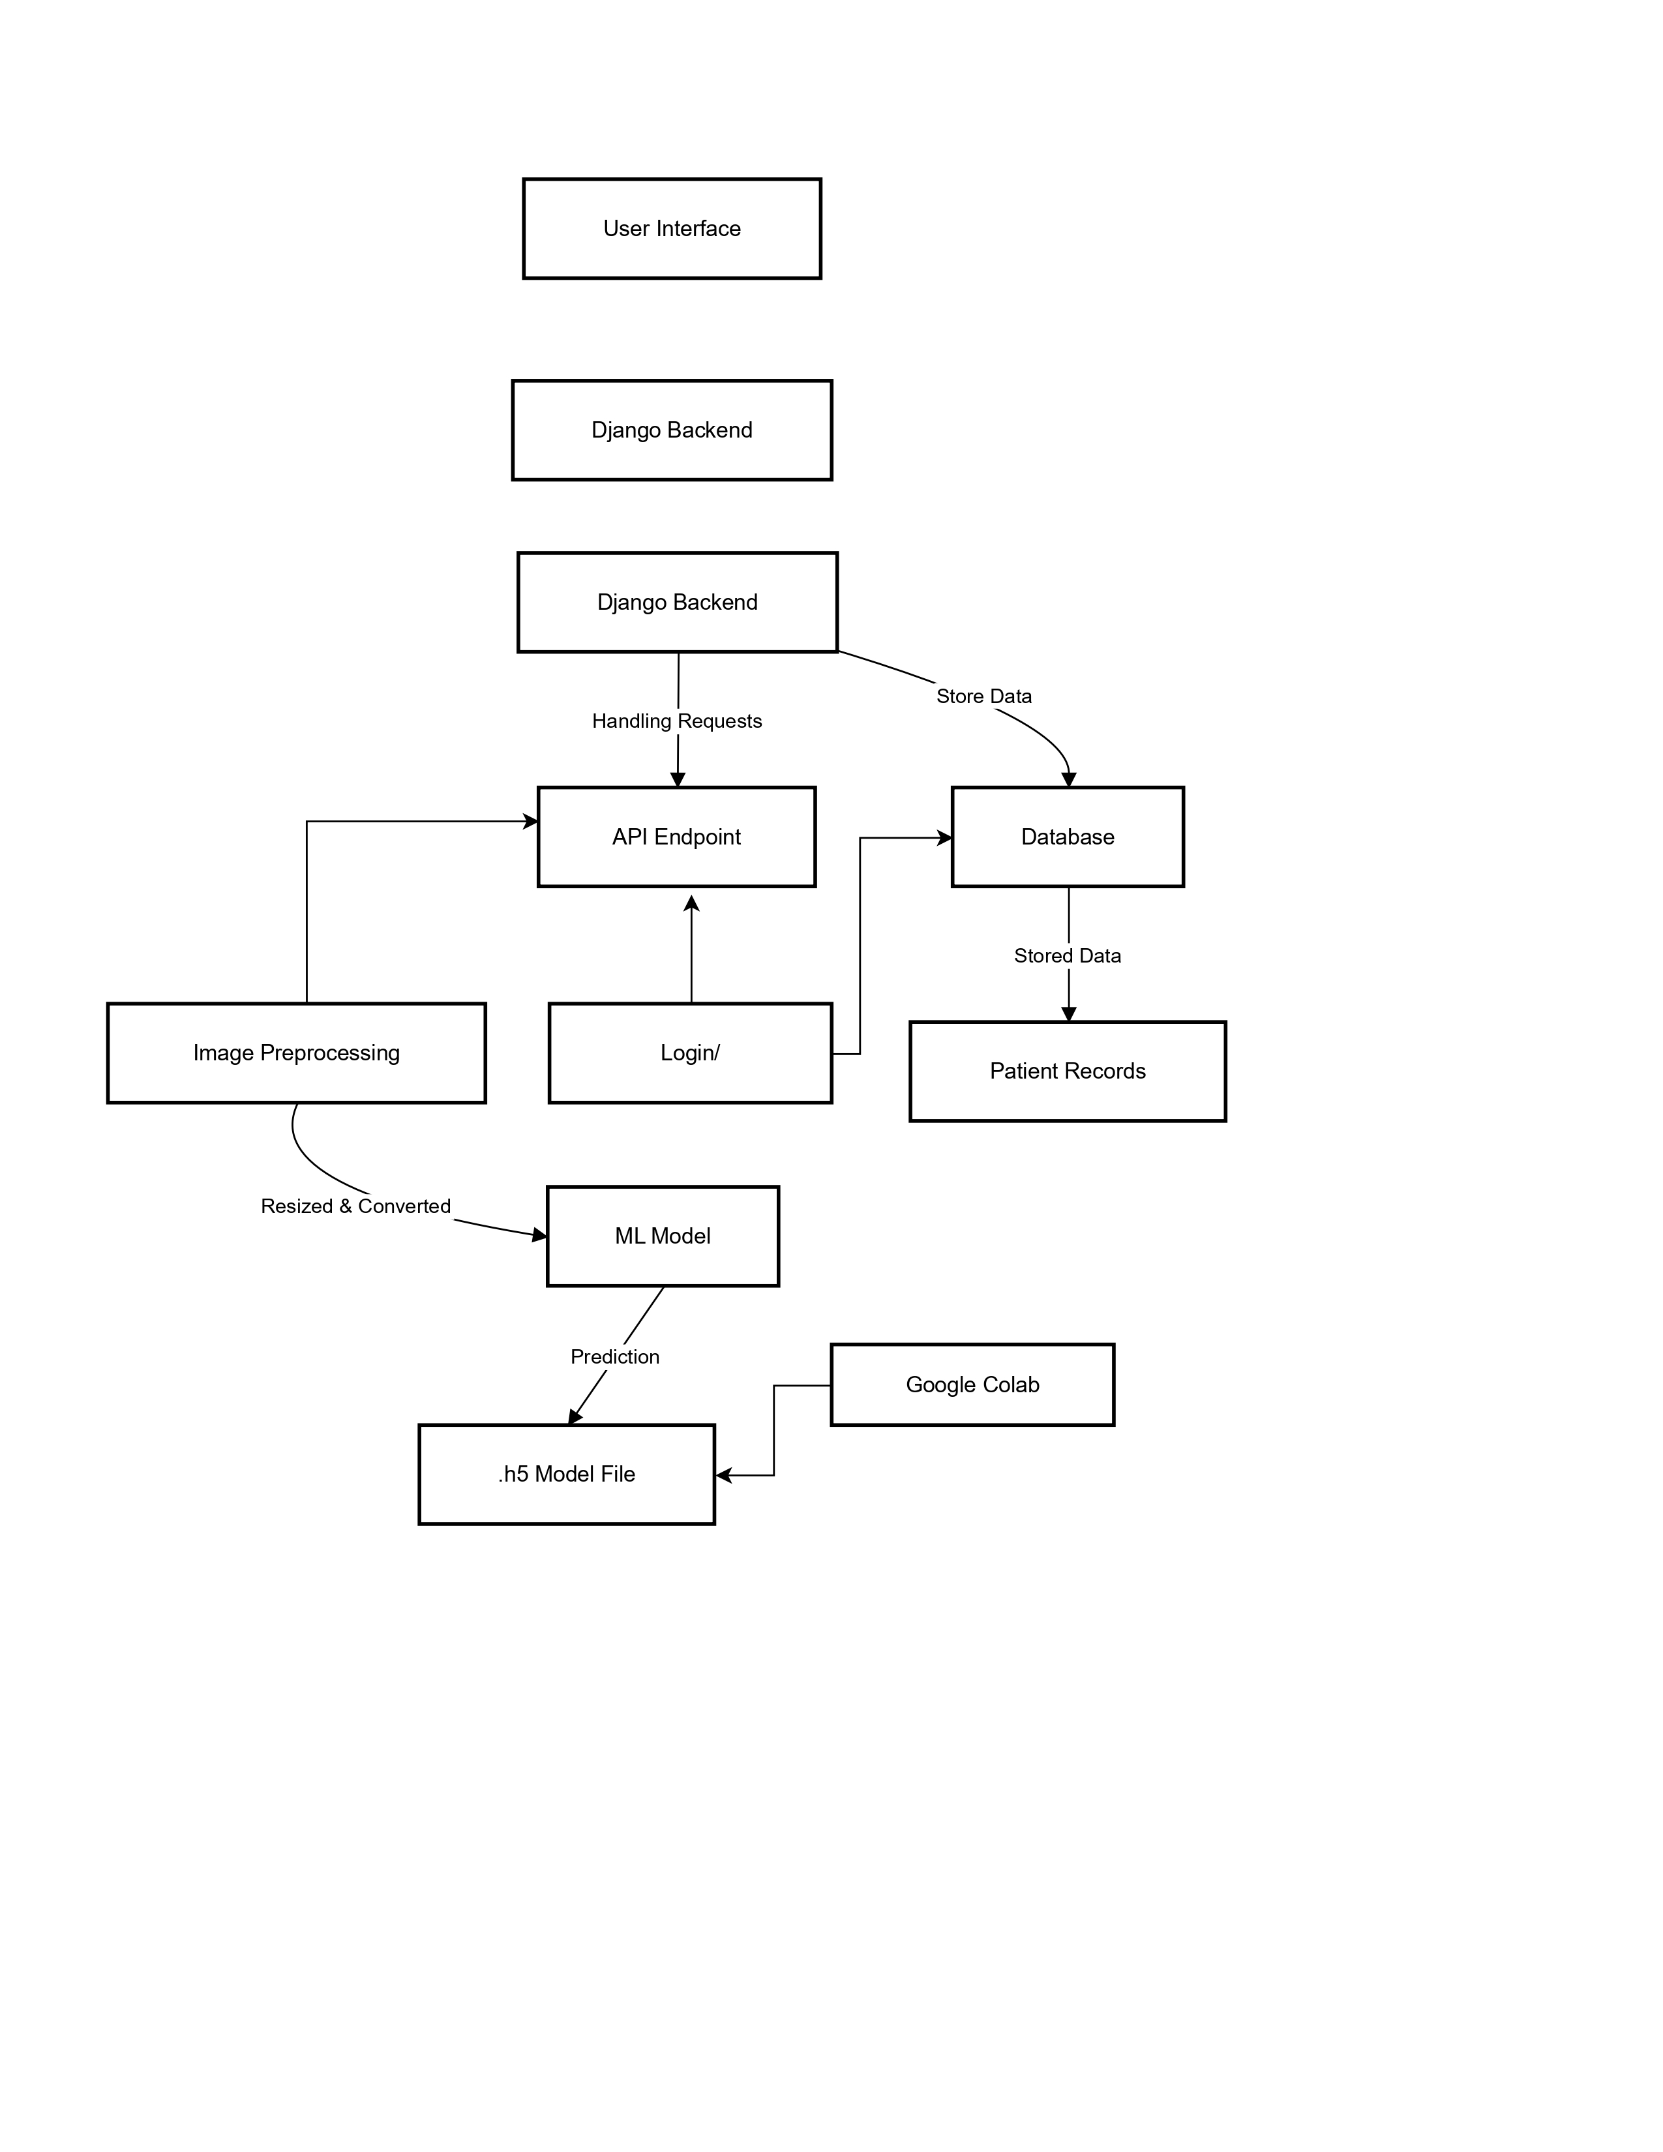
The system follows a Client-Server architecture.
The system follows a structured Client–Server architecture in which the mobile application acts as the client and the Django-based backend acts as the server. The client is responsible for user interaction, image capture, and result display, while the server handles image preprocessing, model inference, and response generation.
When a user uploads an image, the frontend sends an HTTP POST request to the backend API endpoint. The request includes the image file in multipart form data format. The backend receives the image, temporarily stores it in memory, and initiates the preprocessing pipeline before passing it to the CNN model.
A key design decision in the architecture is maintaining a global model instance. Instead of loading the trained .h5 model file for every prediction request, the model is loaded once when the server starts. This reduces inference latency and prevents repeated disk I/O operations. The model remains in memory during runtime, improving response time under multiple requests.
The architecture ensures separation of concerns. The frontend does not contain any AI logic, and the backend does not handle user interface rendering. This modular separation improves maintainability and allows independent updates to either component.

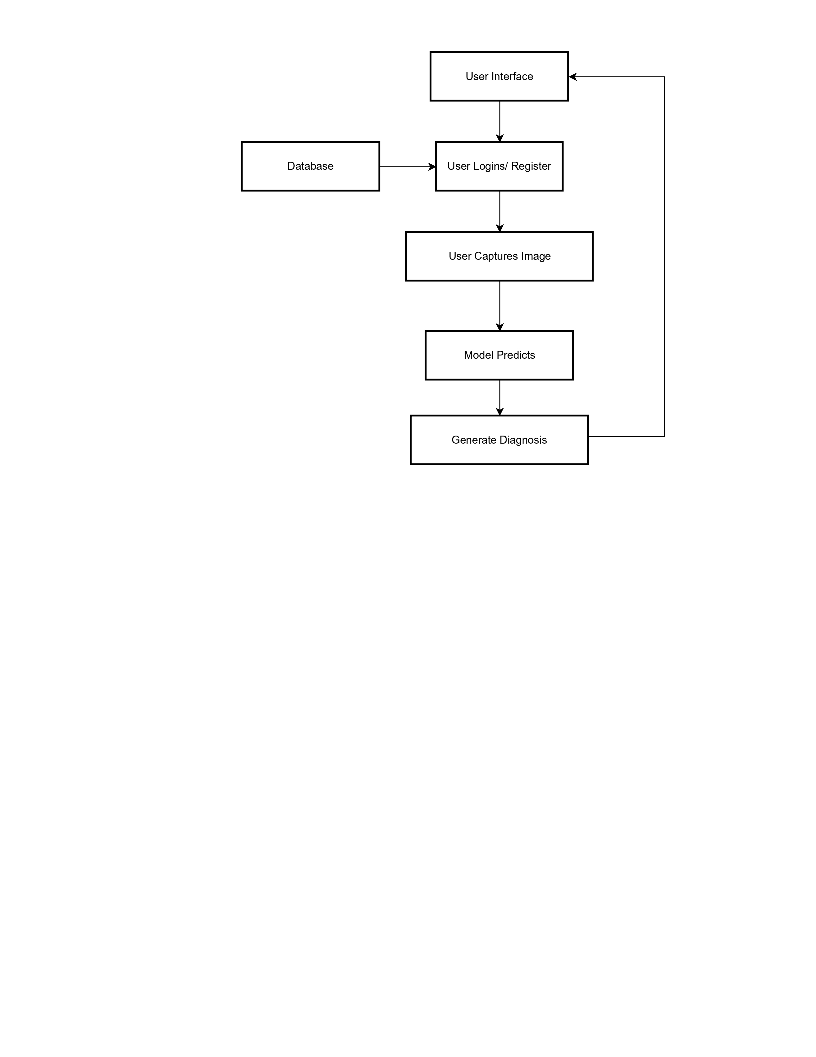
5.2 Data Flow
The data flow begins when the user selects or captures a skin lesion image through the mobile application. The image is transmitted to the backend server via a REST API call.
Upon receiving the image, the backend performs the following sequence:
- Image Decoding – Raw byte data is converted into an image object compatible with processing libraries.
- Grayscale Conversion – The image is converted to grayscale to reduce dimensional complexity while preserving texture information.
- Resizing – The image is resized to 100 × 100 pixels to match the CNN input requirement.

- Normalization – Pixel values are normalized using L2 normalization to standardize numerical scale.
- Batch Dimension Addition – A batch axis is added to match the expected input shape of the model.
After preprocessing, the structured tensor is passed to the CNN model for inference. The model produces a probability distribution across all disease classes.
The backend applies the argmax function to determine the predicted class index. This index is mapped to a disease code and full disease name. A confidence score is calculated by converting the highest probability into a percentage.
Finally, the backend constructs a JSON response containing:
- Predicted disease name
- Confidence percentage
- Severity-based guidance
This response is sent back to the frontend and displayed to the user in a structured format.

5.3 Supported Diseases
The model is trained to identify the following conditions:
- Eczema (ECZ)
- Melanoma (MEL)
- Atopic Dermatitis (ATD)
- Basal Cell Carcinoma (BCC)
- Melanocytic Nevi (NV)
- Benign Keratosis (BKL)
- Psoriasis / Lichen Planus (PLP)
- Seborrheic Keratoses (SKB)
- Tinea / Fungal Infections (TRF)
- Warts / Viral Infections (WMV)
The model is trained to classify ten dermatological conditions. Each condition presents distinct visual patterns that the CNN learns during training. Differences may include lesion shape, border irregularity, color variation, scaling patterns, or surface texture.
For example:
- Melanoma often exhibits irregular borders and color asymmetry.
- Eczema may show inflamed, red, and patchy areas.
- Fungal infections typically appear as ring-shaped lesions with defined edges.
- Warts often present as raised, rough-textured growths.
The inclusion of multiple disease categories allows the system to function as a generalized screening tool rather than focusing on a single condition. However, classification performance depends on the similarity between real-world images and training dataset samples.
It is important to note that visually similar conditions may pose classification challenges. The CNN distinguishes them based on learned feature representations, but borderline cases may result in lower confidence scores.

5.4 Implementation Details
The implementation of the AI-Based Skin Disease Detection System is divided into two major components: the model management and inference layer and the image preprocessing and prediction utility layer. These components are implemented using Python and integrated with the Django backend to ensure efficient, scalable, and reliable prediction of skin diseases. To avoid repeated loading of the deep learning model for every prediction request, a global model state is maintained in the backend. The trained Convolutional Neural Network (CNN) model is stored as an .h5 file and loaded only once during server runtime.
A global variable is used to hold the model instance. When a prediction request is received, the system first checks whether the model is already loaded in memory. If not, it loads the model from the specified directory using TensorFlow’s Keras API. This approach significantly reduces inference latency and improves system performance under multiple user requests. Before feeding an image into the CNN model, a structured preprocessing pipeline is applied to ensure compatibility with the model’s expected input format.
The uploaded image is first received as raw byte data from the frontend application. It is then decoded and converted into grayscale format to reduce computational complexity and remove unnecessary color variations. The image is resized to a fixed dimension of 100×100 pixels to maintain uniformity across all inputs. After resizing, the image is converted into a numerical array and normalized using L2 normalization. Normalization ensures that pixel values fall within a consistent range, improving model stability and prediction accuracy. Finally, a batch dimension is added to match the model’s input shape requirement. Once preprocessing is completed, the processed image is passed to the trained CNN model for inference. The model outputs a probability distribution across all supported skin disease classes.
The system identifies the class with the highest probability score using the argmax operation. This class index is mapped to a standardized disease code and a corresponding full disease name. Along with the predicted disease, a confidence score is calculated and converted into a percentage for better user interpretation.
The prediction process also logs model input and output shapes to ensure consistency and detect any mismatch errors during runtime, thereby improving system robustness. The implementation emphasizes efficient model management and consistent inference behavior. The CNN model is loaded during server initialization and stored in a global variable. This avoids repeated loading delays and improves throughput.
To ensure consistency, input shape verification is performed before inference. The backend logs the input tensor shape and model output shape during prediction. This helps detect dimensional mismatches and runtime errors.
The preprocessing pipeline is deterministic, meaning every image undergoes identical transformation steps. This consistency reduces unpredictability during inference. Any deviation in preprocessing can significantly impact prediction accuracy, especially in image-based models.
Error handling mechanisms are implemented to manage invalid inputs. If a user uploads an unsupported file format or a corrupted image, the backend returns an appropriate error response rather than attempting inference.
The prediction module is designed to be stateless per request, except for the globally loaded model. This improves scalability and prevents conflicts between simultaneous users.

5.5 Module wise Description
- User Authentication Module - Handles user registration, login, and secure session management.
- Image Preprocessing Module - Processes images by resizing, normalization, and format conversion.
- Prediction Module - Loads the trained CNN model and performs disease classification.
- Recommendation Module - Generates severity-based advice and doctor recommendations.
User Authentication Module
This module manages user registration and login processes. It ensures that only authenticated users can access prediction history. Password data is securely stored in encrypted format within the database. Session management maintains secure communication between frontend and backend.
Image Preprocessing Module
This module standardizes raw image input into model-compatible format. Since CNN models require fixed input dimensions, resizing is mandatory. Grayscale conversion reduces computational cost without eliminating structural lesion information. Normalization stabilizes numerical input range and enhances prediction consistency.
Prediction Module
This module interfaces directly with the trained CNN model. It receives preprocessed tensors and executes forward propagation. The module then interprets probability outputs and selects the highest confidence class.
Recommendation Module
After classification, the system categorizes risk level based on confidence score thresholds. For higher-risk predictions, the system advises medical consultation. For lower-risk predictions, general skin care guidance is displayed. This module ensures that predictions are accompanied by contextual interpretation rather than raw output.

CHAPTER 6: RESULTS AND APPLICATIONS

6.1 Results
The system successfully classifies images with a confidence score. During testing, the application demonstrated the ability to distinguish between high-risk conditions. The trained CNN model was evaluated using the testing dataset obtained from the 80:20 data split. The evaluation process involved feeding unseen images into the model and comparing predicted outputs with actual labels. This approach provides a realistic estimate of the model’s generalization capability.
Model performance was primarily assessed using classification accuracy, which measures the proportion of correctly predicted samples relative to total test samples. Accuracy provides an overall indication of performance; however, in multi-class classification problems, additional metrics such as precision and recall are also important for balanced evaluation.
Precision measures the proportion of correctly predicted positive instances among all predicted instances of a particular class. Recall measures the proportion of correctly predicted positive instances among all actual instances of that class. These metrics are especially relevant in medical applications where false negatives may have serious consequences.
A confusion matrix can be used to visualize classification performance across all disease classes. Each row represents actual classes, while each column represents predicted classes. Diagonal elements indicate correct classifications, while off-diagonal elements represent misclassifications. Analysis of this matrix helps identify which disease classes are frequently confused by the model.
Confidence scores generated by the Softmax layer provide additional insight into prediction certainty. High confidence scores indicate strong model certainty, while lower scores suggest possible ambiguity. This information is used in the recommendation module to categorize risk levels.
Testing results indicate that the model can effectively distinguish visually distinct conditions. However, classification performance may vary for diseases with similar visual characteristics. Continuous dataset expansion and retraining can improve accuracy in such cases.

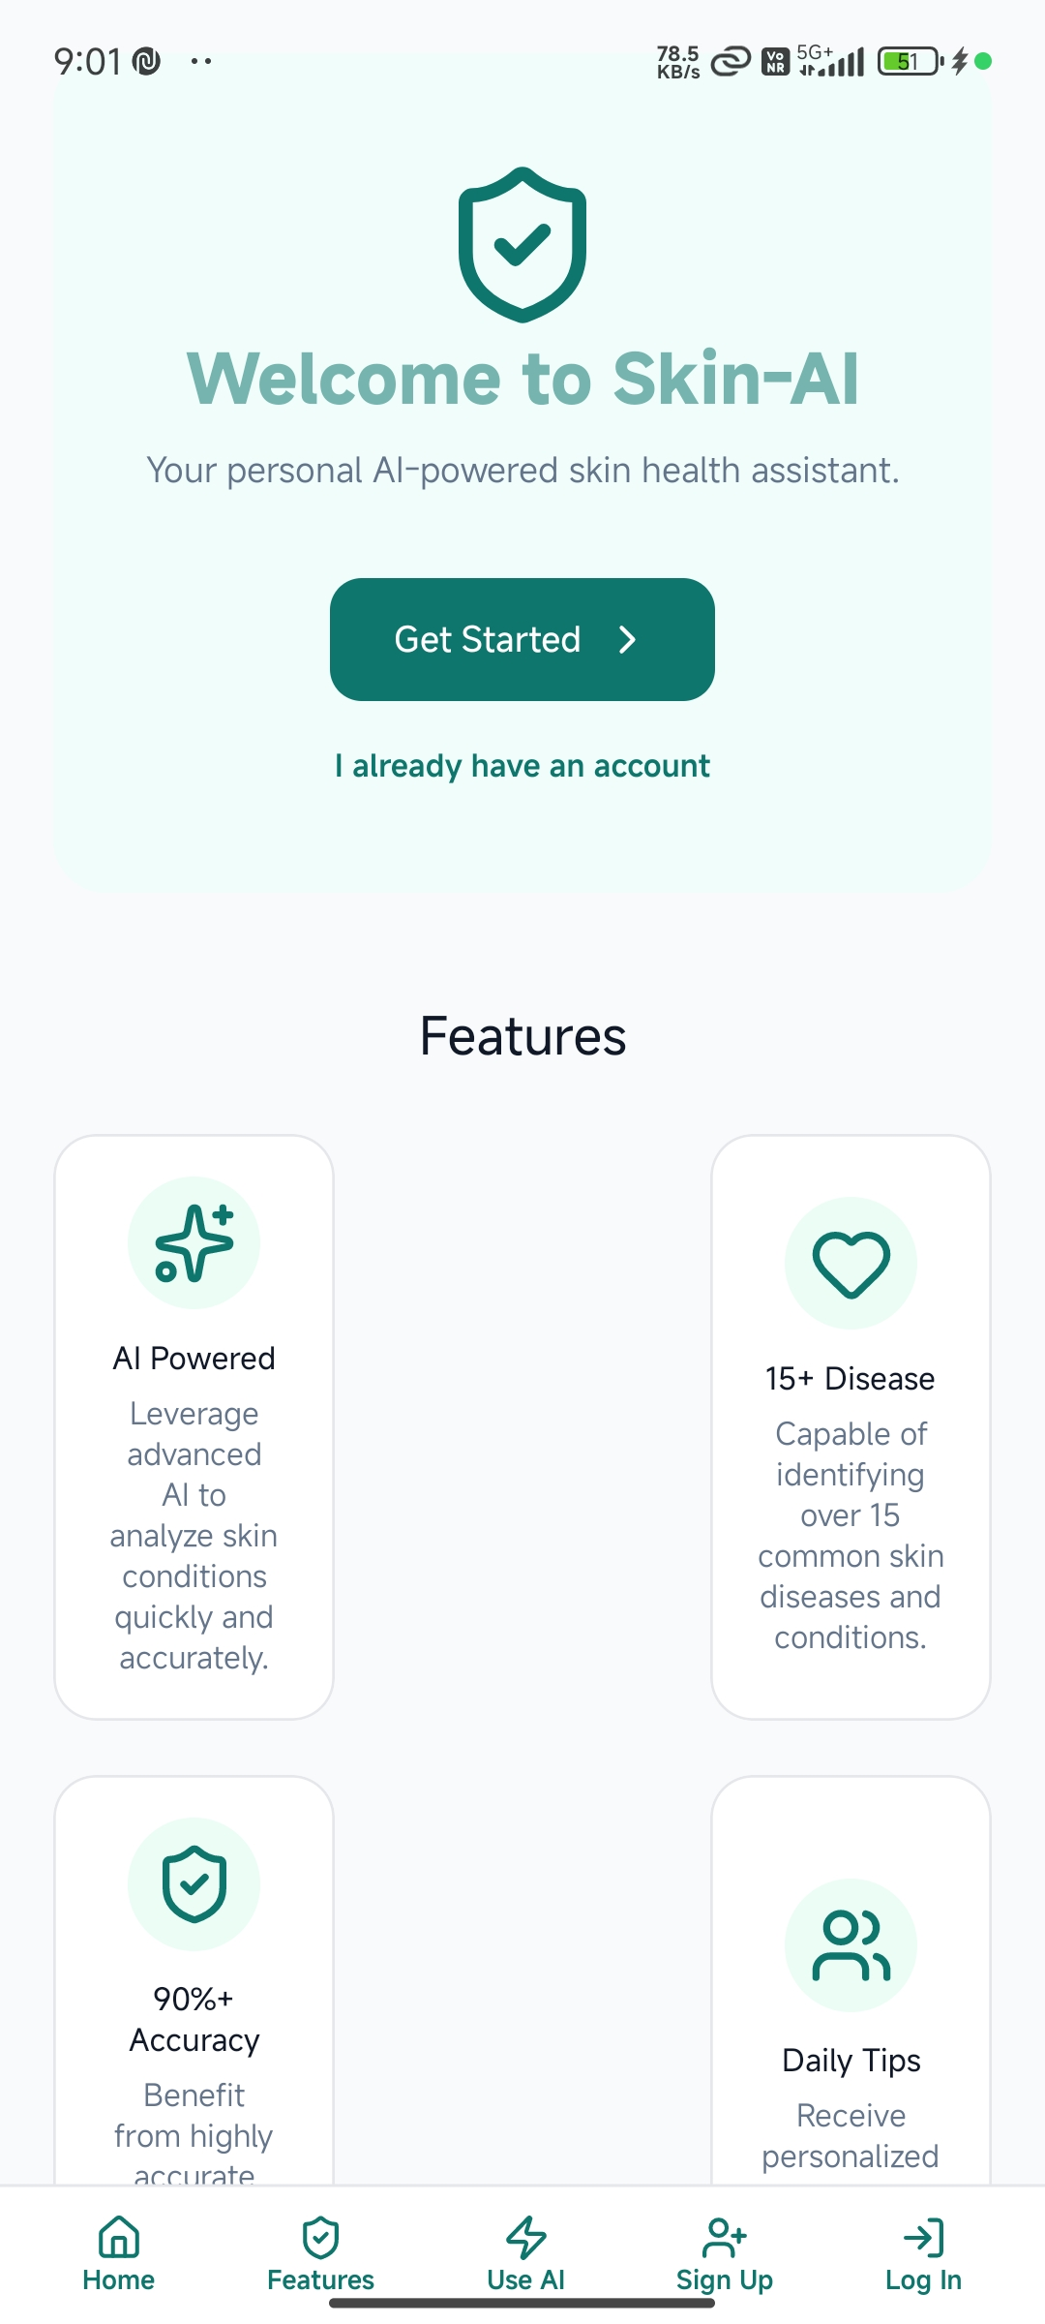

Figure 6.1: Home Screen
The Home Screen serves as the primary entry point of the Skin-AI mobile application. It is designed with a minimal and structured user interface to ensure clarity and ease of navigation. The layout follows a vertical arrangement that guides the user from introduction to interaction without unnecessary complexity.

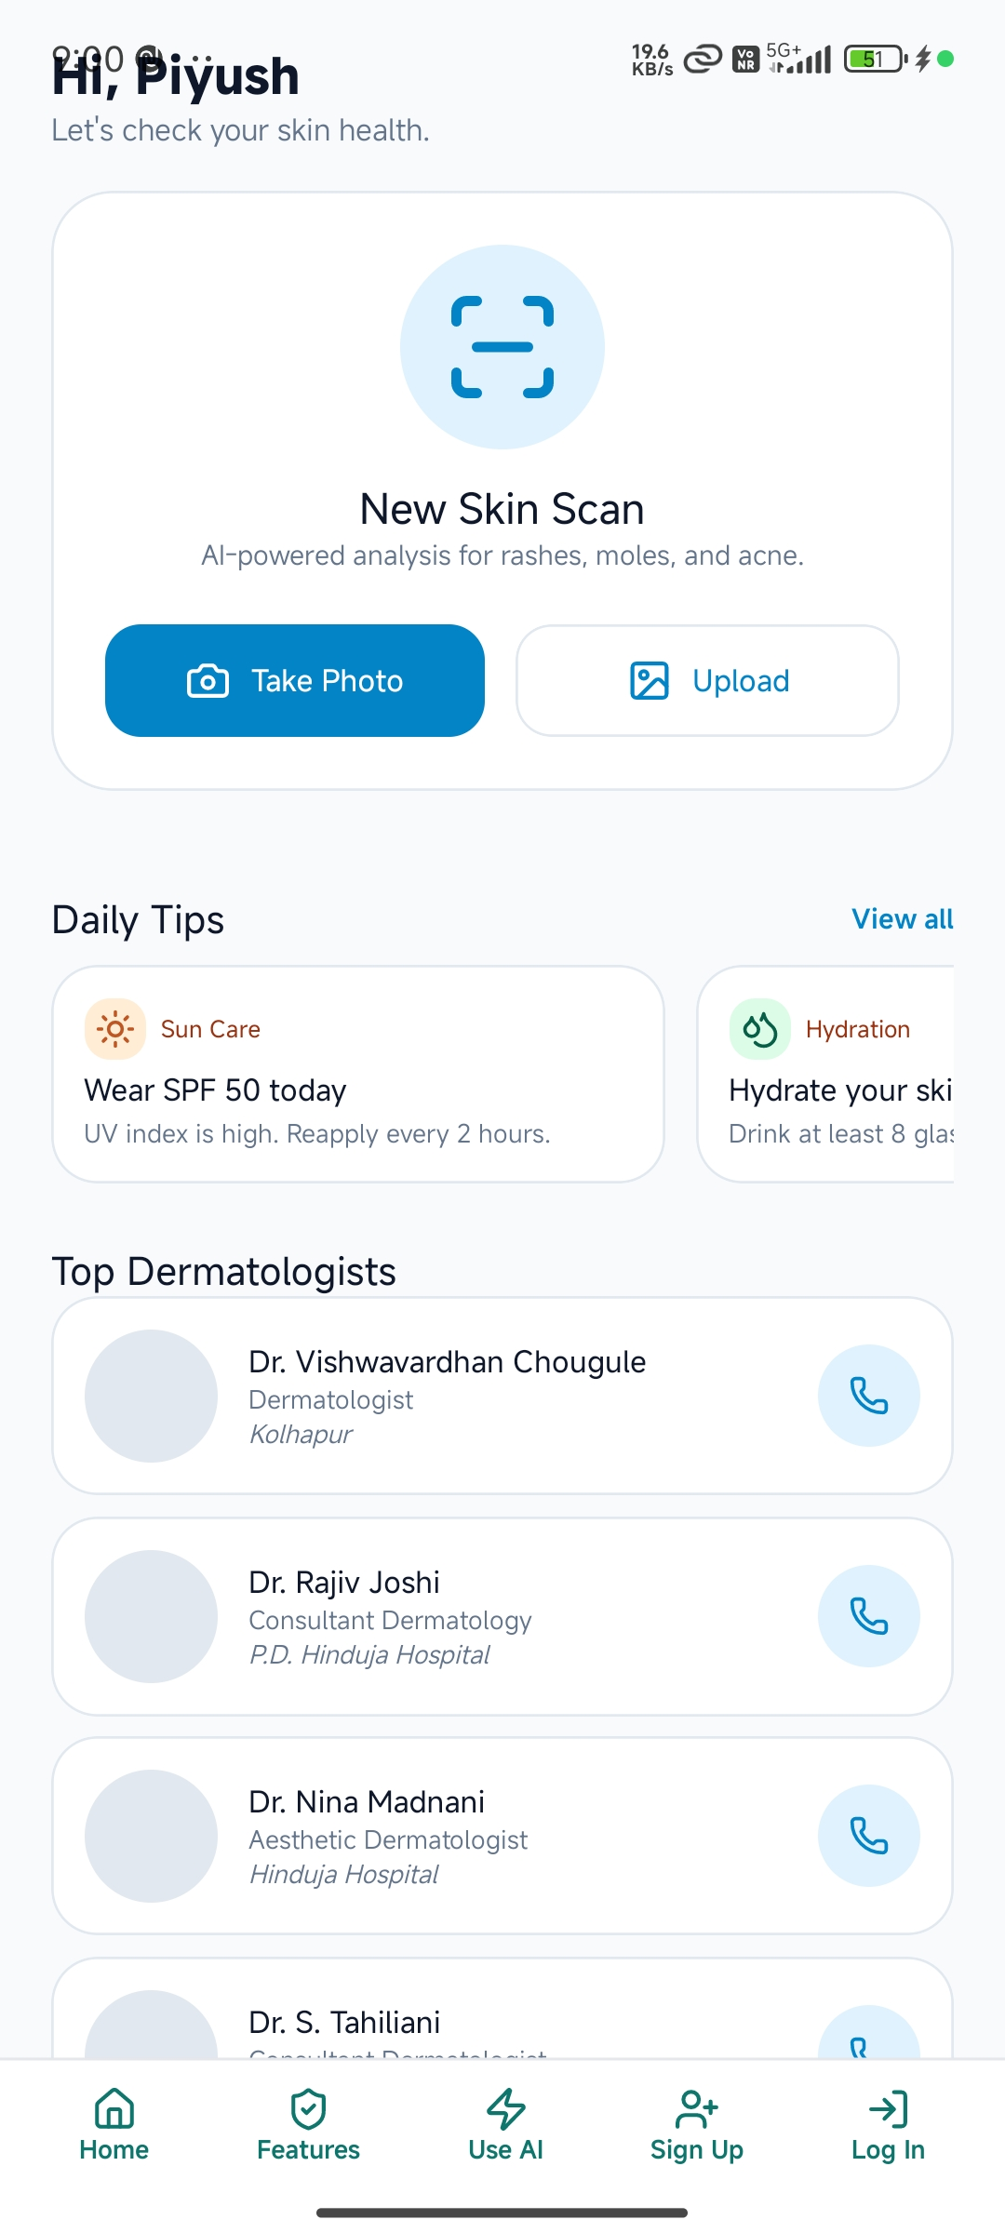

Figure 6.2: Main Model
The Main Model Screen functions as the central operational interface of the Skin-AI application. Unlike the Home Screen, which focuses on introduction and onboarding, this screen is designed for active interaction and AI-based skin analysis. Two primary action buttons are provided:
- Take Photo – Allows the user to capture a real-time image using the device camera.
- Upload – Enables selection of an existing image from the device gallery.
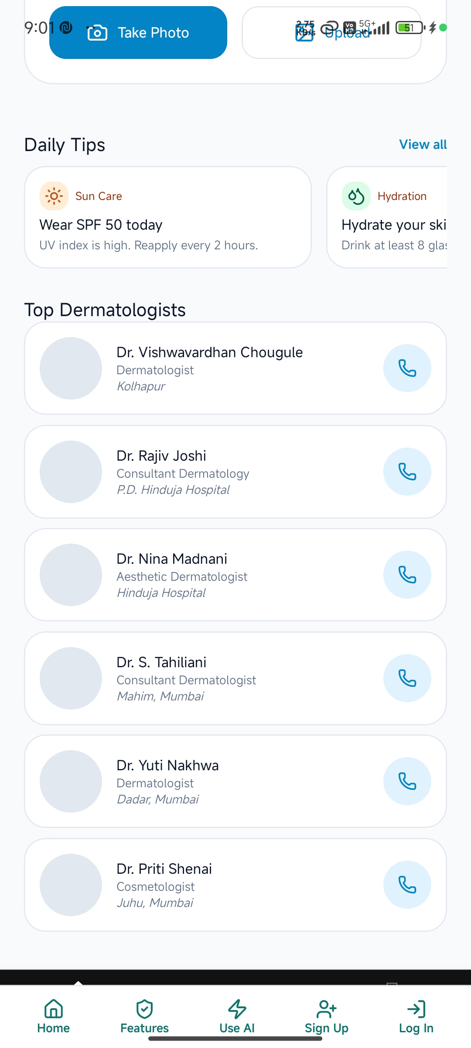

Figure 6.3: Daily Tips & Top Dermatologists
This screen section focuses on preventive healthcare guidance and professional consultation support within the Skin-AI application. It extends the system’s functionality beyond disease prediction by incorporating educational and referral components.

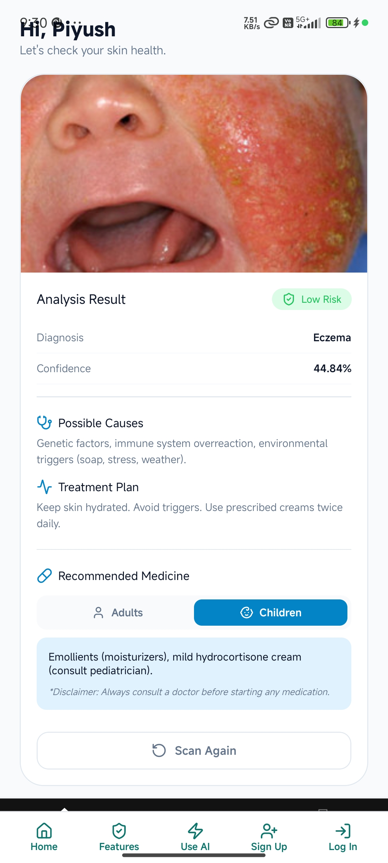

Figure 6.4: Analysis Page
The Analysis Result Screen represents the output stage of the AI-based prediction process. This interface displays the processed results generated by the Convolutional Neural Network after image submission and backend inference.
The “Analysis Result” section presents structured diagnostic information. The result is organized into key components:
- Risk Indicator – A visual label (e.g., “Low Risk”) categorizes the predicted severity level based on model confidence and predefined thresholds.
- Diagnosis – Displays the predicted disease name (e.g., Eczema).

6.2 Training Accuracy and Loss

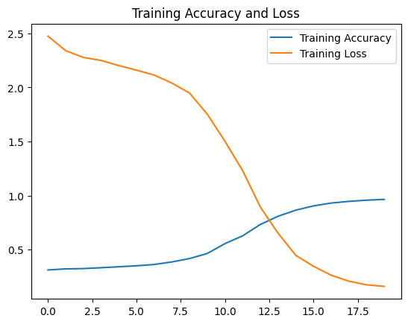

The validation accuracy and validation loss curves provide insight into the model’s performance on unseen data. The validation accuracy shows a steady and consistent increase across epochs, rising from approximately 33% in the initial stage to nearly 97–98% in the final epochs. This progressive improvement indicates that the model effectively learned meaningful visual features and was able to generalize its learning beyond the training dataset. There are no abrupt fluctuations or stagnation points, which suggests stable learning behavior throughout the training process.

At the same time, the validation loss demonstrates a continuous downward trend, decreasing from around 2.3 in the early epochs to approximately 0.1–0.2 toward the end of training. This steady reduction in loss indicates that prediction errors on unseen data were consistently minimized as training progressed. The absence of increasing validation loss in later epochs suggests that the model does not exhibit significant overfitting. The simultaneous increase in validation accuracy and decrease in validation loss confirm that the CNN model achieved strong generalization performance and is capable of reliably classifying skin disease images outside the training dataset.
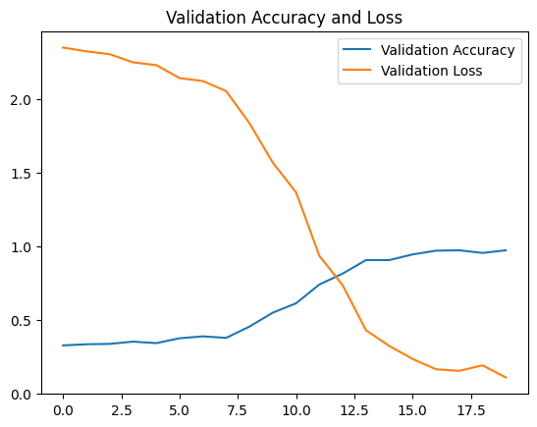

The training accuracy curve shows a consistent and gradual increase across epochs, starting from approximately 31–33% in the initial epoch and reaching nearly 97–98% by the final epoch. This steady upward progression indicates that the model successfully learned discriminative features from the training dataset over time. The absence of sharp fluctuations or sudden drops suggests that the optimization process was stable and that gradient updates were properly converging toward a minimum.
Simultaneously, the training loss decreases consistently from around 2.5 in the early epochs to approximately 0.15 in the final stage. This continuous decline demonstrates that the model progressively minimized classification errors during learning. The smooth downward trend in loss confirms effective backpropagation and proper adjustment of network weights.
Together, the increasing training accuracy and decreasing training loss indicate successful model convergence. The behavior of these curves reflects stable learning dynamics and confirms that the CNN architecture effectively captured relevant patterns from the training images.

6.3 Advantages
- Accessibility
The proposed system significantly improves accessibility to preliminary dermatological assessment by leveraging widely available smartphone technology. Users do not require specialized medical devices such as dermatoscopes, nor do they need immediate access to dermatology specialists. This is particularly beneficial in rural or semi-urban regions where expert consultation may be limited. By integrating AI-based classification into a mobile application, the system reduces geographical dependency and enables early screening at the user’s convenience.

- Speed of Diagnosis
The architecture is optimized for rapid inference. Since the trained CNN model is loaded into memory at server startup, prediction latency is minimized during runtime. After image preprocessing, the forward propagation process generates classification probabilities within seconds. This near real-time feedback improves user experience and allows quick preliminary evaluation, which may be critical when monitoring rapidly changing skin conditions.

- Cost Efficiency
The system reduces the need for frequent physical consultations for minor or non-critical conditions. While it does not replace professional medical diagnosis, it acts as a filtering mechanism that helps users determine whether immediate consultation is necessary. This can lower unnecessary medical visits and associated expenses, making preliminary screening more economically feasible.

- Standardization of Evaluation
Unlike manual visual inspection, which may vary depending on clinician experience, the CNN-based model applies consistent evaluation criteria across all inputs. Every image undergoes the same preprocessing steps and passes through identical trained network weights. This standardization reduces subjectivity and ensures uniform diagnostic assessment under controlled computational conditions.

- Educational Value
The system provides contextual information alongside predictions, including possible causes and general treatment guidelines. This transforms the application from a simple classifier into an awareness tool. By presenting structured explanations and preventive advice, the system encourages informed decision-making and promotes understanding of common dermatological conditions.

- Privacy and Confidentiality
Users can perform initial screening privately without visiting a clinic, which may reduce hesitation associated with minor or socially sensitive skin conditions. The digital workflow limits exposure to in-person interaction during early assessment. Since processing occurs through secure backend communication, the system maintains user confidentiality within the constraints of its architecture.

- Scalability and Expandability
The modular client–server architecture allows the system to scale with increasing user demand. The separation between frontend interface and backend inference engine supports independent updates. Additional disease classes, improved models, or enhanced preprocessing techniques can be integrated without redesigning the entire application structure.

6.4 Conclusion
The AI-Based Skin Disease Detection System presented in this project demonstrates the effective application of deep learning techniques in the healthcare domain. The system successfully integrates a Convolutional Neural Network (CNN) model with a mobile-based user interface and a robust backend architecture to provide fast, reliable, and accessible preliminary skin disease screening.
Skin diseases remain one of the most commonly occurring health conditions worldwide, and delayed diagnosis often leads to severe complications, particularly in the case of skin cancer. The proposed system addresses this challenge by offering an automated solution that assists users in identifying potential skin conditions at an early stage. By reducing dependency on immediate physical consultation, the system helps bridge the gap between patients and dermatological expertise, especially in regions with limited medical resources.
The project effectively demonstrates how machine learning models can be deployed in real-world environments through careful integration with web technologies. The use of a centralized backend ensures efficient model loading, secure handling of user data, and consistent prediction performance. The preprocessing pipeline standardizes image input, enhancing model accuracy and robustness. Additionally, the inclusion of confidence scores and disease-specific medical information improves transparency and user understanding of prediction results.
From a technical perspective, the system validates the suitability of Convolutional Neural Networks for medical image classification tasks. The CNN model is capable of learning complex visual patterns and differentiating between multiple skin disease categories with satisfactory accuracy. The modular design of the application ensures scalability, maintainability, and ease of future enhancements.
The project also emphasizes the importance of ethical and practical considerations in healthcare applications. While the system provides preliminary diagnostic insights, it does not replace professional medical consultation. Instead, it acts as a decision-support tool that encourages users to seek timely expert advice when necessary. This responsible approach ensures that the system is used as an aid rather than a substitute for clinical diagnosis.
In terms of usability, the mobile-based interface makes the system accessible to a wide range of users, including the general public, medical students, and general physicians. The intuitive design allows users to capture or upload images easily and receive results within seconds. Such accessibility promotes awareness of skin health and encourages preventive care.
Despite its effectiveness, the system has certain limitations. The accuracy of predictions depends on the quality of input images and the diversity of the training dataset. Rare or visually ambiguous conditions may not always be classified correctly. Additionally, internet connectivity is required for backend processing. These limitations highlight areas for future improvement and research.
Overall, the AI-Based Skin Disease Detection System successfully achieves its objectives by delivering a reliable, user-friendly, and technically sound solution for early skin disease screening. The project demonstrates the practical value of artificial intelligence in healthcare and highlights its potential to improve diagnostic efficiency, reduce costs, and enhance patient awareness. With further enhancements and clinical validation, such systems can play a significant role in modern digital healthcare ecosystems.

CHAPTER 7: REFERENCES

- World Health Organization, Skin Diseases, WHO Fact Sheets, Geneva, Switzerland, 2023.
- Esteva, A., Kuprel, B., Novoa, R. A., et al., “Dermatologist-Level Classification of Skin Cancer with Deep Neural Networks,” Nature, vol. 542, no. 7639, pp. 115–118, 2017.
- International Skin Imaging Collaboration (ISIC), ISIC Archive: Melanoma Project, Available: https://www.isic-archive.com
- TensorFlow Developers, TensorFlow Documentation, Available: https://www.tensorflow.org
- Chollet, F., Deep Learning with Python, Manning Publications, 2018.
- Keras Team, Keras: The Python Deep Learning API, Available: https://keras.io
- Goodfellow, I., Bengio, Y., and Courville, A., Deep Learning, MIT Press, 2016.
- Rajpurkar, P., Irvin, J., et al., “Deep Learning for Medical Image Analysis,” IEEE Computer Society, 2018.
- Django Software Foundation, Django Documentation, Available: https://docs.djangoproject.com
- Litjens, G., Kooi, T., et al., “A Survey on Deep Learning in Medical Image Analysis,” Medical Image Analysis, Elsevier, vol. 42, pp. 60–88, 2017.

