Dear Bu Vicky,

Here we send the estimated detailed budget for the Ministry of Foreign Affairs' Export Delivery Plan for Medical Devices, and if you wish, please pay for the minimum payment

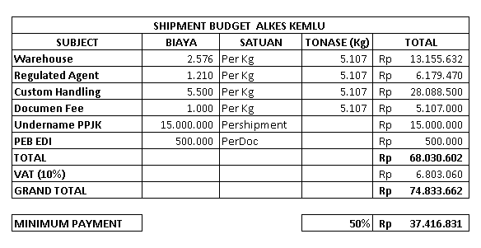

Term & Condition :

1. The weight and volume taken are when the goods have been RCS at the Warehouse

2. Minimum Paynemt payment is made 3 days before Cargo arrives at RA

3. Payment to account Maybank Account No 2083215819 for PT Mitra Elang Niaga Indonesia

4. The remaining payment when the cargo has entered the warehouse

Thus, we convey this request, for your attention and cooperation, we thank you

Best Regards,

**Dias Heridiansyah**

Manager Mit E