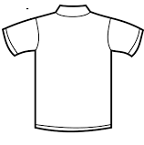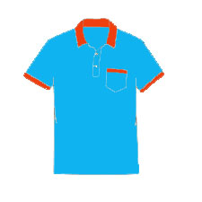**TAMPAK DEPAN**

**WAREHOUSE**

**BDL**

**TAMPAK BELAKANG**