**Nama : Alfandi Rifa’ul Nurhuda**

**NIM : 2702393673**

**Assurance of Learning Scientific Computing**

1. **Identifying the Trend in Bag Production Over Time**

**Methodology:** To identify the trend in bag production over time, we employ polynomial regression. Polynomial regression fits a polynomial function to the data, capturing both the overall trend and the fluctuations observed over the 144 months of production data. Here, we've chosen a polynomial of degree 6 to adequately model the complex variations in production data.

Heres the formula:

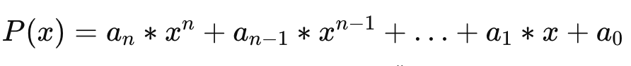

**Reasoning:** Polynomial regression is suitable for this task because it allows us to model non-linear relationships between time (months) and production quantity. By fitting a polynomial curve to the data points, we can visualize and quantify the trend over the entire dataset.

**Graphical Representation:**

1. **Estimating When Production Will Exceed 25,000 Bags per Month**

**Methodology:** To estimate when production will exceed 25,000 bags per month, we utilize numerical optimization techniques. Specifically, we employ fsolve from SciPy to find the month where the polynomial fit intersects the threshold of 25,000 bags. This approach solves the equation poly_func(month) - 25000 = 0 to determine the breach month.  
  
Here’s the formula:



**Reasoning:** Numerical optimization is appropriate here because it provides an accurate solution to finding the root of a function (in this case, the polynomial function minus the threshold). By pinpointing the month when production is projected to exceed 25,000 bags, we can make informed decisions about capacity planning and resource allocation.

**Graphical Representation:**

Taylor Series Approximation:

T(x) = f(a) + f'(a)(x-a) + (f''(a)/2!)(x-a)^2 + ...

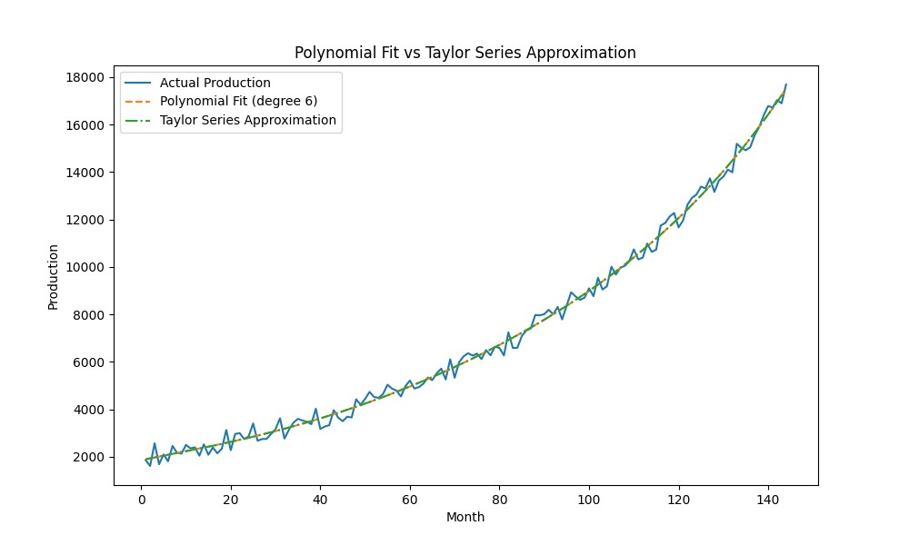

1. **Predict when to build a new warehouse based on the trend.**

**Methodology:** To decide when to start building a new warehouse, we calculate the month when production is expected to breach 25,000 bags and then plan to start construction 13 months prior to that estimated breach. This proactive approach ensures that the new warehouse is operational before production exceeds current capacity.

Here’s the formula:

**Reasoning:** Starting warehouse construction sufficiently ahead of the projected production increase mitigates risks associated with capacity constraints. By planning 13 months in advance of the breach month, the organization can manage resources effectively and avoid potential disruptions to production flow.

Root Finding Method:

We find the root of the equation: P(x) - 25000 = 0

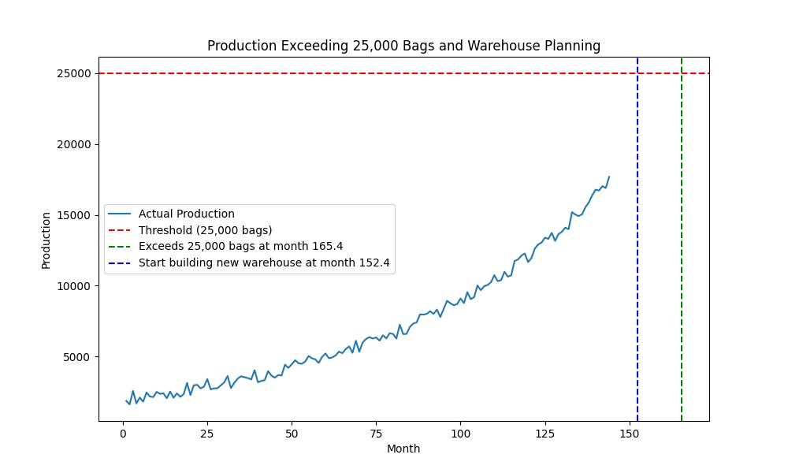

1. **Google Colab Link:**

Link of my code:

<https://colab.research.google.com/drive/1uNpgVheK1TtX4fr1JwiTFxUxNwt8ZC4m?usp=sharing>