What Do Document Forgery Localizers Learn from Box Masks? Pixel-Change Ground Truth and Shortcut Audits for AI-Inpainted Financial Documents
Authors: ……… (AIC515 Image Processing, Topkapı University) — DRAFT, not for distribution
Abstract — Public benchmarks of AI-inpainted financial documents annotate forgeries with the bounding box of the edited field. Auditing AIForge-Doc v1 (4,061 forgeries, Gemini 2.5 Flash Image and Ideogram v2 Edit) we find that all masks are rectangles, that only a median 49 % of box pixels actually differ from the released authentic source, that one third of forgeries also change pixels outside the box, and that the released test "authentic" set is not the mirror of the test forgeries. Using the 3,247 verified training pairs we derive pixel-change and glyph-level ground truths and train the same ResNet-18 U-Net under three supervision geometries (3 seeds each). Evaluated against its own box ground truth the box-trained model reaches 0.95 pixel-AUPRC on the official test split (TruFor zero-shot: F1 0.40), but the same predictions score 0.37 against the pixel-change ground truth; each ground truth ranks its own model first. Box-trained predictions are rectangles (median rectangularity 0.87), insensitive to blurring the glyphs inside the field, and, at the default threshold, flag 44 % of authentic images (pixel-trained: 10 %) with equal image-level AUROC (0.89). Two pre-registered shortcut hypotheses were falsified: blurring the 5-px paste-back boundary costs the box model less than it costs the pixel model (−1.5 % vs −3.0 % AP), and no usable image-wide trace exists outside the field (AUROC 0.52, removed by symmetric resampling). Pixel-change supervision does not transfer better to an unseen generator and is more fragile to blur and rescaling. We conclude that reported localization accuracy on box-annotated document benchmarks is largely a measure of field geometry, release derived masks, controls and probes, and recommend dual-ground-truth, threshold-free reporting.
Index Terms — document forensics, tampering localization, generative inpainting, shortcut learning, ground-truth annotation, U-Net.

I. Introduction
Commercial image-editing APIs built on diffusion and multimodal generators (e.g., Gemini 2.5 Flash Image, Ideogram v2 Edit, GPT-Image-2) can rewrite a single numeric field of a receipt or form while leaving no visible seam. Recent benchmarks show that forensic detectors trained on classical splicing or on synthetic document tampering transfer poorly to this threat: on AIForge-Doc v1, the generic localizer TruFor reaches an image-level AUC of 0.751 and a pixel IoU of 0.358 zero-shot, while the document-specific DocTamper/DTD model drops to AUC 0.563 and IoU 0.020 [S01]; on AIForge-Doc v2 (GPT-Image-2) humans are at chance (2AFC 0.501) and TruFor reaches only 0.599 AUC [S02]. The natural response is to fine-tune localizers on these new datasets. This paper asks a prior question: what does the ground truth of such datasets actually teach a localizer?
AIForge-Doc annotates every forgery with the bounding box of the edited field, not with the pixels that changed. Our audit of the released files shows that these masks are rectangles without exception, that at a difference threshold of 8 gray levels only a median 49 % of the pixels inside the box actually differ from the paired authentic image, and that one third of the forgeries also change pixels outside the box. A segmentation network trained on such masks is therefore rewarded for predicting a rectangle around any detectable glyph change — the paste-back boundary becomes a shortcut in the sense of Geirhos et al. [E01]. Shortcut reliance of document localizers is well documented for the JPEG 8×8 grid (ADCD-Net reports a 68–73 % F1 drop of DTD under a one-pixel shift [S06]; DocQT shows a 14.5-point F1 effect of the quantization table alone [S15]), but no study has examined the effect of the annotation geometry on what is learned, nor measured it on AI-inpainted documents.
AIForge-Doc is unusual in that the authentic source image is released for every training forgery. This lets us derive a second, pixel-change ground truth from paired differences and run a controlled comparison: the same architecture, data, augmentation and budget, with only the training mask changed. We contribute:
- A dataset audit of AIForge-Doc v1 (12,187 files) that quantifies mask semantics, outside-box edits, train/test source-document leakage (8.9 % of test forgeries) and the invalidity of the released test "authentic" set for image-level evaluation.
- Derived pixel-change and glyph-constrained ground truths for all 3,247 verified training pairs, with an ε-sensitivity analysis separating local edits from the global ±1–3 re-encoding trace that affects half of the Gemini outputs.
- A shortcut-audit protocol for box-annotated localizers: dual-ground-truth evaluation, boundary ablation with a placebo control, rectangle-fit post-processing, benign paste-back and full-image resampling controls, and a global-trace probe on clean crops.
- Full-data experiments (ResNet-18 U-Net, three ground truths × three seeds, held-out generator, degradations) together with zero-shot TruFor and ADCD-Net references under identical evaluation code.

II. Related Work
Document tampering localization. DocTamper/DTD [S04] introduced a 170k-image synthetic benchmark and a dual-stream network that fuses RGB with 8×8 block-DCT coefficients and the JPEG quantization table; FFDN [S05] injects frequency cues through a zero-initialised module and wavelet decomposition; ADCD-Net [S06] gates the DCT stream with a predicted block-alignment score and adds OCR-based text/background disentanglement. All three train on the same synthetic pipeline and rely on JPEG evidence; DOCFORGE-BENCH [S03] shows that none of 14 published detectors reaches pixel-F1 ≥ 0.3 on six of eight document test sets zero-shot, and attributes much of the failure to threshold calibration when tampered pixels are 0.27–4 % of the image. DiffNet [S16] and DocQT [S15] explicitly name synthetic-pipeline and compression-profile shortcuts.
AI-generated document forgeries. AIForge-Doc v1 [S01] and v2 [S02] are, to our knowledge, the only public pixel-annotated benchmarks of API-inpainted financial documents; both evaluate detectors zero-shot only. GPT4o-Receipt [S19] and the MLLM study of [S20] show that fully generated receipts are often detectable from arithmetic inconsistency rather than pixels; TextFake [S21] documents a "text-density curse" for low-level detectors. TGIF [I01] shows that when an inpainting API re-decodes the whole image, classical splicing localizers collapse (F1 ≤ 0.1).
Shortcuts, generalization and evaluation reliability. Geirhos et al. [E01] define shortcut learning; GenD [E02] shows that unpaired real/fake training alone can inflate deepfake AUROC from 56.8 to 90.0; Smeu et al. [E03] expose a trivial dataset artefact in audio-visual deepfakes; Aoudi et al. [E06] describe a "metric trap" in natural-image forgery localization where pixel agreement hides reliance on boundary artefacts; GIFTBench [E05] separates source, target and operation shifts. Our work transfers these concerns to the geometry of document annotations.
Image processing foundations. The classical pipeline of this study follows the course material: spatial high-pass filtering and frequency-domain Gaussian high-pass filtering [Gonzalez & Woods], block DCT, LBP [Ojala 2002], GLCM [Haralick 1973], SVM/random forests, ResNet [He 2016] and U-Net [Ronneberger 2015].

III. Dataset and Audit
AIForge-Doc v1. 4,061 forged document images (3,249 train / 812 test; PNG, RGB) derived from CORD v2 (1,000), WildReceipt (1,696), SROIE (946) and XFUND (419); receipts form 89.7 % and forms 10.3 %; nine languages. Each image has one edited field; the generator is Gemini 2.5 Flash Image for 3,639 images (89.6 %; metadata label gemini-nano) and Ideogram v2 Edit for 422 (10.4 %; label qwen-inpaint, mapping stated by the dataset card only). Masks are 8-bit PNG with values {0, 255}.
Audit procedure. We re-computed all statistics from the files with a reproducible script (audit_dataset.py, ~3 min on 32 cores). Forged–authentic pairs were matched by 256-bit perceptual hash and verified by pixel difference (mean outside-mask difference < 25 and either hash distance ≤ 10 or < 5 % of outside-mask pixels changed by more than 8), yielding 3,247/3,249 verified training pairs and only 89/812 test pairs.
Findings. (i) Mask geometry: all 4,061 masks are single rectangles (rectangularity 1.00); the metadata box matches the mask in 4,047 cases, the remaining 12 rows have swapped provenance. (ii) Mask semantics: with D = max-channel |forged − authentic|, the median fraction of box pixels with D > 8 is 0.49 (IQR 0.37–0.62) and the median IoU between {D > 8} and the box is 0.48; the paper's "pixel-precise" wording describes box precision. (iii) Outside-box edits: 33.5 % of pairs have D > 8 pixels outside the box (Gemini 35.9 % vs Ideogram 11.9 %; WildReceipt 60 %, CORD 0.4 %), typically the whole text line being re-synthesised; 48.6 % of pairs show a global ±1–3 difference over the entire image at D > 0, which vanishes for ε ≥ 4 (fraction of pairs with > 1 % outside-box change: 47.8 % → 4.7 %). (iv) Scale: median tampered area is 0.98 % of the image (50.7 % of images < 1 %); median mask height 33 px; images range from 0.03 to 34.8 MP, so native-resolution tiling is mandatory. (v) Leakage and negatives: 72/812 test forgeries (8.9 %) share a source document with a training image (pHash ≤ 20); the released TestingSet/authentic folder mirrors the test forgeries for only 86 images, 254 files are byte-identical to training authentics and no SROIE authentic is included, so it cannot serve as the negative class for image-level evaluation. (vi) Confounds: generator and source are entangled (no Ideogram in WildReceipt, 45 % in XFUND) and Ideogram edits are smaller (median 0.27 % vs 1.07 %). (vii) Licence: the card states CC BY-NC-SA 4.0 with gating while dataset_info.json says CC BY 4.0; we treat the restrictive reading as binding and redistribute only identifier lists and derived masks.
Splits. The official test split is untouched. Training images are divided by source-document groups (connected components of pair and near-duplicate edges) into 2,762 train and 487 validation images with no group overlap; the 581 training groups that touch the test split are kept in training. We report test results on all 812 images and on the 740 "clean" images without a near-duplicate in training.

IV. Method

A. Pixel-change and glyph ground truths
For every verified pair we compute D and derive: pixel_ε = {D > ε} for ε ∈ {4, 8, 16}; pixel_8_morph = {D > 8} followed by a 3×3 opening, removal of components smaller than 8 px and a 3×3 closing; glyph = (Sauvola text pixels of forged ∪ authentic, window 25, k = 0.2) ∩ dilate({D > 8}, 7×7), with polarity inverted when the dark-pixel ratio inside the box exceeds 0.5 (glyph_v2; the naive median-brightness rule mis-fires on 199 dim photographs); and bbox ∩ pixel_8 as a conservative variant. Median box coverage / IoU with the box are 0.67/0.62 (ε = 4), 0.49/0.48 (ε = 8), 0.35/0.35 (morph) and 0.29/0.27 (glyph_v2). Ten pairs with D_max ≤ 4 (forged ≈ authentic) and five pairs whose only changes lie outside the box are excluded from training under every condition. A stratified set of 100 pairs is provided as a verification sheet for human inspection.

B. Benign controls
From the authentic image of every validation forgery we construct (a) benign paste-back: the box expanded by 50 % per side (≥ 100 px) is up-sampled 2× with Lanczos, down-sampled back and only the box region is pasted onto the authentic copy — the generation pipeline's compositing step without any content change; (b) full-image resampling: the whole image through the same 2× up/down cycle; (c) PNG re-encoding (pixel-identical, kept as a null control). Benign paste-back leaves a median of 72 pixels with D > 8 (real forgeries: 3,020) confined to the box, whereas full-image resampling produces a comparable count of D > 8 pixels (median 2,627) spread over all text edges at much lower amplitude (D_max 27 vs 180).

C. Localizer and training
A U-Net with an ImageNet-initialised ResNet-18 encoder (14.3 M parameters) is trained on 512×512 native-resolution crops (70 % containing ground-truth positives with ±32 px jitter, 30 % random), BCE + Dice loss, AdamW (lr 1e-4), batch 16, bf16 mixed precision, two crops per image per epoch, early stopping on validation AUPRC under the training ground truth. The only factor varied between conditions is the training mask: bbox, pixel_8_morph or glyph_v2; three seeds (42–44) per condition, plus one Gemini-only run per condition for the held-out-generator analysis. Inference is full-image sliding-window (512, stride 448, averaged overlaps). A preliminary frequency-augmented variant (RGB + FFT Gaussian high-pass + Laplacian residual channels) did not improve over RGB on the pilot subset and is not pursued.

D. Evaluation and probes
All models are scored against all three ground truths on validation (dual-GT evaluation), and against the box ground truth on the official test set (all 812 / clean 740). Metrics: pooled pixel AUPRC and AUROC (threshold-free), F1 and IoU at 0.5, F1 at the validation-calibrated threshold τ, per-image Oracle-F1 (upper bound), stratified by tampered-area bin, generator and source. Shortcut probes: (1) boundary ablation — Gaussian blur (σ = 1.5) of a 5-px ring around the box boundary, with a placebo ring at a random non-overlapping location and an interior variant that blurs the inside of the box but preserves the boundary; (2) rectangle fit — the largest connected component of the thresholded prediction is replaced by its bounding box, which measures how much each metric rewards rectangular shape, together with the rectangularity of raw predictions; (3) controls — false-positive pixel rate and image-level scores on authentic, benign paste-back and full-image-resampled validation images; (4) global-trace probe (H4) — a ResNet-18 classifier trained to separate 256-px crops that do not* touch the mask of a forged image from the same-coordinate crops of its authentic source; an AUROC above chance indicates image-wide evidence outside the edited field, and re-testing with full-image-resampled negatives tests whether that evidence is the resampling trace. Degradations (JPEG Q75, 0.75× rescale, Gaussian blur σ = 1) are applied to validation images at test time only. Zero-shot TruFor (≤ 2 MP, official weights) and ADCD-Net (JPEG Q100 re-encoding, 512-px long side, repository protocol) are evaluated with the same code as references; they are not trained on AIForge-Doc and are reported in a separate table.

E. Statistics
Per-image metrics are aggregated with 1,000 bootstrap resamples over source-document groups; condition differences are reported as mean over seeds with 95 % group-bootstrap intervals; multiple comparisons within a hypothesis family use Holm correction. Hypotheses and falsification criteria were fixed before the full-data runs (PHASE 1 report, §I).

V. Results
Unless stated otherwise, numbers are means ± standard deviation over three seeds on the 487 validation images with full-image inference; "AUPRC" is the pooled pixel AUPRC, "AP" the mean per-image average precision, and F1@τ* uses the validation-calibrated global threshold. Group-bootstrap confidence intervals and Holm-corrected p-values for the pre-registered contrasts are given in Table VII (Sec. V-F).

A. The same predictions, three ground truths (H1)
Table I crosses training ground truth with evaluation ground truth. The box-trained model reaches AUPRC 0.923 ± 0.015 and F1@τ 0.842 ± 0.023 against the box ground truth, but the same probability maps score 0.374 ± 0.008 against the pixel-change ground truth and 0.257 ± 0.007 against the glyph ground truth. Every ground truth ranks its own model first (bbox → bbox model; pixel → pixel model 0.610 ± 0.012; glyph → glyph model 0.676 ± 0.019), i.e., the ranking of the nine models is not preserved across ground truths. Pixel AUROC, in contrast, stays above 0.9 for most cells (the box model reaches 0.988 under the pixel ground truth), confirming that AUROC is insensitive to the 1:100 class imbalance and should not be used alone. The ΔF1 between box- and pixel-based evaluation of the box model is 0.40, far above the 0.05 falsification bound; H1 is confirmed.*
train GT \ eval GT | bbox AUPRC / F1@τ* | pixel AUPRC / F1@τ* | glyph AUPRC / F1@τ*
bbox | 0.923 ± 0.015 / 0.842 ± 0.023 | 0.374 ± 0.008 / 0.447 ± 0.011 | 0.257 ± 0.007 / 0.387 ± 0.009
pixel_8_morph | 0.579 ± 0.014 / 0.600 ± 0.014 | 0.610 ± 0.012 / 0.577 ± 0.007 | 0.511 ± 0.010 / 0.532 ± 0.008
glyph_v2 | 0.351 ± 0.015 / 0.401 ± 0.007 | 0.379 ± 0.012 / 0.457 ± 0.006 | 0.676 ± 0.019 / 0.674 ± 0.011

Table I. Validation (n = 487), full-image inference, 3 seeds.

B. Official test set and zero-shot references
On the official test split (box ground truth, τ from validation) the box-trained U-Net obtains AUPRC 0.950 ± 0.011, F1@τ 0.846 ± 0.015 and IoU 0.789 ± 0.018 on all 812 images and 0.949 / 0.845 / 0.788 on the 740 leakage-free images — the 8.9 % source-document overlap does not inflate the score. On the 89 test images with a released authentic pair, the box model scores AUPRC 0.963 (box GT) but 0.427 (pixel GT), while the pixel-trained model scores 0.739 (box GT) and 0.654 (pixel GT), reproducing the validation pattern. The zero-shot references, evaluated with the same code against the box ground truth, reach F1@0.5 0.403 / IoU 0.328 / Oracle-F1 0.456 (TruFor, ≤ 2 MP; the AIForge-Doc paper reports 0.434 / 0.358) and 0.182 / 0.149 / 0.328 (ADCD-Net, JPEG Q100 re-encoding). These are not trained on AIForge-Doc and are listed for context only; a straightforward 10-epoch fine-tune of a 14 M-parameter U-Net doubles the zero-shot F1, but Sec. V-A shows what fraction of that gain is "box geometry".

C. What the box model predicts (H2)
Predictions of the box-trained model are rectangles: median rectangularity (mask area / area of its bounding box) is 0.87 with a single connected component, versus 0.32 (median 7 components) for the pixel model and 0.05 (27 components) for the glyph model. Blurring the interior of the edited field (σ = 1.5, boundary ring preserved) leaves the box model unchanged (+1.2 ± 0.3 % AUPRC) — it does not rely on glyph texture — whereas the same manipulation costs the glyph model 10.5 % AP and the pixel model 7.2 %. Blurring the 5-px boundary ring costs the box model only 2.0 ± 0.4 % pooled AUPRC (placebo ring: 0.0 %), so the paste-back seam is not the dominant cue either; the box model appears to recognise the re-rendered field as a region. Two metric artefacts follow: (i) interior blur raises the pixel model's score under the box ground truth (pooled AUPRC +10.9 ± 5.6 %, per-image AP +4.4 % [1.7, 7.0]) while lowering it under the pixel ground truth by 8.3 % — the box metric rewards erasing content; (ii) replacing predictions by the bounding box of their largest component ("rectangle fit") is harmless under the box ground truth for the box model (ΔF1 −0.019 ± 0.039, within seed noise) but destroys the pixel and glyph models under their own ground truths (−0.18 and −0.48). On benign controls, at the default threshold 0.5 the box model flags 44 % of authentic validation images (> 0.1 % positive pixels), 50 % of benign paste-backs and 53 % of full-image-resampled images, the pixel model 10 %, 13 % and 14 %; at the validation-calibrated thresholds, however, the per-pixel false-positive rates are similar (1.65 ‰ vs 1.99 ‰ on authentic images), so this difference is largely one of calibration. Benign paste-back raises the false-positive rate of every model by a small but significant amount (box: +0.50 ‰ [0.36, 0.66]). Image-level discrimination (top-1 % score, forged vs authentic, 3-seed mean) is 0.892 [0.876, 0.907] for the box model, 0.892 [0.874, 0.909] for the pixel model and 0.799 for the glyph model, dropping by 1.6–3.0 points against benign paste-back or resampled negatives. Boundary sensitivity is actually smaller for the box model (−1.5 % [−2.0, −1.1] per-image AP) than for the pixel (−3.0 %) and glyph (−3.4 %) models. H2 is partially supported: box training induces rectangular predictions whose score is independent of the glyph content, and the box metric rewards content erasure; but the pre-registered boundary-shortcut mechanism is falsified (direction reversed) and the paste-back resampling trace explains only a small part of the behaviour.

D. Transfer and robustness (H3)
Pixel- and glyph-trained models are not more robust. Under pooled AUPRC the pixel model loses more than the box model under Gaussian blur σ = 1 (0.361 ± 0.032 vs 0.190 ± 0.058, each under its own ground truth) and 0.75× rescaling (0.245 vs 0.112), and about the same under JPEG Q75 (0.137 vs 0.154). Under per-image AP the differences are small and mixed: JPEG favours the pixel model (+0.021 [0.007, 0.034]), blur favours the box model (−0.016 [−0.029, −0.002], Holm p = 0.06) and rescaling is indistinguishable (−0.007 [−0.018, 0.003]). Held-out generator (models trained on Gemini only, single seed): on the source-matched Ideogram subset the box model keeps AP 0.395 (vs 0.908 on Gemini), the pixel model 0.255 (vs 0.559) under the box GT and 0.279 (vs 0.582) under the pixel GT; the absolute gap is smaller for the pixel model (0.30 vs 0.51) but its Ideogram performance is not higher, and under the pixel ground truth the two models are indistinguishable on Ideogram (0.254 vs 0.279, n = 41). Models that saw Ideogram during training reach AP 0.629 (box) and 0.454 (pixel, pixel GT) on it. The held-out contrast under the common pixel ground truth is +0.025 [−0.039, 0.088] (Holm p = 0.86). H3 is falsified: pixel-change supervision gives no consistent robustness or transfer advantage; where it loses (blur, rescale under pooled AUPRC) the likely reason is its reliance on high-frequency glyph edges.

E. No global trace outside the edited field (H4)
A ResNet-18 trained to separate 224-px crops that do not touch the mask of a forged image from the same-coordinate crops of the authentic source reaches AUROC 0.516 (457 validation pairs; 0.516 Gemini, 0.512 Ideogram), and 0.498 when the negatives are full-image-resampled authentics; the same pipeline on box-centred crops (positive control) reaches 0.980. The global ±1–3 re-encoding difference found in the audit at ε = 0 is therefore not exploitable by a standard classifier. The AUROC is statistically above 0.5 (CI [0.513, 0.519]) but practically nil; a post-hoc look shows why: in 260/457 pairs the outside-box crops are pixel-identical, while in the remaining 197 pairs the classifier orders forged above authentic 92 % of the time — and only 48 % against the resampled authentic. A weak re-encoding trace therefore exists where the generator touched pixels outside the box (mostly WildReceipt/Gemini), but it is a resampling signature, not forgery evidence, and it is removed by symmetric preprocessing. H4 is falsified in its practical form: image-level detection must come from the edited field itself.
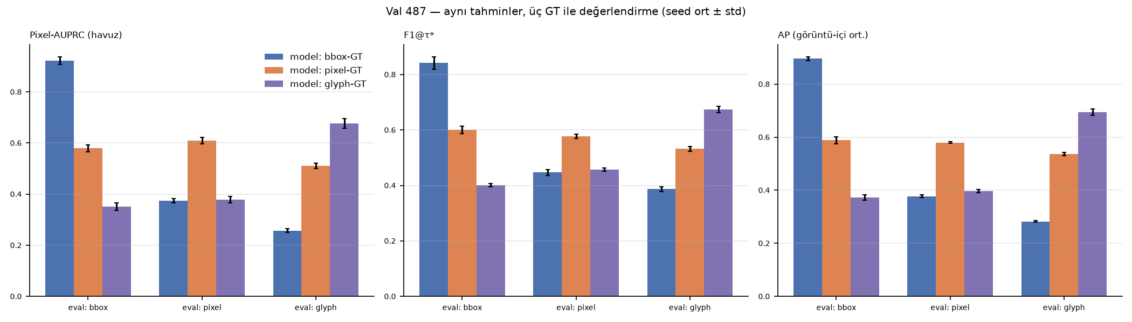
Fig. 1. Same predictions, three ground truths (validation, 3 seeds).
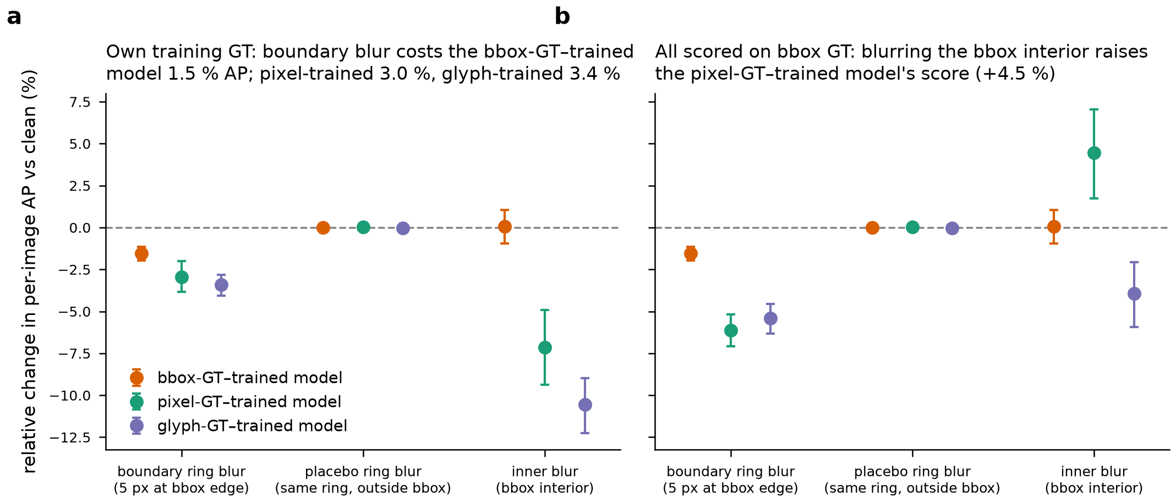
Fig. 2. Boundary / placebo / interior ablation with group-bootstrap CIs.
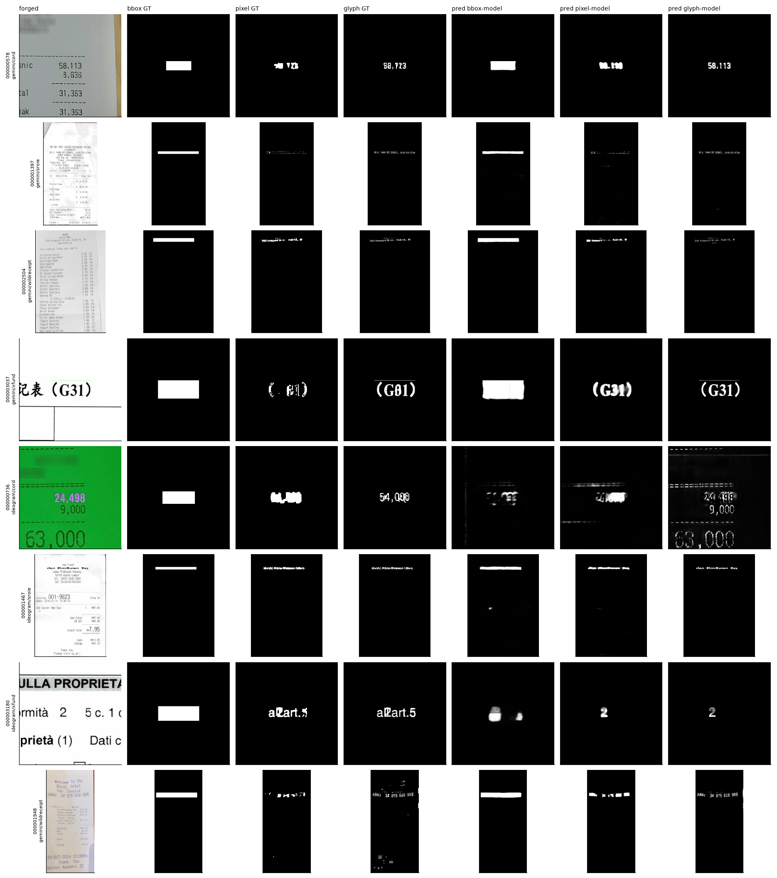
Fig. 3. Example predictions of the three models.

F. Statistical summary
Pre-registered decisions (group bootstrap, B = 1000, Holm within family; full ledger of 463 contrasts in phase2/stats/stats_summary.csv):
Hypothesis | Falsification criterion (fixed in PHASE 1) | Observed (95 % CI) | Decision
H1 metric / ranking | ΔF1 < 0.05 and Kendall τ ≥ 0.9 | ΔF1@τ* (box GT − pixel GT, box model) 0.398 [0.377, 0.418]; ΔAP 0.522 [0.500, 0.544]; Kendall τ (9 models, box vs pixel GT) −0.22 [−0.28, 0.06], P(τ ≥ 0.9) = 0.001 | Confirmed
H2 boundary shortcut | Both models drop alike (difference CI covers 0) and benign FP ≈ authentic | Boundary relΔAP: box −1.5 % [−2.0, −1.1] vs pixel −3.0 % [−3.8, −2.0] (difference +1.4 % [0.5, 2.4], reversed); placebo 0.0 %; interior blur box +0.1 % [−0.9, 1.0]; benign paste-back FP +0.50 ‰ [0.36, 0.66] | Partial (shape/content-insensitivity yes; boundary mechanism no)
H3 transfer / robustness | No difference or reversed | Ideogram ΔAP pixel − box (pixel GT) +0.025 [−0.039, 0.088], Holm p 0.86; robustness differences mixed in sign | Falsified
H4 global trace | AUROC ≈ 0.5 | 0.516 [0.513, 0.519]; resampled negatives 0.498 [0.492, 0.503]; positive control 0.980 [0.972, 0.988] | Falsified (practically)

Additional contrasts: test all-812 vs clean-740 ΔAP 0.0012 [−0.003, 0.005]; box model − TruFor ΔAP 0.465 [0.436, 0.492] and − ADCD-Net 0.625 [0.598, 0.652] on the official test set (not on equal footing: zero-shot vs trained). Groups are mostly singletons (451/469 in validation), so the group bootstrap is close to an image bootstrap; seeds are treated as a fixed factor and the held-out-generator runs have one seed.

VI. Discussion
What the numbers mean. A localizer trained and scored on field boxes achieves 0.95 AUPRC on AIForge-Doc, but this measures field localization, not pixel-change localization: half of the "correct" pixels never changed, and the same maps drop to 0.37–0.43 when scored against the pixels that did. The box model learns the geometry it was taught — single rectangles whose score is unaffected by erasing the glyphs inside. Benchmarks that release box masks should therefore report a threshold-free metric under a pixel-change or glyph ground truth alongside the box metric; AIForge-Doc makes this possible for training pairs, and we release the derived masks.
Which ground truth to train on. The answer depends on the deployment goal. Pixel-change supervision yields more precise, better-calibrated masks (4.5× fewer authentic images flagged at the default threshold) with equal image-level discrimination, but no robustness or transfer gain; box supervision transfers better in absolute terms to Ideogram but over-segments and is poorly calibrated at 0.5. A practical compromise — training on the pixel mask with a box-level auxiliary loss, or box training with a glyph-weighted loss — is an obvious next step that this study did not test.
Negative results. Two pre-registered hypotheses were falsified and one mechanism of a third reversed. The paste-back boundary and the generation pipeline's resampling asymmetry, which the dataset authors flag as a caveat, contribute little: a 5-px boundary blur costs the box model 1.5–2 % (less than it costs the pixel model), benign paste-backs lower image-level AUROC by about two points, and the only image-wide trace outside the field is a weak resampling signature that symmetric preprocessing removes. These results narrow the shortcut question to the region-level appearance of API-rendered text, which is also the cue that collapses on Ideogram (whose edits are smaller and leave 3× fewer outside-box changes).
Limitations. (1) The derived pixel-change ground truth is itself an estimate (ε = 8, morphology); its threshold sensitivity is reported, but the 100-pair human verification sheet has not yet been filled in. (2) Pixel ground truth exists only where authentic pairs are released (training split and 89 test images); test-set conclusions therefore rest on the box ground truth. (3) 10 epochs were fixed a priori and pixel/glyph curves were still rising; absolute gaps may shrink with longer training, although the ranking was stable across seeds. (4) Generator is confounded with source and edit size, and Ideogram comprises 422 images; held-out-generator runs use one seed. (5) All models are a single architecture (ResNet-18 U-Net); zero-shot references are not on equal footing. (6) The dataset is 90 % receipts with one edited field per image, nine languages but 90 % English/Indonesian; nothing here should be read as a statement about invoices, bank statements or multi-field forgeries.

VII. Conclusion
On AIForge-Doc v1 the ground-truth geometry, not the generator, is the first-order determinant of what a document forgery localizer learns and how well it appears to perform. We quantified the mismatch between box masks and actual pixel changes, derived pixel-change and glyph ground truths from the released authentic pairs, and showed with a controlled nine-model experiment that (i) metrics and rankings are not transferable across ground truths, (ii) box training produces rectangular, content-insensitive predictions that are poorly calibrated at the default threshold, (iii) pixel training is more precise but not more robust or transferable, and (iv) neither the paste-back seam nor a global re-encoding trace is a usable shortcut. We release the audit script, derived masks, controls, probes and evaluation code; the next step is a loss that combines box-level robustness with pixel-level specificity, evaluated under both ground truths.

References
See literature/references.bib for the 38 verified records; identifiers in brackets refer to literature/literature_matrix.md (S = document-specific, G = generic IML, I = inpainting, E = evaluation/shortcut). Classical references (Gonzalez & Woods; Ojala et al. 2002; Haralick et al. 1973; He et al. 2016; Ronneberger et al. 2015; Cortes & Vapnik 1995; Breiman 2001) are to be added with DOIs before submission.

