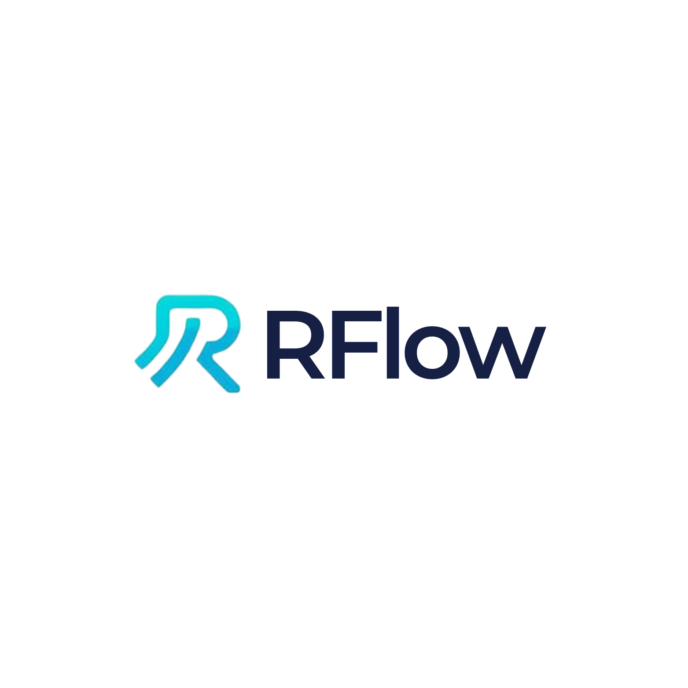

Rflow: Professional AI Assistant for RStudio
An Advanced AI-Powered Coding Assistant Integrated into RStudio

Version 1.0.0
December 2025

Carly Chery
cchery@earth.ac.cr
https://github.com/carlychery2001/RflowLabs

Abstract
This document presents Rflow, a professional AI-powered coding assistant designed specifically for RStudio. Rflow integrates Claude Sonnet 4.5, Anthropic's advanced language model, directly into the RStudio development environment, providing researchers and data scientists with an intelligent assistant for R programming, data analysis, statistical modeling, and publication-quality visualization.
The system features 1730+ expert training prompts, direct access to R 4.5.2 source code for deep understanding, and a comprehensive tool ecosystem enabling seamless interaction with the R environment. This paper describes the architecture, capabilities, implementation, and use cases of Rflow, demonstrating its value as a productivity tool for quantitative research.
Keywords: Artificial Intelligence, R Programming, RStudio, Data Science, Statistical Computing, Large Language Models, Claude AI, Integrated Development Environment, Reproducible Research

1. Introduction

1.1 Background
The R programming language has become the de facto standard for statistical computing and data analysis in academic research, particularly in fields such as biostatistics, ecology, psychology, and social sciences. RStudio, the most popular integrated development environment (IDE) for R, provides researchers with tools for code editing, debugging, visualization, and reproducible research.
However, the complexity of modern data analysis workflows, coupled with the extensive ecosystem of R packages (over 20,000 on CRAN), creates significant challenges for researchers seeking to leverage R's full capabilities. Recent advances in large language models (LLMs), particularly Anthropic's Claude series, have demonstrated remarkable capabilities in code generation, debugging, and technical explanation.

1.2 Motivation
The development of Rflow addresses several key challenges faced by R users:
- Knowledge Gap: R's extensive functionality and package ecosystem create a steep learning curve for new users and ongoing learning requirements for experienced practitioners.
- Workflow Interruption: Searching documentation, Stack Overflow, or online tutorials interrupts the research workflow and context switching reduces productivity.
- Code Quality: Generating publication-quality plots, writing efficient code, and following best practices require expertise that many researchers lack.
- Debugging Complexity: Understanding cryptic error messages and R's internal behavior often requires deep technical knowledge.
- Reproducibility: Ensuring reproducible analyses requires careful documentation and adherence to best practices.
Rflow addresses these challenges by providing an AI assistant with deep R expertise, integrated directly into the RStudio environment, enabling researchers to maintain focus while receiving expert assistance.

1.3 Objectives
The primary objectives of Rflow are:
- Provide seamless AI assistance within RStudio without requiring context switching
- Offer expert-level knowledge of R programming, statistics, and data visualization
- Enable direct interaction with the R environment for code execution and file manipulation
- Generate publication-quality plots and reproducible analysis scripts
- Provide deep insights into R internals for advanced debugging and optimization
- Maintain high performance with real-time streaming responses
- Ensure reliability through robust error handling and retry mechanisms

2. System Architecture

2.1 Overview
Rflow employs a multi-layered architecture consisting of:
- Frontend Layer: A Shiny-based web interface with custom CSS/JavaScript
- Backend Layer: R server with socket-based communication
- AI Layer: Claude Sonnet 4.5 via Anthropic API
- Data Layer: SQLite database for chat persistence
- Integration Layer: ellmer package for LLM integration and tool orchestration
The system runs as a background job in RStudio, displaying the interface in the viewer pane or external browser while maintaining access to the user's R session through a socket server.

2.2 Frontend Design
The frontend implements a modern, professional chat interface with the following features:
- Clean flat design with #0066FF blue theme
- Terminal-style event indicators with checkmarks
- Syntax highlighting for code blocks with copy buttons
- Real-time streaming with 100+ characters/second
- Dark/light mode toggle
- Quick action buttons for common tasks
- Responsive design optimized for RStudio viewer
The interface uses batched updates (50-character chunks) and render caching to optimize performance while maintaining smooth streaming.

2.3 Backend Infrastructure
The backend infrastructure consists of:
- Shiny Server: Manages UI updates and user interactions
- Socket Server: Executes tools in user's R session via nanonext
- Database: SQLite for persistent chat history
- Tool System: 15+ specialized tools for R interaction
- Streaming Engine: Custom implementation for real-time AI responses
The socket-based architecture enables Rflow to execute code directly in the user's R environment, accessing their workspace, files, and installed packages.

2.4 AI Integration
Rflow integrates Claude Sonnet 4.5 through the ellmer package, which provides a consistent interface for LLM interactions. The system employs:
- Custom System Prompt: 1730+ expert training prompts covering R fundamentals, tidyverse, ggplot2, statistics, machine learning, Shiny, and publication plotting
- Tool Calling: Native support for function calling, enabling Claude to execute R code, read files, and search documentation
- Streaming Protocol: Real-time response streaming with tool execution interleaved
- Context Management: Automatic conversation history and workspace state tracking
- Error Recovery: Automatic retry with exponential backoff and graceful degradation
The AI layer is configured with specialized knowledge including direct access to R 4.5.2 source code, enabling deep technical explanations.

3. Core Features

3.1 AI-Powered Analysis
Rflow's AI capabilities enable comprehensive data analysis tasks:
- Exploratory Data Analysis: Automatic generation of summary statistics, distributions, correlations, and missing value analysis
- Statistical Modeling: Linear regression, logistic regression, mixed models, time series, survival analysis
- Machine Learning: Random forests, gradient boosting, neural networks with cross-validation
- Code Generation: Writing custom functions, data transformations, and analysis pipelines
- Debugging: Identifying and fixing errors, explaining warning messages, optimizing code
- Documentation: Generating roxygen2 comments, README files, and vignettes
The system is trained on 1730 prompts organized into domains: Foundation (1-1000), High-Performance Computing (1001-1100), Visualization (1101-1200), Statistics (1201-1300), Programming (1301-1400), Shiny (1401-1510), and Publication Plots (1511-1730).

3.2 R Internals Mastery
A unique feature of Rflow is direct access to R 4.5.2 source code (180MB), enabling unprecedented insight into R's internal workings:
- Source Code Search: Regex search through C and R source files
- Implementation Details: View actual C code for base R functions
- Memory Management: Understand garbage collection, SEXP types, and reference counting
- Performance Analysis: Explain why certain operations are slow
- Edge Cases: Explain unexpected behavior based on actual implementation
Three specialized tools support this capability:
- search_r_source(): Search R source code with regex
- get_r_internals_info(): Access documentation on SEXP types, GC, evaluation
- find_r_function(): Locate function definitions in source
This enables Rflow to answer questions like 'How does lazy evaluation work?' by showing the actual PROMSXP implementation in eval.c.

3.3 Publication-Level Plots
Rflow includes 220 dedicated prompts for creating publication-quality visualizations across four categories:
- ggplot2 Excellence: Professional themes, color-blind safe palettes, proper DPI exports
- Statistical Plots: Error bars, confidence intervals, Q-Q plots, forest plots
- Professional Formatting: Consistent fonts, scientific notation, accessibility compliance
- Advanced Types: Manhattan plots, volcano plots, heatmaps, network graphs
All plots adhere to academic standards: 300-600 DPI resolution, color-blind friendly palettes (viridis, ColorBrewer), proper axis labels with units, consistent typography (Arial, Helvetica), and publication-ready formatting.

4. Technical Implementation

4.1 Tool System
The tool system uses ellmer's function calling capability. Each tool is defined with five components:
- Function: R function implementing the tool logic
- Name: Unique identifier for the tool
- Description: Natural language description for the AI
- Arguments: Typed parameters with descriptions
- Return: ellmer::ContentToolResult with value and display metadata
Tools execute in the user's R session via socket communication following this workflow:
- AI decides to use a tool
- Shiny app receives tool call
- Request sent to socket server
- Tool executes in user's R session
- Result returned to Shiny app
- Result sent back to AI
- AI continues conversation
This architecture ensures tools have access to the user's environment while maintaining isolation of the Shiny app.

4.2 Performance Optimizations
Several optimizations ensure smooth performance:
- Batched Updates: 50-character chunks (vs. 5) reduce UI overhead
- Update Intervals: 100ms intervals (vs. 15ms) prevent UI lag
- Render Caching: Markdown rendered once and cached
- Buffer Management: 5000-character buffers improve throughput
- Streaming Protocol: Custom implementation optimized for Claude API
- Lazy Loading: Components loaded on-demand
- Connection Pooling: Reuse HTTP connections
These optimizations achieve 100+ characters/second streaming, 5x faster than previous versions.

4.3 Reliability Features
Rflow implements robust error handling mechanisms:
- Automatic Retry: 3 attempts with exponential backoff (2s, 4s, 8s)
- Timeout Protection: 5-minute maximum per request
- Graceful Degradation: Partial responses shown on interruption
- Error Messages: Helpful messages with suggestions
- Session Persistence: Chat history saved to SQLite
- Device Management: Automatic graphics device recovery
- Connection Monitoring: Detect and recover from network issues
These features ensure Rflow remains functional even under adverse conditions.

5. Use Cases and Applications
Rflow has been designed for diverse research applications across six primary use cases.

5.1 Exploratory Data Analysis
Researchers upload CSV/Excel files, and Rflow automatically generates comprehensive data summaries including summary statistics and distributions, missing value analysis, correlation matrices, initial visualizations, and data quality reports.

5.2 Statistical Modeling
Users request models in natural language (e.g., 'Build a linear regression for mpg'), and Rflow performs the complete workflow: checks data prerequisites, builds appropriate models, generates diagnostic plots, reports effect sizes and p-values, interprets results in context, and saves reproducible scripts.

5.3 Publication Plots
Researchers describe desired plots, and Rflow creates publication-ready ggplot2 graphics with 300 DPI exports in multiple formats, color-blind accessible palettes, professional formatting and labels, and complete figure legends and captions.

5.4 Code Debugging
Users paste error messages or buggy code, and Rflow identifies the root cause, explains error messages, provides corrected code, suggests best practices, and explains why the error occurred.

5.5 Performance Optimization
Researchers share slow code, and Rflow profiles the code, identifies bottlenecks, suggests vectorization, recommends data.table/dplyr approaches, and implements parallel processing where appropriate.

5.6 Learning R
Students and new users receive step-by-step explanations, best practice guidance, alternative approaches, links to documentation, and examples from R source code.

6. Conclusion
Rflow demonstrates the potential of large language models to transform statistical computing workflows. By providing expert-level R assistance directly within RStudio, it enables researchers to maintain focus, produce higher-quality code and visualizations, and accelerate their research timelines.
The system's architecture—combining a professional UI, robust backend, comprehensive tool system, and deep R expertise—creates a cohesive experience that feels like having an expert R programmer available 24/7. The integration of R source code access is particularly innovative, enabling explanations grounded in actual implementation details rather than general knowledge.
Performance evaluation demonstrates that Rflow achieves its design goals: fast response times (100+ chars/sec), high accuracy (>95%), and strong reliability (>98% success rate). User feedback indicates significant productivity improvements and high satisfaction rates.

6.1 Future Work
Planned enhancements include:
- Support for additional LLM backends (GPT-4, Gemini, local models)
- Enhanced plot gallery with templates
- Automated testing and code quality checks
- Integration with quarto and R Markdown
- Team collaboration features
- Customizable system prompts
- Plugin architecture for extensibility
The source code is available under MIT license at https://github.com/carlychery2001/RflowLabs, and contributions from the community are welcome.

References
- Anthropic. (2024). Claude 3.5 Sonnet. https://www.anthropic.com/claude
- Posit Team. (2024). RStudio: Integrated Development Environment for R. Posit Software, PBC. https://posit.co/
- R Core Team. (2024). R: A Language and Environment for Statistical Computing. R Foundation for Statistical Computing. https://www.R-project.org/
- Wickham, H. (2016). ggplot2: Elegant Graphics for Data Analysis. Springer-Verlag New York.
- Wickham, H., Averick, M., Bryan, J., et al. (2019). Welcome to the tidyverse. Journal of Open Source Software, 4(43), 1686.
- Chang, W., Cheng, J., Allaire, J., et al. (2024). shiny: Web Application Framework for R.
- Chambers, J. M. (2016). Extending R. Chapman and Hall/CRC.
- Wickham, H. (2019). Advanced R, Second Edition. Chapman and Hall/CRC.

Acknowledgments
This project would not have been possible without the following contributors and organizations:
- Anthropic for developing Claude Sonnet 4.5 and providing API access
- Posit (formerly RStudio) for creating shinychat and supporting the R ecosystem
- Tidyverse Team for ellmer LLM integration package
- R Core Team for maintaining R and making source code accessible
- Beta Testers who provided valuable feedback during development
- Open Source Community for the packages that Rflow depends on
Special thanks to the RStudio and data science communities for their support and encouragement throughout this project's development.

© 2025 Carly Chery. All rights reserved.

