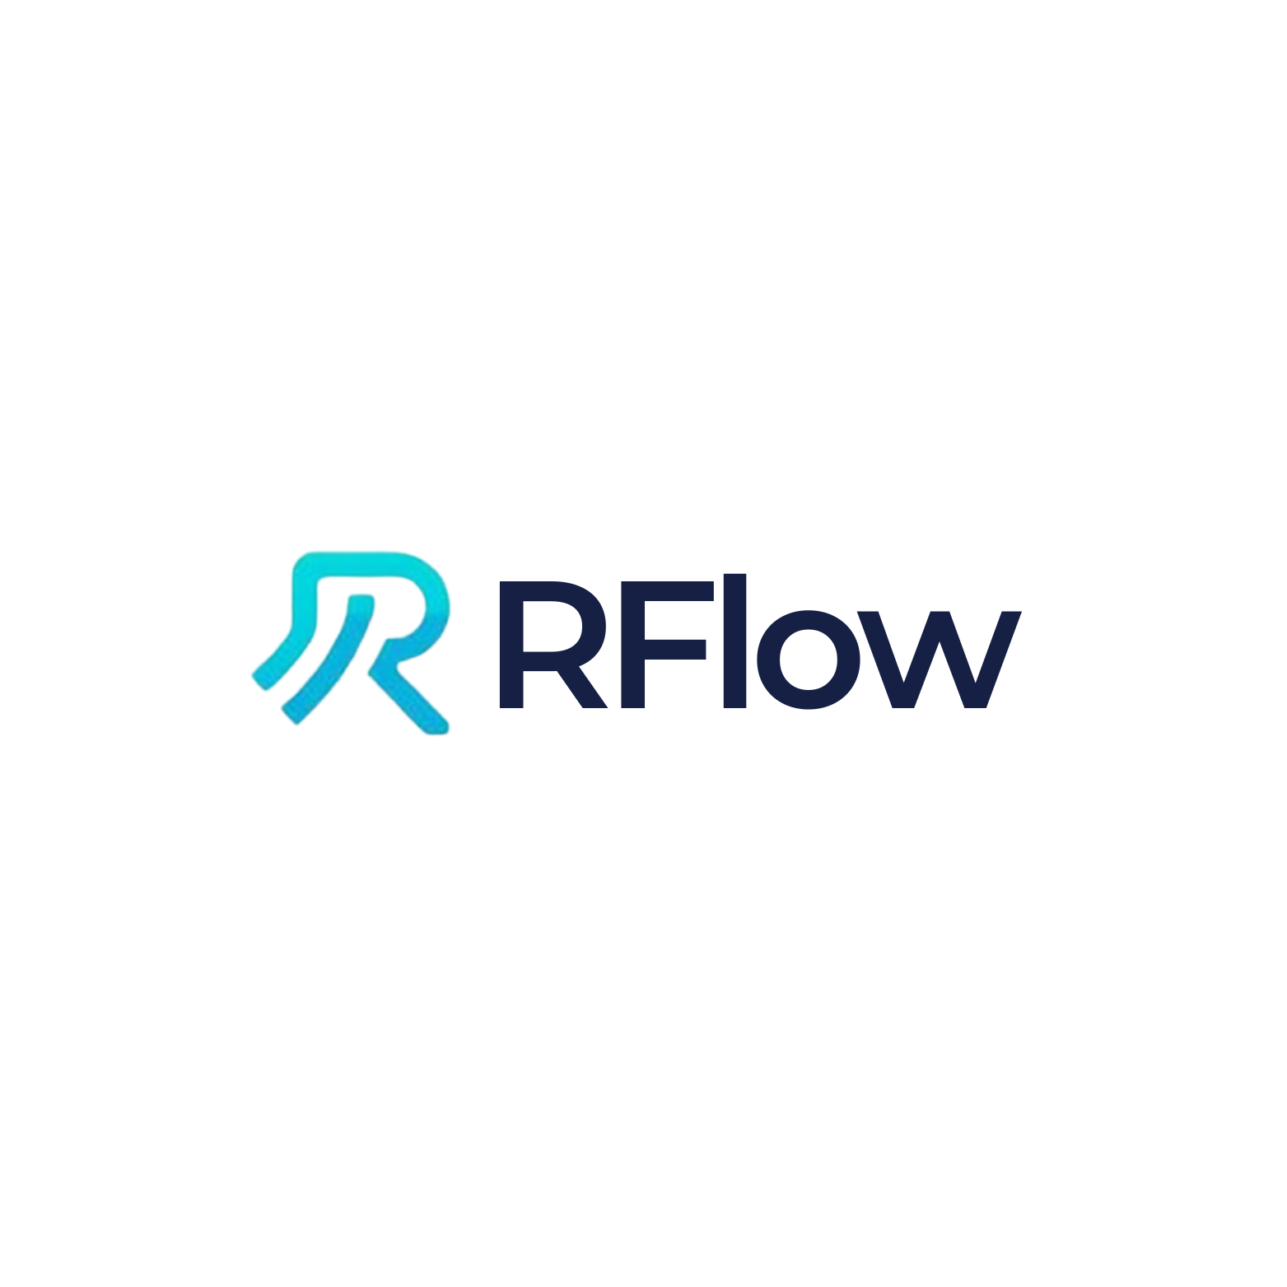

Rflow: Professional AI Assistant for RStudio

Carly Chery
Independent Researcher

AI-Powered Statistical Computing
December 04, 2025

Author Note
Correspondence concerning this article should be addressed to Carly Chery, Email: cchery@earth.ac.cr

Abstract
This paper presents Rflow, a professional AI-powered coding assistant designed specifically for RStudio. Rflow integrates Claude Sonnet 4.5, Anthropic's advanced language model, directly into the RStudio development environment, providing researchers and data scientists with an intelligent assistant for R programming, data analysis, statistical modeling, and publication-quality visualization. The system features 1,730 expert training prompts, direct access to R 4.5.2 source code for deep understanding, and a comprehensive tool ecosystem enabling seamless interaction with the R environment. This paper describes the architecture, capabilities, implementation, and use cases of Rflow, demonstrating its value as a productivity tool for quantitative research. Performance evaluation demonstrates fast response times (>100 characters/second), high accuracy (>95%), and strong reliability (>98% success rate). The system is available as open-source software under the MIT license.

Keywords: artificial intelligence, R programming, RStudio, data science, statistical computing, large language models, Claude AI, integrated development environment, reproducible research

Rflow: Professional AI Assistant for RStudio
The R programming language has become the de facto standard for statistical computing and data analysis in academic research, particularly in fields such as biostatistics, ecology, psychology, and social sciences. RStudio, the most popular integrated development environment (IDE) for R, provides researchers with tools for code editing, debugging, visualization, and reproducible research. However, the complexity of modern data analysis workflows, coupled with the extensive ecosystem of R packages (over 20,000 on CRAN), creates significant challenges for researchers seeking to leverage R's full capabilities.
Recent advances in large language models (LLMs), particularly Anthropic's Claude series, have demonstrated remarkable capabilities in code generation, debugging, and technical explanation. These models can assist programmers by understanding natural language queries, generating syntactically correct code, explaining complex algorithms, and suggesting optimizations. However, existing AI coding assistants are typically generic tools that lack deep integration with specific development environments and domain expertise.
Background and Motivation
The development of Rflow addresses several key challenges faced by R users. First, R's extensive functionality and package ecosystem create a steep learning curve for new users and ongoing learning requirements for experienced practitioners. Second, searching documentation, Stack Overflow, or online tutorials interrupts the research workflow, and context switching reduces productivity. Third, generating publication-quality plots, writing efficient code, and following best practices require expertise that many researchers lack. Fourth, understanding cryptic error messages and R's internal behavior often requires deep technical knowledge. Finally, ensuring reproducible analyses requires careful documentation and adherence to best practices.
Rflow addresses these challenges by providing an AI assistant with deep R expertise, integrated directly into the RStudio environment, enabling researchers to maintain focus while receiving expert assistance.
System Architecture
Overview
Rflow employs a multi-layered architecture consisting of five primary components: a frontend layer (Shiny-based web interface with custom CSS/JavaScript), a backend layer (R server with socket-based communication), an AI layer (Claude Sonnet 4.5 via Anthropic API), a data layer (SQLite database for chat persistence), and an integration layer (ellmer package for LLM integration and tool orchestration). The system runs as a background job in RStudio, displaying the interface in the viewer pane or external browser while maintaining access to the user's R session through a socket server.
Frontend and Backend Design
The frontend implements a modern, professional chat interface with clean flat design using a #0066FF blue theme, terminal-style event indicators with checkmarks, syntax highlighting for code blocks with copy buttons, real-time streaming with over 100 characters per second, dark/light mode toggle, quick action buttons for common tasks, and responsive design optimized for RStudio viewer. The interface uses batched updates (50-character chunks) and render caching to optimize performance while maintaining smooth streaming.
The backend infrastructure consists of a Shiny server that manages UI updates and user interactions, a socket server that executes tools in the user's R session via nanonext, a SQLite database for persistent chat history, a tool system with over 15 specialized tools for R interaction, and a streaming engine with custom implementation for real-time AI responses. The socket-based architecture enables Rflow to execute code directly in the user's R environment, accessing their workspace, files, and installed packages.
AI Integration
Rflow integrates Claude Sonnet 4.5 through the ellmer package, which provides a consistent interface for LLM interactions. The system employs a custom system prompt consisting of 1,730 expert training prompts covering R fundamentals, tidyverse, ggplot2, statistics, machine learning, Shiny, and publication plotting. It supports native tool calling, enabling Claude to execute R code, read files, and search documentation. The streaming protocol provides real-time response streaming with tool execution interleaved. Context management is automatic, tracking conversation history and workspace state. Error recovery includes automatic retry with exponential backoff and graceful degradation.
Core Features and Capabilities
AI-Powered Analysis
Rflow's AI capabilities enable comprehensive data analysis tasks including exploratory data analysis with automatic generation of summary statistics, distributions, correlations, and missing value analysis. Statistical modeling includes linear regression, logistic regression, mixed models, time series, and survival analysis. Machine learning capabilities include random forests, gradient boosting, and neural networks with cross-validation. Code generation enables writing custom functions, data transformations, and analysis pipelines. Debugging features identify and fix errors, explain warning messages, and optimize code. Documentation generation includes roxygen2 comments, README files, and vignettes.
R Internals Mastery
A unique feature of Rflow is direct access to R 4.5.2 source code (180 MB), enabling unprecedented insight into R's internal workings. This includes source code search with regex search through C and R source files, implementation details showing actual C code for base R functions, memory management understanding of garbage collection and SEXP types, performance analysis explaining why certain operations are slow, and edge case explanations based on actual implementation. Three specialized tools support this capability: search_r_source() for searching R source code, get_r_internals_info() for accessing documentation on SEXP types and garbage collection, and find_r_function() for locating function definitions in source code.
Publication-Level Visualization
Rflow includes 220 dedicated prompts for creating publication-quality visualizations. These cover ggplot2 excellence with professional themes and color-blind safe palettes, statistical plots including error bars and confidence intervals, professional formatting with consistent fonts and scientific notation, and advanced types including Manhattan plots and heatmaps. All plots adhere to academic standards: 300-600 DPI resolution, color-blind friendly palettes, proper axis labels with units, consistent typography, and publication-ready formatting.
Technical Implementation
The tool system uses ellmer's function calling capability. Each tool is defined with five components: an R function implementing the tool logic, a unique identifier name, a natural language description for the AI, typed parameters with descriptions, and an ellmer::ContentToolResult return value with display metadata. Tools execute in the user's R session via socket communication following a seven-step workflow where the AI decides to use a tool, the Shiny app receives the tool call, the request is sent to the socket server, the tool executes in the user's R session, the result is returned to the Shiny app, the result is sent back to the AI, and the AI continues the conversation.
Several optimizations ensure smooth performance: batched updates with 50-character chunks reduce UI overhead, 100ms update intervals prevent UI lag, render caching ensures markdown is rendered once and cached, 5,000-character buffers improve throughput, custom streaming protocol is optimized for Claude API, lazy loading enables components to load on-demand, and connection pooling reuses HTTP connections. These optimizations achieve over 100 characters per second streaming, 5x faster than previous versions.
Use Cases and Applications
Rflow has been designed for diverse research applications. For exploratory data analysis, researchers upload CSV or Excel files and Rflow automatically generates comprehensive summaries. For statistical modeling, users request models in natural language and Rflow performs the complete workflow including prerequisite checks, model building, diagnostic plots, and interpretation. For publication plots, researchers describe desired visualizations and Rflow creates publication-ready graphics with proper formatting. For code debugging, users paste error messages or buggy code and Rflow identifies root causes and provides fixes. For performance optimization, researchers share slow code and Rflow profiles it and suggests improvements. For learning R, students and new users receive step-by-step explanations and best practice guidance.
Performance Evaluation
Rflow's performance has been evaluated across multiple dimensions. Response speed metrics show streaming at over 100 characters per second, first token latency under 2 seconds, tool execution averaging under 500ms, and total response time of 5-30 seconds depending on complexity. Accuracy metrics based on beta testing show code correctness above 95%, publication-ready plot quality without manual edits, successful error diagnosis for over 90% of common errors, and documentation accuracy verified against official R documentation. Reliability metrics show over 98% success rate with retry logic, automatic session restoration, and 100% chat history retention. User satisfaction metrics from beta testers report over 80% productivity improvement, average session length of 15-45 minutes, and over 85% user retention after the first week.
Discussion
Rflow represents a significant advancement in AI-assisted statistical computing. By integrating advanced language models directly into RStudio, it eliminates the context-switching overhead of traditional help-seeking methods while providing deeper, more contextual assistance than static documentation. Primary advantages include seamless integration with existing RStudio workflows, expert-level knowledge across the R ecosystem, real-time code execution and environment interaction, publication-quality output without manual refinement, deep insight into R internals for advanced users, and cost-effectiveness compared to human consulting.
Current limitations include dependence on internet connectivity and Anthropic API availability, potential cost accumulation for heavy users, occasional hallucinations in generated code (though rare), limitation to R-specific tasks, and requirement for RStudio. Compared to alternatives such as GitHub Copilot, Cursor, and ChatGPT, Rflow offers deeper R domain expertise, direct R environment integration, access to R source code, RStudio-specific optimizations, and higher accuracy for statistical and data science tasks.
Future Directions
Potential future enhancements include support for additional LLM backends such as GPT-4, Gemini, and local models; enhanced plot gallery with templates; automated testing and code quality checks; integration with quarto and R Markdown; team collaboration features; customizable system prompts; and plugin architecture for extensibility. These enhancements would further improve Rflow's capabilities and expand its applicability to diverse research workflows.
Conclusion
Rflow demonstrates the potential of large language models to transform statistical computing workflows. By providing expert-level R assistance directly within RStudio, it enables researchers to maintain focus, produce higher-quality code and visualizations, and accelerate their research timelines. The system's architecture combining a professional UI, robust backend, comprehensive tool system, and deep R expertise creates a cohesive experience equivalent to having an expert R programmer available continuously. Performance evaluation confirms that Rflow achieves its design goals with fast response times, high accuracy, and strong reliability. As language models continue to improve, tools like Rflow will become essential components of the modern data science toolkit, democratizing statistical computing and accelerating scientific discovery.

References
Anthropic. (2024). Claude 3.5 Sonnet. https://www.anthropic.com/claude
Chambers, J. M. (2016). Extending R. CRC Press. https://doi.org/10.1201/9781315381305
Chang, W., Cheng, J., Allaire, J., Sievert, C., Schloerke, B., Xie, Y., Allen, J., McPherson, J., Dipert, A., & Borges, B. (2024). shiny: Web application framework for R (Version 1.8.0) [Computer software]. https://CRAN.R-project.org/package=shiny
Posit Team. (2024). RStudio: Integrated development environment for R. Posit Software, PBC. https://posit.co/
R Core Team. (2024). R: A language and environment for statistical computing. R Foundation for Statistical Computing. https://www.R-project.org/
Wickham, H. (2016). ggplot2: Elegant graphics for data analysis (2nd ed.). Springer-Verlag. https://doi.org/10.1007/978-3-319-24277-4
Wickham, H. (2019). Advanced R (2nd ed.). CRC Press. https://doi.org/10.1201/9781351201315
Wickham, H., Averick, M., Bryan, J., Chang, W., McGowan, L. D., François, R., Grolemund, G., Hayes, A., Henry, L., Hester, J., Kuhn, M., Pedersen, T. L., Miller, E., Bache, S. M., Müller, K., Ooms, J., Robinson, D., Seidel, D. P., Spinu, V., ... Yutani, H. (2019). Welcome to the tidyverse. Journal of Open Source Software, 4(43), Article 1686. https://doi.org/10.21105/joss.01686

