**THANK YOU FOR DOWNLOADING TRADETOOL!**

**CONTENTS**

1. Release Notes
2. User Guide
   1. Enabling TradeTool
   2. Input Fields
   3. Usage

**I. Release Notes:**

**v.1.2**

- Added provisions for pending orders

**v.1.2**

- Fixed a visibility issue

**v.1.0**

- Initial Release

**II. USER GUIDE**

**TradeTool** is a basic order management solution, and an extension of MetaTrader’s One Click Trading feature, that allows Stop Loss and Take Profit levels to be automatically placed based on set POINTS distance.

**II.a. ENABLING TRADETOOL**

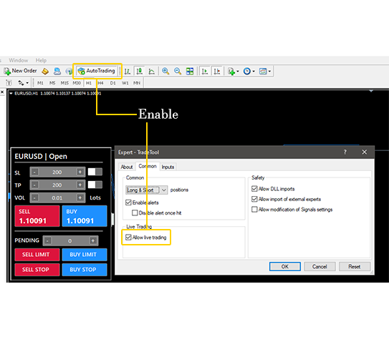Make sure ***AutoTrading*** is enabled and ***Allow live trading*** is checked. Tradetool will not work if both are disabled.

**II.b. INPUTS**

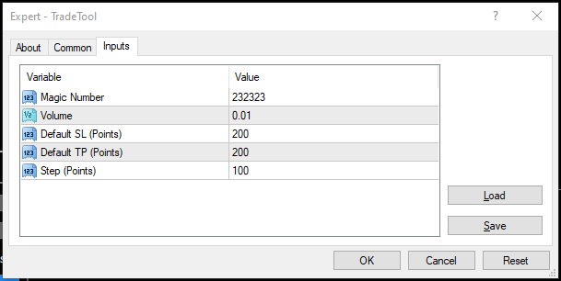

1. Magic Number – Expert Magic Number
2. Volume – Default Volume
3. Default SL – Stop Loss default points distance from current market price
4. Default TP – Take Profit default points distance from current market price
5. Step – Adjustment step size in points

**II.c. USAGE**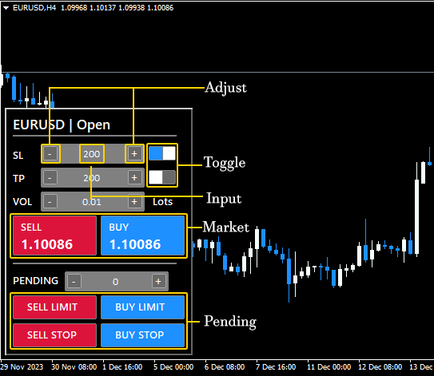

**Adjustment Buttons** – Adjusts SL and TP points based on input step size

**Toggle** – Enables/Disables placing SL and TP

**Input** – Input field for SL and TP points

**Market** – Market Buy/Market Sell

**Pending** – Pending Order (Limit / Stop)