Working on Pepper robot project constrains

SoftBank Choreography for Pepper:

The main issue is a fundamental software incompatibility between the legacy Choregraphe tool and modern hardware or software environments. Most commonly, Choregraphe crashes because it is designed strictly for the older NAOqi 2.5 (Python) operating system; when it attempts to handshake with a newer NAOqi 2.9 (Android) Pepper, it fails to locate critical deprecated services (like ALBehaviorManager), causing a fatal error. Alternatively, on modern Windows computers, Choregraphe's outdated 3D rendering engine often conflicts with current graphics card drivers (OpenGL), forcing the application to close immediately when it tries to generate the visual model of the robot.
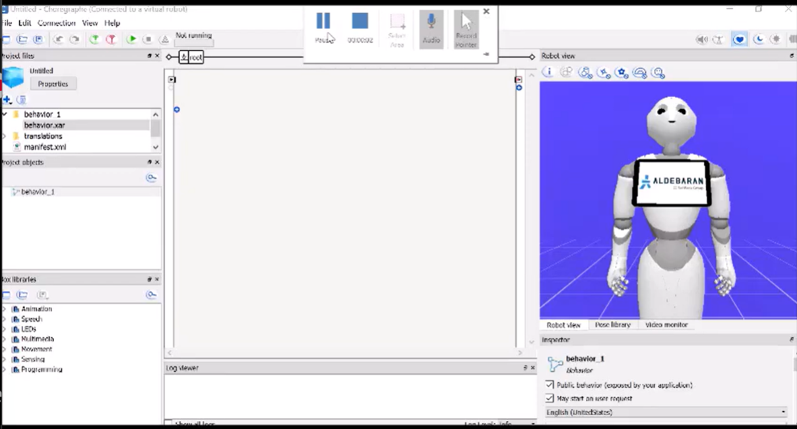

Using Python SDK
Python SDK lacks access to the Android tablet layer, meaning we cannot display user interfaces, images, or interactive buttons on Pepper's chest. Furthermore, we lose autonomous deployment capabilities, as Python scripts cannot be packaged into an installable app icon on the robot's home screen, forcing us to initiate the robot via a terminal rather than having it run as a standalone, interactive system.

Using QISDK on Android studio:
- Android studio version
QiSDK works only on specific version (4.2.2 released on 2021)
2) certification errors
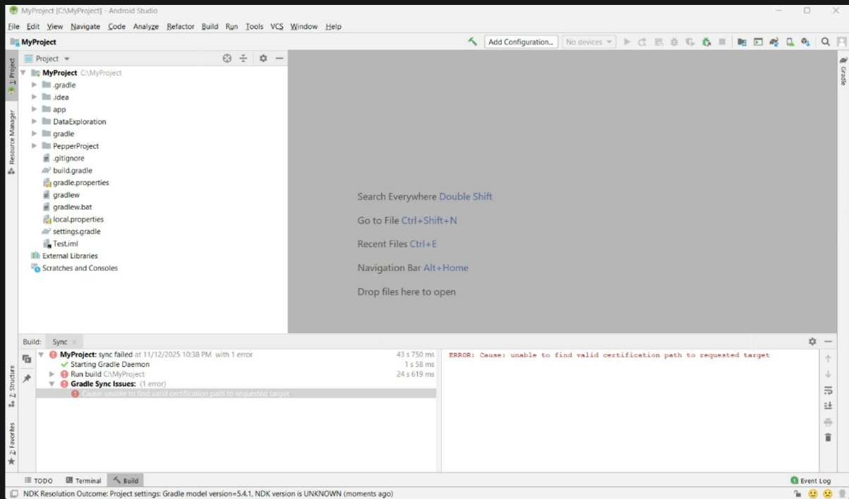

2) Gradle configuration issues
  - Different java versions for each module Gradle and app Gradle
  - mavenCentral() configuration

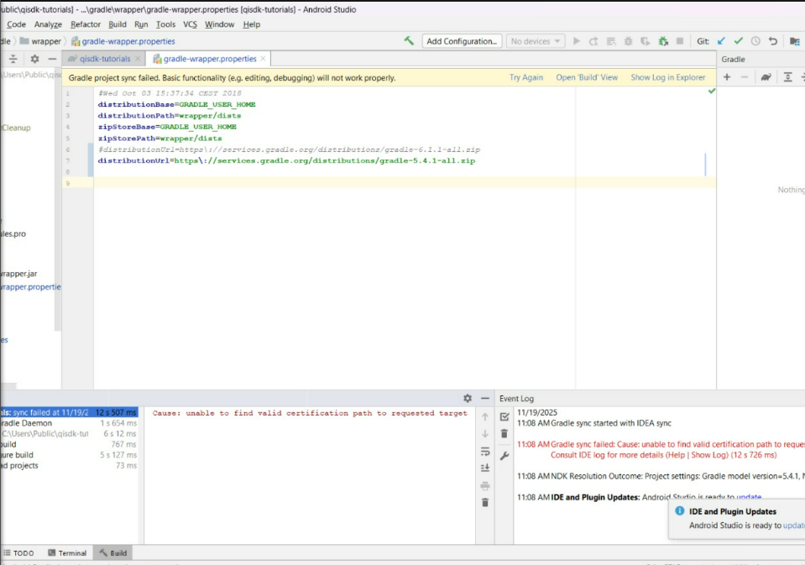

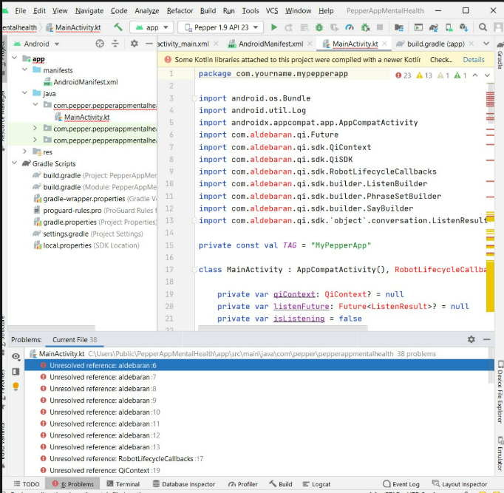

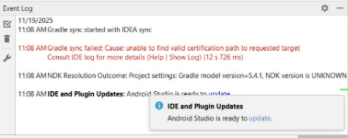

Emulator issues
Even if there are no errors and configuration mismatch, the Emulator still not able to work on every device, because hardware and software driviers.
The QiSDK emulator fails on most modern devices primarily because it relies on outdated virtualization and graphics technologies that conflict with current Windows and hardware standards. The plugin depends on Intel HAXM to run the virtual robot, which frequently clashes with Windows Hyper-V (essential for Docker and WSL2), causing the boot process to hang indefinitely. Furthermore, the software was optimized for Android Studio 4.2 (circa 2021), so running it on modern versions of Android Studio or with newer NVIDIA/AMD graphics drivers often triggers internal API mismatches or OpenGL rendering errors that force the emulator to crash immediately.

