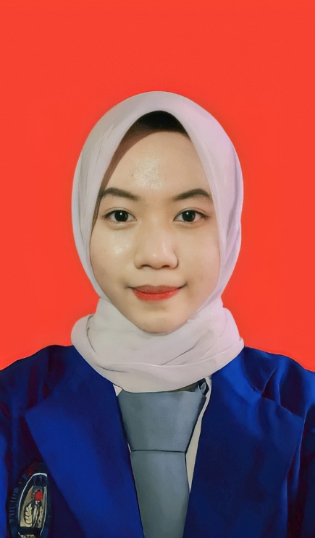

WhatsApp : +6287819997037

Instagram : @slsaauliia

E-mail : salsaauliaa25@gmail.com

Date of Birth : Jakarta, 25 February 2005

Gender : Female

Address : Gg. Siaga 1 RT.03/RW.03 No. 7

Kel. Cempaka Baru, Kec.

Kemayoran, Jakarta Pusat 10640

Martial Status : Single

Height : 164 cm

Weight : 42 kg

Nationally : Indonesian

Region : Moslem

Ms. Word

Ms. Excel

Ms. Powerpoint

Public Speaking

**SKILLS**

**CONTACT**

**EXPERIENCE**

July – September 2021

Carry Out Field Work Practices In :

**KODIM 0501/JP BS**

**STAF LOGISTIK**

Jl. Selaparang, RW.10, Gunung Sahari Selatan, Jakarta Pusat, DKI Jakarta

**EDUCATION**

2009 – 2010

**TK Ad – Darussalam**

2010 – 2016

**SD Negeri Cempaka Baru 11 Pagi**

2016 – 2019

**SMP Negeri 119 Jakarta Pusat**

2019 – 2022

**SMK Negeri 44 Jakarta Pusat**

* Watch Kdrama
* Listening Music

I am seventeen years old. I have a background majoring in office administration in a vocational high school 44 . I am confident that my qualification and skills. I am a person who can work well as part of team and my own.

**HOBBIES**

**PROFILE**

CURICULUM VITAE

**SALSABILA AULIA EMIR**