LAPORAN PROYEK SCRUM

BAB 1: PENDAHULUAN

1.1 Identitas Kelompok
Nama Kelompok: PEH
Kelas: IF-A Sore
Anggota :
1. 231110321 - Richi putra lin
2. 231111118 - Derry
3. 231112458 - Ahmad danu
4. 231112897 – Asyifa Alfath Kasman
5. 231112721 - Sherly

1.2 Topik Pengerjaan
Topik yang dikerjakan oleh kelompok kami adalah:
Vooting App

BAB 2: PEMBAHASAN

2.1 Product Backlog
Berikut ini adalah screenshot dari Product Backlog menggunakan template Excel dari Miss:
Product Backlog & User Story
ID | Epic | As a … | I Want to … | So that … | Tasks | Priority | Estimation
101 | User Authentication | User | log in to the app | I can access my personal dashboard | Design login UI | HIGH | 3
 |  |  |  |  | Coding
102 | User Registration | User | create a new account | I can join and vote in polls | Design sign up UI | HIGH | 3
103 | Navigation | User | navigate between pages | I can access different features | Bottom navigation setup | HIGH | 2
104 | Homepage | User | view trending polls | I can vote on popular topics | Build homepage UI | HIGH | 5
105 | Poll Component | User | view poll cards | I can read poll information | Create PollCard widget | MEDIUM | 2
106 | Saved Polls | User | see saved polls | I can revisit them | Build saved polls page | MEDIUM | 3
107 | Search Feature | User | search for polls | I can find specific polls easily | Design search page | MEDIUM | 4
108 | Reusable Widgets | Developer | build reusable component | UI looks consistent | Create CategoryIcon, SavedItem | LOW | 2
Yg ditambahkan ada:
109 | Profile Page | User | view my profile | I can see my information | Build profile UI | MEDIUM | 3
110 | Settings Page | User | adjust settings | I can customize my experience | Build settings UI | MEDIUM | 3
111 | Logout Feature | User | log out from the app | I can secure my account | Implement logout | HIGH | 2
112 | Dark Mode | User | enable dark mode | I can use the app comfortably at night | Implement dark mode toggle | MEDIUM | 3
113 | View Result | User | view voting results | I can see poll outcomes | Build result page | HIGH | 4
114 | Share Feature | User | share poll results | I can share with friends | Implement share button | MEDIUM | 2
115 | Feedback Feature | User | give feedback on polls | I can express my opinion | Build feedback form | MEDIUM | 3
116 | Edit Profile | User | edit my profile information | I can update my data anytime | Build edit profile UI & logic | MEDIUM | 3
117 | Account Linking | User | link my email and social media | I can log in easily | Implement linking feature | MEDIUM | 4
118 | Report Problem | User | report app problems | Developer can fix bugs quickly | Build report problem form | HIGH | 2

2.2 Sprint Planning
Kami melakukan perencanaan sprint sebanyak minimal 2 sprint. Berikut adalah tabel dari Sprint Planning kami:
Sprint Planning
Sprint 1
Sprint Goals :
1 | Implement authentication and navigation
2 | Setup user registration and login flow
Sprint Backlog :
ID | Backlog Items
101 | As a user, I want to log in so I can access my personal dashboard
102 | As a user, I want to create a new account so I can join and vote in polls
103 | As a user, I want to navigate between pages so I can explore the app easily

Sprint Planning
Sprint 2
Sprint Goals :
1 | Develop main pages and components
2 | Implement search and saved polls features
Sprint Backlog :
ID | Backlog Items
104 | As a user, I want to see trending polls so I can vote on popular topics
106 | As a user, I want to see saved polls so I can revisit them
107 | As a user, I want to search for polls so I can find specific topics easily
Berikut update dari tugas sebelumnya:
Sprint Planning
Sprint 3
Sprint Goals :
1 | Develop profile and settings pages
2 | Implement logout, dark mode, and feedback features
Sprint Backlog :
ID | Backlog Items
109 | As a user, I want to view my profile so I can see my information
110 | As a user, I want to adjust settings so I can customize my experience
111 | As a user, I want to log out from the app so I can secure my account
112 | As a user, I want to enable dark mode so I can use the app comfortably at night
115 | As a user, I want to give feedback on polls so I can express my opinion

Sprint Planning
Sprint 4
Sprint Goals :
1 | Implement view result and share features
2 | Implement edit profile, account linking, and report problem
Sprint Backlog :
ID | Backlog Items
113 | As a user, I want to view voting results so I can see poll outcomes
114 | As a user, I want to share poll results so I can share with friends
116 | As a user, I want to edit my profile information so I can update my data anytime
117 | As a user, I want to link my email and social media so I can log in easily
118 | As a user, I want to report app problems so developer can fix bugs quickly

2.3 Daily Scrum meeting report

No. | Nama Anggota | Task yang dikerjakan
1 | Asyifa | Membuat UI login
2 | Richi | Membuat homepage UI
3 | Ahmad Danu | Membuat saved polls page
4 | Sherly | Implementasi dark mode
5 | Derry | Membuat profile page UI
6 | Asyifa | Membuat setting page
7 | Ahmad Danu | Implementasi view result dan share
8 | Sherly | Membuat edit profile dan report problem page

No. | Tanggal Pengerjaan | Kendala yang dihadapi | Waktu Perkiraan Selesai
1 | 01/06/2005 | Error routing page | 1 hari
2 | 02/06/2005 | Layout overlapping | 2 hari
3 | 02/06/2005 | Masalah provider state | 2 hari
4 | 03/06/2005 | Error switch theme | 1 hari
5 | 03/06/2005 | Masalah integrasi data user | 2 hari
6 | 01/06/2005 | Tidak ada | 1 hari
7 | 04/06/2005 | Error parsing data | 2 hari
8 | 04/06/2005 | Belum connect API edit profile | 2 hari

2.4 Sprint Review
Sprint Review
Sprint 1
Completed Task | Incompleted Task | What's Next
Login page UI, settings page | Tidak ada | Develop homepage and saved polls

Sprint Review
Sprint 2
Completed Task | Incompleted Task | What's Next
Homepage, saved polls | Tidak ada | Profile, settings, logout, dark mode, feedback

Sprint Review
Sprint 3
Completed Task | Incompleted Task | What's Next
Profile, settings, logout, dark mode, feedback | Tidak ada | View result, share, edit profile, account linking, report problem

Sprint Review
Sprint 4
Completed Task | Incompleted Task | What's Next
View result, share, edit profile, report problem | Account linking | Integrasi OAuth dan final testing

2.5 Sprint Retrospective
Sprint Retrospective
Sprint 1
Analysis
What went well? |  | What could be improved?
Login dan settings page selesai cepat |  | Koordinasi task awal
Actions
What to stop doing? | What to Keep doing? |  | What to Start doing?
Menunda standup meeting | Komunikasi yang baik via WA |  | Membuat backlog lebih detail

Sprint Retrospective
Sprint 2
Analysis
What went well? |  | What could be improved?
UI sesuai desain |  | Testing unit belum dibuat
Actions
What to stop doing? | What to Keep doing? |  | What to Start doing?
Coding tanpa testing | Desain UI sesuai Figma |  | Menulis unit test

Sprint Retrospective
Sprint 3
Analysis
What went well? |  | What could be improved?
Fitur selesai sesuai sprint goal |  | Masih ada bug kecil
Actions
What to stop doing? | What to Keep doing? |  | What to Start doing?
Push langsung ke main branch | Daily standup tepat waktu |  | Gunakan branch develop untuk fitur baru

Sprint Retrospective
Sprint 4
Analysis
What went well? |  | What could be improved?
Kolaborasi berjalan baik |  | OAuth setup belum selesai
Actions
What to stop doing? | What to Keep doing? |  | What to Start doing?
Mengabaikan testing di local | Komunikasi terbuka antar anggota |  | Fokus finishing account linking

BAB 3: LAMPIRAN

3.1 Trello
Berikut adalah screenshot dari Trello Board kami:
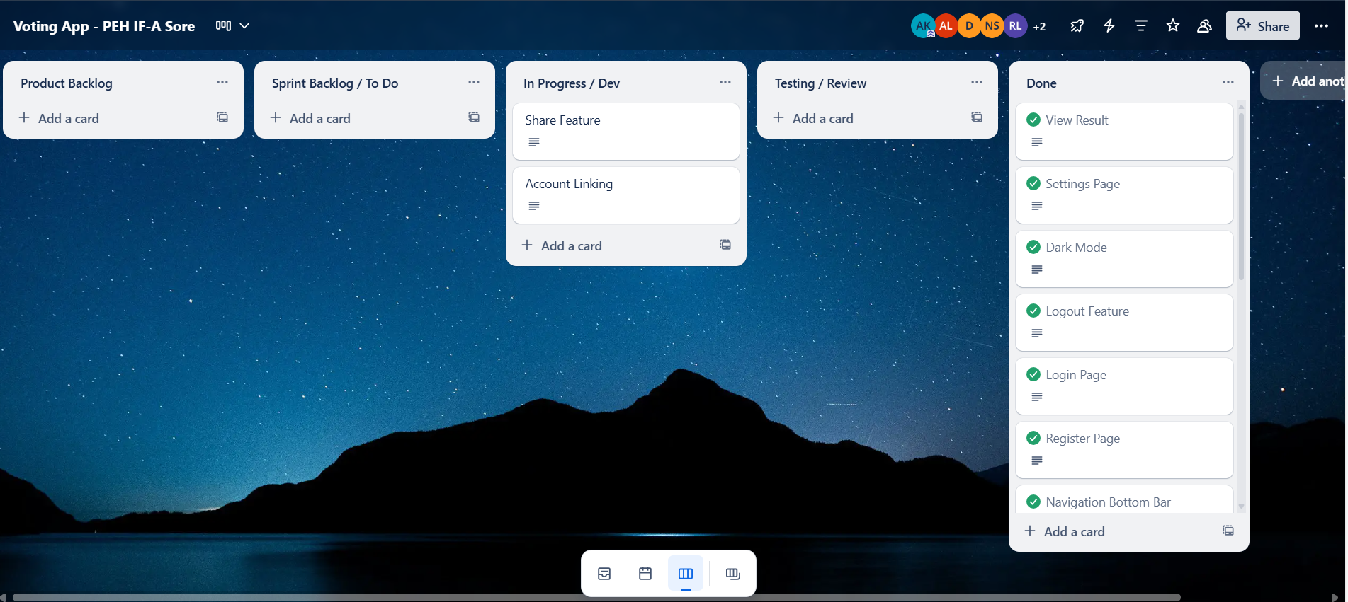
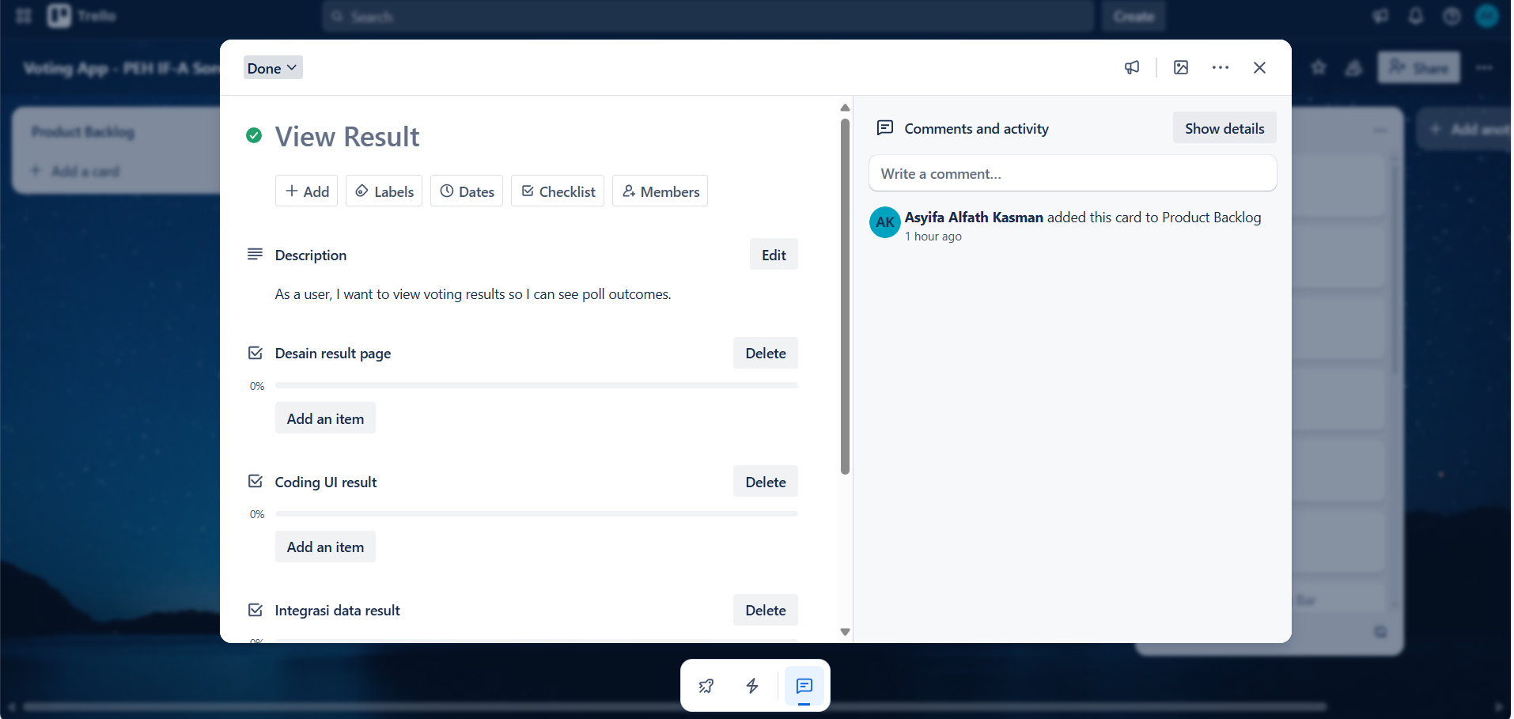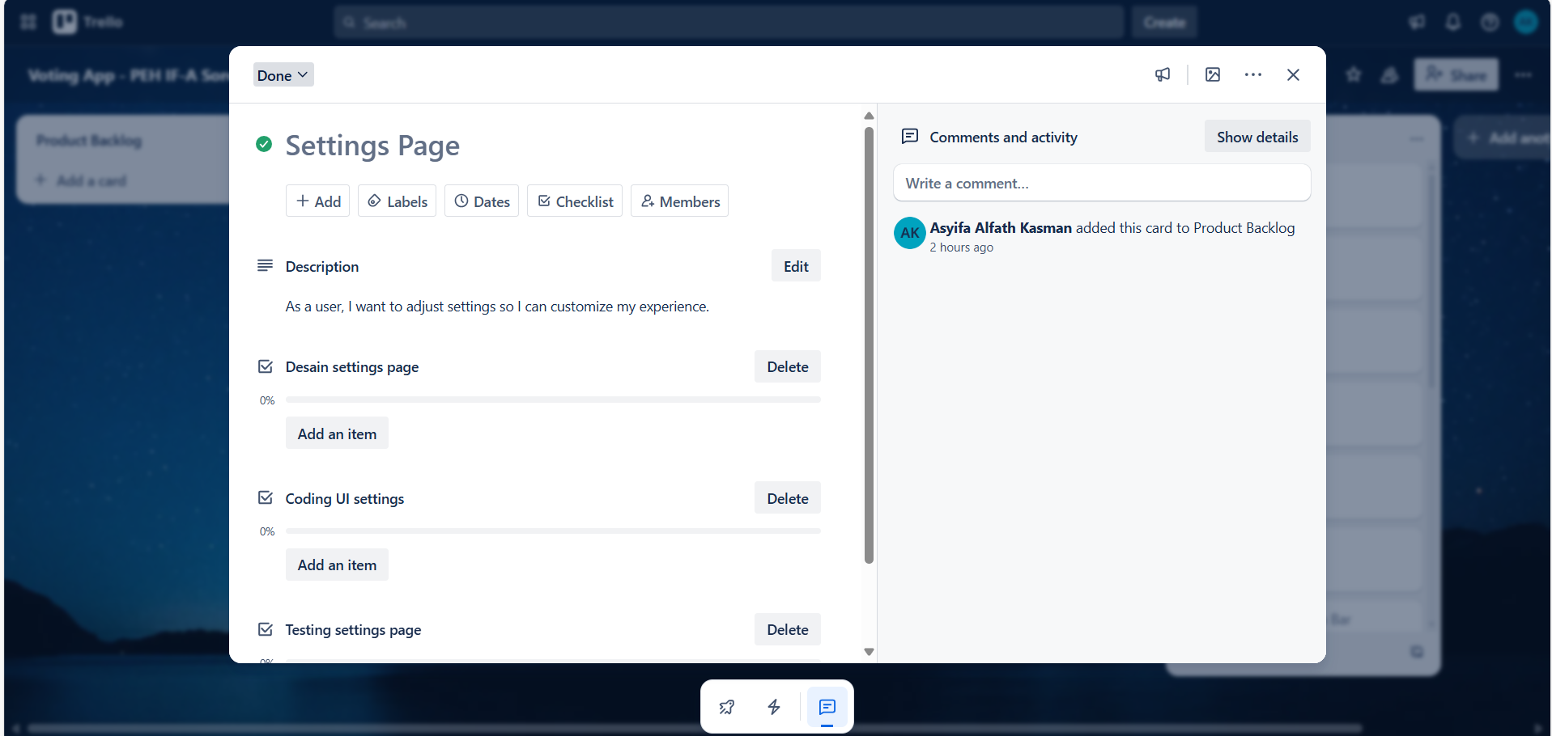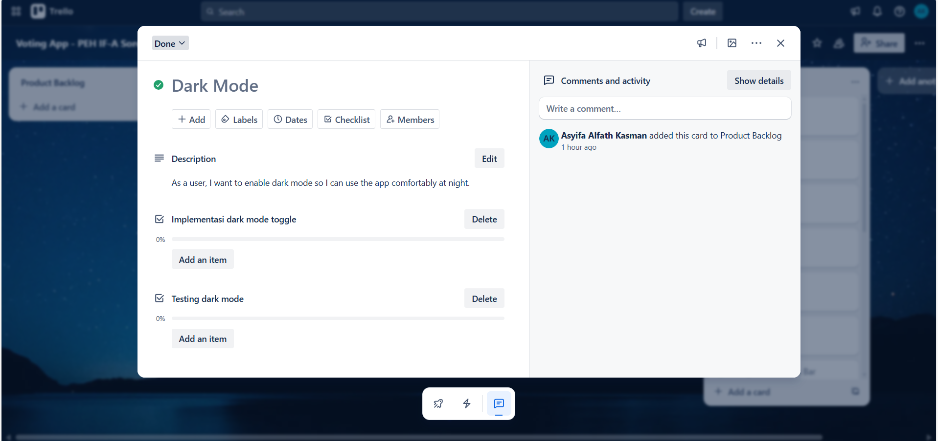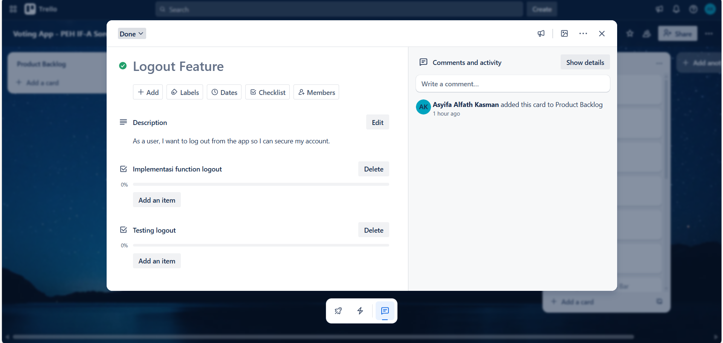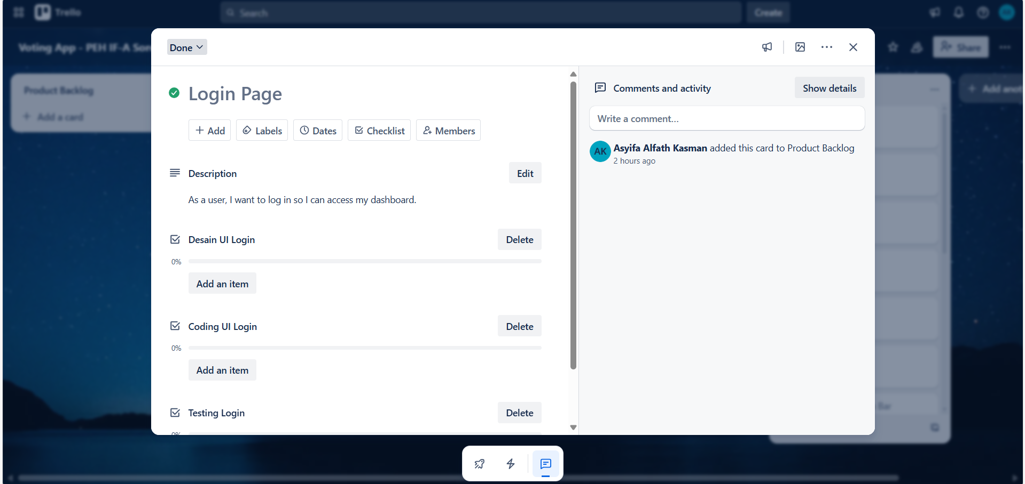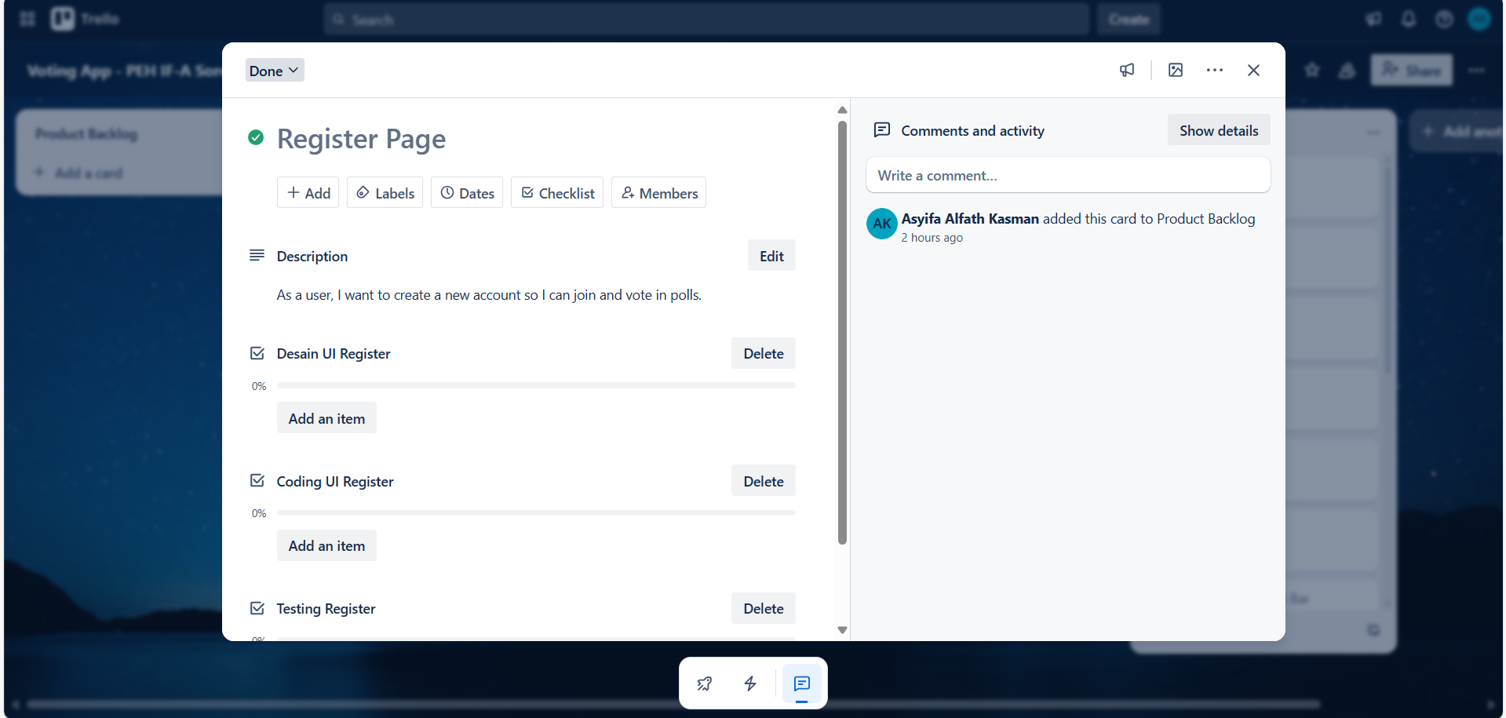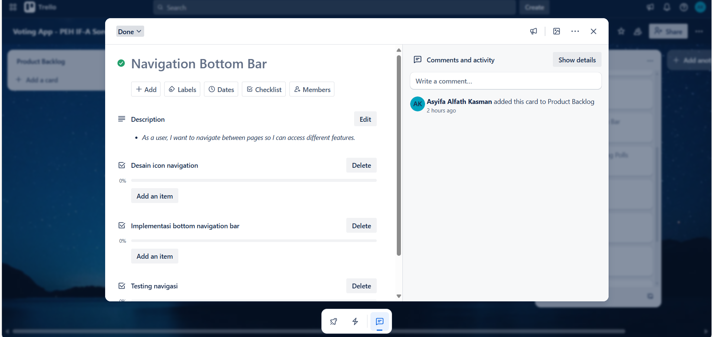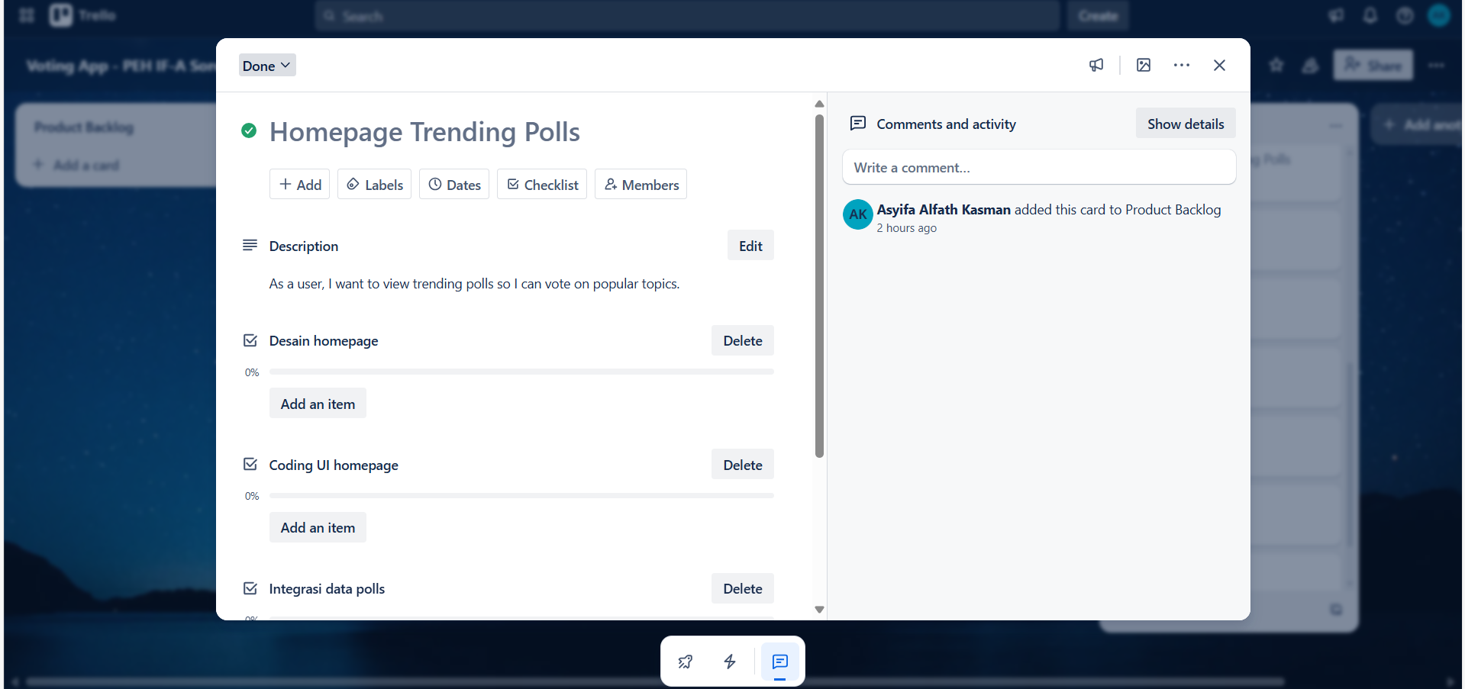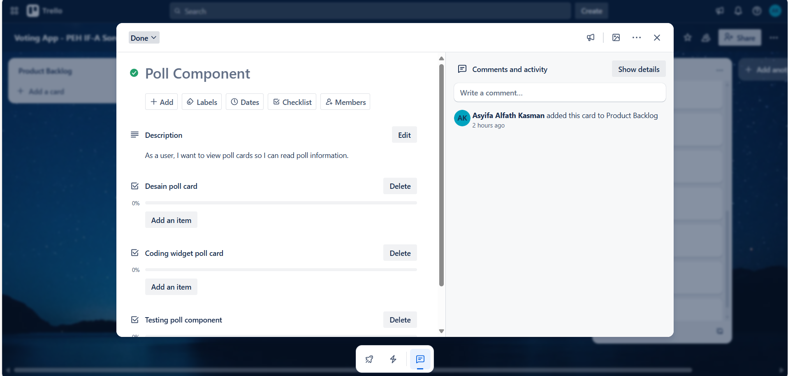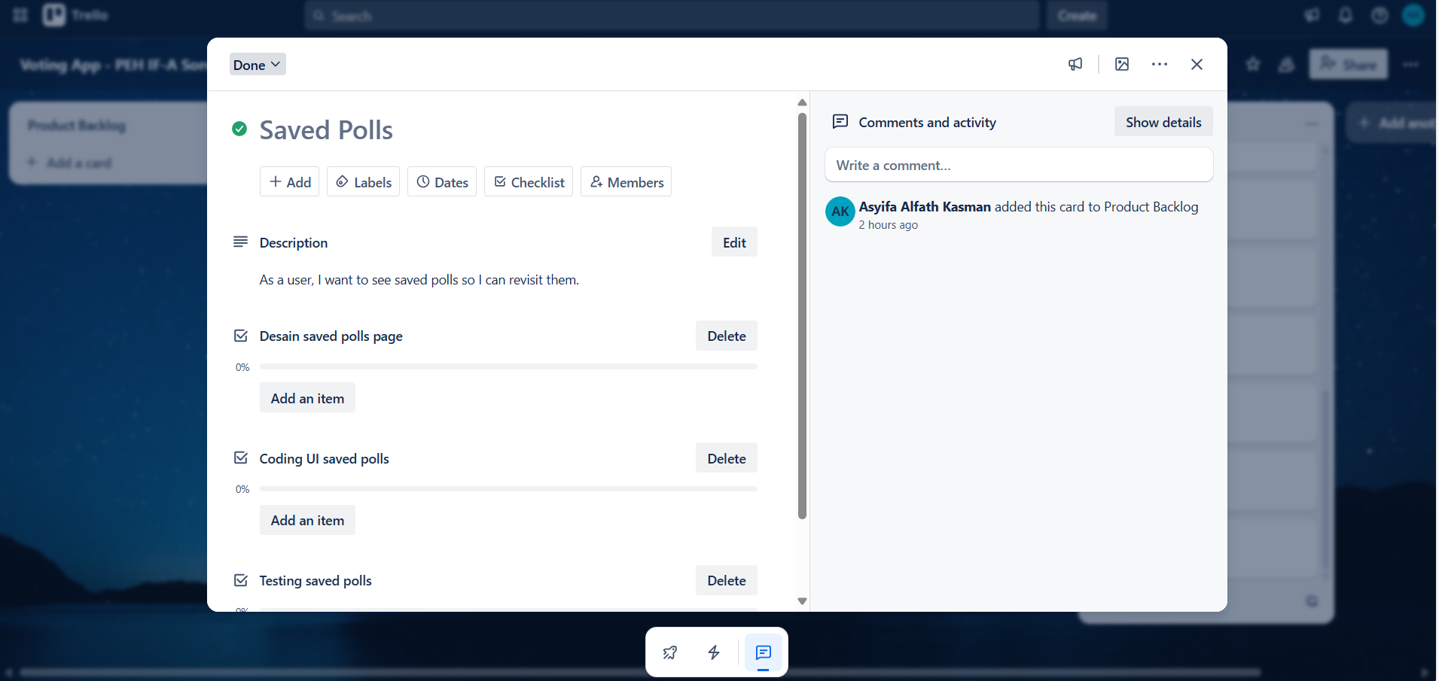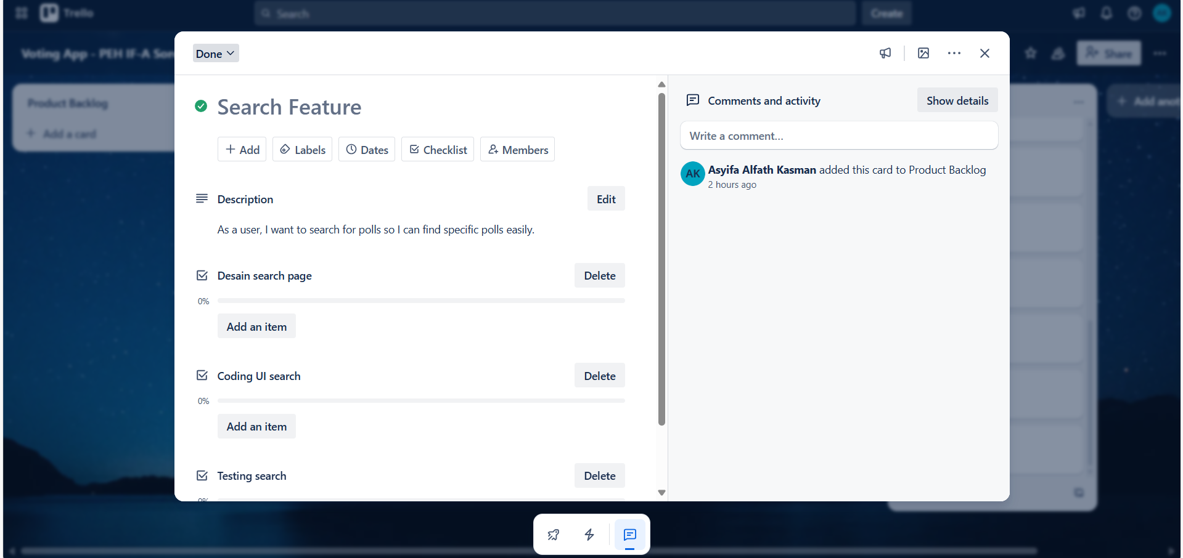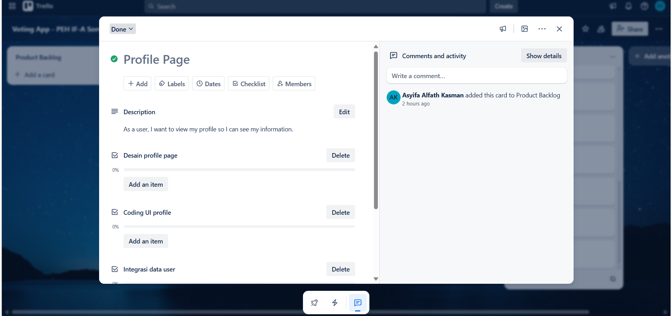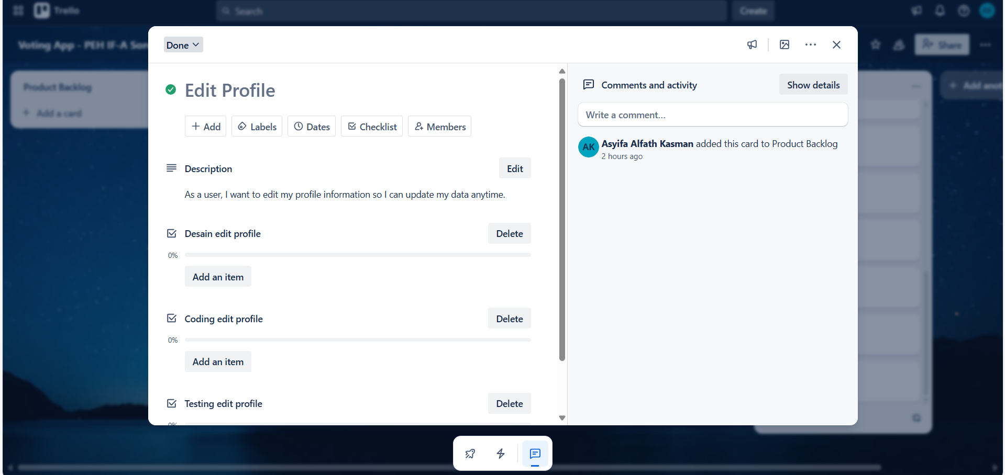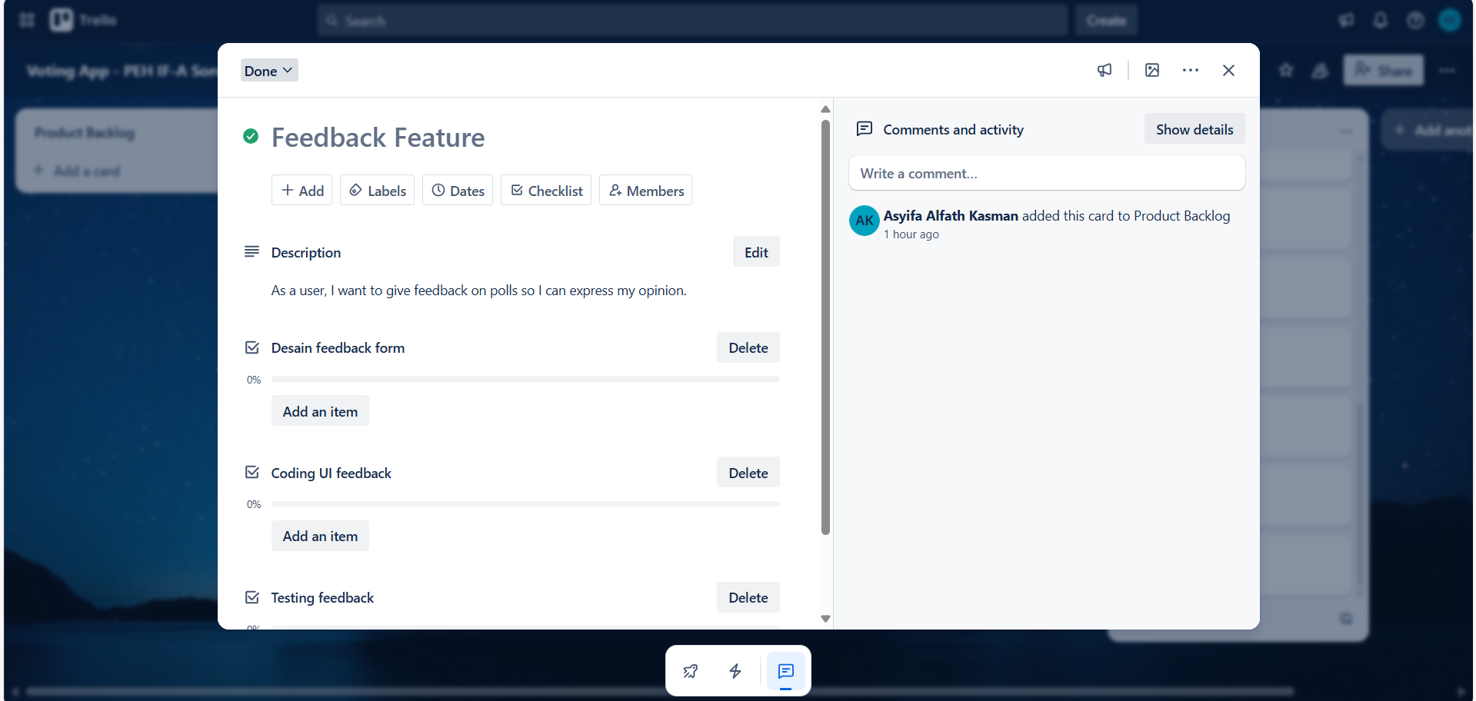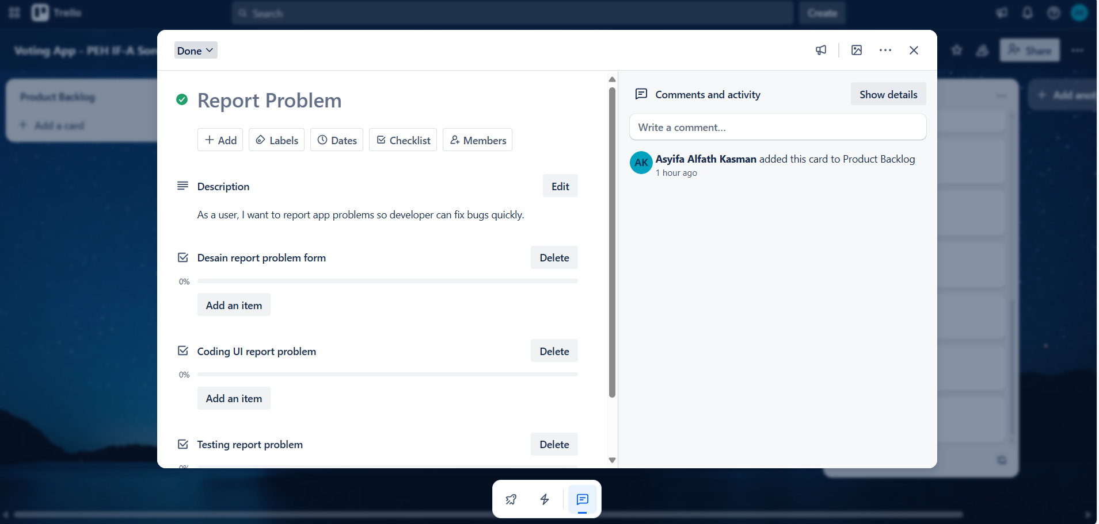
Link Trello Board: https://trello.com/invite/b/686a665a10e2b6c7c8b24af8/ATTIaa0cf693f3dda363e34bab9e0dfa3d707A53EFD0/voting-app-peh-if-a-sore
Nama Workspace: Voting App - PEH IF-A Sore

3.2 Github
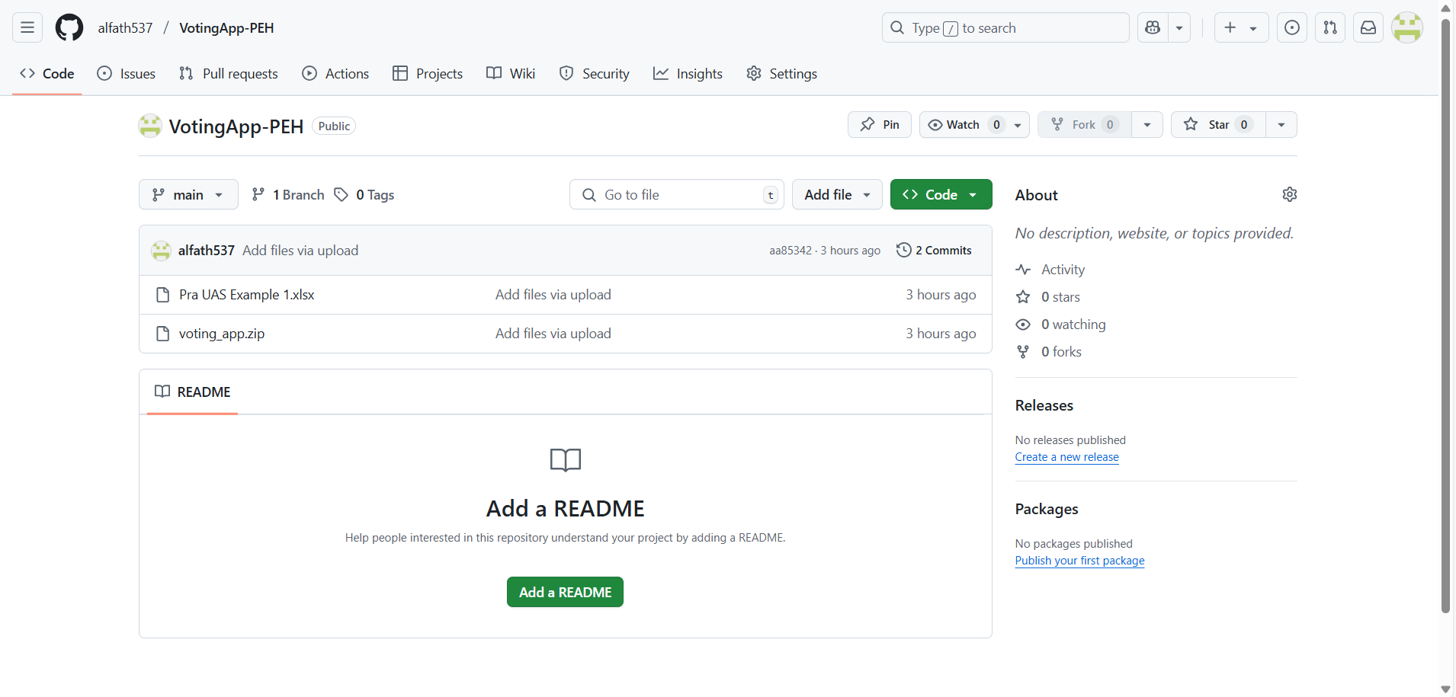

Link Github : alfath537/VotingApp-PEH

Username masing masing anggota:
Asyifa Alfath Kasman : alfath537
Ahmad Danu : danu-ahmd
Derry : DERRY2309
Sherly : sherlyangelinazalukhu
Richi Putra Lin : RichiPutra123

