shell scripting
A comprehensive guide to shell scripting fundamentals.

Table of Contents
- Basics
- Variables
- Environment Variables
- Arrays
- Conditional Operators
- Loops
- Functions
- Input/Output
- String Operations
- File Operations
- Cron Jobs
- Useful Commands

Basics

Shebang
Every script should start with a shebang to specify the interpreter:
#!/bin/bash
# or
#!/bin/sh
# or for env-based (more portable)
#!/usr/bin/env bash

Running a Script
# Make executable
chmod +x script.sh

# Run it
./script.sh
# or
bash script.sh

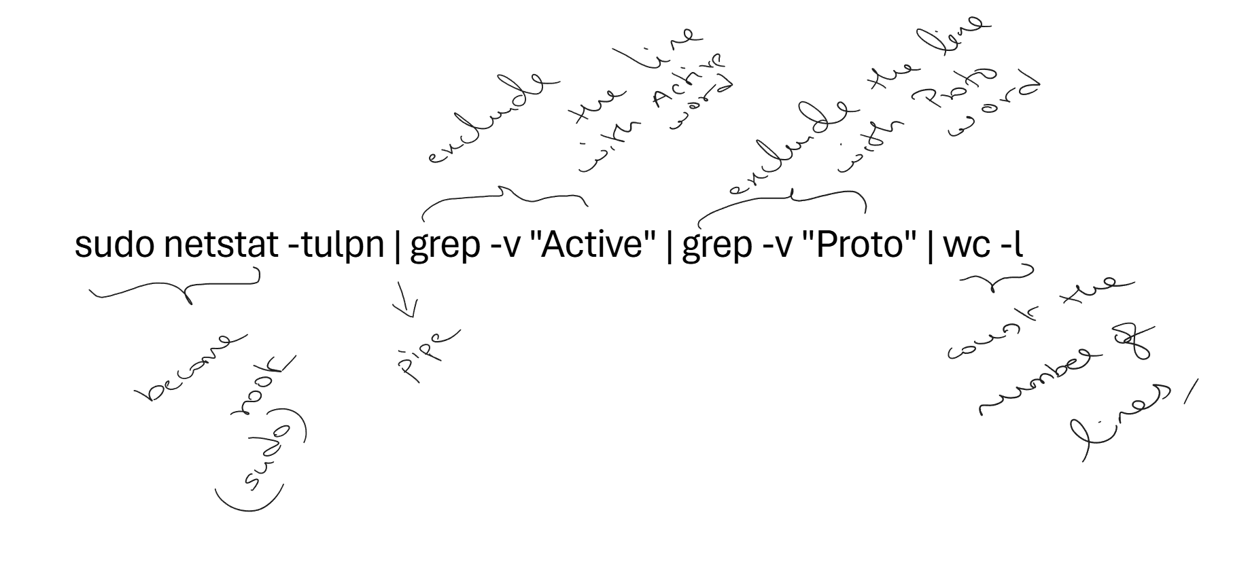

Comments
# This is a single-line comment

: '
This is a
multi-line comment
'

Variables

Declaring Variables
# No spaces around the equals sign!
name="John"
age=25
readonly CONSTANT="cannot change" # Read-only variable

# Using variables
echo $name
echo ${name} # Preferred - clearer and safer
echo "Hello, ${name}!"

Variable Types
# String
greeting="Hello World"

# Integer
count=10

# Command output
current_date=$(date)
# or using backticks (older syntax)
current_date=`date`

# Arithmetic
result=$((5 + 3))
((count++))
((count += 5))

Special Variables
$0 # Script name
$1 - $9 # Positional parameters (arguments)

Environment Variables

Viewing Environment Variables
env # List all environment variables
printenv # Same as env
echo $PATH # View specific variable

Common Environment Variables
$HOME # User's home directory
$USER # Current username
$PWD # Current working directory
$OLDPWD # Previous working directory
$PATH # Executable search path
$SHELL # Current shell
$TERM # Terminal type
$HOSTNAME # System hostname
$LANG # System language
$EDITOR # Default text editor

Setting Environment Variables
# For current session only
export MY_VAR="my value"

# For current script/session
MY_VAR="my value"

# Permanent - add to ~/.bashrc or ~/.bash_profile
echo 'export MY_VAR="my value"' >> ~/.bashrc
source ~/.bashrc # Reload

# Unset a variable
unset MY_VAR

PATH Variable
# View PATH
echo $PATH

# Add to PATH temporarily
export PATH=$PATH:/new/path

# Add to PATH permanently (in ~/.bashrc)
export PATH=$PATH:$HOME/bin

Arrays

List / Indexed Arrays
# Declaration methods
fruits=("apple" "banana" "cherry")
declare -a vegetables

# Individual assignment
colors[0]="red"
colors[1]="green"
colors[2]="blue"

# Accessing elements
echo ${fruits[0]} # First element: apple
echo ${fruits[-1]} # Last element: cherry
echo ${fruits[@]} # All elements
echo ${fruits[*]} # All elements as single string
echo ${#fruits[@]} # Array length
echo ${!fruits[@]} # All indices

# Slicing
echo ${fruits[@]:1:2} # Elements from index 1, length 2 advanced

# Adding elements
fruits+=("date")

# Removing elements
unset fruits[1]

Arrays
# Declaration (must use declare)
declare -A person

# Assignment
person[name]="John"
person[age]=30
person[city]="NYC"

# Or inline
declare -A colors=(
[red]="#FF0000"
[green]="#00FF00"
[blue]="#0000FF"
)

# Accessing
echo ${person[name]}
echo ${person[@]} # All values
echo ${!person[@]} # All keys

Conditional Operators

If-Else Statement
if [ condition ]; then
# commands
elif [ condition ]; then
# commands
else
# commands
fi

# Using double brackets (preferred for bash)
if [[ condition ]]; then
# commands
fi

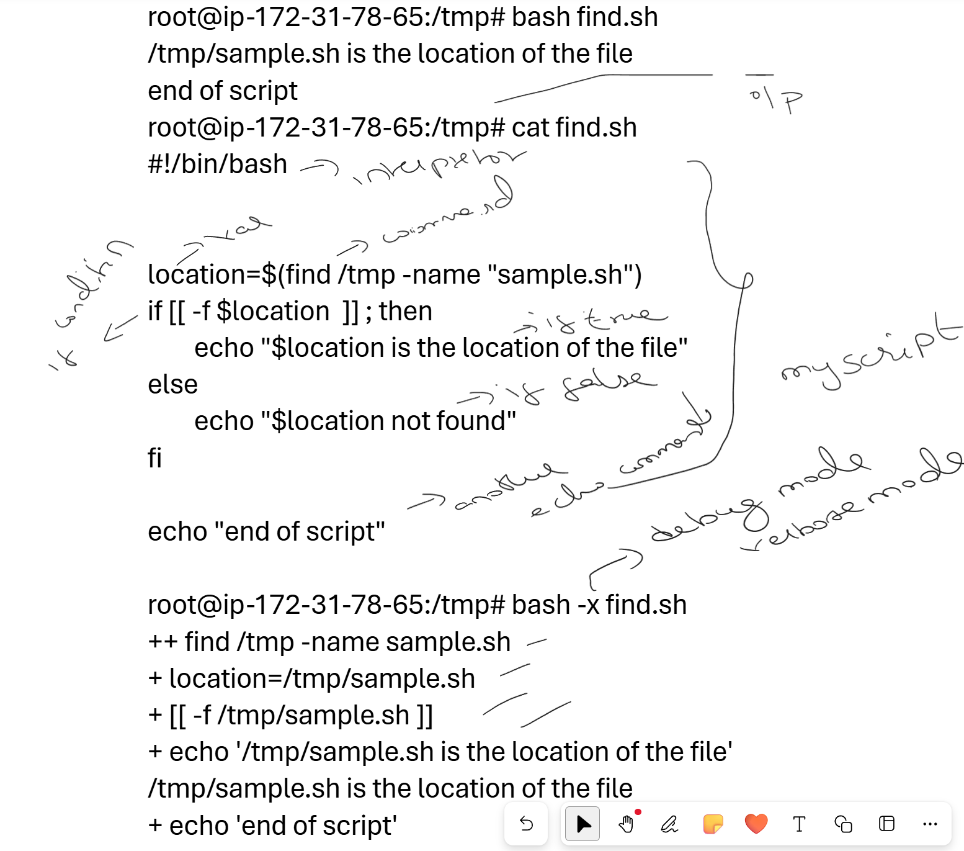

Test Operators

String Comparisons
[[ $str1 == $str2 ]] # Equal
[[ $str1 != $str2 ]] # Not equal
[[ -z $str ]] # String is empty
[[ -n $str ]] # String is not empty
[[ $str == pattern* ]] # Pattern matching (glob)

Numeric Comparisons
[[ $a -eq $b ]] # Equal
[[ $a -ne $b ]] # Not equal
[[ $a -lt $b ]] # Less than
[[ $a -le $b ]] # Less than or equal
[[ $a -gt $b ]] # Greater than
[[ $a -ge $b ]] # Greater than or equal

# Or use (( )) for arithmetic
(( a == b ))
(( a != b ))
(( a < b ))
(( a <= b ))
(( a > b ))
(( a >= b ))

File Tests
[[ -e $file ]] # Exists
[[ -f $file ]] # Is a regular file
[[ -d $file ]] # Is a directory
[[ -L $file ]] # Is a symbolic link
[[ -r $file ]] # Is readable
[[ -w $file ]] # Is writable
[[ -x $file ]] # Is executable
[[ -s $file ]] # Has size > 0
[[ -O $file ]] # Owned by current user
[[ -G $file ]] # Owned by current group
[[ $f1 -nt $f2 ]] # f1 is newer than f2
[[ $f1 -ot $f2 ]] # f1 is older than f2
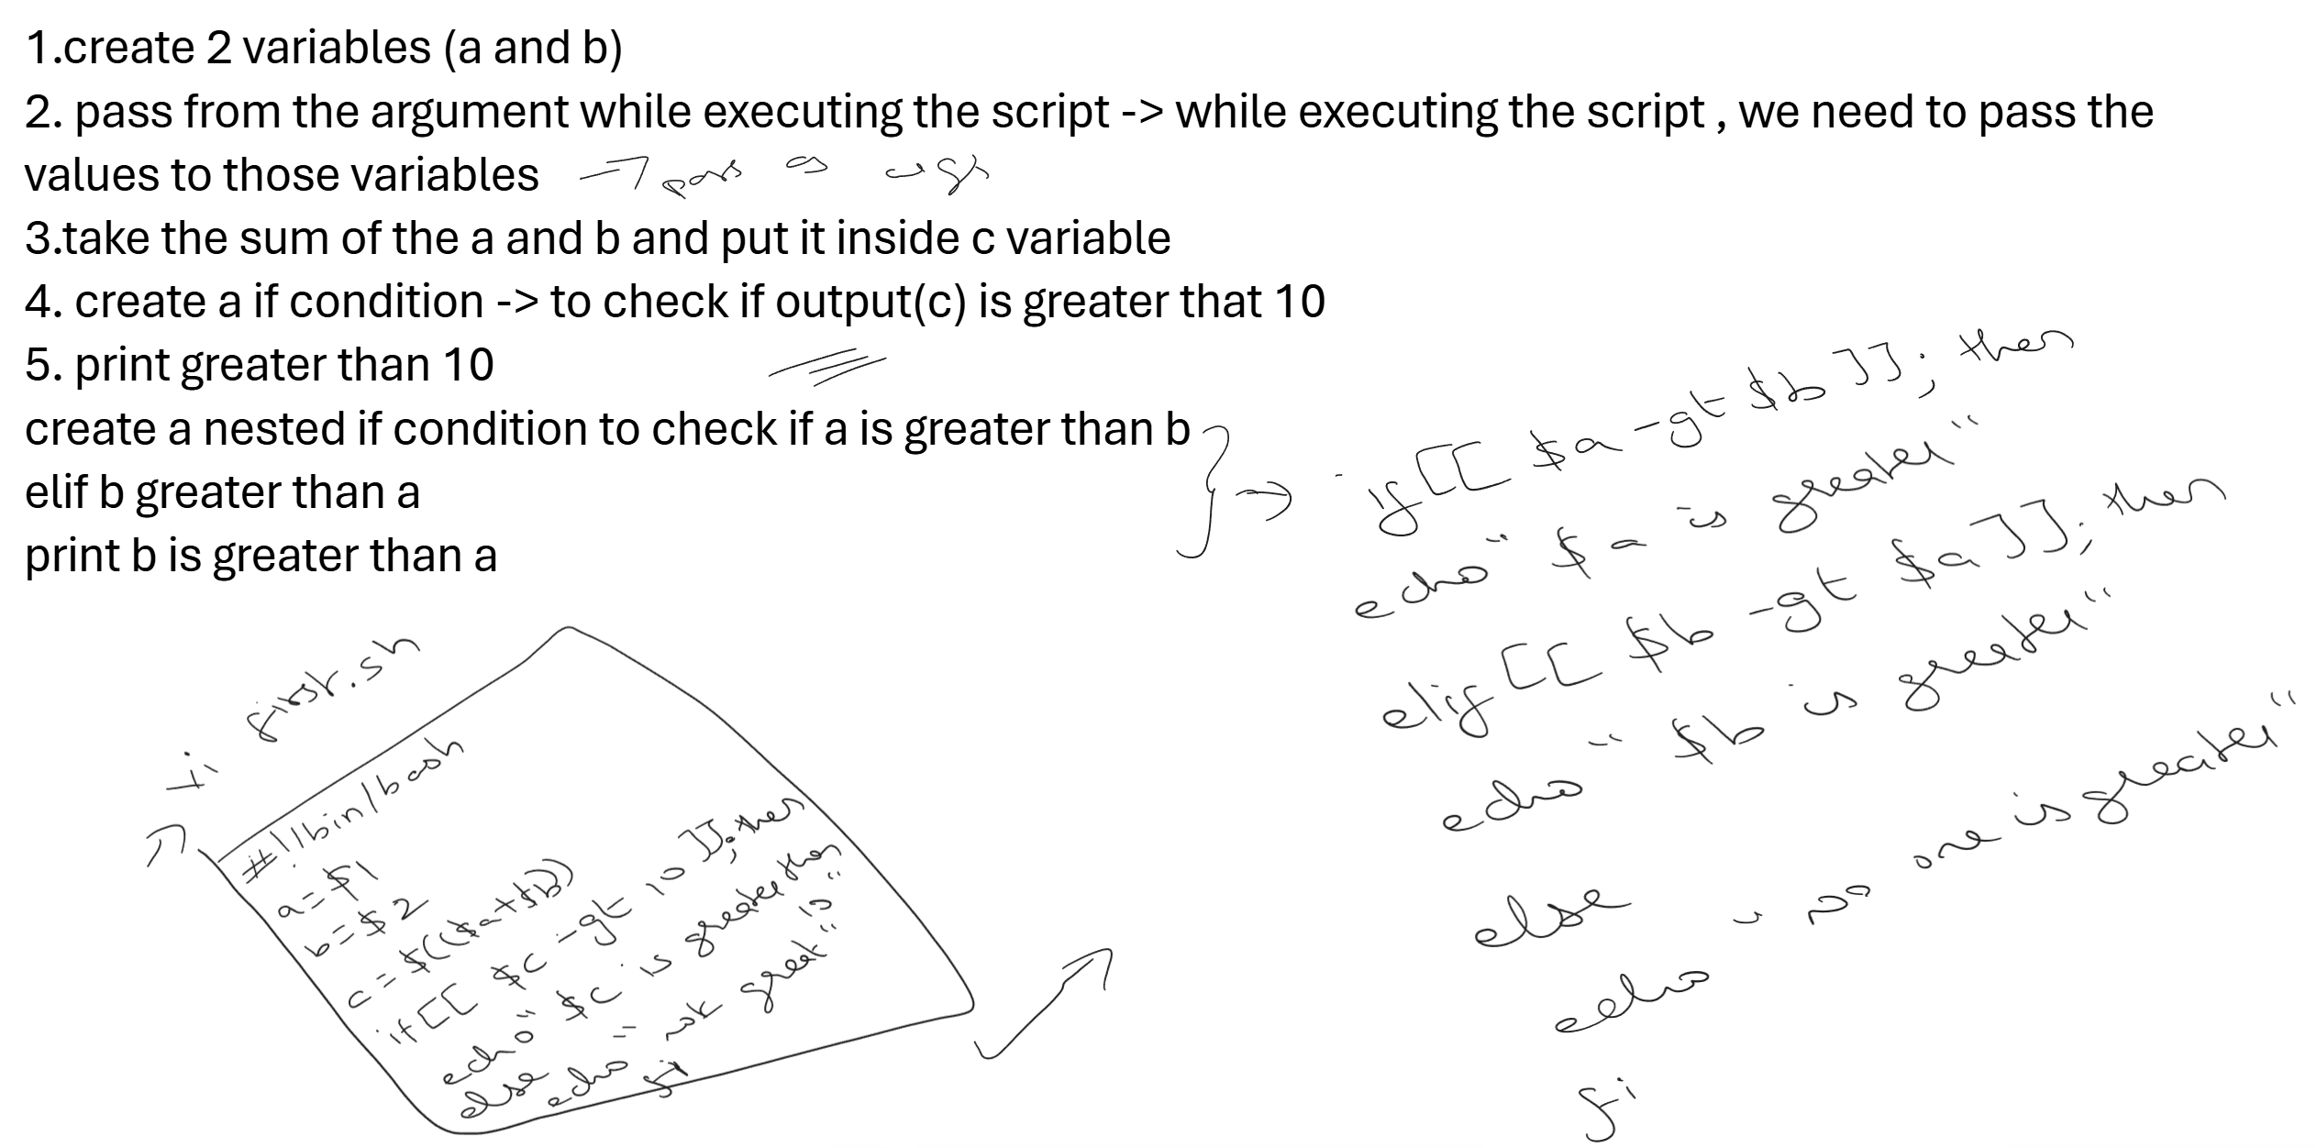

Logical Operators
# AND
[[ condition1 && condition2 ]]
[ condition1 ] && [ condition2 ]

# OR
[[ condition1 || condition2 ]]
[ condition1 ] || [ condition2 ]

# NOT
[[ ! condition ]]

# Combining
if [[ -f "$file" && -r "$file" ]]; then
echo "File exists and is readable"
fi

Case Statement
case $variable in
pattern1)
# commands
;;
pattern2|pattern3)
# commands for multiple patterns
;;
*)
# default case
;;
esac

# Example
case $day in
Mon|Tue|Wed|Thu|Fri)
echo "Weekday"
;;
Sat|Sun)
echo "Weekend"
;;
*)
echo "Invalid day"
;;
esac

Ternary-like Operations
# Using && and ||
[[ $a -gt $b ]] && max=$a || max=$b

# Using arithmetic
max=$(( a > b ? a : b ))

Loops

For Loop
# Basic for loop
for i in 1 2 3 4 5; do
echo $i
done

# Range (bash)
for i in {1..10}; do
echo $i
done

# Range with step
for i in {0..20..2}; do
echo $i # 0, 2, 4, ..., 20
done

# C-style for loop
for ((i=0; i<10; i++)); do
echo $i
done

# Loop over files
for file in *.txt; do
echo "Processing $file"
done

# Loop over array
for item in "${array[@]}"; do
echo $item
done

# Loop over command output
for user in $(cat /etc/passwd | cut -d: -f1); do
echo $user
done

While Loop
# Basic while
count=0
while [[ $count -lt 10 ]]; do
echo $count
((count++))
done

# Read file line by line
while IFS= read -r line; do
echo "$line"
done < file.txt

# Infinite loop
while true; do
echo "Running..."
sleep 1
done

# Read from command
while read -r line; do
echo "$line"
done < <(ls -la)

Until Loop
# Runs until condition is true
count=0
until [[ $count -ge 10 ]]; do
echo $count
((count++))
done

Loop Control
# Break - exit loop
for i in {1..10}; do
if [[ $i -eq 5 ]]; then
break
fi
echo $i
done

# Continue - skip iteration
for i in {1..10}; do
if [[ $i -eq 5 ]]; then
continue
fi
echo $i
done

# Break from nested loops
for i in {1..3}; do
for j in {1..3}; do
if [[ $j -eq 2 ]]; then
break 2 # Break out of 2 loops
fi
echo "$i $j"
done
done

Functions

Defining Functions
# Method 1
function greet() {
echo "Hello, $1!"
}

# Method 2 (POSIX compliant)
greet() {
echo "Hello, $1!"
}

# Calling function
greet "World"

Parameters and Return Values
# Parameters
add() {
local a=$1
local b=$2
echo $((a + b))
}

result=$(add 5 3)
echo "Sum: $result"

# Return status (0-255)
is_even() {
if (( $1 % 2 == 0 )); then
return 0 # Success/True
else
return 1 # Failure/False
fi
}

if is_even 4; then
echo "Even!"
fi

# Return value via global variable
get_data() {
RESULT="Some data"
}

get_data
echo $RESULT

Local Variables
my_function() {
local local_var="I'm local"
global_var="I'm global"
echo "Inside: $local_var"
}

my_function
echo "Outside: $global_var"
# echo "Outside: $local_var" # Won't work

Input/Output

Reading Input
# Basic read
echo "Enter your name:"
read name
echo "Hello, $name!"

# Read with prompt
read -p "Enter your name: " name

# Silent read (for passwords)
read -sp "Enter password: " password
echo

# Read with timeout
read -t 5 -p "Quick! Enter something: " input

# Read into array
read -a colors -p "Enter colors: "
echo "First color: ${colors[0]}"

# Read with default value
read -p "Enter name [John]: " name
name=${name:-John}

Output
# Echo
echo "Hello"
echo -n "No newline"
echo -e "Tab:\tNewline:\n"

# Printf (more control)
printf "Name: %s, Age: %d\n" "John" 25
printf "%10s | %5d\n" "Item" 100

# Here document
cat << EOF
This is a
multi-line
text block
EOF

# Here string
cat <<< "Single line here string"

Redirection
# Output redirection
command > file.txt # Overwrite
command >> file.txt # Append

# Input redirection
command < file.txt

# Stderr redirection
command 2> error.txt # Redirect errors
command 2>&1 # Redirect stderr to stdout
command &> file.txt # Redirect both (bash)

# Pipe
command1 | command2

# Tee - write to file and stdout
command | tee file.txt
command | tee -a file.txt # Append

# Discard output
command > /dev/null 2>&1
command &> /dev/null

String Operations

String Manipulation
str="Hello World"

# Length
echo ${#str} # 11

# Substring
echo ${str:0:5} # Hello (start:length)
echo ${str:6} # World (from index 6)
echo ${str: -5} # World (last 5 chars, note space)

# Replace
echo ${str/World/Universe} # Hello Universe (first match)
echo ${str//o/0} # Hell0 W0rld (all matches)

# Remove pattern
filename="document.txt"
echo ${filename%.txt} # document (remove suffix)
echo ${filename%.*} # document (remove extension)
echo ${filename#*.} # txt (remove prefix)

path="/home/user/file.txt"
echo ${path##*/} # file.txt (basename)
echo ${path%/*} # /home/user (dirname)

# Case conversion (bash 4+)
echo ${str^^} # HELLO WORLD (uppercase)
echo ${str,,} # hello world (lowercase)
echo ${str^} # Hello World (capitalize first)

# Default values
echo ${var:-default} # Use default if var is unset/empty
echo ${var:=default} # Set var to default if unset/empty
echo ${var:+alternate} # Use alternate if var is set
echo ${var:?error msg} # Exit with error if var is unset

String Tests
# Check if string contains substring
if [[ "$str" == *"World"* ]]; then
echo "Contains World"
fi

# Check if string starts with
if [[ "$str" == Hello* ]]; then
echo "Starts with Hello"
fi

# Check if string ends with
if [[ "$str" == *World ]]; then
echo "Ends with World"
fi

# Regex match
if [[ "$str" =~ ^Hello ]]; then
echo "Matches regex"
fi

File Operations

Reading Files
# Read entire file
content=$(cat file.txt)

# Read line by line
while IFS= read -r line; do
echo "$line"
done < file.txt

# Read specific line
sed -n '5p' file.txt

# Read first/last lines
head -n 5 file.txt
tail -n 5 file.txt

Writing Files
# Overwrite
echo "content" > file.txt

# Append
echo "more content" >> file.txt

# Multi-line
cat > file.txt << EOF
Line 1
Line 2
Line 3
EOF

File Checks
# Check if file exists
if [[ -f "$file" ]]; then
echo "File exists"
fi

# Check multiple conditions
if [[ -f "$file" && -r "$file" && -s "$file" ]]; then
echo "File exists, is readable, and not empty"
fi

Cron Jobs

Cron Syntax
┌───────────── minute (0 - 59)
│ ┌───────────── hour (0 - 23)
│ │ ┌───────────── day of month (1 - 31)
│ │ │ ┌───────────── month (1 - 12)
│ │ │ │ ┌───────────── day of week (0 - 6) (Sunday = 0)
│ │ │ │ │
* * * * * command

Special Characters
* Any value
, Value list separator (1,3,5)
- Range of values (1-5)
/ Step values (*/15 = every 15)

Managing Cron Jobs
# Edit crontab
crontab -e

# List crontab
crontab -l

# Remove all cron jobs
crontab -r

# Edit another user's crontab (root)
crontab -u username -e

Cron Examples
# Every minute
* * * * * /path/to/script.sh

# Every 5 minutes
*/5 * * * * /path/to/script.sh

# Every hour at minute 0
0 * * * * /path/to/script.sh

# Every day at 2:30 AM
30 2 * * * /path/to/script.sh

# Every Monday at 9 AM
0 9 * * 1 /path/to/script.sh

# First day of month at midnight
0 0 1 * * /path/to/script.sh

# Every weekday at 6 PM
0 18 * * 1-5 /path/to/script.sh

# Every 15 minutes during work hours
*/15 9-17 * * 1-5 /path/to/script.sh

# With output logging
0 * * * * /path/to/script.sh >> /var/log/myscript.log 2>&1

# Suppress output
0 * * * * /path/to/script.sh > /dev/null 2>&1

Special Cron Strings
@reboot # Run once at startup
@yearly # 0 0 1 1 * (annually)
@monthly # 0 0 1 * *
@weekly # 0 0 * * 0
@daily # 0 0 * * * (midnight)
@hourly # 0 * * * *

Cron Environment
# Cron has limited environment, set PATH in crontab
PATH=/usr/local/bin:/usr/bin:/bin

# Or in script
#!/bin/bash
export PATH=/usr/local/bin:/usr/bin:/bin
# rest of script

Useful Commands

Text Processing
# grep - search patterns
grep "pattern" file.txt
grep -r "pattern" directory/ # Recursive
grep -i "pattern" file.txt # Case insensitive
grep -v "pattern" file.txt # Invert match
grep -c "pattern" file.txt # Count matches
grep -n "pattern" file.txt # Show line numbers

# sed - stream editor
sed 's/old/new/' file.txt # Replace first occurrence
sed 's/old/new/g' file.txt # Replace all
sed -i 's/old/new/g' file.txt # In-place edit
sed -n '5,10p' file.txt # Print lines 5-10
sed '/pattern/d' file.txt # Delete matching lines

# awk - pattern scanning
awk '{print $1}' file.txt # Print first column
awk -F: '{print $1}' /etc/passwd # Custom delimiter
awk 'NR==5' file.txt # Print line 5
awk '{sum+=$1} END {print sum}' # Sum column

# cut - extract columns
cut -d: -f1 /etc/passwd # First field
cut -c1-5 file.txt # Characters 1-5

# sort
sort file.txt # Alphabetical
sort -n file.txt # Numeric
sort -r file.txt # Reverse
sort -u file.txt # Unique
sort -t: -k3 -n /etc/passwd # Sort by field

# uniq - remove duplicates
sort file.txt | uniq # Remove adjacent duplicates
sort file.txt | uniq -c # Count occurrences
sort file.txt | uniq -d # Show only duplicates

# wc - word count
wc -l file.txt # Line count
wc -w file.txt # Word count
wc -c file.txt # Byte count

# tr - translate characters
tr 'a-z' 'A-Z' < file.txt # Uppercase
tr -d '0-9' < file.txt # Delete digits
tr -s ' ' < file.txt # Squeeze spaces

Process Management
# Background processes
command & # Run in background
jobs # List background jobs
fg %1 # Bring job 1 to foreground
bg %1 # Continue job 1 in background

# Process info
ps aux # All processes
ps -ef # Full format
pgrep -f "pattern" # Find process by pattern
top # Interactive process viewer
htop # Better process viewer

# Killing processes
kill PID # Send SIGTERM
kill -9 PID # Send SIGKILL (force)
killall process_name # Kill by name
pkill -f "pattern" # Kill by pattern

Debugging Scripts
# Debug mode
bash -x script.sh # Print commands as executed
set -x # Enable debug in script
set +x # Disable debug

# Error handling
set -e # Exit on error
set -u # Exit on undefined variable
set -o pipefail # Exit on pipe failure
set -euo pipefail # All three (recommended)

# Trap errors
trap 'echo "Error on line $LINENO"' ERR
trap cleanup EXIT # Run cleanup on exit

Useful Snippets
# Check if command exists
if command -v git &> /dev/null; then
echo "Git is installed"
fi

# Check if running as root
if [[ $EUID -ne 0 ]]; then
echo "This script must be run as root"
exit 1
fi

# Get script directory
SCRIPT_DIR="$(cd "$(dirname "${BASH_SOURCE[0]}")" && pwd)"

# Timestamp
timestamp=$(date +"%Y-%m-%d_%H-%M-%S")

# Random number
random=$((RANDOM % 100))

# Yes/No prompt
read -p "Continue? [y/N] " -n 1 -r
echo
if [[ $REPLY =~ ^[Yy]$ ]]; then
echo "Continuing..."
fi

# Retry logic
max_attempts=3
attempt=1
while [[ $attempt -le $max_attempts ]]; do
if command_that_might_fail; then
break
fi
echo "Attempt $attempt failed, retrying..."
((attempt++))
sleep 2
done

Quick Reference
Operation | Syntax
Variable assignment | var="value"
Command substitution | $(command)
Arithmetic | $((expression))
String length | ${#var}
Substring | ${var:start:length}
Replace | ${var/old/new}
Default value | ${var:-default}
Array access | ${arr[0]}
Array all | ${arr[@]}
Array length | ${#arr[@]}
Test condition | [[ condition ]]
Numeric test | (( expression ))

Happy scripting! 🐧

