A sample report

The author

Thu May 17 13:03:43 2012

# The first part of my R script

Here I can generate my data

a <- matrix(rnorm(100), nrow = 10)

# Results

An now the reults are plotted

image(a)

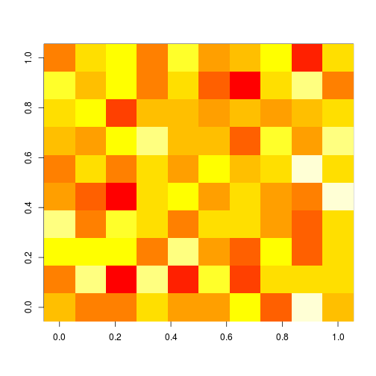

# More

Of course I can use inline elemtnts: 3 + 3 = 6.