**2014 Data**

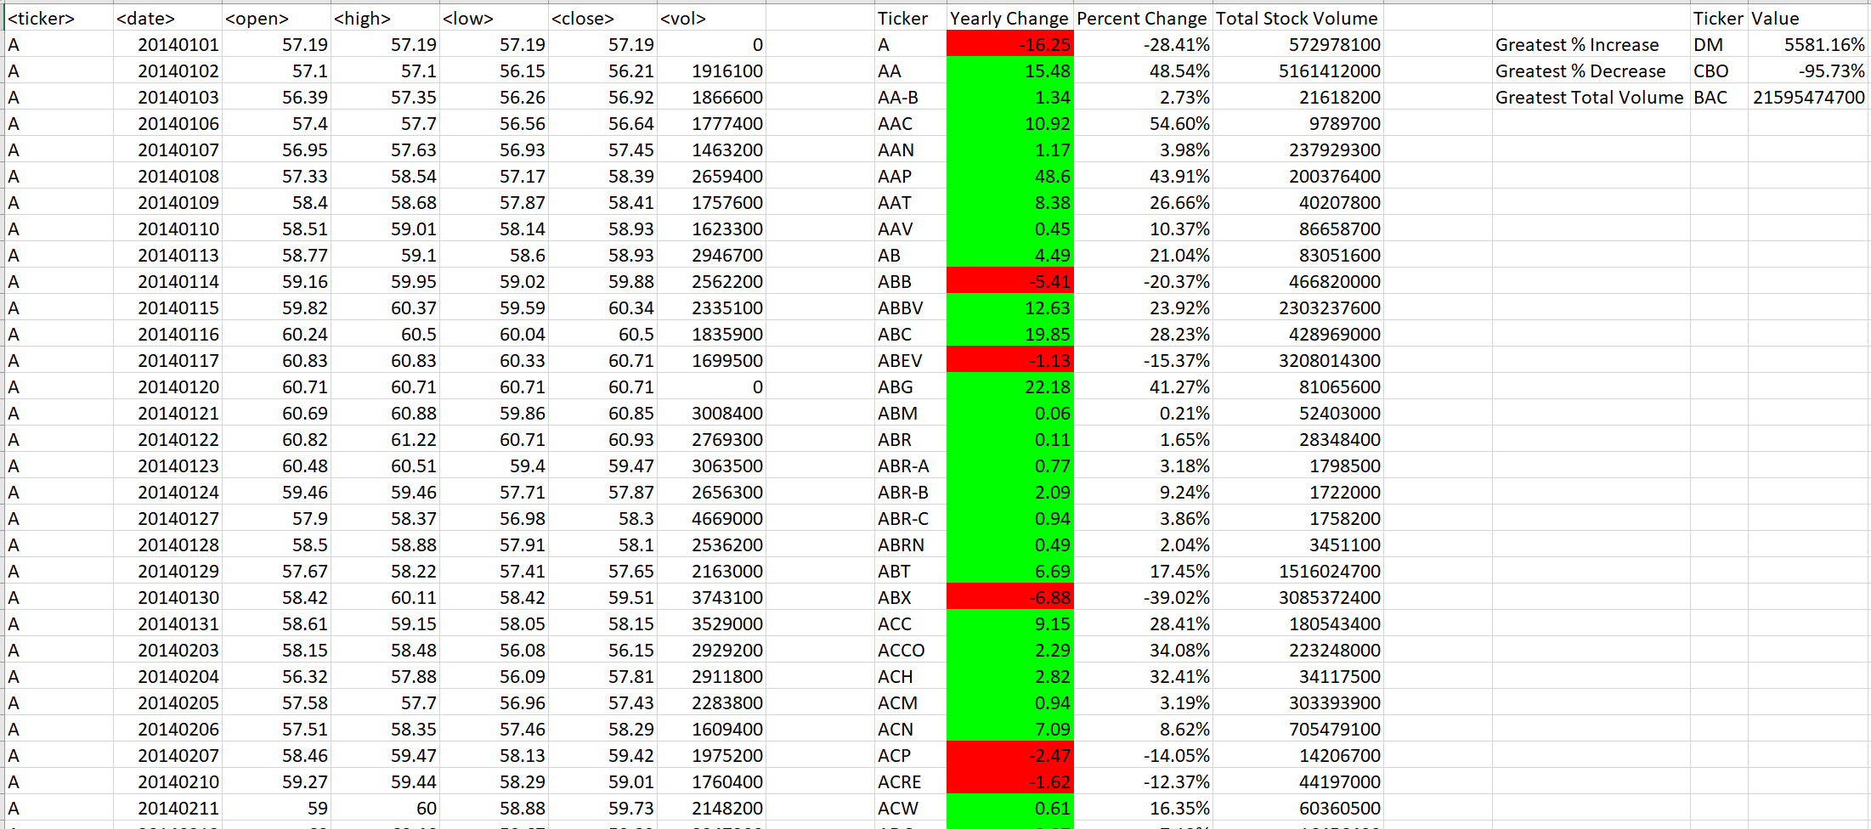

**2015 Data**

**PLNT did not start trading until 8/7/2015; however, reporting started before that date and provided a starting open at $0.00 **

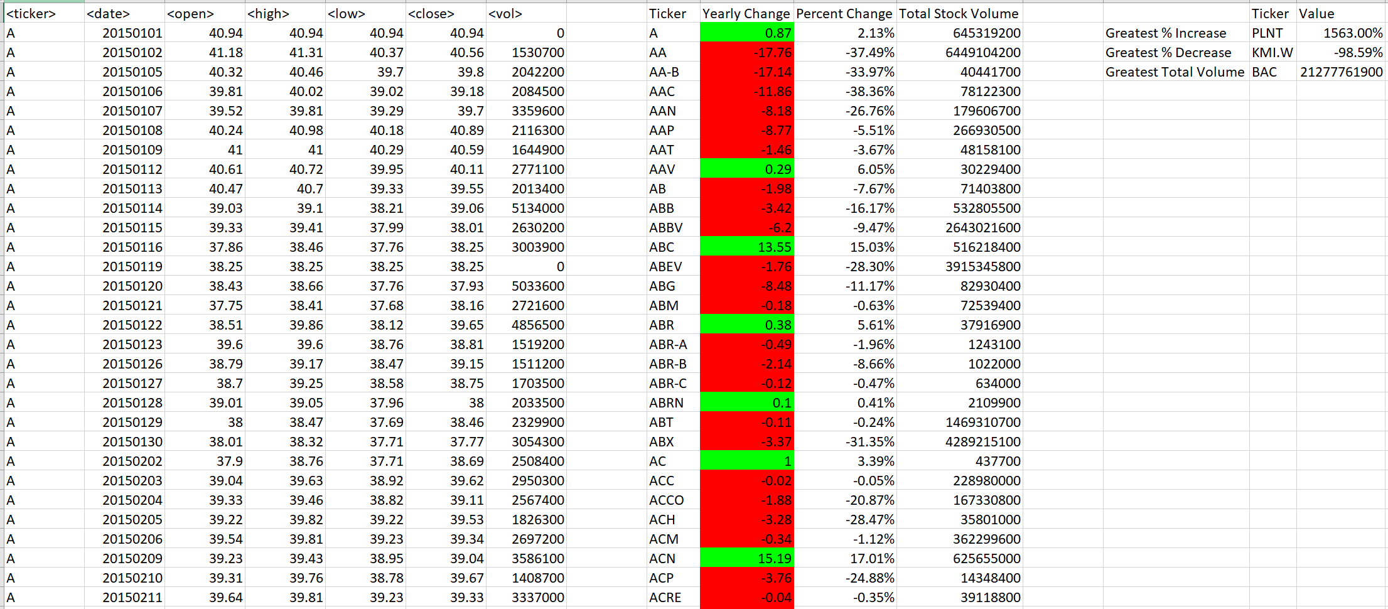

**2016 Data**

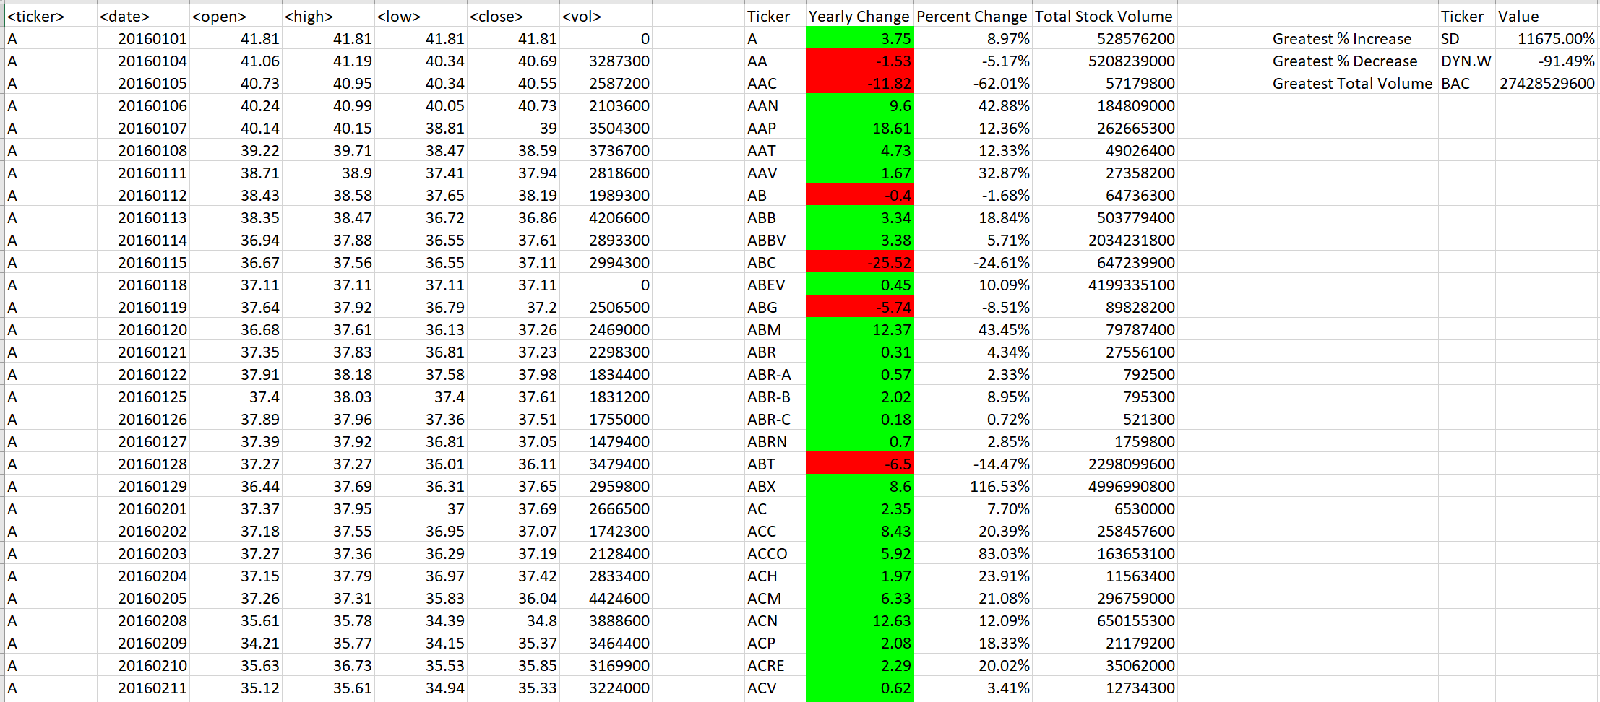

**Comparisons based on Total Stock Volume from Highest to Lowest**

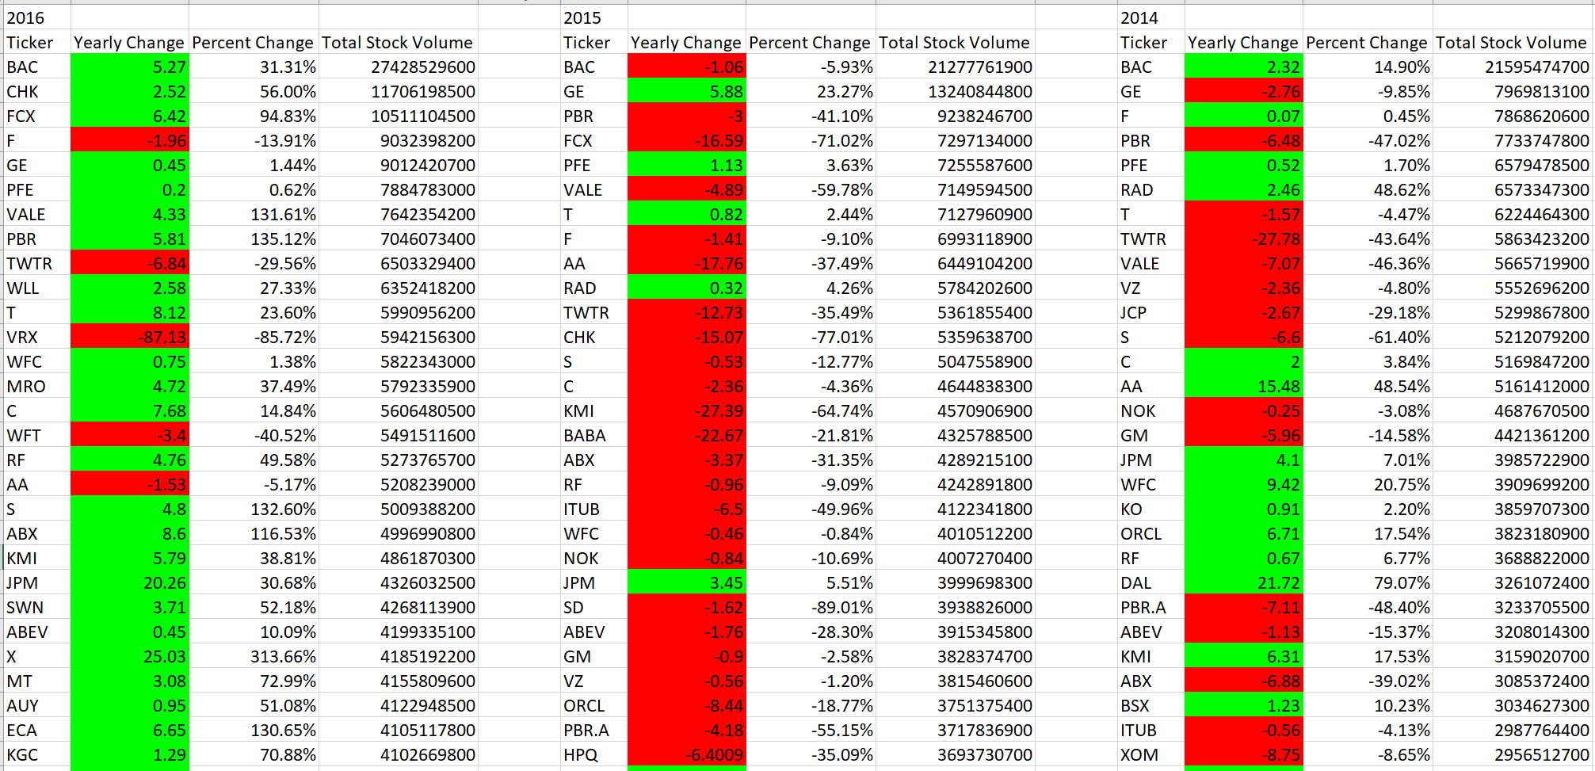

**Top Earners and Losers 2014 based on Percent Change**

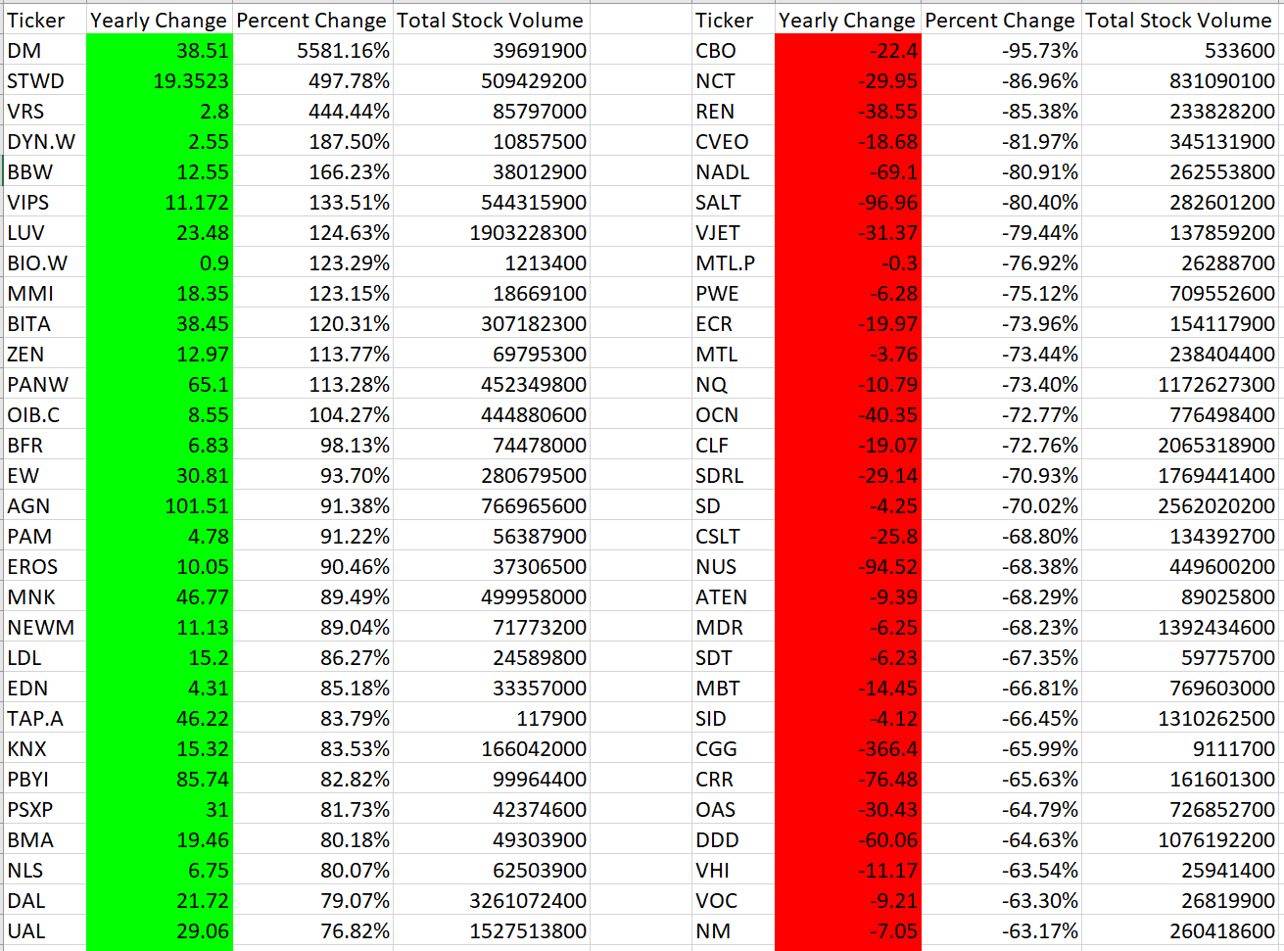

**Top Earners and Losers 2015 based on Percent Change**

**PLNT did not start trading until 8/7/2015; however, reporting started before that date and provided a starting open at $0.00 **

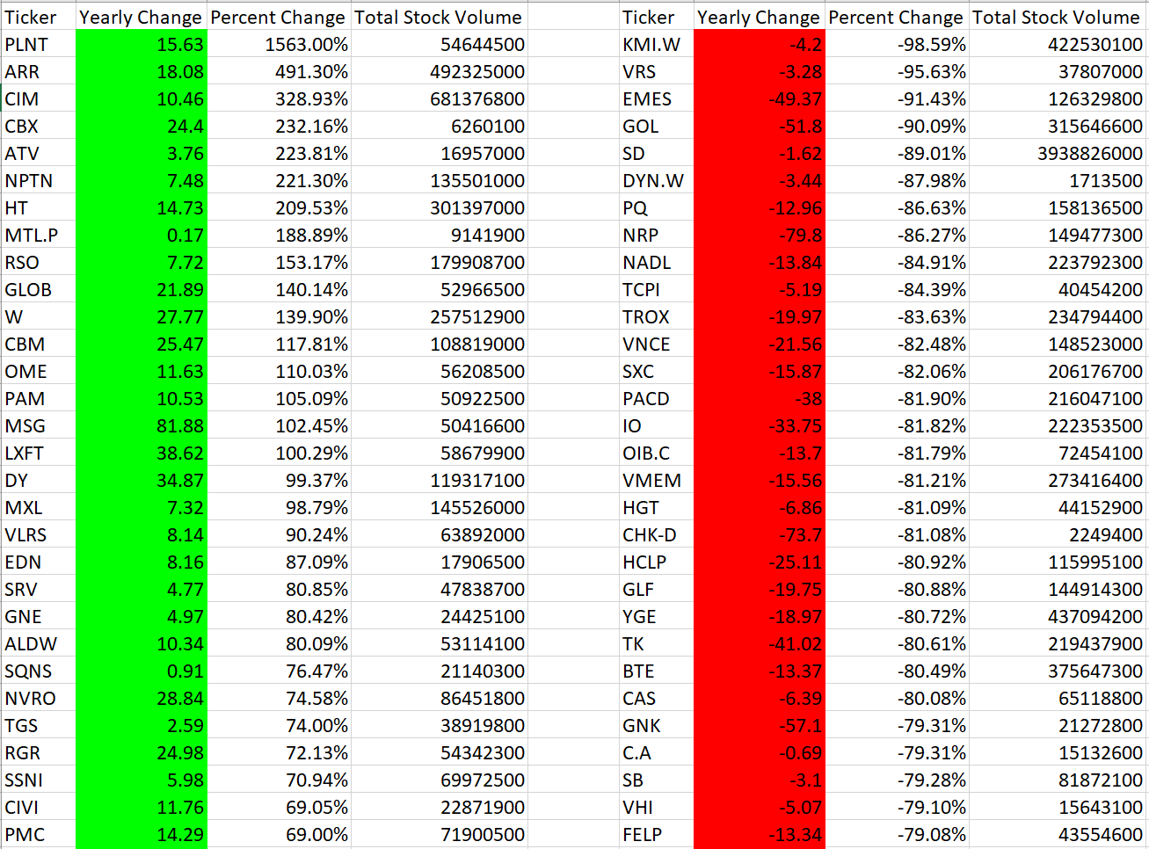

**Top Earners and Losers 2016 based on Percent Change**

