tarea T-student

The purpose of an investigation by Morley et al. (A-17) was to evaluate the analgesic effectiveness of a daily dose of oral methadone in patients with chronic neuropathic pain syndromes. The researchers used a visual analogue scale (0-100 mm, higher number indicates higher pain) ratings for maximum pain intensity over the course of the day. Each subject took either 20 mg of methadone or a placebo each day for 5 days. Subjects did not know which treatment they were taking. The following table gives the mean maximum pain intensity scores for the 5 days on methadone and the 5 days on placebo. Do these data provide sufficient evidence, at the .05 level of significance, to indicate that in general the maximum pain intensity is lower on days when methadone is taken?

## importar los datos

library(tidyverse)

## -- Attaching packages ----------------------------------------------------------------------- tidyverse 1.2.1 --

## v ggplot2 3.0.0 v purrr 0.2.5  
## v tibble 1.4.2 v dplyr 0.7.6  
## v tidyr 0.8.1 v stringr 1.3.1  
## v readr 1.1.1 v forcats 0.3.0

## -- Conflicts -------------------------------------------------------------------------- tidyverse_conflicts() --  
## x dplyr::filter() masks stats::filter()  
## x dplyr::lag() masks stats::lag()

datos <- read.csv("EXR_C07_S04_03.csv")  
datos

## Meth Plac  
## 1 29.8 57.2  
## 2 73.0 69.8  
## 3 98.6 98.2  
## 4 58.8 62.4  
## 5 60.6 67.2  
## 6 57.2 70.6  
## 7 57.2 67.8  
## 8 89.2 95.6  
## 9 97.0 98.4  
## 10 49.8 63.2  
## 11 37.0 63.6

treatment <- factor( c(rep(1,11),rep(2,11)),  
 labels = c("Placebo","Methadone"))

## Acomodar los datos

score <- c(datos$Plac,datos$Meth)  
datos2 <- data.frame(treatment,score)  
datos2

## treatment score  
## 1 Placebo 57.2  
## 2 Placebo 69.8  
## 3 Placebo 98.2  
## 4 Placebo 62.4  
## 5 Placebo 67.2  
## 6 Placebo 70.6  
## 7 Placebo 67.8  
## 8 Placebo 95.6  
## 9 Placebo 98.4  
## 10 Placebo 63.2  
## 11 Placebo 63.6  
## 12 Methadone 29.8  
## 13 Methadone 73.0  
## 14 Methadone 98.6  
## 15 Methadone 58.8  
## 16 Methadone 60.6  
## 17 Methadone 57.2  
## 18 Methadone 57.2  
## 19 Methadone 89.2  
## 20 Methadone 97.0  
## 21 Methadone 49.8  
## 22 Methadone 37.0

## Test de varianza

variance_test <- var.test(datos2$score[datos2$treatment=="Placebo"],datos2$score[datos2$treatment =="Methadone"])  
variance_test

##   
## F test to compare two variances  
##   
## data: datos2$score[datos2$treatment == "Placebo"] and datos2$score[datos2$treatment == "Methadone"]  
## F = 0.4593, num df = 10, denom df = 10, p-value = 0.2358  
## alternative hypothesis: true ratio of variances is not equal to 1  
## 95 percent confidence interval:  
## 0.1235744 1.7071242  
## sample estimates:  
## ratio of variances   
## 0.4593005

## Gráfico

ggplot(data = datos2,  
 mapping = aes(x=treatment,y=score))+  
 geom_boxplot()+  
 geom_point()+  
 geom_jitter(height = 0.03,width = 0.03)

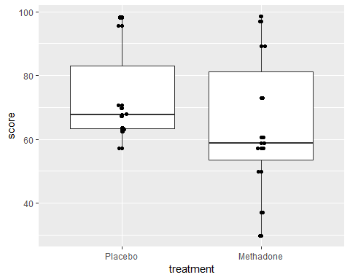 ## Prueba T-student para muestras relacionadas

comparison <- t.test(score~treatment,data = datos2,paired=T)  
comparison

##   
## Paired t-test  
##   
## data: score by treatment  
## t = 3.1554, df = 10, p-value = 0.01024  
## alternative hypothesis: true difference in means is not equal to 0  
## 95 percent confidence interval:  
## 2.826473 16.409891  
## sample estimates:  
## mean of the differences   
## 9.618182

**Interpretación**: - No existen diferencias significativas en la prueba de varianza por lo que es posible emplear una prueba paramétrica - al Realizar una prueba T-student para muestras relacionadas, los resultados indican que las medias son diferentes debido al tratamiendo con placebo o metadona