

**LOGS AUTOMATION API**

# save project entry

**The save_project_entry.php script is called to update or add project and option list data when a new project is entered or an existing project is updated.**

**Diagram**

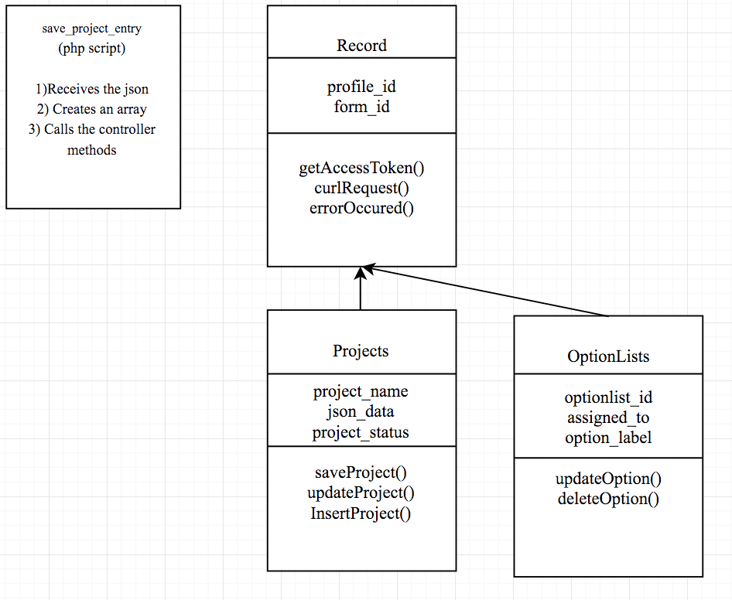

1. **Record:**

This controller record represents each record.

Fields: profile_id : unique id of the profile

Form_id : unique id of the form

Methods:

getAccessToken() : This function is used for getting the access token that is used for making a call to iformbuilder APIs

curlRequest() : This function is used for making curl request to the iformbuilder api, by using the url and the required curl options

errorOccured() : This function is used for emailing, reporting and recording errors occurred while execution of the code to the user

1. **Projects:**

This controller is used for saving projects that are updated or inserted.

Fields:

Project_name: stores the name of the project

Json_data: is used to store the json data received after form submission that is required to update the project data

Project_status: is used to store the project status value

Methods:

saveProject(): This function checks to see if the project already exists, if it does it updates it with the data in the json_data array. If not then inserts a new project.

InsertProject(): This function is used for inserting/adding details of a new project.

UpdateProject(): This function is used for updating an existing project.

1. **OptionLists:**

This controller is used for updating details for an option list

Fields:

optionlist_id : Id of the option list that needs to be updated

Assigned_to: assigned_to field stores the name of the user; this is used to add as condition value to the option list.

Option_label : label name of the option

Methods:

UpdateOptionList: This function checks to see if the optionlist exists, if it does then it updates it with the option and the condition value, if it doesn’t then it adds a new one.

DeleteOption : Used for deleteing the option from the option list

As shown in the diagram, the json data is received by the php script which is called after the form submission. Functions from project and option list controllers are called to update the project and option list.

# UPDATE project STATUS

**This script is called to update the project status in the project table. It also deletes the project from the option list if the project status is completed.**

**Diagram:**

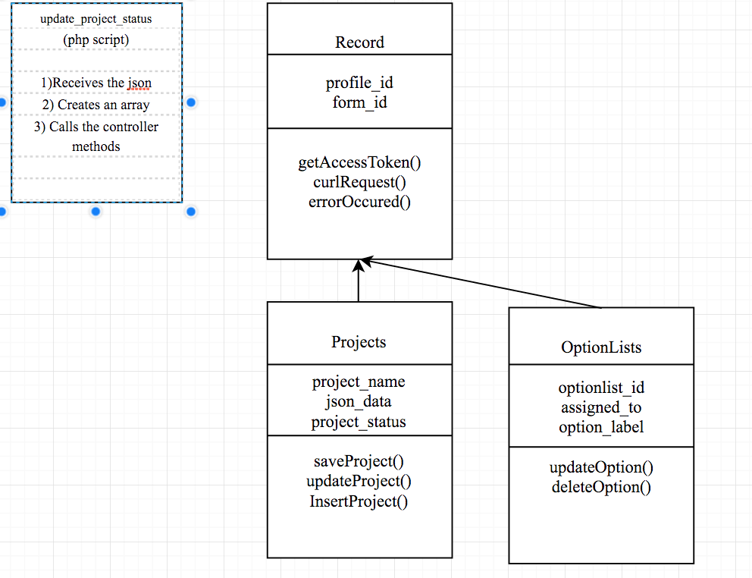

1. Refer to page 1 for details about each controller.
2. The script update_project_status is called when the form is submitted. It receives the json data. The json data has project status details. It calls saveProject() method in the Project controller to update the project status and if the project status is completed it calls deleteOption in the OptionLists controller.

# SAVE IMAGES

**This script is called to upload image files to appropriate directory on the filecloud.**

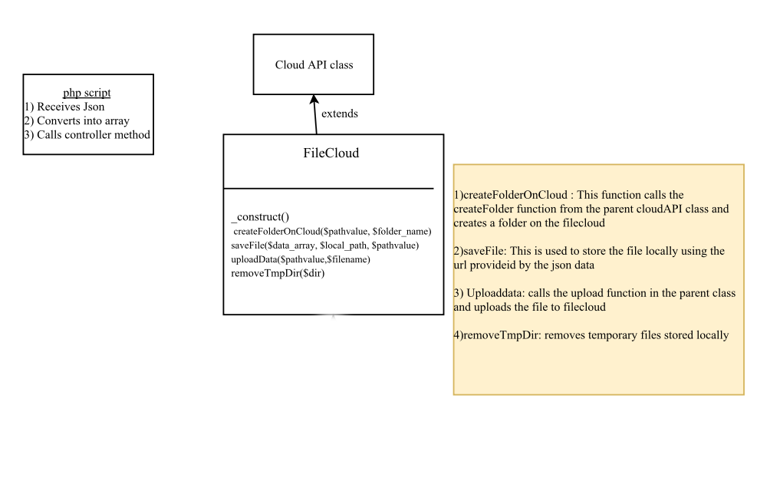

1. **Cloud API** class is used for calling the API to login to the filecloud, creating a folder and uploading files.
2. **FileCloud** controller has methods, which calls the api in cloudapi class to login and upload files to the filecloud. The url received as json is first used to download the file locally and then this image file is uploaded in the right directory on the filecloud. The local image file is later removed.