

**custom tables in tnmp elasticube**

1. **Project Issue Photos**

The purpose of this custom table is to get the photos from the take_and_annotate_photos table that are related to project issues sub form.

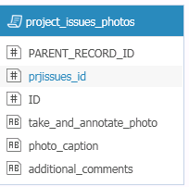

**sql query :**

SELECT

b.parent_record_id,a.id AS prjissues_id, b.id, b.take_and_annotate_photo,b.photo_caption,b.additional_comments from

[tpsiformdb._data441442_tnmp_substation_project_issues_subform] a

LEFT JOIN

[tpsiformdb._data441442_tnmp_capture_annotate_photos_subform] b

ON a.id = b.parent_record_id

AND b.PARENT_PAGE_ID=3471832 AND b.PARENT_ELEMENT_ID=278008716

This query does a left join between project issues subform table and photos table. It has hardcoded values for the project issues subform page id and the element id in the form.

The result shows the photo details related to project issues.

The custom tables substation_safety_photos, line_issues_photos have the same logic of retrieving photos from the photo table related to a sub form.

1. Combined Structures

This table is a result of union of two tables

[sde.longneck_structures_evw]

[sde.longneck_climax_structures_evw]

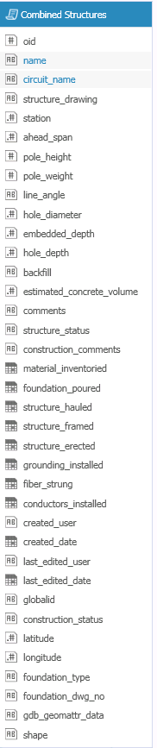

Sql query: SELECT * FROM [sde.longneck_structures_evw]

UNION ALL

SELECT * FROM [sde.longneck_climax_structures_evw]

1. Project Category Name Table

The project category name table contains the information about a project, its name, engineer, and contractor, manager involved. Also status, location and type of each project.

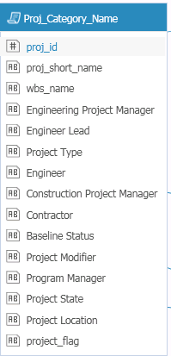 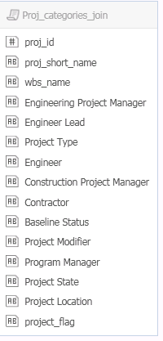 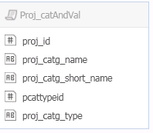

1. Proj_catAndVal

Sql query:

SELECT

res.*,T.proj_catg_type

FROM

(SELECT

C.proj_id,V. proj_catg_name,V.proj_catg_short_name,c.PROJ_CATG_TYPE_ID AS pcattypeid

FROM

Projpcat as C

JOIN

Pcatval as V

ON

C.Proj_catg_id = V.Proj_catg_id and c.proj_catg_type_id=v.proj_catg_type_id) AS res

INNER JOIN [PCATTYPE] AS T

ON res.pcattypeid=T.PROJ_CATG_TYPE_ID

This query is a result of join between the Projpcat table and Pcatval table based on the project category id.

1. Proj_categories_join

Sql query:

SELECT

result.PROJ_ID,result.PROJ_SHORT_NAME,W.wbs_name, result.[Engineering Project Manager],

……. result.project_flag

FROM

(SELECT P.PROJ_ID,P.PROJ_SHORT_NAME,P.PROJECT_FLAG,

t1.proj_catg_name AS [Engineering Project Manager],

…..t11.proj_catg_name as [Project Location]

FROM [PROJECT] AS P

left JOIN [Proj_catAndVal] t1

ON P.PROJ_ID=t1.PROJ_ID

AND t1.PROJ_CATG_TYPE='Engineering Project Manager'

left JOIN [Proj_catAndVal] t2

ON P.PROJ_ID=t2.PROJ_ID AND

t2.PROJ_CATG_TYPE='Engineer Lead'

.

.

.

left JOIN [Proj_catAndVal] t11 ON P.PROJ_ID=t11.PROJ_ID AND t11.PROJ_CATG_TYPE='Project Location'

WHERE coalesce(

t1.proj_catg_name,

t2.PROJ_CATG_NAME,

t3.proj_catg_name,

t4.proj_catg_name,

t5.proj_catg_name,

t6.PROJ_CATG_NAME,

t7.proj_catg_name,

t8.proj_catg_name,

t9.proj_catg_name,

t10.PROJ_CATG_NAME,

t11.proj_catg_name

) is not NULL

) AS result

inner JOIN [PROJWBS] AS W

ON result.proj_id = W.proj_id

WHERE result.PROJECT_FLAG='Y' AND result.PROJ_SHORT_NAME NOT LIKE '%TEMPLATE%' AND W.PROJ_NODE_FLAG='Y' AND W.wbs_name NOT LIKE '%Template%'

AND result.PROJ_SHORT_NAME NOT LIKE '%- B%' AND result.PROJ_SHORT_NAME NOT LIKE '%TEST%' AND result.PROJ_SHORT_NAME NOT LIKE '%REVIEW%'

This project gets details of a project from the project table, it gets the project category names based on different category types for each project.

Also this result table is then joined with the project wbs table to get the wbs_name.

There are certain conditions in the where clause to exclude test or template projects.

1. Proj_Category_Name:

SELECT J.*

FROM [Proj_categories_join] AS J

This table selects the result from Proj_categories_join table and displays it.