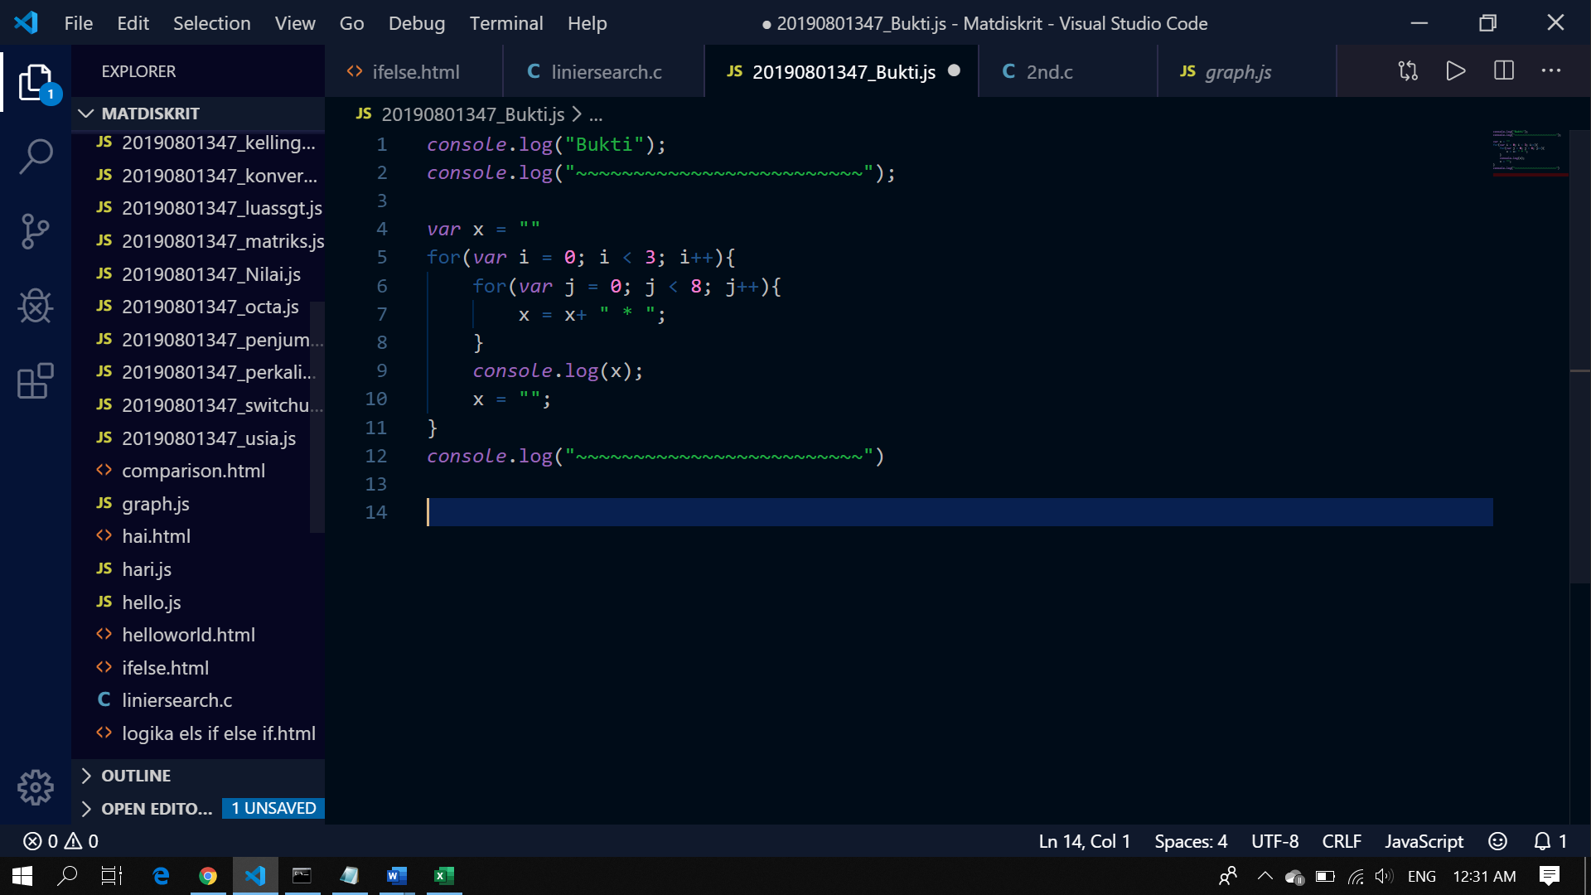

**RESULT**

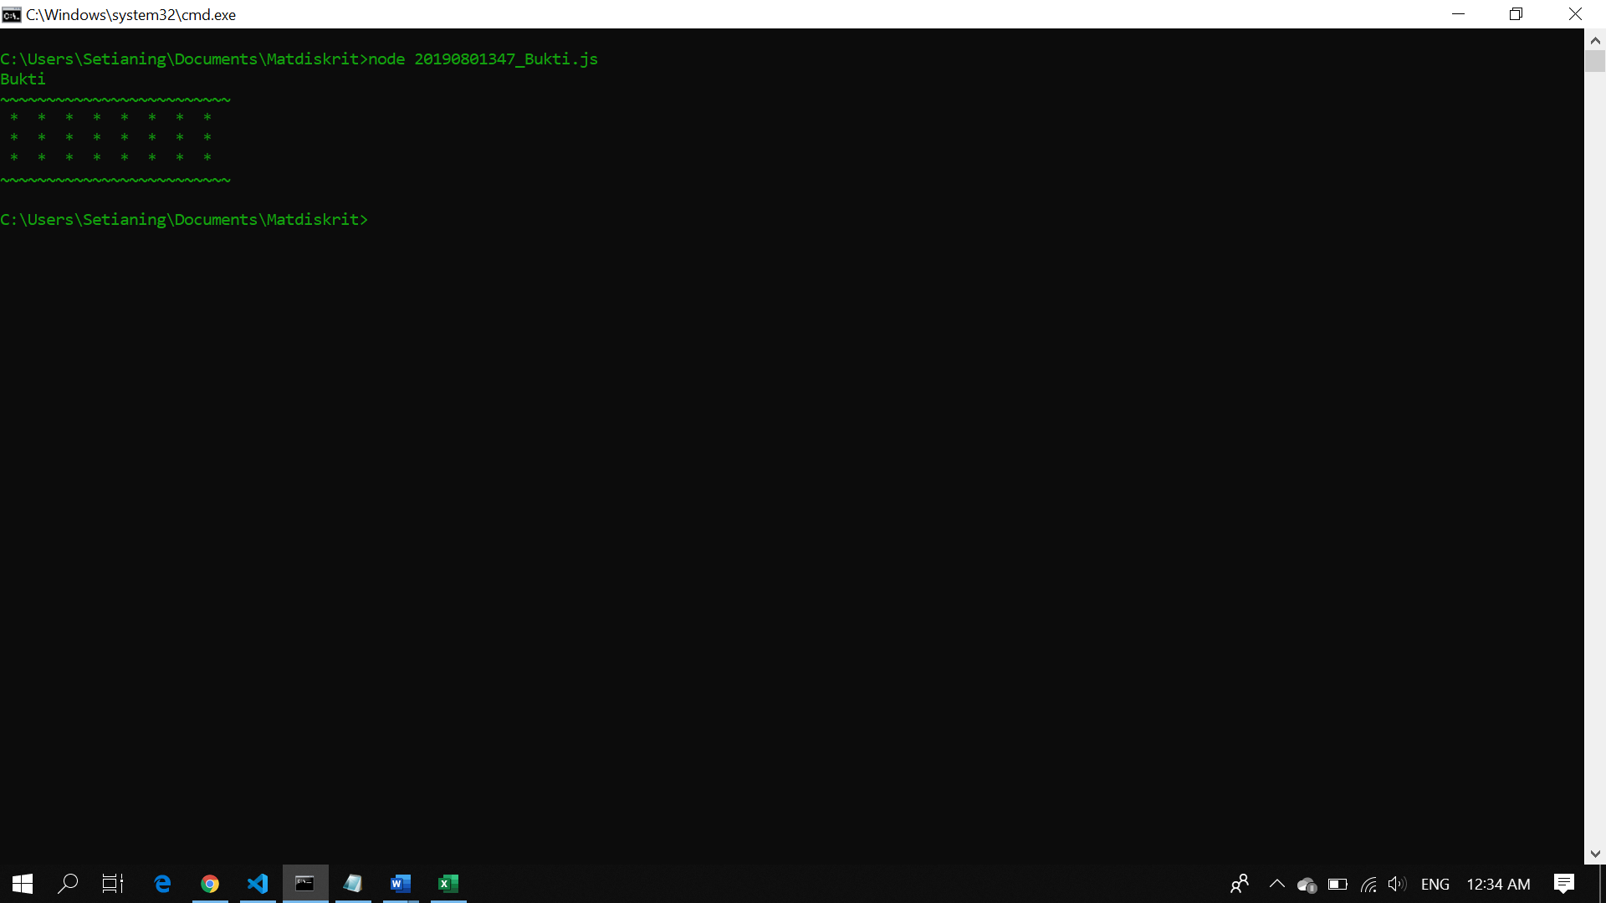

**PEMBUKTIAN**

|  |  |  |
| --- | --- | --- |
| **Input** | **Processing** | **Output** |
| 3 | 0 < 3 (TRUE) && 0 < 8 (TRUE) | * * * * * * * * |
| 8 | 1 < 3 (TRUE) && 0 < 8 (TRUE) | * * * * * * * * |
|  | 2 < 3 (TRUE) && 0 < 8 (TRUE) | * * * * * * * * |
|  | 3 < 3 (FALSE) |  |