**Code**

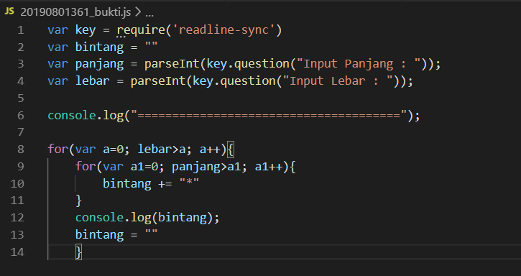

**result**

**\* * * * * * * \***

**\* * * * * * * \***

**\* * * * * * * \***

**Pembuktian**

|  |  |  |
| --- | --- | --- |
| Input | proses | output |
| 3 | 0 < 3 (TRUE) && 0 - 7 (TRUE) output “*” | **\*\*\*\*\*\*\*\*** |
| 8 | 1 < 3 (TRUE) && 0 - 7 (TRUE) output “*” | **\*\*\*\*\*\*\*\*** |
|  | 2 < 3 (TRUE) && 0 - 7 (TRUE) output “*” | **\*\*\*\*\*\*\*\*** |
|  | 3 < 3 (FALSE) |  |
|  |  |  |
|  |  |  |