**Soal 1**

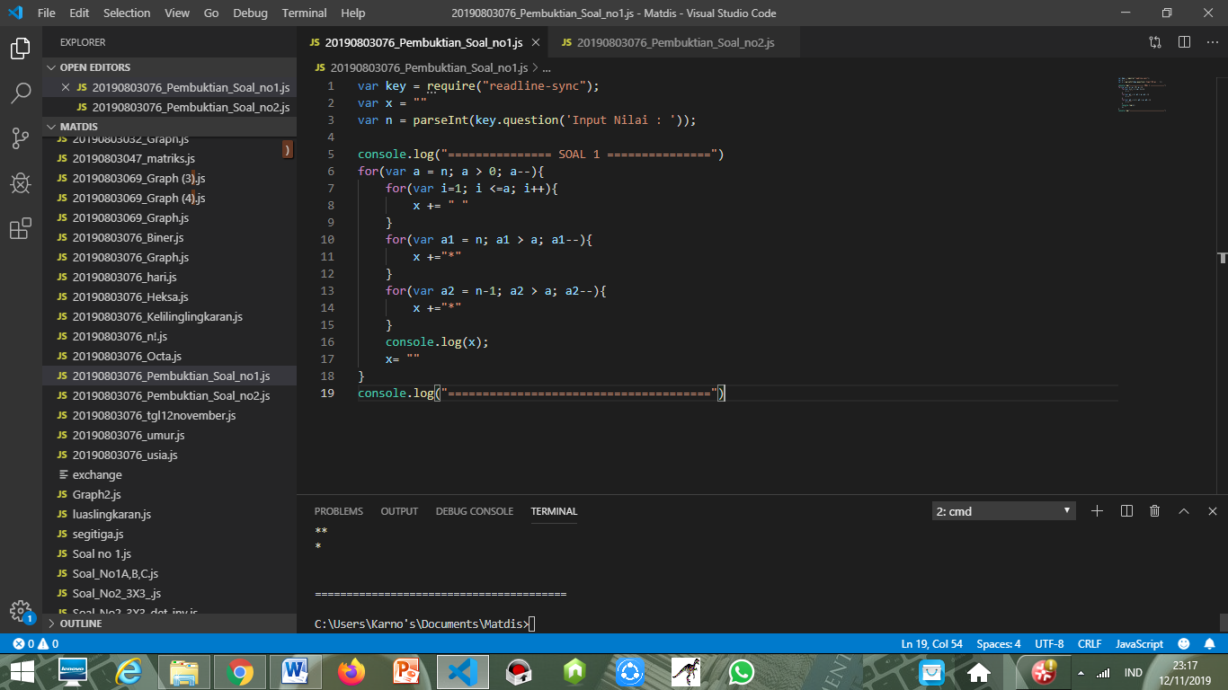

|  |  |  |
| --- | --- | --- |
| INPUT | PROSES | OUTPUT |
| **6** | A > 0 (TRUE) A – 1  I < A (TRUE) print “spasi” sampai **False**  A1 > A ((TRUE), A = 1, 2>1) print “*”  A2 > A-1 ((FALSE) A=2-1, 1>1) | **\*** |
|  | A > 0 (TRUE) A – 1  A1 > A ((TRUE, A = , 3>1)) output “*”  A1 > A ((TRUE, A = , 2>1)) output “*”  A2 > A-1 ((FALSE) A=3-1, 1>2) | **\*\*\*** |
|  | A > 0 (TRUE) A – 1  A1 > A ((TRUE, A = , 4>1)) output “*”  A1 > A ((TRUE, A = , 3>1)) output “*”  A1 > A ((TRUE, A = , 2>1)) output “*”  A2 > A-1 ((FALSE) A=4-1, 1>3) | **\*\*\*\*\*** |
|  | A > 0 (TRUE) A – 1  A1 > A ((TRUE, A = , 5>1)) output “*”  A1 > A ((TRUE, A = , 4>1)) output “*”  A1 > A ((TRUE, A = , 3>1)) output “*”  A1 > A ((TRUE, A = , 2>1)) output “*”  A2 > A-1 ((FALSE) A=5-1, 1>4) | **\*\*\*\*\*\*\*** |
|  | A > 0 (TRUE) A – 1  A1 > A ((TRUE, A = , 6>1)) output “*”  A1 > A ((TRUE, A = , 5>1)) output “*”  A1 > A ((TRUE, A = , 4>1)) output “*”  A1 > A ((TRUE, A = , 3>1)) output “*”  A1 > A ((TRUE, A = , 2>1)) output “*”  A2 > A-1 ((FALSE) A=6-1, 1>5) | **\*\*\*\*\*\*\*\*\*** |

**Soal 2**

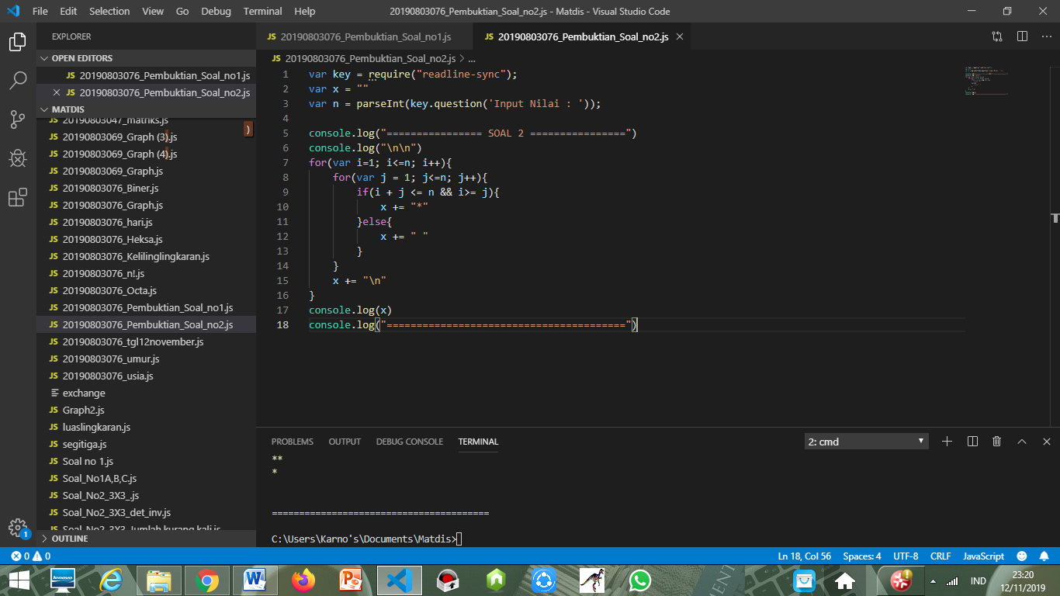

|  |  |  |
| --- | --- | --- |
| INPUT | PROSES | OUTPUT |
| **6** | I < N (TRUE)  J<=6 (TRUE)  IF I + J <= 6 && i > J ((FALSE), 2 <= 6, 1> 1) IF ((TRUE)) | **\*** |
|  | I < N (TRUE)  J<=6 (TRUE)  IF I + J <= 6 && i > J ((FALSE), 2 <= 6, 1> 1) IF ((TRUE))  IF ((TRUE)) | **\* \*** |
|  | I < N (TRUE)  J<=6 (TRUE)  IF I + J <= 6 && i > J ((FALSE), 2 <= 6, 1> 1) IF ((TRUE))  IF ((TRUE))  IF ((TRUE)) | **\* * \*** |
|  | I < N (TRUE)  J<=6 (TRUE)  IF I + J <= 6 && i > J ((FALSE), 2 <= 6, 1> 1) IF ((TRUE))  IF ((TRUE)) | **\* \*** |
|  | I < N (TRUE)  J<=6 (TRUE)  IF I + J <= 6 && i > J ((FALSE), 2 <= 6, 1> 1) IF ((TRUE)) | **\*** |