WORK INSTRUCTION
FOR PROCESSING
GPS DATA

Project Name:
Measurement of Velocities of Earthquake Faults
(MOVE Faults)

Project Leader:
Teresito C. Bacolcol, PhD, CESO IV

Authors:
Cassandra Joy V. Cabigan*
Alyssa Dane S. Pariñas*
Abegail Riva L. Abrenica*
Kurt Zedrick M. Baldemoro
Ken Louis L. Villar
Alfie R. Pelicano

October 2025

TABLE OF CONTENTS

1. Objective 3
2. Scope 3
3. Definitions 3
4. Procedure: Data conversion 4
4.1. Prerequisites 4
4.2. Command-line conversion of GNSS data 6
4.2.1. Antenna height computation 6
4.2.2. Converting Trimble raw data to intermediary file 7
4.2.3. Converting intermediary file to RINEX format 10
4.2.4. Converting Leica raw data to RINEX format 12
4.3. Automated conversion of GNSS campaign data using Python 14
4.4. Automated conversion of GNSS continuous data using Python 17
4.5. Troubleshooting 21
5. Procedure: Post-processing using Bernese GNSS Software Version 5.2 24
5.1. Installation 25
5.2. Campaign setup 26
5.3. Preparation of Campaign files 30
5.4. BPE Setup 42
5.5. First BPE Processing 44
5.6. Routine processing 54
5.6.1. Daily BPE processing 54
5.6.2. Updating station information 55
5.6.3. Adding a new site 55
5.6.4. Adding an IGS reference site 56
5.6.5. Updating GEN folder 56
5.7. Manual download of external inputs 58
5.7.1. IGS products 58
5.7.2. Daily RINEX data from IGS reference stations 59
6. Procedure: Time series 59
6.1. Prerequisites 59
6.2. Plotting of final coordinates 60
6.3. Outlier removal 64

Objective
The objective of this work instruction is to provide a clear and standardized workflow for handling and processing GPS data. By documenting the procedure in detail, this ensures the accuracy and efficiency in executing office tasks related to GPS data processing, as well as consistency in producing reliable results that support the Project's monitoring and research activities.

Scope
This work instruction covers office-based GPS data processing activities, specifically these three main tasks: (1) data conversion of raw GNSS files into RINEX format, (2) data processing using the Bernese GNSS 5.2 software, and (3) generation of time series plots from processed station coordinates. The procedures are limited to routine data handling and do not extend to fieldwork, coseismic measurements, or advanced analytical techniques beyond the regular GPS processing workflow.

Definitions
- Campaign (Bernese processing context)
A set of GNSS data over a specific period that is to be processed together using the Bernese software.
- Campaign (Data collection context)
A GNSS data collection method that involves occupying established benchmarks for a specific time period to gather measurements.
- Center for Orbit Determination in Europe (CODE)
A global analysis center for organizations such as the International GNSS Service (IGS) that processes data from various satellite navigation systems to generate precise and consistent satellite orbits and related geodetic products.
- Continuously Operating Reference Station (CORS)
A GNSS station that uses permanently installed instruments operating 24/7, providing high-precision, long-term data.
- Global Navigation Satellite System (GNSS)
An umbrella term for any constellation of satellites for global positioning, crucial for various applications, including navigation, logistics, and scientific research, encompassing systems like Galileo, GPS, GLONASS, and BeiDou.
- Global Positioning System (GPS)
A specific type of GNSS developed by the United States government, formally known as the Navstar Global Positioning System, which utilizes a network of ground stations and satellite control stations for monitoring and control.
- International GNSS Service (IGS)
A service that collects, archives, and provides openly available high-precision GNSS data and products using an international network of over 500 continuously operating geodetic-quality GNSS stations and data centers.
- International Terrestrial Reference Frame (ITRF)
A globally recognized, time-dependent terrestrial reference frame used for precise and consistent positioning, satellite navigation, and Earth science applications, which accounts for Earth’s movements using observations from geodetic instruments.
- Normal EQuation (NEQ) file
A binary file with extension .NQ0 in Bernese software, which stores the normal equations and essential information, such as parameter characterization and a priori values.
- Receiver INdependent EXchange (RINEX) format
A standardized file format for processing, storing, and archiving GNSS observation and navigation data.
- Sessions (Bernese processing context)
A defined time interval that covers all GNSS observations and associated products that are to be processed together.
- Solution INdependent EXchange (SINEX) format
A standardized file format used in exchanging geodetic solution data from multiple geodetic techniques between different analysis centers and applications.

Procedure: Data conversion

After collecting data from GNSS receivers, the raw data is converted into a standardized RINEX 2 observation file format. This section outlines the steps for converting raw GNSS data from campaign and continuous collection methods.

You can use the following decision points to determine which conversion method to use:
- When to use command-line (Subsection 4.2):
- Learning how the conversion process works
- Converting single files for testing
- Troubleshooting conversion issues
- Automated scripts are unavailable
- Combining raw file segments into one daily observation session

- When to use Python automation (Subsections 4.3 or 4.4):
- Processing multiple sites
- Routine daily processing
- Consistent, repeatable workflows

4.1. Prerequisites

4.1.1. Open an internet browser. Download and install the following on your designated computer:
- fixdatweek.exe | - downloadable at Trimble.com
- runpkr00.exe | - downloadable at UNAVCO.org; this should be placed in C:\Windows\System32
- teqc.exe | - downloadable at UNAVCO.org; this should be placed in C:\Windows\System32
- Notepad++ | - downloadable at notepad-plus-plus.org
- Python | - downloadable at python.org

4.1.2. Log in to Google Drive with your work email. Access the Project’s Google Drive folder, go to 3 GPS > GPS Processing > 03 Scripts > 01 RINEX conversion. Download and copy the following files to your computer:
- campaign_v5.py | - for automated conversion of campaign data
- continuous_v5.py | - for automated conversion of CORS data
- compute_ant-h.xlsx | - for antenna height computation

4.1.3. Familiarize yourself with the file naming conventions, as detailed below.

- Trimble raw data naming and structure

A conventionally named raw file from Trimble receivers uses the proprietary data file formats, specifically T00, T01, T02, and T04.

68511430.T01 is an example of a conventionally named Trimble raw file. The first four digits of the raw file (6851) represent the last four digits of the Trimble receiver’s serial number (S/N) or the 4-character site name. The next three digits of the raw file (143) indicate the Julian Day of Year (JJJ) when data was observed (e.g., 143 is JJJ for May 23). It is followed by another digit (0-9 or a-x), depending on the number of files generated during the observation session. Keep in mind that some files might contain an additional session identifier (A-D) at the end of the file name to manage different logging session properties.

For Trimble NetR9 receiver, a common raw data file naming format is SITE______YYYYMMDDHHmm[A-C].T02, which includes the station name (SITE), date and time of observation [year (YYYY), month (MM), day (DD), hour (HH), and minute (mm)], and the session identifier (A-C).

- Leica raw data naming and structure

A typical file name of a raw file from a Leica receiver uses the proprietary MDB format (with extension .m**), following the convention SITEJJJs.m[0-9][0-9], where:
SITE | = | 4-character site name, e.g., PIVS
JJJ | = | Julian day of year (001 to 365/366), e.g., 001 corresponds to January 1
s | = | session identifier (a-x) indicating the hour in the day (in UTC) for hourly sessions; for daily sessions, the identifier is fixed as ‘a’ to represent the 24-hr period
m[0-9][0-9] | = | full observation session can be stored as a single .m00 file or segmented sequentially as .m00, .m01, .m02, and so on

- Standard naming convention for RINEX Version 2

All daily RINEX files follow the file name structure, SITEJJJ0.YYo, regardless of the receiver type, where:
SITE | = | 4-character site name, e.g., PIVS
JJJ | = | Julian day of year (001 to 365/366), e.g., 001 corresponds to January 1
0 | = | character indicating daily session
YY | = | 2-digit year of the observation, e.g., 21 for 2021
o | = | file type indicating raw observation data, containing measurements such as time, pseudo-range, and carrier phase.

Note: For more information regarding the RINEX Version 2 format, please visit https://files.igs.org/pub/data/format/rinex211.txt.

4.2. Command-line conversion of GNSS data

4.2.1. Antenna height computation

Before running TEQC for data collected from campaign surveys, calculate the correct vertical antenna height. For data from continuous stations, this height is typically assumed to be zero.

4.2.1.1. Prepare the log sheets of the campaign data to be converted.
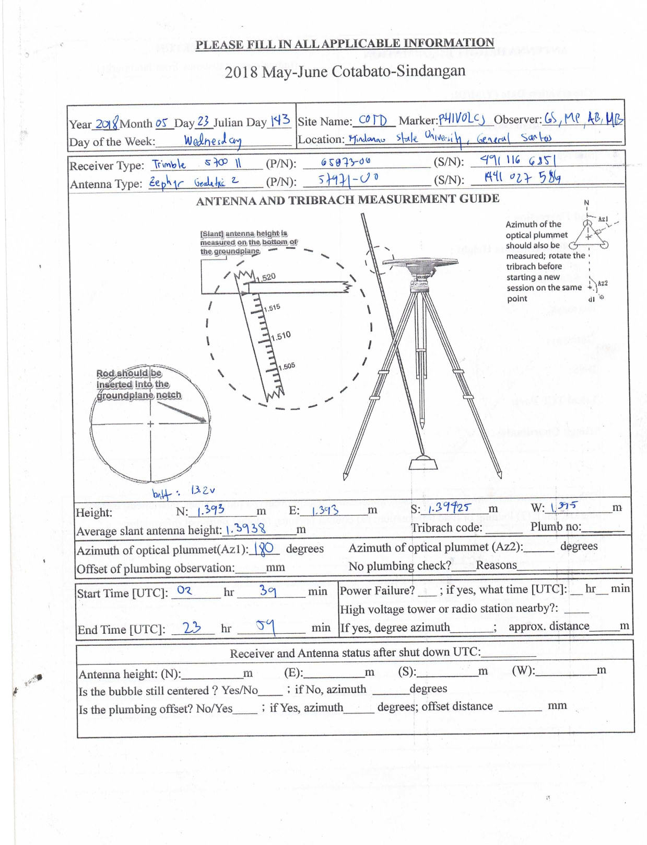

Sample campaign log sheet

4.2.1.2. Open compute_ant-h.xlsx using Microsoft Excel (or your preferred spreadsheet editor).

4.2.1.3. Enter average slant antenna height in the “slant” column. This value is calculated using four measurements around the antenna. The spreadsheet will then automatically compute the vertical height (h).

4.2.1.4. Use this h value to set the -O.pe parameter in Step 4.2.3.1 (for Trimble receivers) or Step 4.2.4.1 (for Leica receivers).

Note: When working with the antenna height measurements, avoid these common mistakes:
- Using slant height instead of vertical height: This will introduce 5-15 cm coordinate error.
- Forgetting to account for the antenna reference point: This causes a systematic offset in coordinates.
- Mixing units (cm vs. m): This will lead to a large 100× scaling error.

4.2.2. Converting Trimble raw data to intermediary file

This procedure is required for raw data collected from a Trimble receiver before it is converted into the standard RINEX file format. The demonstration used the raw data collected from the MAR2 continuous station in Marilao, Bulacan, spanning the entire month of June 2024. The observations were stored in daily files with a logging rate of 30 seconds.
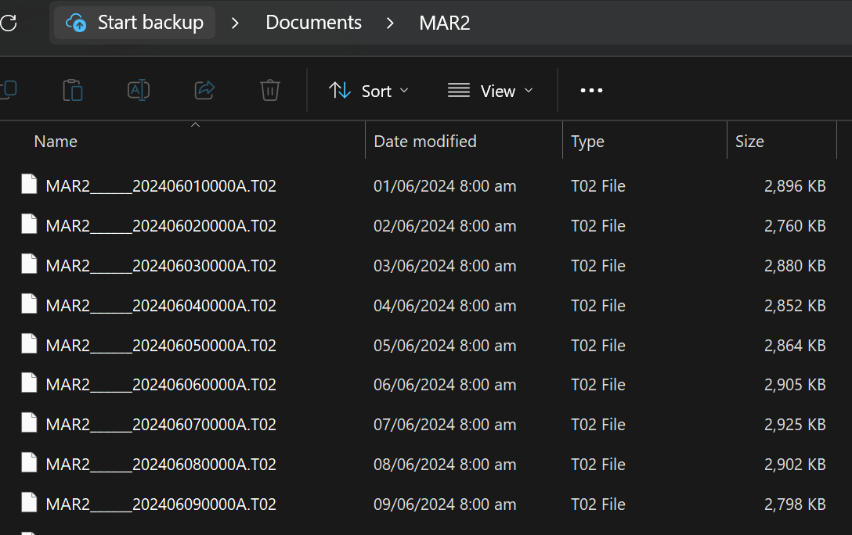

4.2.2.1. Open a terminal window by typing cmd in the Windows search bar and pressing Enter or left-clicking on "Command Prompt" in the search results.

4.2.2.2. Use the cd (Change Directory) command to navigate to the folder containing the raw data. Enter the command syntax cd followed by the absolute or relative path, C:\Path\To\Your\Folder (e.g., cd Documents\MAR2).

4.2.2.3. Type the command dir/b>convert2dattgd.bat to list all raw data in the current folder and write that list into the convert2dattgd.bat file.

4.2.2.4. Edit convert2dattgd.bat using Notepad++. Manually delete any lines that do not contain the file names of the raw data (e.g., delete line 1 in the example below).
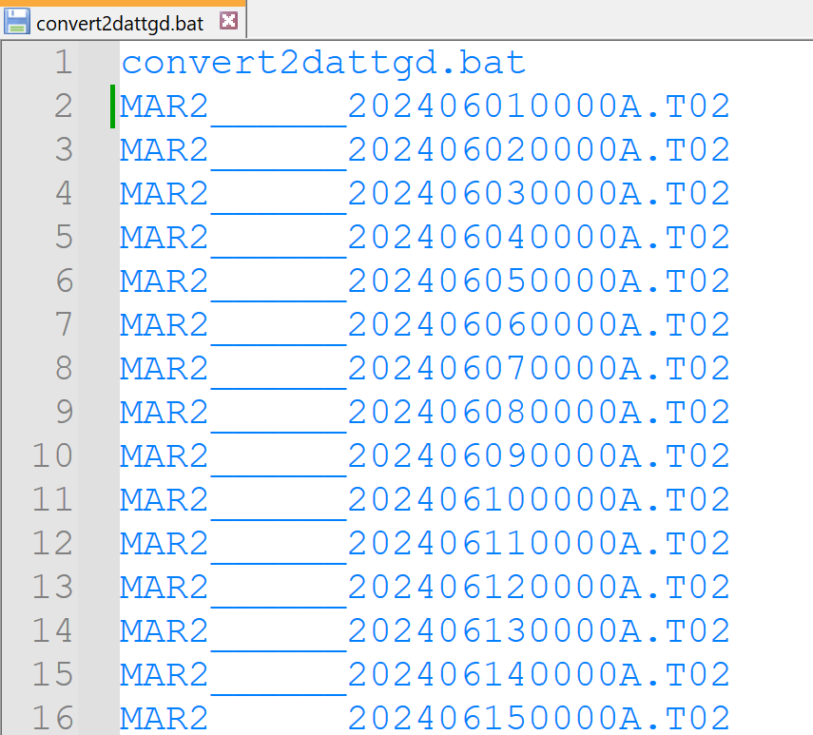

4.2.2.5. Insert the command runpkr00 -g -d before the file names and save the file. The runpkr00 program will convert all the Trimble raw files (.T00, .T01, or .T02) into teqc-readable files (.DAT or .TGD). The “-d” and “-g” flags are required for producing .DAT/.TGD files.
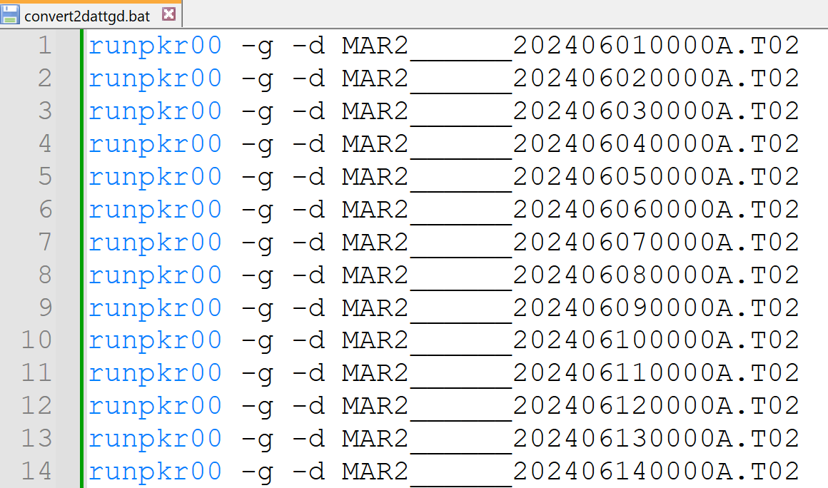

4.2.2.6. Execute runpkr00.exe by double-clicking the batch file convert2dattgd.bat. This will create new files with .DAT or .TGD extension inside the current directory.
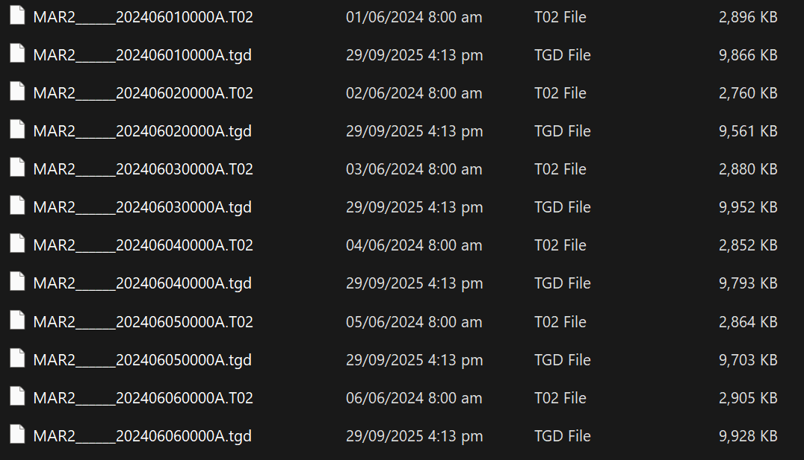

Check that .DAT or .TGD files are created (one for each raw file). If files are missing or you see error messages:
- Verify raw files are not corrupted and the file sizes are not zero.
- Ensure runpkr00.exe is in System32 or the current directory.
- Check for GPS week rollover issues (see Subsection 4.5).

4.2.3. Converting intermediary file to RINEX format

After the initial conversion of the Trimble raw data, the next step is to convert the teqc-readable files into standard RINEX format files.

4.2.3.1. Open Notepad++. Write the following command:
teqc -tr d -O.r NAME -O.o MOVEFaultsProject -O.ag PHIVOLCS -O.dec 30 -O.mo SITE -O.mn SITE -O.pe h E N +C2 +obs + -tbin 1d SITE INPUT

The teqc options and arguments used for creating the RINEX files are:
-tr d | = | receiver type and format; corresponds to Trimble’s .DAT or .TGD
-O.r | = | name of program user, e.g., PIVS for NAME
-O.o | = | name of site operator
-O.ag | = | name of agency
-O.dec | = | modulo decimation of observation epochs; -O.dec 30 corresponds to a 30-second interval
-O.mo | = | marker name, e.g., MAR2 for SITE
-O.mn | = | marker number (use the 4-character site name if the marker number is unavailable)
-O.pe | = | antenna topocentric correction, in meters; h, E, and N are height, east, and north, respectively; apply the vertical height (h) calculated from Subsubsection 4.2.1
+C2 | = | include RINEX 'C2' in the output, and include any associated data that is found
+obs + -tbin | = | create RINEX observation files (.YYo) with specified time bins; +obs + -tbin 1d SITE produces daily observation files with names starting with SITE
INPUT | = | specify the input file(s), e.g., *.tgd or MAR2______????????0000A.tgd (recommended to use wildcards, such as an asterisk (*) and a question mark (?), to select or refer to multiple files)

For example,
teqc -tr d -O.r PIVS -O.o MOVEFaultsProject -O.ag PHIVOLCS -O.dec 30 -O.mo MAR2 -O.mn MAR2 -O.pe 0 0 0 +C2 +obs + -tbin 1d MAR2 MAR2______????????0000A.tgd

Note: The complete documentation for TEQC software is available at https://www.unavco.org/software/data-processing/teqc/doc/UNAVCO_Teqc_Tutorial.pdf.

4.2.3.2. Go to “File” > “Save As”. Locate the directory containing the .DAT/.TGD files. Save the file as a batch file by setting “File name” to “dattgd2rinex” and “Save as type” to “Batch file”. Click Save.
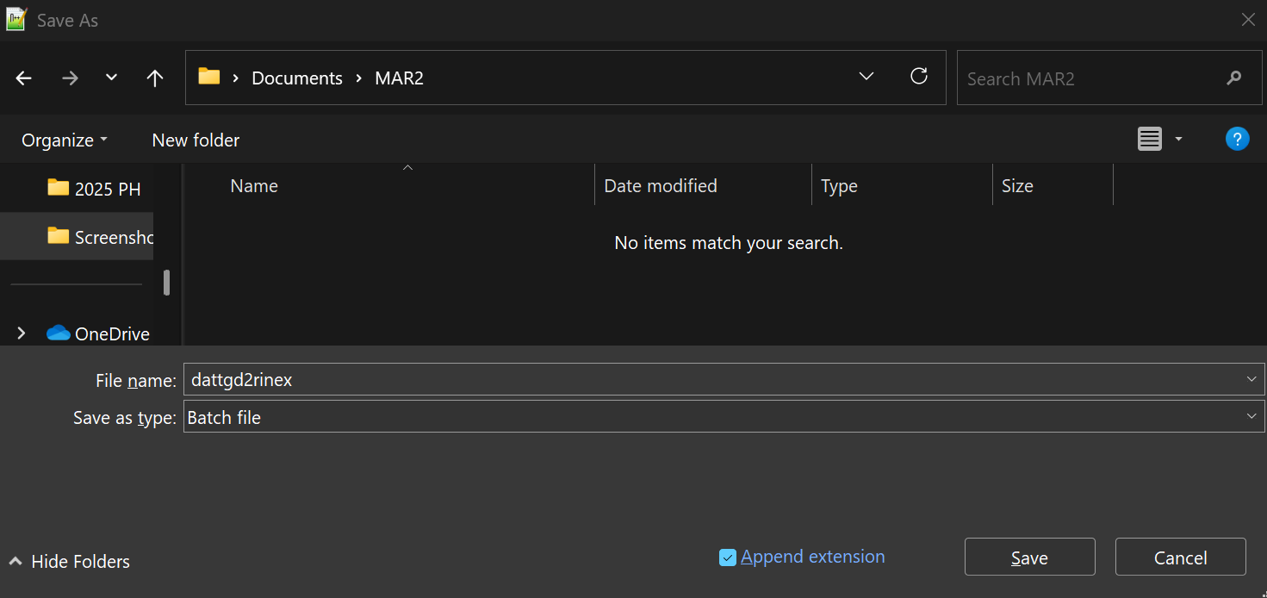

4.2.3.3. Execute teqc.exe by double-clicking the batch file dattgd2rinex.bat. This will produce the RINEX files inside the current directory. Review the headers of these RINEX files and make any neccesary edits to ensure the receiver and antenna information are accurate and complete.
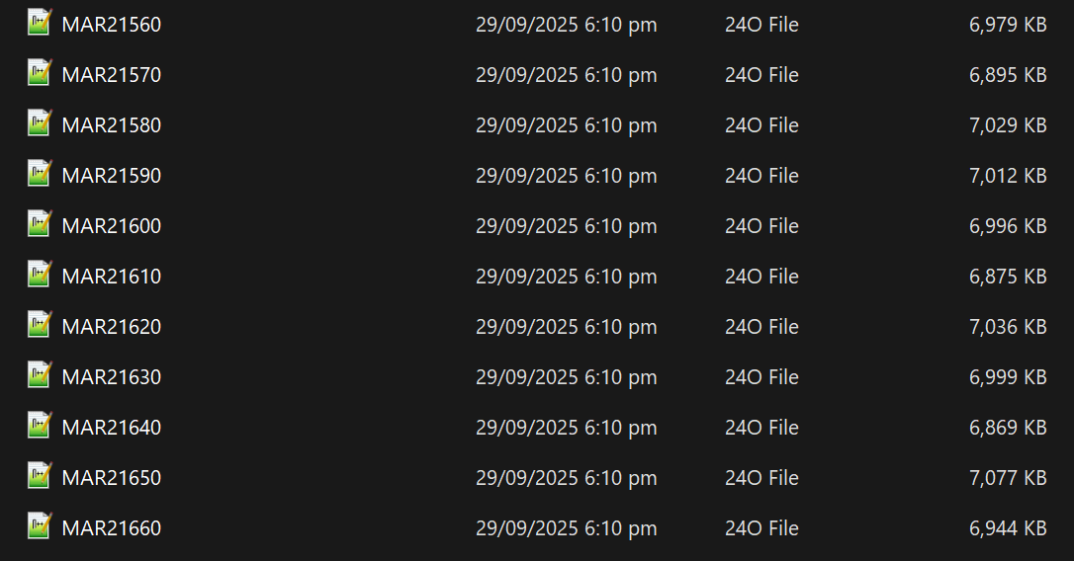

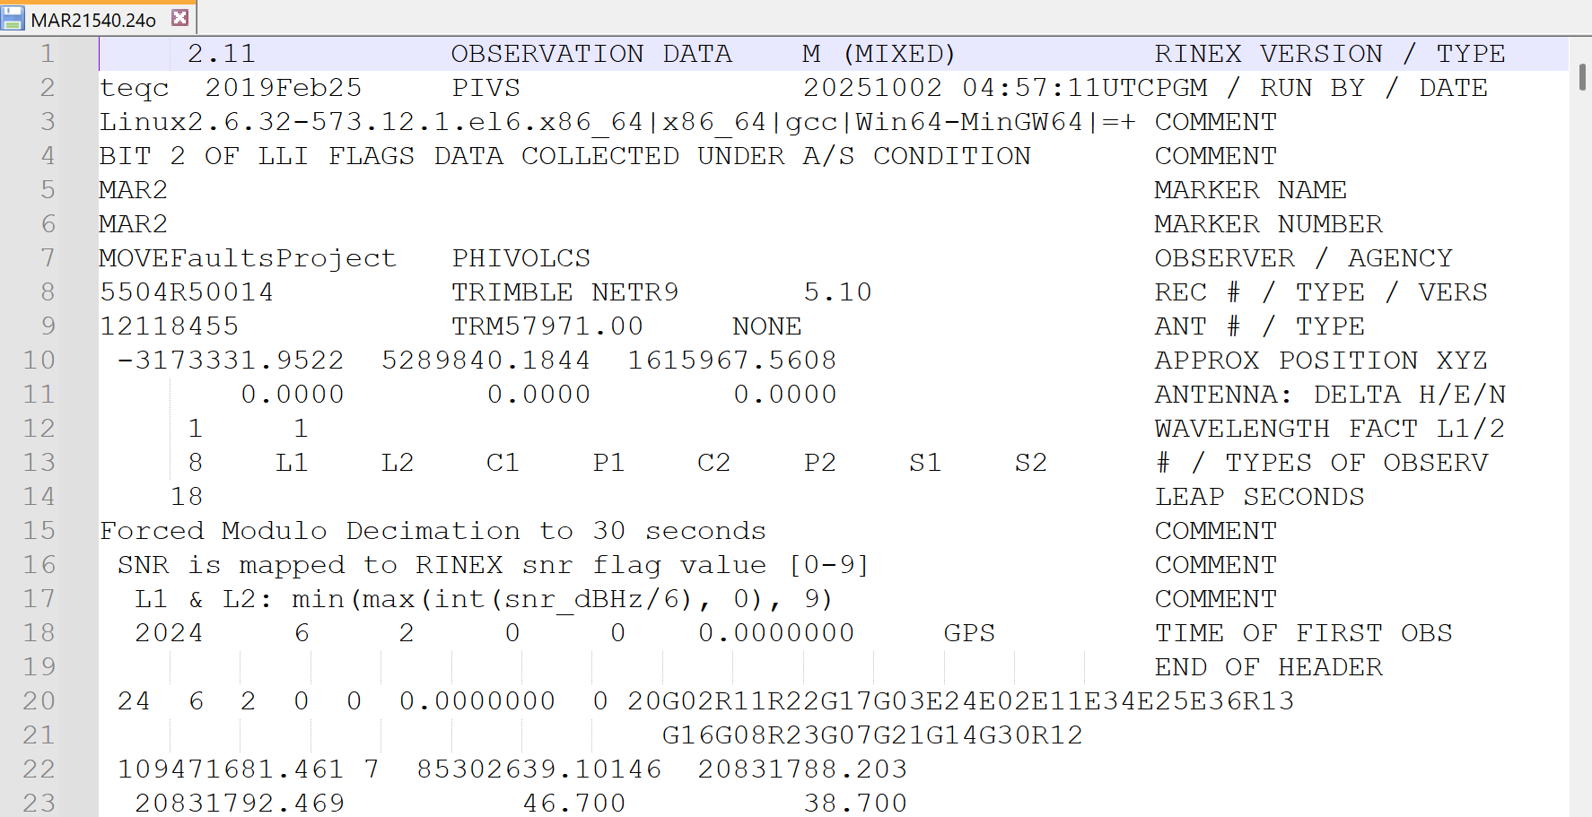
Sample daily RINEX observation file for MAR2 station. The file, MAR21540.24o, contains 24 hours of raw GNSS observations from June 2, 2024 (2024 DOY 154). The header section provides metadata, including the approximate receiver position, the equipment used, the types of observation, and the data interval.

4.2.4. Converting Leica raw data to RINEX format

This subsection demonstrates the process for handling Leica raw data using observations collected from ALCO, a continuous station in Alcoy, Cebu. These observations, stored in hourly files with a logging rate of 30 seconds, are combined to create a single daily RINEX file.
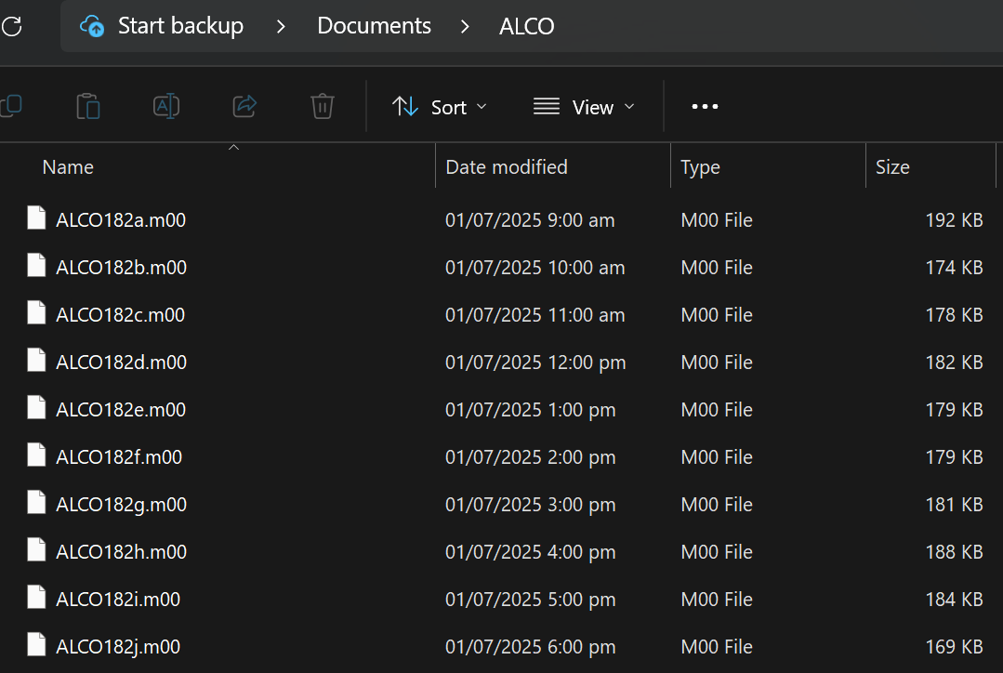

4.2.4.1. Open Notepad++. Write the following command:
teqc -lei mdb -O.r NAME -O.o MOVEFaultsProject -O.ag PHIVOLCS -O.dec 30 -O.mo SITE -O.mn SITE -O.pe h E N +C2 +obs + -tbin 1d SITE INPUT

The teqc command option -lei mdb specifies that the input data is in Leica’s proprietary MDB format (with .m** extension). The other options and arguments used for creating the RINEX files are explained in Step 4.2.2.1.

For example,
teqc -lei mdb -O.r PIVS -O.o MOVEFaultsProject -O.ag PHIVOLCS -O.dec 30 -O.mo ALCO -O.mn ALCO -O.pe h E N +C2 +obs + -tbin 1d ALCO ALCO*.m??

Note: In some instances, the raw data collected during a single session is segmented across multiple files with different file extensions. For example, the hourly raw data for ALCO on DOY 182 is broken up into three separate files: ALCO182q.m00, ALCO182q.m14, and ALCO182q.m31. You can use wildcards, such as an asterisk (*) and a question mark (?), to help select and sequentially combine these files to complete the full observation.

4.2.4.2. Go to “File” > “Save As”. Locate the directory containing the Leica raw data files. Save the file as a batch file by setting “File name” to “leiconvert2rinex” and “Save as type” to “Batch file”. Click Save.
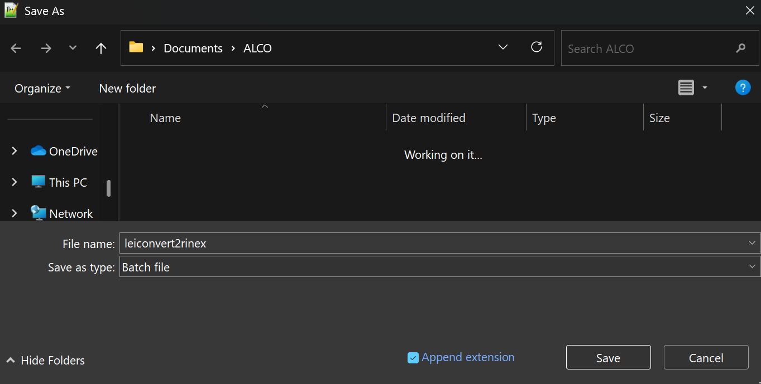

4.2.4.3. Execute teqc.exe by double-clicking the batch file leiconvert2rinex.bat. This will produce the RINEX files inside the current directory. Review the headers of these RINEX files and edit any receiver or antenna information that is incomplete or incorrect.
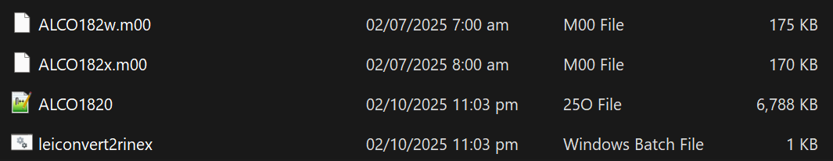

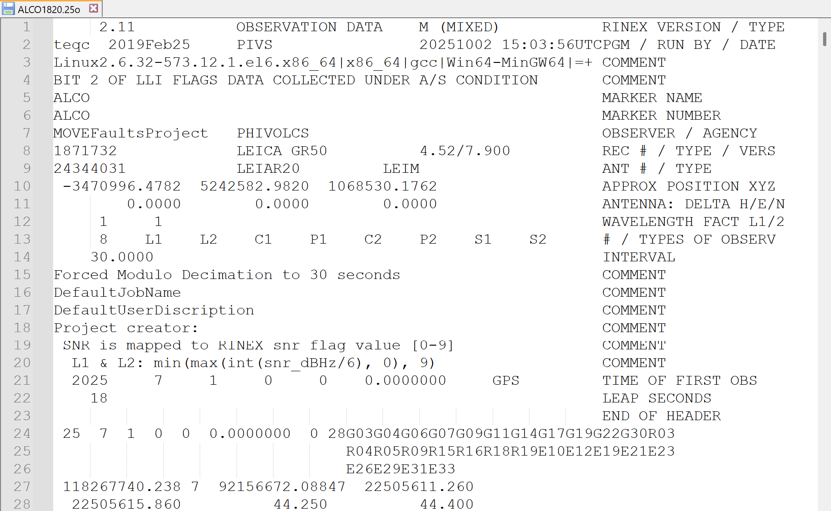
Sample daily RINEX observation file for ALCO station. The file, ALCO1820.25o, contains 24 hours of raw GNSS observations from July 1, 2025 (2025 DOY 182). The header section provides metadata, including the approximate receiver position, the equipment used, the types of observation, and the data interval.

4.3. Automated conversion of GNSS campaign data using Python

4.3.1. Prepare the log sheets of the campaign data to be converted.


Sample campaign log sheet. Important details are boxed.

4.3.2. Open File Explorer (or your preferred file manager like Total Commander). Transfer the raw data to the Documents folder (e.g., c:\Users\Juan\Documents) and organize it into subfolders by their site name (e.g., COTD).
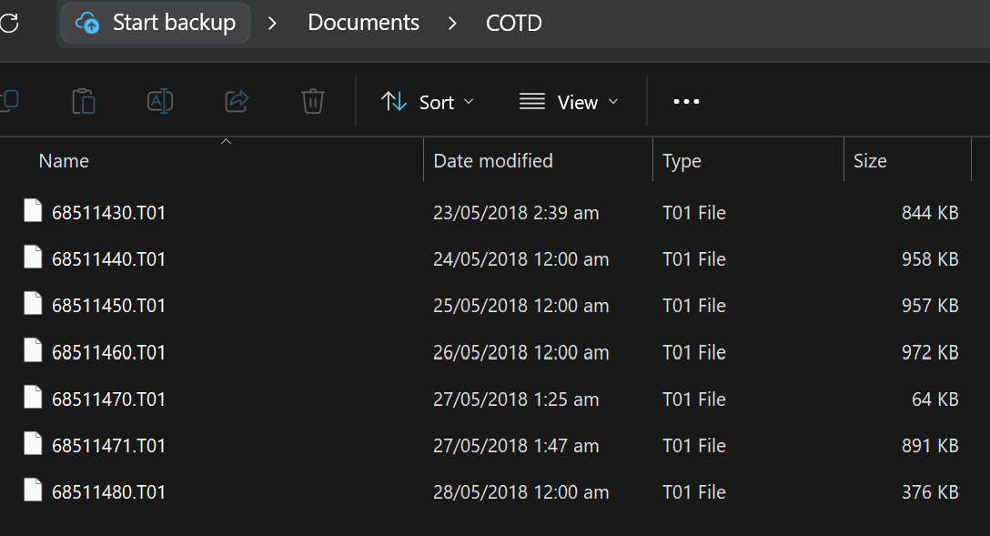

Sample raw data downloaded from a Trimble 5700 receiver

4.3.3. Run campaign_v5.py.

4.3.3.1. When prompted with “Input Documents Folder”, write the 4-character site name (e.g., COTD).
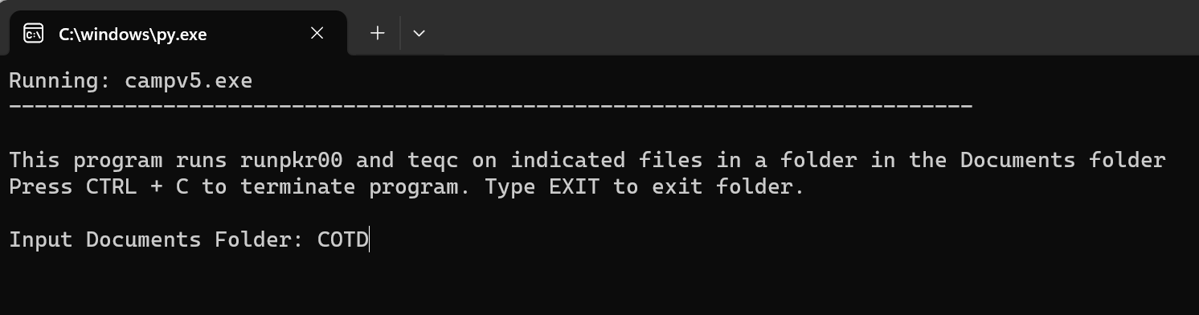

4.3.3.2. Upon entering the site name, the following prompt appears:
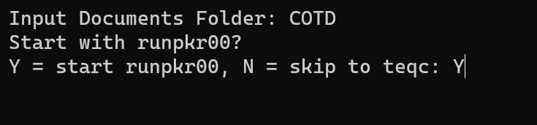
Input “Y” to run runpkr00.exe. Since Trimble receivers are typically used in campaign surveys, the runpkr00.exe program must be run first. This will convert all the Trimble raw files (.T00, .T01, or .T02) into teqc-readable files (.DAT or .TGD). Check if the .DAT/.TGD files are created in the current folder (e.g., c:\Users\Juan\Documents\COTD). Each newly produced .DAT/.TGD file has the same file name as the raw data.
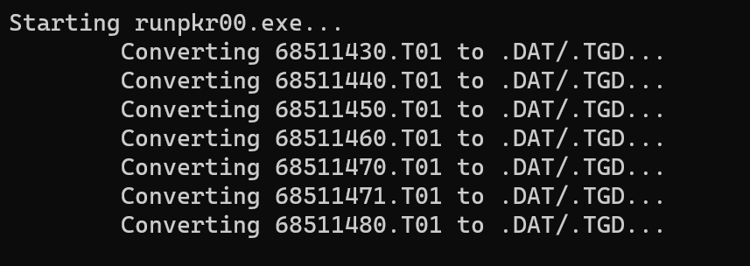

4.3.3.3. Input the file name of a .DAT/.TGD file to be processed by teqc.exe and converted into a RINEX file. (e.g., 68511430.tgd)

4.3.3.4. Input the 4-character site name (e.g., COTD). Refer to the campaign log sheet that matches both the site name and observation date.
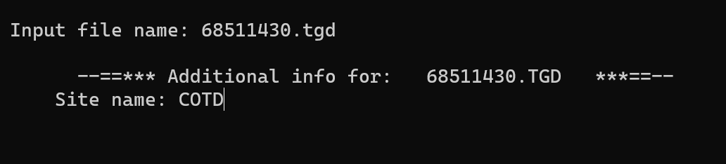

4.3.3.5. Input the antenna type. Type “1” for TRM TRM41249.00, “2” for TRM57971.00, or “3” for TRM115000.00. (e.g., 2 from the sample log sheet).
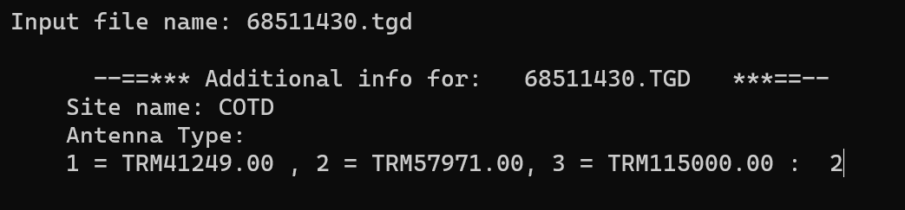

4.3.3.6. Input the average antenna height. (e.g., 1.3938 from the sample log sheet).
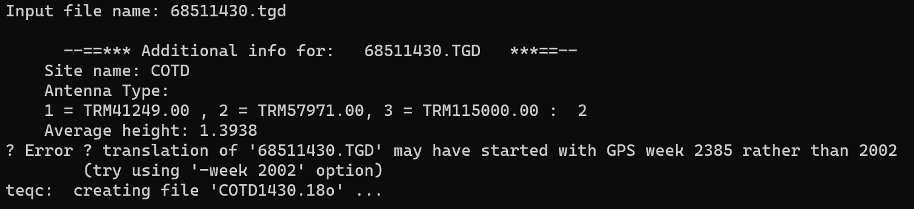

4.3.3.7. Repeat Steps 4.3.3.3 to 4.3.3.6 for each remaining .DAT/.TGD file.

4.3.3.8. Finally, type “Ctrl + C” to close the script, or “EXIT” to proceed with converting data from another site. If continuing to the next site, re-execute Steps 4.3.3.1 through 4.3.3.7.
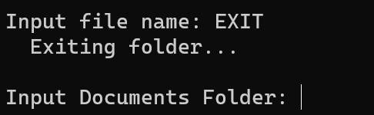
The RINEX files will be generated in their respective folders. As shown below, all raw data within the “COTD” folder have been successfully converted into RINEX files. Review the headers of these files and edit any receiver or antenna information that is incomplete or incorrect.
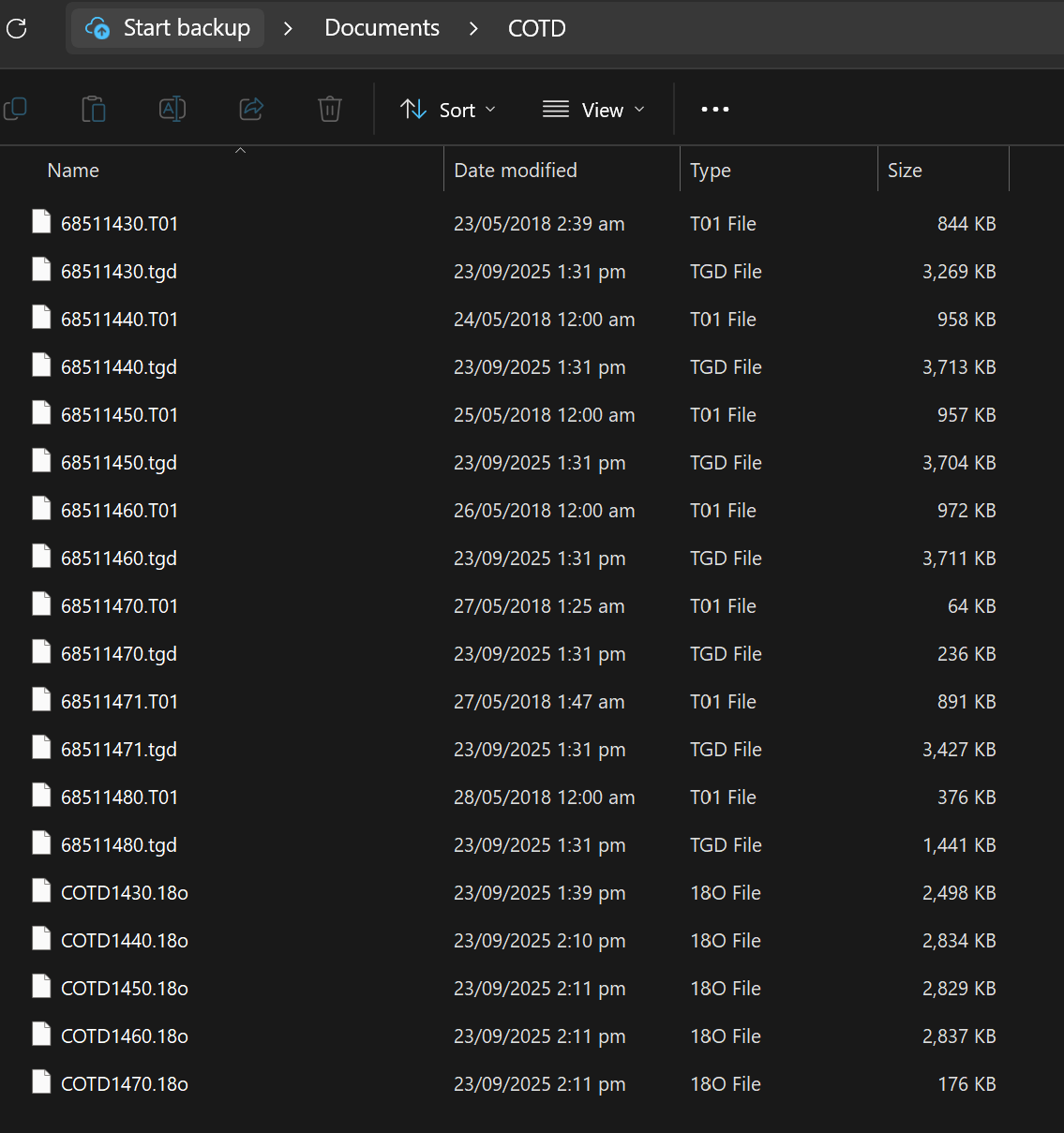

For example, the file COTD1430.18o is the RINEX data for the COTD site on May 23, 2018.
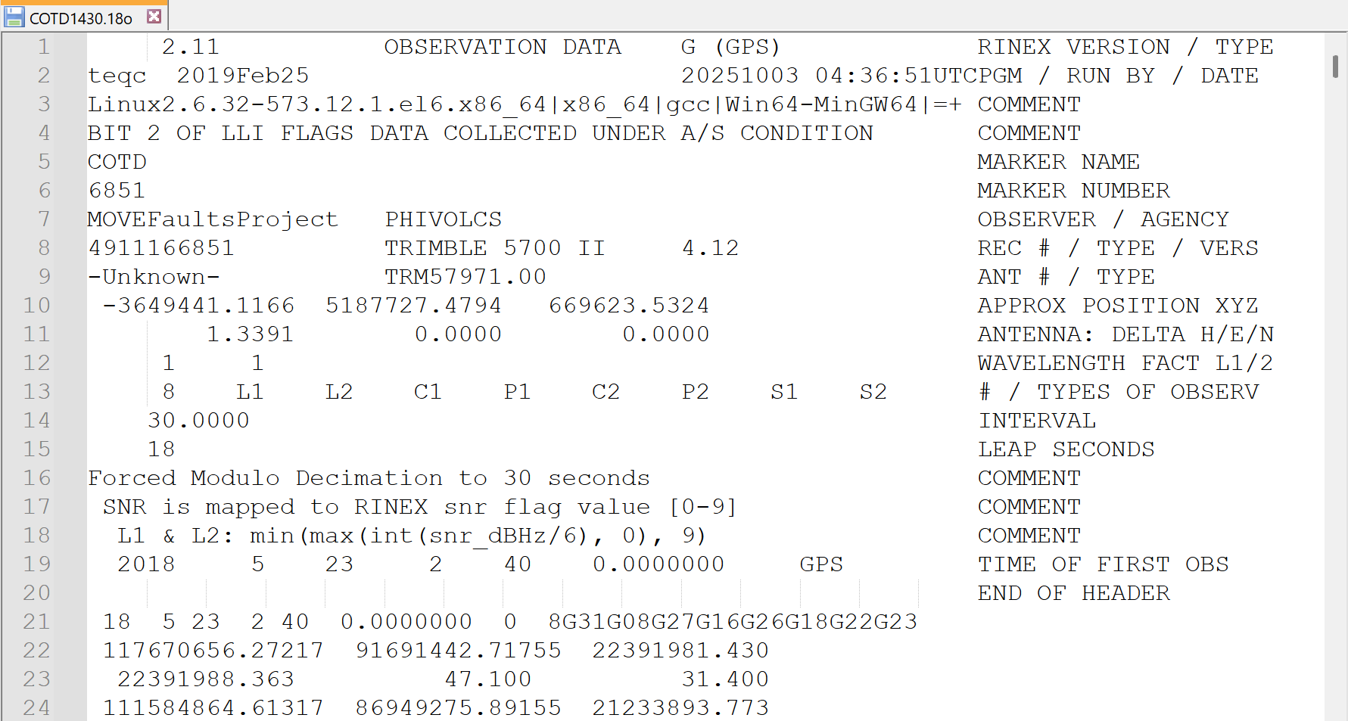
Sample daily RINEX observation file for COTD site

4.4. Automated conversion of GNSS continuous data using Python

4.4.1. Open File Explorer (or your preferred file manager like Total Commander). Transfer the raw data to the Documents folder (e.g., c:\Users\Juan\Documents) and organize it into subfolders by their site name (e.g., MAR2 or ATIM).
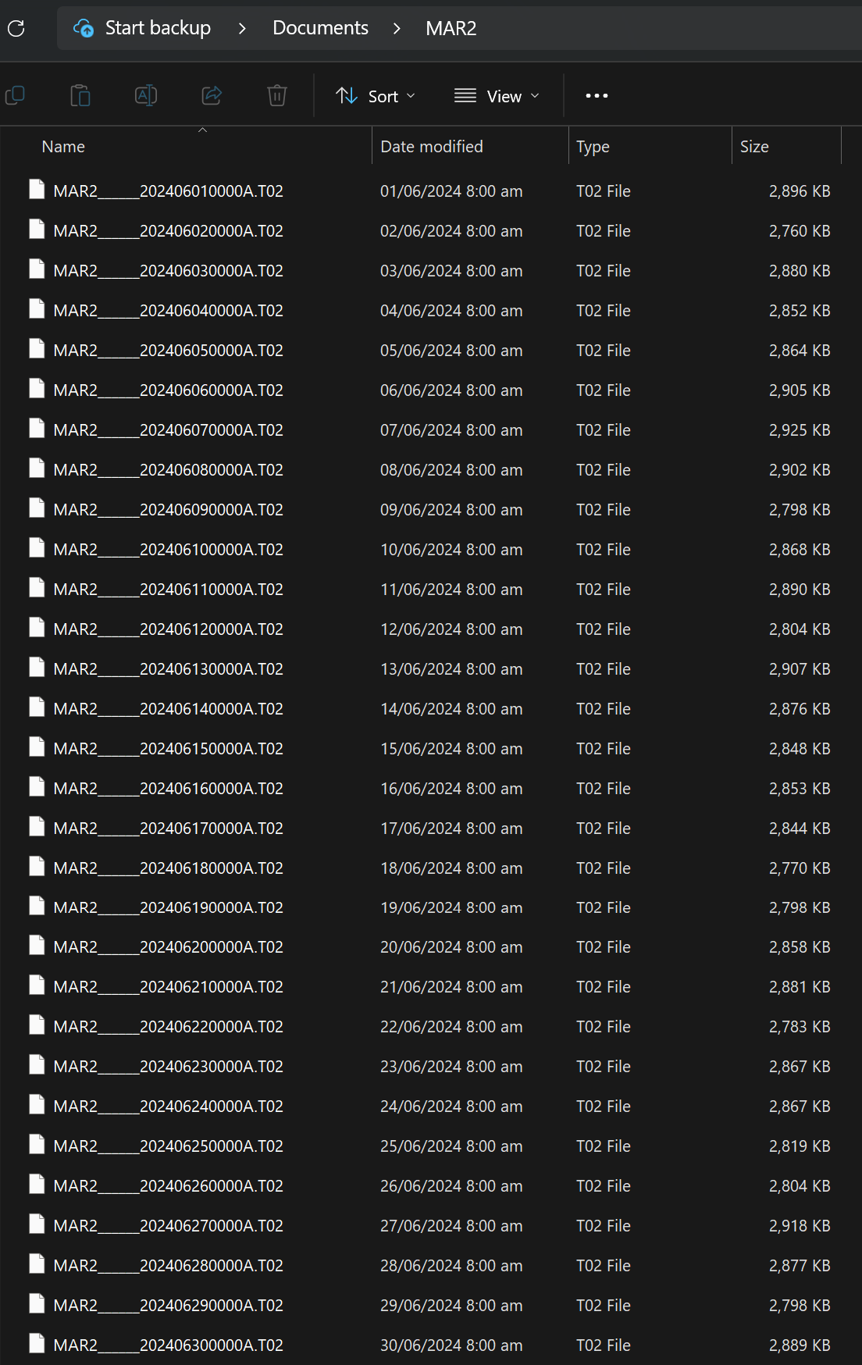

Sample raw data downloaded from a Trimble NetR9 receiver

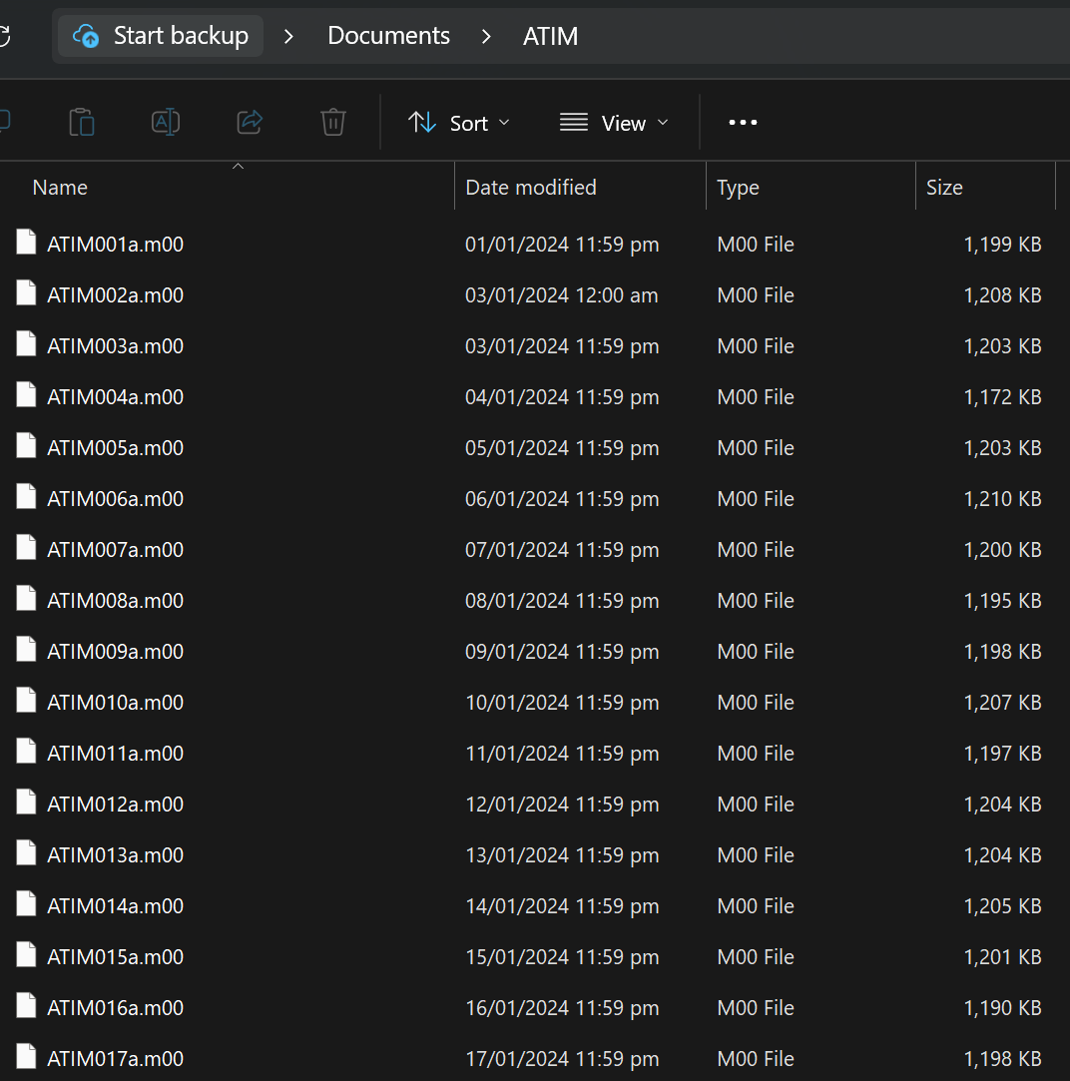

Sample raw data downloaded from a Leica receiver

4.4.2. Run continuous_v5.py.

4.4.2.1. Enter your 4-letter name (e.g., JUAN). When prompted with “Input Documents Folder”, type the 4-character site name (e.g., MAR2 or ATIM).
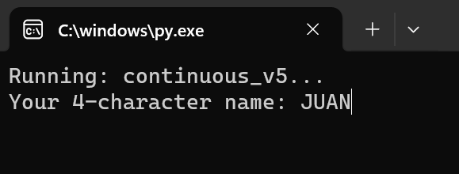

4.4.2.2. Upon entering the site name, the following prompt appears:
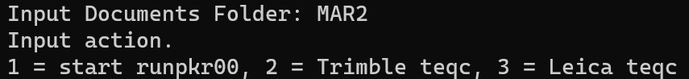

a. For Trimble data (.T00, .T01, or .T02), input “1” to run runpkr00.exe. This will convert all the raw Trimble files into teqc-readable files (.DAT or .TGD). Check if the .DAT/.TGD files are created in the current folder (e.g., c:\Users\Juan\Documents\MAR2). Each newly produced .DAT/.TGD file has the same file name as the raw data.
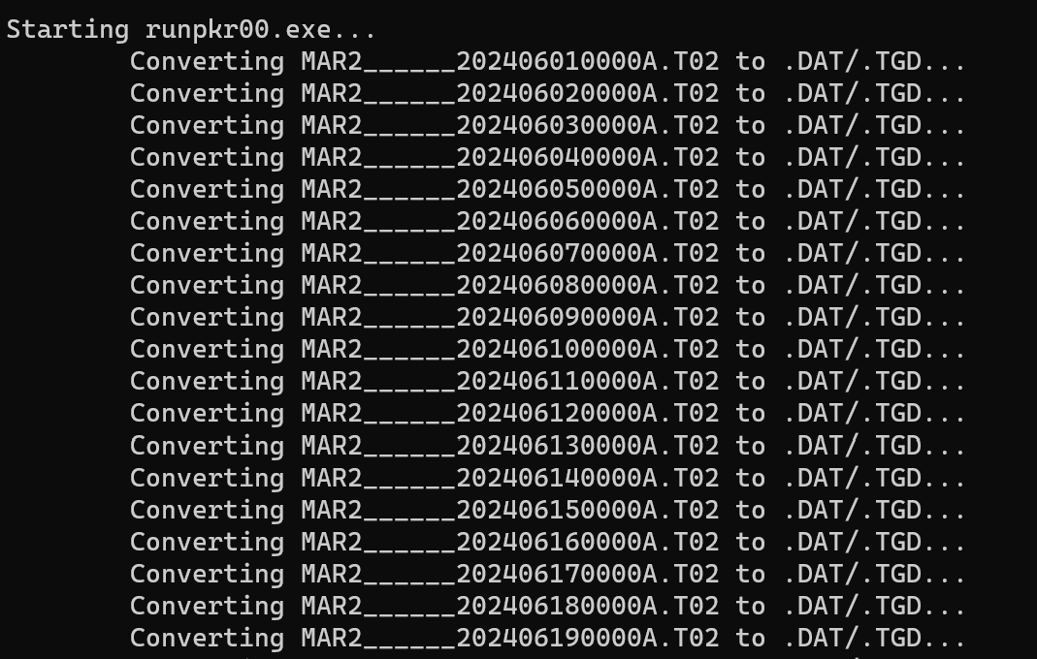
Then, input “2” and the site name (e.g., MAR2) to convert .DAT/.TGD files to RINEX using the teqc program.
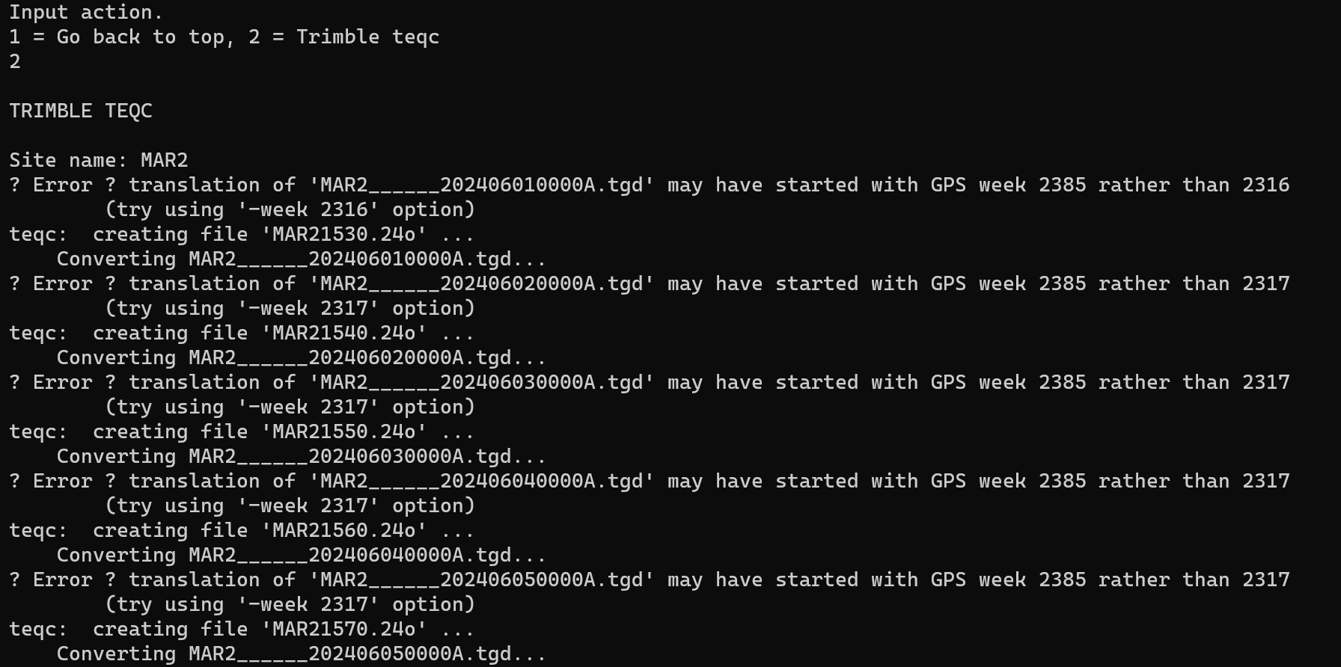

b. For Leica data (with a .m** extension), input “3” to convert the .m files to RINEX using the teqc program.
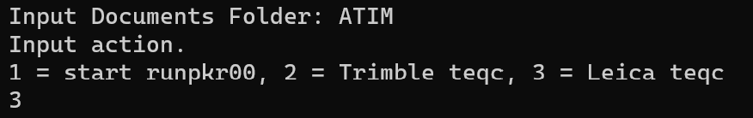
Next, proceed by typing the site name (e.g., ATIM) and the file extension “m”.
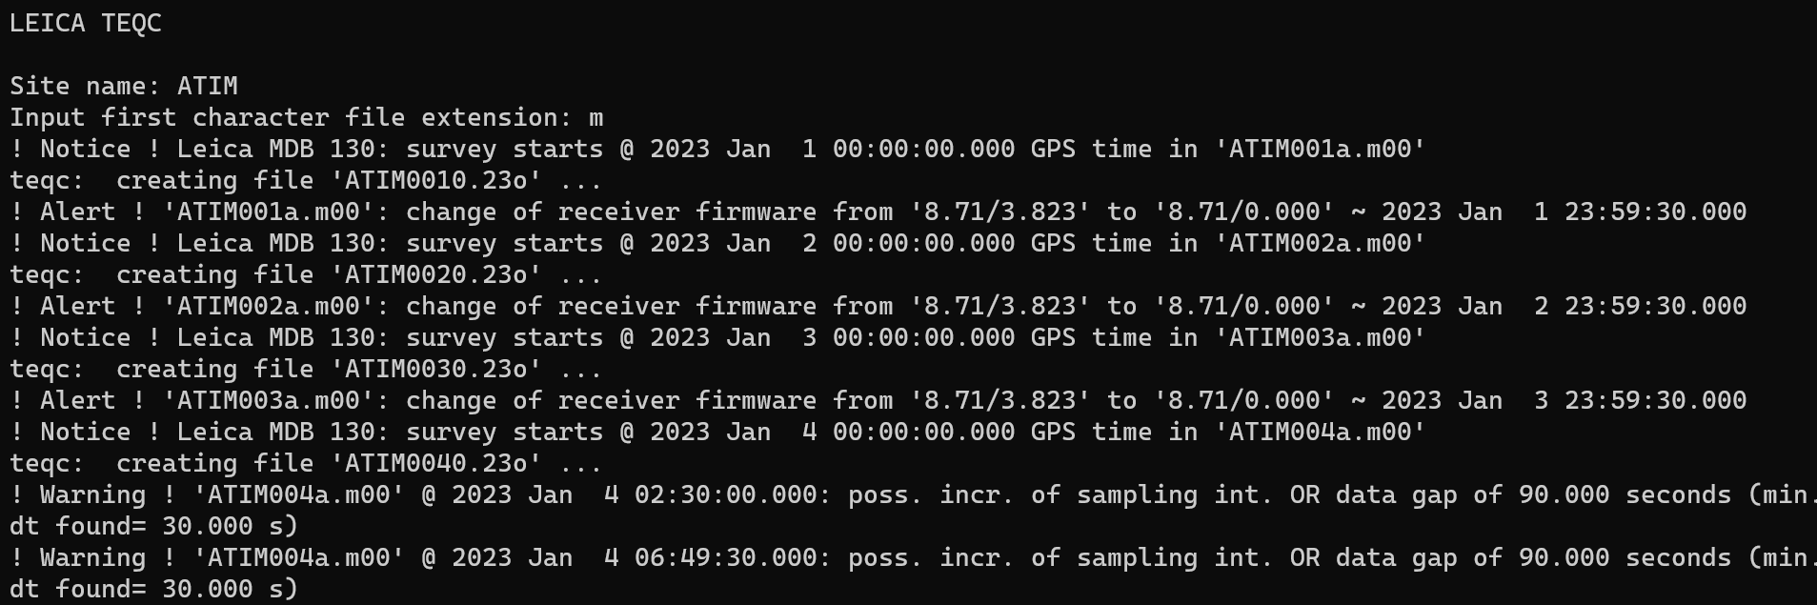

4.4.2.3. Finally, type “Ctrl + C” to close the script, “E” to go back to “Input Documents Folder” and convert another site, or “R” to retry the same site. If continuing to the next site, simply re-execute Step 4.4.2.2.
The RINEX files will be generated in their respective folders. As shown below, all raw data within their folders have been successfully converted into RINEX files. Review the headers of these files and edit any receiver or antenna information that is incomplete or incorrect.
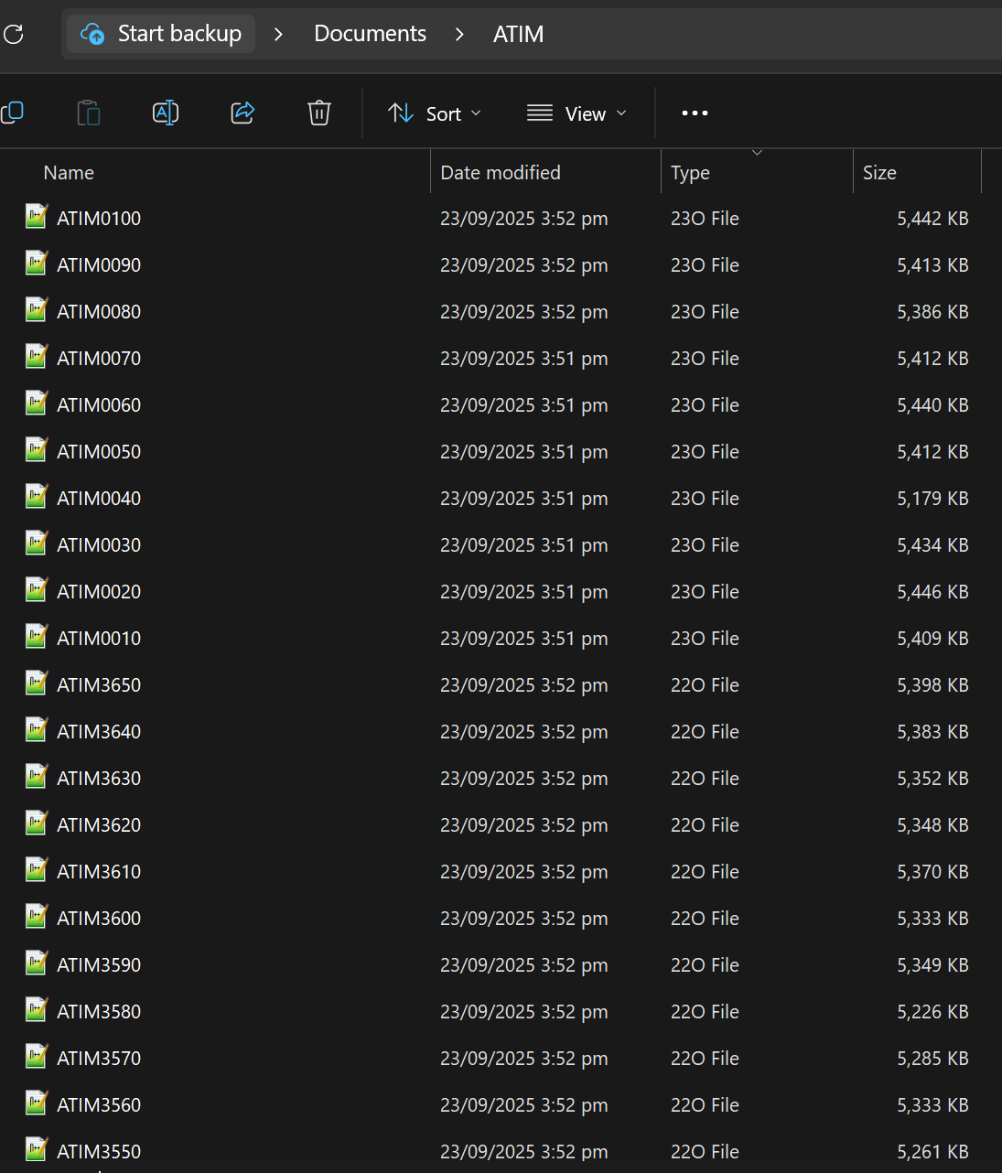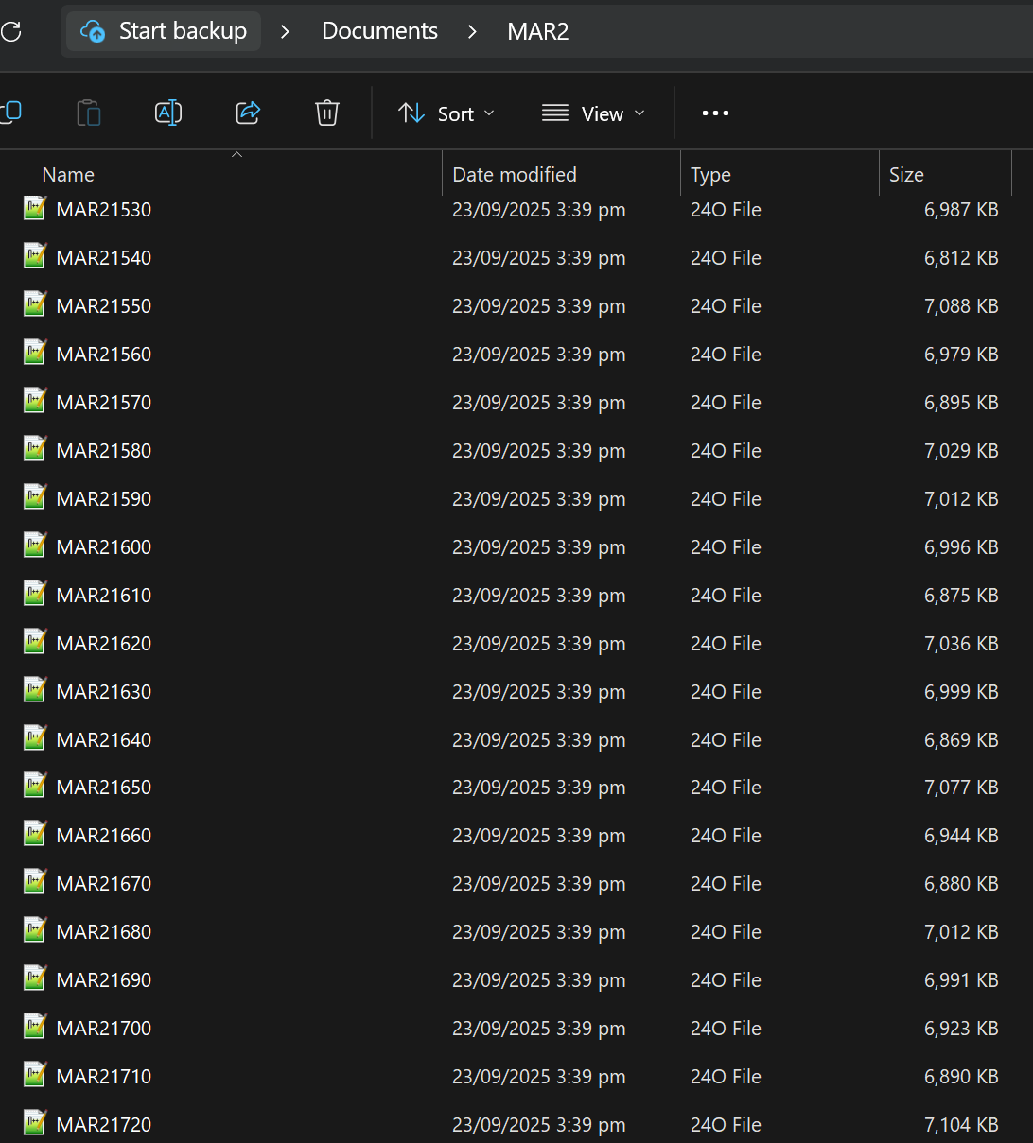

For example, the file ATIM0010.23o is the RINEX data for the ATIM site on January 1, 2023. Similarly, MAR21530.24o contains the data for the MAR2 site, observed on June 1, 2024.
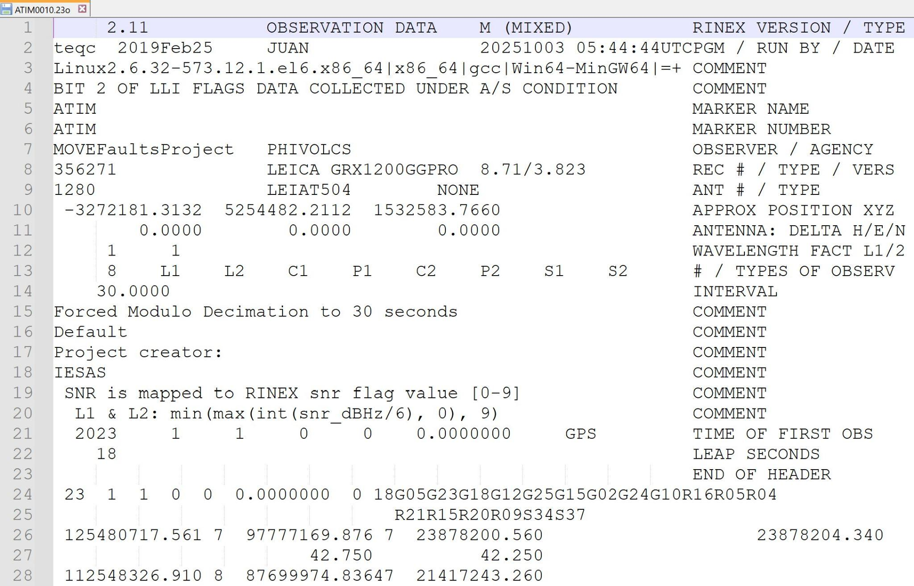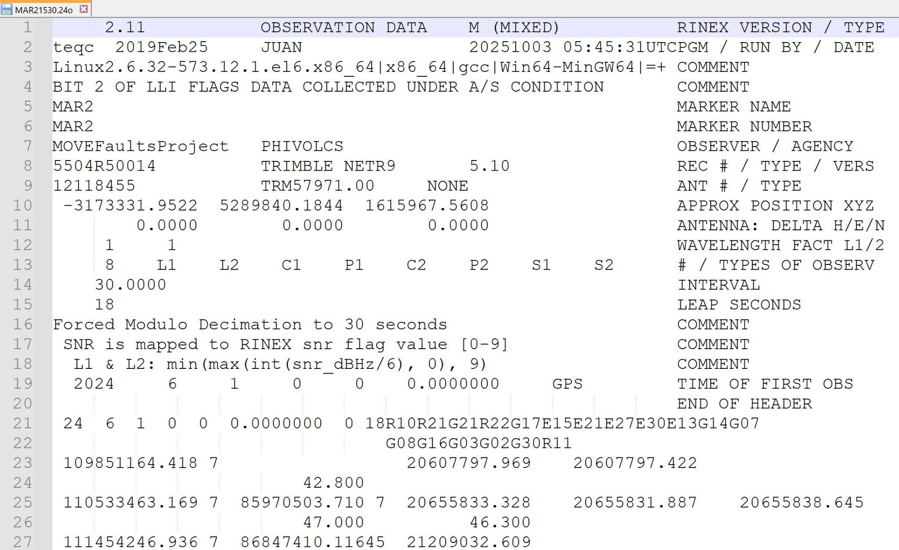
Sample daily RINEX observation files for ATIM and MAR2 stations

4.5. Troubleshooting

In case of Trimble .DAT or .TGD files with incorrect GPS week information, use the fixdatweek.exe utility to correct the issue. This may be encountered with the Trimble 5700 receiver type.

4.5.1. Check if the produced RINEX files have an incorrect year (.YYo) in their file extension (e.g., .05o instead of .25o).
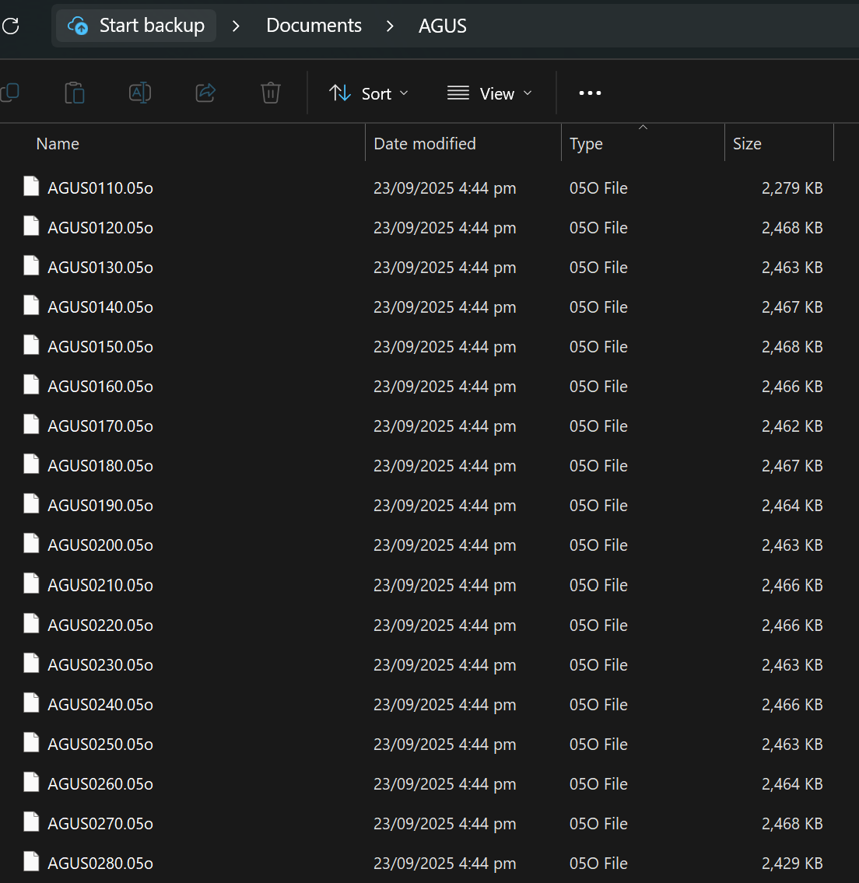

Sample RINEX file with incorrect GPS week information

4.5.2. Delete the RINEX files with the incorrect year. Then, move the .DAT/.TGD files to a new folder (e.g., fixdatweek) within the current directory.
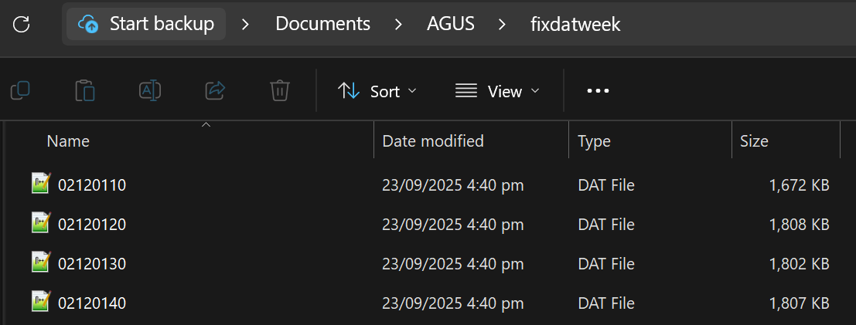

4.5.3. Copy fixdatweek.exe to the new folder.

4.5.4. Open a terminal window (command prompt) by typing cmd in the Windows search bar and pressing Enter, or left-clicking on "Command Prompt" in the search results.

4.5.5. Use the cd (Change Directory) command to navigate to the new folder containing both the fixdatweek.exe and the .DAT/.TGD files. Enter the command syntax cd followed by the absolute or relative path, C:\Path\To\Your\Folder (e.g., cd Documents\AGUS\fixdatweek).

4.5.6. Type dir/b>fixdatweek.bat. This will produce a fixdatweek.bat file in the current folder.

4.5.7. Edit fixdatweek.bat using Notepad++. Delete all lines except those that contain .DAT/.TGD files (e.g., delete lines 191 and 192 in the example below).
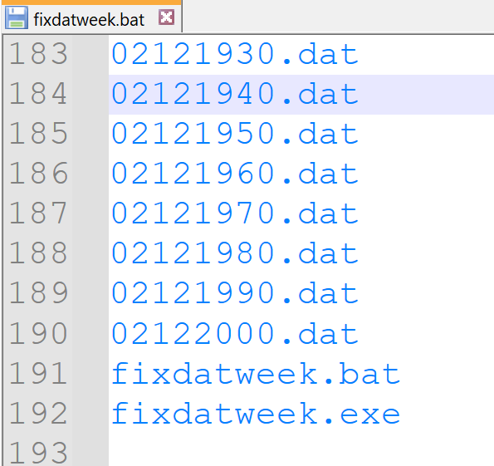

4.5.8. Insert fixdatweek.exe and a space before .DAT/.TGD file names (e.g., fixdatweek.exe filename.dat). Save file.
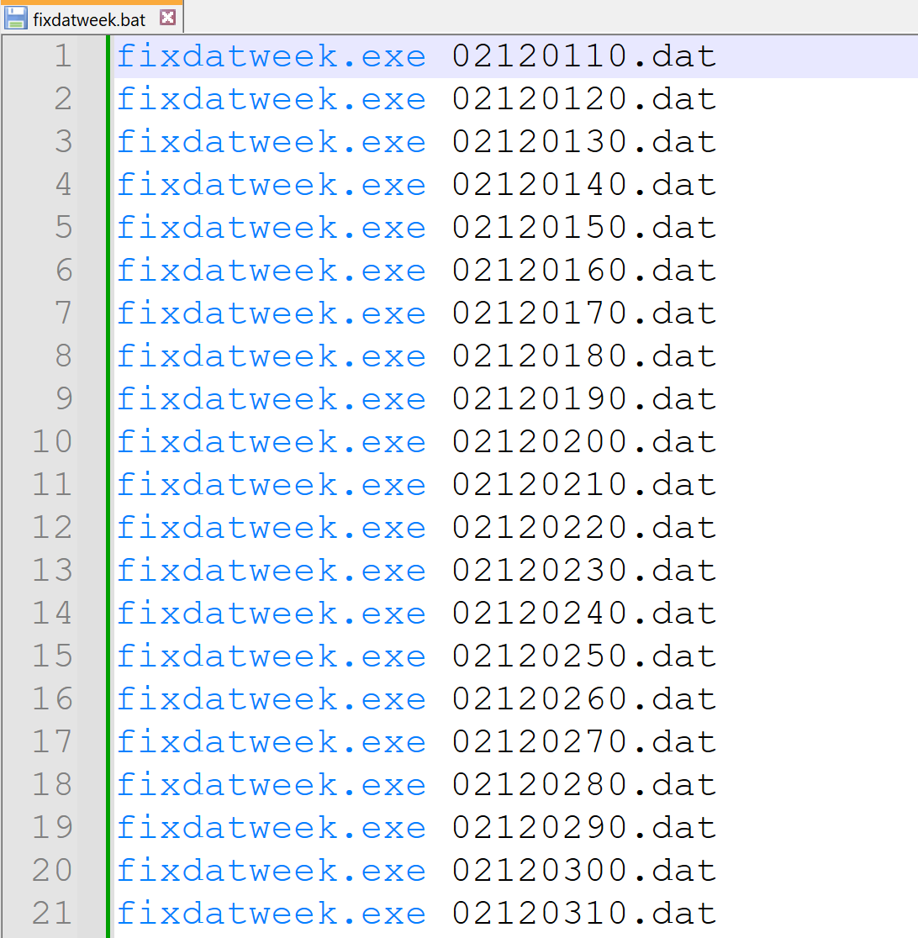

4.5.9. Run fixdatweek.bat by double-clicking on it. This will generate corrected .DAT/.TGD files with a prefix “wn_”.
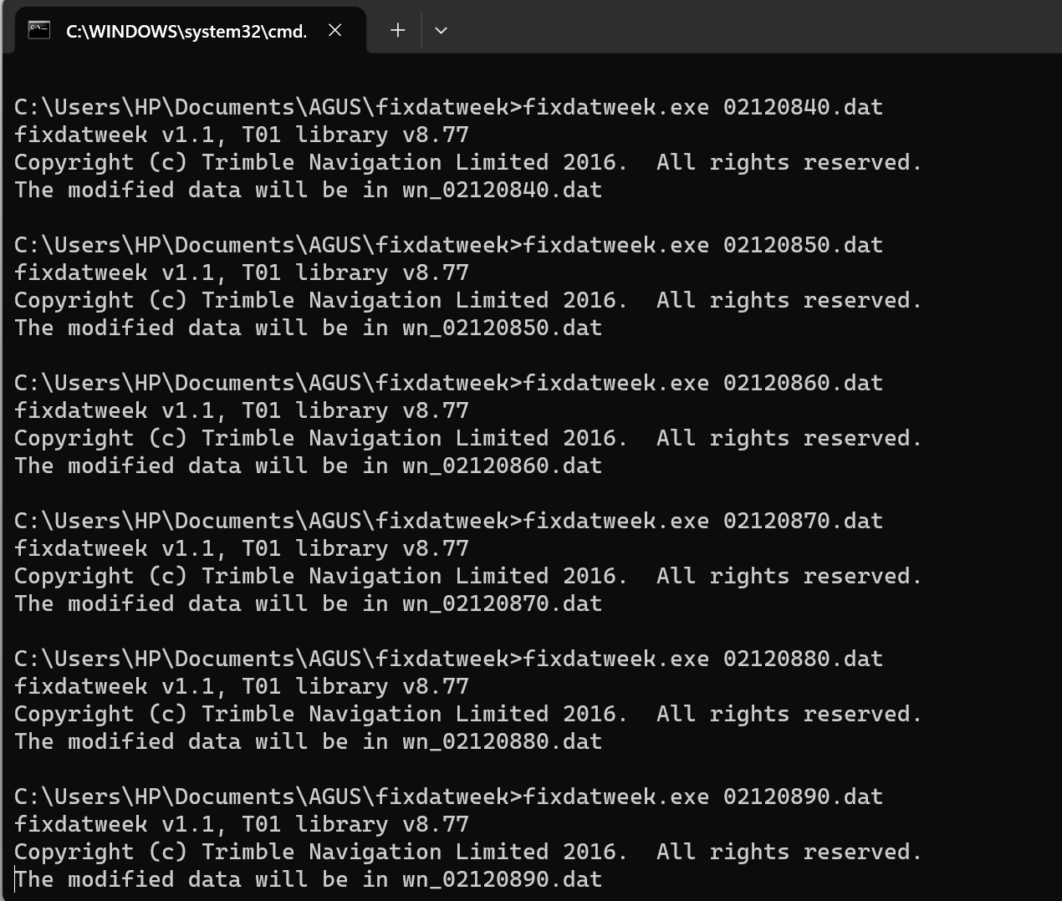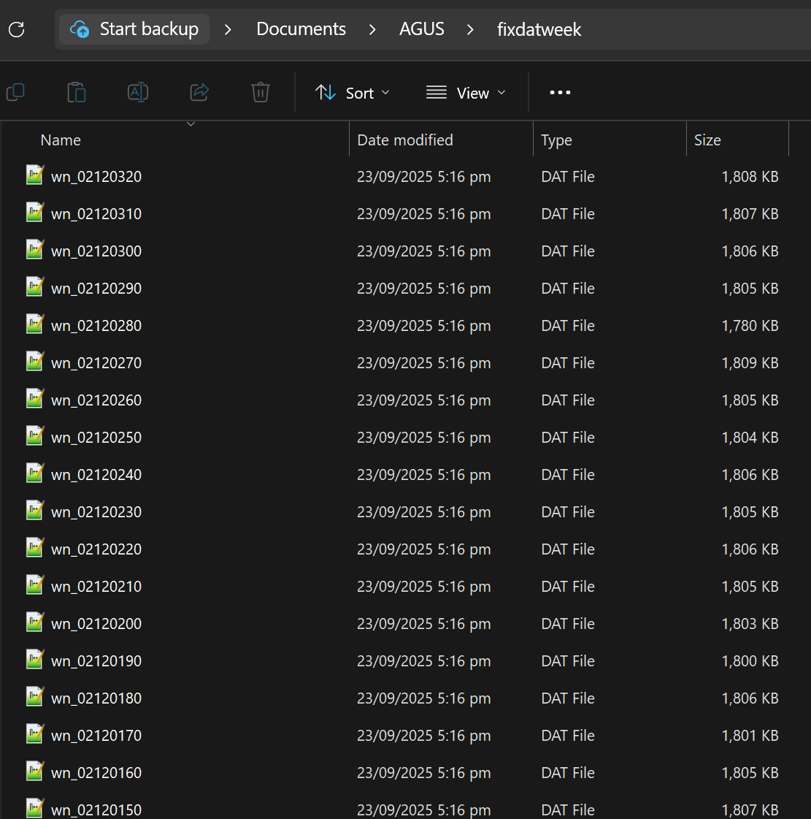

4.5.10. Transfer the wn_filename.dat (or .tgd) files back to the original directory.
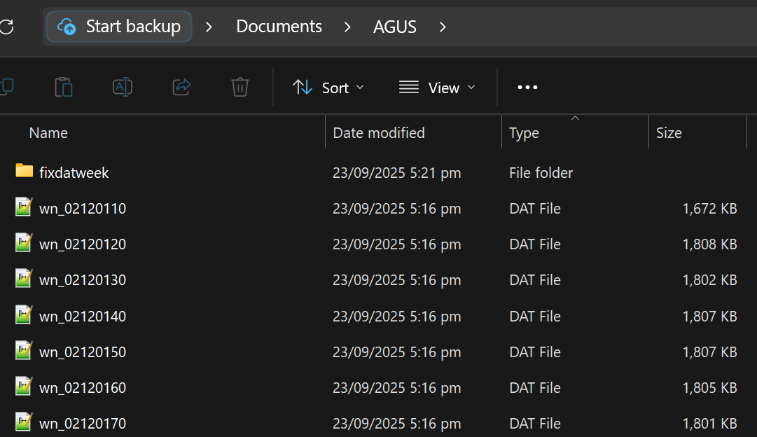

4.5.11. To convert the new .DAT/.TGD files to RINEX files, re-run the Python script for conversion straight to teqc.exe. Based on your data type, continue as follows:
- For campaign data, proceed from Step 4.3.3.3.
- For continuous data, go to Step 4.4.2.2.a, but skip running runpkr00.exe.

Procedure: Post-processing using Bernese GNSS Software Version 5.2

Now that the raw GNSS data is converted, the daily RINEX files can be processed. The following subsections discuss the step-by-step procedure for post-processing GPS data using the Bernese GNSS 5.2 Software. For first-time users, it is mandatory to complete Subsections 5.1 through 5.5. Users who already have an existing Campaign can skip ahead to Subsection 5.6.

The user manual of Bernese GNSS Software Version 5.2 is published by the Astronomical Institute of the University of Bern (AIUB) and can be accessed online at the official Bernese website: https://www.bernese.unibe.ch/. If you encountered any issues, refer to the BERN52 Solutions and Updates document, located on the Project’s Google Drive folder under 03 GPS > GPS Processing > 02 Guide, or consult the online FAQ at https://www.bernese.unibe.ch/faq/.

5.1. Installation

The Bernese GNSS Software is a commercial scientific software developed at AIUB for high-precision processing of multi-GNSS data. The software is installed using three setup wizards: BERN52, GPSUSER52, and CAMPAIGN52. These, along with the installation guide and the update procedure, are located in the Bernese_Install folder on the Project’s server. It is strongly recommended that the software be installed in a single folder directly on the root drive (e.g., C:\Bernese or D:\Bernese). After the execution of the Bernese installers, the following folders are automatically created:
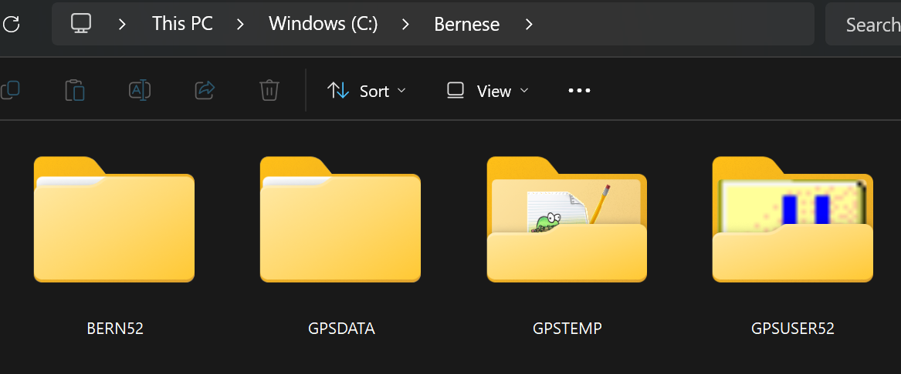

Bernese’s automation system, known as the Bernese Processing Engine (BPE), is used to process multiple PHIVOLCS sites by running the processing steps repeatedly on a session basis. It requires a Process Control File (PCF) to provide the list of scripts to run, variables to be used, parameters to be passed to each script, and instructions on how scripts are to be executed. PHIVOL_REL.PCF is a PCF file already prepared for the Project’s data processing purposes.

For the BPE to operate properly, the following software and tools need to be installed before Bernese:
- Perl | - scripting language used by Bernese; downloadable at activestate.com; this must be in Perl version 5.24 or newer
- gzip | - for managing RINEX data; downloadable at gzip.org; this should be included in the %PATH% variable
- Hatanaka | - for managing RINEX data; downloadable at terras.gsi.go.jp/ja/crx2rnx.html; this should be included in the %PATH% variable
- FTPSSL | - Perl module for file transfers via FTP over TLS/SSL connection; install via command prompt by typing ppm install Net-FTPSSL; this must be in version 0.40

5.2. Campaign setup

This subsection demonstrates how to create an active Campaign directory within c:\Bernese\GPSDATA\CAMPAIGN52, which is necessary for those using the Bernese software for the first time or simply starting a new Campaign.

5.2.1. To launch Bernese, double-click on the Bernese 5.2 icon located on either the taskbar or the desktop.
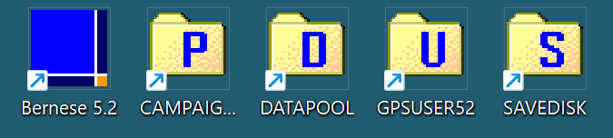

Upon launching the software, the Bernese Interface will be displayed, as shown in the image below. It consists of three main components:
Menu | provides access to all the Bernese programs, BPE, and Online Help
Input Panels | the main window, where a series of panels are used to configure the processing options for each Bernese program (this will appear once an item from the menu is selected)
Status Bars & Buttons | provides the information on the current campaign, session, input panel, and the user, and features a set of action buttons, such as Next, Run, and Save, to perform program operations
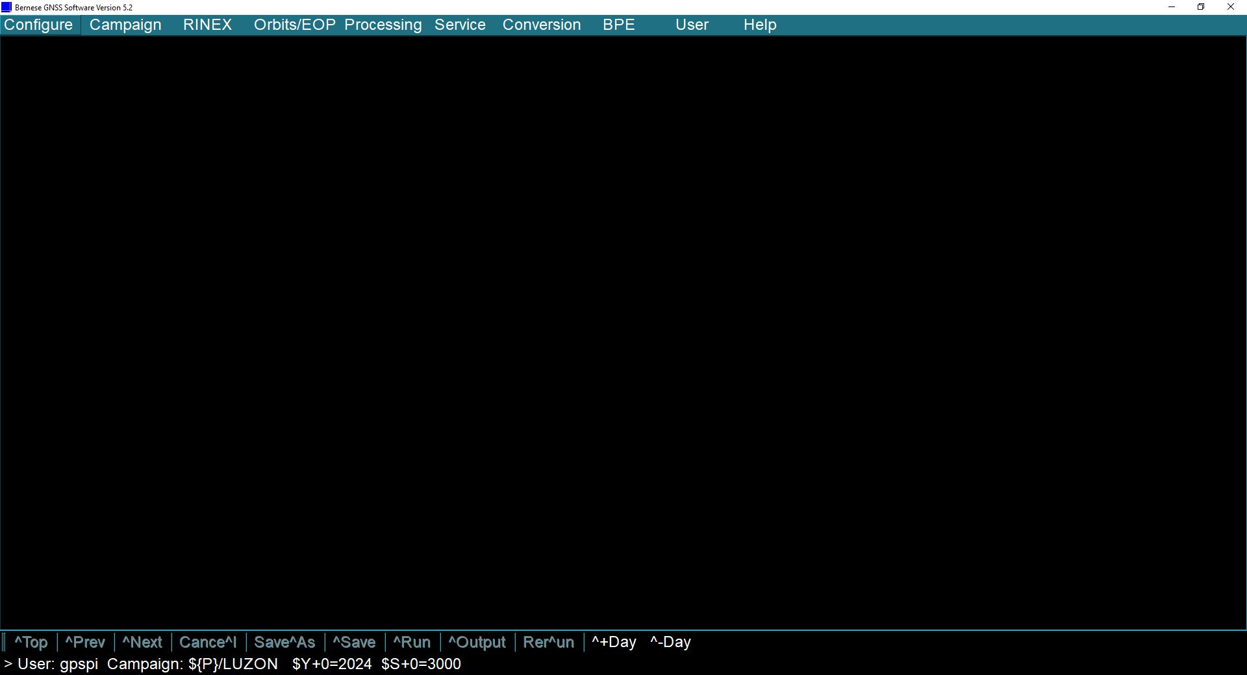
Input Panels
Status Bar
Menu
Bernese Interface

5.2.2. An active Campaign directory must first be created before processing any RINEX data. Start this process by choosing Campaign > Edit list of campaigns from the main menu. On the list of Campaigns, click on the “+” button, double-click the text box to edit, then type the Campaign name (e.g., PHIVOLCS). Save the list by clicking the Save button or by pressing Ctrl + S.
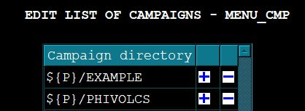

Note: Do not remove the ${P}/ at the beginning of the Campaign name, as this tells Bernese where the folder is located. The Campaign name should be no more than 8 characters and must be in uppercase letters. The Campaign directory may also be removed by clicking the “-” button.

5.2.3. To choose the Campaign you want to work on, select Campaign > Select active campaign. Select the desired Campaign name (e.g., PHIVOLCS) from the list of existing Campaigns, and then click OK.
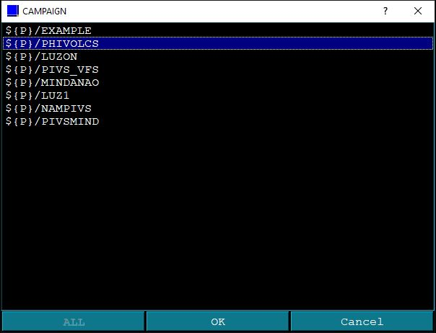

5.2.4. After setting up an active Campaign, create the subfolders that Bernese uses during processing. To do this, select Campaign > Create new campaign. On the NEWCAMP panel, you will see the subfolders to be created. Click Run or press Ctrl + R. Ignore any pop-up message and check the subfolders inside the active Campaign directory (e.g., c:\Bernese\GPSDATA\CAMPAIGN52\PHIVOLCS).
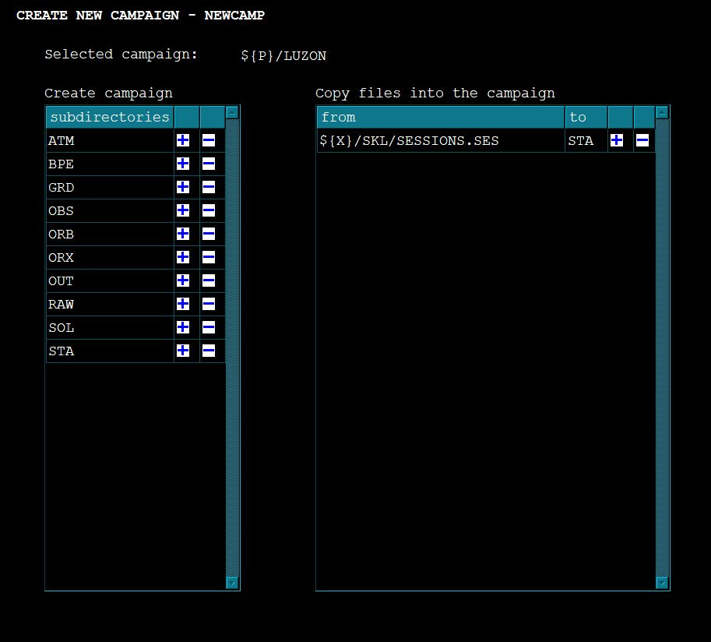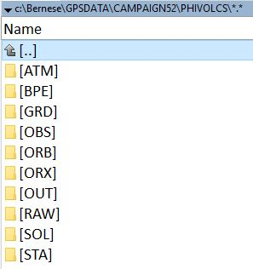
The purpose of each subfolder is listed below.
ATM | Atmospheric files, both input and output files, are placed in this folder. Examples include global ionospheric models obtained from the IGS and tropospheric zenith path delay files generated by Bernese.
BPE | Output from the BPE scripts
GRD | Station and atmosphere-related grid files are stored here. These files contain VMF1 coefficients and station displacement models.
OBS | Bernese format observation files (CZH, CZO, PZH, PZO, CSH, CSO, PSH, PSO) can be found here once RINEX files have been imported.
ORB | Satellite orbits, Earth rotation parameters, and differential code biases are stored in this folder.
ORX | This folder is used to store original hourly RINEX observation files, before concatenation or sampling.
OUT | Output from the various Bernese programs is written to this folder. The first place to look for results and debug problems.
RAW | RINEX files that are ready for importing to Bernese format.
SOL | Bernese Normal Equations are placed here for later combination or re-processing.
STA | Station coordinates, receiver information, abbreviations, and so forth are stored in this folder.

5.2.5. Create a session table by selecting Campaign > Edit session table. The default SESSION TABLE panel for a daily session will be displayed. Click Save or press Ctrl + S to save the Session Table. This will produce a SESSIONS.SES file inside the STA folder.
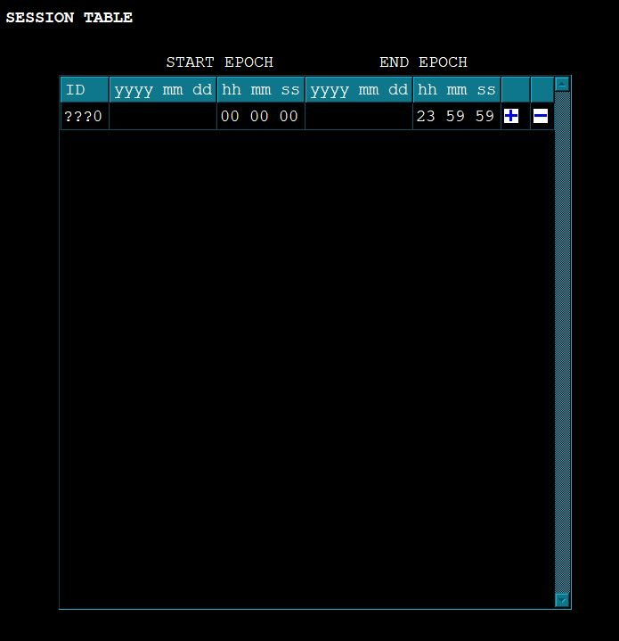

5.2.6. Examine the available menu variables that can be incorporated into the program options by accessing Configure > Menu Variables. The MENU VARIABLES is split into two panels: the first shows predefined, user-defined, and environment variables, while the second provides a complete list of all available variables. These are automatically replaced with the date of the current session during processing.
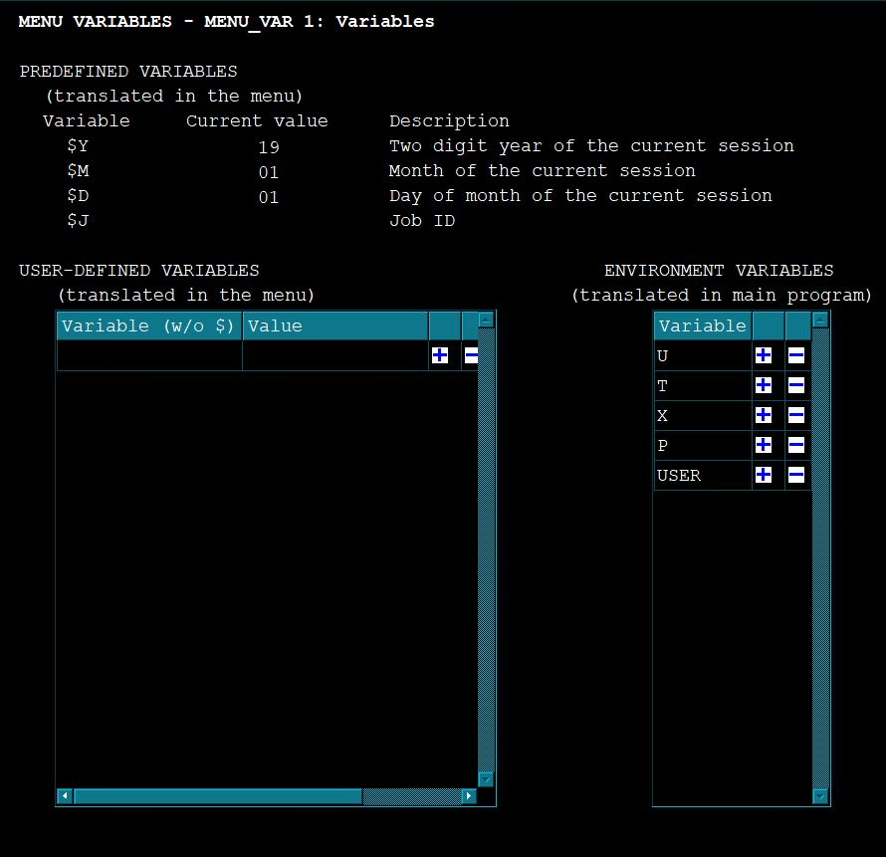
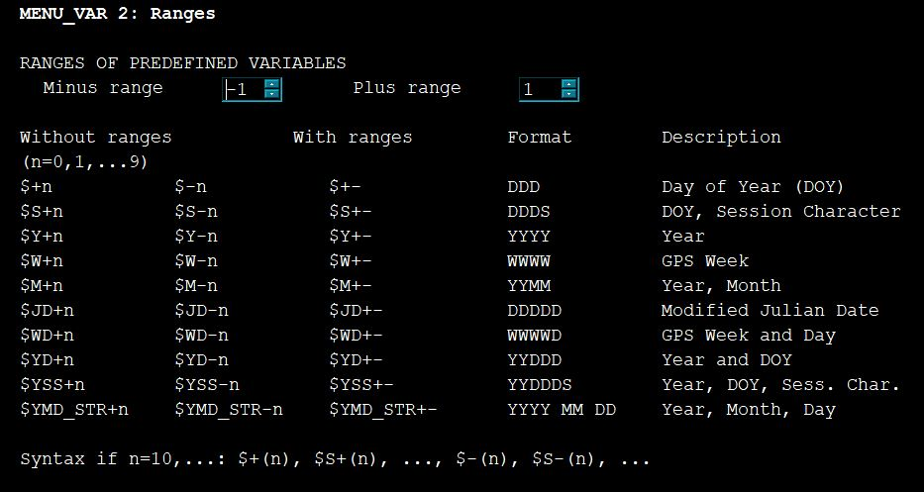

5.3. Preparation of Campaign files

To run a Campaign, Bernese requires a set of pre-prepared input files related to your stations located within the active Campaign’s STA folder (e.g., GPSDATA\CAMPAIGN52\PHIVOLCS\STA). These files (see table below) contain general information on receivers, antennas, approximate coordinates, tectonic plate assignments, atmospheric and ocean tidal loading coefficients, and other relevant details.

Abbreviation | Bernese Input File
STA | Station Information File
CRD | Coordinate File
ABB | Abbreviation File
ATL | Atmospheric Tidal Loading Coefficients File
PLD | Plate Definition File
VEL | Velocity File
CLU | Cluster File
BLQ | Ocean Tide Loading Coefficients File

For this subsection until Subsection 5.5, we will keep using PHIVOLCS as the active Campaign. We will also use the RINEX observation data from multiple sites in the PHIVOLCS network, along with the S01R station in Taiwan. The continuously operating station S01R, which sits on the stable Chinese continental margin, will serve as the reference point for plotting the time series.

5.3.1. Open File Explorer (or your preferred file manager like Total Commander). Manually create a folder in the DATAPOOL directory. Name this folder with the same name as the Campaign name. Copy the RINEX observation files to the folder you created.
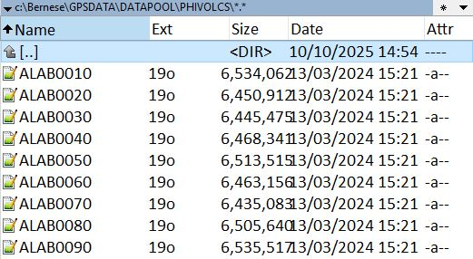

5.3.2. To set the starting date of the Campaign session, go to the Bernese interface and click on Configure > Set session. On the Date Selection Dialog, click the button next to the Year Month Day (YYYY MM DD) field and enter the start date of the data to be processed (e.g., 2019 01 01). You may enter the date in any of the other available formats. Click Compute > Set > OK.
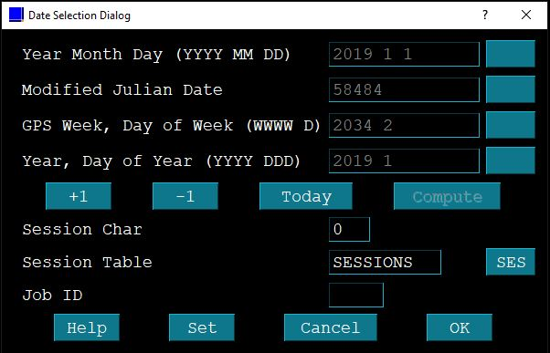

5.3.3. Using your preferred file manager, copy the RINEX files of the current session date from DATAPOOL to the RAW folder of the Campaign.
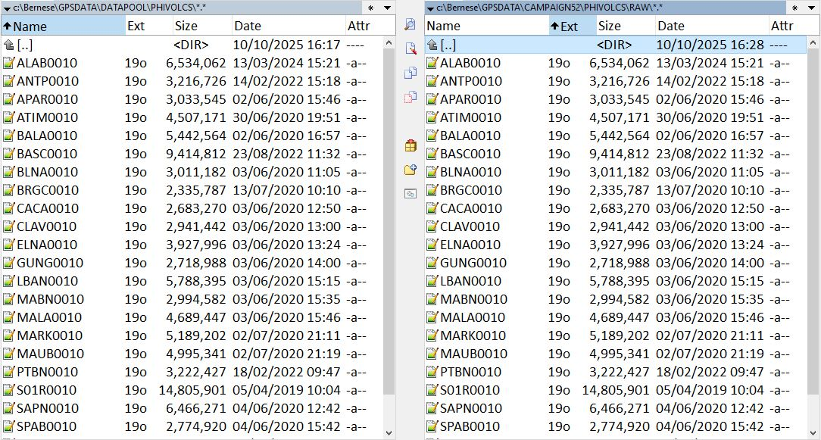

5.3.4. Create the Station Information (STA) File using the RNX2STA program, which extracts the header information directly from the RINEX files.

5.3.4.1. From the main menu, go to Service > Station information files > Extract information from RINEX.
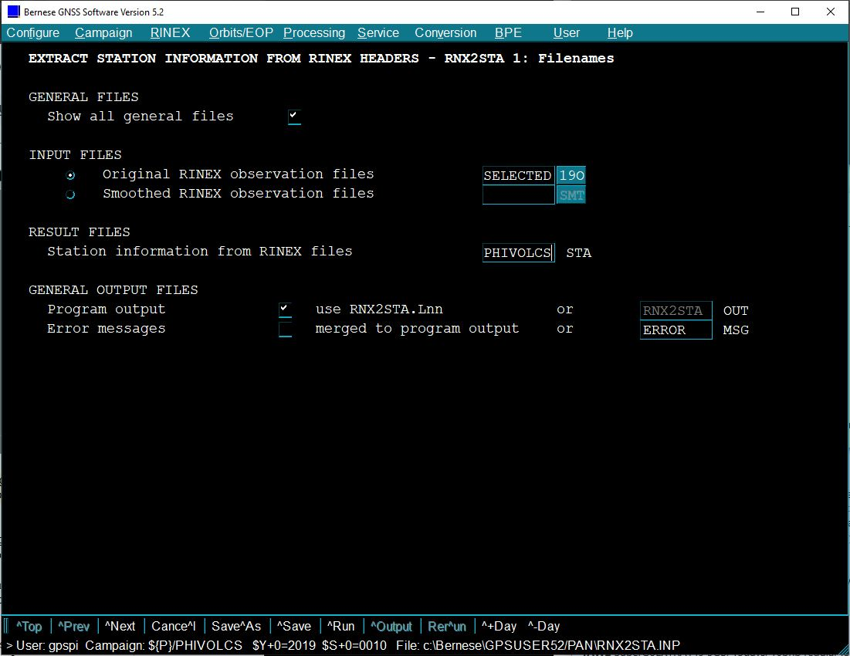

5.3.4.2. On the RNX2STA 1 panel, click the button next to Original RINEX observation files. This opens a dialog box showing the contents of the RAW folder. Choose all RINEX observation files for the current session date, and then click Open.
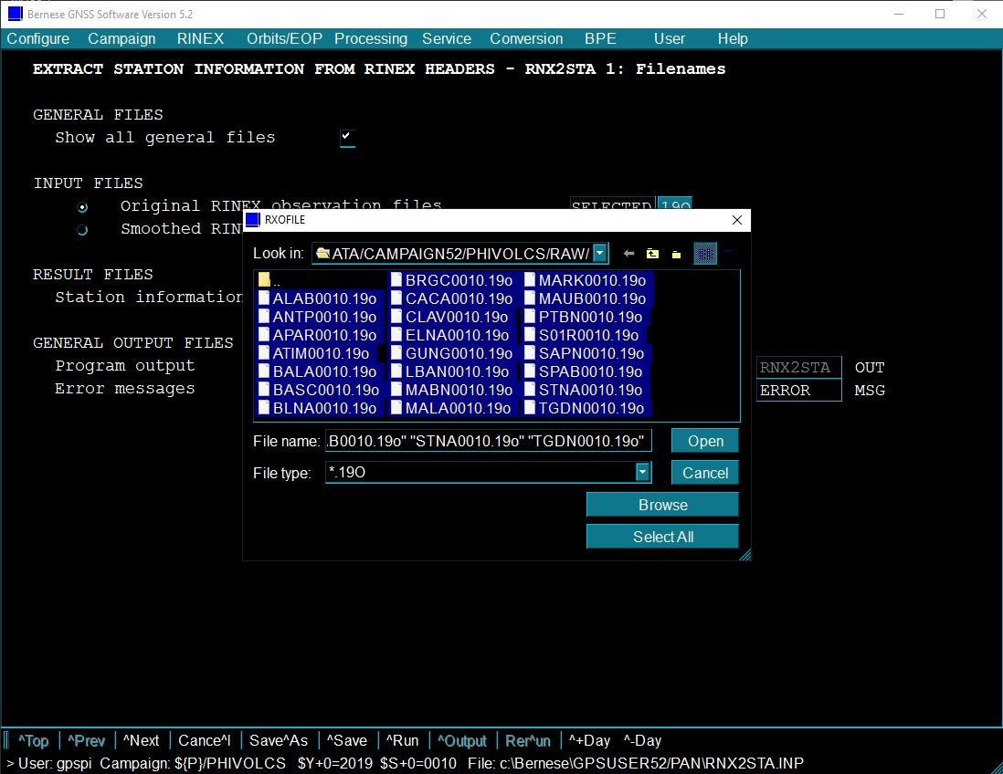

5.3.4.3. In the field labeled Station information from RINEX files, type PHIVOLCS as the file name for the STA file. This should be changed accordingly depending on the Campaign. Select Run or press Ctrl + R. The resulting PHIVOLCS.STA file, containing the information on receiver and antenna combinations, will be created in the STA folder.
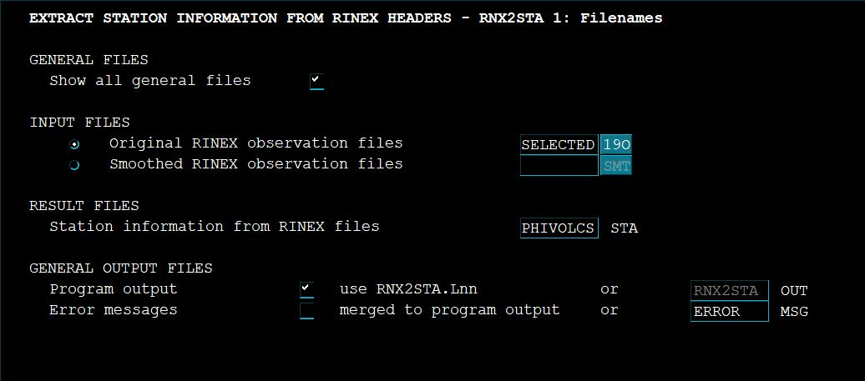

5.3.5. Create the Coordinate (CRD) and Abbreviation (ABB) Files using the RXOBV3 program.

5.3.5.1. Back to the main menu, select RINEX > Import RINEX to Bernese format > Observation files.

5.3.5.2. Similar to Step 5.3.4.2, select all RINEX observation files that match the current session date on the RNX2STA 1 panel.

5.3.5.3. Type the file name of the STA file created in the previous step into the Station information file field. Input PHIVOLCS as the file name for the CRD file in the text box for Update coordinates. Always name it after the Campaign name.
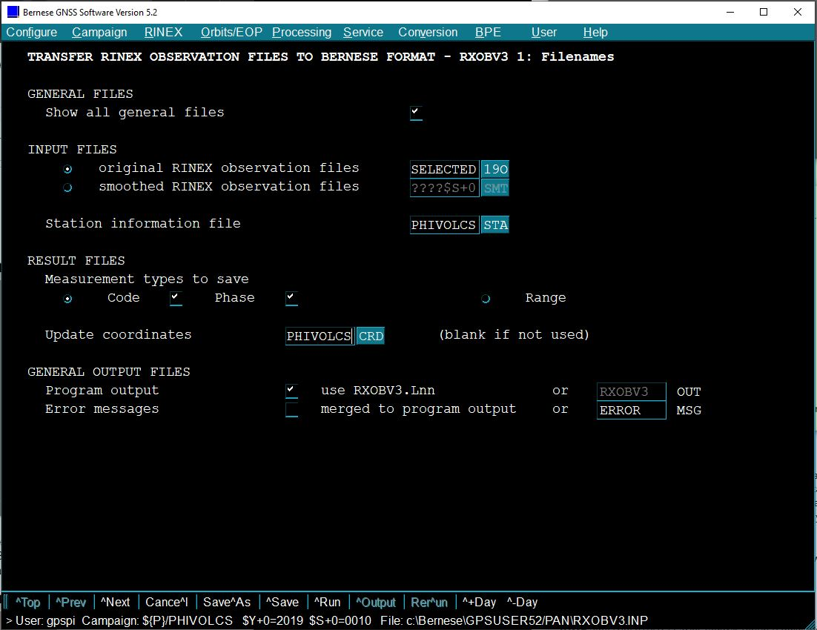

5.3.5.4. Click Next (or press Ctrl + N) to show the RXOBV3 1.1: General Files panel. Ignore the pop-up message. Edit the file name of the ABB file to PHIVOLCS in the Abbreviation table field. Click Run or press Ctrl + R.
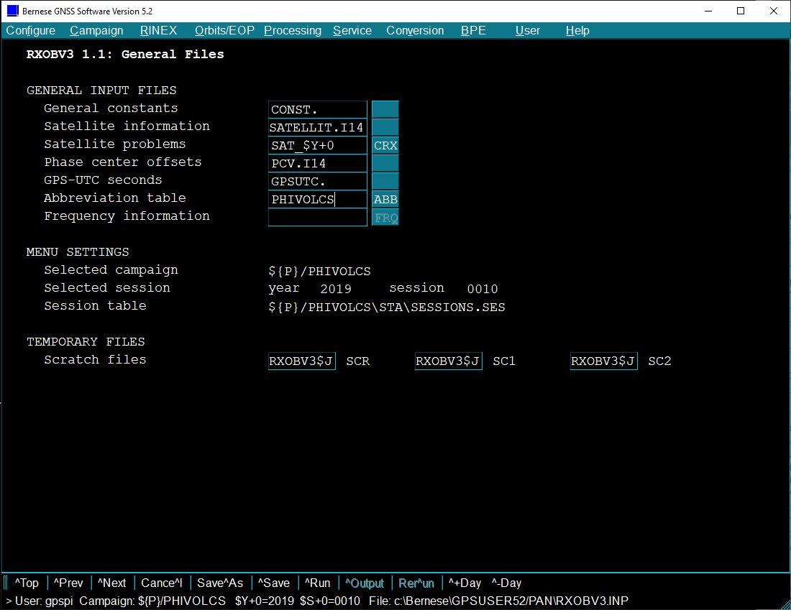

5.3.6. To create the Atmospheric Tidal Loading (ATL) Coefficients File, use the GRDS1S2 program by accessing Service > Coordinate tools > Extract atmospheric tidal loading coefficients. You will be redirected to the first panel, GRDS1S2 1: Filenames. Write the file name of the recently created CRD file, PHIVOLCS.CRD, in the Input coordinate file field. Now, input PHIVOLCS in the S1/S2 loading coeff. box. Click Run or press Ctrl + R to produce a result file named PHIVOLCS. ATL.
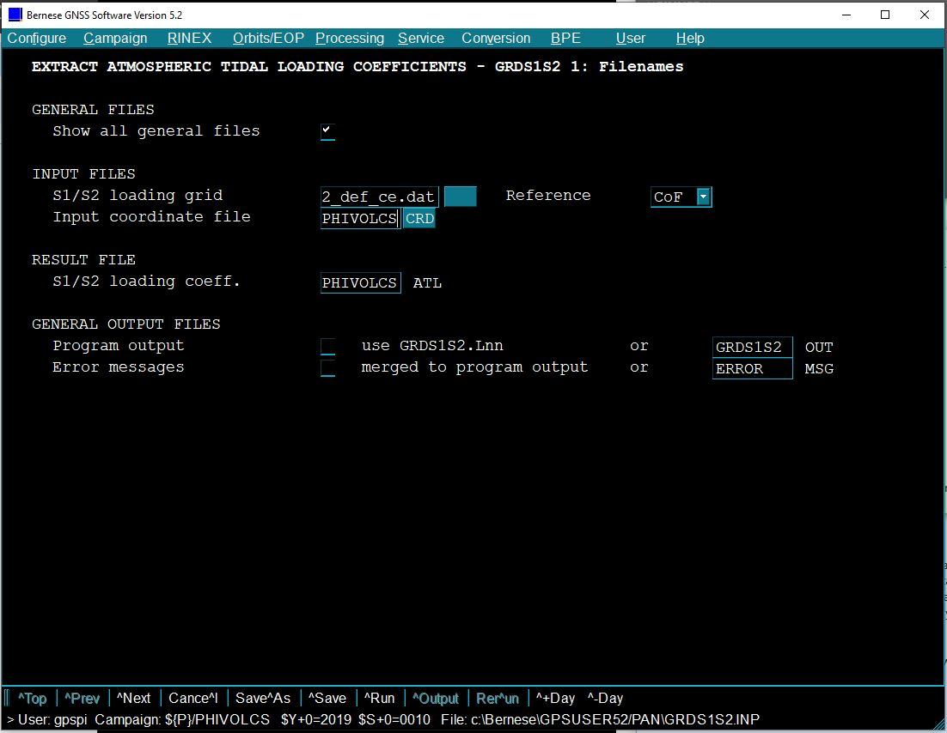

5.3.7. Open the EDITPLD program by clicking Campaign > Edit station files > Tectonic Plate Assignment to create the Plate Definition (PLD) File.

5.3.7.1. In the file dialog box, type “PHIVOLCS” with the file extension .PLD in the “File name" text box and click OK.
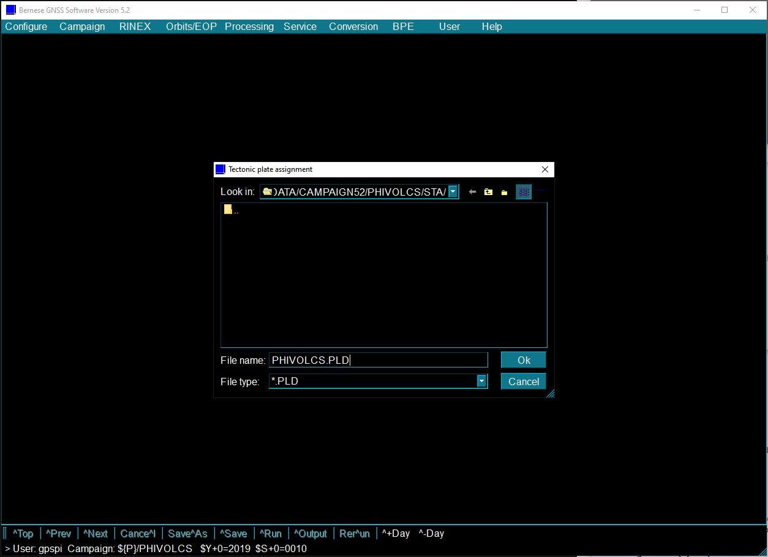

5.3.7.2. In the “Select Skeleton Coordinate File” window, select the CRD file you have previously created, and then click Open.
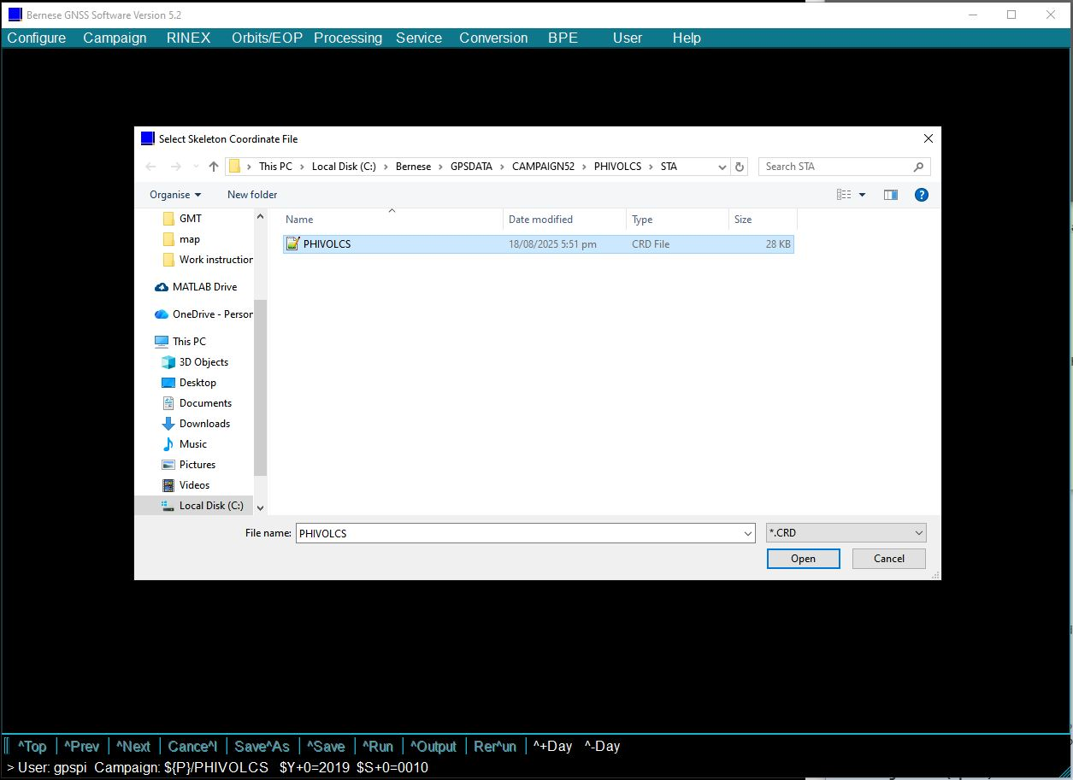

5.3.7.3. After selecting the CRD file, the EDITPLD panel is displayed. You must then manually assign a plate for each site from the 14 available tectonic plates, as shown in the image below. Double-click on the text box under the Plate column to edit and type the correct plate. In this case, use EURA since the PHIVOLCS sites lie on the Eurasian Plate. Click the “+” button to add sites or the “-” button to remove sites. Click Save or press Ctrl + S.
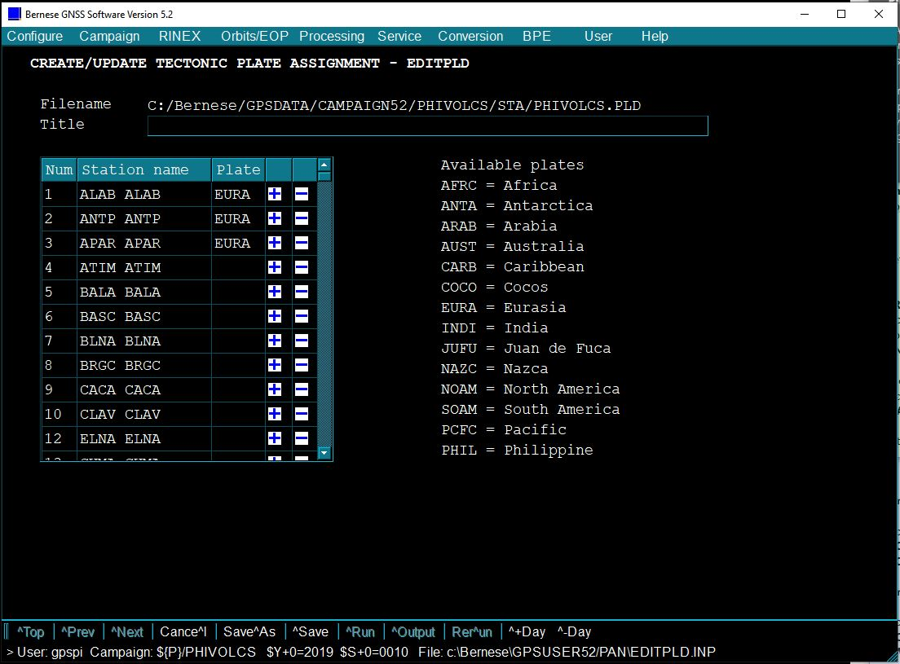

5.3.8. With the tectonic plate assignment and approximate station coordinates, the velocity file can now be created. Generate the Velocity (VEL) File using the NUVELO program.

5.3.8.1. From the main menu, select Service > Coordinate tools > Compute NUVEL velocities to open the NUVELO 1: Input/Output Files panel.

5.3.8.2. Write the file names of the created CRD and PLD files in the Input coordinate file and Plate definition file fields, respectively. Name the VEL file after the Campaign name in the Output velocity file field.
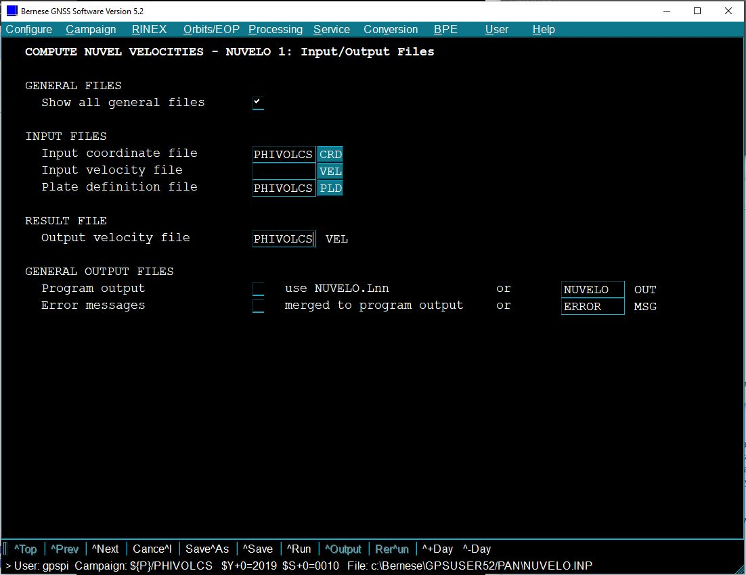

5.3.8.3. Click Next (or press Ctrl + N) twice to go to the third panel, and make sure that the velocity model is NUVEL1A. Click Run or press Ctrl + R.

5.3.9. Create the Cluster (CLU) File using the EDITCLU program. Click Campaign > Edit station files > Cluster definition file. In the file dialog box, type “PHIVOLCS” with the file extension .CLU in the “File name" text box and click OK. Similar to Step 5.3.7.2, select the CRD file you have previously created on the “Select Skeleton Coordinate File” window, and then click Open. On the EDITCLU panel, make sure that all sites are included. Click Save or press Ctrl + S.

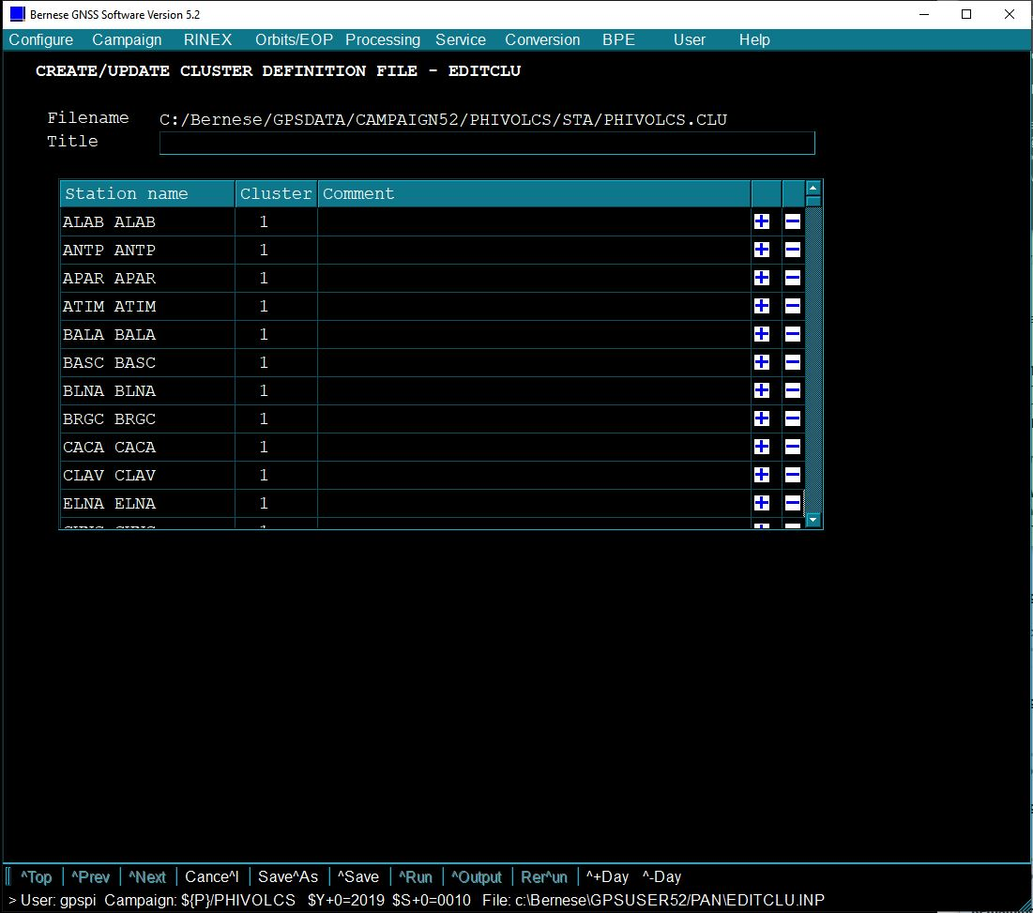

Note: As long as the number of files is under 100, Bernese will automatically assign all stations to cluster 1.

5.3.10. Create the Ocean Tide Loading Coefficients (BLQ) File. This is the only file created outside of Bernese.

5.3.10.1. Open an internet browser. Go to http://holt.oso.chalmers.se/loading/. On the webpage, look for “If you still prefer to use Holt, click here.” and click the hyperlink. This will redirect you to another webpage. Scroll down until you find the dropdown menu of Select ocean tide model and choose the “FES2004” model from the list.
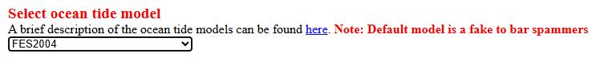

5.3.10.2. Leave all other options as they are and scroll further down to the input textbox. Copy and paste the site name and XYZ coordinates from the CRD file into the empty textbox. Adjust the spacing using spaces and avoid using tabs.
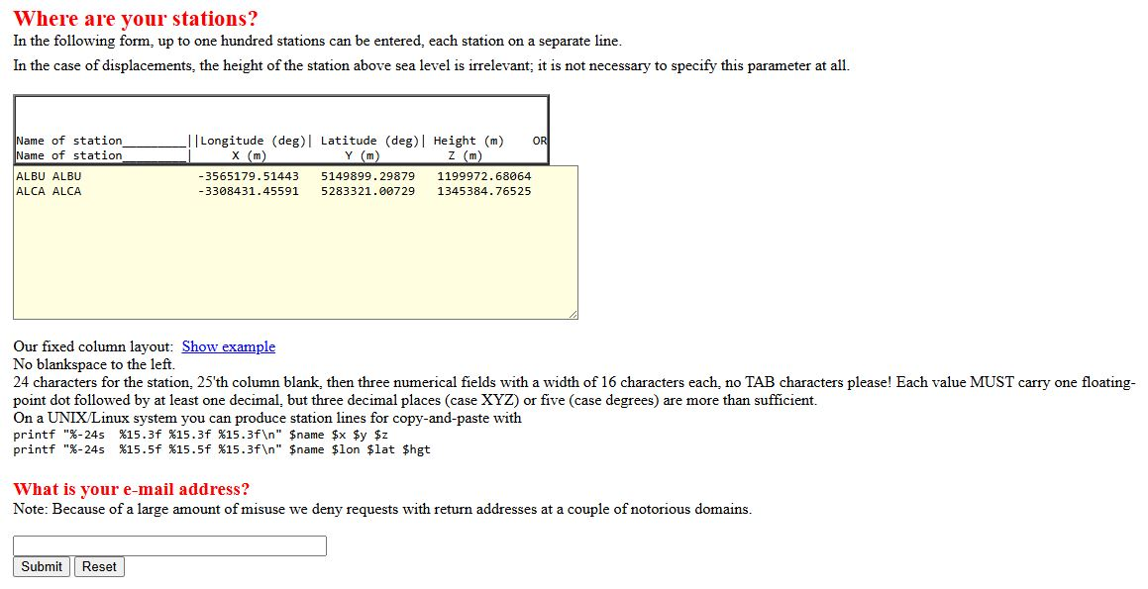

5.3.10.3. Enter your email address and click Submit. An email will be sent shortly.

5.3.10.4. Open File Explorer (or your preferred file manager like Total Commander) and navigate to the folder GPSDATA\DATAPOOL\REF52. Locate the EXAMPLE.BLQ file and open it using Notepad++.
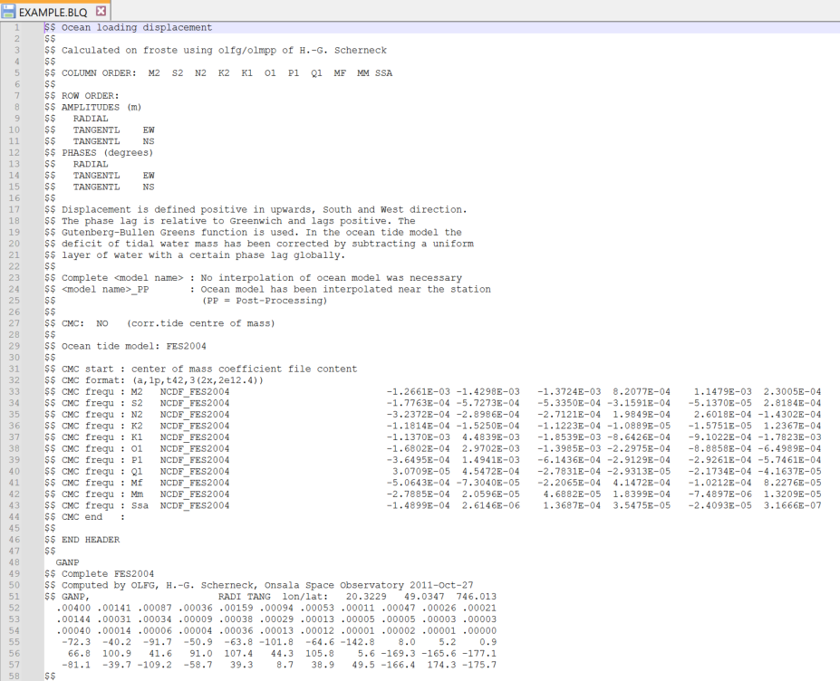
EXAMPLE.BLQ

5.3.10.5. Copy everything from the e-mail after the END HEADER line. Replace the content after the END HEADER line in the EXAMPLE.BLQ file. Refer to the sample below.
EXAMPLE.BLQ file
$$
$$ END HEADER
$$
* paste the content from the e-mail *
$$ END TABLE

5.3.10.6. Go to “File” > “Save As”. Locate the STA folder and save the file by setting “File name” to “PHIVOLCS.BLQ” and “Save as type” to “Normal text file”. Click Save.
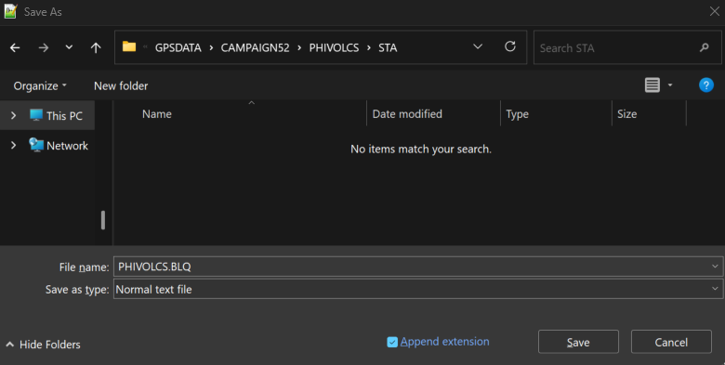

5.3.11. Go to the STA folder. Then, copy all eight Campaign files (STA, CRD, ABB, ATL, PLD, VEL, CLU, and BLQ) and paste them into DATAPOOL\REF52.

5.4. BPE Setup

With the Campaign’s station-related files now created, the next step is to edit PHIVOL_REL.PCF and the RNXGRA program for the automated processing.

5.4.1. From the main menu, click on BPE > Edit process control file (PCF) > PHIVOL_REL.PCF > OK.
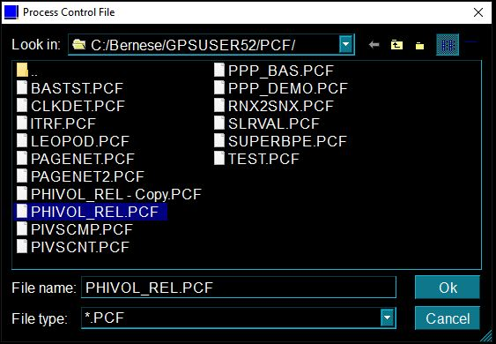

5.4.2. Click Next (or press Ctrl + N) until you reach the EDITPCF 4 panel. Edit the default value for V_ATLINF, V_BLQINF, V_CRDINF, and V_RNXDIR and change it to the Campaign name. Click Save or press Ctrl + S.
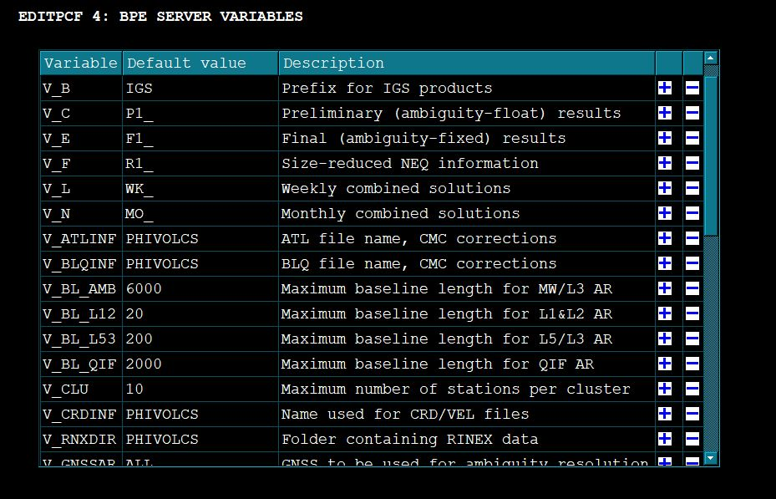

5.4.3. Edit the RNXGRA panel. Select BPE > Edit PCF program input files > PHIVOL_REL.PCF > 212 RNXGRA > OK. Click Next (or press Ctrl + N) until you reach RNXGRA 3. On this panel, customize the text boxes based on the type of observation method (refer to the table below). Save the changes by clicking Save or pressing Ctrl + S.
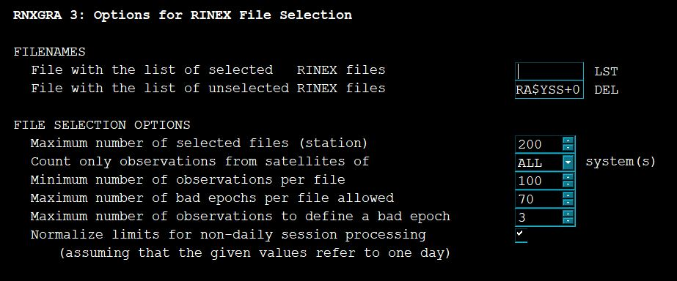
 | Campaign Survey | Continuous
Minimum number of observations per file | 100 | 200
Maximum number of bad epochs per file allowed | 70 | 10
Maximum number of observations to define a bad epoch | 3 | 3

Note: The file selection, depending on the collection method, ensures that the processing can include most of the available data, particularly the campaign observations that are often excluded.

5.5. First BPE Processing

In this subsection, the goal is to process the first session through BPE to both integrate the IGS stations and replace the approximate coordinates with the final coordinates. The IGS reference stations act as the direct link to propagate the ITRF14 to the PHIVOLCS stations.

5.5.1. Run FTP_DWLD to download the IGS (or related Analysis Centre) products and the RINEX data of the IGS reference stations. These external inputs are required to successfully compute a relative baseline solution in Bernese. To manually download these files, please refer to Subsection 5.7.

5.5.1.1. Click BPE > Start BPE processing from the main menu.

5.5.1.2. On the RUNBPE 1 panel, check on the Start processing if the year and session are correct. Set the Number of sessions to be processed field to 1.
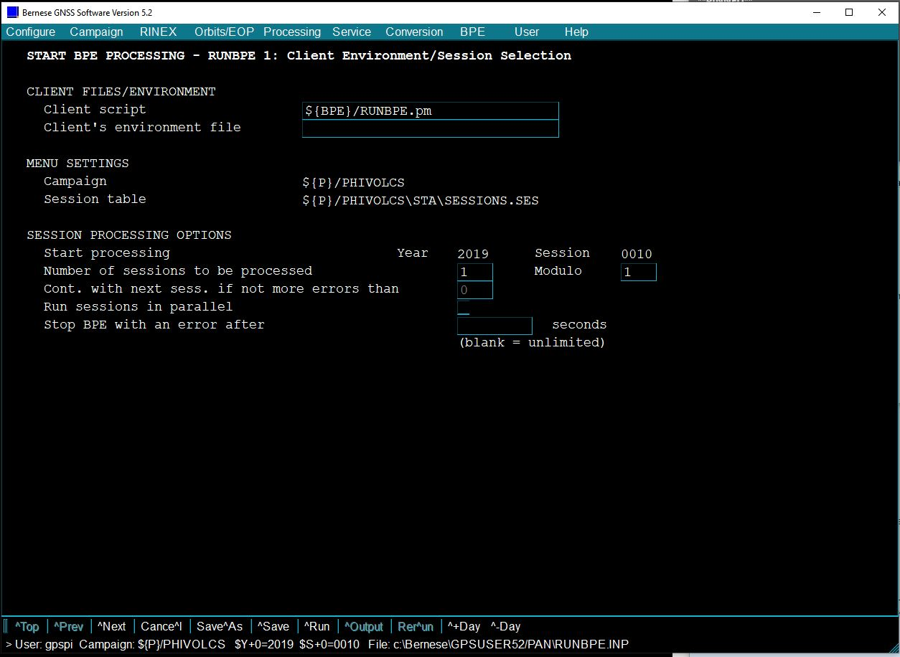

5.5.1.3. After setting the number of sessions, click Next or press Ctrl + N. On the RUNBPE 2 panel, click the button next to Start with script. This allows you to choose which script to start the processing with. Select 000 FTP_DWLD, and then click OK.
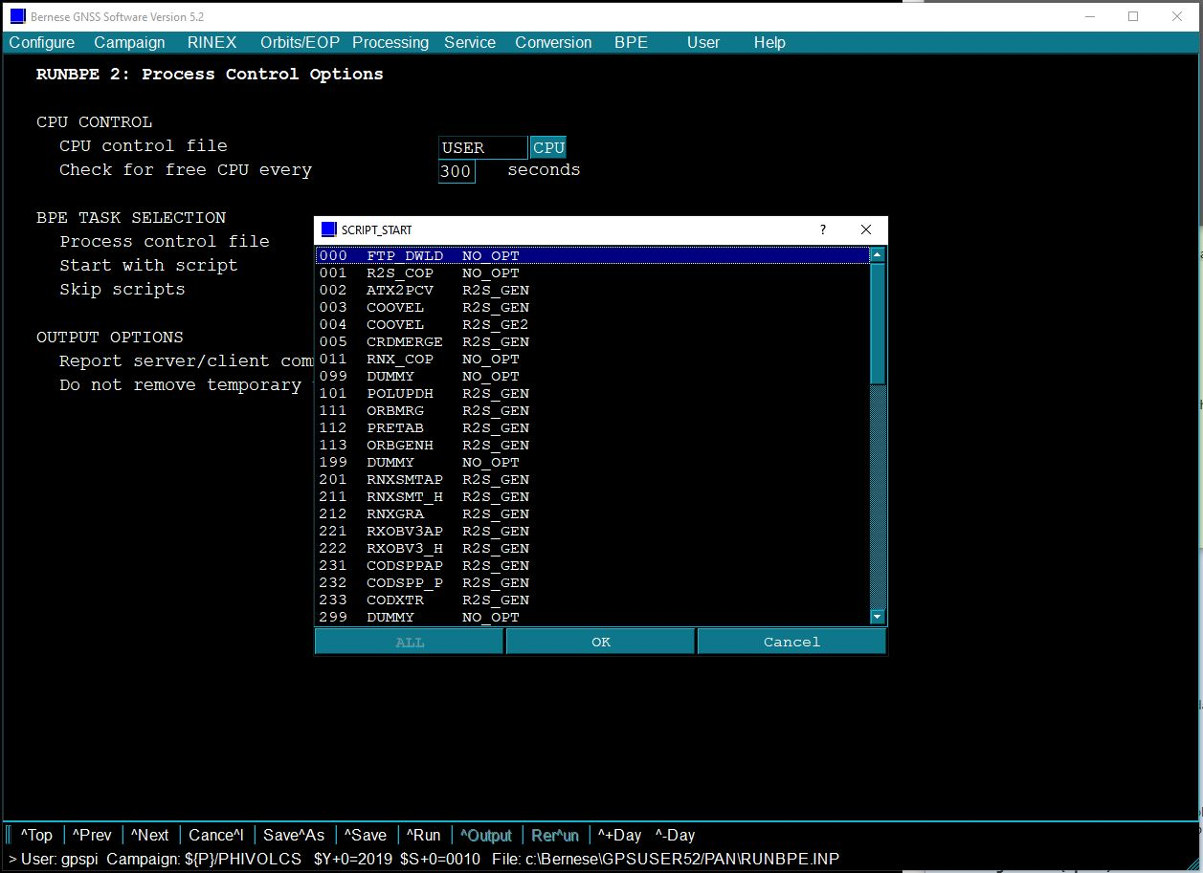

5.5.1.4. Click the Skip scripts button. Highlight the scripts starting from 001 R2S-COP up to 999 DUMMY, and then select OK. Click Run or press Ctrl + R.
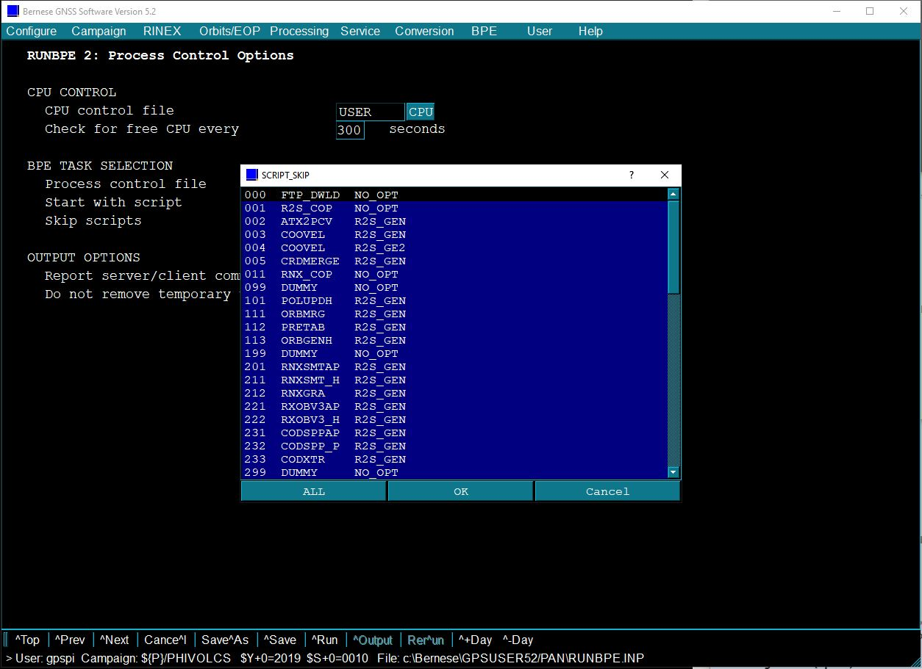
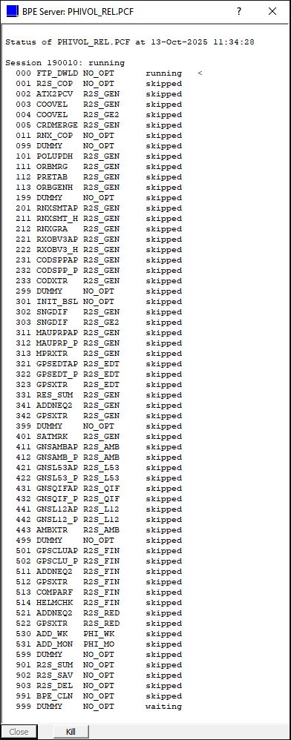
This will appear when you start the processing. If an error occurs, you may simply close the window by clicking the “X” button on the upper right side of the window. Then, check the log file in the BPE folder to view the specific error message.

5.5.1.5. Once completed, the following message is displayed. You can verify that the files are downloaded by checking their designated folders (refer to Steps 5.7.1 and 5.7.2.4 for the file locations).
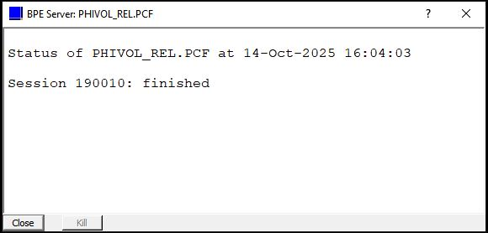

5.5.2. If the IGS products and RINEX are successfully downloaded, run the BPE starting from 001 R2S_COP to 099 DUMMY.

5.5.2.1. Click BPE > Start BPE processing.

5.5.2.2. Ensure that the Number of sessions to be processed = 1. Click Next or press Ctrl + N to move to the second panel.

5.5.2.3. Start the BPE with script 001 R2S_COP and skip the scripts from 101 POLUPDH up to 999 DUMMY. Click Run or press Ctrl + R.
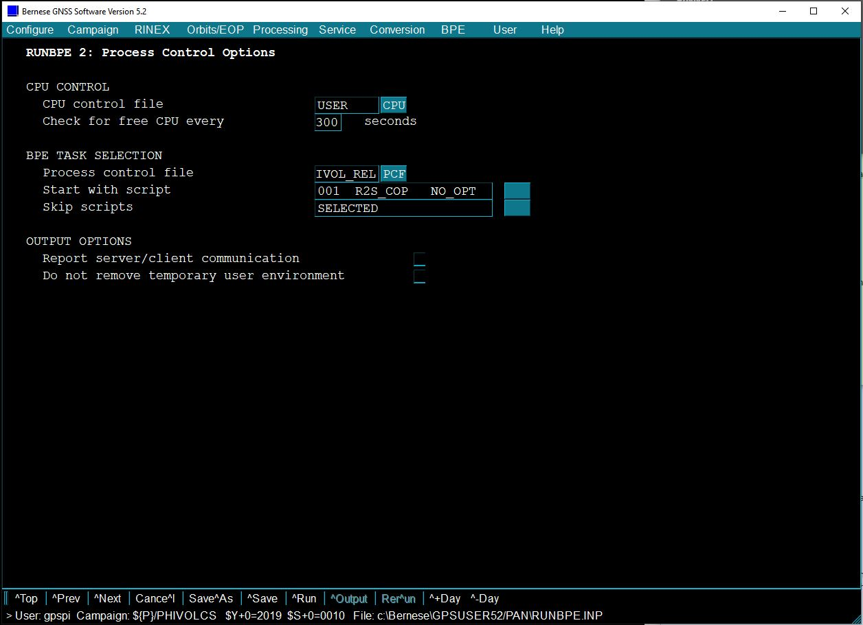
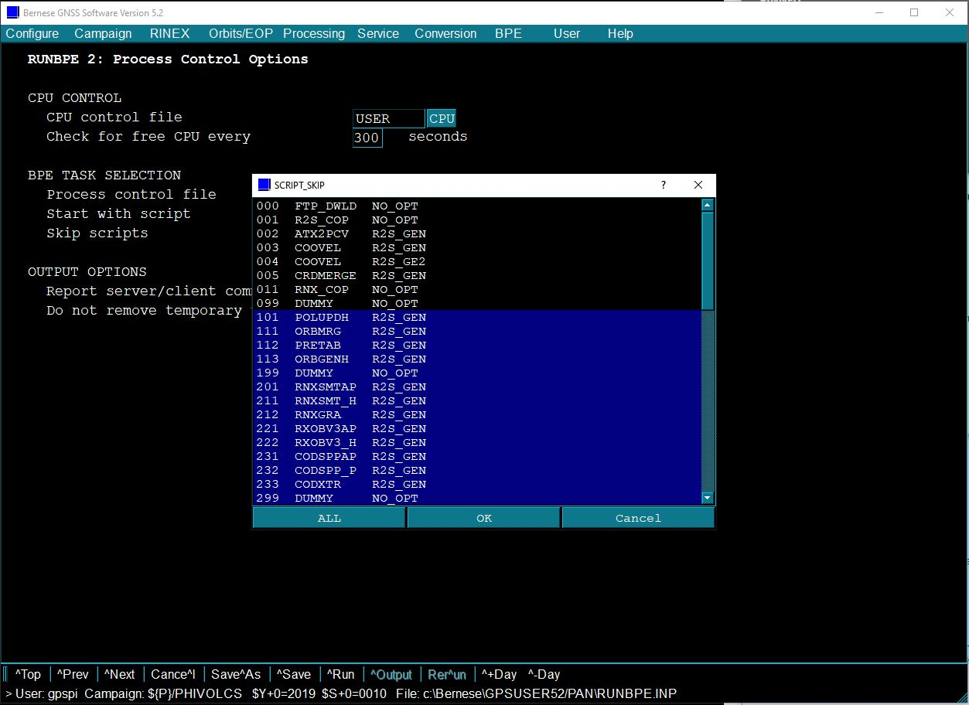

5.5.2.4. Once finished, the IGS stations’ RINEX files must be successfully copied from the DATAPOOL to the Campaign’s RAW folder.
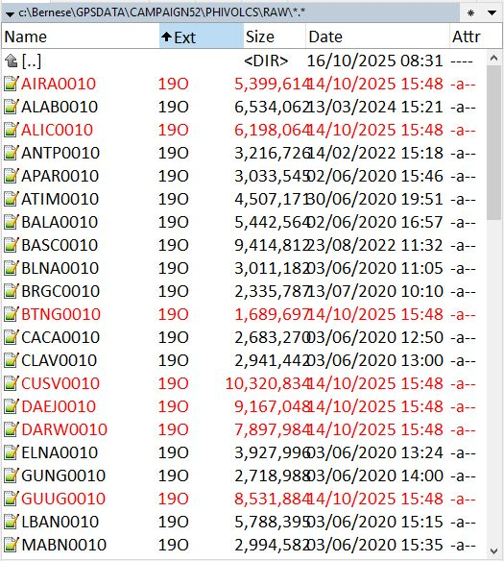

5.5.3. Update the STA, CRD, ABB, and CLU files located in the STA folder of the active Campaign.

5.5.3.1. Updating STA file

5.5.3.1.1. Repeat Step 5.3.4. Make sure to select all RINEX observation files in the RAW folder, including those of the IGS stations.

5.5.3.1.2. Locate the PHIVOLCS.STA file and open it with Notepad++.

5.5.3.1.3. Open another file named IGS.STA from the DATAPOOL\REF52 folder. This file contains the complete information on the IGS stations for Bernese. If it’s missing or outdated, refer to Step 5.7.1.2 for instructions on how to download it.
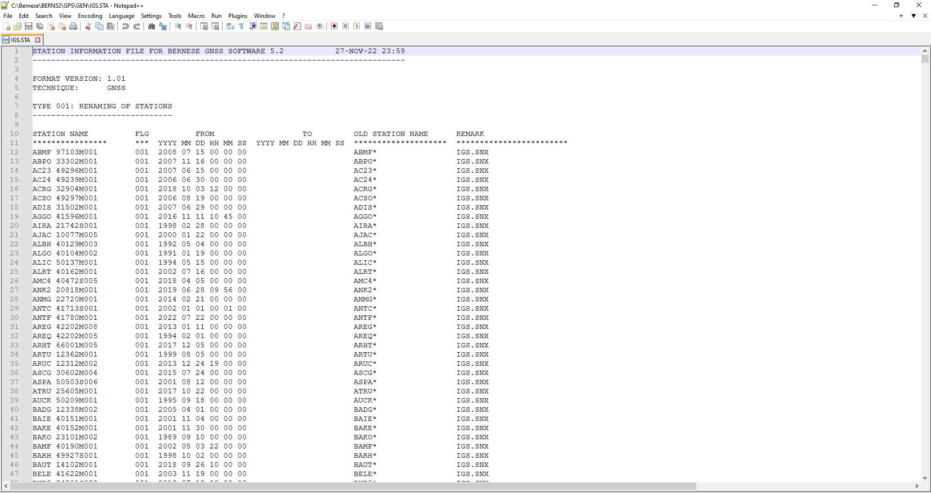
Sample IGS.STA

5.5.3.1.4. Copy the information for the IGS reference stations from IGS.STA and use them to overwrite the corresponding entries in PHIVOLCS.STA.
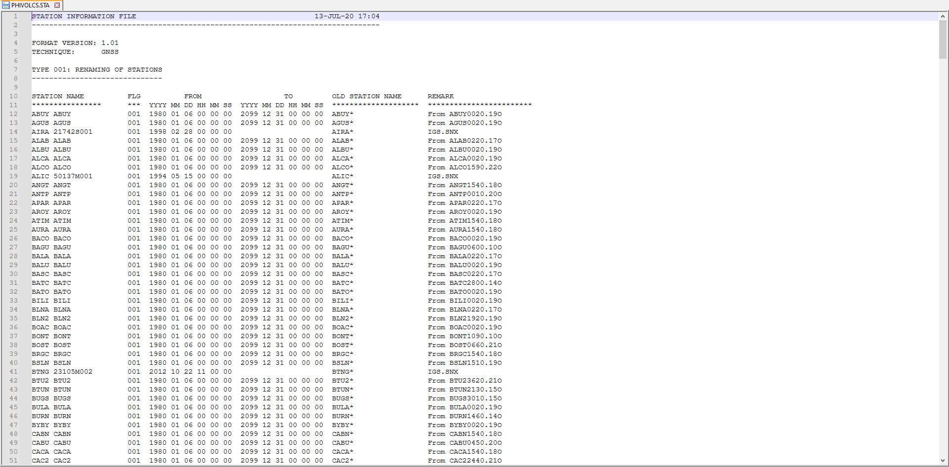

Note: Alternatively, you can merge PHIVOLCS.STA with IGS.STA. To do this, click Service > Station information files > Merge station information files from the menu. On the STAMERGE 1: Input/Output Files panel, type IGS in the Master station information file box. Enter PHIVOLCS in both the Secondary station information file and Station information file boxes. Click Run or press Ctrl + R.
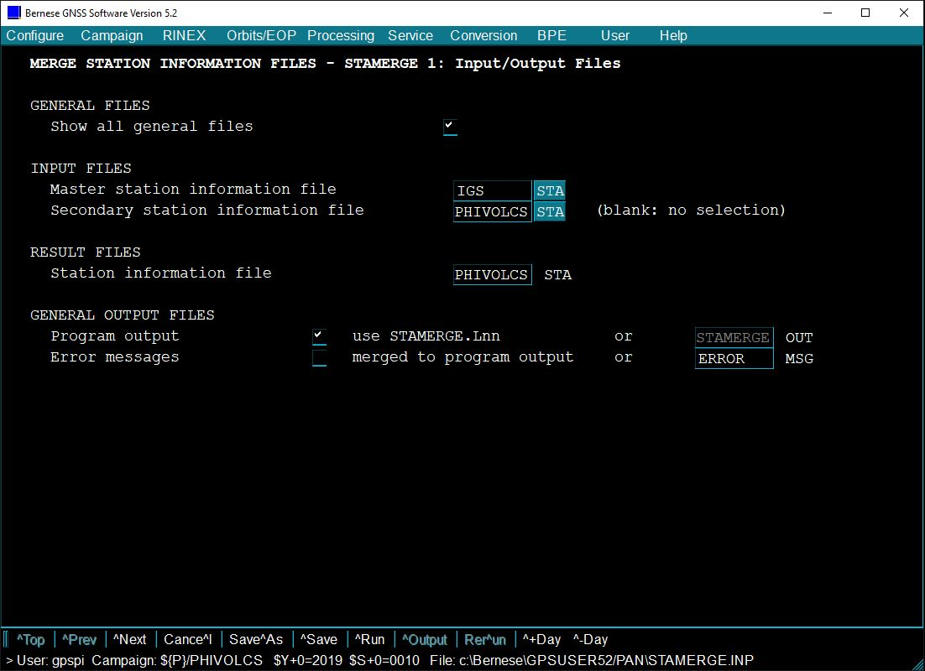

5.5.3.2. For updating CRD and ABB files, repeat Step 5.3.5. This time, however, select the RINEX observation files for the IGS stations.
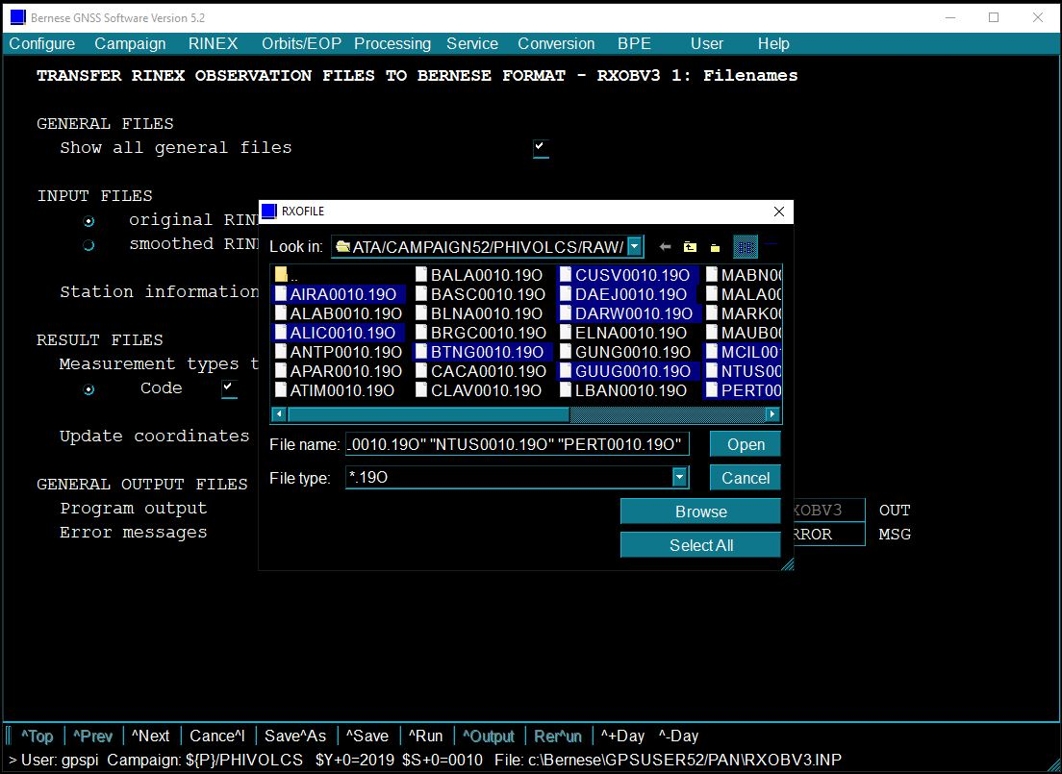

5.5.3.3. To update the CLU file, delete the existing PHIVOLCS.CLU and then repeat Step 5.3.9. When running the step, make sure to select all the available RINEX files for both PHIVOLCS and IGS sites.
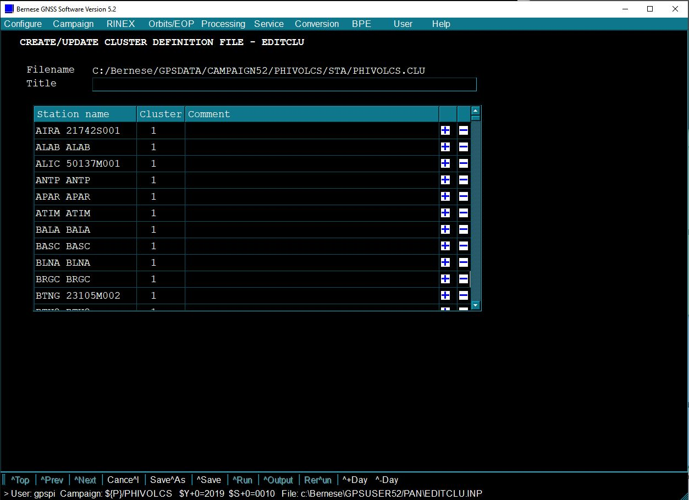

5.5.3.4. Check the files to confirm if IGS stations are successfully added. If the said files are updated, overwrite the older STA, CRD, ABB, and CLU files in the DATAPOOL\REF52 folder.

5.5.4. Click BPE > Start BPE Processing and run the BPE until the last script. In the second panel, set the starting script to 001 R2S_COP. Clear the Skip scripts box. Click Run or press Ctrl + R.
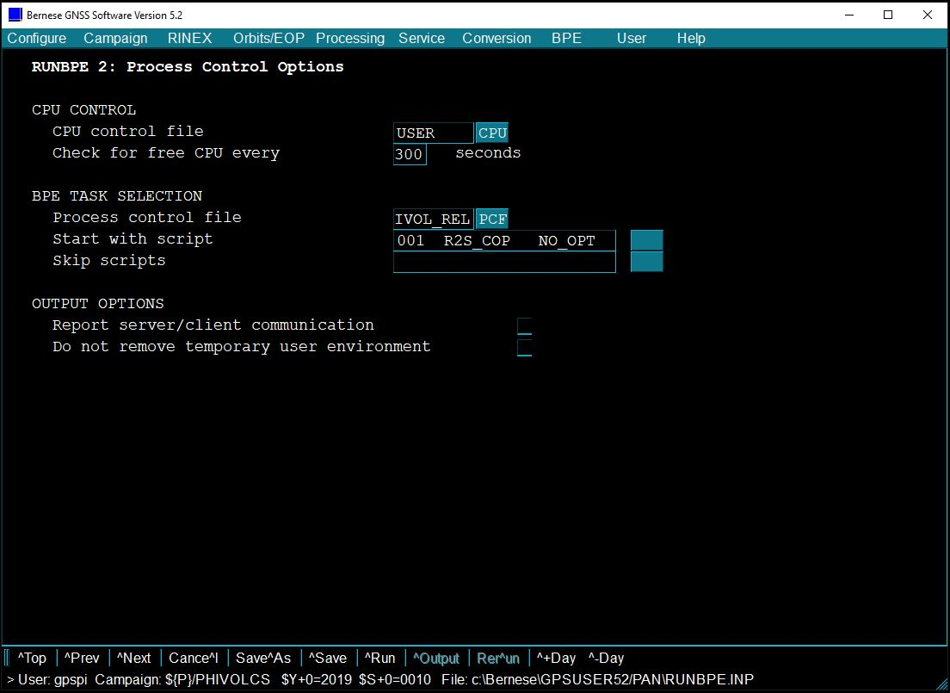
Should the need arise, you can terminate the BPE processing immediately by clicking the “Kill” button on the lower left side of the window, or closing the window using the “X” button on the upper right. Note that if the processing has been forced to stop, it is necessary to reset the CPU. Click BPE > Reset CPU file. Choose USER.CPU. A prompt message will appear saying that the “CPU File C:/Bernese/GPSUSER52/PAN/USER.CPU has been reset”, and then click OK.
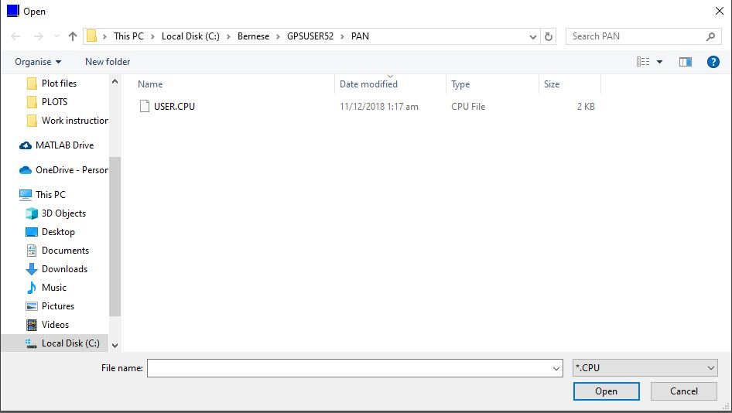
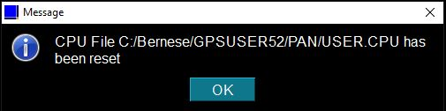
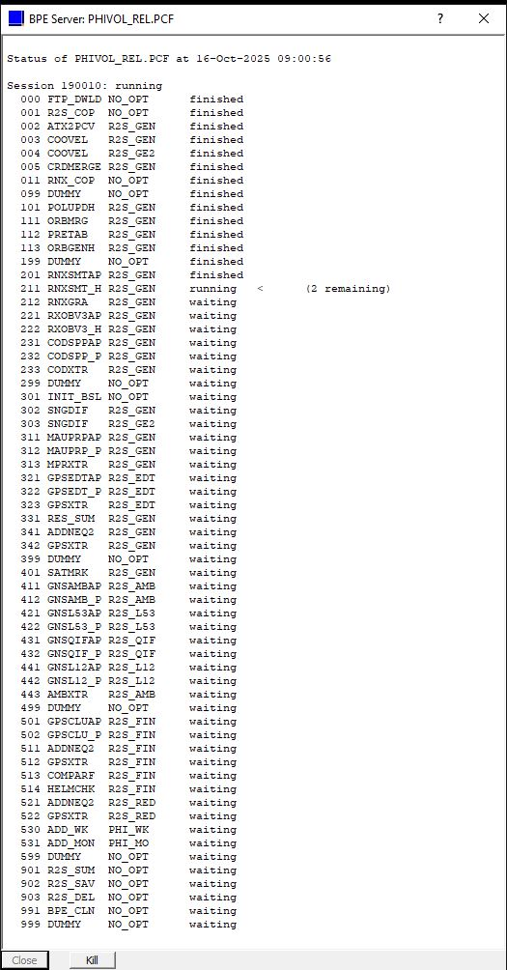

5.5.5. If the processing is successful, check the important output files archived in GPSDATA\SAVEDISK\YYYY. This folder is organized into four subfolders: ATM, OUT, SOL, and STA. The final coordinate files (F1_$YSS+0.CRD) — the target output — are stored in the STA subfolder. Other output files, including those in the Campaign directory, are:
R2S$YSS+0.PRC | BPE processing summary, in the OUT subfolder
F1_$YSS+0.NQ0 | NEQ files, in the SOL subfolder
F1_$YSS+0.SNX | SINEX format for one-session solution, in the SOL subfolder
R1_$YSS+0.NQ0 | NEQ files, in the SOL subfolder
F1_$YSS+0.TRO | SINEX format tropospheric estimates, in the ATM subfolder.
F1_$YSS+0.TRP | Bernese format tropospheric estimates, in the ATM subfolder.
F1_$YSS+0.OUT | GPSEST output, in the Campaign’s OUT folder
F1_$YSS+0.SUM | GPSXTR summary file of GPSEST output, in the Campaign’s OUT folder.
Otherwise, check the error messages in the log files for each script in the BPE folder. The log files follow the naming format $YSS+0_$PID_$SUBID.LOG, where $YSS+0 represents the year and session, $PID is the process ID, and $SUBID is the sub-process ID. For instance, if the current session (2019 001) has an error in script number 514 (HELMCHK), check the 190010_514_000.LOG file. If you don’t know which script failed, look for the PHIVOL_REL.OUT file first.
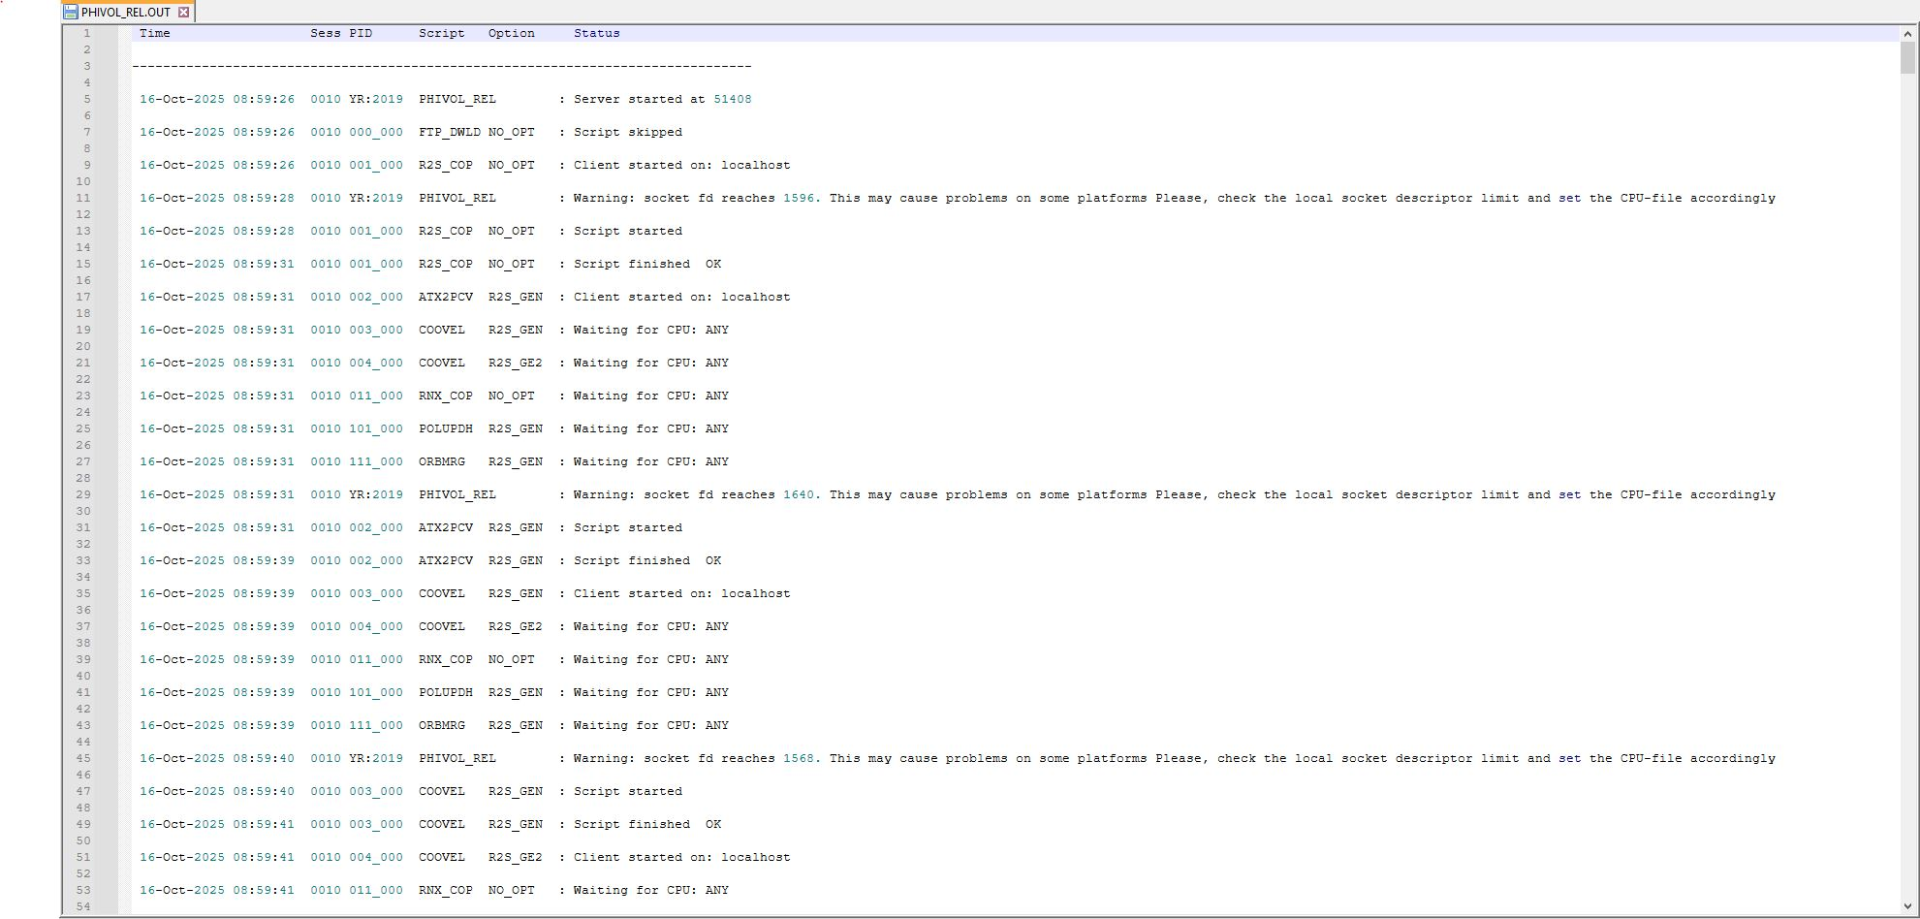

5.5.6. Replace the previous CRD file in the Campaign’s STA folder by copying the final CRD file from SAVEDISK and renaming it as PHIVOLCS.CRD. This new coordinate file gives a more accurate XYZ approximation. Finally, take this newly updated file and overwrite the older CRD file located in the DATAPOOL\REF52 folder.
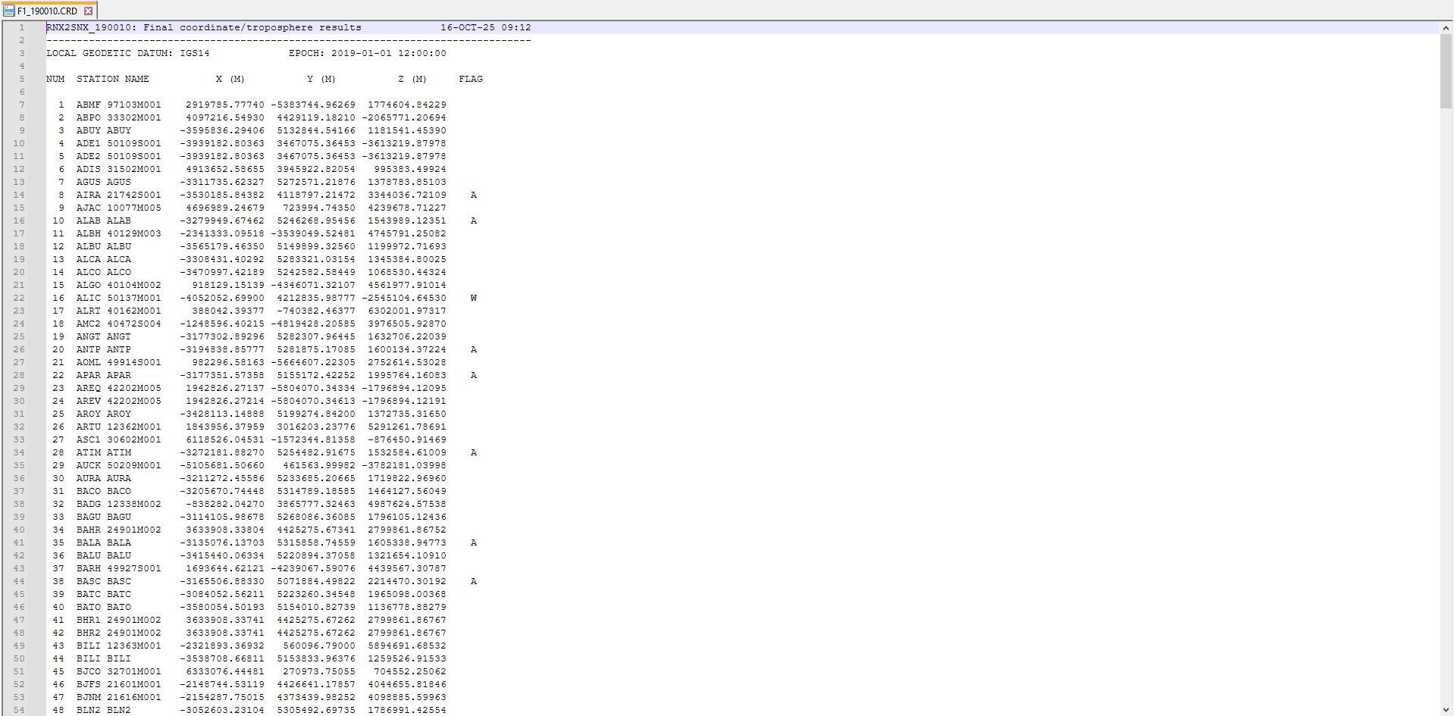

Note: In a coordinate file, the IGS stations are typically marked with a W (Weighted) flag and the PHIVOLCS stations with an A (Adjusted) flag.

5.6. Routine processing

5.6.1. Daily BPE processing

Given that the Campaign directory has been created and all required files are complete and up to date, follow these steps to initiate the BPE processing for a dataset consisting of multiple stations over a specific period.

5.6.1.1. Open File Explorer (or your preferred file manager like Total Commander). If new data has been collected, transfer the RINEX observation files to the Campaign folder inside the DATAPOOL directory.

5.6.1.2. Choose the Campaign you want to work on by accessing Campaign > Select active campaign. Select the desired Campaign name from the list of existing Campaigns, and then click OK.

5.6.1.3. Repeat all the steps outlined in Subsection 5.4 (BPE Setup), customizing based on the Campaign name and method of data collection.

5.6.1.4. Set the starting date of the Campaign session by accessing Configure > Set session from the menu. On the Date Selection Dialog, click the button next to the Year Month Day (YYYY MM DD) field and enter the start date of the data to be processed (e.g., 2019 01 01). Click Compute > Set > OK.

5.6.1.5. Click BPE > Start BPE processing from the main menu. On the RUNBPE 1 panel, check on the Start processing if the year and session are correct. Input the desired number of sessions in the Number of sessions to be processed field (i.e., 100 sessions = 100 days). Click Next or press Ctrl + N.

5.6.1.6. On the RUNBPE 2 panel, click the button next to Start with script. Select 000 FTP_DWLD, and then click OK. The Skip scripts box should be empty. Click Run or press Ctrl + R.

Alternatively, you can skip the script FTP_DWLD and follow the instructions in Subsection 5.7. After downloading the external inputs, start from 001 R2S_COP instead.

5.6.1.7. If the processing is successful, check the important output files archived in GPSDATA\SAVEDISK\YYYY. Otherwise, check the error messages in the log files for each script in the BPE folder.

5.6.2. Updating station information

Manually update the Campaign’s STA file whenever there are changes in site information, such as site name, receiver, antenna, or antenna height for campaign surveys. If the equipment is changed, create a new line right after the original entry. This new line must include the details of the new receiver or antenna, the updated start and end dates, and the source RINEX file. Do not use tabs, only spaces. Remember to use spaces only for formatting and avoid using tabs.

5.6.3. Adding a new site

When a new, unlisted site is introduced, all Campaign files (STA, CRD, ABB, ATL, PLD, VEL, CLU, and BLQ) must be updated to prevent processing errors.

5.6.3.1. Transfer the RINEX files of the new site to the Campaign folder inside the DATAPOOL directory.

5.6.3.2. Set the starting date of the Campaign session by accessing Configure > Set session from the menu. On the Date Selection Dialog, enter the date of the first complete RINEX file for the new site. Click Compute > Set > OK.

5.6.3.3 Copy the new site’s RINEX file corresponding to the session date from DATAPOOL to the RAW folder of the Campaign.

5.6.3.4. Follow Steps 5.3.4 to 5.3.11. Be mindful of programs that overwrite existing files. You will need to create a separate file for them.

5.6.3.4.1. For updating the STA file, it is strongly advised to create a separate file. Repeat the instructions on Step 5.3.4, but only select the RINEX file of the new site. In the field labeled Station information from RINEX files, rename the result file with a minor tweak so that you can still easily distinguish both STA files apart without confusion (e.g., Main file: PHIVOLCS.STA, Separate file: PHIVOLC1.STA). Manually transfer the station information from the separate STA file to the main STA file. Review and edit the station information as needed, especially the start and end dates.

5.6.3.4.2. For updating the CRD and ABB files, repeat Step 5.3.5, but only select the RINEX file of the new site.

5.6.3.4.3. For updating the ATL file, running the program in Step 5.3.6 overwrites the existing file. Similar to Step 5.6.3.4.1, rename the ATL file in the S1/S2 loading coeff. box to a name slightly different from the main ATL file’s name (e.g., Main file: PHIVOLCS.ATL, Separate file: PHIVOLC1.ATL). Copy the new site’s atmospheric tidal loading coefficients from the separate ATL file and paste them into the main ATL file.

5.6.3.4.4. To update the PLD and CLU files, use Steps 5.3.7 and 5.3.9 as guides. Instead of creating a new one, select the existing PLD/CLU file in the file dialog box. Once the file is open, click the “+” button to insert the new site, making sure it is numbered correctly and sorted alphabetically.

5.6.3.4.5. Repeat Step 5.3.8 to regenerate the VEL file.

5.6.3.4.6. To update the BLQ file, repeat Step 5.3.10. As the last step, copy the content from the e-mail and manually add it to the existing BLQ file.

5.6.3.5. Run the BPE. Set the Number of sessions to be processed field to 1 on the RUNBPE 1 panel. On the second panel, click the button next to Start with script. Select 000 FTP_DWLD, and then click OK. The Skip scripts box should be empty. Click Run or press Ctrl + R.

5.6.3.6. Replace the existing CRD file in the Campaign’s STA folder with the processed CRD file from SAVEDISK.

5.6.4. Adding an IGS reference site

For a new, unlisted IGS reference site, repeat Steps 5.5.3 to 5.5.4 to append the necessary site information to the Campaign’s STA, CRD, ABB, and CLU files.

5.6.5. Updating GEN folder

The GEN folder contains standard or reference files, like information on satellite antenna offsets, which the Bernese software uses to process data. This folder must be kept updated to produce accurate output files. Below is the guide for manually updating the GEN folder.

5.6.5.1. Locate the folder at c:/Bernese/BERN52/GPS/GEN. Create a date-named backup folder inside the GEN folder and copy the current files into it.

5.6.5.2 Access and connect to the AIUB server using FileZilla. Simply input ftp.aiub.unibe.ch in the “Host” field box and click “Quickconnect”.
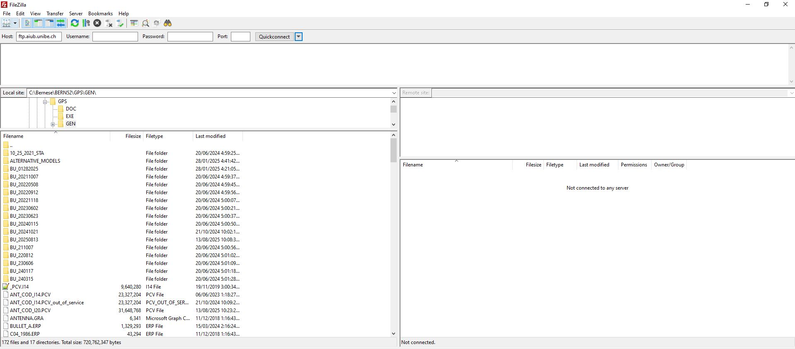

5.6.5.3 Upon connecting to the server, go to BSWUSERS52/GEN. Select all the files except the ALTERNATIVE_MODELS folder. Select all the files and copy them to the GEN folder.
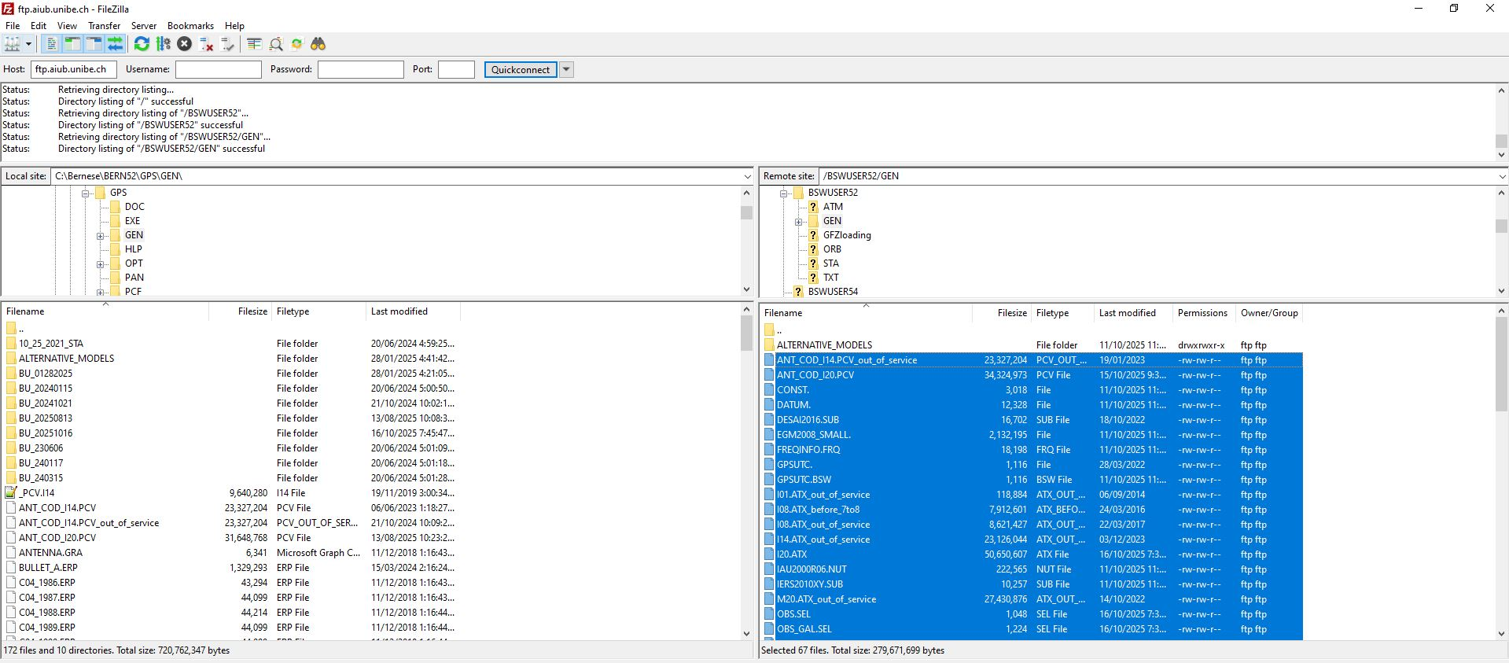

5.6.5.4. The pop-up window “Target file already exists” will appear because the selected files are already in the destination folder. To resolve this, choose the action “Overwrite if source newer” and check “Apply to current queue only”.
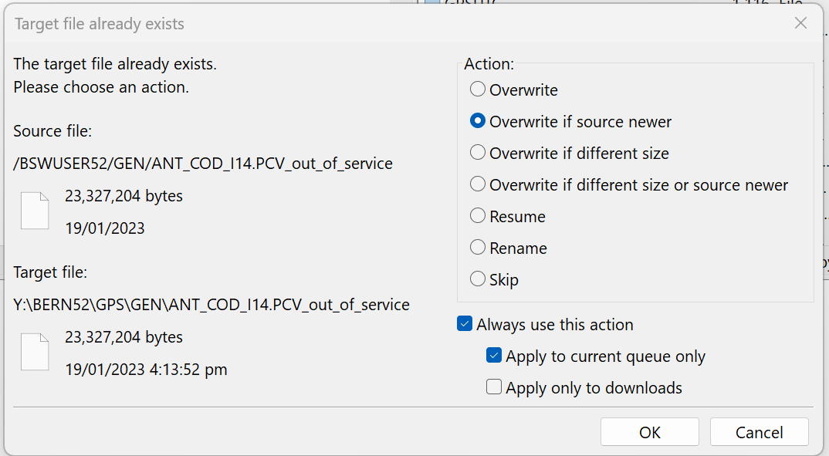

5.6.5.5. Navigate to the remote directory BSWUSERS52/ORB and download C04_YYYY.ERP file(s). Place the file(s) inside the GEN folder. Your GEN folder is now updated.

Note: You may simply refer to the video guide through this link: https://www.youtube.com/watch?v=lptIx54tkGE.

5.7. Manual download of external inputs

As an alternative to the FTP_DWLD script, IGS (or related Analysis Centre) data and products can be downloaded manually using either FileZilla or Total Commander.

5.7.1. IGS products

5.7.1.1. NASA's Crustal Dynamics Data Information System (CDDIS) archives and distributes space geodesy data and related products, supporting the global scientific community in Earth science research. To download IGS products from the CDDIS archive, create a session (using your preferred FTP client) with the following credentials:

Session: CDDIS Archive
Host name: ftps://gdc.cddis.eosdis.nasa.gov
Username: anonymous
Password: gps.phivolcs@gmail.com

Refer to the table for the location of files to be downloaded and where to place them in the Bernese directory.
Product | Location | File(s) | Put it in…
IGS Final GPS Orbits | pub/gps/products/wwww | igswwwwd.sp3.Z | DATAPOOL/IGS
IGS Final GLONASS Orbits | pub/glonass/products/wwww | iglwwwwd.sp3.Z | DATAPOOL/IGS
IGS Final Weekly ERP | pub/gps/product/wwww | igrwwww7.erp.Z | DATAPOOL/IGS

Note: For more information about the CDDIS, visit this link: https://www.earthdata.nasa.gov/centers/cddis-daac.

5.7.1.2. Products from the CODE processing, including station-related files in Bernese format, can be downloaded from the AIUB server. Simply connect to ftp.aiub.unibe.ch via the preferred FTP client. Refer to the table for the file location and where to place the downloaded files.
Product | Location | File(s) | Put it in…
CODE DCBs | CODE/yyyy | P1C1yymm.dcb.Z  P1P2yymm.dcb.Z | DATAPOOL/BSW52
CODE Iono Products | CODE/yyyy | CODwwwwd.ion.Z | DATAPOOL/BSW52
AIUB IGS Coordinates | BSWUSER52/STA | IGS14_R.CRD | DATAPOOL/REF52
AIUB IGS Velocities | BSWUSER52/STA | IGS14_R.VEL | DATAPOOL/REF52
AIUB IGS Station Information | BSWUSER52/STA | IGS.STA | DATAPOOL/REF52

Note: For a complete description of the AIUB’s anonymous FTP server, refer to this link: http://ftp.aiub.unibe.ch/AIUB_AFTP.TXT.

5.7.2. Daily RINEX data from IGS reference stations

5.7.2.1. Access the CDDIS archive using the same credentials mentioned in Step 5.7.1.1.

5.7.2.2. Locate the folder pub/gps/data/daily/YYYY/JJJ/25d, where YYYY represents the year and JJJ refers to the day of the year. This directory contains the daily GNSS data in RINEX V2 and V3 formats from the global IGS stations, compressed in either gzip or UNIX format.

5.7.2.3. Download the necessary RINEX files of the selected IGS stations. In our case, we will use the following IGS station files: AIRA, ALIC, BTNG, CUSV, DAEJ, DARW, GUUG, MCIL, NTUS, PIMO, PNGM, and TNML.

5.7.2.4. Place the RINEX V2 files in the Campaign folder within the DATAPOOL directory, and the RINEX V3 files in DATAPOOL/RINEX3.

Procedure: Time series

Once the final daily positions of the PHIVOLCS stations are obtained through Bernese processing, the time series plots can be generated. This section explains how to create and clean these plots to visualize station movements over time.

6.1. Prerequisites

6.1.1. Before proceeding, the following programs need to be installed on your computer:
- Python | - Downloadable at python.org.
- MATLAB | - Downloadable at mathworks.com.

6.1.2. Download the following files required for time series plotting from the Project’s Google Drive folder, 03 GPS > GPS Processing > 03 Scripts > 02 Time Series:
- filter-fncrd.bat | batch file used to generate filtered daily .CRD files containing only the final coordinates of the local sites and the IGS reference stations used in the processing
- plot_v2.py | Python script used for creating individual site plot files
- vel_line_v8.m | Matlab script used to generate time series plots
- outlier_input-site.py | Python script used in visually identifying outliers from the generated time series plots
- offsets | list of all offsets for each site in the DOST-PHIVOLCS’s nationwide GNSS network

6.1.3. Take note of the following notations:
- YYYY | = | 4-digit year format (e.g., 2025)
- YY | = | 2-digit year format (e.g., 25 for 2025)
- DDD | = | 3-digit Julian day, representing the sequential day of the year used in GPS data processing, which ranges from 001-365 or 001-366 in leap years (e.g., 001 for January 01)

6.2. Plotting of final coordinates

6.2.1. Open a file manager (like Total Commander and File Explorer) and navigate to Bernese\GPSDATA\SAVEDISK\YYYY\STA. Extract all files matching the format F1_YYDDD0.CRD and transfer them to a different folder. For example, if YYYY is 2025:
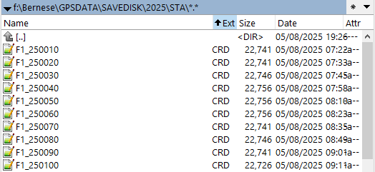

6.2.2. Copy the files filter-fncrd.bat and plot_v2.py to the same folder as the .CRD files.

6.2.3. Run the filter-fncrd.bat by double-clicking the batch file to generate FNYYDDD0.CRD files for each corresponding F1_YYDDD0.CRD files. This also automatically creates an F1CRD folder and moves all the F1_YYDDD0.CRD files into this folder.
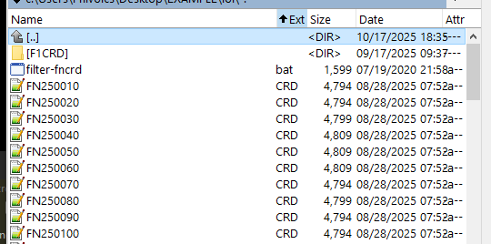

6.2.4. Run the plot_v2.py by double-clicking the script to generate PLOT files for each site.

6.2.4.1 Press Enter as instructed when the command prompt appears. This will create an XYZ file that contains the daily ECEF (XYZ) coordinates of all sites from the FNYYDDD0.CRD files.
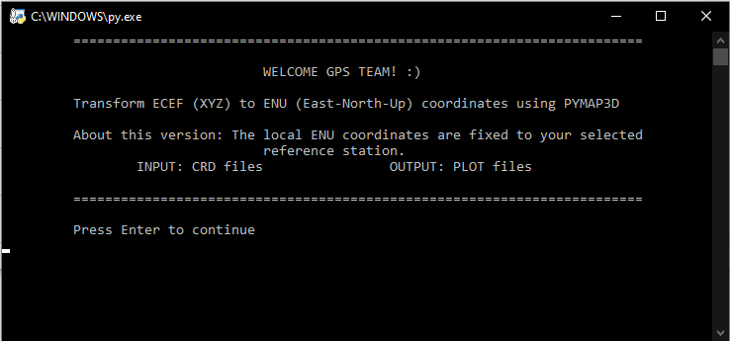

6.2.4.2. When prompted to “Input the reference station”, enter “S01R”. This site in Taiwan is used as the reference point for velocity computations relative to the Eurasian Plate. Note that the choice of reference station for velocity computations is not fixed, as other stations may be used based on needs or the intended analysis. The resulting output is an ENU file compiling the daily XYZ-to-ENU converted coordinates of all sites, as well as individual files named after each site containing their respective daily ENU coordinates.
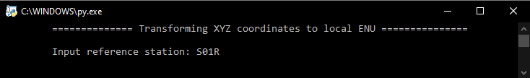

6.2.4.3. Wait until the prompt “To create PLOT files, press Enter” appears, then press Enter. A PLOTS folder will be created containing a file named 123 (listing all site names with final coordinates) and site-specific plot files labeled with their respective site names. The terminal window will close automatically once the plot files are generated.
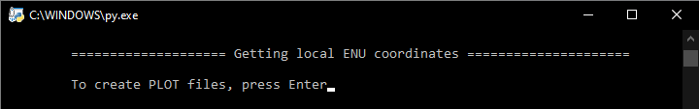

6.2.5. Add the MATLAB script vel_line_v8.m and the file offsets in the PLOTS folder.

6.2.6. Check the 123 file to see if all the sites needed for plotting are listed, and the offsets file for any offsets for each site. You can opt to remove IGS/reference sites from the 123 file if they are not required for plotting.

Note: Each entry in the offsets file contains the 4-character site name, followed by the date of occurrence and type of offset. Offsets are classified based on their cause: EQ (earthquake), VE (volcanic eruption), CE (change of equipment), and UK (unknown cause). This file must be updated whenever new offsets are identified.
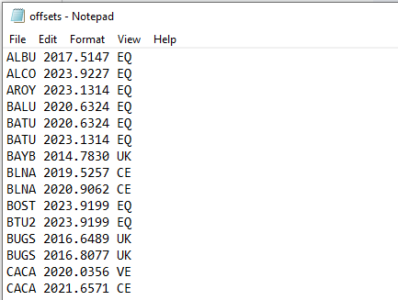
Sample offsets file

6.2.7. Open MATLAB and set its working directory to the PLOTS folder. Open the vel_line_v8.m, and then run the script either by clicking the “Run” button or by typing its file name in the MATLAB Command Window and pressing Enter.
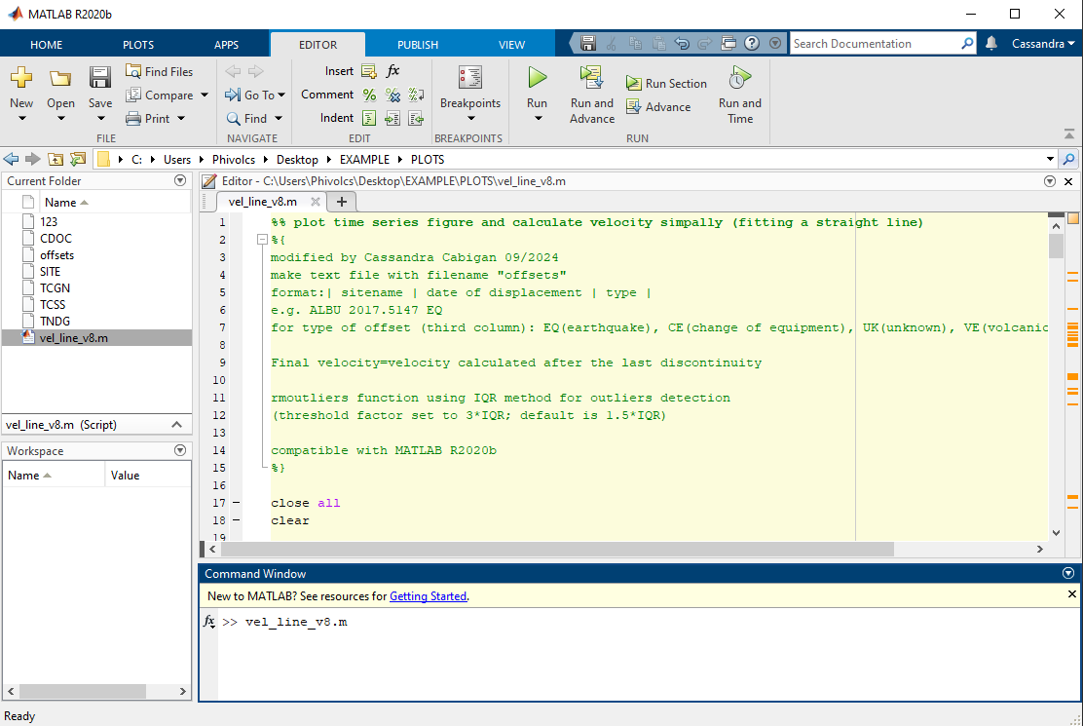

This will generate the time series plots of each site in JPG format, an outliers file listing all detected outliers (can be empty if no outliers are detected), and a Velocity_rover(regress)_10 file containing the velocities of each site separated into East, North, and Up components. Examples of these output files for a GNSS station named ‘SITE’ are shown below.
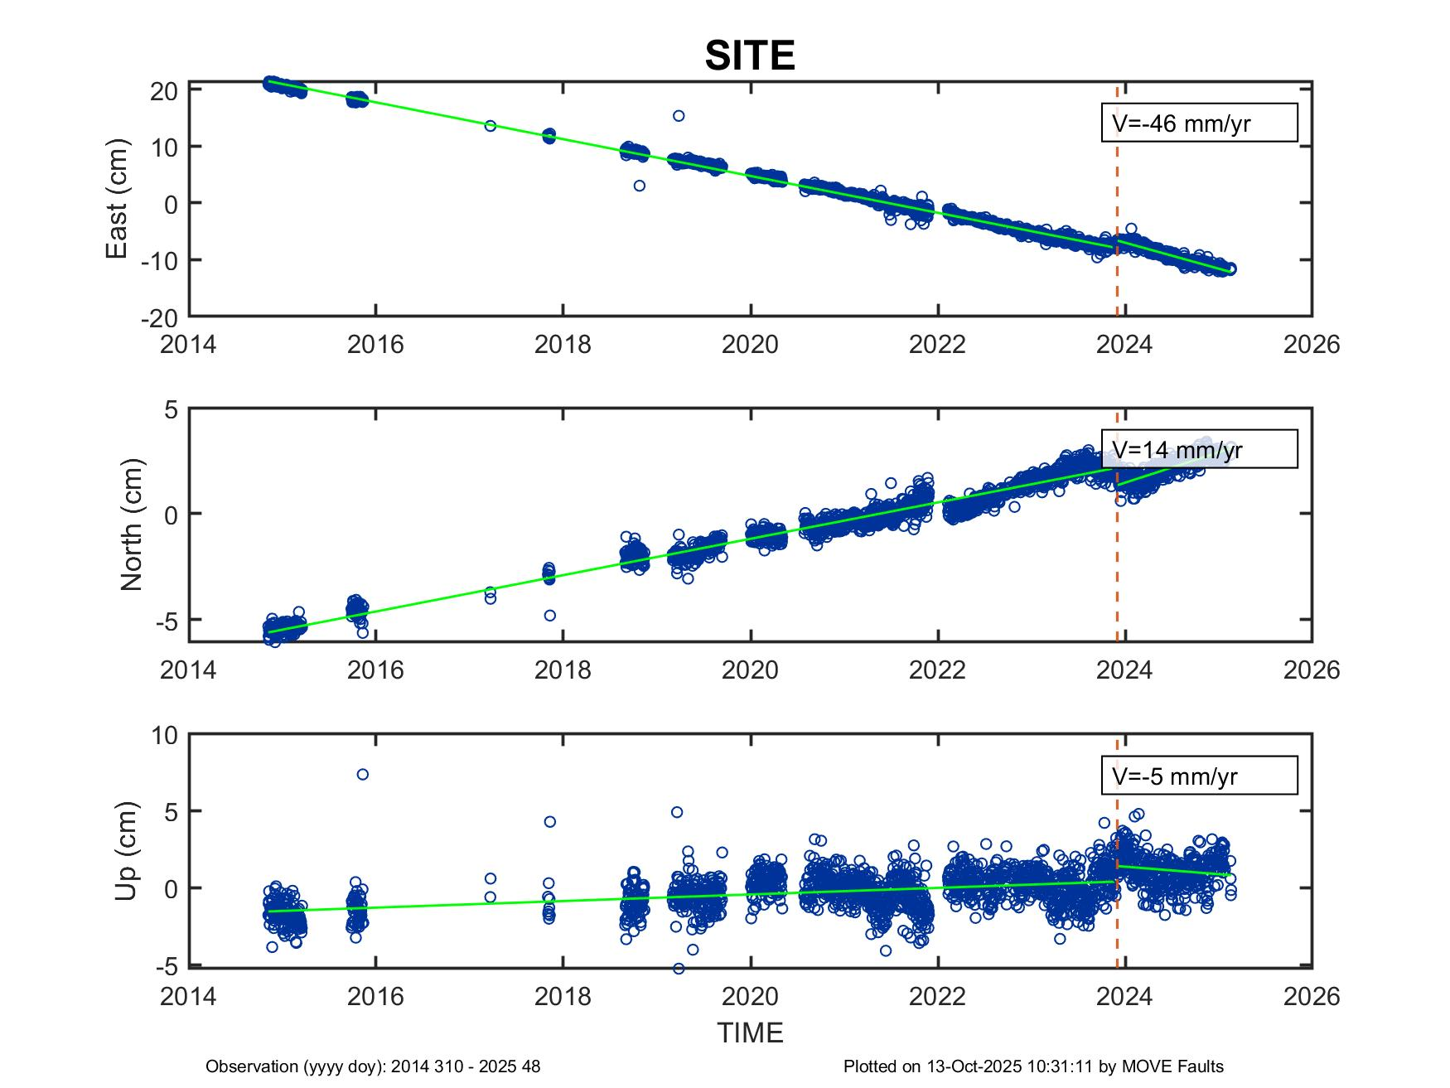
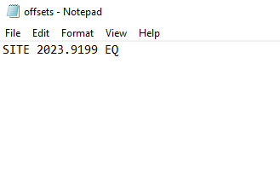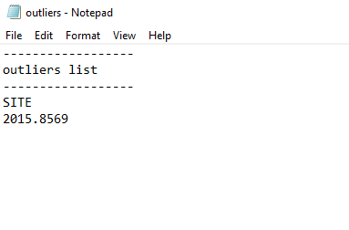
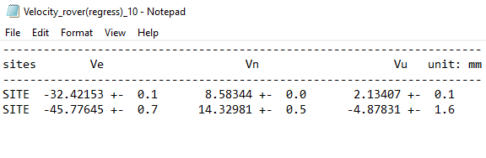The time series plot for ‘SITE’ from 2014 to 2025 displays the daily positions as blue circles with a green linear regression fit. An earthquake-related offset at 2023.9199 (2023 DOY 336) listed in the offset file is shown as a red dashed line. The Velocity_rover(regress)_10 file contains the velocities computed before and after the indicated offset. An outlier at 2015.8569 (2015 DOY 313) is detected and listed in the produced outliers file.

Note: Typically, only the horizontal components (northing and easting) are analyzed in the time series. The vertical component is generally excluded due to accuracy and precision limitations, except in special cases where vertical movement is of specific interest.

6.3. Outlier removal

6.3.1. Copy outlier_input-site.py to the PLOTS folder.

6.3.2. Identify the sites that require outlier removal by visually inspecting the individual time series plots of the sites generated in MATLAB.

6.3.3. Run the outlier_input-site.py by double-clicking the Python script.
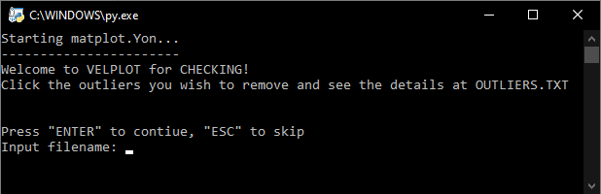

6.3.3.1. Input the site name to generate the time series plot. Right-click to select the outliers on the plot, which will then be highlighted in red.
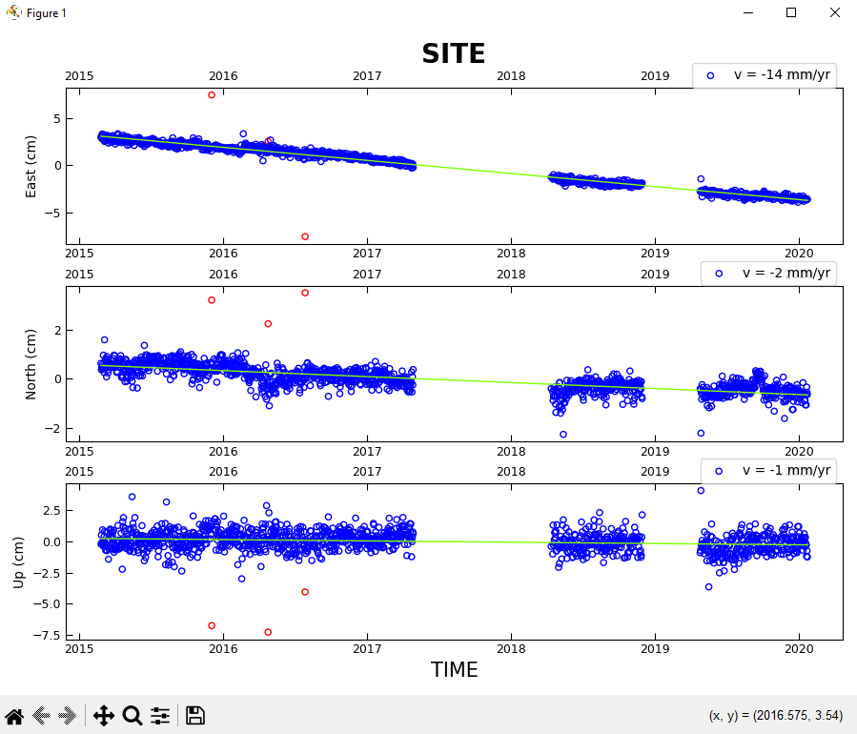

6.3.3.2. Once done with outlier selection, close the time series plot to generate an OUTLIERS.txt file listing the selected outliers, with each line showing the site name and the date (in decimal year format) of the outlier.
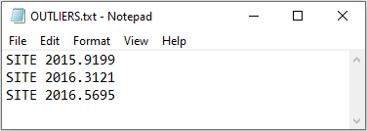

6.3.3.3. Repeat Steps 6.3.3.1 to 6.3.3.2 for all sites needing outlier removal. The OUTLIERS.txt should be automatically overwritten for every site.

6.3.4. Manually remove the outliers from each site’s PLOT files using OUTLIERS.txt (or the outliers file previously produced from running vel_line_v8.m) as a reference.

6.3.5. Open MATLAB and rerun vel_line_v8.m to generate updated time series plots, a revised outliers file, and an overwritten file Velocity_rover(regress)_10 containing the new site velocities.

