Universal Predictive Maintenance System
Project Design & Technical Report
Author: alfiesafc | Status: Complete

1. Executive Summary
The Universal Predictive Maintenance System (UPMS) is an edge-computed physical-digital monitoring rigged engineered to evaluate real-time multi-variable industrial telemetry. Utilizing an ESP32 microcontroller as the core processor integrated within critical mechanical and electrical sensors, it logs sensor data locally to LittleFS at 4Hz and streams it to a local Python Dashboard for real-time fault detection and anomaly tracking.

2. Bill of Materials
This table here details the hardware inventory that was used to construct and validate this simulator rig:
Component | Function | Requirements
ESP32 Microcontroller | Core Processing, GPIO communication, LittleFS local storage and serial telemetry streaming | Dual – Core, 240MHz CPU Clock, 3.3V logic & WIFI capability
MPU-6050 Accelerometer | Monitor acceleration magnitude and detect real-time mechanical vibration faults | I2C Bus communication interface, 3.3V compatibility
LM393 Optical Sensor Module | Count motor rotations via slotted encoder discs to calculate real-time RPM | Digital output availability with comparator and status indication
DS18B20 Temperature Sensor | Non-blocking thermal tracking to monitor system and motor operating temperatures, triggering safety alerts when threshold breaches 45 degrees Celsius | OneWire digital protocol support, stainless steel waterproof probe and 3.3V compatible
INA219 Current/Voltage Sensor | Measure high-precision bus voltage, current draw to provide accurate power of system | I2C Bus interface, low-side to high-side bus monitoring
0.96” I2C OLED Display | Provide on-device pagination, up-to-date metrics and full-screen fault warnings | SSD1306 Driver, 128x64 resolution, 3.3V compatible
Inline Fuse Holder | Effectively kill circuit when current overloads system to protect health of microcontroller and sensors | Reasonably compact, compatible with 12V power source and ability to change fuses within holder
1N4007 Flyback Diode | Protect microcontroller and circuit from inductive kickback from voltage spikes created by motor and fan | High reverse voltage tolerance and fast transient suppression
Nylon Standoffs and Screws | Hold modules in place and provide structural support for the rig | High quality and structural integrity
12V DC Jack & Buck Converter | Provide stable 12V input and a step-down rail of 3.3V | Secure insulated routing and voltage insulation
Electrolytic Capacitor | Supress Electrical Noise and stabilise power rail | 25V, 100µF ratings
12V DC Motor & CPU Fan | Used to test each sensor to provide evidence of rigs function | 12V compatible.

3. System Design & Architecture
The system design integrates both mechanical and electrical architecture into a unified platform. Power is supplied via a 12V DC barrel jack, feeding buck converters to establish two power rails at 12V and 3.3V, respectively. To protect said architecture of a microcontroller and vulnerable components from destructive inductive kickback (Back-EMF) spikes generated by inductive loads such as motors and fans, 1N4007 flyback diode is wired in reverse bias across the positive and negative screw blocks. The sensor array interfaces directly with the ESP32 through a dedicated I2C Bus line communicating via SDA and SCL on pins 21/22 for the MPU6050, INA219 and OLED Display. A OneWire bus (pin 23) for the DS18B20 Temperature Sensor, and a hardware interrupt-driven digital pin (pin 4) for the LM393 optical rotation sensor. Telemetry is sampled and logged locally every 250ms (4 Hz) to ensure a high-resolution yet reliable data pool.

4. System Resilience
In embedded deployment environments, hardware vulnerability – such as peripheral bus degradation, voltage spike events or sensor node failure, such poses a significant threat to continuous data acquisition and system availability. To prevent single-point-of-failure hats in the telemetry pipeline, the architecture incorporates a robust Graceful Degradation and Fallback Strategy.
Rather than relying entirely on a monolithic hardware dependency chain, the system design separates core processing and logging logic from physical peripheral acquisition. In the event of bus or sensor disruption, the firmware features a modular fallback mode. This layer preserves the integrity of the device maintaining a continuous serial telemetry output, real-time threshold evaluation and automated instability flagging triggers without compromising execution.
This design ensures that downstream dashboard, logging mechanisms and analysis pipelines can continue to operate, which ensures control over failure points.

4. Data Pipeline & Acquisition
Data Transmission operates over a zero-cloud local serial bridge. The ESP32 processes raw digital pulses and multi-sensor telemetry locally on the edge. Through the implementation of the LittleFS flash storage file system, the microcontroller persistently writes session data to a local CSV log at a 4 Hz sampling rate with decimal-precision timestamps. Upon receiving an explicit DUMP command from the local Python monitoring script via serial communication, the ESP32 streams the complete historical dataset of flash storage for immediate parsing, validation and visualisation.

5. Data Analysis & Visualisation
To validate the zero-cloud predictive maintenance pipeline, telemetry extracted via the serial DUMP command from the ESP32’S LittleFS flash memory is parsed into dedicated local Python Analytical Dashboards. Operating at a continuous 4 Hz sampling frequency, the pipeline monitors multi-variable operational health across three distinct channels:

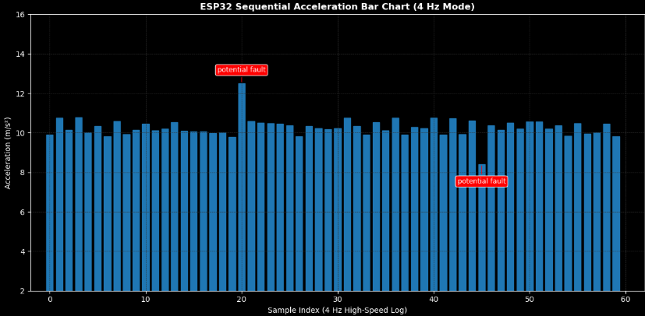

Figure 5.1 (Acceleration): Tracks vibrational dynamics against a stable baseline, flagging structural fault spike at 12.5 m/s² and a drop at 8.4 m/s².

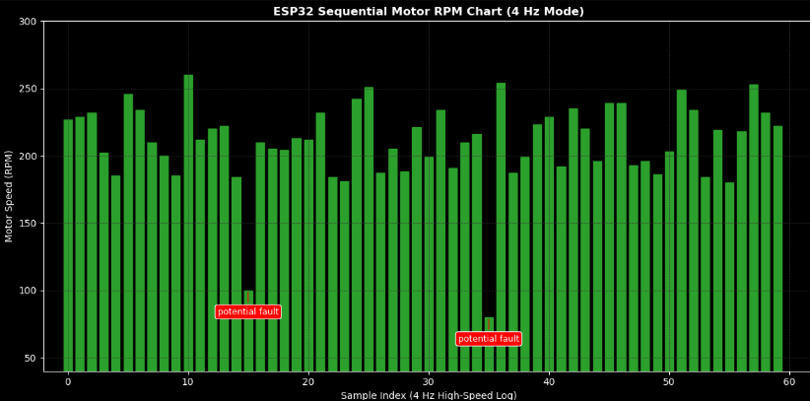

Figure 5.2 (RPM): Monitors rotational velocity within a 180-260 RPM band, isolating transient drops at 100 RPM and 80 RPM due to manual fault injection evident in repository.
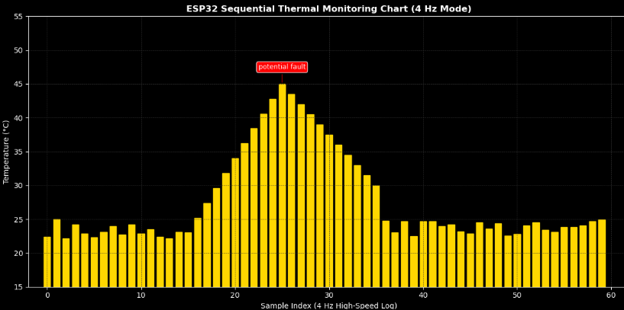

Figure 5.3 (Thermal): Traces operational heating from a 23-degree Celsius baseline to a critical threshold of 45-degree Celsius before cooling.

6. Rig Validity & Integrity
To confirm that data logged by the ESP32 accurately mirrors real-world mechanical behaviour rather than electrical noise or sensor drift, the physical rig’s integrity is validated against the three core operational metrics within this project:
Sequential Acceleration Monitoring: Tracks vibrational dynamics against a stable baseline of around 10 ms². An automated trigger flags structural anomalies when the acceleration breaches safety boundaries, capturing sudden mechanical spikes evident here of around 12.5 ms² and 8.4 ms² indicating an imbalance of mechanical function.
Motor RPM Monitoring: Evaluates rotational velocity trends. Transient speed drops evident here of values 100 RPM and 80 ROM from an estimated 180-260 RPM operating range. They are isolated instantly to detect load stalling or drive slip.
Thermal Gradient Monitoring: Measures a continuous temperature profile via the DS18B20 sensor. It traces operational heating cycles from a ambient baseline of 23 degrees Celsius up to thermal critical thresholds rated at 45 degrees Celsius in which automatically logs warning states during overheating phases before stabilising through subsequent cooling phases.

7. Reusability and Modularity
To ensure that the zero-cloud predictive maintenance system is maintainable, easily upgradeable and robust against physical wear, the hardware architecture incorporates key reusability and modularity principles:
Component Mounting & Reusability: Rather than entirely soldering sensitive microcontrollers and sensors directly to permanent boards, the design utilizes Female Header Strips and IC Sockets. This allows for core components such as the ESP32 microcontroller and sensor breakouts to be modular in the sense they can be easily replaced, tested or upgraded instantaneously without risking heat damage from desoldering.
External Connection & Interfacing: Field Wiring and external sensors are isolated from the main logic board using Screw Terminal Blocks and a standardised DC Barrel Jack. This modular interface allows power inputs and peripheral signal lines to be connected or disconnected cleanly, preventing wire fraying and making bench testing or enclosure mounting seamless.
Structural Hardware & Isolation: Mechanical assemblies are secured using Nylon Standoffs and Screws, which prevent electrical short circuits between the perfboard and physical chassis.

8. Hardware Assembly & Final Build
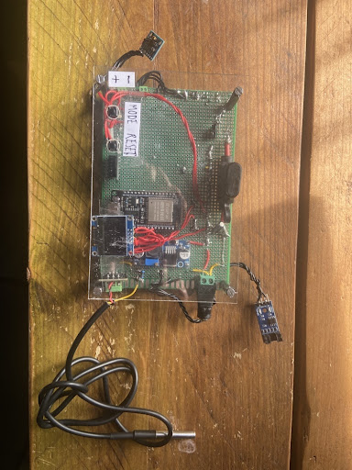
The following images display the final physical build of the predictive maintenance system including circuitry and the components subjected to the demonstrations.

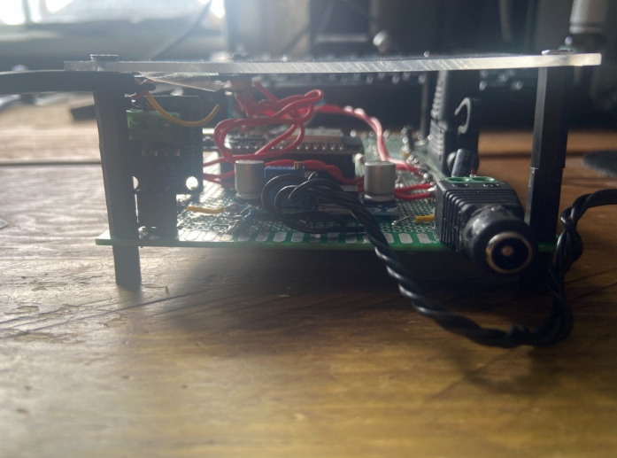
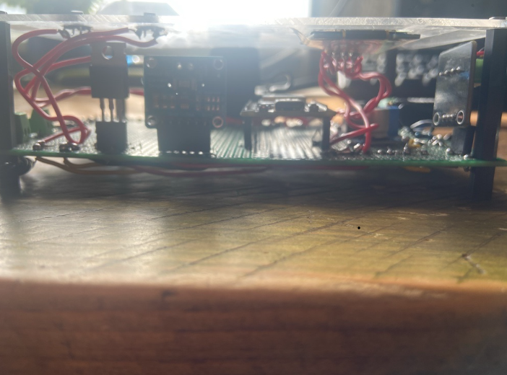

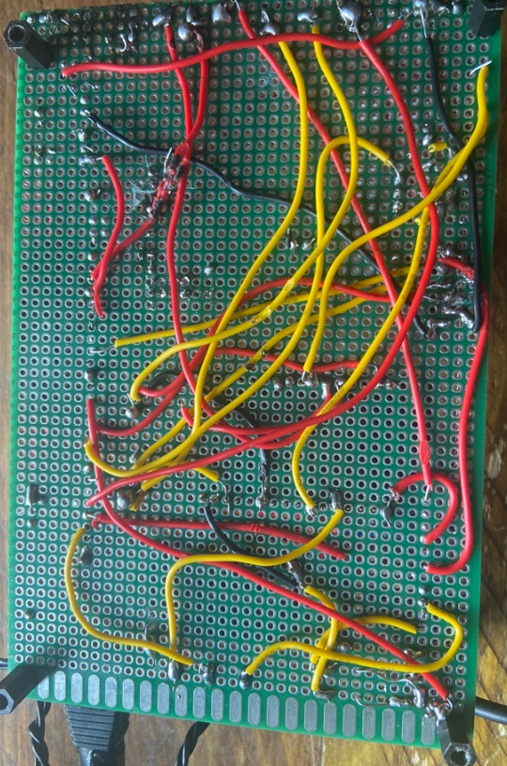

These images display the plan, front and rear view of the physical rig.

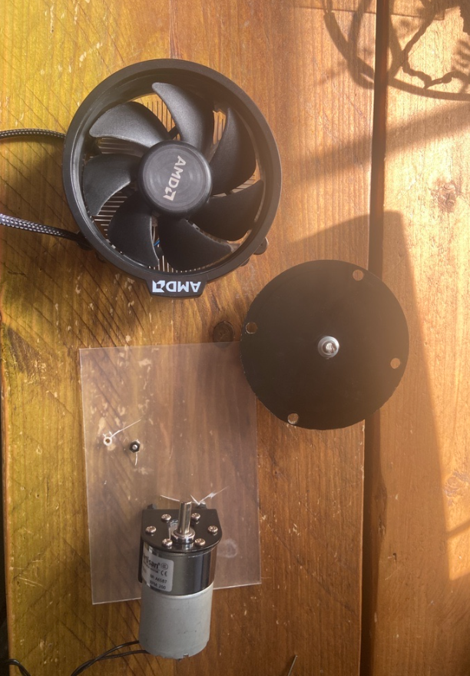

The circuitry of the device.

This image shows the 12V DC Motor and the AMD CPU Cooling Fan that were used to support the functionality of the Universal Predictive Maintenance System as well as a slotted disc used to determine the rpm.

9. Conclusion
The development and implementation of the zero-cloud ESP32-based Universal Predictive Maintenance System successfully demonstrate that robust industrial health monitoring can be achieved cost-effectively at the edge without dependence on external cloud infrastructure. By integrating a multi-sensor array comprising of the MPU-6050 for vibration analysis, LM393 Optical sensor for rotational speed, DS18B20 for thermal tracking and INA219 for power monitoring. The system provides a comprehensive multi-variable perspective on mechanical asset health.
Key achievements and architectural outcomes of this project include:
Edge-Native Reliability: Utilising local LittleFS persistence on the ESP32 ensures continuous data logging, safeguarding critical telemetry against network outages or cloud latency issues while maintaining strict data privacy.
Effective Telemetry Retrieval & Analysis: The implementation of a structured 4 Hz sampling pipeline coupled with the serial DUMP protocol allows for seamless extraction of historical performance logs into local Python visualisation suites.
Actionable Diagnostic Clarity: Custom dark-themed analytical dashboards successfully automate the detection of structural anomalies, utilising precise threshold triggers to isolate mechanical imbalances, drive-train stalls and thermal critical events.
Sustainable Hardware Design: Grounded in principles of modularity and maintainability featuring socketed components, secure terminal blocks, and robust power isolation. The physical rig bridges the gap between rapid breadboard prototyping and a durable, long-term deployment
Ultimately, this project delivers a scalable, transparent, and self-contained maintenance framework capable of providing early fault detection, reducing unplanned downtime and extending the operational lifecycle of mechanical machinery through localised intelligence.

