Stochastic Multi-Sensor Simulator
Project Design & Technical Report
Author: alfiesafc | Status: Complete

1. Executive Summary
The Stochastic Multi-Sensor Simulator is a physical-digital rig engineered to evaluate real-time multi-variable sensor telemetry. Through the implementation of an ESP32 microcontroller with a physical motor system consisting of a shaft and multiple discs, data is streamed directly to a local Python dashboard. This project replicates the stochastic environmental conditions found in a range of industrial machinery to study data acquisition under noise and varying conditions.

2. Bill of Materials
This table here details the hardware inventory that was used to construct and validate this simulator rig:
Component | Function | Requirements
ESP32 Microcontroller | Core Processing, GPIO Communication & Serial Telemetry Streaming and Storage | Dual – Core, 240MHz CPU Clock, 3.3V logic & WIFI availability
DC Motor, Shaft and Discs | Drive Mechanism continuously and securely | Rotate at 200RPM within Optical Sensors in order to generate range of data
12V DC Jack, Solid-Core Hookup Wire & Buck Converters | Provide stable 12V as well as providing 5V and 3.3V stepped down voltage sources | 12V and ability to step down sources as well as providing safe and insulated voltage routes
Motor Driver | Allow motor to be controlled via ESP32 | Compatible with DC Motor
Optical Sensor | Record each time the disc passes through the sensor module | 3.3V compatible with ESP32 GPIO and analogue availability
Ceramic and Electrolytic Capacitors | Provide a clean signal via minimising electrical noise | Electrolytic rated 25V and 100µF and Ceramic 100nF
Nylon Standoffs and Screws | Hold modules in place and provide structural support for the rig | High quality and structural integrity

3. System Design & Architecture
The system design integrates both mechanical and electrical architecture into a unified platform. Power is supplied via a 12V DC barrel jack, feeding buck converters to establish three distinct power rails at 12V, 5V, and 3.3V, respectively. This configuration delivers a stable power supply to the microcontroller, motor, and sensors. The sensors interface with the ESP32’s analog-compatible GPIO pins, recording telemetry outputs every 100ms to ensure a precise, high-resolution data pool.

4. Data Pipeline & Acquisition
Data Transmission operates over a zero-cloud local serial bridge. The ESP32 processes raw digital pulses generated via the motor rig and sensors. Through the implementation of a SPIFFS flash storage file system the microcontroller retains historical data locally, which is then transferred via serial communication to a Python dashboard. This data is captured through a designated COM port enabling seamless data transfer from the ESP32 to a Python script for processing.
5. Data Analysis & Visualisation
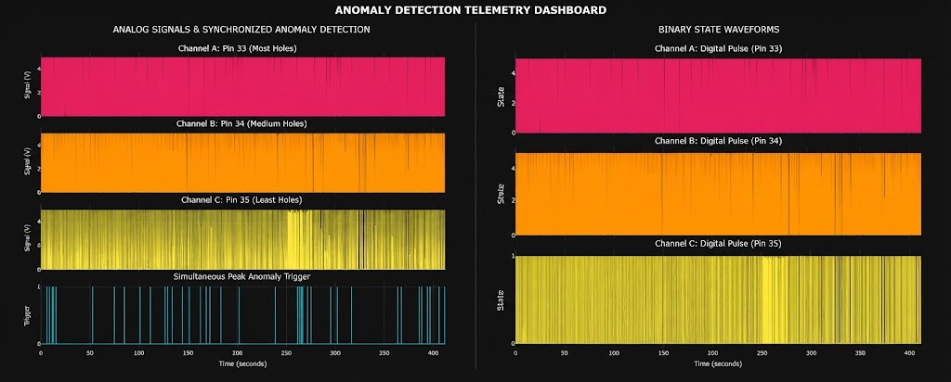
To support pipeline integrity, the telemetry outputs are processed from the ESP32 into several local Python graphs and dashboards:

Dashboard A displays the raw imported data from the sensors. The left side displays the analog signal system—ranging from 0 to 4095—alongside a synchronized anomaly trigger generated when all three sensors register peak values simultaneously. Conversely, the right side illustrates the analog-to-digital transformation, where the sensor telemetry is converted into discrete binary states of 0 or 1.
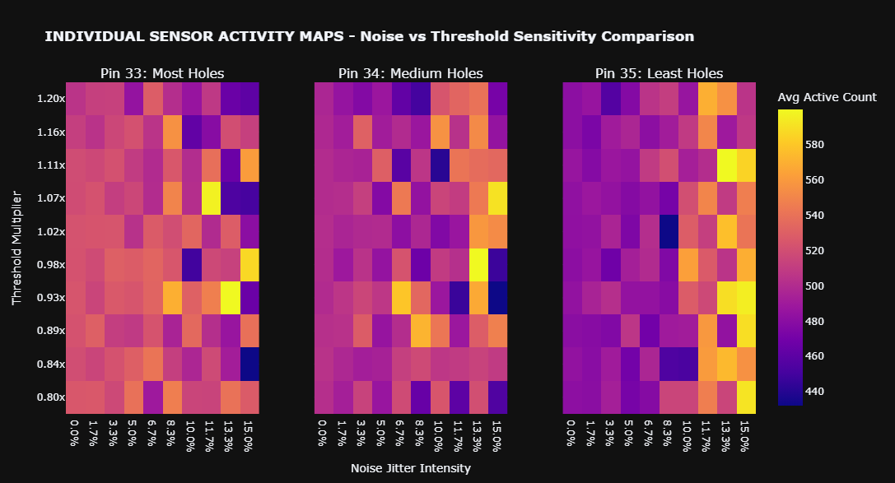

Dashboard B contains individual sensitivity maps that vary depending on the number of holes on each sensor's disc. The three activity maps show that sensors with the most holes can maintain stability, as the gradient resulting from increasing jitter intensity changes minimally. Conversely, it highlights unpredictability in sensors with the least holes, demonstrated by a significant gradient shift from 0.0% to 15.0% noise jitter
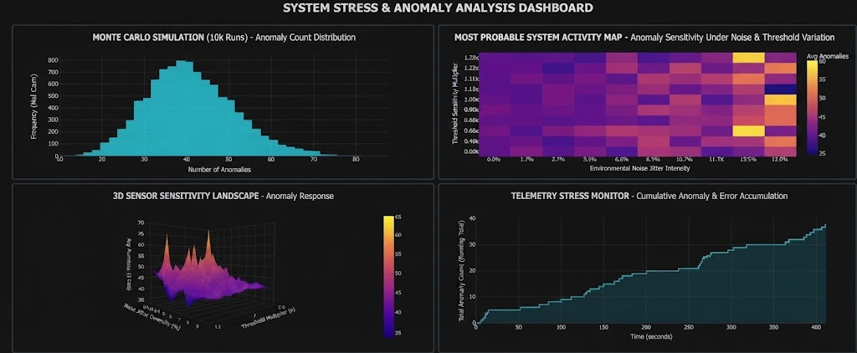

Dashboard C presents a comprehensive range of quantitative graphs. The top-left quadrant displays a Monte Carlo simulation running 10,000 iterations, identifying a modal outcome where approximately 43 anomalies are detected. This establishes a baseline to graph system activity and sensitivity against the most probable scenario, while the top-right and bottom-left graphs still illustrate a degree of systemic uncertainty through significant spatial gradients. Finally, the bottom-right quadrant displays a telemetry stress monitor, tracking cumulative anomaly detection and error accumulation over the entire duration of the data recording session
6. Rig Validity & Integrity
The physical rig underwent extensive testing to ensure mechanical stability and signal integrity. Testing included minimising structural vibrations and electrical noise, this proved successful via the implementation of electrolytic and ceramic capacitors as well as secure structural framing resulting in reliable yet clean signal across all motor speeds.
7. Reusability and Modularity
A core philosophy of engineering is maximising the lifecycle of a component. Rather than employing a permanent build, the system was primarily constructed using nylon screws & standoffs to ensure each component is easy to remove and reuse. This practice ensured that components can be harvested from the current rig and be repurposed for future projects for instance, as a stand-alone Predictive Maintenance System.
8. Hardware Assembly & Final Build
The following images display the final rig from the physical build all the way to the circuitry:
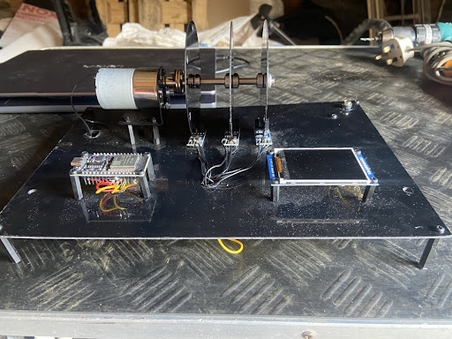
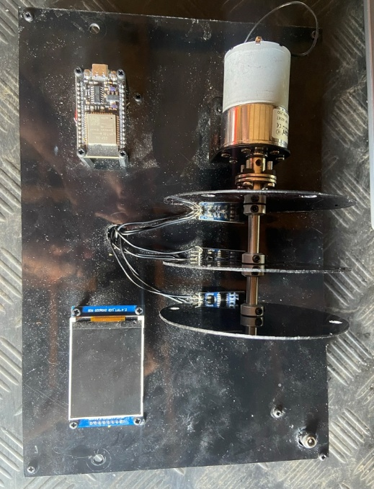

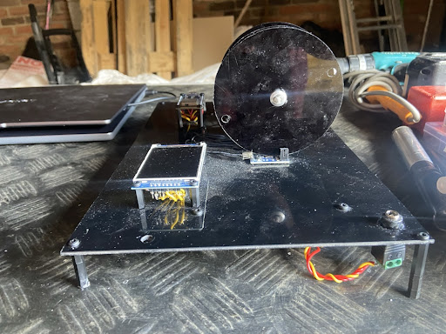

Multi-View Orthographic Projection of the Physical Rig.
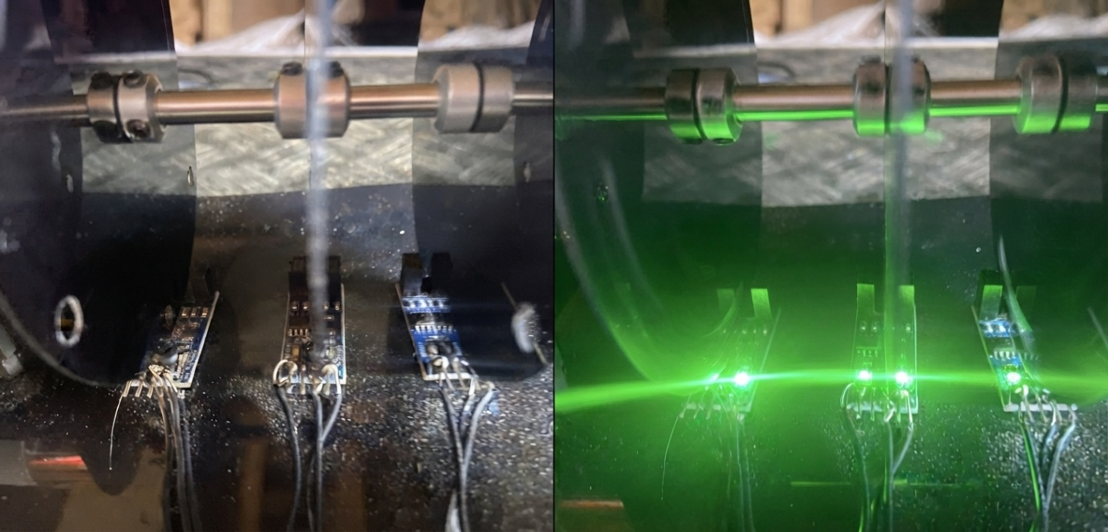

View of LM393 Optical Sensors Unpowered and Powered.

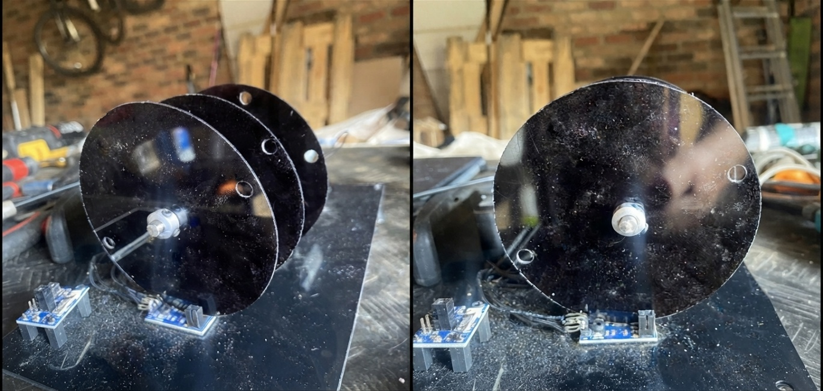

Multi-View of the Rotating Encoder Discs.
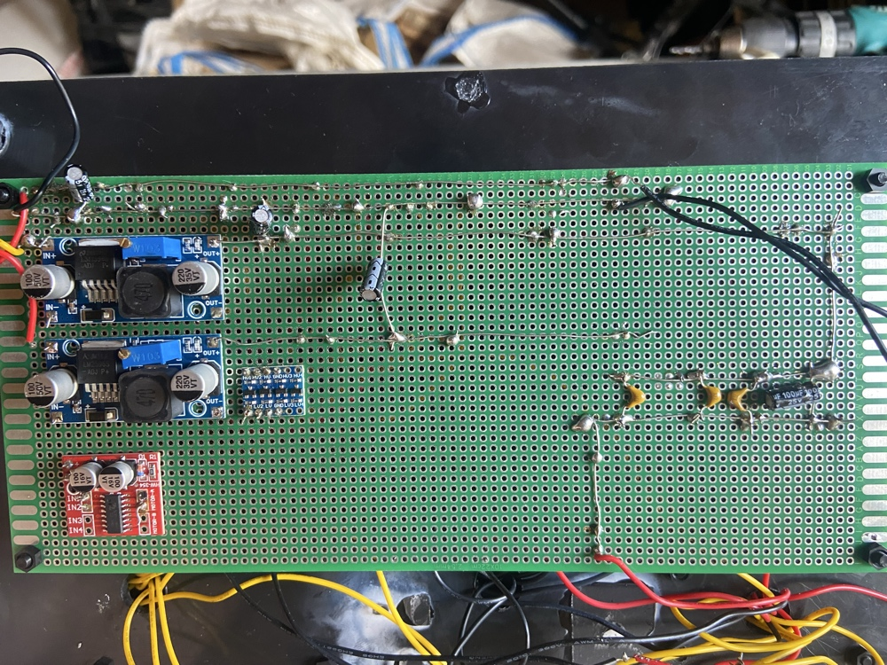

Top view of the custom perfboard, featuring a DC power input jack feeding three distinct voltage channels, a motor driver, and a sensor hub implementing ceramic capacitors for signal conditioning.
9. Conclusion
The Stochastic Multi-Sensor Simulator successfully bridged Mechanical and Electrical assembly. From embedded hardware to the motor’s structural integrity, it forms a robust desktop data processing rig. By adhering to a modular and reusable design pattern, the project not only validated stochastic data acquisition but also established a flexible hardware rig that is a foundation for simulating advanced industrial monitoring applications.

