STUDENT PERFORMANCE ANALYSIS

Data Analysis Project
Tools Used: MySQL, Excel
Dataset: Student Performance Dataset
Total Students: 1,000

- Introduction
Student performance analysis is an important application of data analysis because it helps identify patterns in students' academic performance and the factors associated with their results. This project analyzes a dataset containing information about 1,000 students, including study time, attendance, sleep, previous exam performance, internet access, extracurricular activities, part-time employment, parental education, and final exam performance.
SQL was used to explore, clean, transform, and analyze the dataset. The analysis focuses on understanding student performance, identifying patterns between different factors and final exam scores, and measuring changes between previous and final examination results.
2.Aim & Objectives
The primary objective of this project is to analyze student academic performance using SQL and identify patterns and relationships between students' study habits, attendance, lifestyle factors, background characteristics, and examination results. The project aims to transform and validate the dataset, calculate key performance indicators, compare previous and final examination performance, measure student improvement, and identify factors associated with differences in final exam scores.
The analysis also aims to generate meaningful insights that can help identify performance patterns, recognize students showing significant improvement or decline, and provide data-driven recommendations for supporting student academic performance.

specific objectives
- Assess data quality by identifying duplicate records, NULL values, and checking the ranges of important numerical variables.
- Transform the data by creating meaningful fields such as improvement, improvement status, attendance status, study-time groups, grades, and student ranking.
- Measure overall academic performance using KPIs such as average, minimum, and maximum final exam scores.
- Analyze the relationship between study time and final exam performance.
- Examine the association between attendance and final exam performance.
- Analyze the relationship between sleep duration and final exam scores.
- Compare previous examination performance with final examination performance and measure average improvement.
- Examine how internet access, extracurricular activities, part-time employment, and parental education are associated with final exam performance.
- Analyze the final grade distribution and identify top-performing students.
- Develop data-driven insights and recommendations based on the findings
3. Dataset Overview
The dataset used for this project contains information on 1,000 students and includes 21 columns covering academic performance, study habits, attendance, sleep, personal background, and other factors. The dataset was analyzed using MySQL to understand patterns in student performance and identify factors associated with final examination scores.
3.1Dataset Structure
Category | Variables
Student Information | Student ID, Gender
Study & Attendance | Study Time, Study Time Group, Attendance, Attendance Status
Lifestyle | Sleep Hours, Sleep Status
Background | Parental Education, Internet Access
Activities | Extracurricular Activities, Part-time Job
Previous Performance | Previous Exam Score, Previous Grade, Previous Exam Status
Final Performance | Final Exam Score, Final Grade, Student Rank, Final Exam Status
Improvement | Improvement, Improvement Status

3.2Dataset Summary
Description | Value
Total Students | 1,000
Total Columns | 21
Duplicate Student IDs | 0
Minimum Study Time | 0.5 hours
Maximum Study Time | 8.1 hours
Minimum Attendance | 54.8%
Maximum Attendance | 100%
Minimum Sleep | 3.2 hours
Maximum Sleep | 10 hours
Minimum Previous Exam Score | 31.3
Maximum Previous Exam Score | 100
Minimum Final Exam Score | 46.8
Maximum Final Exam Score | 100
4. Data Cleaning & Validation
4.1 Duplicate Record Check
A duplicate check was performed using the student_id column to ensure that each student record was unique. The analysis identified 0 duplicate student IDs, indicating that there were no duplicate student records in the dataset.
Validation Check | Result
Total Students | 1,000
Duplicate Student IDs | 0
4.2 Missing Value Check
Missing-value checks were performed on the major variables used in the analysis, including student ID, gender, study time, attendance, sleep, parental education, internet access, extracurricular activities, part-time job, previous exam score, final exam score, and final grade. No missing values were identified in these fields.
Variable Group | Missing Values
Student ID | 0
Gender | 0
Study Time | 0
Attendance | 0
Sleep | 0
Previous Exam Score | 0
Final Exam Score | 0
Final Grade | 0

4.3 Range Validation
Numerical variables were also checked to understand their minimum and maximum values and to identify any potentially unusual values. The observed ranges were recorded for study time, attendance, sleep, previous exam score, and final exam score.
4.4 Data Cleaning Summary
The validation process found no duplicate student records or missing values in the key analytical fields. Therefore, no records needed to be removed because of duplication or missing data, allowing the analysis to proceed with all 1,000 student records

5. Data Transformation
After validating the dataset, additional calculated and categorical columns were created to make the data more useful for analysis. These transformations helped classify student performance, measure improvement, and analyze patterns across different student groups.
New Column | Purpose
improvement | Measures the difference between final and previous exam scores
improvement_status | Classifies students as significant improvement, moderate improvement, no change, or decline
attendance_status | Categorizes attendance into performance levels
sleep_status | Categorizes students based on sleep duration
previous_grade | Converts previous exam scores into A–F grades
previous_exam_status | Categorizes previous exam performance
Final_exam_status | Converts final grades into descriptive performance categories
Students_Rank | Stores the student's ranking based on final exam score
6. Key Performance Indicators (KPIs)
Key Performance Indicators (KPIs) were calculated to provide an overall summary of student academic performance and the main characteristics of the dataset.
KPI | Value
Total Students | 1,000
Average Final Exam Score | 83.54
Highest Final Exam Score | 100
Lowest Final Exam Score | 46.80
Average Study Time | 3.57 hours
Average Attendance | 85.09%
Average Sleep | 6.80 hours
Average Previous Exam Score | 69.74
The dataset shows an overall average final exam score of 83.54, with scores ranging from 46.80 to 100. The average attendance was 85.09%, while students studied for an average of 3.57 hours and slept for an average of 6.80 hours. The average final exam score of 83.54 was higher than the average previous exam score of 69.74, indicating an overall improvement in average examination performance.

7. Detailed Analysis
The dataset was analyzed to identify patterns and relationships between student characteristics, academic habits, and final examination performance. The following analyses examine study time, attendance, sleep, previous performance, improvement, access to resources, extracurricular activities, part-time employment, parental education, and final grade distribution.
7.1 Study Time vs Final Exam Score
Study Time Group | Students | Avg. Study Time | Avg. Final Score
Very Low | 144 | 1.27 | 74.79
Low | 588 | 3.29 | 82.27
Medium | 256 | 5.33 | 90.73
High | 12 | 7.32 | 97.78
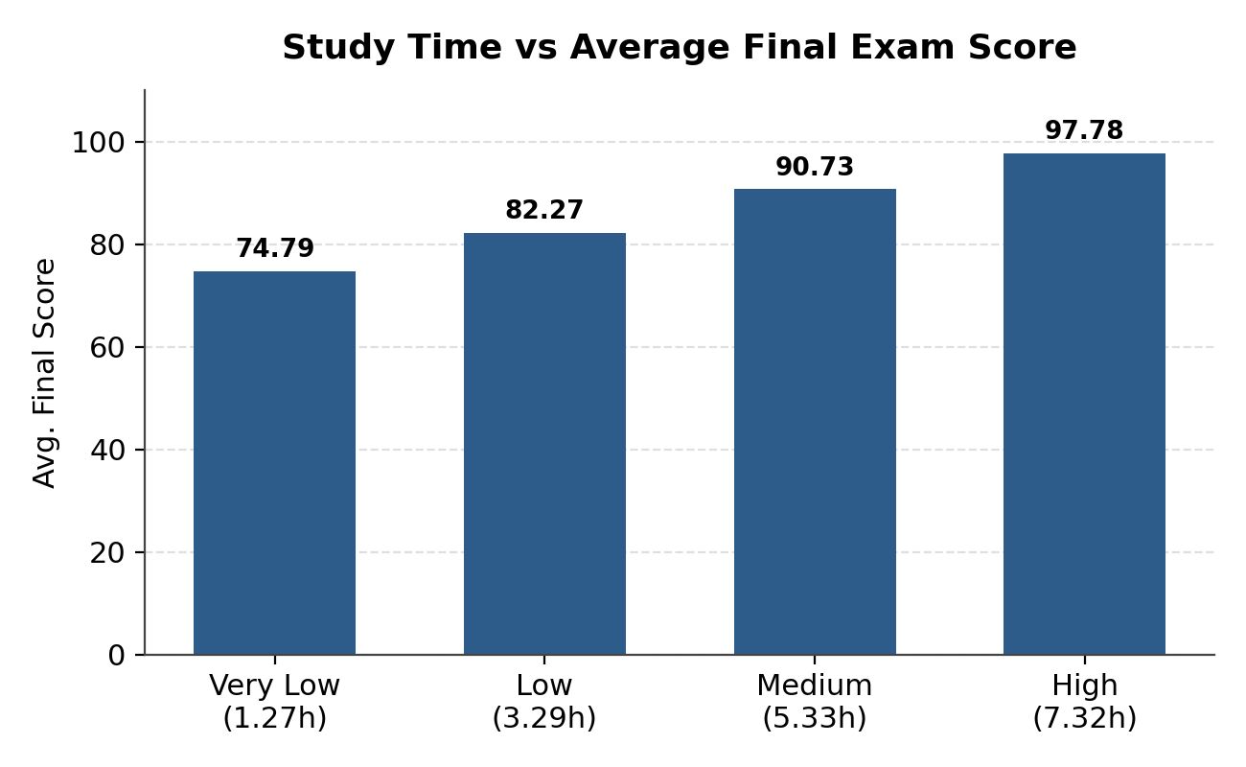
The analysis shows a clear positive relationship between study time and final exam performance. Students in the Very Low study-time group had an average final score of 74.79, while students in the High study-time group achieved an average of 97.78. Average final scores increased consistently as study time increased. Students who spent more time studying generally achieved higher final exam scores.

7.2 Attendance vs Final Exam Score
Attendance Group | Students | Avg. Attendance | Avg. Final Score
Low | 62 | 65.68% | 76.91
Average | 223 | 75.92% | 81.46
Good | 389 | 84.89% | 83.40
Excellent | 326 | 95.30% | 86.41
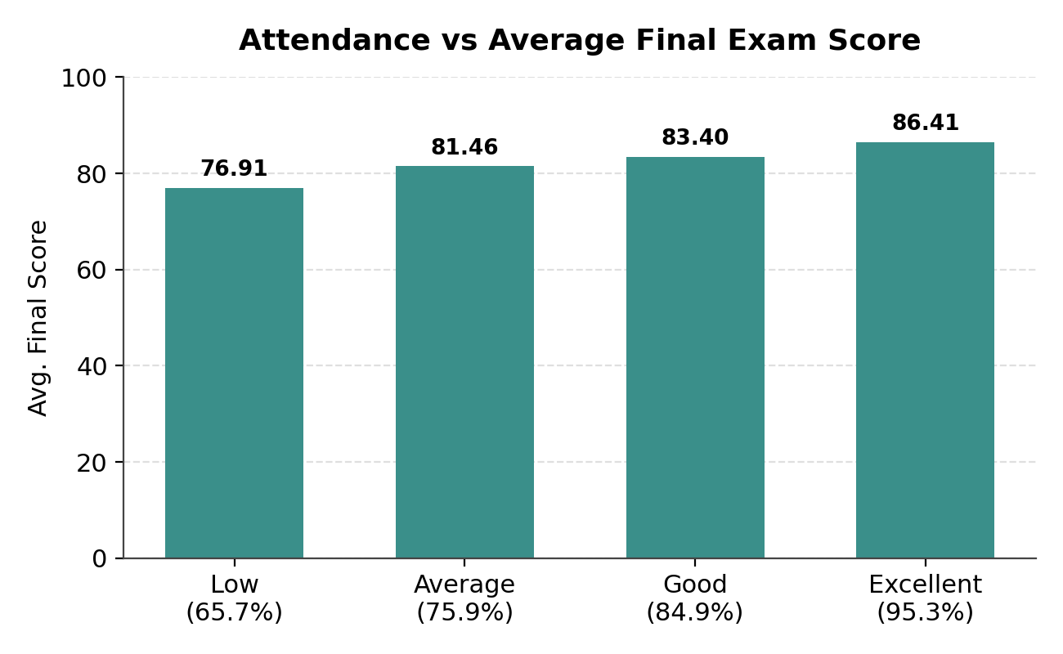
Students with higher attendance generally achieved higher final exam scores. The consistent increase in average final scores across attendance groups suggests that regular attendance is associated with better academic performance in this dataset. The analysis shows a positive relationship between attendance and final exam performance. Students in the Low attendance group achieved an average final score of 76.91, while students in the Excellent attendance group achieved an average of 86.41. This represents a difference of 9.50 points.
7.3 Sleep vs Final Exam Score
Sleep Status | Students | Avg. Sleep | Avg. Final Score
Adequate Sleep | 16 | 8.00 hrs | 87.49
Extended Sleep | 153 | 8.65 hrs | 86.59
Average Sleep | 577 | 6.95 hrs | 83.14
Deficit Sleepers | 254 | 5.28 hrs | 82.37
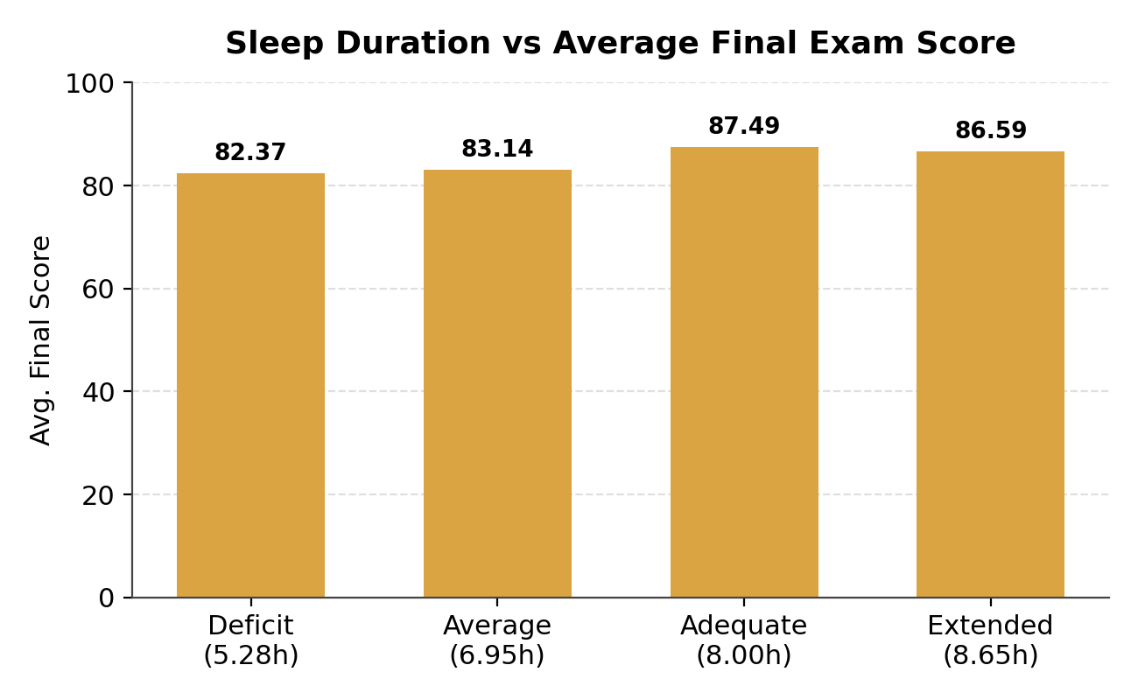
The analysis suggests that students with moderate-to-adequate sleep generally had higher average final scores than students with lower sleep duration. However, the relationship was not strictly linear. Students classified as Adequate Sleep had an average final score of 87.49, while Deficit Sleepers had an average score of 82.37, a difference of 5.12 points. Students with lower sleep duration tended to have lower average final exam scores. However, the Extended Sleep group did not have the highest average score, suggesting that the relationship between sleep duration and academic performance may not be strictly linear.
7.4 Previous vs Final Exam Score
Previous Grade | Students | Avg. Previous Score | Avg. Final Score | Avg. Improvement
A | 64 | 94.17 | 93.52 | -0.67
B | 148 | 84.26 | 87.81 | +3.57
C | 274 | 74.66 | 84.18 | +9.54
D | 295 | 65.11 | 82.80 | +17.67
F | 219 | 52.88 | 77.95 | +25.08
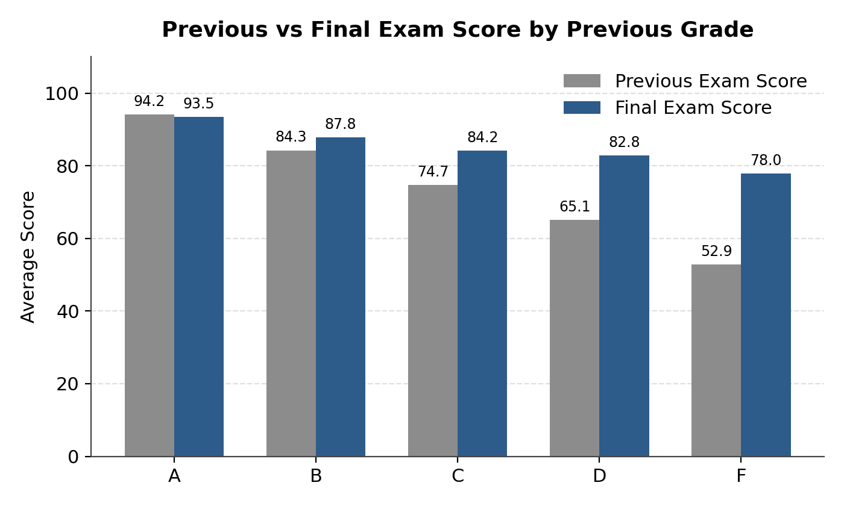
The comparison between previous and final examination scores shows that students in the lower previous-grade groups experienced the greatest improvement. Students in the F group improved by an average of 25.08 points, while students in the D group improved by 17.67 points. In contrast, the A group experienced a small decline of 0.67 points.Overall, the results indicate substantial improvement among students who had lower previous examination scores. While students who were already performing at a high level showed relatively little change, students in the lower-performing groups demonstrated much larger increases in their final examination scores.

7.5 Improvement Status
Improvement Status | Students | Avg. Improvement | Avg. Final Score
Significant Improvement | 295 | +28.77 | 88.11
Moderate Improvement | 561 | +11.01 | 83.08
No Change | 24 | 0.00 | 83.51
Decline | 120 | -7.18 | 74.50
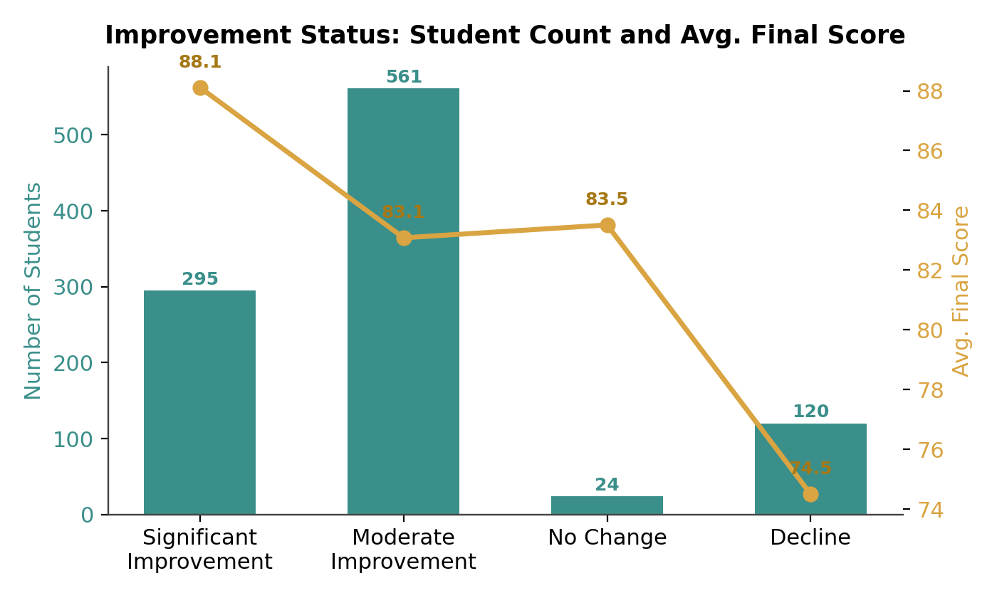
The majority of students improved between their previous and final examinations. A total of 856 students (85.6%) showed improvement, while 120 students (12.0%) experienced a decline and 24 students (2.4%) showed no change. Students classified as having significant improvement increased their scores by an average of 28.77 points and achieved an average final score of 88.11. In contrast, students in the decline group experienced an average decrease of 7.18 points and had the lowest average final score of 74.50.
7.6 Internet Access vs Final Exam Score
Internet Access | Students | Avg. Final Score
Yes | 854 | 84.28
No | 146 | 79.26
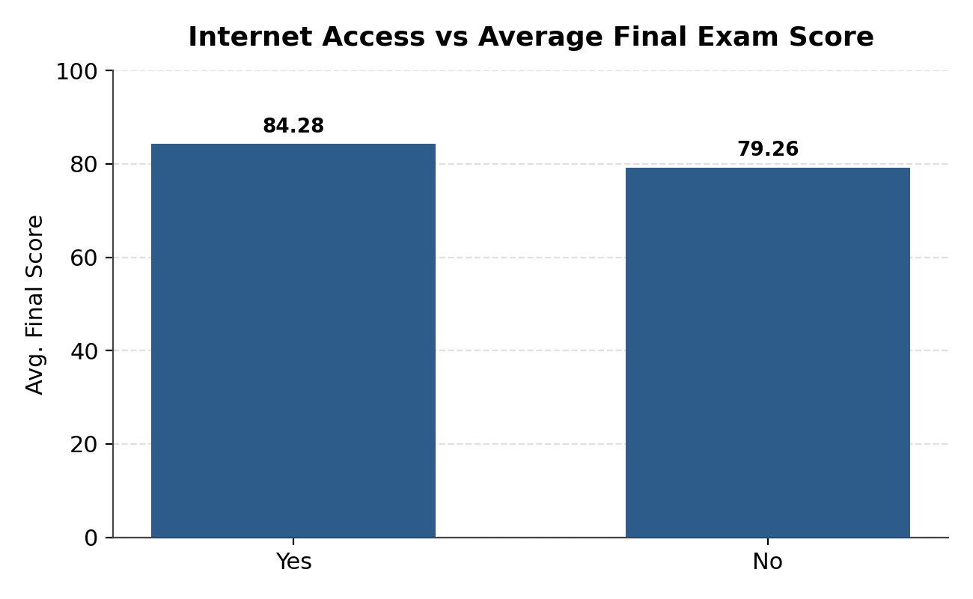
Students with internet access achieved an average final exam score of 84.28, compared with 79.26 among students without internet access. This represents a difference of 5.02 points. The analysis indicates that students with internet access generally achieved higher final exam scores than students without internet access. This suggests an association between access to internet-based resources and academic performance in the dataset. However, the analysis does not establish that internet access directly causes higher examination scores.
7.7 Extracurricular Activities vs Final Exam Score
Extracurricular Activities | Students | Avg. Final Score
Yes | 572 | 83.74
No | 428 | 83.28
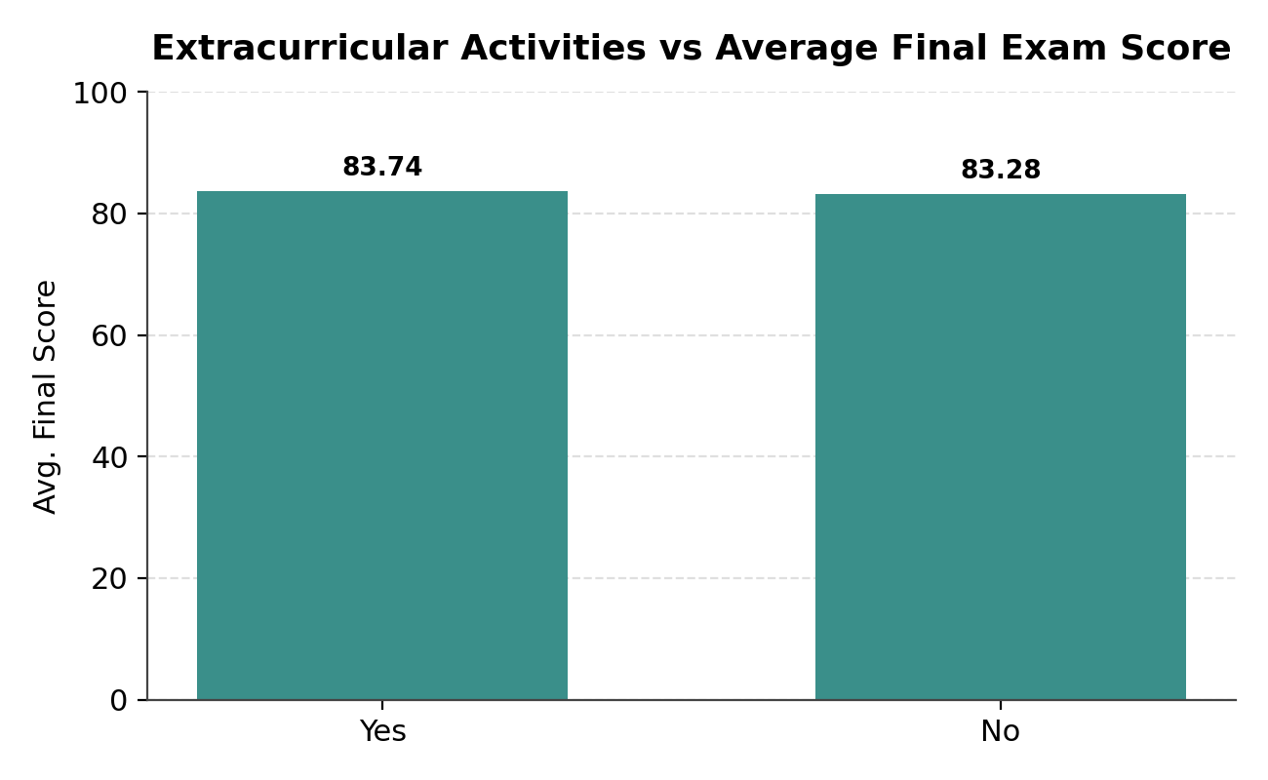
Students who participated in extracurricular activities had an average final exam score of 83.74, compared with 83.28 among students who did not participate. The difference was only 0.46 points. The analysis shows very little difference in final exam performance between students who participated in extracurricular activities and those who did not. Although the participation group had a slightly higher average score, the difference of 0.46 points suggests a relatively weak association with final exam performance in this dataset.
7.8 Part-time Job vs Final Exam Score
Part-time Job | Students | Avg. Final Score
No | 684 | 84.58
Yes | 316 | 81.29
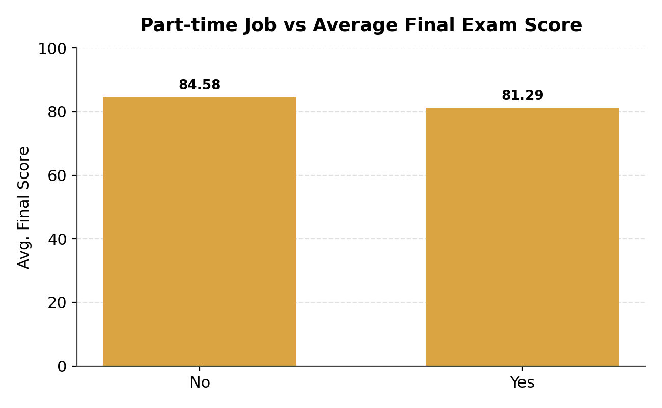
Students without a part-time job achieved an average final exam score of 84.58, compared with 81.29 among students who had a part-time job. This represents a difference of 3.29 points. The analysis indicates that students without part-time jobs generally achieved higher final exam scores than students who had part-time jobs. This suggests an association between part-time employment and academic performance in the dataset. However, this analysis does not establish that having a part-time job directly causes lower scores.
7.9 Parental Education vs Final Exam Score
Parental Education | Students | Avg. Final Score
PhD | 50 | 85.06
Masters | 184 | 84.03
None | 102 | 83.44
Bachelors | 308 | 83.40
High School | 356 | 83.23
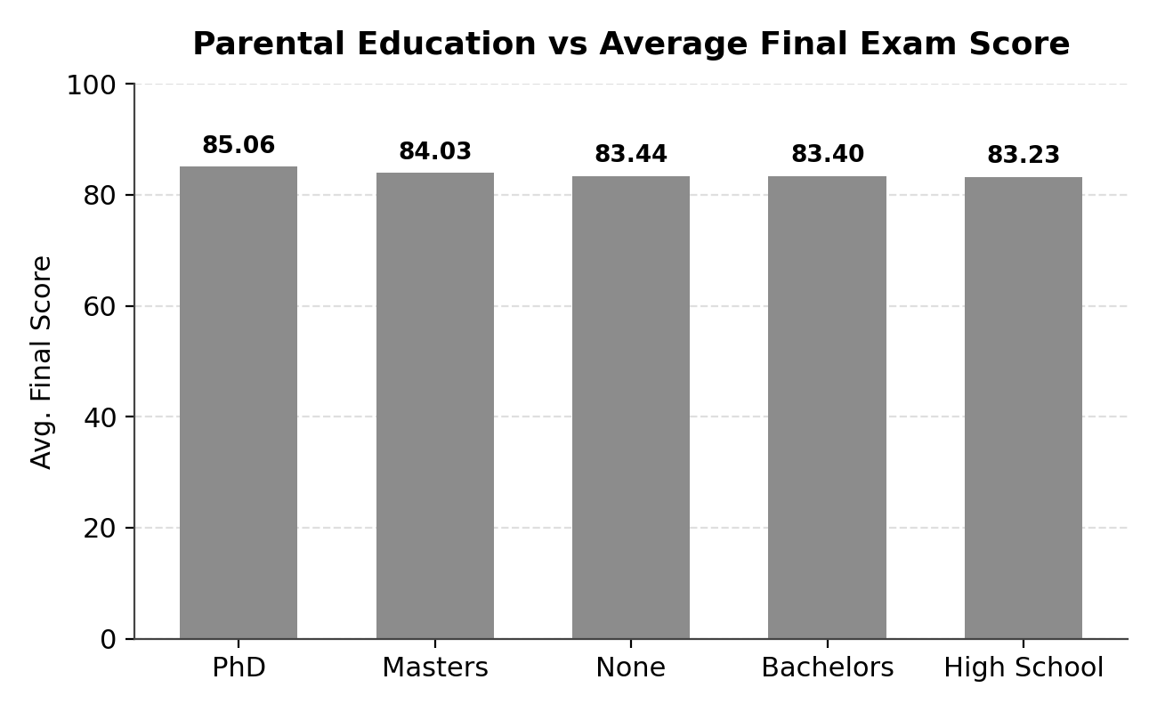
Students whose parents had a PhD recorded the highest average final exam score of 85.06, while students whose parents had a high-school education recorded the lowest average of 83.23. The difference between the highest and lowest groups was 1.83 points. The differences in average final exam scores across parental education groups were relatively small. This suggests that parental education had a weaker association with final exam performance in this dataset compared with factors such as study time and attendance. The PhD group contains only 50 students, while the High School group contains 356 students. Therefore, the difference should be interpreted carefully.
7.10 Final Grade Distribution
Final Grade | Students | Percentage
A | 284 | 28.40%
B | 354 | 35.40%
C | 261 | 26.10%
D | 89 | 8.90%
F | 12 | 1.20%
Total | 1,000 | 100%
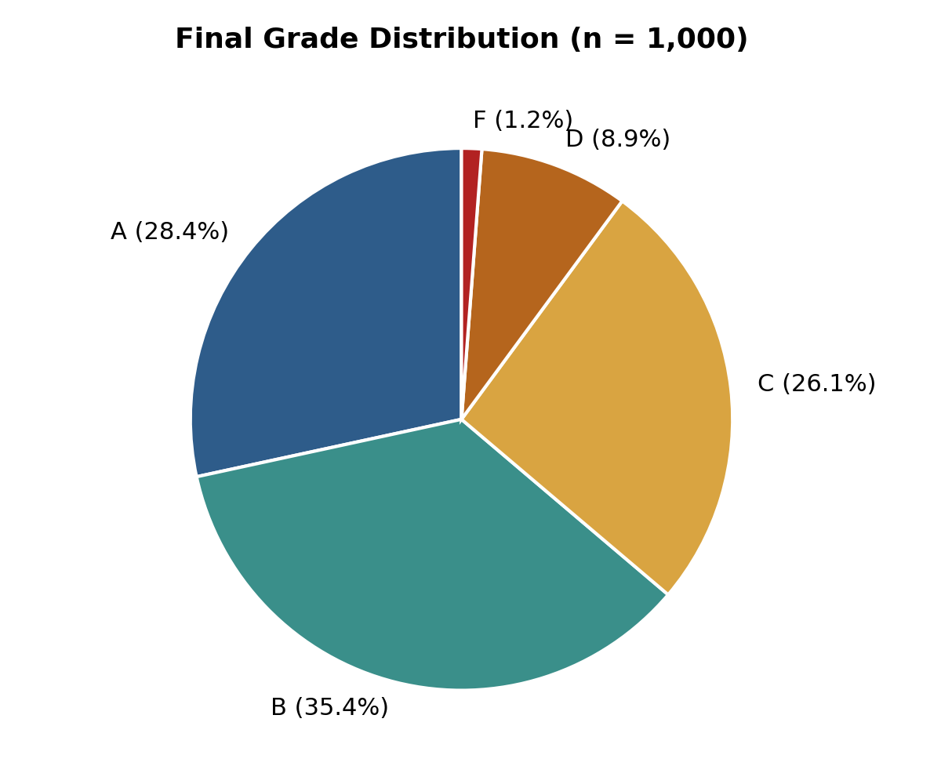
Grade B was the most common final grade, with 354 students (35.40%), followed by Grade A with 284 students (28.40%). Grade C accounted for 261 students (26.10%), while only 12 students (1.20%) received an F. The final grade distribution indicates generally strong academic performance among the students. A total of 638 students (63.8%) achieved an A or B, while 900 students (90%) achieved an A, B, or C. Only 1.2% of students received an F.
7.11 Top-Performing Students
Student ID | Final Exam Score | Rank
1 | 100 | 1
2 | 100 | 1
88 | 100 | 1
51 | 100 | 1
43 | 100 | 1
131 | 100 | 1
33 | 100 | 1
109 | 100 | 1
35 | 100 | 1
22 | 100 | 1
The top-performing students achieved a perfect final exam score of 100. Multiple students shared Rank 1 because they achieved the same highest score. The ranking analysis identified multiple students who achieved the maximum possible final exam score of 100. Since the RANK() function was used, all students with the same score received the same rank. This demonstrates the presence of tied top scores within the dataset.
8. Key Insights
The analysis of 1,000 student records identified several important patterns related to academic performance. The key findings are summarized below.

8.1 Study Time
Students with higher study time generally achieved higher final exam scores. Average final scores increased from 74.79 for the Very Low study-time group to 97.78 for the High study-time group.

8.2 Attendance
Higher attendance was associated with better final exam performance. Students in the Excellent attendance group achieved an average score of 86.41, compared with 76.91 among students in the Low attendance group.

8.3 Student Improvement
856 students (85.6%) improved between their previous and final examinations, while 120 students (12%) experienced a decline and 24 students (2.4%) showed no change.

8.4 Previous vs Final Performance
Students with lower previous grades showed the greatest improvement. The F group improved by an average of 25.08 points, while the A group experienced a small decline of 0.67 points.

8.5 Access and Other Factors
Students with internet access had an average final score 5.02 points higher than students without access. Students without part-time jobs also had a 3.29-point higher average score than students with part-time jobs. In contrast, extracurricular activities showed only a 0.46-point difference.

8.6 Overall Academic Performance
Overall performance was strong, with an average final exam score of 83.54. 63.8% of students achieved an A or B, while 90% achieved an A, B, or C. Only 1.2% received an F.
9. Recommendations
Based on the findings from the analysis, the following recommendations can be considered to support better academic performance and identify students who may require additional support.

9.1 Encourage Consistent Study Habits
Students in higher study-time groups achieved higher average final scores. Encouraging students to maintain consistent and structured study schedules may help support academic performance.

9.2 Monitor Attendance
Higher attendance was associated with higher average final exam scores. Institutions can monitor students with low attendance and provide appropriate academic support where required.

9.3 Identify Students Experiencing Decline
120 students (12%) experienced a decline between their previous and final examination scores. These students could be identified for additional academic guidance or mentoring.

9.4 Support Lower-Performing Students
Students with lower previous examination scores showed substantial improvement but still had lower final scores than higher-performing groups. Targeted tutoring and additional learning support could help these students continue improving.

9.5 Improve Access to Learning Resources
Students with internet access had a higher average final score than students without access. Providing students with better access to digital learning resources may help reduce differences in academic performance.

9.6 Support Students Balancing Work and Studies
Students with part-time jobs had a lower average final score than students without part-time jobs. Academic institutions could consider flexible support for students who balance employment with their studies.

10. Conclusion
This project analyzed the academic performance of 1,000 students using SQL. The analysis examined study time, attendance, sleep, previous examination performance, improvement, internet access, extracurricular activities, part-time employment, parental education, and final grade distribution.
The findings indicate that study time and attendance showed the clearest positive associations with final examination performance. A large majority of students, 85.6%, improved between their previous and final examinations. Internet access was also associated with higher average final scores, while students with part-time jobs recorded somewhat lower average scores. Other factors, such as extracurricular activities and parental education, showed relatively small differences in average final scores.
Overall, the students demonstrated strong academic performance, with an average final exam score of 83.54 and 90% of students achieving an A, B, or C. The project demonstrates how SQL can be used to validate, transform, analyze, and interpret student performance data and convert raw data into meaningful insights for decision-making. The analysis provides a data-driven view of student performance and highlights areas where additional academic support and resources could be considered.
11. SQL Queries Used for Analysis

11.1 Data Validation
SELECT COUNT(*)
FROM student_performance_dataset;
SELECT student_id, COUNT(*) AS duplicate_count
FROM student_performance_dataset
GROUP BY student_id
HAVING COUNT(*) > 1;
11.2 Study Time Analysis
SELECT
study_time_group,
COUNT(*) AS student_count,
AVG(study_time_hours) AS avg_study_time,
AVG(final_exam_score) AS avg_final_exam_score
FROM student_performance_dataset
GROUP BY study_time_group;
11.3 Attendance Analysis
SELECT
CASE
WHEN attendance_percent >= 90 THEN 'Excellent'
WHEN attendance_percent >= 80 THEN 'Good'
WHEN attendance_percent >= 70 THEN 'Average'
ELSE 'Low'
END AS attendance_group,
COUNT(*) AS student_count,
AVG(attendance_percent) AS avg_attendance,
AVG(final_exam_score) AS avg_final_score
FROM student_performance_dataset
GROUP BY attendance_group;
11.4 Previous vs Final Exam
SELECT
previous_grade,
COUNT(*) AS student_count,
AVG(previous_exam_score) AS avg_previous_score,
AVG(final_exam_score) AS avg_final_score,
AVG(improvement) AS avg_improvement
FROM student_performance_dataset
GROUP BY previous_grade;
11.5 Improvement Status
SELECT
improvement_status,
COUNT(*) AS student_count,
AVG(improvement) AS avg_improvement,
AVG(final_exam_score) AS avg_final_score
FROM student_performance_dataset
GROUP BY improvement_status;
11.6 Internet Access
SELECT
internet_access,
COUNT(*) AS student_count,
AVG(final_exam_score) AS avg_final_score
FROM student_performance_dataset
GROUP BY internet_access;
11.7 Final Grade Distribution
SELECT
final_grade,
COUNT(*) AS student_count
FROM student_performance_dataset
GROUP BY final_grade;
11.8 Top Students
SELECT
student_id,
final_exam_score,
RANK() OVER (
ORDER BY final_exam_score DESC
) AS student_rank
FROM student_performance_dataset
ORDER BY final_exam_score DESC
LIMIT 10;

