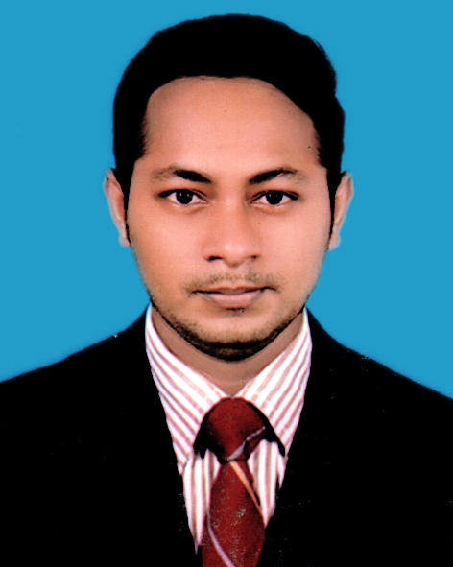­­­­­­­Coffee Maker:

**MD. PARVEJ MIAJI**

Phone: 0564649213

Email: parvezmodel@gmail.com

Experience

­­­­

My Life Coffee:

Maintained a clean and professional appearance. Took coffee,

food and others order and prepared them for customer quickly

and more effective.

**From** 2017 - 2020

ABOUT ME

Hi it’s my pleasure you are reading my CV, I am dedicated to my work it doesn't matter which sector it is, through a self learner in sort of time i can gather the fundamental of each and every work.

I have much professional communication skills that would be enough to convince clients.

Lotti House Coffee:

Delivered excellent customer service and prompt food and beverage delivery. Took orders from client quick and effective.

**From** 2020 - 2022

Education

secondary school certificate (ssc)

Language

* English
* Arabic
* Hindi