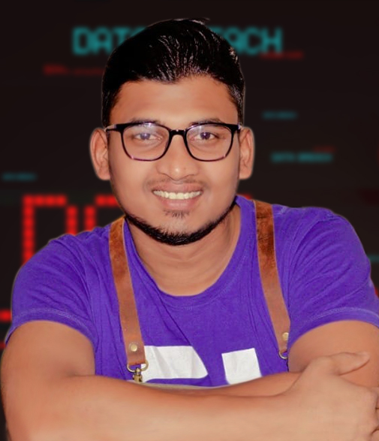­­­­­­­Coffee Maker:

Phone: 0571012135

Email: [freelanceralfin@gmail.com](mailto:freelanceralfin@gmail.com)

www.cleavercode.com

Ar Alfin Arif BRONSON

Experience

­­­­

Coffee Maker(Barista):

Sir I Was Working Last 3 Years In Coffee shop As A Coffee Maker (Barista), I Know How To Communication With Customers Or Others Person Like Professional.

Responsibilities of Barista:

ABOUT ME

Handled the ingredients used for the coffee mixes.

Assured that the coffee served to the customers are hot and high quality.

Experimented on regular basis new concoctions and have some customers for free tasting.

Served coffee to customers and collected money.

Supervised the work of staff and evaluated them quarterly.

Hello Sir Hope You Are Absolutely Fine, My Name Is Ar Alfin Arif, I'm Searching A New Job For The Full Time, I Think This Is The Right Place To Work For Me And As Well For My Skills , Out Of My Skills Also I Can Work As A Assistant Of Any Technology Master. Some Skills I Am Present Down Bellow Please Check This Out.

Coffee Maker:

March 2017-2020

High Garden Cafe, Riyadh exit 28

Web Design & Development :

I am a Web Developer and I'm very passionate and dedicated to my work With 2 years experience as a professional Web developer, I have acquired the skills and knowledge necessary to work as a programmer. I enjoy every step of the design and development process, from discussion and collaboration to concept and execution, but I find the most satisfaction in seeing the finished product do everything for you that it was created to do.

Skills

Coffee Maker:

Bachelor of Science Degree with a Major in Aviation Technology

Arts, 2016

Homna Degree College

Education

PHP:

Web Development:

Wordpress:

Web Design: