Nama : Alfin Kerin Saputra

Nim : L200122007

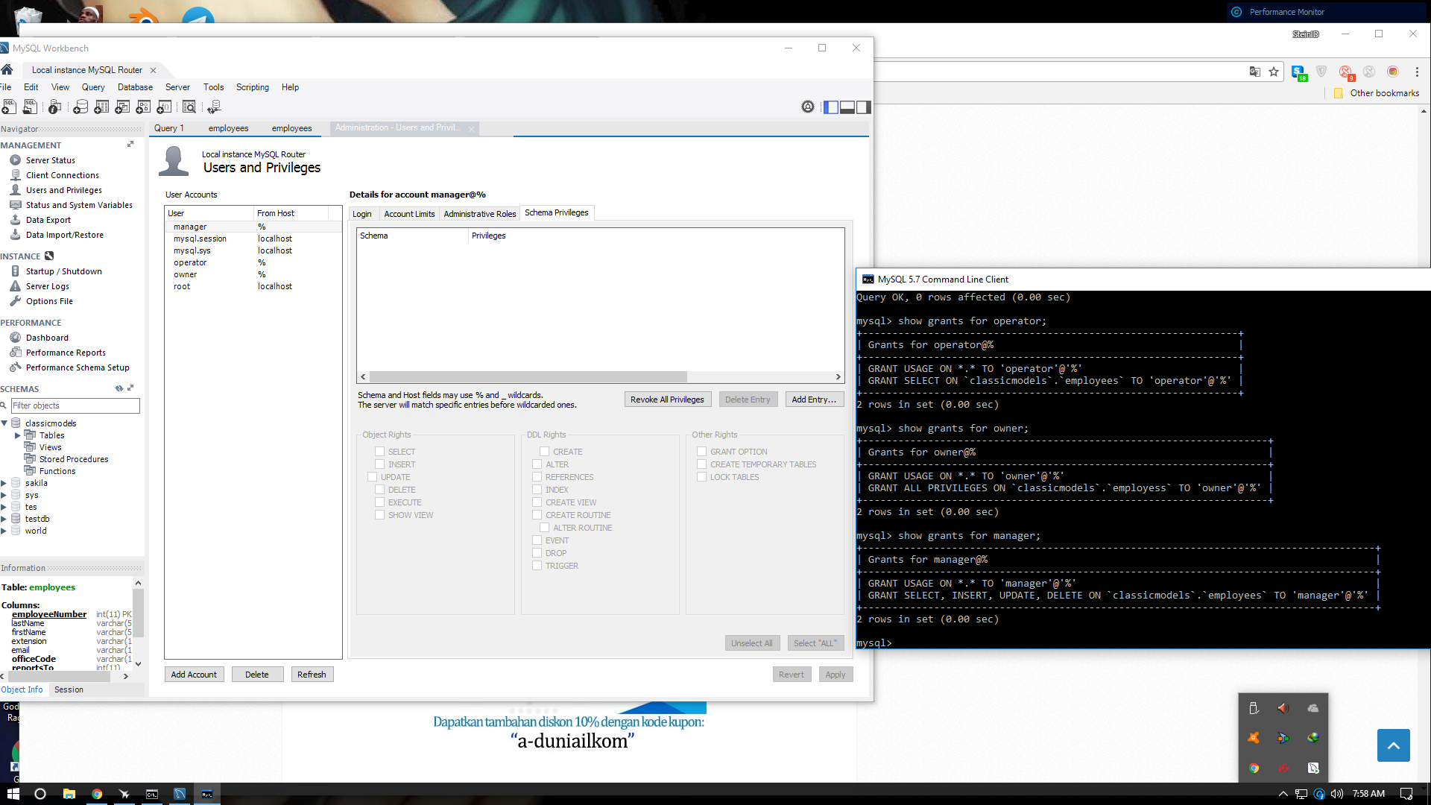

In my company I have 3 roles for manage our database is owner , manager and operator , you can see on my screenshot there are has different privileges for manage database our company.

Owner got all privileges , manager got select , insert , and update for manage the database , and the last is operator got only select .

The owner can access all of table , the manager can read and write all of table , and the operator can read table of product , order , payment , and customer