Annual exam (2024_25)

**Subject:_English (MM 80)**

**Class _UKG**

**Name_______ RollNo_____. Teacher sig______**

**1.** Write the capital letter Alphabet? ( 3)

A__ ___ ___ ___ ___ ______ _____Z

**2.** Write the small letter Alphabet ? (3)

a______ ____________ ___________

**3.**write the 3 words beginning with the. ( 5) following letters?

a)F________. e) P______

b)V________ f)C________

c)R_________. g)M_______

d)N__________. h)J_______

I)H_______.

j)B_________

**4**)See the pictures and fill the cross word (2) with the right vowels?

S

H____. T.

N

D

C_____ w

G

**5)** Write the plurals of the following? ( 5)

a) Tree______. f)frog______

b)bird_________. g)apple_____

c) flower _______. h)guava_____

d)doll________. I)cat______

e)girl_______. j)mango_____

**6)** Complete the following using 'a' or'. ( 5)

an'

a)_____occtopus. g) _____book

b)______lamp. h)_______insect

c)_______umbrella. I)________urn

d)_______hut. J)_______leaf

f)________eye. k)_______ant

**7)** Complete the questions using correct. (5) question words given in the help box

[How,Which, Where, When What]

a)_________do you live?

b)_________is your birthday?

c)_________old are you?

d)_________are you going?

f) __________is your name?

**8)** Write the opposites words. ( 10)

a)Big_____. f)old ______

b)fat_______. g)close_____

c)fast______. h) Happy ____

d)Hot______. I)close_______

e)Full_____. J)Day_________

**9**)Fill in the write words (6)

[Is ,am are]

a)I_____boy

b)This _____hut

c)The cat ____black

d)The roses _____rose

e)The birds _____flying

f)He ______a teacher

**10)** Write any Rhyme? ( 5)

____________________

____________________

____________________

_________________

___________&_________

**11**)Write the Rhyming words (5)

________ _____ ___ ______. ______

_______________. ___________

________ _______ ____ _____

**12)** Look at the pictures that go together (5)

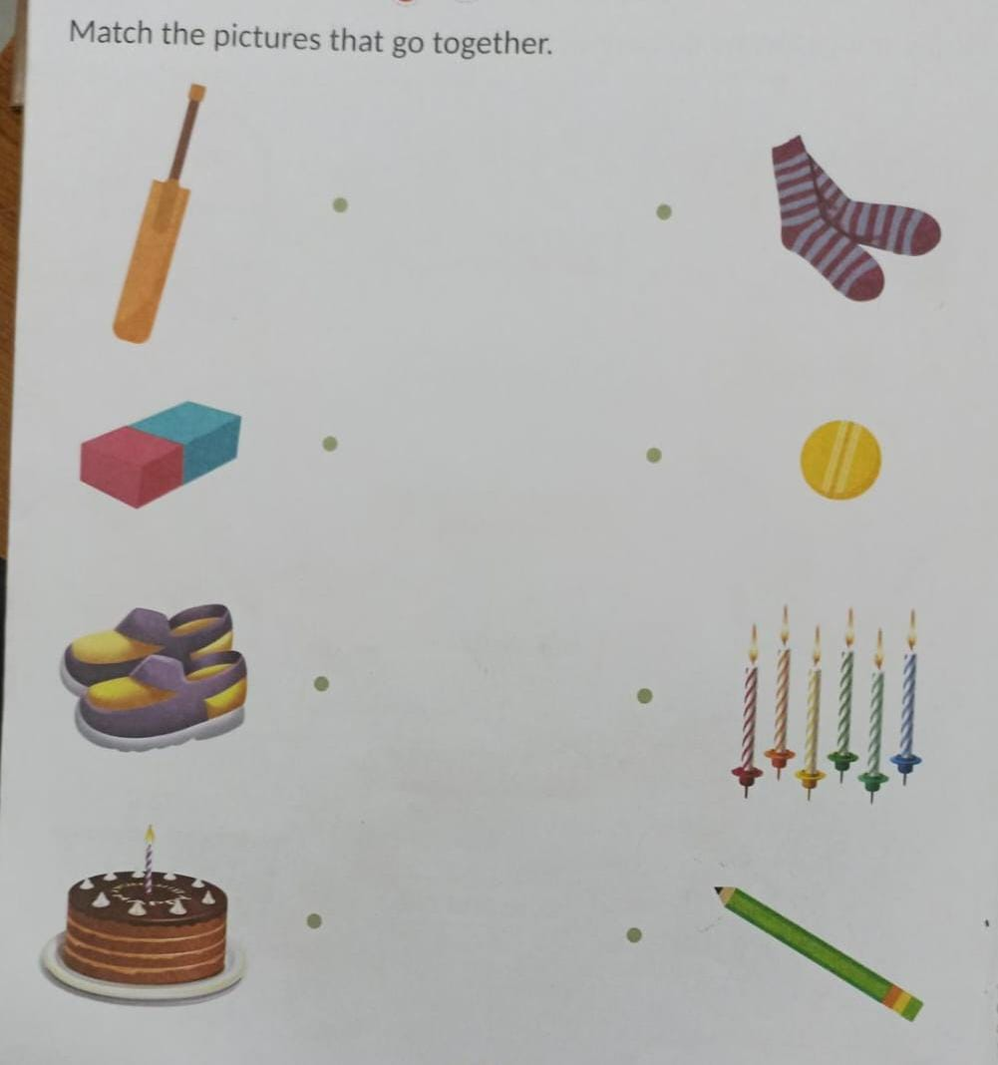

**13)** Look and match the proposition with the correct picture ( 5 )

a). between

,b). behind

c). On

d). In

e). Under

**14)** Correct pictures to their describing words (6)

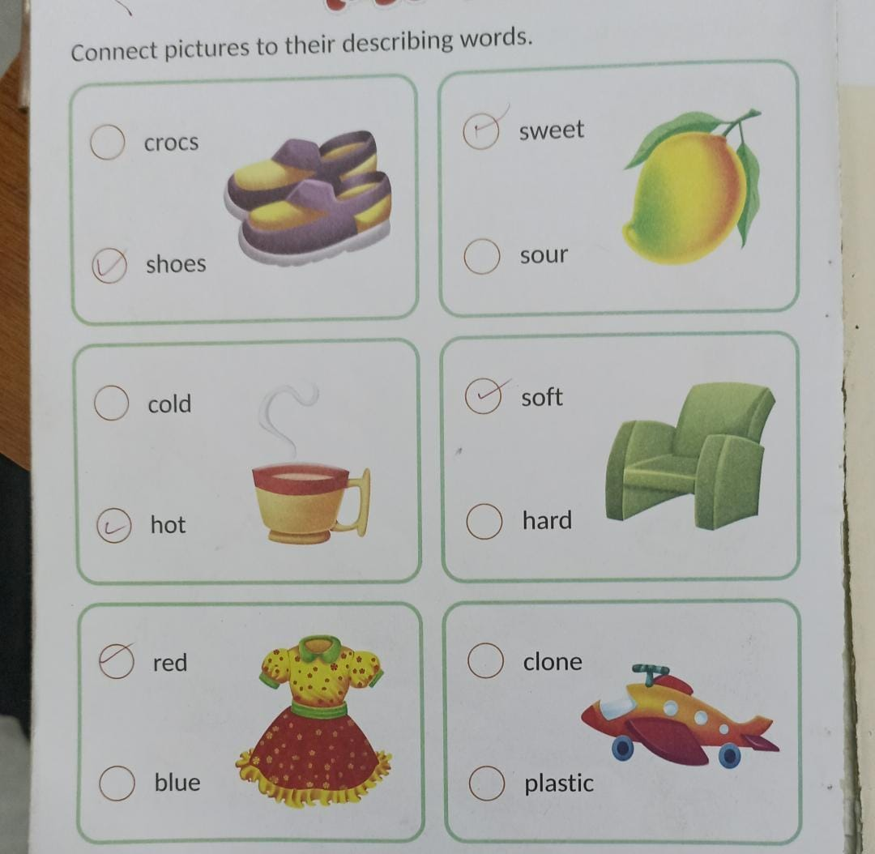

**15)** Write the 10 action words. ( 5)

________________

_________________

________________

_________________

_________________

**16**)Tick (✓)the correct word for the given (5) picture

