Context-Aware Multimodal Classification of Coffee Leaf Diseases Using Vision Transformer and Agro-Environmental Sensor Data

Alfis Arif^{1*} Desi Puspita¹ Siti Aminah¹

¹Informatics Engineering Study Program, Pagar Alam Institute of Technology, Pagar Alam, Indonesia
* Corresponding author’s Email: alfisarif@itpa.ac.id

Abstract: Coffee leaf diseases may show overlapping visual symptoms and are also associated with surrounding agro environmental conditions. This study develops a context-aware multimodal framework integrating coffee leaf images with agro-environmental information for four-class disease classification. A pretrained Vision Transformer (ViT-Base) extracts visual features, while an MLP encodes relative humidity, soil moisture, and soil pH, followed by feature-level fusion. The dataset contains 840 paired observations, divided into 672 training and 168 source-separated validation observations. Six configurations were evaluated: Sensor-only MLP, EfficientNet-B0, ViT-Base, MaxViT-Tiny, ViT + Sensor, and ViT + Shuffled Sensor. The proposed ViT + Sensor achieved 100.00% validation accuracy, 100.00% macro F1-score, balanced accuracy, Cohen’s kappa of 1.0000, and MCC of 1.0000. The Sensor-only MLP achieved 71.43%, confirming predictive information in the environmental variables. However, ViT-only and shuffled-sensor models also achieved 100.00%. Thus, multimodal integration is feasible, but no incremental accuracy benefit from image-sensor correspondence was demonstrated.
Keywords: Coffee leaf disease; Multimodal learning; Vision transformer; Agro-environmental sensing; Feature fusion

- Introduction
Coffee is an important plantation commodity that supports rural livelihoods and regional economies in Indonesia. In smallholder production areas such as Pagar Alam, South Sumatra, coffee leaf diseases can reduce plant vigor, bean quality, and yield when symptoms are detected late or confused with other disorders [1, 2]. Manual inspection remains common because it is inexpensive and readily available, but its reliability depends on farmer experience, symptom severity, illumination, and access to plant-pathology expertise. These limitations motivate the development of intelligent systems that can provide rapid and consistent support for coffee plant health assessment [3].
Deep learning has substantially advanced image-based plant disease recognition. Convolutional neural networks can learn local texture and lesion patterns, whereas Vision Transformers (ViTs) can model relationships among image patches. A recent study on coffee leaves demonstrated that EfficientNet-B0 and ViT can recognize Leaf spot, Coffee rust, and Sooty mold from natural images [4]. However, image-based diagnosis can remain challenging because different diseases may exhibit overlapping discoloration, lesion morphology, and surface texture, while disease appearance can vary with illumination, leaf age, symptom severity, camera conditions, and environmental exposure. Thus, visual information alone may not fully represent the context in which disease symptoms develop.
Environmental conditions also influence plant health and disease development. Variables such as relative humidity, soil moisture, soil acidity, temperature, and leaf wetness can affect pathogen development, plant stress, and disease-conducive conditions. Artificial intelligence and sensor-enabled precision agriculture have therefore been applied to environmental monitoring, irrigation, nutrient management, and agricultural risk assessment [5-6]. However, environmental measurements are generally used for monitoring and management rather than being jointly learned with visual representations for coffee leaf disease classification.
Multimodal learning provides a framework for combining these heterogeneous information sources. Separate encoders can transform each modality into task-specific representations, which are then integrated through feature fusion for joint prediction [7-9]. In this study, the visual modality represents observable leaf characteristics, while the environmental modality represents contextual information from relative humidity, soil moisture, and soil pH. This formulation treats sensor measurements as complementary contextual information rather than direct indicators of disease identity.
Despite advances in image-based plant disease recognition and sensor-enabled agriculture, the integration of visual and agro-environmental information remains insufficiently explored for coffee leaf disease classification. Existing coffee disease studies predominantly rely on visual data [4], whereas sensor-based agricultural systems mainly address environmental monitoring and management [5-6]. The research gap therefore lies in developing and evaluating a context-aware framework that jointly represents coffee leaf appearance and agro-environmental conditions within a unified classification system.
Accordingly, this study develops and evaluates a multimodal ViT-MLP architecture that combines a pretrained Vision Transformer representation of coffee leaf images with learned representations of relative humidity, soil moisture, and soil pH through feature-level fusion. The study addresses the following research question: Can a unified multimodal framework that jointly encodes coffee leaf images and agro-environmental measurements provide reliable classification of coffee leaf health conditions under the implemented experimental setting? The evaluation includes image-only, sensor-only, multimodal, and shuffled-sensor configurations to examine the role of the two information sources under a common validation protocol.
The main contributions of this work are as follows:
- A multimodal ViT-MLP framework that integrates coffee leaf images and agro-environmental sensor data through feature-level fusion.
- A paired image-sensor dataset formulation using relative humidity, soil moisture, and soil pH, with training-only sensor and visual augmentation.
- A controlled evaluation using image-only, sensor-only, multimodal, and shuffled-sensor configurations with multiple classification metrics.
- An analysis of the framework's limitations, practical decision-support implications, and requirements for external validation.
The remainder of this paper is organized as follows. Section 2 reviews related studies and establishes the research gap. Section 3 describes the dataset, multimodal architecture, training procedure, and evaluation protocol. Section 4 presents the experimental results, comparison, discussion, and practical implications. Section 5 concludes the study and outlines future research directions.
- Related work
  - Transformer-Based plant disease recognition
Deep learning has become an important approach for automated plant disease recognition, with convolutional neural networks and Transformer-based architectures widely applied to image-based diagnosis [3, 10]. For coffee leaf disease recognition, deep learning ensembles have demonstrated the feasibility of automated classification [2], while comparative evaluation of EfficientNet-B0 and Vision Transformer (ViT) has shown the potential of Transformer-based models for natural coffee leaf images [4].
The original ViT introduced image patches as tokens processed through Transformer layers, enabling the modeling of relationships among image regions [11]. Subsequent studies have applied ViT and hybrid architectures to plant disease recognition, including generative approaches [12-13], mixture-of-experts models [14], CNN-Transformer architectures [15], ViT-U-Net frameworks [16], and CNN-ViT combinations [17-18]. Despite these advances, image-based recognition remains sensitive to illumination, background, camera conditions, symptom severity, and acquisition environments [10,19]. These factors may limit generalization when visual symptoms are ambiguous or differ across field conditions.
  - Environmental sensing in smart agriculture
Environmental sensing provides complementary information about agricultural conditions. AI and IoT-based systems have been applied to precision agriculture, including irrigation, nutrient, pest, and environmental management [5,6]. Such measurements can describe growing conditions that are not directly observable from plant images. A related study also demonstrated the potential of combining deep learning with agricultural information for disease detection in chili pepper production [20].
However, sensor-based systems are generally designed for environmental monitoring and agricultural management rather than joint disease classification. Moreover, environmental variables may provide predictive, redundant, or weak information depending on the disease and dataset. Their contribution should therefore be evaluated empirically when combined with visual models.
  - Multimodal learning and fusion
Multimodal learning enables heterogeneous information sources to be represented and combined within a unified predictive framework. Existing research describes input-, feature-, and decision-level fusion strategies [7], while multimodal deep learning demonstrates the ability to learn representations from different modalities jointly [8-9].
For agricultural disease classification, this approach allows visual representations of leaf appearance to be combined with contextual information from environmental measurements. However, additional modalities do not necessarily improve classification performance because they may provide complementary, redundant, or noisy information. Therefore, modality-specific and multimodal configurations should be compared to determine their actual contribution.
  - Research gap and positioning of this study
The reviewed studies show that image-based disease recognition, environmental sensing, and multimodal learning have largely developed as separate research directions. Coffee disease studies mainly focus on visual classification [2,4], while sensor-based agricultural systems emphasize environmental monitoring and management [5-6,20]. Although multimodal learning provides established mechanisms for heterogeneous data fusion [7-9], its application to paired coffee leaf images and agro-environmental measurements remains limited. Table 1 summarizes the position of the present study relative to these research directions.
Accordingly, this study addresses the limited integration of coffee leaf visual characteristics and agro-environmental context within a unified disease classification framework. The proposed approach combines a pretrained ViT with an MLP encoder for relative humidity, soil moisture, and soil pH, followed by feature-level fusion. The framework is evaluated against image-only, sensor-only, and shuffled-sensor configurations to examine the role of each information source under the implemented experimental protocol.

Table 1. Research gap and positioning of the present study
Research direction | Focus | Limitation | Position of this study
Coffee leaf disease recognition [2, 4] | Image-based disease classification | Visual evidence only | Combines images and sensor data
Transformer-based plant disease recognition [10,12-18] | ViT, CNN-Transformer, segmentation, and generative models | Limited environmental context | Uses ViT with agro-environmental features
Sensor-based smart agriculture [5-6, 20] | Environmental monitoring and precision agriculture | Sensors rarely used for joint disease classification | Learns sensor data as predictive features
Multimodal learning [7-9] | Fusion of heterogeneous modalities | Limited application to coffee disease | Fuses leaf images and sensor data
- Methodology
  - Research design and overall framework
This study develops a context-aware multimodal framework for coffee leaf disease classification by integrating visual leaf characteristics with three agro-environmental variables: relative humidity, soil moisture, and soil pH. A pretrained ViT-Base/patch16-224 is used as the visual encoder, while an MLP processes the environmental variables. The resulting representations are combined through feature-level fusion for four-class disease classification.
The dataset initially contains 840 paired observations consisting of leaf images, environmental measurements, and disease labels. After label harmonization, the observations are divided using source-group-separated stratified partitioning into 672 training and 168 validation observations. Sensor augmentation is applied only to the training set, producing 2,016 effective training entries, while the validation set remains fixed and unaugmented.
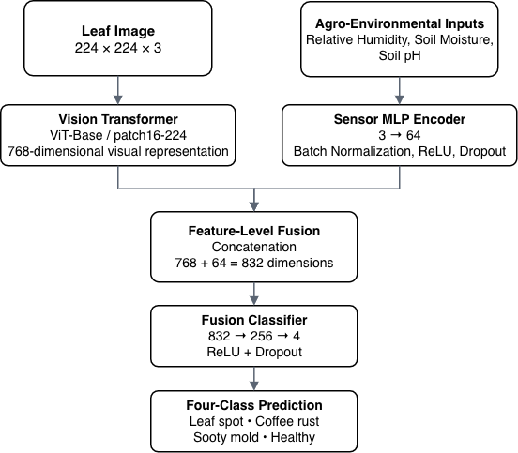
Figure. 1 Proposed multimodal ViT-MLP feature-fusion architecture for coffee leaf disease classification

Six configurations are evaluated: sensor-only MLP, EfficientNet-B0, ViT-Base, MaxViT-Tiny, the proposed ViT + Sensor model, and ViT + Shuffled Sensor. The image-only models provide visual baselines, the sensor-only model evaluates the independent contribution of environmental information, and the shuffled-sensor configuration serves as a control for testing whether the multimodal model benefits from the original image-sensor correspondence.
In the proposed model, ViT produces a 768-dimensional visual representation, while the environmental MLP produces a 64-dimensional representation. These representations are concatenated and classified using a fully connected head. The ViT encoder, sensor MLP, and fusion classifier are jointly fine-tuned during training. The overall workflow is illustrated in Fig. 1.
  - Dataset characteristics and label harmonization
The source dataset contains 840 paired observations collected from coffee-growing environments in Pagar Alam, South Sumatra, Indonesia. Each observation consists of a coffee leaf image, three agro-environmental measurements (relative humidity, soil moisture, and soil pH), and a disease label. The paired observation is represented as Eq. (1).
$D={\left\{\left(I_{i},S_{i},y_{i}\right)\right\}}_{i=1}^{N}, N=840$ (1)
where I_{i} denotes the leaf image, S_{i} denotes the environmental vector containing relative humidity, soil moisture, and soil pH, Y_{i} denotes the disease label, and N = 840 is the number of original paired observations.
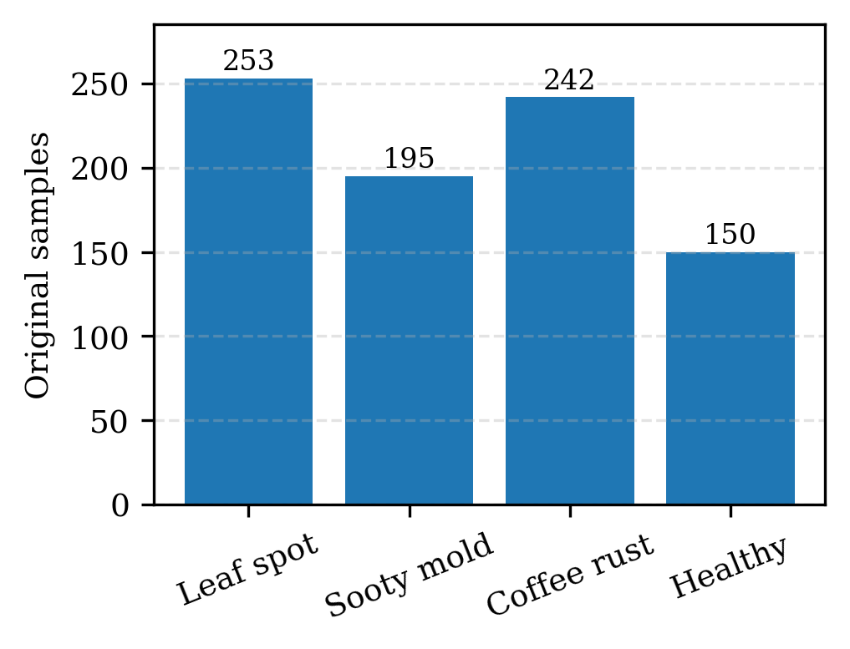
Figure. 2 Semantic class distribution of the 840 original observations after label harmonization

The classification task comprises four target classes: Leaf spot, Coffee rust, Sooty mold, and Healthy. The original class distribution consists of 253 Leaf spot, 242 Coffee rust, 195 Sooty mold, and 150 Healthy observations, indicating moderate class imbalance.
Before model training, the raw labels were harmonized to ensure a consistent four-class taxonomy. The labels "Bercak Daun" and "Bercak daun", which represent the same Leaf spot condition, were mapped to the canonical label Leaf spot before categorical encoding. Following label harmonization, the class distribution of the 840 original observations is presented in Fig. 2. The source-separated stratified partitioning is described in Section 3.3.
  - Data partitioning and leakage prevention
To prevent information leakage between the training and validation sets, the 840 original paired observations were partitioned before any augmentation. The partitioning was performed using source-group-separated stratified sampling, where observations associated with the same original image source were kept within the same partition. The source group is identified by the source_id assigned during dataset verification. This procedure prevents the same source from contributing to both training and validation.
The resulting partition contains 672 original training observations (80%) and 168 original validation observations (20%). The validation set was fixed throughout all experiments and contained only original observations, with no sensor or random visual augmentation. Thus, all configurations were evaluated on the same source-separated validation set.
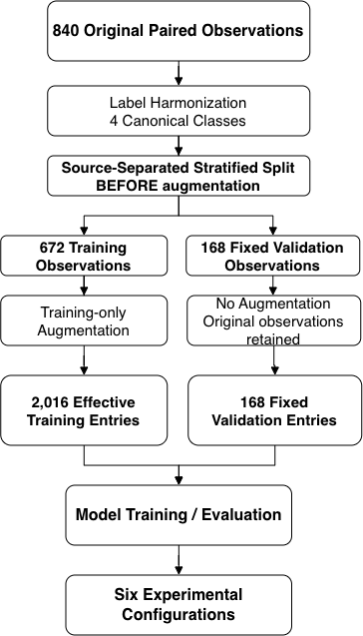
Figure. 3 Source-separated data partitioning and leakage-prevention workflow for multimodal coffee leaf disease classification

After partitioning, augmentation was applied only to the training set. Each of the 672 original training observations was retained and supplemented with two sensor-perturbed variants, resulting in 2.016 effective training entries. Relative humidity and soil moisture were perturbed using Gaussian noise with a standard deviation of 1.2, while soil pH used a standard deviation of 0.08. The perturbed values were constrained to plausible ranges as defined in Eqs. (2)-(4).

$RH_{i}^{'}=clip\left(RH_{i}+ϵ_{RH},40,100\right), ϵ_{RH}N∼\left({0,1.22}^{2}\right)$ (2)
$SM_{i}^{'}=clip\left(SM_{i}+ϵ_{SM},30,100\right), ϵ_{SM}∼N\left({0,1.22}^{2}\right)$ (3)
$pH_{i}^{'}=clip\left(pH_{i}+ϵ_{pH},4.0,8.5\right), ϵ_{pH}∼N\left({0,0.082}^{2}\right)$ (4)

Visual augmentation was also restricted to the training set and consisted of random horizontal and vertical flipping, rotation up to 20°, and moderate brightness and contrast perturbation [21]. Validation images were processed without random visual transformations. The resulting data preparation and leakage-prevention workflow is illustrated in Fig. 3.
  - Visual modality: vision transformer encoder
The visual modality uses the pretrained ViT-Base/patch16-224 architecture. Each coffee leaf image is processed as a three-channel RGB image with a resolution of 224 × 224 pixels. The image is divided into 16 × 16 patches, which are processed together with a learnable classification token through the Transformer encoder [11]. The final [CLS] representation provides a 768-dimensional visual embedding, as expressed in Eq. (5).
$Z_{img}=f_{ViT}\left(I\right)$ (5)
where f_{ViT} denotes the pretrained ViT-Base encoder and I denotes the preprocessed coffee leaf image.
The ViT parameters were fully fine-tuned during training rather than frozen, allowing the pretrained visual representation to adapt to coffee leaf disease characteristics such as lesion texture, discoloration, and surface patterns.
Visual augmentation was applied dynamically only to training images, including random horizontal and vertical flipping, rotation up to ±20°, and moderate brightness and contrast perturbation [21]. Validation images were processed without random visual augmentation.
  - Agro-Environmental modality: MLP encoder
The agro-environmental modality consists of three numerical variables associated with each paired observation: relative humidity, soil moisture, and soil pH. For each observation ii, the environmental vector is defined as Eq. (6).
$s_{i}=\left[RH_{i},SM_{i},pH_{i}\right]$ (6)
where RH_{i}, SM_{i}, and pH_{i} denote relative humidity, soil moisture, and soil pH, respectively.
Because the three variables have different numerical scales and ranges, standardization was applied before MLP encoding. The scaling parameters were estimated only from the 672 original training observations to prevent information from augmented or validation data from influencing the scaler. For each sensor feature j, the training-set mean was calculated as Eq. (7) and the corresponding standard deviation was calculated as Eq. (8).
$μ_{j}=\frac{1}{N_{\text{tr}}}\sum_{i=1}^{N_{\text{tr}}}{s_{ij}}$ (7)
$σ_{j}=\sqrt{\frac{1}{N_{\text{tr}}}\sum_{i=1}^{N_{\text{tr}}}{{\left(s_{ij}-μ_{j}\right)}^{2}}}$ (8)
where N_{train}=672 denotes the number of original training observations. The standardized sensor feature was then obtained using Eq. (9).
$\hat{s_{ij}}=\frac{s_{ij}-μ_{j}}{σ_{j}}$ (9)
where ϵ is a small numerical constant used to avoid division by zero. The same training-derived μ_{j} and σ_{j} values were subsequently applied to the 168 validation observations without refitting the scaler.
The standardized three-dimensional sensor vector was processed using an MLP with two fully connected hidden layers containing 64 units each. The first layer uses batch normalization, ReLU activation, and dropout with a probability of 0.3, while the second layer uses ReLU activation to produce the final 64-dimensional agro-environmental representation, as expressed in Eq. (10).
$Z_{env}=f_{\text{MLP}}\left(\hat{s}\right)$ (10)
where f_{MLP} denotes the environmental encoder and Z_{env} ∈ R⁶⁴ represents the learned agro-environmental embedding. The resulting representation is subsequently combined with the 768-dimensional visual representation in the multimodal configuration.
  - Experimental Configurations
Six experimental configurations were evaluated under the same source-separated validation protocol: (1) Sensor-only MLP, (2) EfficientNet-B0, (3) ViT-Base, (4) MaxViT-Tiny, (5) ViT + Sensor, and (6) ViT + Shuffled Sensor. The sensor-only MLP evaluates the independent predictive capability of the three agro-environmental variables, while EfficientNet-B0, ViT-Base, and MaxViT-Tiny serve as image-only baselines. The proposed ViT + Sensor configuration combines the 768-dimensional visual representation with the 64-dimensional environmental representation.
For the ViT + Shuffled Sensor control, the complete three-variable sensor vector was jointly permuted across observations, thereby disrupting the original image-sensor correspondence while preserving the sensor-vector structure and its distribution. This configuration provides a control for assessing whether the multimodal model benefits from the original pairing between visual and environmental information. All six configurations were evaluated using the same fixed 168 source-separated validation observations and four canonical disease classes.
  - Feature fusion and classification
The visual and agro-environmental representations are integrated through feature-level concatenation. The ViT encoder produces a 768-dimensional visual representation z_{img} while the MLP encoder produces a 64-dimensional environmental representation z_{env}. The fused representation is defined as Eq. (11).
$z_{fusion}=\left[z_{img};z_{env}\right]∈R^{832}$ (11)
where [z_{img};z_{env}] denotes vector concatenation, resulting in an 832-dimensional representation (768 + 64). For the proposed multimodal configuration, the fused representation is passed to a fully connected classification head consisting of a 256-unit hidden layer with ReLU activation and dropout of 0.4, followed by a four-class output layer. The class scores are defined in Eq. (12).
$o=W_{\text{c}}Dropout\left({ReLU (W_{h}z}_{fusion}+ b_{i})\right)+ b_{c}$ (12)
where W_{h} and b_{h} denote the weights and bias of the 256-unit hidden layer, while W_{c} and b_{c} denote those of the four-class output layer. Class probabilities are obtained using the softmax function in Eq. (13), and the predicted class is determined by the highest posterior probability in Eq. (14).
${P(y=k | z}_{fusion}=\frac{\exp\left(o_{k}\right)}{\sum_{k=1}^{4}{\exp\left(o_{j}\right)}},k∈ \{1,2,3,4\}$ (13)
$\hat{y}=\arg{\max_{k∈\{1,2,3,4\}}{P}}\left(y=k ∣ z_{\text{fusion}}\right)$ (14)
The classification head directly predicts the four canonical classes: Leaf spot, Coffee rust, Sooty mold, and Healthy. For the image-only configurations, the visual representation is connected directly to the corresponding classification head, while the sensor-only configuration uses the 64-dimensional environmental representation as its input.
  - Training objective and implementation
All six experimental configurations were trained using multiclass cross-entropy loss under the same four-class label space. For a training or validation sample i with C=4 classes, the cross-entropy loss is defined as Eq. (15).
$L=-\frac{1}{N}\sum_{i=1}^{N}{\sum_{c=1}^{C}{y_{ic}\log\left(p_{ic}\right)}}$ (15)

where N denotes the number of samples, C is the number of classes, y_{ic} is the ground-truth indicator for class c, and p_{ic} is the predicted probability for class c.
The models were optimized using AdamW with a learning rate of 2×10⁻⁵, weight decay of 0.01, a batch size of 8, and a maximum of 10 epochs on an NVIDIA Tesla T4 GPU. The proposed ViT + Sensor model jointly optimized the ViT visual encoder, sensor MLP, and fusion classifier. The pretrained visual backbone used google/vit-base-patch16-224, with all ViT parameters enabled for fine-tuning.
A fixed random seed of 42 was used for the main experiments, while 4242 was used for the shuffled-sensor permutation. No early stopping was applied. Training and validation loss and accuracy were recorded after each epoch, and the final checkpoint was selected using a predefined criterion: minimum validation cross-entropy loss, followed by validation accuracy and then the earlier epoch as tie-breakers. The selected epochs were 10, 9, 10, 3, 9, and 9 for Sensor-only MLP, EfficientNet-B0, ViT-Base, MaxViT-Tiny, ViT + Sensor, and ViT + Shuffled Sensor, respectively. The selected model weights were restored from the corresponding best.pt checkpoint for final evaluation.
Training-only sensor augmentation produced 2,016 effective training entries from the 672 original training observations, while visual augmentation was applied dynamically during training. The 168 validation observations remained fixed and unchanged throughout the experiments. The common training settings and configuration-specific architectures are summarized in Tables 2 and 3.

Table 2. General Training and Implementation Settings
Setting | Value
Original paired observations | 840
Training observations | 672
Validation observations | 168
Effective training entries | 2,016
Image input | RGB, 224 × 224 pixels
Image preprocessing | Training-derived normalization
Sensor variables | Relative humidity, soil moisture, soil pH
Sensor augmentation | Two perturbed variants per training observation
Visual augmentation | Random flip, rotation, brightness/contrast; training only
Optimizer | AdamW
Learning rate | 2×10−52\times10^{-5}
Weight decay | 0.01
Batch size | 8
Maximum epochs | 10
Loss function | Multiclass cross-entropy
Random seed | 42
Shuffled-sensor seed | 4242
Pretrained ViT checkpoint | google/vit-base-patch16-224
ViT fine-tuning | All parameters trainable
Early stopping | None
Hardware | NVIDIA Tesla T4
Checkpoint selection | Minimum validation loss → validation accuracy → earlier epoch
Selected checkpoint | best.pt

Table 3. Configuration-Specific Settings of the Six Experimentally Reproduced Models
Configuration | Input / Encoder | Representation / Classification Head
Sensor-only MLP | 3 sensor variables → MLP | 64-dimensional sensor embedding → 4-class classifier
EfficientNet-B0 | RGB image → EfficientNet-B0 | Image representation → 4-class classifier
ViT-Base | RGB image → ViT-Base/patch16-224 | 768-dimensional visual embedding → 4-class classifier
MaxViT-Tiny | RGB image → MaxViT-Tiny | Image representation → 4-class classifier
ViT + Sensor | ViT-Base + sensor MLP | 768 + 64 = 832 → 256 → 4 classes
ViT + Shuffled Sensor | ViT-Base + shuffled sensor MLP | 768 + 64 = 832 → 256 → 4 classes
  - Evaluation protocol and performance metrics
All six experimental configurations were evaluated on the same fixed set of 168 source-separated validation observations. The validation data were kept unchanged and were not subjected to sensor augmentation or random visual augmentation. Predictions were generated using the checkpoint selected according to the criteria described in Section 3.8.
Model performance was assessed using accuracy, macro-averaged precision, recall, and F1-score, balanced accuracy, Cohen's kappa, and Matthews correlation coefficient (MCC). Accuracy represents the proportion of correctly classified validation observations, while macro-averaged metrics give equal weight to the four disease classes. Balanced accuracy is calculated as the mean class-wise recall, whereas Cohen's kappa and MCC provide complementary measures of agreement and classification quality.
Class-wise precision, recall, and F1-score were also reported for the four canonical classes. The number of correct predictions and total validation observations were recorded, and a 95% Wilson confidence interval was calculated for the proposed model's validation accuracy.
In addition to record-level evaluation, source-level predictions were generated by averaging the predicted class probabilities of records sharing the same source_id. This provides a complementary evaluation at the image-source level and helps assess whether the observed performance is consistent when multiple records correspond to the same underlying image source.
- Result and discussion
  - Experimental Evaluation and Training Behavior
The revised evaluation used the harmonized four-class dataset and the fixed source-separated protocol described in Section 3. The dataset contained 840 paired image-sensor observations from four canonical classes: Leaf spot, Coffee rust, Sooty mold, and Healthy. The original observations were partitioned before augmentation into 672 training observations and 168 validation observations. Training-only sensor augmentation expanded the training data to 2,016 effective entries, while visual augmentation was applied dynamically during training. The validation set remained fixed at 168 original observations and was used consistently across all six configurations.
Six configurations were evaluated: Sensor-only MLP, EfficientNet-B0, ViT-Base, MaxViT-Tiny, ViT + Sensor, and ViT + Shuffled Sensor. In the shuffled-sensor configuration, the complete three-variable sensor vector was jointly permuted across observations, disrupting the original image-sensor correspondence while preserving the sensor-vector structure. All configurations were evaluated on the same fixed validation set. Checkpoint selection was predefined using minimum validation cross-entropy loss, followed by validation accuracy and earlier epoch as tie-breakers. The resulting performance is summarized in Table 4.

Table 4. Performance comparison of the six experimentally reproduced configurations on the source-separated validation set
Model | Acc. | Macro F1 | Balanced Acc. | MCC
Sensor-only MLP | 71.43% | 72.95% | 74.43% | 0.618
EfficientNet-B0 | 100% | 100% | 100% | 1.000
ViT-Base | 100% | 100% | 100% | 1.000
MaxViT-Tiny | 100% | 100% | 100% | 1.000
ViT + Sensor | 100% | 100% | 100% | 1.000
ViT + Shuffled Sensor | 100% | 100% | 100% | 1.000

The Sensor-only MLP achieved 71.43% accuracy, with a macro F1-score of 72.95% and balanced accuracy of 74.43%. This result indicates that the three agro-environmental variables contain predictive information associated with the disease classes, although they are less discriminative than visual information when used independently.
In contrast, EfficientNet-B0, ViT-Base, and MaxViT-Tiny each correctly classified all 168 validation observations. The proposed ViT + Sensor model also achieved 168/168 correct predictions, while the ViT + Shuffled Sensor configuration produced the same result. Thus, the proposed multimodal model did not provide an observable accuracy improvement over the image-only baselines under the present validation protocol.
The equal performance of the paired and shuffled-sensor configurations is important for interpreting the role of environmental information. Since shuffling disrupts the original image-sensor correspondence, the identical validation performance indicates that no accuracy difference was detectable from preserving that correspondence under the current conditions. This does not imply that the sensor variables are irrelevant, as the Sensor-only MLP achieved 71.43% accuracy. Rather, the result suggests that the visual modality was already sufficient to classify the fixed validation observations correctly, leaving limited opportunity for the sensor modality to produce an observable improvement in accuracy.
The training histories provide additional information about model convergence. The image-containing configurations reached high accuracy rapidly, whereas the Sensor-only MLP improved more gradually. The proposed ViT + Sensor model reached 100% validation accuracy from epoch 2 onward, with its minimum validation cross-entropy loss occurring at epoch 9 (0.001012). The selected checkpoints for EfficientNet-B0, ViT-Base, MaxViT-Tiny, and ViT + Shuffled Sensor occurred at epochs 9, 10, 3, and 9, respectively, while the Sensor-only MLP selected epoch 10 with a validation loss of 0.678672.
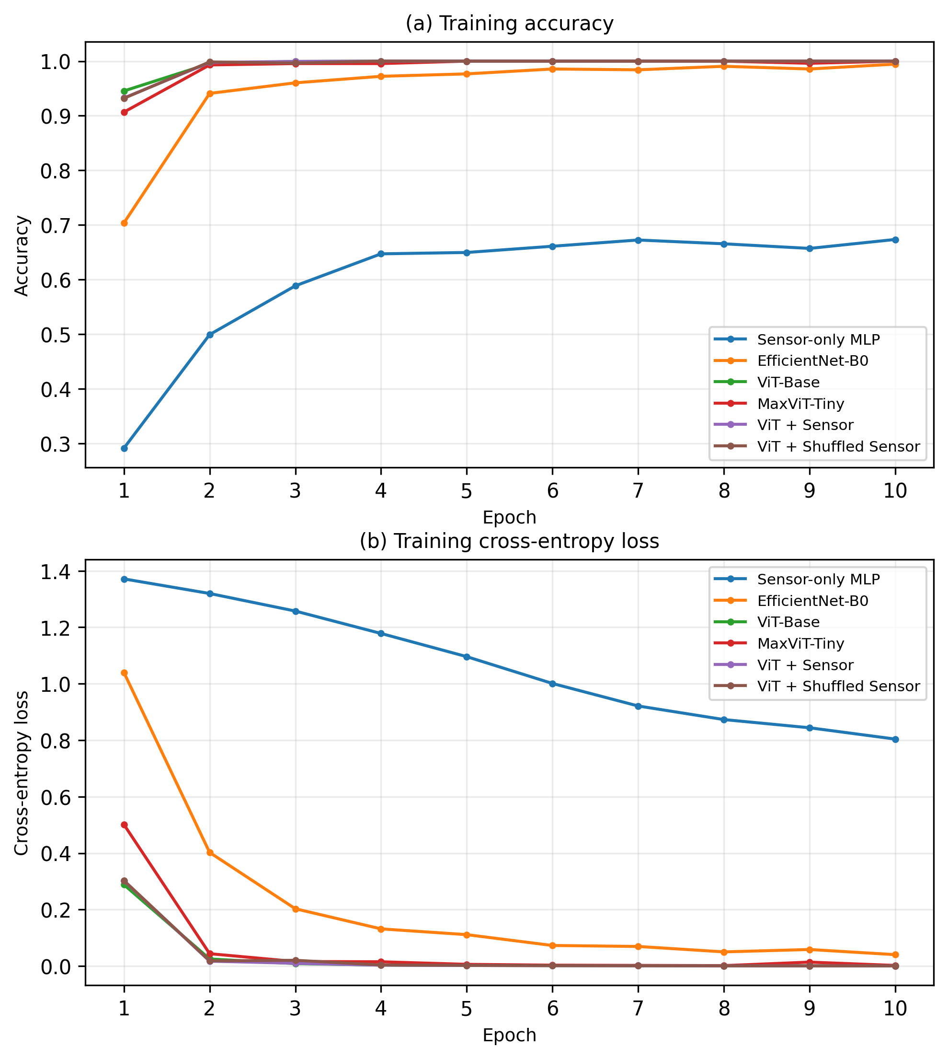
(a) Training accuracy

(b) Training cross-entropy loss

Figure 4. Training dynamics of the six experimental configurations: (a) training accuracy and (b) training cross-entropy loss.

Figure 4 shows that the image-containing configurations converged more rapidly than the Sensor-only MLP. The training accuracy of the image-based and multimodal configurations increased sharply during the early epochs, accompanied by a corresponding reduction in training loss. In comparison, the Sensor-only model exhibited slower convergence and remained at a lower performance level.
Overall, the training and validation results indicate that visual information provides the strongest discriminative signal for the present four-class task. The environmental variables provide independent predictive information, but their incremental contribution cannot be demonstrated through validation accuracy because the image-only configurations already achieved perfect classification on the fixed source-separated validation set.
  - Comparison of Image, Sensor, and Multimodal Models
The six experimental configurations provide a controlled comparison of sensor-only, image-only, multimodal, and shuffled-sensor approaches under the same source-separated validation protocol. As summarized in Table 4, the Sensor-only MLP achieved 71.43% accuracy, whereas EfficientNet-B0, ViT-Base, and MaxViT-Tiny each achieved 100.00%. The proposed ViT + Sensor model and the ViT + Shuffled Sensor configuration also achieved 100.00%.
The 28.57 percentage-point difference between the Sensor-only MLP and the image-containing configurations indicates that visual information provides a substantially stronger discriminative signal for the present four-class classification task than the three environmental variables when used independently. At the same time, the 71.43% accuracy of the Sensor-only MLP confirms that the environmental variables contain predictive information related to the disease classes.
The equivalent performance of EfficientNet-B0, ViT-Base, and MaxViT-Tiny suggests that the high validation performance is not specific to a single visual architecture. More importantly, the proposed ViT + Sensor model did not exceed the ViT-only baseline, which already achieved 100.00% accuracy. Therefore, the current experiment does not provide evidence of an incremental accuracy benefit from multimodal fusion.
The result should be interpreted as evidence that environmental information can be integrated into the proposed architecture without reducing the classification performance achieved by the visual modality. Whether the sensor modality provides additional benefits under more challenging conditions cannot be determined from the present validation set. Such benefits would be more appropriately assessed using ambiguous cases, independent field observations, or data collected under different environmental and acquisition conditions.
Figure 5 further illustrates the validation behavior of the six configurations over the 10 training epochs.

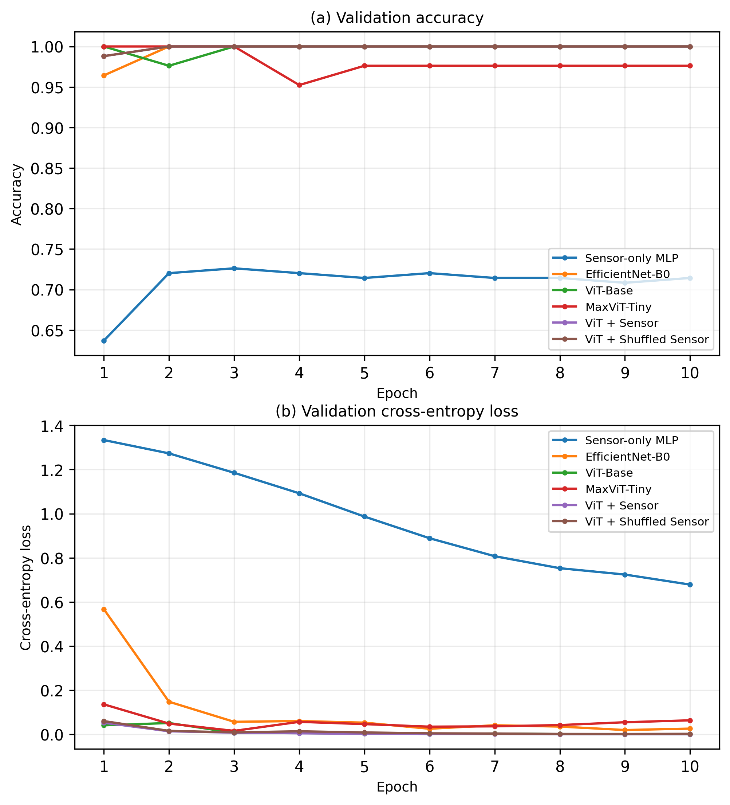
(a) Validation accuracy

(b) Validation cross-entropy loss
Figure 5. Validation dynamics of the six evaluated configurations over 10 epochs: (a) validation accuracy and (b) validation cross-entropy loss

The validation curves show a clear performance gap between the Sensor-only MLP and the image-containing configurations. The latter rapidly reached very high validation accuracy, while the Sensor-only model remained substantially lower. However, these curves represent performance on the same fixed source-separated validation partition and should therefore be interpreted as evidence of in-domain behavior rather than external generalization.
  - Effect of Sensor Information and Shuffled-Sensor Control
The paired-sensor and shuffled-sensor configurations were designed to examine whether preserving the correspondence between each leaf image and its environmental measurements produced an observable effect on classification performance. As shown in Table 4, both ViT + Sensor and ViT + Shuffled Sensor achieved 100.00% accuracy, macro F1-score, balanced accuracy, and MCC on the 168-observation validation set.
The identical performance indicates that no measurable accuracy difference was obtained by maintaining the original image-sensor correspondence under the present validation conditions. This result should not be interpreted as evidence that environmental information is irrelevant. The Sensor-only MLP achieved 71.43% accuracy, demonstrating that relative humidity, soil moisture, and soil pH contain predictive information associated with the disease classes.
Instead, the result suggests that the visual modality was already sufficiently discriminative to correctly classify all validation observations. Consequently, the accuracy metric provides limited sensitivity for detecting any additional contribution from the correctly paired sensor information. The multimodal model therefore demonstrates compatibility with the environmental modality without establishing an incremental accuracy benefit over the ViT-only baseline.
The shuffled-sensor control further supports this conservative interpretation. Because the complete sensor vector was jointly permuted across observations, the environmental values were retained while their original correspondence with individual images was disrupted. The unchanged validation performance shows that the current experiment cannot establish whether the model exploits the specific image-sensor pairing.
A stronger assessment of sensor complementarity would require more challenging or independently collected data, such as visually ambiguous disease cases, different environmental regimes, acquisition periods, sensor devices, or external field observations. Such evaluation would provide greater opportunity to determine whether environmental context contributes information beyond the visual representation.
  - Class-wise Performance and Error Analysis
The class-wise performance of the proposed ViT + Sensor model was examined using the confusion matrix shown in Fig. 6. All 168 validation observations were correctly classified, including 51 Leaf spot, 48 Coffee rust, 39 Sooty mold, and 30 Healthy observations. No off-diagonal predictions were observed.
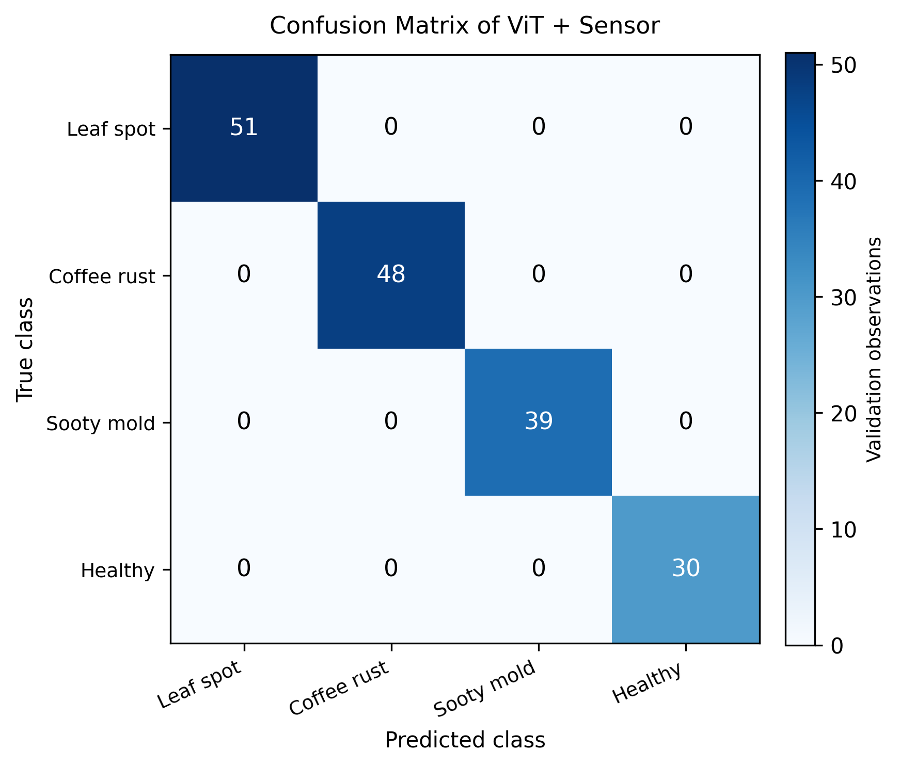
Figure 6. Confusion matrix of the proposed ViT + Sensor model on the fixed source-separated validation set

The resulting class-wise precision, recall, and F1-score were 100% for all four canonical classes, as summarized in Table 5. This indicates that no class-specific errors were observed within the evaluated validation partition. The result also shows that the moderate class imbalance did not produce an observable difference in class-wise performance for this particular split.

Table 5. Class-wise performance of the proposed ViT + Sensor model
Class | Precision (%) | Recall (%) | F1-score (%) | Support
Leaf spot | 100 | 100 | 100 | 51
Coffee rust | 100 | 100 | 100 | 48
Sooty mold | 100 | 100 | 100 | 39
Healthy | 100 | 100 | 100 | 30
Macro average | 100 | 100 | 100 | 168
Weighted average | 100 | 100 | 100 | 168

Because no validation errors were observed, a specific class boundary cannot be identified as difficult under the present evaluation conditions. This differs from the earlier evaluation, where confusion was observed between Leaf spot and Healthy. The revised experiment therefore supersedes that earlier error analysis. However, the absence of errors should be interpreted as a property of the current source-separated validation set rather than evidence that these classes are universally easy to distinguish under uncontrolled field conditions.
The aggregate results are presented in Table 6. The proposed model achieved 100% accuracy, macro precision, macro recall, macro F1-score, and balanced accuracy, with Cohen's kappa and MCC both equal to 1.0000. The model correctly classified all 168 validation observations. The nominal 95% Wilson confidence interval for the observed accuracy was 97.76%–100.00%.

Table 6. Overall validation metrics of the proposed ViT + Sensor model
Metric | Result
Accuracy | 100%
Macro precision | 100%
Macro recall | 100%
Macro F1-score | 100%
Balanced accuracy | 100%
Cohen's kappa | 1.0000
Matthews correlation coefficient | 1.0000
Correct / total predictions | 168 / 168
Nominal 95% Wilson CI | 97.76%–100%

Although these results demonstrate strong in-domain performance, they should not be interpreted as evidence of broad field generalization. The validation set contains 168 observations associated with 46 unique image sources and represents the distribution available in the collected dataset. Independent observations from different locations, acquisition periods, cameras, sensor devices, and environmental conditions would be required to evaluate external generalization.
  - Comparison with Previous Studies
The revised results should be compared with previous studies cautiously because the reported experiments differ in crop species, number of classes, dataset size, image acquisition conditions, augmentation strategies, and evaluation protocols. Therefore, Table 7 is intended to provide contextual positioning rather than a direct accuracy ranking.

Table 7. Contextual comparison with representative plant-disease recognition studies
Task Study | Approach | Data | Result
Coffee leaf disease [2] | CNN ensemble | Four coffee-leaf disease classes | 97.31% validation
Coffee leaf disease [4] | EfficientNet-B0 | 843 natural field images; 3 classes | 88.37% test
Tomato leaf disease [12] | CycleGAN + CNN/Transformer hybrid | PlantVillage / AI Challenger / private | 99.45% / 98.30% / 95.40%
Plant disease [13] | ViT + generative augmentation | Augmented image benchmark | 99.92%
Plant disease [14] | ViT + mixture of experts | PlantVillage / PlantDoc / cross-domain | 99.96% / 74% / 68%
Plant disease [15] | CNN-Transformer hybrid | PlantVillage / complex field dataset | 98.85% / 88.53%
Citrus disease [16] | U-Net + transfer-learning CNNs | Citrus leaf and fruit images | 99.12% test
Apple and corn leaf disease [17] | CNN ensemble + ViT | PlantVillage apple / corn | 99.24% / 98.00%
This study | ViT + MLP sensor fusion | Paired image-sensor observations; 4 classes | 100% validation

For coffee leaf disease specifically, Novtahaning et al. [2] reported 97.31% validation accuracy using a CNN ensemble, whereas Arif et al. [4] reported 88.37% test accuracy for EfficientNet-B0 on natural field images with three classes. In the present study, the reproduced EfficientNet-B0 baseline achieved 100% validation accuracy on the source-separated validation set. However, this difference should not be interpreted as evidence that one model is generally superior, because the datasets, class definitions, acquisition conditions, and evaluation protocols are not equivalent.
The broader plant-disease literature also reports substantial variation in performance across datasets and domains. Several studies achieve accuracy above 99% on in-domain or benchmark datasets, whereas lower performance is reported when models are evaluated on complex field or cross-domain data [12-17]. This variation highlights the importance of distinguishing in-domain validation performance from external generalization. Accordingly, the 100% accuracy obtained in this study demonstrates strong performance on the evaluated source-separated validation set, but does not establish equivalent performance under unseen field conditions.
The main methodological distinction of the present study is the integration of visual and agro-environmental information through a ViT-MLP architecture, together with controlled image-only, sensor-only, and shuffled-sensor comparisons. Importantly, the multimodal model did not produce an observable accuracy improvement over the ViT-only baseline because the latter also achieved 100% accuracy. Thus, the contribution of the proposed framework should be understood as context-aware multimodal integration and controlled evaluation, rather than a demonstrated accuracy gain over visual-only models.
  - Discussion, Limitations, and Practical Implications
The revised results show that visual information provides the strongest discriminative signal for the present coffee leaf disease classification task. EfficientNet-B0, ViT-Base, MaxViT-Tiny, and the proposed ViT + Sensor model all achieved 100.00% validation accuracy, while the Sensor-only MLP achieved 71.43%. This confirms that the agro-environmental variables contain predictive information, but their incremental contribution could not be demonstrated because the image-only models already classified all validation observations correctly.
The identical performance of the ViT + Sensor and ViT + Shuffled Sensor configurations further indicates that the present experiments do not establish a measurable benefit from preserving the original image-sensor correspondence. Therefore, the main contribution of the proposed framework should be interpreted as the integration of visual and agro-environmental information within a unified decision-support architecture, rather than as a demonstrated accuracy improvement over image-only models.
Despite the strong results, the evaluation has important limitations. The validation set contains 168 observations from the available acquisition domain, and no independent external dataset from different plantations, seasons, cameras, sensor devices, or environmental conditions was available. Consequently, the 100.00% validation accuracy represents strong in-domain performance and should not be interpreted as evidence of broad field generalization. External validation is required to assess robustness under unseen conditions.
From a practical perspective, the proposed framework can support early coffee leaf disease screening by combining visual symptoms with environmental context. The operational workflow of the proposed system, from image and sensor data acquisition to multimodal prediction, is illustrated in Fig. 7. It is intended as a decision-support tool rather than a replacement for expert plant-pathology assessment. Future work should therefore focus on independent field validation, more challenging disease cases, and robustness and calibration assessment before operational deployment.

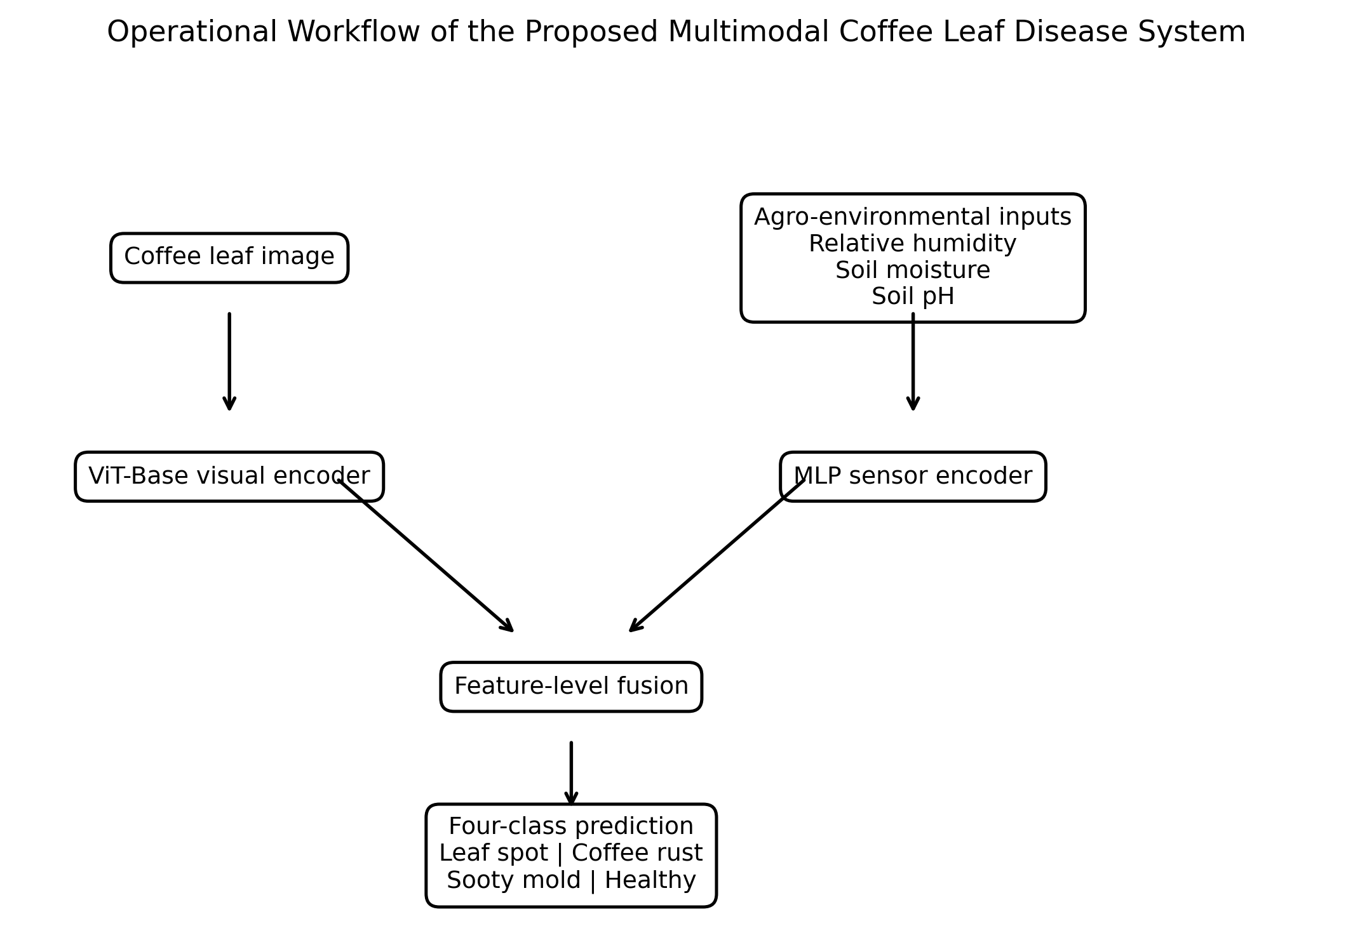
Figure 7. Operational workflow of the proposed multimodal coffee leaf disease classification system
- Conclusion
This study developed a context-aware multimodal framework for coffee leaf disease classification by integrating ViT-based visual representations with agro-environmental information consisting of relative humidity, soil moisture, and soil pH. The proposed ViT + Sensor model achieved 100% validation accuracy, 100% macro F1-score, 100% balanced accuracy, Cohen's kappa of 1.0000, and MCC of 1.0000 on the fixed source-separated validation set.
The Sensor-only MLP achieved 71.43% accuracy, confirming that the environmental variables contain predictive information. However, the ViT-only and ViT + Shuffled Sensor configurations also achieved 100%. Thus, the current results demonstrate the feasibility of multimodal integration but do not establish an incremental accuracy benefit from preserving the original image-sensor correspondence.
The findings represent strong in-domain validation performance on the evaluated dataset rather than evidence of broad field generalization. Future work should validate the framework using independent observations from different plantations, seasons, devices, and environmental conditions. The proposed framework therefore provides a reproducible basis for context-aware coffee leaf disease decision support, subject to further external validation.

Conflicts of interest
The authors declare no conflict of interest.

Author contributions
Conceptualization, AA and DP; methodology, AA and SA; software, AA; validation, DP and SA; formal analysis, AA; investigation, AA and DP; resources, DP; data curation, AA; writing original draft preparation, AA; review and editing, DP and SA; visualization, AA; project administration, AA.

Acknowledgments
This work was supported by the Ministry of Higher Education, Science, and Technology of the Republic of Indonesia through the Research and Community Service Program, Fiscal Year 2026, under Grant No. 197/LL2/AL.04.03/PL-BARU/2026 and 011/SPK/PPPM/ITPA/PL-BARU/VI/2026. The authors also gratefully acknowledge Institut Teknologi Pagar Alam for its institutional support during the implementation of this research.

References
[1] D. G. D. Prahara and S. Sulistyaningsih, “Analysis of smallholder Arabica coffee farming in Kayumas Village, Arjasa District, Situbondo Regency,” Agribios J. Ilm., vol. 21, no. 2, p. 293, 2023, [Online]. Available: https://unars.ac.id/ojs/index.php/agribios
[2] D. Novtahaning, H. A. Shah, and J. M. Kang, “Deep learning ensemble-based automated and high-performing recognition of coffee leaf disease,” Agriculture, vol. 12, no. 11, 2022, doi: 10.3390/agriculture12111909.
[3] Ramanjot, U. Mittal, A. Wadhawan, J. Singla, N. Z. Jhanjhi, and R. M. Ghoniem, “Plant disease detection and classification: A systematic literature review,” Sensors, vol. 23, no. 10, 2023, doi: 10.3390/s23104769.
[4] A. Arif, F. Putrawansyah, and I. Jangcik, “Detection of coffee leaf diseases using lightweight deep learning: A comparative study of EfficientNet-B0 and Vision Transformer,” Ing. des Syst. d’Information, vol. 30, no. 9, pp. 2393–2404, 2025, doi: 10.18280/isi.300915.
[5] J. Bayar, N. Ali, Z. Cao, Y. Ren, and Y. Dong, “Artificial intelligence of things for precision agriculture: Applications in smart irrigation, nutrient and pest management,” Smart Agric. Technol., vol. 12, 2025, doi: 10.1016/j.atech.2025.101629.
[6] A. Simo, S. Dzitac, G. E. Badea, and D. Meianu, “Smart agriculture: IoT-based greenhouse monitoring system,” Int. J. Comput. Commun. Control, vol. 17, no. 6, 2022, doi: 10.15837/ijccc.2022.6.5039.
[7] T. Baltrusaitis, C. Ahuja, and L. P. Morency, “Multimodal machine learning: A survey and taxonomy,” IEEE Trans. Pattern Anal. Mach. Intell., vol. 41, no. 2, pp. 423–443, 2019, doi: 10.1109/TPAMI.2018.2798607.
[8] J. Ngiam, A. Khosla, M. Kim, J. Nam, H. Lee, and A. Y. Ng, “Multimodal deep learning,” in Proceedings of the 28th International Conference on Machine Learning (ICML), 2011, pp. 689–696. [Online]. Available: https://icml.cc/2011/papers/399_icmlpaper.pdf
[9] S. Li and H. Tang, “Multimodal alignment and fusion: A survey,” arXiv Prepr., 2025, [Online]. Available: https://arxiv.org/abs/2411.17040
[10] A. Upadhyay et al., “Deep learning and computer vision in plant disease detection: a comprehensive review of techniques, models, and trends in precision agriculture,” Artif. Intell. Rev., vol. 58, no. 3, p. 92, 2025, doi: 10.1007/s10462-024-11100-x.
[11] A. Dosovitskiy, L. Beyer, A. Kolesnikov, D. Weissenborn, X. Zhai, and T. Unterthiner, “An image is worth 16x16 words: Transformers for image recognition at scale,” in International Conference on Learning Representations (ICLR), 2021. [Online]. Available: https://arxiv.org/abs/2010.11929
[12] Z. Chen, “Cycle-consistent generative adversarial transformer for tomato leaf disease recognition,” Agronomy, vol. 14, no. 4, 2024, doi: 10.3390/agronomy14040673.
[13] A. K. Singh, A. Rao, P. Chattopadhyay, R. Maurya, and L. Singh, “Effective plant disease diagnosis using vision transformer trained with leafy-generative adversarial network-generated images,” Expert Syst. Appl., vol. 254, 2024, doi: 10.1016/j.eswa.2024.124387.
[14] S. Zafar, M. Abdullah, and D. Han, “Plant disease classification in the wild using vision transformers and mixture of experts,” Front. Plant Sci., vol. 16, 2025, doi: 10.3389/fpls.2025.1522985.
[15] S. Jia, G. Wang, H. Li, Y. Liu, L. Shi, and S. Yang, “ConvTransNet-S: A CNN-Transformer hybrid disease recognition model for complex field environments,” Plants, vol. 14, no. 15, 2025, doi: 10.3390/plants14152252.
[16] A. Goyal and K. Lakhwani, “A dual-pass vision transformer-U-Net framework with adaptive feature fusion for citrus leaf disease segmentation and classification,” Iran. J. Comput. Sci., vol. 8, pp. 2409–2430, 2025, doi: 10.1007/s42044-025-00322-z.
[17] S. Aboelenin, F. A. Elbasheer, M. M. Eltoukhy, W. M. El-Hady, and K. M. Hosny, “A hybrid framework for plant leaf disease detection and classification using convolutional neural networks and vision transformer,” Complex Intell. Syst., vol. 11, 2025, doi: 10.1007/s40747-024-01764-x.
[18] M. Ali, M. Salma, M. El Haji, and B. Jamal, “Plant disease detection using vision transformers,” Int. J. Electr. Comput. Eng., vol. 15, no. 2, pp. 2334–2344, 2025, doi: 10.11591/ijece.v15i2.pp2334-2344.
[19] J. Yao, S. N. Tran, S. Garg, and S. Sawyer, “Deep learning for plant identification and disease classification from leaf images: Multi-prediction approaches,” ACM Comput. Surv., vol. 56, no. 6, 2024, doi: 10.1145/3639816.
[20] M. G. F. Odounfa, C. G. Hounmenou, V. K. Salako, A. Affokpon, and R. L. G. Kakai, “Deep learning enables precision agriculture for sustainable chili pepper disease detection in Benin,” Discov. Artif. Intell., vol. 5, 2025, doi: 10.1007/s44163-025-00583-4.
[21] E. Karantoumanis, V. Balafas, and M. Louta, “Real-time disease detection on bean leaves from a small image dataset using data augmentation and deep learning methods,” Soft Comput., vol. 28, pp. 12929–12941, 2024, doi: 10.1007/s00500-024-10348-3.
[22] D. Chicco and G. Jurman, “The advantages of the Matthews correlation coefficient over F1 score and accuracy in binary classification evaluation,” BMC Genomics, vol. 21, 2020, doi: 10.1186/s12864-019-6413-7.

