Problem Set: The Effect of Superfund Cleanups on Housing Markets

Overview
What we’ll do
In this problem set, you’ll estimate the effect of Superfund cleanups on housing markets in the US. This roughly replicates Greenstone and Gallagher (2008), which is one of the most famous hedonic pricing analyses in environmental economics.

Please submit the following on Canvas:
- Your code in .R format
- Your written answers (i.e., the tables and figures you create plus additional text in response to the questions) in PDF format.

Why we’re doing this
- Non-market valuation is crucial to making good environmental policy, and hedonic house price analyses are an important technique for non-market valuation.
- Difference-in-differences (event study) designs are perhaps the most widely used quasi-experimental method for causal inference.
- The data and interpretations in Greenstone and Gallagher (2008) are messier than in previous weeks, offering us a chance to think through some common issues in applied economics.

Dataset codebook
Download Superfund_panel.csv. This has panel data on housing and demographics for U.S. census tracts from the 1970, 1980, 1990, and 2000 decennial census rounds.

Key: [fips, year]

Fields:
- fips: tract FIPS code [a concatenation of state and county tract]
- year: year in {1970, 1980, 1990, 2000}
- hrs_1982: 1982 HRS score
- npl_ever: 1 if ever on National Priorities List by 2000, 0 if HRS score but never NPL, missing otherwise
- npl_1982: 1 if hrs_1982 > 28.5, 0 if hrs_1982 < 28.5, missing otherwise
- income: mean household income
- share_black: proportion identifying as Black
- share_college: proportion of adults with college degree
- house_price: average house price (nominal $)
- housing_units: number of housing units

1. Descriptive histograms
The key outcome variable is house price.
- Make histograms of house_price for each year.
Answer. Histograms of house_price by census year (raw data, before cleaning). The first panel uses free axes per year; the second uses a log scale so the tails are visible.
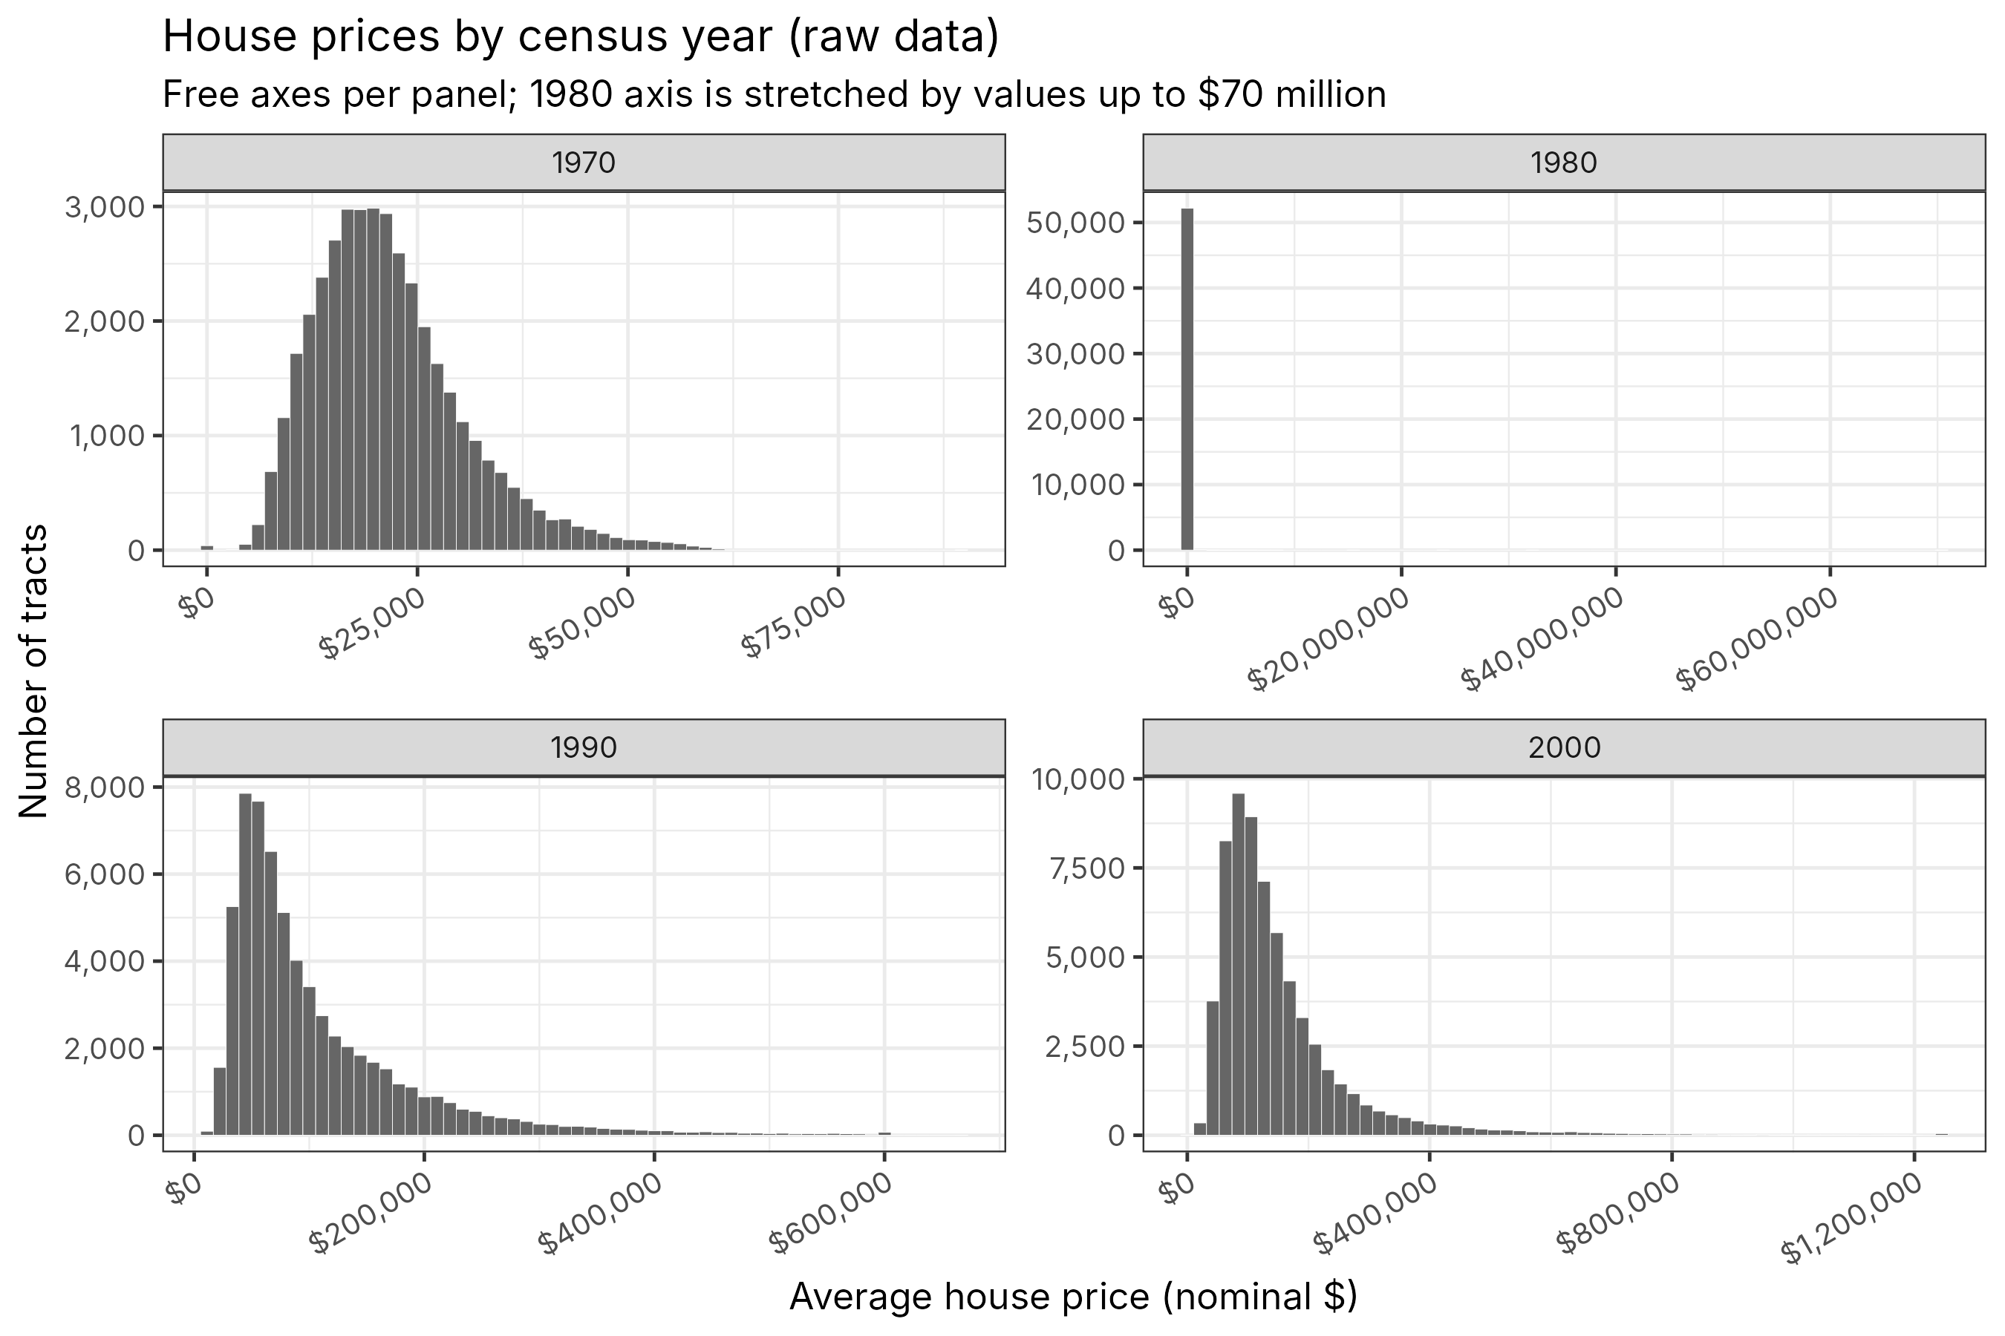
Figure 1a. Raw house prices by year (linear scale).
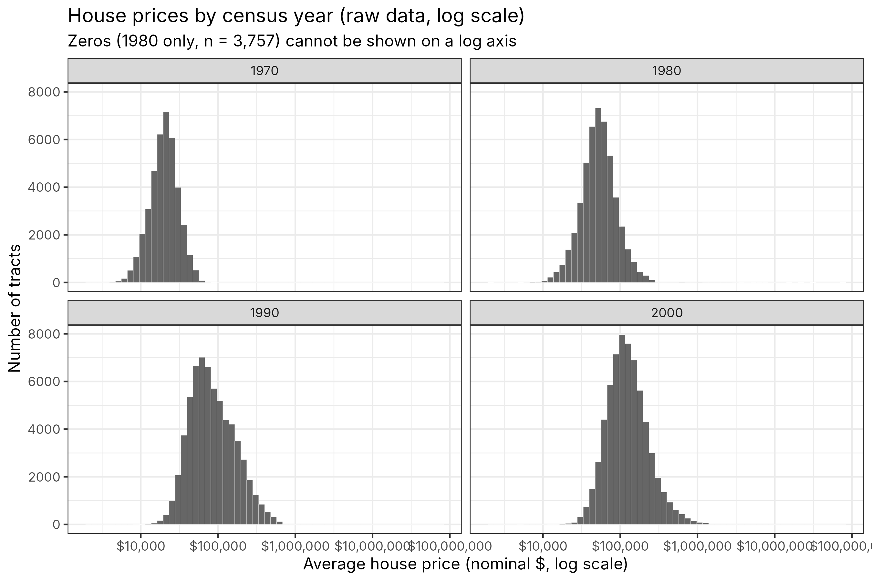
Figure 1b. Raw house prices by year (log scale; zeros cannot be shown).

- Do you see any outliers? If so, do you think these values are correct or data errors?
Answer. Yes. The 1970, 1990 and 2000 distributions look reasonable, but 1980 has two kinds of clear data errors:
(1) Zeros. 3,757 tracts report an average house price of $0 in 1980. An average house value of $0 is impossible, so these are missing values coded as 0.
(2) Implausibly high values. The 1980 maximum is $70.4 million, and 90 tracts are above $1 million. For comparison, the 1980 99th percentile is about $200,000, the 1970 maximum is about $90,000, and the 1990 maximum is about $665,000. The 1980 Census top-coded home values at $200,000+, and there is a pile-up of tracts at exactly $250,000 (the value assigned to the top bin). So a tract average above $250,000 is mechanically impossible. Many of these tracts also report absurd 1980 incomes (e.g., a mean household income of $95), which points to a mis-merge or shifted columns.
The right tails in 1990 and 2000 (up to $1.25 million) are plausible for wealthy tracts, so I treat them as correct.

- If you see any data errors (e.g., implausibly high values or values of 0 that should not be 0) for any of the variables in the data: in your data prep code, set those values to missing so that they are not used in the analyses below.
Answer. In the data-prep code I set the following to missing (NA):
• house_price = 0 (all 1980; 3,757 tracts).
• 1980 house_price > $250,000, above the 1980 top-code value (170 tracts).
• All variables for tract-years with housing_units = 0. In 1970 (19,227 tracts) and 1980 (13,600 tracts) these areas had not been tracted yet, so income, share_black, pop_den, etc. are also recorded as 0 rather than missing.
• income = 0 with positive housing units, and 1980 mean household income below $1,000 (implausible).
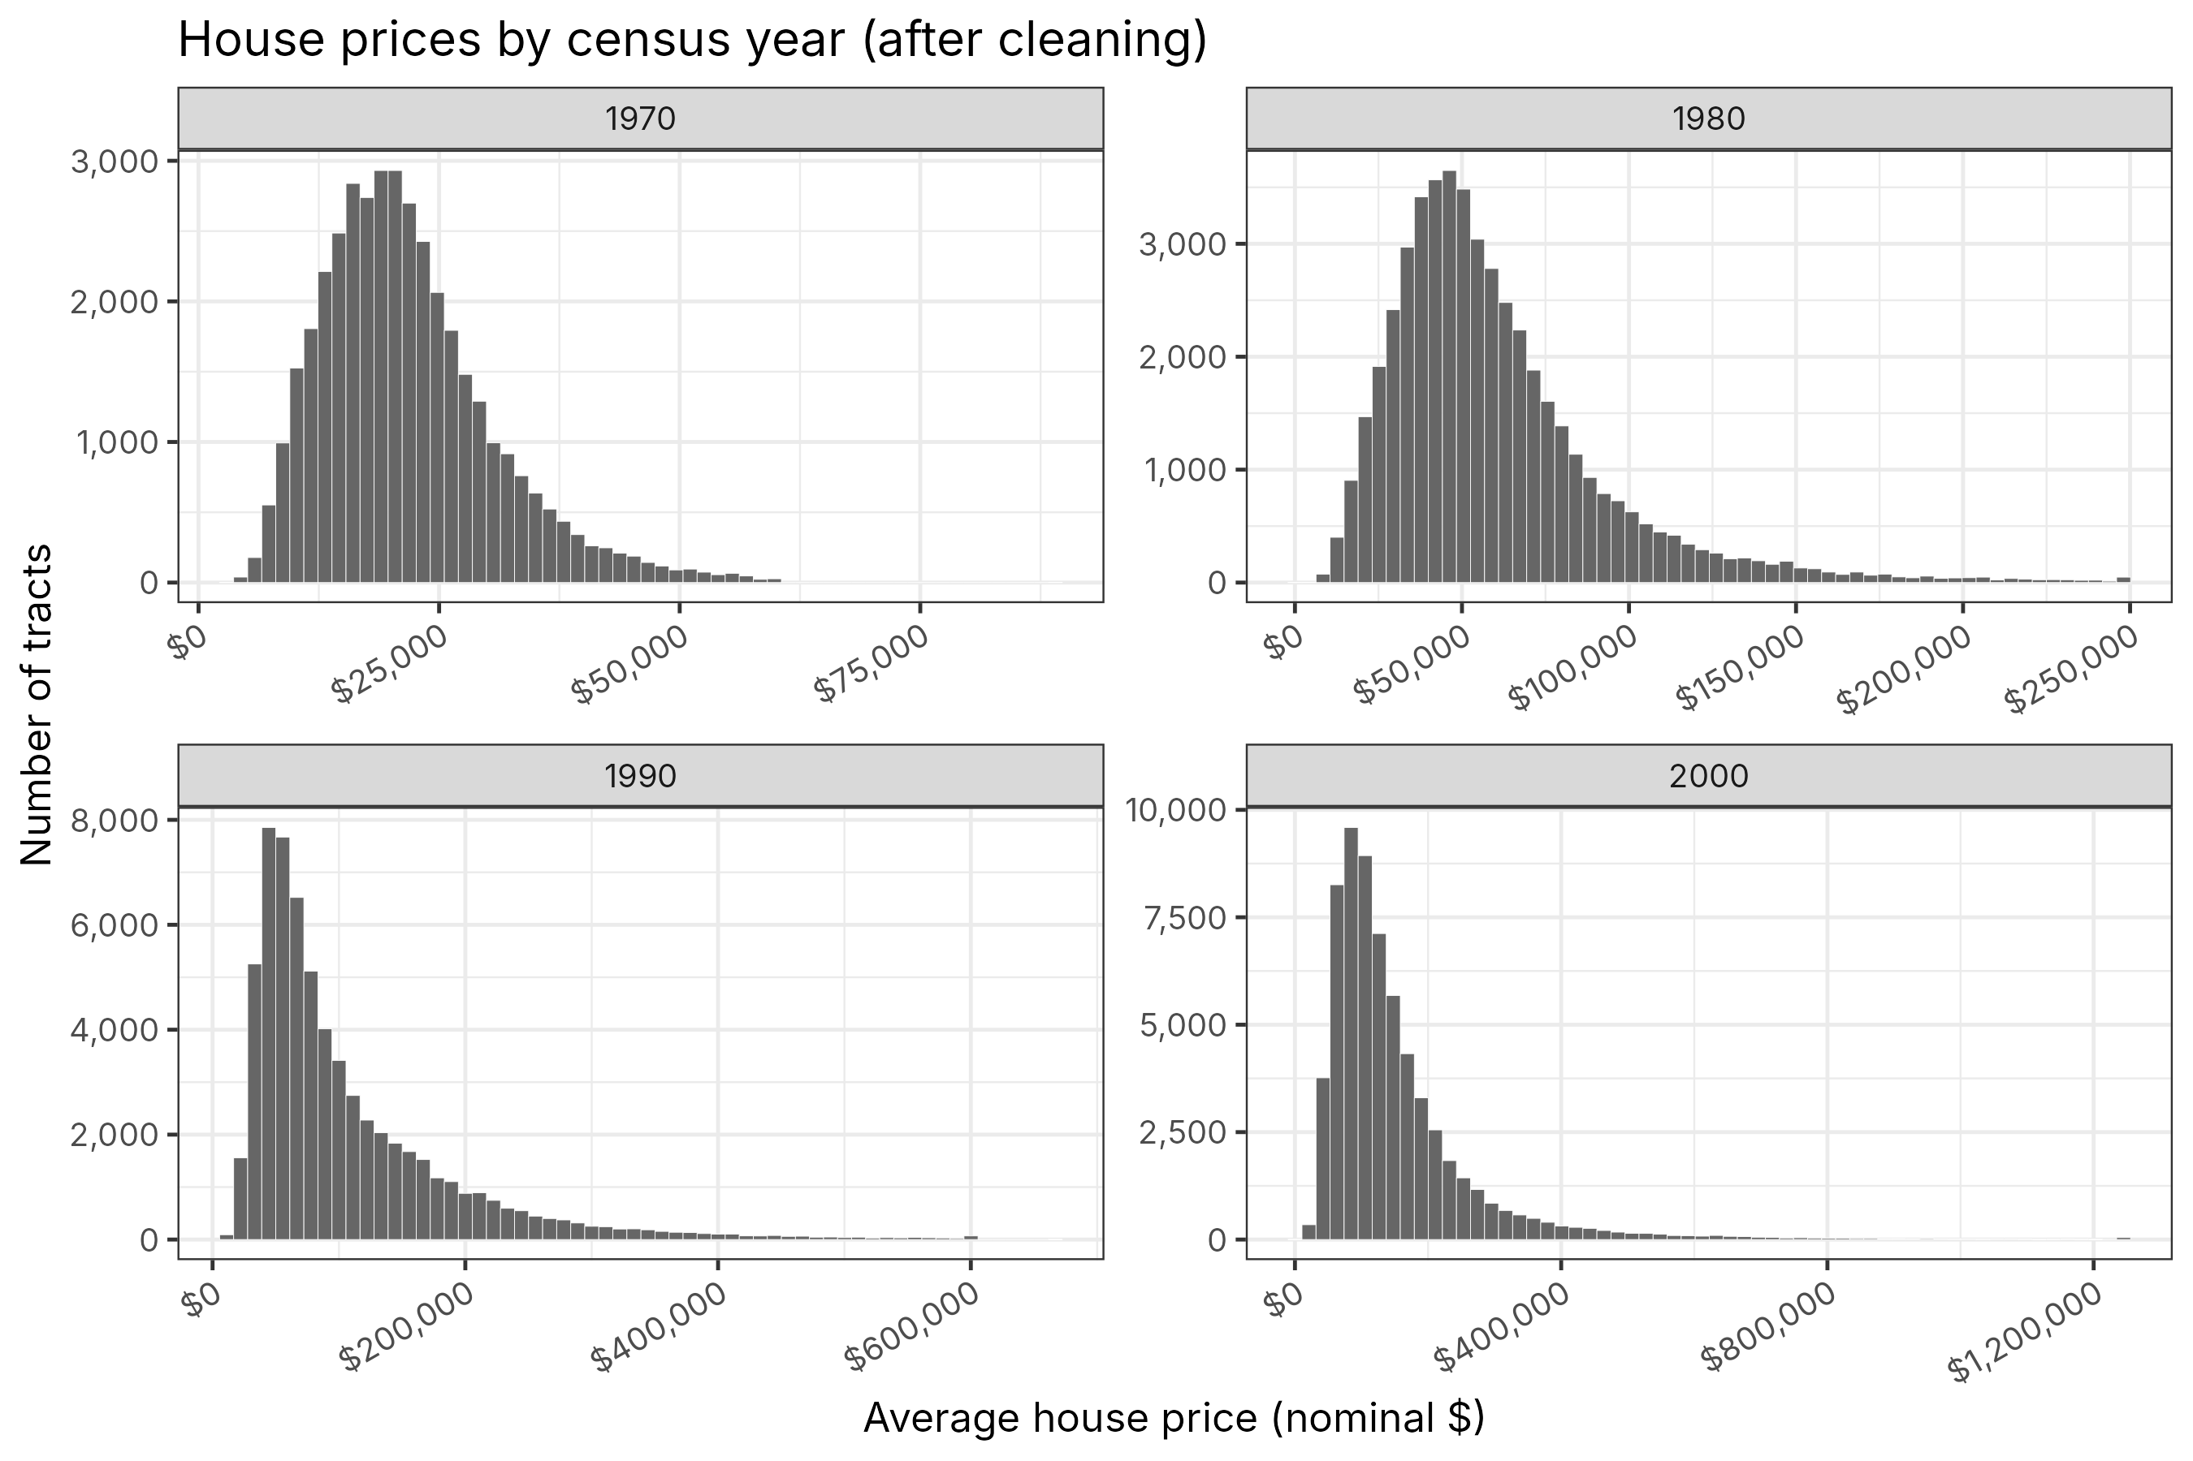
Figure 1c. House prices by year after cleaning.

2. Cross-sectional hedonic relationship
- Using all census tracts nationwide, run the following regression using data from 1980:

- $y_{c}=α1[HRS_{c }]+β+ε_{c},$ (1)

where $c$ indexes census tracts, $y_{c}$ is ln(house price), $1[HRS_{c}]$ is an indicator for whether tract $c$ has a non-missing HRS score, and $β$ is a constant.
Answer. OLS of ln(house price) on an indicator for having a 1982 HRS score, 1980 cross-section, heteroskedasticity-robust standard errors:
 | ln(house price), 1980
1[HRS score] (α) | -0.143*** (0.020)
Constant (β) | 10.871*** (0.002)
Observations | 48,367
Mean price: tracts without / with HRS site | $60,128 / $49,693

Robust SEs in parentheses. *** p < 0.01.

- Interpret your estimate of $α$. This should be a sentence like, “The average student at Yale has an X% higher SAT score than the average student at Princeton.”
Answer. In 1980, the average census tract with a hazardous waste site that received an HRS score has house prices about 14.3 log points lower, i.e. about 13% lower (e^-0.143 - 1 = -0.133), than the average census tract without such a site.

- Does the estimated house price difference in neighborhoods with vs. without toxic waste sites equal the population average willingness-to-pay to avoid this disamenity? Why or why not?
Answer. No, for two reasons.
1. It is not a causal estimate. Hazardous waste sites are not randomly placed. They tend to be in older, more industrial, lower-income areas with worse housing stock and other disamenities (factories, highways, noise), and all of these lower house prices. The cross-sectional gap therefore mixes the effect of the site with these omitted variables and likely overstates the price penalty from the site itself.
2. Even if it were causal, it would not be the population-average WTP. In the hedonic model, the price gradient reflects the marginal WTP of the households who sort into each location. People who care less about pollution (or who have lower incomes and can't afford to avoid it) sort into tracts near waste sites, so the price difference reflects their relatively low WTP and likely understates the WTP of the average person in the population. In addition, a waste site is a large (non-marginal) change, and the regression pools many separate local housing markets with different hedonic price functions.

3. Causal analysis
We now estimate the effect of initial NPL placement on housing market outcomes. To estimate the average treatment effect on the treated, we estimate

$y_{ct}=τN_{c}⋅1\{t≥1990\}+γ_{c} + ϕ_{t} +(βX_{ct }+) ε_{ct}$ , (2)

where $c$ indexes tracts, $t$ indexes years, $y_{ct}$ is ln(house price), $N_{c}$ is an NPL indicator, and $X_{ct }$ is a vector of variables that vary within a county over time: income, share_black, and share_college.

To create the event study figures, we estimate
$y_{ct}=\sum_{s=\{1970, 1990, 2000\}}{}[τ_{s}⋅N_{c}⋅1\{t = s\}]+γ_{c} + ϕ_{t} (+βX_{ct })+ ε_{ct}$ . (3)

In words, the summation term means: “include three terms: one for $N_{c}⋅1\{t=1970\}$, one for $N_{c}⋅1\{t=1990\}$, and one for $N_{c}⋅1\{t=2000\}$.” Following convention, we let the final pre-treatment period ($t=1980$) be the excluded year.

These regressions will be easiest if you use the fixest package as outlined in the R guide. Focus especially on the demo for event studies.

- We wrote $βX_{ct }$ in parentheses because it is optional. Decide whether or not to include those variables in your upcoming analyses, and explain your decision.
Answer. I do not include the controls in my main specification. Income, share Black and share college-educated vary over time within a tract and can themselves respond to NPL listing and cleanup: households re-sort when a neighborhood is stigmatized or cleaned up. They are "bad controls" (outcomes of the treatment), so conditioning on them could absorb part of the effect we want to measure or introduce selection bias. The tract fixed effects already absorb all time-invariant tract characteristics, and the year fixed effects absorb national shocks. As a robustness check, adding them barely changes the estimate (-0.058 vs. -0.052; see 3H).

- For the NPL indicator $N_{c }$, decide whether to use npl_ever or npl_1982 in your upcoming analyses, and explain your decision.
Answer. I use npl_1982. It is a deterministic function of the 1982 HRS score (score > 28.5), and the 28.5 cutoff was set for administrative reasons (to produce a list of about 400 sites) and is hard to manipulate. That gives quasi-random variation in NPL status near the cutoff. npl_ever also counts sites that were added to the NPL later, after re-scoring, new information or political pressure, and those later additions may be correlated with local trends in house prices, which makes npl_ever endogenous. In the data, 37 of the 232 sites below the cutoff were listed later and 5 sites above it never were. Using npl_1982 gives a cleanly identified intent-to-treat effect.

- Decide whether to use robust (non-clustered) standard errors, robust standard errors clustered by census tract, or robust standard errors clustered by county in your upcoming analyses, and explain your decision.
Answer. I use robust standard errors clustered by county. Errors for the same tract are serially correlated over time, so at minimum we need to cluster by tract (Bertrand, Duflo & Mullainathan 2004). Errors are also likely correlated across nearby tracts in the same local housing market: county-level economic shocks, school districts and tax assessors all affect neighboring tracts together. Clustering by county allows for both kinds of correlation (it nests tract clustering) and is the more conservative choice, and there are still enough clusters for valid inference (356 counties in sample (i), 215 in sample (ii)). In practice, the tract- and county-clustered SEs are similar (0.048 vs. 0.047 in my main specification).

- Explain why we need to exclude one year in the sum in equation (3), and why we chose to exclude 1980.
Answer. If we included N_c x 1{t = s} for all four years, the four terms would add up to N_c, which is constant over time within a tract and so perfectly collinear with the tract fixed effect γ_c. The model would not be identified, so one year must be omitted (normalized to zero), and every τ_s is then measured relative to that year. We omit 1980 because it is the last census before treatment (NPL listing happened in 1982-83), so it is the natural baseline: τ_1990 and τ_2000 measure how the treatment-control gap changed after listing relative to just before, and τ_1970 serves as a test for pre-trends.

- Consider two possible samples for estimating the effect of NPL designation:
(i) All census tracts with HRS scores.
(ii) The subset of census tracts with 1982 HRS scores within 12 units of the cutoff (i.e., from 16.5 to 40.5). (This is roughly like a regression discontinuity analysis.)

For each of these two samples, create the two plots:
(a) Raw averages: the average of Treatment ln(house_price) by year in one color, and the average of Control ln(house_price) by year in another color.
(b) Event study figure: the difference between Treatment and Control ln(house_price) by year. To make this, estimate equation (3) above, and plot the $τ_{s}$ coefficients and their 95% confidence intervals.
Answer. Treatment = npl_1982 = 1 (red); Control = npl_1982 = 0 (blue). Event-study coefficients are from equation (3) with tract and year fixed effects, 1980 omitted, 95% CIs from county-clustered SEs.
Sample (i): all tracts with HRS scores (591 tracts)
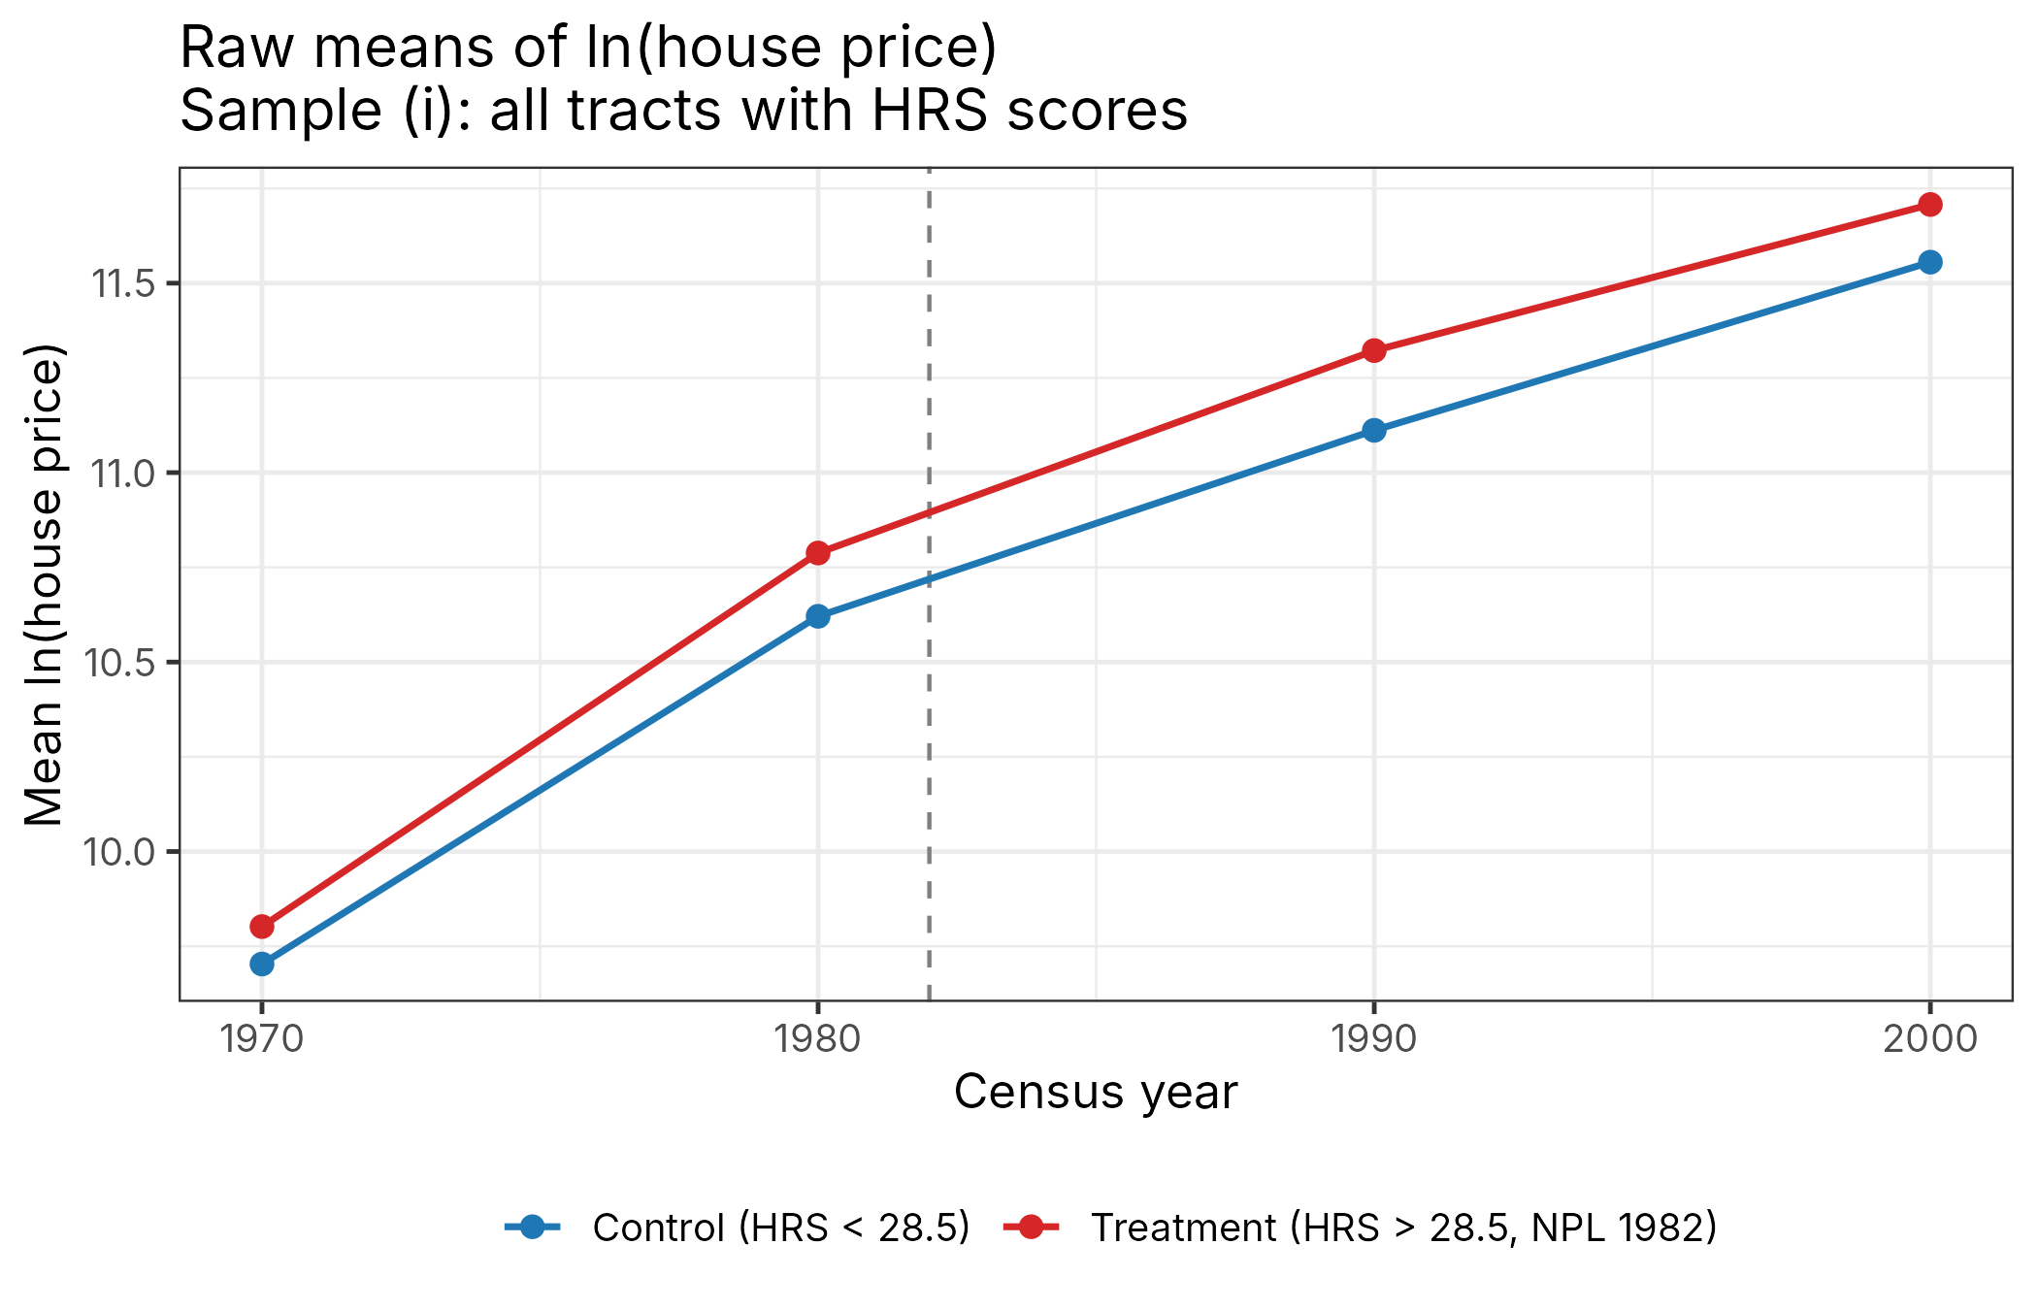
Figure 3a. Raw means of ln(house price), sample (i).
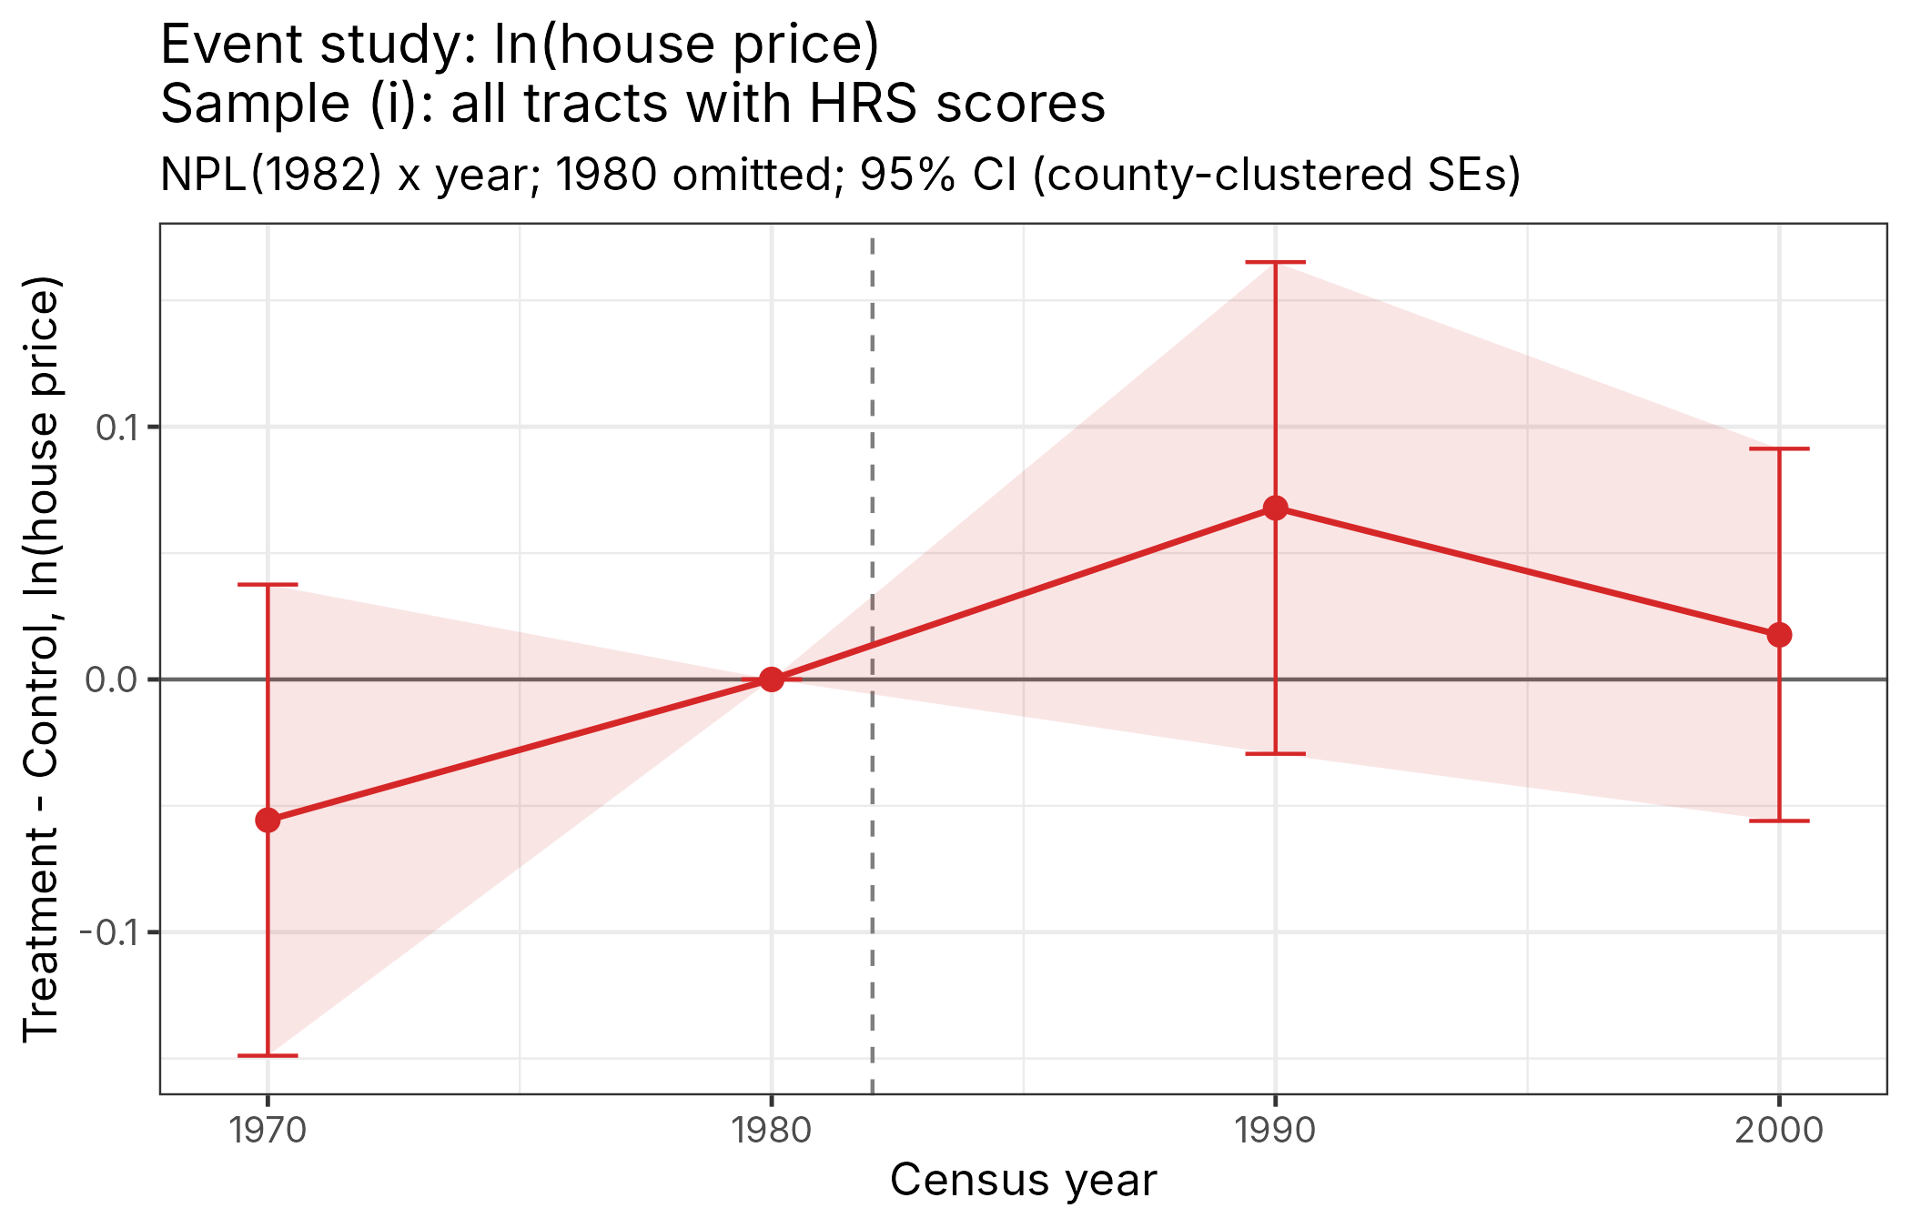
Figure 3b. Event study, sample (i).
Sample (ii): 1982 HRS score from 16.5 to 40.5 (288 tracts)
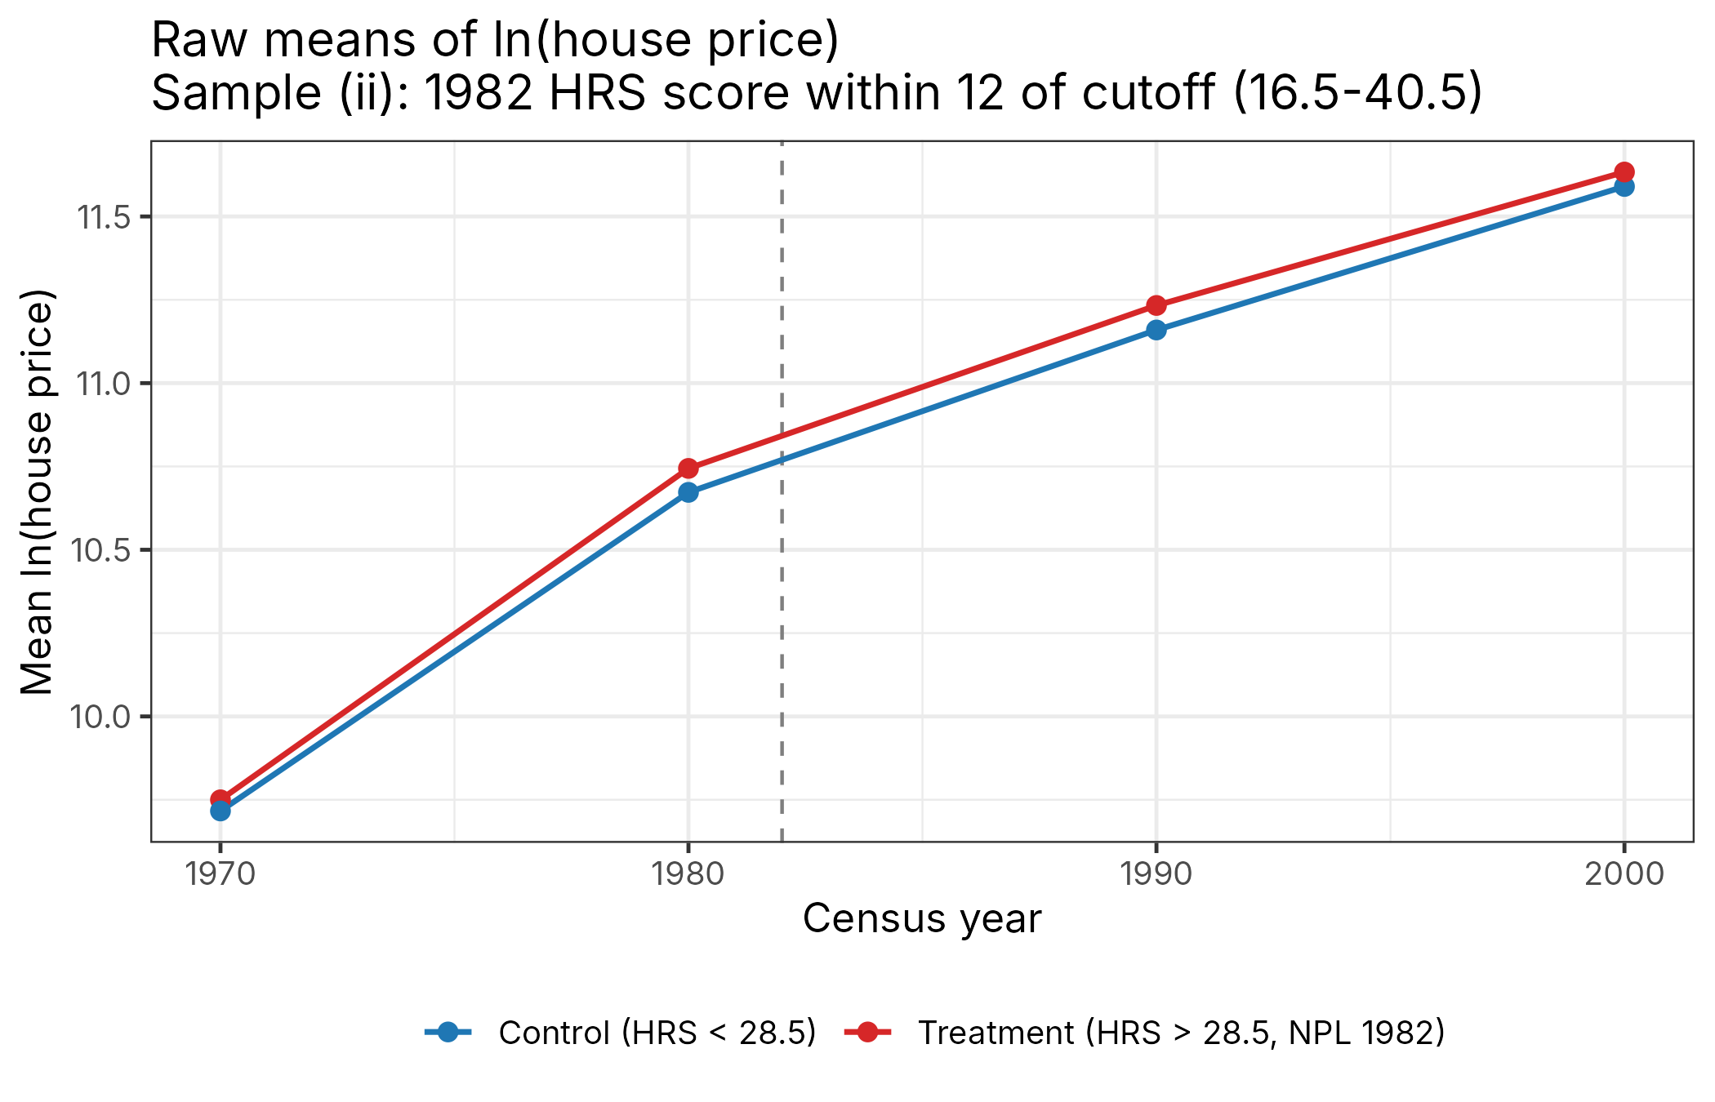
Figure 3c. Raw means of ln(house price), sample (ii).
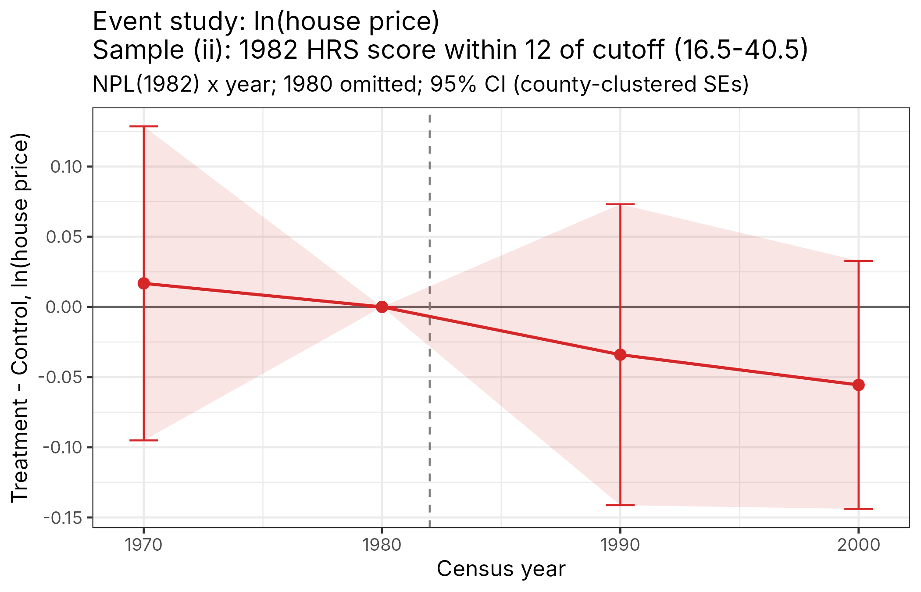
Figure 3d. Event study, sample (ii).
Coefficient | Sample (i) | Sample (ii)
τ_1970 | -0.056 (0.048) | 0.017 (0.057)
τ_1980 | 0 (omitted) | 0 (omitted)
τ_1990 | 0.068 (0.050) | -0.034 (0.055)
τ_2000 | 0.018 (0.038) | -0.056 (0.045)
Observations | 1,918 | 919

County-clustered SEs in parentheses.

- Looking at the event study figure you just created for each of the two samples, interpret the coefficient on $τ_{1970}$ (the Treatment-Control difference for 1970) in a sentence or two. On the basis of those results, in which sample would it be more plausible that $τ_{1990}$ (the Treatment-Control difference for 1990) is unbiased?
Answer. τ_1970 is the treatment-control difference in ln(house price) in 1970 relative to 1980, before anyone knew which sites would be listed. In sample (i), τ_1970 = -0.056: treated tracts were about 5.6 log points further behind controls in 1970 than in 1980, i.e. their prices were already growing faster before treatment. This is a pre-trend, although it is imprecisely estimated. In sample (ii), τ_1970 = 0.017, small and close to zero, so treatment and control tracts were on parallel paths during 1970-80. The parallel-trends assumption, and therefore an unbiased τ_1990, is more plausible in sample (ii).

- Using these event study figures plus any other arguments, decide whether to designate sample (i) or (ii) as your “primary sample.”
Answer. I designate sample (ii) as my primary sample. (1) Its pre-period coefficient is close to zero, while sample (i) shows a differential pre-trend that would bias the post-period estimates upward. (2) Near the 28.5 cutoff, sites scoring 25 and 32 are very similar: the HRS score is a noisy measure of risk, and the cutoff was chosen to produce a list of about 400 sites, not for health reasons. So the control group is a much better counterfactual, in the spirit of a regression discontinuity design. Sites far from the cutoff (scores near 0 or near 70) differ systematically in severity, location and economic trends. (3) The cost is a smaller sample (288 vs. 591 tracts) and less precision, which I think is worth paying for more credible identification.

- Estimate equation (2) using your primary sample and report a table with the results. Interpret the $τ$ coefficient. If it is statistically indistinguishable from zero, state the effect sizes that you can rule out with 95% confidence.
Answer. Equation (2), with tract and year fixed effects and SEs clustered by county:
 | (1) Main: (ii) | (2) (ii) + controls | (3) (ii) tract cl. | (4) Sample (i)
NPL_1982 x Post (τ) | -0.052 (0.047) | -0.058 (0.036) | -0.052 (0.048) | 0.066 (0.046)
95% CI | [-0.143, 0.040] | [-0.130, 0.013] | [-0.146, 0.042] | [-0.025, 0.157]
Controls | No | Yes | No | No
Tract & year FE | Yes | Yes | Yes | Yes
Clustering | County | County | Tract | County
Observations | 919 | 919 | 919 | 1,918

Dependent variable: ln(house price). Column (1) is the preferred specification.
Interpretation. After 1982, house prices in tracts whose site was placed on the NPL changed by about -5.2 log points (about -5%) relative to tracts whose sites scored just below the cutoff, compared with the 1980 difference between the two groups. The estimate is not statistically different from zero (p = 0.27). With 95% confidence we can rule out price increases larger than about 4.0% and price decreases larger than about 14.3%. In particular, we can rule out the sizeable positive capitalization of cleanups that one might have expected, consistent with Greenstone and Gallagher's (2008) finding that Superfund cleanups had small, statistically insignificant effects on local property values.

- Now re-estimate the event study plot using equation (3) in your primary sample, except with ln(housing_units) as the dependent variable. Using the logic of the hedonic model described in the lecture note, are these results consistent or inconsistent with the idea that any effects on house prices could be interpreted as the effect on WTP for local amenities?
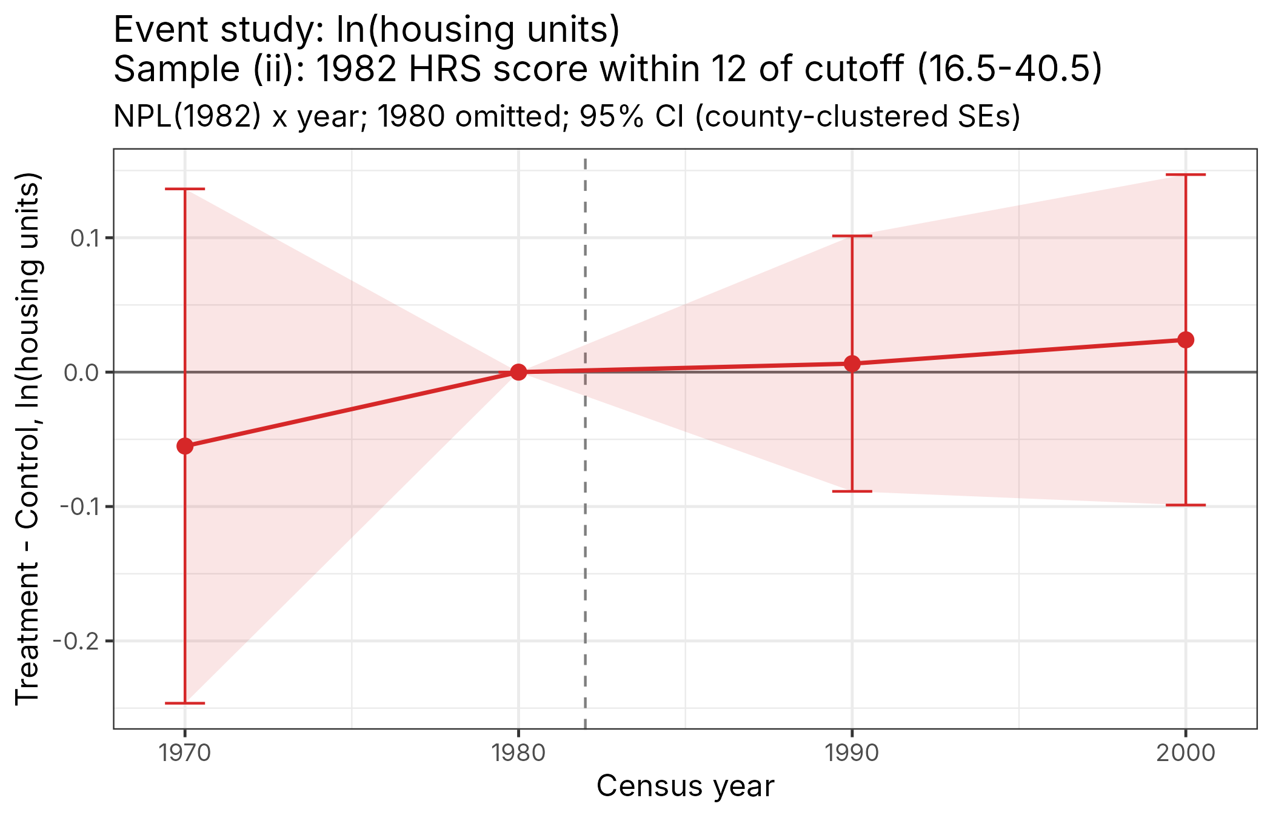
Figure 3e. Event study for ln(housing units), sample (ii).
Coefficients: τ_1970 = -0.055 (0.098), τ_1990 = 0.006 (0.048), τ_2000 = 0.024 (0.063); none is statistically significant.
Answer. In the hedonic model, a change in house prices can be read as the change in WTP for the local amenity only if housing supply does not respond. If cleanup had triggered new construction, the extra supply would push prices down, and the price change would understate WTP (and the population living near the site would change as well). Here NPL listing has no detectable effect on the number of housing units: the coefficients are small, close to zero and stable over time. That is consistent with a fixed housing stock in the short-to-medium run, so any price effect could be interpreted as the change in WTP for the local amenity. Caveat: the confidence intervals are fairly wide (we can't rule out supply changes of roughly ±10%), and in sample (i) treated tracts do add housing units faster, which is another reason to prefer sample (ii).

4. Reading responses
- With perfectly elastic supply:
  - In the Corrective Taxes lecture note, how would Figure 19 (“Incidence and Distributional Effects of a Corrective Tax”) change?
  - Would the economic incidence be on consumers or producers?
  - What is the pass-through rate?
How Figure 19 changes. The supply curve becomes horizontal at p_0. The tax shifts the equilibrium up the demand curve from A to B, but the tax-exclusive price does not change: p_1 = p_0, so points D and E (and A and F) lie on the same horizontal line. The consumer price rises by the full tax, to p_0 + t_1. Producer surplus is zero both before and after the tax, so trapezoid ADEF disappears. Consumers lose trapezoid ABCD, the government collects rectangle BCDF (= q_1 t_1), and avoided damages are rectangle AGBF. The net total surplus gain is triangle ABG = ½(q_0 - q_1)φ.
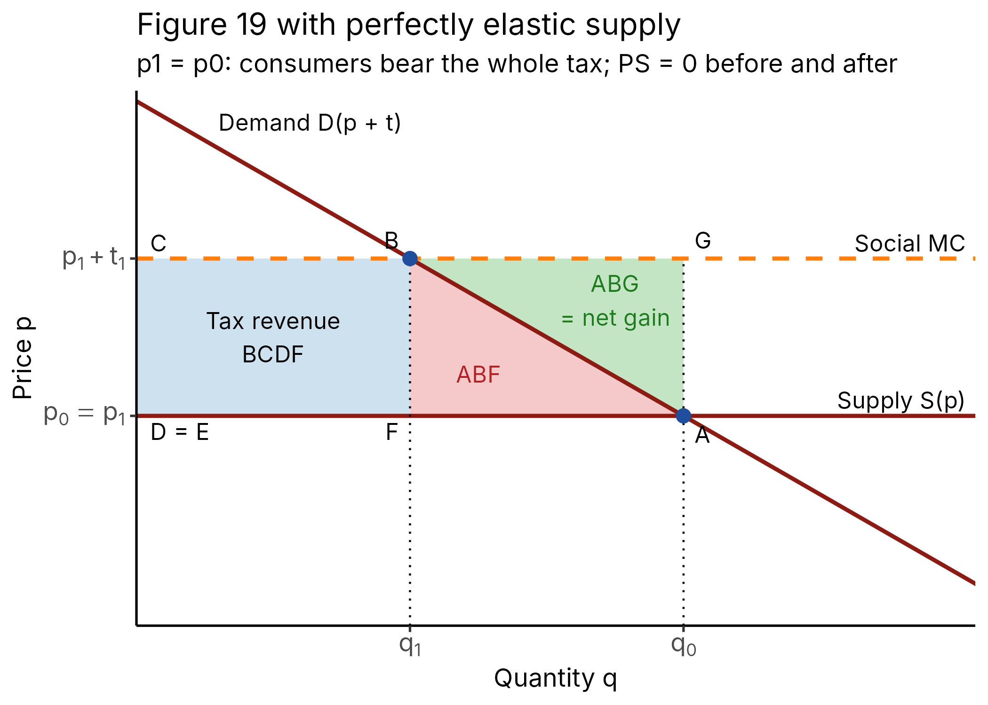
Figure 4. Figure 19 redrawn with perfectly elastic supply.
Incidence. Entirely on consumers. With η_S = ∞, dp/dt = η_D/(η_S - η_D) = 0, so the producer price doesn't move.
Pass-through rate. d(p+t)/dt = η_S/(η_S - η_D) → 1 (100%): the whole tax is passed through to consumers.

- With perfectly inelastic supply or demand, what is the total surplus gain from the optimal tax?
Answer. Zero. If either supply or demand is perfectly inelastic, the tax does not change the equilibrium quantity (q_1 = q_0; in equation 10.26, D' = 0 or S' = 0). Since ΔTS = ½(q_0 - q_1)φ = 0, the optimal tax only moves money around: it transfers surplus from consumers (inelastic demand) or producers (inelastic supply) to the government, and because quantity doesn't change, it doesn't reduce externality damages or deadweight loss.

- Explain in plain English why achieving net zero carbon emissions may not be socially optimal.
Answer. The socially optimal amount of emissions is where the benefit of the last ton emitted (equivalently, the cost of avoiding it) equals the damage that ton causes, i.e. the social cost of carbon. The first tons of abatement are cheap (e.g., replacing coal with wind), but the last ones are extremely expensive: for some uses such as long-haul flights, steel, cement or backup power, eliminating the final emissions might cost far more per ton than the climate damage those tons cause. At net zero, every remaining emission has been eliminated no matter how costly, so we would be giving up more in value than we gain in avoided damages. That is why the optimal carbon tax is t = φ rather than infinity: it cuts emissions only where cutting is worth it. (Net zero could still be optimal if clean technology becomes cheap enough, or if carbon removal can offset the remaining emissions at a cost below the damage they cause.)

- Describe another example of instrumental variables (other than the examples mentioned in the Instrumental Variables lecture note). Specifically:
  - describe the x, y, and z variables;
  - state in words how you could estimate the first stage, second stage, and reduced form regressions and construct ${\hat{β}}^{IV}$; and
  - give reasons why the exclusion restriction might hold and might not hold.
Example: the effect of wildfire smoke-driven air pollution on hospital visits.
Variables. Unit: county-day. y = hospital emergency-room visits for respiratory illness per 100,000 residents. x = daily PM2.5 concentration. z = an indicator for whether a wildfire smoke plume from a fire more than 100 km away passes over the county that day (from satellite smoke-plume maps). OLS of y on x is biased because PM2.5 is higher in dense, industrial, often poorer places with worse baseline health, and on days with heavy local traffic or economic activity.
Estimation. First stage: regress PM2.5 on the smoke-plume indicator (with county and date fixed effects and weather controls) to estimate how much a plume raises PM2.5 (φ_1). Reduced form: regress ER visits on the smoke-plume indicator with the same controls to estimate how much a plume raises ER visits (δ_1). Second stage: regress ER visits on the predicted PM2.5 from the first stage. Equivalently, β^IV = δ_1 / φ_1, the reduced form divided by the first stage, i.e. the extra ER visits per extra µg/m³ of PM2.5.
Why the exclusion restriction might hold. Whether smoke from a fire hundreds of kilometers away drifts over a county on a given day depends on distant ignitions and high-altitude winds, which are unrelated to local economic conditions, local health care or local emissions. With county fixed effects we only compare the same county on smoke vs. non-smoke days.
Why it might fail. Smoke could affect health through channels other than PM2.5: it contains other pollutants (ozone precursors, VOCs, carbon monoxide), it blocks sunlight and changes temperature, and smoke days come with fire anxiety, evacuations and people staying indoors (less exercise, fewer injuries). Smoke days might also coincide with hot, dry weather that independently affects health. Any of these would mean z affects y through channels other than x.

- Using the Krugman and Economist magazine articles, briefly list several arguments for carbon taxes, and several arguments against.
Arguments for a carbon tax:
• Efficiency: it puts a price on the externality, so every emitter faces the true social cost (t = φ), and the cheapest emissions cuts happen first. It reaches the same abatement at lower cost than mandates or subsidies.
• Decentralized information: firms and households decide how to cut, so the government does not need to know every abatement cost or pick winning technologies.
• Innovation incentives: a predictable carbon price rewards clean technology over the long run.
• Revenue: it raises money that can cut other distorting taxes (labor, capital), fund rebates or dividends that offset the burden on low-income households, or pay for climate adaptation.
• Broad support among economists, and transparency: the price signal is simple and hard to game compared with complex regulation.
Arguments against (or concerns):
• Political difficulty: taxes are unpopular, the costs are visible and immediate while the benefits are diffuse and in the future (e.g., the "yellow vest" protests over France's fuel tax).
• Regressivity: energy is a larger budget share for low-income and rural households, unless the revenue is recycled to them.
• Leakage and competitiveness: unilateral taxes can push emissions-intensive production to countries without a carbon price unless paired with border adjustments.
• Uncertainty about the right rate: estimates of the social cost of carbon vary widely with the discount rate and damage assumptions, and a tax does not guarantee a specific emissions quantity (unlike cap-and-trade).
• Inelastic short-run demand: fuel demand may respond little in the short run, so a moderate tax may deliver modest emissions cuts and higher prices.

