Superfund Problem Set
1A
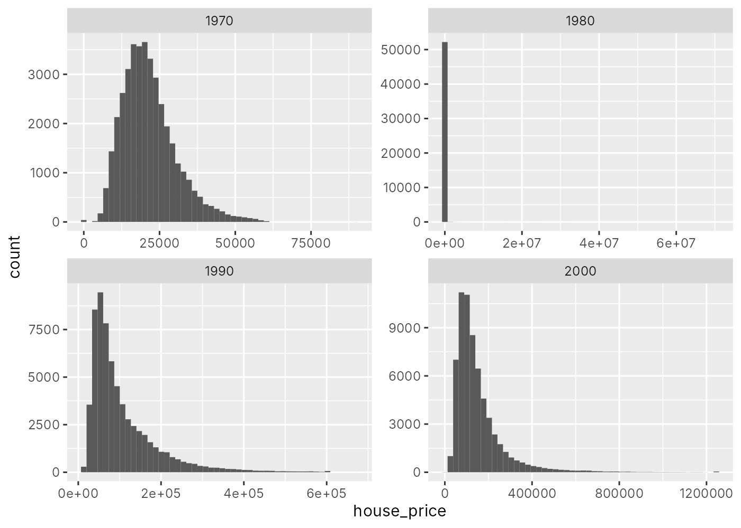
1B
Yes. 1990 and 2000 look reasonable, but 1980 has two problems (and 1970 has a smaller version of the first one). First, 3,757 tracts in 1980 (and 39 in 1970) have a house price of $0, which isn't possible, so these are really missing values. Second, there are some huge values in 1980: the max is about $70 million and 90 tracts are over $1 million, even though 99% of 1980 prices are under $200,000 and the highest 1970 price is about $90,000. A tract average in the millions isn't believable for 1980, and there's a clear cluster right at $250,000 that looks like a top-code, so I treated anything above that as an error. I think both of these are data errors.
The high values in 1990 and 2000 (up to about $1.25 million) seem believable for wealthy areas, so I kept them.
1C
In my cleaning code I set these to missing: house prices of $0, 1980 house prices above $250,000, incomes of $0, 1980 incomes below $1,000, and housing_units and share_black when housing_units is 0 (a lot of tracts in 1970 and 1980 have 0 for everything, which means they just weren't tracted yet).
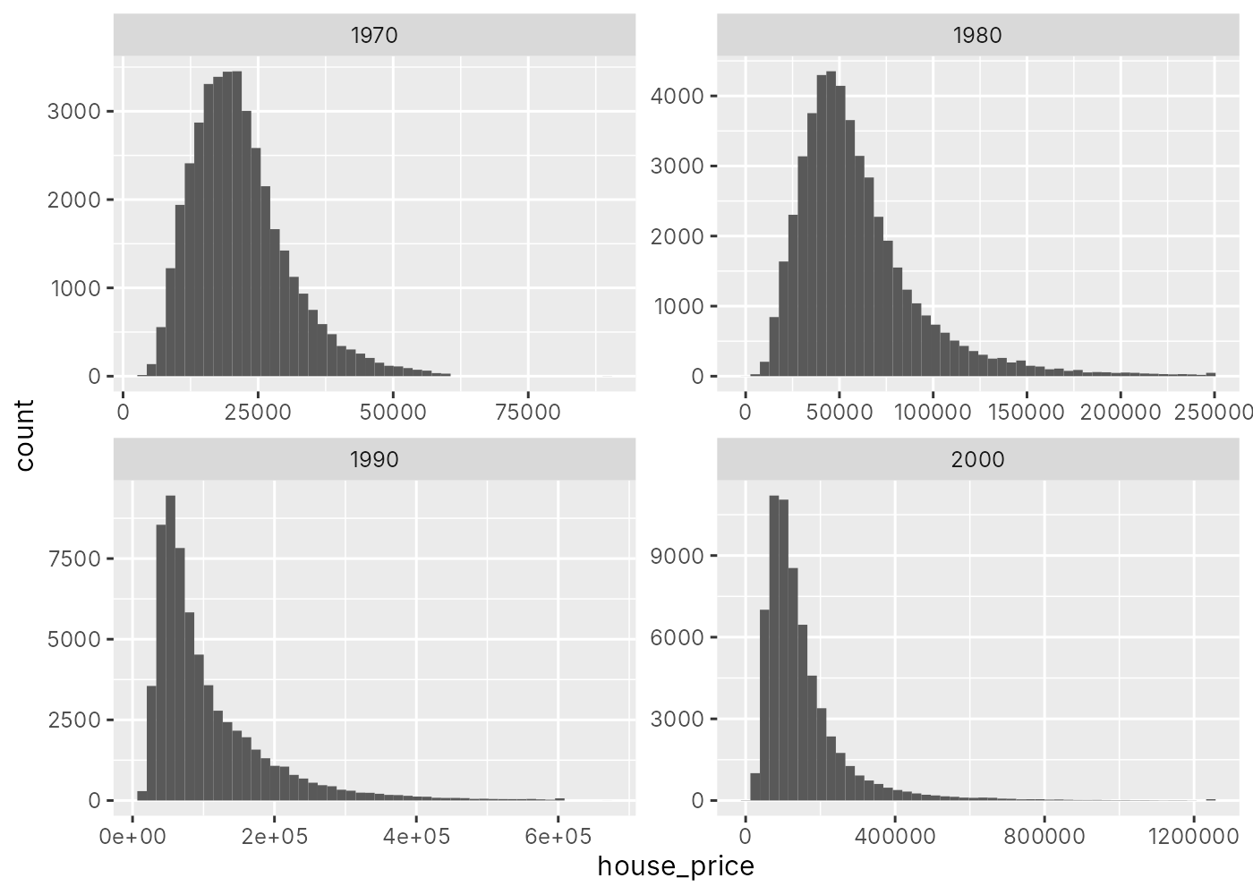
2A
α = -0.143 (robust SE = 0.020), constant = 10.87, N = 48,367.
2C
In 1980, the average census tract with a hazardous waste site that received an HRS score had house prices about 13% lower (0.143 log points) than the average tract without one.
2D
No. First, this isn't a causal estimate. Waste sites tend to be in poorer, more industrial areas with older housing, and those things lower house prices on their own. So the 13% gap is probably picking up a lot more than just the waste site.
Second, even if it were causal, the hedonic price difference reflects the willingness to pay of the people who actually live near these sites. People who care less about pollution (or can't afford to avoid it) are the ones who sort into these neighborhoods, so the estimate likely understates what the average person would pay to avoid a waste site.
3A
I left the controls out. Income, share Black, and share college could all change because of the NPL listing itself (for example, if people move in or out after a cleanup), so controlling for them could soak up part of the effect I'm trying to measure. The tract and year fixed effects already handle things that don't change over time and national trends. Adding the controls barely changes the result anyway (-0.058 vs -0.052).
3B
I used npl_1982. It's based only on whether the 1982 HRS score was above 28.5, and that cutoff was basically arbitrary, so sites just above and below it should be pretty similar. npl_ever includes sites that got added later, and those later additions could be related to things like political pressure or local changes that also affect house prices. Using npl_1982 avoids that problem.
3C
I clustered by county. House prices in the same tract are correlated over time, and tracts in the same county share a local housing market, so their errors are probably correlated too. Clustering by county covers both and is the more conservative choice. There are still plenty of counties (215 in my primary sample).
3D
If we included all four years, the four dummies would add up to N_c, which doesn't change over time and is already absorbed by the tract fixed effect. That's perfect collinearity, so one year has to be dropped. We drop 1980 because it's the last census before the NPL listings in 1982, so every other coefficient is measured relative to right before treatment.
3E
Sample (i):
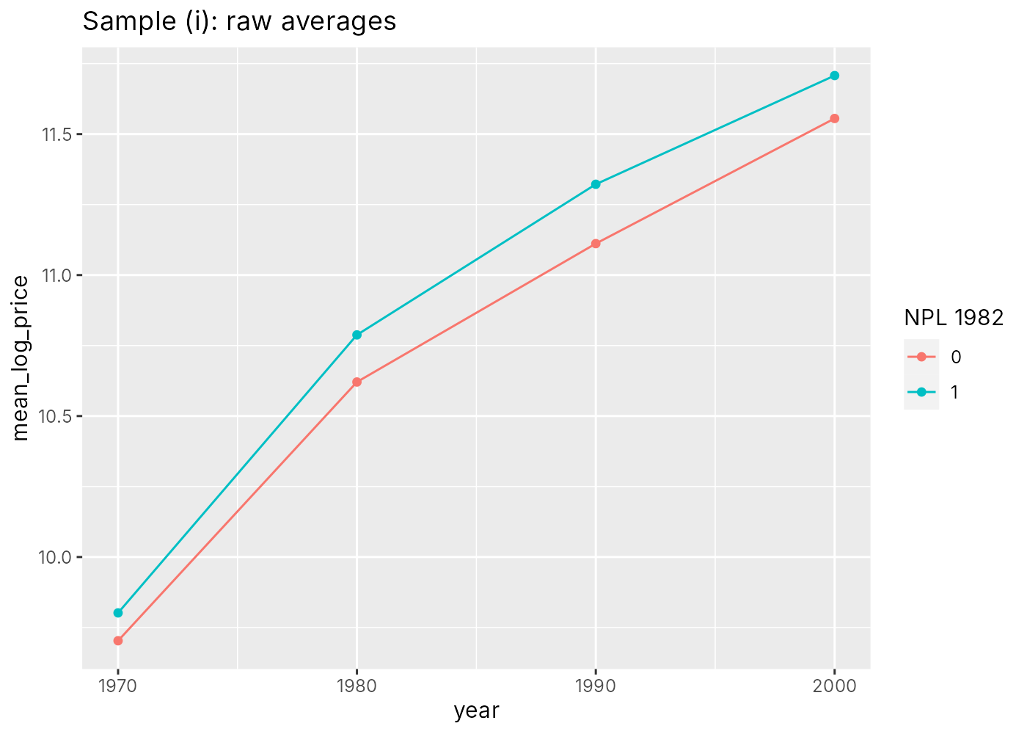
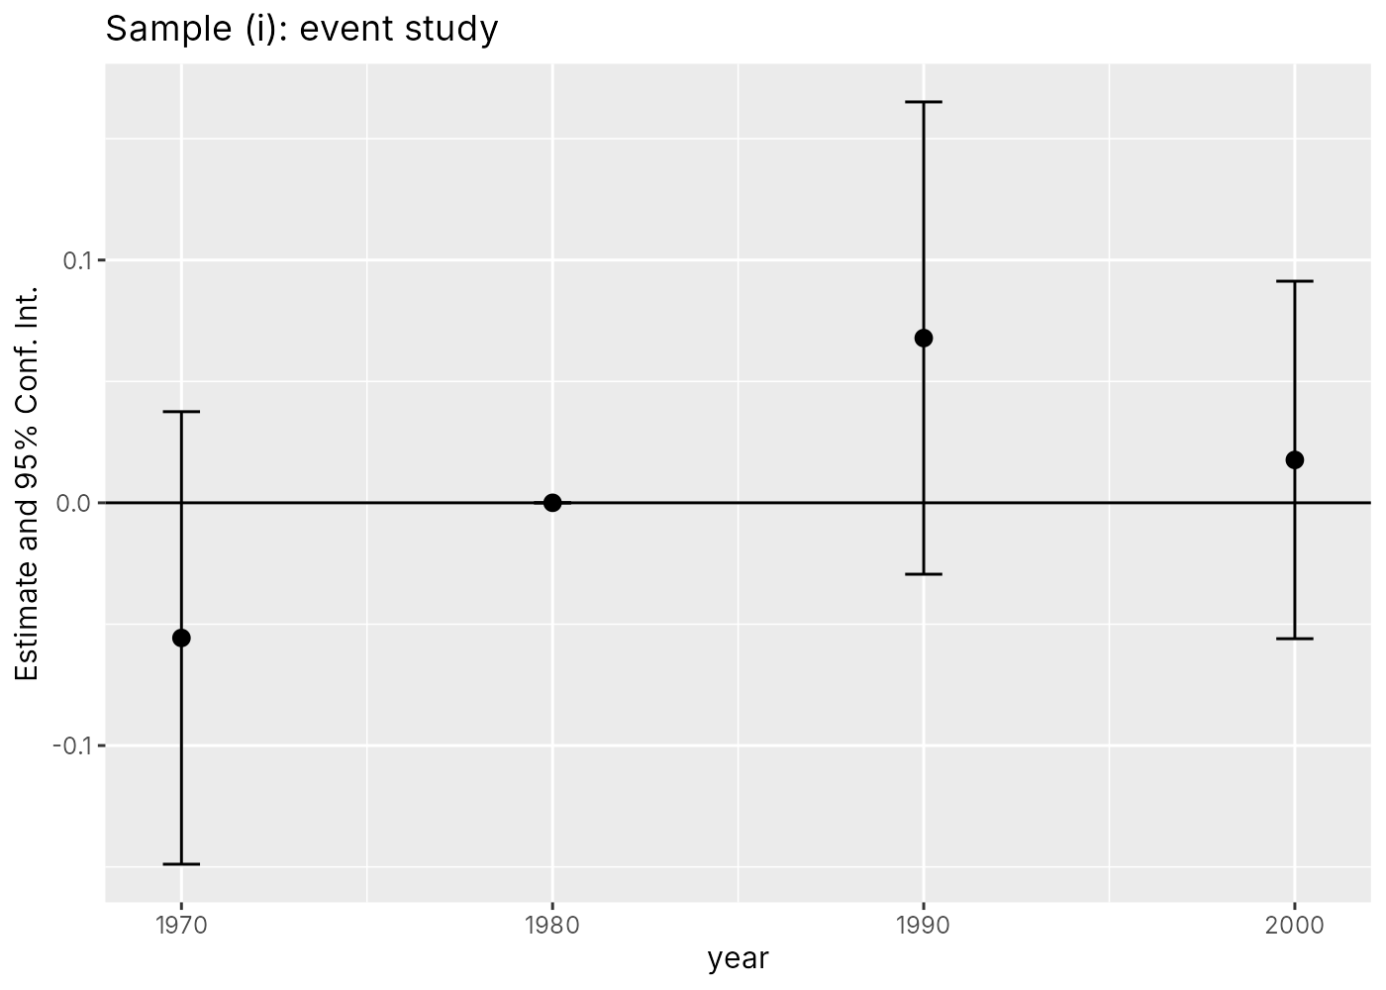
Sample (ii):
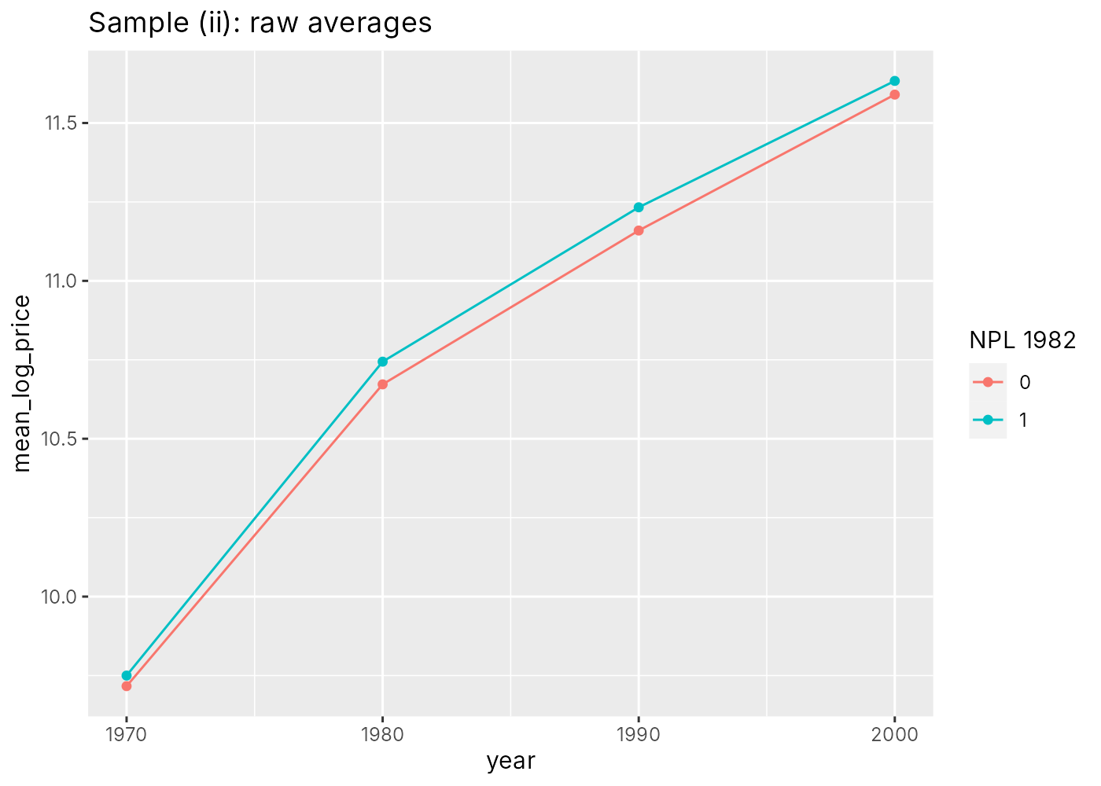
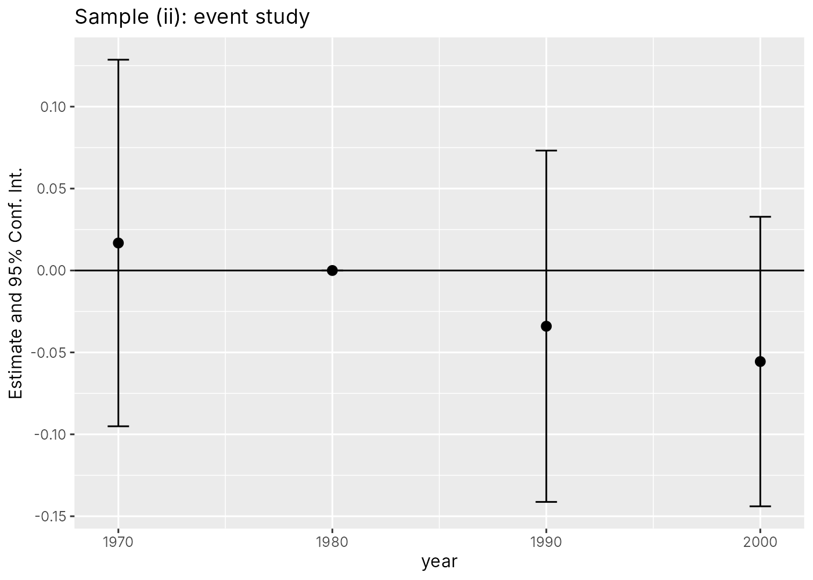
3F
τ1970 is the treatment-control difference in 1970 compared to 1980, before anyone knew which sites would be listed. In sample (i) it's -0.056, meaning treated tracts' prices were already growing faster than control tracts' between 1970 and 1980, before treatment. That's a pre-trend. In sample (ii) it's 0.017, basically zero, so the two groups were on similar paths before 1982. That makes it more plausible that τ1990 is unbiased in sample (ii).
3G
I chose sample (ii). Its pre-trend is basically zero, while sample (i) shows treated tracts already growing faster before treatment. Also, sites just above and below the 28.5 cutoff should be really similar to each other, kind of like a regression discontinuity, while sites with very low or very high scores are probably different in a lot of ways. The downside is a smaller sample (288 tracts vs 591), but I think the better comparison is worth it.
3H
τ = -0.052 (SE = 0.047), 95% CI [-0.143, 0.040], N = 919.
After 1982, house prices in tracts placed on the NPL changed by about -5% relative to tracts just below the cutoff, but this isn't statistically significant (p = 0.27). With 95% confidence, we can rule out a price increase bigger than about 4% and a price decrease bigger than about 13%.
3I
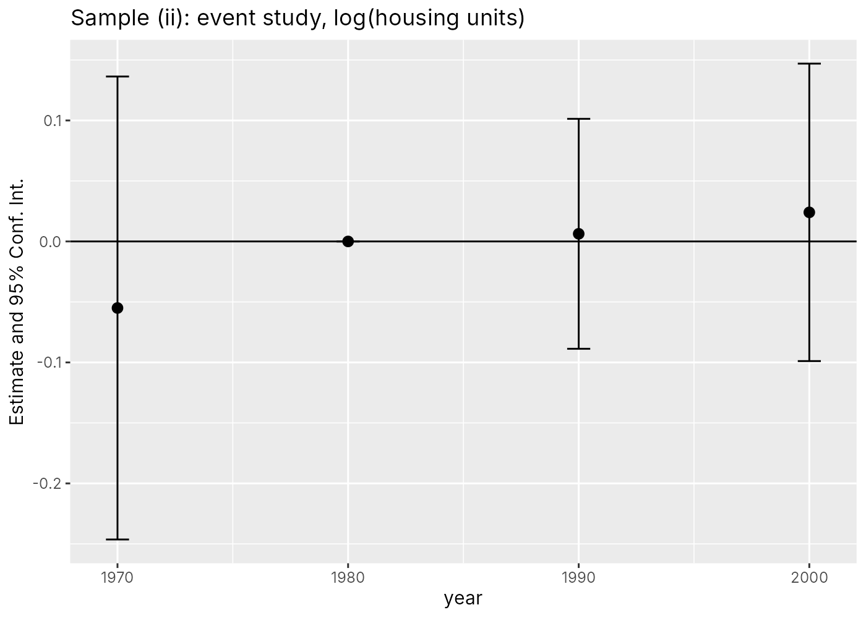
The coefficients are all small and not significant (-0.055, 0.006, 0.024), so NPL listing doesn't seem to change the number of housing units. That's consistent with interpreting price changes as changes in willingness to pay. If the housing supply had changed, for example if new houses got built after a cleanup, then prices would reflect that supply shift and not just how much people value the cleanup. Since supply stays about the same, any price effect can be read as a change in WTP.
4A
Figure 19 would have a flat (horizontal) supply curve at p0. The tax-exclusive price wouldn't change (p1 = p0), so the consumer price rises by the full amount of the tax, and producer surplus stays at zero.
The incidence would be entirely on consumers.
The pass-through rate is 1 (100%), since the whole tax gets passed on to consumers.
4B
Zero. If supply or demand is perfectly inelastic, the quantity doesn't change when you add the tax. Since the surplus gain is ½(q0 - q1)φ, and q0 = q1, the gain is zero. The tax just moves money from consumers or producers to the government without reducing any pollution.
4C
Cutting emissions gets more expensive the closer you get to zero. The first cuts are cheap, like switching from coal to wind, but the last ones (for things like planes, steel, or cement) could cost way more than the climate damage they cause. The optimal amount of emissions is where the cost of cutting one more ton equals the damage from that ton, not zero. That's why the optimal carbon tax equals the damage per ton instead of being infinitely high.
4D
Example: the effect of air pollution on hospital visits, using wildfire smoke.
y = respiratory ER visits in a county on a given day, x = PM2.5 pollution that day, z = whether smoke from a faraway wildfire passes over the county that day (from satellite smoke maps).
First stage: regress PM2.5 on the smoke indicator to see how much smoke raises pollution. Reduced form: regress ER visits on the smoke indicator to see how much smoke raises ER visits. Second stage: regress ER visits on the predicted PM2.5 from the first stage. The IV estimate is the reduced form divided by the first stage.
The exclusion restriction might hold because whether smoke from a fire hundreds of miles away blows over a county depends on wind patterns, not anything about the county itself. It might fail because smoke contains other pollutants besides PM2.5, it can change the temperature, and people might stay inside or feel stressed on smoky days, all of which could affect health on their own.
4E
For: it makes people pay for the damage they cause, so the cheapest emissions cuts happen first. It lets people and firms decide how to cut emissions instead of the government picking technologies. It raises revenue that could be returned to households or used to cut other taxes. It encourages clean innovation over time.
Against: it's politically unpopular because the costs are obvious and immediate while the benefits are spread out and in the future. It can hit low-income and rural households harder since they spend more of their income on energy. If only some countries do it, production could move to places without a tax. And it's hard to agree on the right price.

