EV Subsidy Problem Set
1A
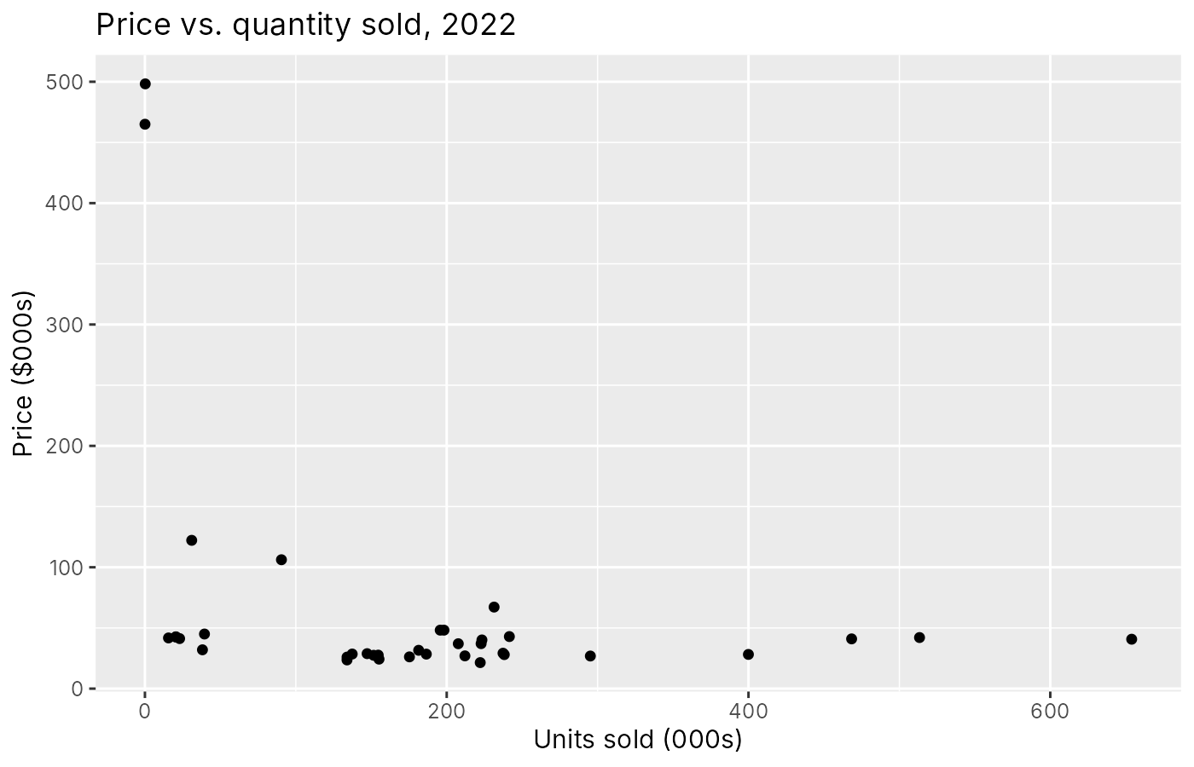
1B
No. The scatterplot mostly shows that cheap, mass-market cars sell a lot and expensive cars (like the Lamborghini and Rolls Royce) sell almost nothing, but that's not the effect of price on quantity. Price is set by carmakers based on the car's quality, size, brand, and features, and those same things affect how many people buy it. A $40,000 F-150 sells more than a $25,000 Corolla not because it's pricier, but because a lot of people want a full-size pickup.
There's also a simultaneity problem: popular models can charge higher prices, so causality runs in both directions. To get the causal effect of price, we'd need to compare otherwise-identical cars at different prices, or use an instrument for price.
1C
 | Average lifetime CO2 damages
Electric vehicles (11 models) | $3,237
Non-electric vehicles (25 models) | $14,262

co2cost = lifetime CO2 (tons) x $190. Every EV has the same damages because the data uses the national average emissions from electricity for all EVs.
1D
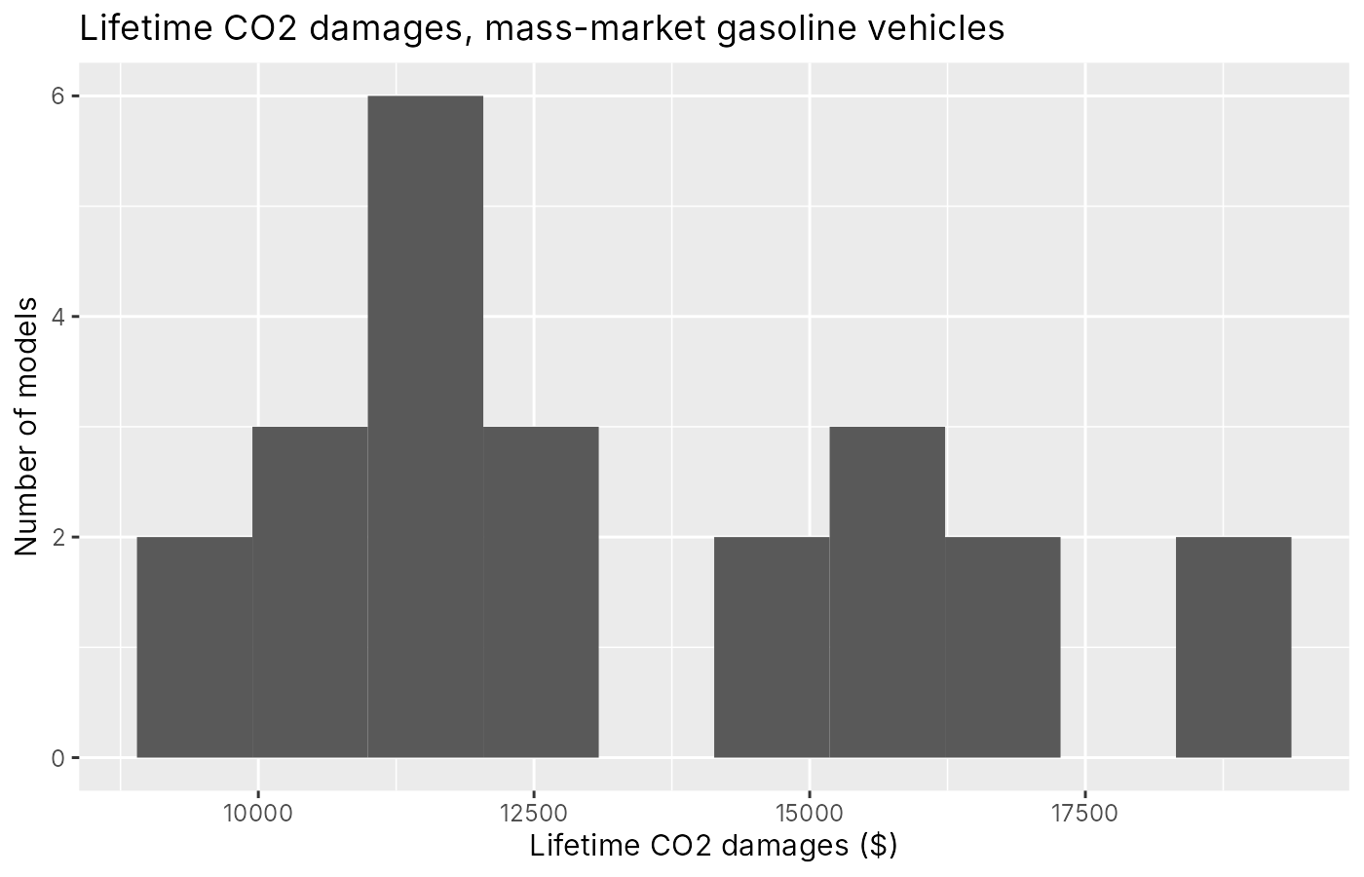
The 23 mass-market gasoline vehicles range from about $9,200 (Honda Civic) to about $18,600 (GMC Sierra) in lifetime CO2 damages.
2A
 | ln(s_j / s_0)
Price ($000s) | -0.0274*** (0.0019)
Weight (tons) | -1.4397** (0.5527)
Horsepower (100s) | 0.6539*** (0.0860)
Annual fuel cost ($) | 0.00087*** (0.00028)
Electric vehicle | 0.3025 (0.6352)
Constant | -6.7589*** (0.7189)
Observations | 36
R-squared | 0.91

Robust (heteroskedasticity-consistent) standard errors in parentheses. * p<0.1, ** p<0.05, *** p<0.01. Market size = 250 million, so the outside option share s_0 = 0.974.
2B
Price: a $1,000 increase in a vehicle's price is associated with about a 2.7 percent decrease in its market share (relative to the outside option), holding the other characteristics fixed.
Electric vehicle: being electric is associated with about a 35 percent higher market share (e^0.30 - 1), holding price, weight, horsepower, and fuel cost fixed. But the standard error is large (0.64), so this isn't statistically different from zero.
2C
I think it's biased toward zero (not negative enough). The error term ξ_j is the car's unobserved quality, like brand reputation, styling, reliability, or interior features. Carmakers charge more for cars that are better in those unobserved ways, so price is positively correlated with ξ_j. That means some of the higher demand that comes from quality gets mixed into the price coefficient, which makes it look like consumers are less sensitive to price than they really are. To fix this we'd need an instrument for price, like cost shifters or the characteristics of competing cars.
3A
All of the incidence is on consumers. Because each vehicle is produced at a constant marginal cost in a perfectly competitive market, supply is perfectly elastic: firms will sell any amount at that cost but won't accept less. So a tax raises the price consumers pay by the full amount of the tax, and a subsidy lowers it by the full amount of the subsidy. The pass-through rate is 100%, and producer surplus doesn't change (it's zero both before and after).
3B
The average optimal CO2 tax across all 36 vehicles (unweighted) is about $10,893 per vehicle. It's $3,237 for every EV and $14,262 on average for gasoline vehicles, ranging up to about $30,600 for the Lamborghini.
3C
Scenario | Average V_j
Baseline (V^B) | -7.880
CO2 tax (V^T) | -8.178
Clean Vehicle Credit (V^S) | -7.828

Baseline utility is V^B = ln(s_j / s_0), since the outside option is normalized to V_0 = 0. With the tax, V^T = V^B + β_price x tax. With the subsidy, eligible EVs get V^S = V^B + β_price x (-7.5), and everything else stays the same.
3D
 | Baseline | CO2 tax | Subsidy
Outside option share | 0.9736 | 0.9810 | 0.9728

The outside option (not buying a new car) gets bigger with the tax and smaller with the subsidy. The tax raises the price of every car, so cars become less attractive compared to not buying one, and some people drop out of the market. The subsidy makes eligible EVs cheaper, which pulls some people who weren't going to buy a car into buying one.
With the tax, every vehicle's share falls, but the high-emission vehicles fall much more. EVs drop about 8%, small sedans like the Civic and Corolla drop about 22%, big pickups like the Silverado and Sierra drop about 39%, and the Lamborghini drops about 56%. So the tax shifts buyers toward cleaner cars, as well as out of the market.
3E
$ per consumer per year | (1) Tax vs. baseline | (2) Subsidy vs. baseline
Consumer surplus change | -$275.02 | +$28.65
Producer surplus change | $0.00 | $0.00
Government revenue change | +$226.68 | -$31.68
Externality change | -$103.45 | +$2.28
Total surplus change | +$55.11 | -$5.31
Cost per ton of carbon abated | -$88.78 per ton | $252.56 per ton*

250 million consumers. Externality change is the change in CO2 damages (negative = less damage). Total surplus = CS + PS + G - externality change. Cost per ton = (CS + PS + G change) / tons abated, so with the tax society gives up $88.78 of private surplus per ton abated (about 0.54 tons per consumer).
*With the subsidy, emissions actually go up (by about 0.012 tons per consumer), so the 'cost per ton' is spending $3.03 per consumer to increase emissions. The positive number is just a negative divided by a negative and doesn't mean anything useful.
4
Why EV subsidies do worse than a CO2 tax in our model:
1. The subsidy is blunt. Figure 1D shows gasoline cars differ a lot in damages, from about $9,200 for a Civic to $18,600 for a Sierra. A CO2 tax charges each car for its own damages, so it pushes people from trucks to small cars too, not just to EVs. The $7,500 credit does nothing about those differences.
2. The subsidy pulls people into the market. Because it lowers prices, some people buy an EV who otherwise wouldn't have bought a car at all, and EVs still cause about $3,200 in damages each. The tax does the opposite and pushes some people out of buying.
3. The subsidy also pays people who would have bought an EV anyway, and it skips some EVs (the EV6 and Ioniq 5 aren't eligible), so its incentive isn't lined up with emissions.
Efficiency and distribution: the CO2 tax increases total surplus by about $55 per consumer per year, while the subsidy actually lowers it by about $5. But the distributional effects are opposite. With the tax, consumers lose $275 each while the government collects $227 in revenue. With the subsidy, consumers gain $29 and the government (taxpayers) pays $32. Producers aren't affected in either case because of our perfectly elastic supply assumption. This helps explain the politics: car buyers see the tax as a direct cost and fight it, while the subsidy gives them money, so subsidies are much easier to pass even though they're less efficient. The tax could be made more popular by giving the revenue back to households.
Is it realistic that EV subsidies increase emissions? Probably not. That result comes mostly from two modeling simplifications. First, the logit model's IIA property means the subsidized EVs take customers proportionally from every option, and since the outside option has about 97% of the market, most new EV buyers come from "no car" instead of from gasoline cars. In reality, people choosing an EV were probably going to buy a similar gasoline car. Second, we assume the outside option has zero emissions. In reality, not buying a new car often means keeping an old gasoline car or buying a used one, which both pollute.
Other simplifications that might bias the results: the price coefficient is probably biased toward zero because of price endogeneity; supply might not be perfectly elastic (carmakers have market power, so pass-through is less than 100% and producers would bear some of the incidence); driving is assumed fixed, even though people drive more when fuel is cheaper; everyone has the same preferences, with no differences by income or location; we only look at one year and ignore the used-car market and scrappage; EV emissions use today's average grid, even though the grid is getting cleaner; the market size of 250 million is an assumption; and we ignore other externalities like local air pollution, congestion, and accidents.
I think the biggest bias comes from the logit substitution patterns (IIA) together with the zero-emission outside option. That's what drives the result that the subsidy increases emissions. If EV buyers were mostly switching from gasoline cars, as they likely do in reality, the subsidy would reduce emissions instead, which changes the sign of the main result. The other simplifications mostly change the size of the numbers.
5A
The equimarginal principle says that to reach a pollution target at the lowest total cost, you should split the abatement across polluters so that every polluter has the same marginal abatement cost. If one firm can cut a ton for $20 and another needs $100, you can save money by having the cheap firm abate more and the expensive firm abate less, without changing total emissions. You keep shifting until the marginal costs are equal, and at that point there's no cheaper way to reach the same total.
5B
Emission standards and technology rules usually require every firm to meet the same limit or install the same equipment. But firms have very different costs of cutting pollution, and the regulator usually doesn't know each firm's costs. So some firms end up paying a lot for their last ton of abatement while others could have abated more cheaply. Marginal abatement costs aren't equalized, which breaks the equimarginal principle. Standards also give firms no reason to go beyond the requirement or to look for cheaper ways to cut pollution.
Pollution taxes and cap-and-trade put one price on every ton. Each firm cuts pollution until its marginal abatement cost equals that price (the tax, or the permit price), so every firm ends up with the same marginal cost automatically. The regulator doesn't need to know anyone's costs, because firms figure it out themselves. That's why these policies are cost-effective.
5C
Taxes and cap-and-trade control the total amount of pollution, but not where it happens. Firms with high abatement costs might just pay the tax or buy permits and keep polluting. For pollutants like CO2 that mix globally, location doesn't matter. But for local pollutants like SO2 or particulates, the damage depends on who lives nearby. Emissions could stay concentrated (or even increase) in certain neighborhoods, which are often lower-income or minority communities, while falling elsewhere. These "hot spots" can mean serious local health harms even when total emissions go down.
5D
In an Energy Market, the RTO runs an auction (a reverse auction) for every hour. Load-serving entities (the utilities that sell power to homes and businesses) say how much electricity they need, and generators submit bids for how much power they can supply and at what price, roughly their marginal cost. The RTO then dispatches generators from cheapest to most expensive (the "merit order") until demand is met. The bid of the last, most expensive generator needed sets the price, and all the dispatched generators get paid that price. Because of transmission constraints, prices can differ by location (locational marginal prices).

