Climate Mortality Problem Set
1A
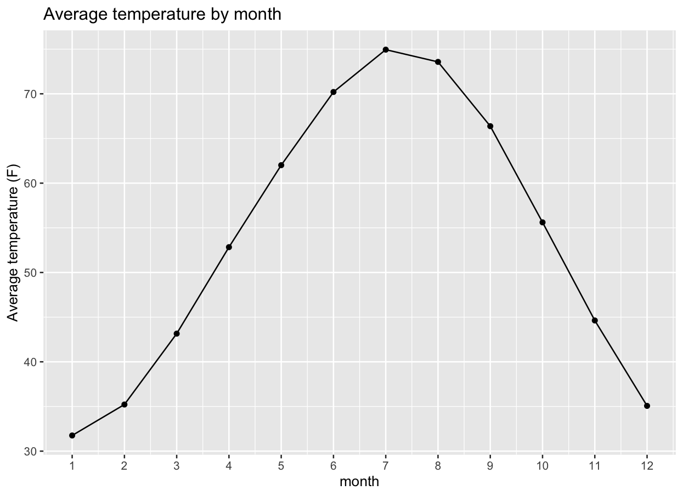
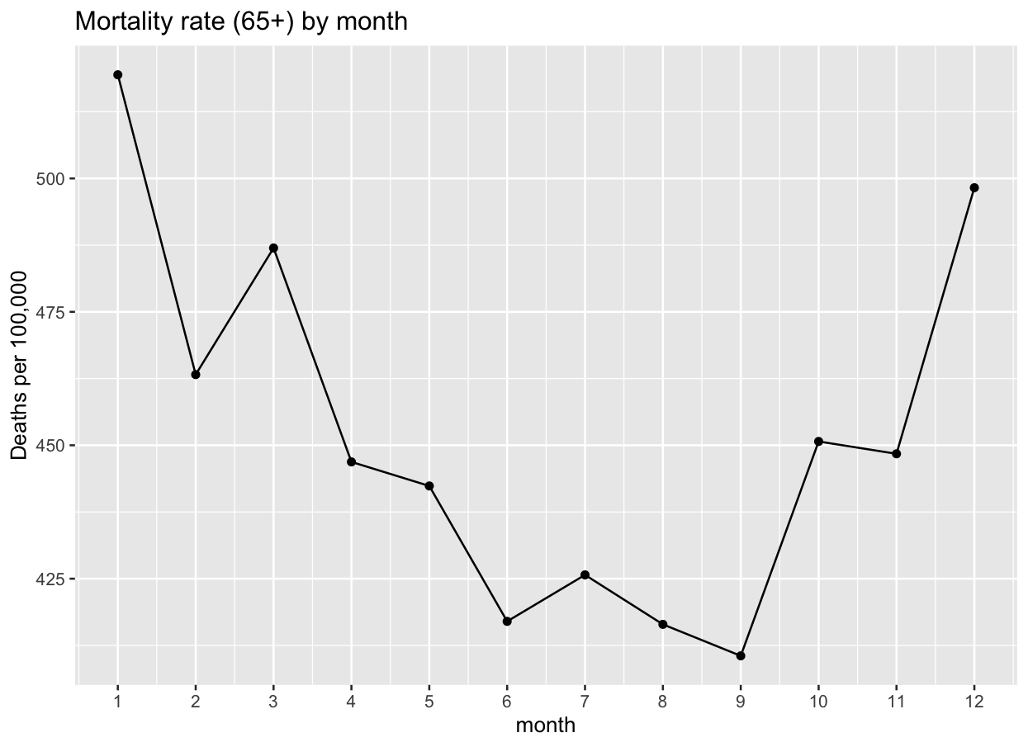
1B
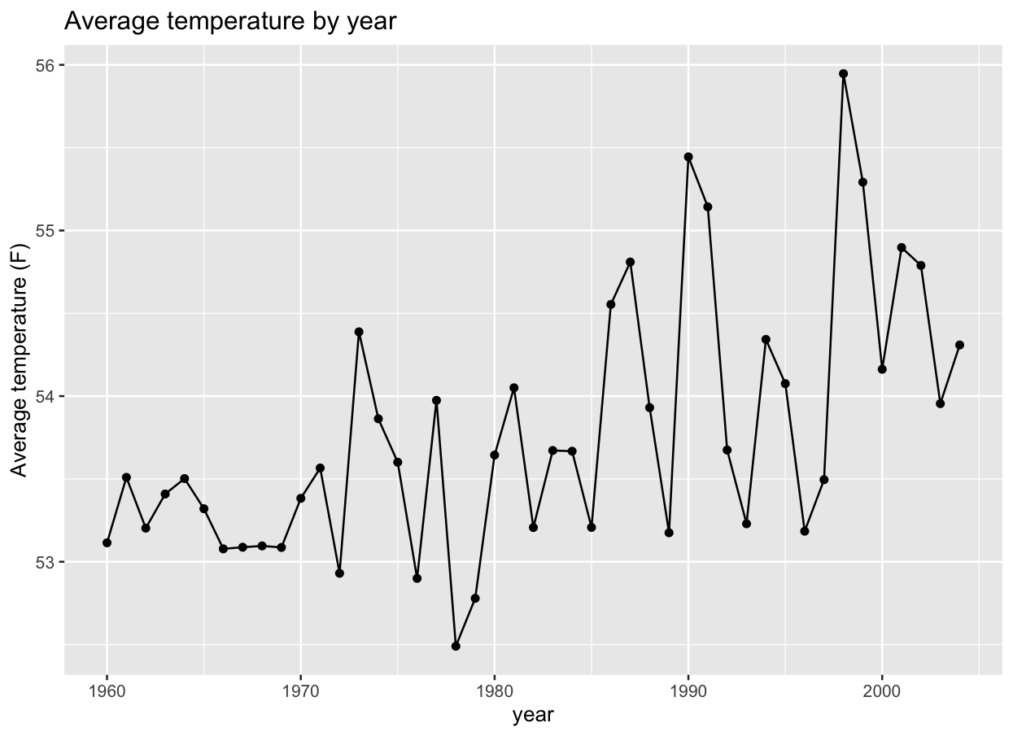
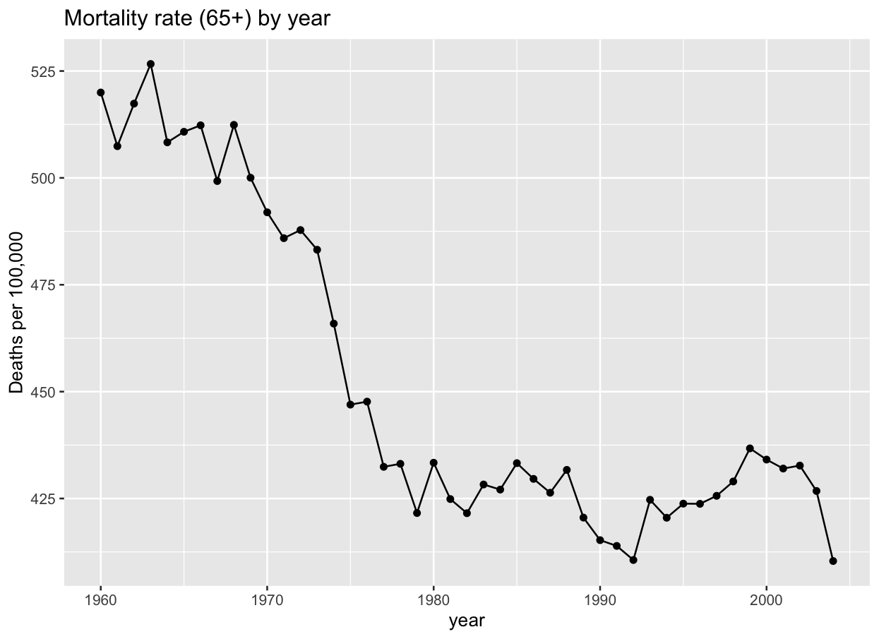
1C
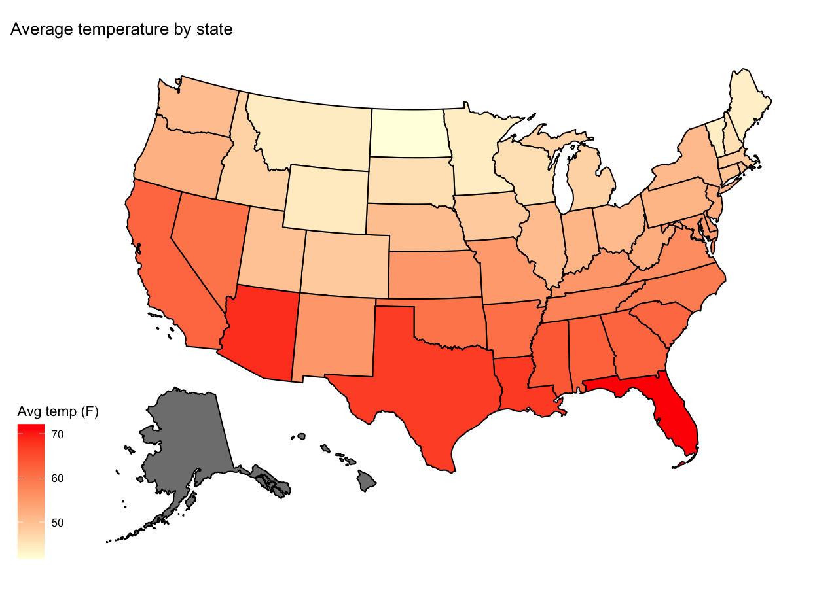
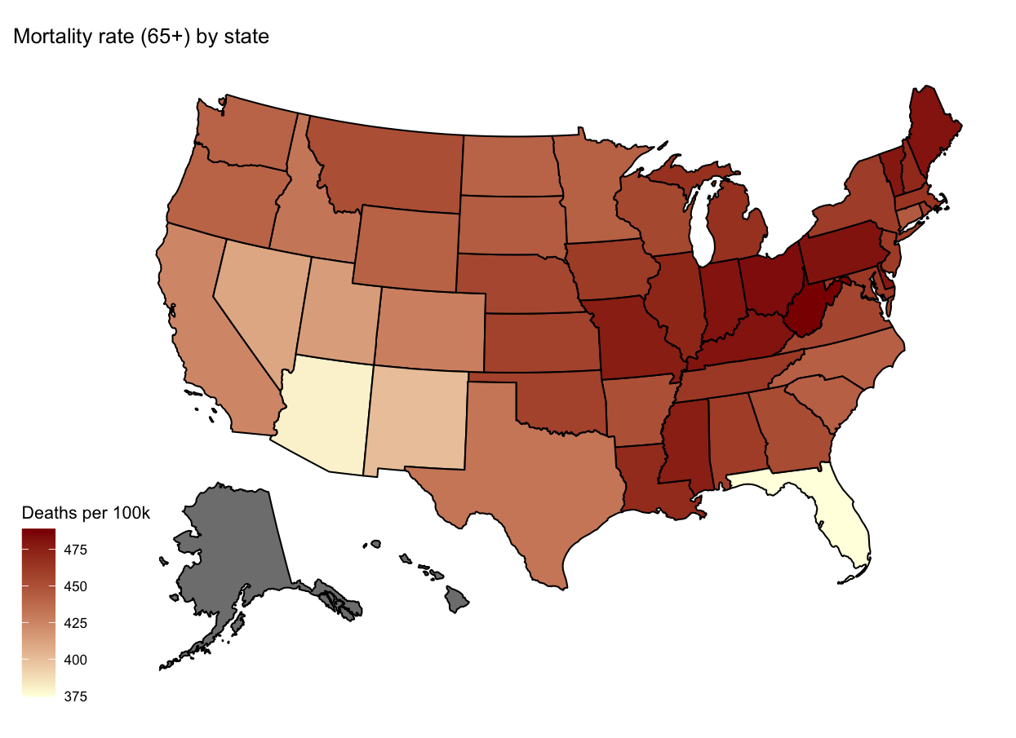
Alaska and Hawaii are not in the data (shown in grey).
2A
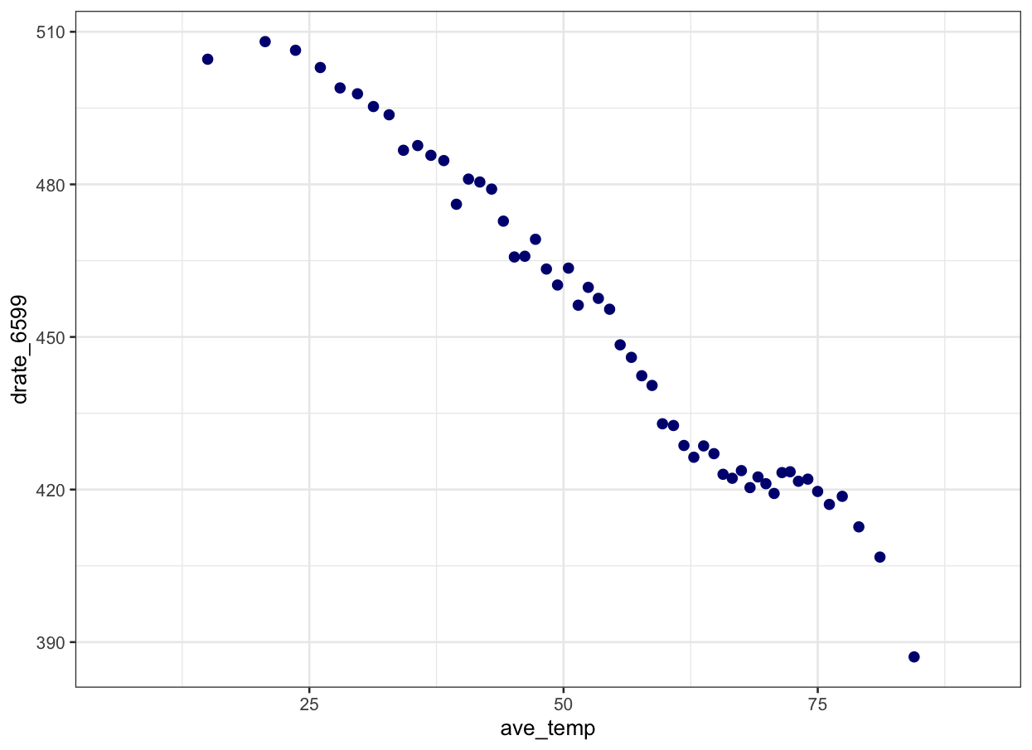
drate_6599 is deaths per 100,000 people aged 65+; ave_temp is average monthly temperature (F).
2B
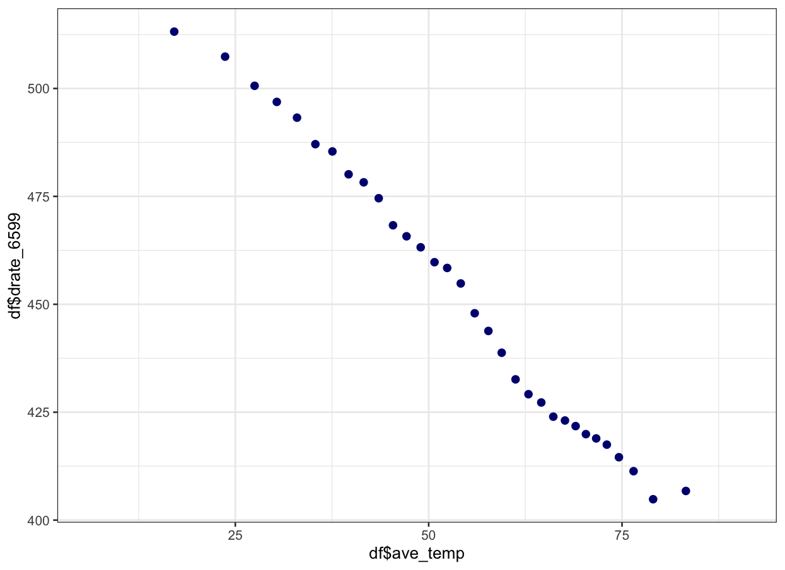
Same plot, controlling for state and year fixed effects.
2C
No, I don't think either one is causal. Both plots show mortality going down as temperature goes up, but that's mostly picking up other things that are correlated with temperature.
In 2A, the comparison is partly across states. Warm states like Florida and Arizona have low mortality (see the 1C maps), but that's probably because of who lives there (for example, healthier retirees who moved there), not because warm weather keeps people alive. It's also partly across years: mortality fell a lot over the sample while temperatures rose slightly (1B), mostly because of better health care.
2B takes out state and year differences, but the remaining variation is mostly seasonal. Mortality is highest in winter (1A), when it's cold, but winter also has flu season and other things that raise deaths. So the downward slope mostly reflects that winter months are deadlier, not the effect of temperature itself. (February even looks low partly because it has fewer days.) To get a causal effect, we need to compare the same state in the same calendar month across years, which is what equation (1) does.
3A
 | ln(65+ mortality rate)
Days above 90F | 0.00580*** (0.00122)
Days 80-90F | 0.00299*** (0.00043)
Days below 40F | 0.00342*** (0.00024)
Low precipitation (devp25) | 0.00224* (0.00117)
High precipitation (devp75) | -0.00193** (0.00095)
State x month FE | Yes
Month-of-sample FE | Yes
Observations | 26,460

Standard errors clustered by state (49 clusters) in parentheses. * p<0.1, ** p<0.05, *** p<0.01. The omitted temperature category is days between 40 and 80F.
3B
I estimate that one more day above 90F in a month (instead of a day between 40 and 80F) increases the monthly mortality rate for people 65+ by about 0.58 percent, with a standard error of 0.12 percent.
3C
Observations from the same state are probably not independent. The unexplained part of mortality in a state in one month is likely related to the same state's mortality in other months, for example because of a local flu outbreak, a hospital system, or the state's population changing over time. If we treat every state-month as independent, we act like we have more information than we really do, and the standard errors come out too small. Clustering by state allows the errors to be correlated within a state and gives more honest standard errors. In my regression, the clustered standard error on days above 90F (0.0012) is about 50% bigger than the non-clustered one (0.0008).
3D
 | ln(65+ mortality rate)
Average temperature (F) | -0.00280*** (0.00023)
Low precipitation (devp25) | 0.00470*** (0.00120)
High precipitation (devp75) | -0.00425*** (0.00089)
Observations | 26,460

This says a month that's 1F warmer has about 0.28% lower mortality. The problem is that this assumes the effect of temperature is a straight line, but it isn't. Both very cold and very hot days increase deaths (in 3A, days below 40F and days above 90F both have positive effects), so the real relationship is U-shaped. Average temperature also hides the extremes: two months can have the same average but very different numbers of dangerous hot days. With climate change, the danger is more extremely hot days, and a linear average-temperature model would wrongly predict that warming reduces mortality, because in this data warmer months mostly means fewer cold days.
3E
 | South 1960-80 | South 1981-2004 | Non-South 1960-80 | Non-South 1981-2004
Days above 90F | 0.00828*** (0.00195) | 0.00091 (0.00087) | 0.01418*** (0.00370) | 0.00421*** (0.00049)
Days 80-90F | 0.00254*** (0.00072) | 0.00023 (0.00044) | 0.00737*** (0.00101) | 0.00069 (0.00041)
Days below 40F | 0.00449*** (0.00075) | 0.00295*** (0.00066) | 0.00366*** (0.00043) | 0.00227*** (0.00035)
devp25 | 0.00343* (0.00179) | 0.00480** (0.00199) | 0.00045 (0.00154) | 0.00245** (0.00109)
devp75 | -0.00134 (0.00204) | -0.00018 (0.00198) | -0.00008 (0.00134) | -0.00364** (0.00146)
States | 16 | 16 | 33 | 33
Observations | 4,032 | 4,608 | 8,316 | 9,504

Outcome is ln(65+ mortality rate). All columns include state x month and month-of-sample fixed effects. Standard errors clustered by state.
3F
The effect of hot days dropped a lot after 1980 in both regions. In the South, the effect of a day above 90F fell from 0.83% to 0.09% (and is no longer significant). In the rest of the country it fell from 1.42% to 0.42%. Hot days were also always less deadly in the South than in the North, even though the South has many more of them.
This looks like adaptation. People in places that get a lot of heat have learned to deal with it, and over time everyone got better at it. The main explanation from Barreca et al. is air conditioning, which spread quickly in the second half of the century, especially in the South. Better health care and people getting used to the heat probably also helped.
Looking forward, I think the effect of each hot day will probably be lower than the average historical estimate from 1960-2004, since the recent estimates are much smaller and AC is now common. But there are reasons it could be higher: future heat waves may be hotter than anything in the data, AC costs money and electricity (so poorer people may not be protected, and power outages during heat waves are dangerous), and places that rarely got hot before, like the North, will see more hot days. Also, a lot of the cheap adaptation (like AC) has already happened, so there may be less room for further improvement.
4A
 | Infectious disease death rate
Days above 90F | -0.00977 (0.02053)
Days 80-90F | 0.01067** (0.00439)
Days below 40F | 0.00026 (0.00214)
Low precipitation (devp25) | -0.00146 (0.00681)
High precipitation (devp75) | 0.00689 (0.00592)
Observations | 26,460

Same fixed effects and clustering as equation (1). The outcome is in levels (deaths per 100,000), with a mean of about 1.15.
4B
Infectious disease deaths shouldn't really be affected by a hot or cold day in the short run, so this works as a placebo. Mostly, it passes: days above 90F and days below 40F have small, insignificant effects. The one exception is days between 80 and 90F, which has a small but significant effect (about 1% of the average infectious disease death rate per day). That could be chance, since we're testing several coefficients, or it could be real, since some infections (like food- and water-borne illness) do spread more in hot weather. Overall, this makes me somewhat more confident in Part 3, because temperature isn't predicting deaths that it shouldn't affect, at least for the extreme temperature bins.
5A
Banzhaf, Ma, and Timmins group the possible mechanisms into four categories:
1. Disproportionate siting: firms put polluting facilities in poor or minority neighborhoods, either because of discrimination or, more often, because those areas have cheap land, low-wage labor, and access to highways and railroads (which themselves may have been placed there because of past discrimination).
2. Coming to the nuisance: the pollution is already there, and households sort around it. Pollution lowers nearby house prices, so lower-income households, who can't afford to outbid richer households for cleaner neighborhoods, end up living near it (Tiebout sorting).
3. Coasean bargaining: firms and communities effectively negotiate over where pollution goes. Communities that would accept less compensation, or that have less ability to organize and bargain, end up with more polluting facilities.
4. Political economy and government: regulators decide where to permit, inspect, enforce, and clean up. Communities with more political power and ability to take collective action can push for stricter enforcement, so pollution ends up in places with less political voice.
5B
The memo's logic is basically the sorting model's second prediction. In the model, richer households have a higher ω, meaning they're willing to pay more for environmental quality and would need more compensation to accept pollution. If demand for a clean environment rises with income, then poor people (or poor countries) would accept pollution for less money, so from a pure efficiency point of view the "cheapest" place to put waste is where incomes are lowest.
Someone could disagree for several reasons. Lower willingness to pay mostly reflects lower ability to pay, not that poor people's health matters less, so using it to decide who gets polluted is unfair. It also assumes the people affected actually get compensated, which usually doesn't happen. And poor communities may not have full information about the risks or the power to say no, so it isn't really a voluntary trade.
5C
(i) Research question: does reducing traffic congestion near toll plazas improve infant health? This is the idea behind Currie and Walker (2011), who studied the introduction of E-ZPass electronic tolling, which cut idling cars and pollution at toll plazas.
(ii) Outcome Y: rates of premature births and low birth weight for mothers living near the road.
(iii) Treatment T: mothers living within about 2 km of a toll plaza (treated) versus mothers living 2-10 km away along the same highway (control), comparing births before and after E-ZPass started.
(iv) Parallel trends: without E-ZPass, birth outcomes for mothers living close to the toll plazas would have changed over time in the same way as for mothers living a bit farther away.
5D
Parallel leads only checks whether the treatment and control groups were moving together before treatment. Parallel trends is about what would have happened after treatment if there had been no treatment, which we can never see. The groups could have moved together for years and then split apart anyway, for example if something else happened to the treatment group at the same time as the treatment (a factory closing, a new policy). So parallel leads makes parallel trends more believable, but it can't prove it.
5E
Not necessarily, but the paper suggests the money could probably be spent better. Greenstone and Gallagher give three possible explanations for the zero effect in Section VII:
1. The people who live near these sites may just not value the cleanups very much. People who care a lot about avoiding toxic waste don't live there in the first place, so the cleanup gives local residents something they don't value highly (even if the average American would value it more).
2. People may believe the cleanups don't really reduce health risks. The epidemiological evidence on health benefits from cleanups isn't strong, so it could be rational to place a low value on them. If future research found big health benefits, valuations could go up.
3. The control sites may have been partly cleaned up too, by state or local programs. The authors checked and found that most non-NPL sites got little or no cleanup (about $3 million on average where there was any), so the result really reflects the extra ~$40 million Superfund spends.
They think the first two are the most likely, which means local residents' benefits fall well short of the costs. But that doesn't automatically mean the money is wasted, because house prices don't capture every benefit. There could be benefits to people who don't live near the site, to ecosystems, and from protecting groundwater. Also, many sites weren't fully cleaned up even by 2000, and the estimates can't rule out modest positive effects.
Their conclusion is that unless those other benefits are large, cheaper approaches like fences, warning signs, and simply containing the toxic waste might be a more efficient use of the money.

