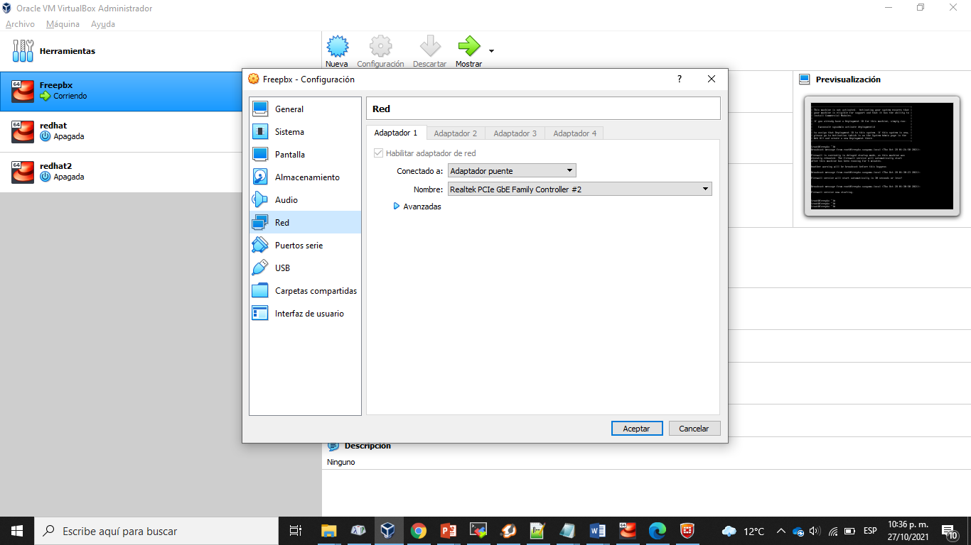

xtensions.conf The dialplans we create will be extremely primitive, but they will prove that the system is working. sip.conf This is where we’ll configure the SIP protocol. iax.conf This is where we’ll configure incoming and outgoing IAX channels.

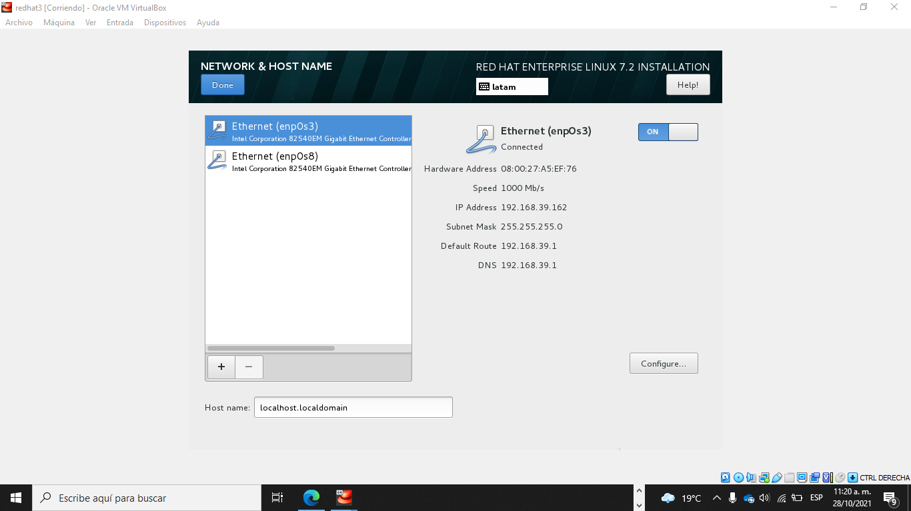

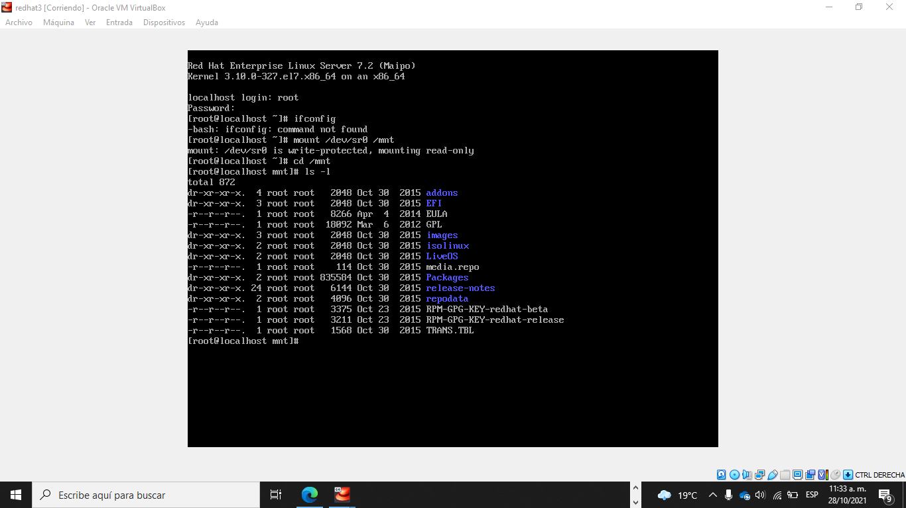

1. Deshabilitar SELINUX



1. Configurar el repositorio local (DVD)

$ vi /etc/yum.repos.d/rhel-dvd.repo

[rhel-7-dvd]

name = RHEL 7 ISO DVD

baseurl = file:///mnt

enabled = 1

gpgcheck = 0

1. Limpiar el repositorio

$ yum clean all

1. Instalar los paquetes
2. X
3. Instalar los paquetes

yum install -y epel-release dmidecode gcc-c++ ncurses-devel libxml2-devel make wget openssl-devel newt-devel kernel-devel sqlite-devel libuuid-devel gtk2-devel jansson-devel binutils-devel libedit libedit-devel

1. Crear usuarios asterisk

# adduser asterisk -c "Asterisk User"

# passwd asterisk

# usermod -aG wheel asterisk

# su asterisk

1. Instalar PJSIP
2. Crear directorio para el build

$ mkdir ~/build && cd ~/build

1. Descargar el código

$ wget https://github.com/pjsip/pjproject/archive/2.11.1.tar.gz

1. Extraer el archivo y cambiarse al directorio

$ tar tar xvzf 2.11.1.tar.gz

$ cd pjproject-2.11.1

1. Preparar el package a ser compilado

$ ./configure CFLAGS="-DNDEBUG -DPJ_HAS_IPV6=1" --prefix=/usr --libdir=/usr/lib64 --enable-shared --disable-video --disable-sound --disable-opencore-amr

1. Asegurarse de tener las dependencias

$ make dep

1. Make and install

$ make && sudo make install && sudo ldconfig

1. Asegurarse que todas las librerías esten instaladas y presents

$ ldconfig -p | grep pj

1. Ir al directorio build

$ cd ~/build

1. Descargar el código de Asterisk

$ wget <http://downloads.asterisk.org/pub/telephony/asterisk/asterisk-16-current.tar.gz>

https://downloads.asterisk.org/pub/telephony/asterisk/old-releases/asterisk-16.5.1.tar.gz

1. Extraer el archive y cambiarse al directorio

$ tar -zxvf asterisk-16-current.tar.gz

$ cd asterisk-16.21.1

1. Instalar otras dependencias

$ sudo yum install svn

$ sudo ./contrib/scripts/get_mp3_source.sh

$ sudo yum install patch

1. Instalar la dependencia libedit-devel

$ wget <http://mirror.centos.org/centos/7/os/x86_64/Packages/libedit-devel-3.0-12.20121213cvs.el7.x86_64.rpm>

sudo rpm -i libedit-devel-3.0-12.20121213cvs.el7.x86_64.rpm

1. Preparar el package para la compilación

$ sudo contrib/scripts/install_prereq install

$ ./configure --libdir=/usr/lib64 --with-jansson-bundled

1. Iniciar el proceso de BUILD

$ make menuselect

1. Habilitar los módulos deseados

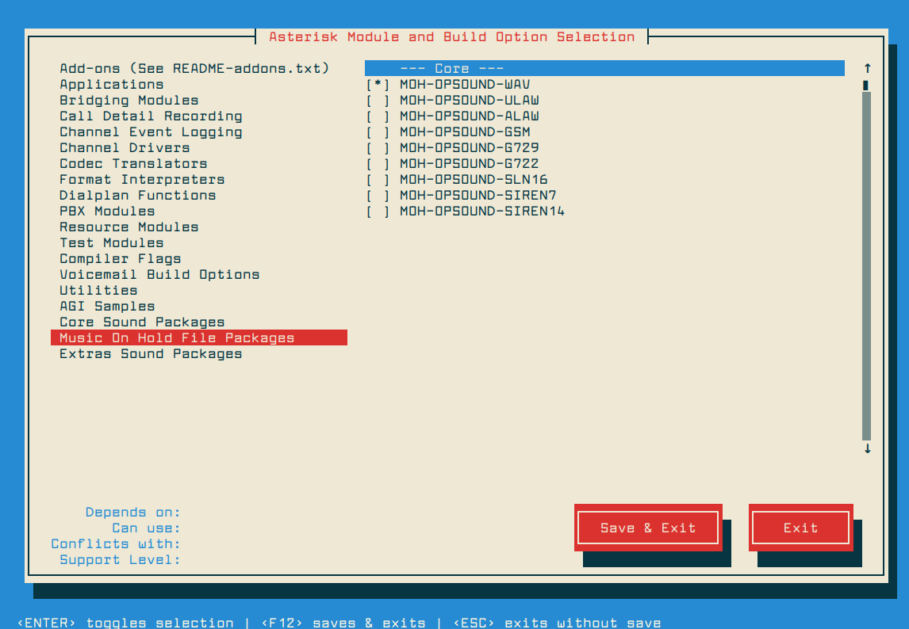

1. Make and install

$ make && sudo make install

1. Crear los ejemplos

$ sudo make samples

1. Configurar para que funcione desde el inicio del Sistema

$ sudo make config

1. Cambiar la propiedad de los archivos

$ sudo chown asterisk. /var/run/asterisk

$ sudo chown asterisk. -R /etc/asterisk

$ sudo chown asterisk. -R /var/{lib,log,spool}/asterisk

1. Probar la instalacion

$ sudo service asterisk start

$ sudo asterisk -rvv

Y se debe ver:

Asterisk 16.5.1, Copyright (C) 1999 - 2018, Digium, Inc. and others.

Created by Mark Spencer <markster@digium.com>

Asterisk comes with ABSOLUTELY NO WARRANTY; type 'core show warranty' for details.

This is free software, with components licensed under the GNU General Public

License version 2 and other licenses; you are welcome to redistribute it under

certain conditions. Type 'core show license' for details.

=========================================================================

Connected to Asterisk 16.5.1 currently running on centos8-tecmint (pid = 9020)

centos8-tecmint*CLI>

1. Ejecutar un comando de mostrar ayuda en el CLI

asterisk*CLI> core show help

1. Salir del CLI

asterisk*CLI> exit

1. Y listo, ya hemos instalado Asterisk