# Omnibus Questions

_______

|  |  |
| --- | --- |
| Project Piper’s Awareness |  |
| Fieldwork 8th – 9th January 2020 |  |
| Methodology Omnibus Online |  |
| Survey length <5 mins |  |
|  |  |

1. **W Which of the following brands have you heard about before today?brands have you heard about before today?**

(MULTICODE – ROTATE) SHOW LOGOS

1. Pipers Crips – Cheddar and Onion

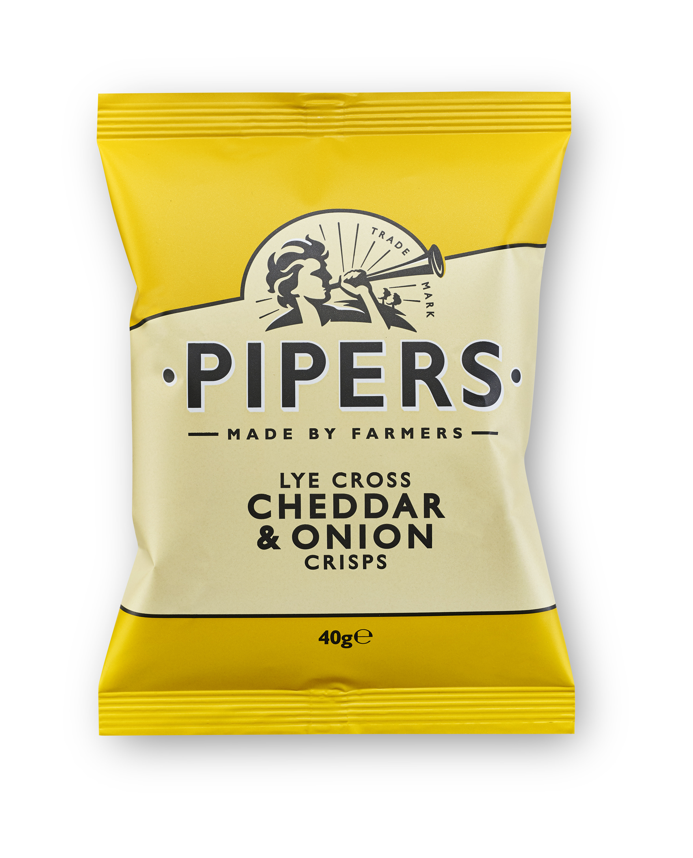

1. 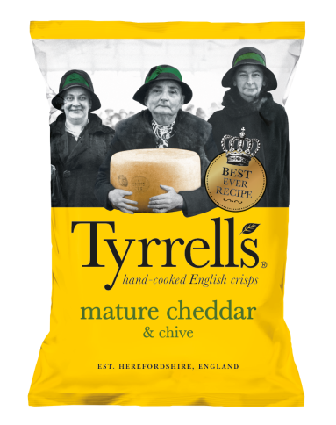Tyrells – Mature Cheddar and Chive
2. Kettle – Mature Cheddar and Red Onion

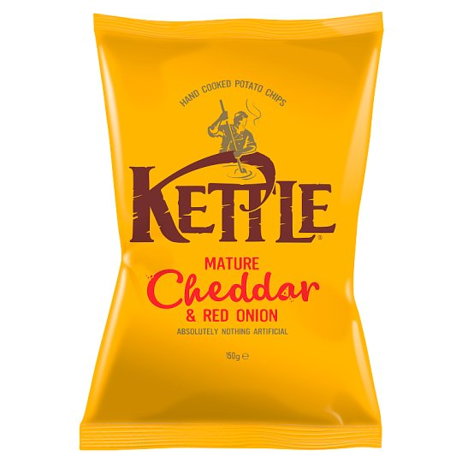

1. Real Crisps – Strong Cheese and Onion

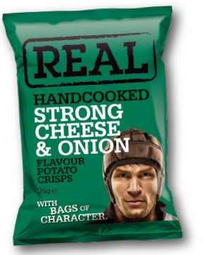

1. Corkers – Cheddar Cheese and Chive

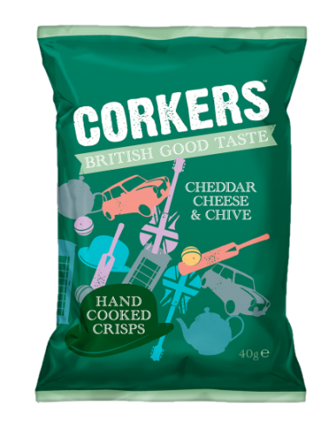

1. Burts – Mature Cheddar and Spring Onion

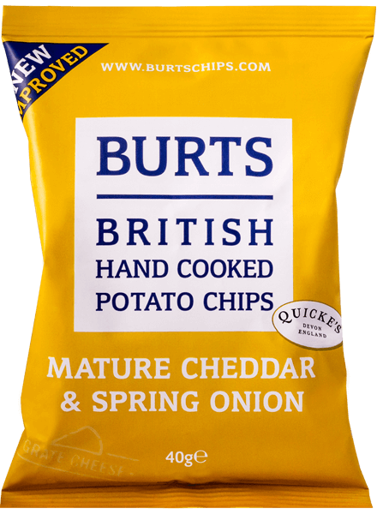

1. Ten Acre – Cheese and Onion

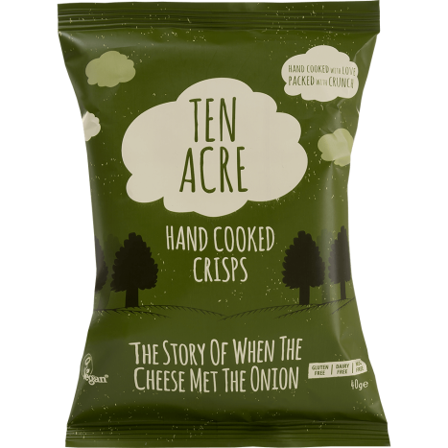

1. Fairfields – Cheese and Onion

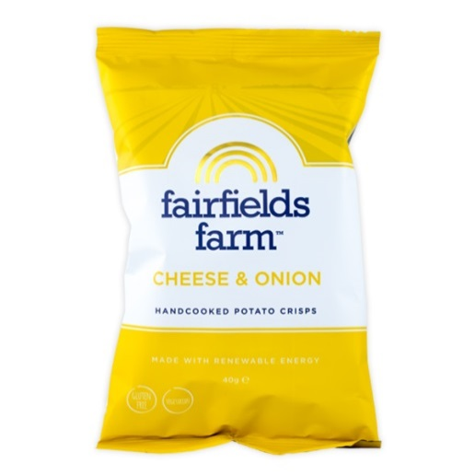

1. Walkers Sensations – Cheddar and Chutney

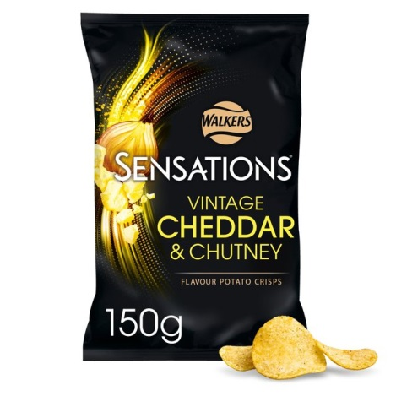

1. Salty Dog – Cheddar & Onion

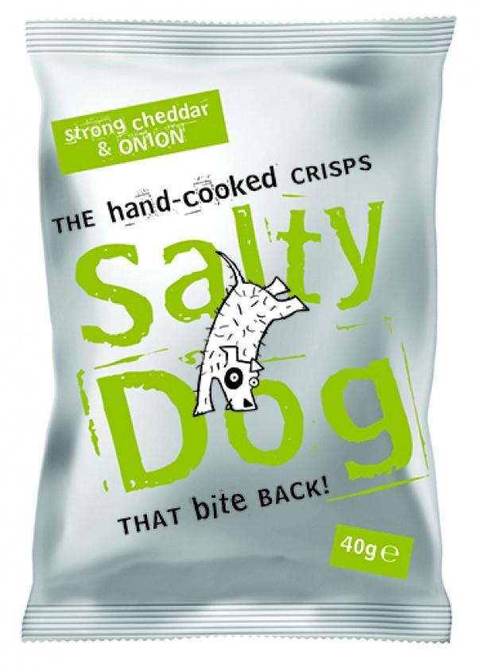

1. Brown Bag Crisps – Cheddar & Onion

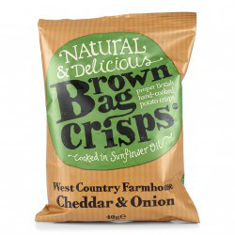

1. None of the above