BUSINESS CARD

Hi,
Thanks for purchasing this file! If you could rate it, that would make my day!
IF YOU SPOT THIS FILE ANYWHERE ELSE OTHER THEN WWW.GRAPHICRIVER.NET THEN CONTACT info@ansonika.com IMMEDIATELY!!
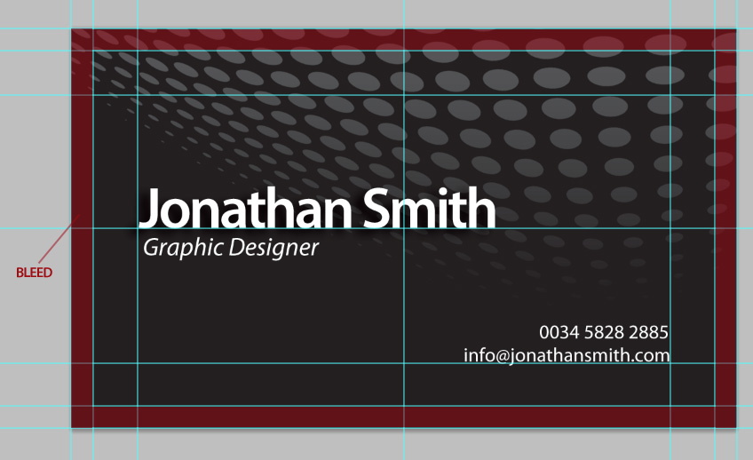
This business card is print ready, CMYK, 300DPI with bleed lines and guides included and enabled. To switch the guides on and off just hit ctrl+; (MAC: command+;). The card is dark based, with a rastered vector element above it; if you need the brush vector element in .eps format, contact me and I'll suddenly send you or help.
All text layers, including the background, the text are full type and can be edited with the click of a button. Back and front side included.

Font information:
Myriad Pro Semibold
Myriad Pro Regular
Myriad Pro Regular Italic

These can be obtained as part of the Adobe font folio.
Other sans serif fonts should work as well.

HOW TO EDIT
OPEN THE DESIRED FILE AND SIMPLY EDIT THE TEXT AS YOU NEED. THEN SAVE THE FILE FILE>SAVE AS … AND CHOOSE JPG HIGH QUALITY OR .TIF THAT IS BETTER.
CONTACT ME IF YOU NEED DIFFERENT SIZE

Contents:
card.psd layered containing both the front and back of the card with guides and bleed lines included @ 300dpi, CMYK.
Read me file

Thanks for purchasing!

Ansonika - Michele Motta
http://graphicriver.net/user/ansonika
info@ansonika.com - www.ansonika.com

