|  |  |
| --- | --- |
| **Practicum Case** |  |
| COMP6048 | COMP6048001 | COMP6048016 | COMP6048049  Data Structures |
| **Computer Science** | **O221-COMP6048-RZ01-01** |
| ***Valid on*** *Even Semester 2021/2022* | **Revision 00** |

**Learning Outcome**

* Explain the concept of data structures and its usage in Computer Science

**Topic**

* Session 1 - Pointer, Array, and Struct

## Subtopics

* Array of Struct Implementation
* Introduction to Pointer and Array
* Struct Declaration
* Struct Implementation

## Soal

*Case*

**BLUE Cake Shop**

**BLUE Cake Shop** is a small cake shop. Mr. Krauser, the manager of BLUE Cake Shop, wants to change the cashier system to be paperless. He needs a program that can handle his cake shop transaction. He asks you as a skillful programmer to make a program like this:

* The program always shows **a list of cakes** which contains **No**, **Cake Code**, **Cake Name**, **Available**, and **Price** of the available cakes.

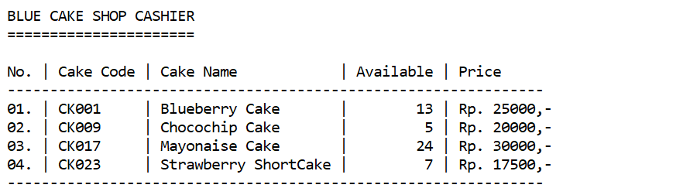

Figure 1. List of Cakes

* The program consists of 3 menus, there are:
  1. Sell
  2. Add Stock
  3. Exit
* If user chooses **Sell** (**Menu 1**), then:
* Ask user to input **cake code** he/she wants to sell**. Validate** the code must consist of **5 characters** and available in **the** **list of** **cakes**. If user inputs **the cake code** other than the one on the list, the program will show the message **“--- The Cake Code doesn’t exist ---”** and ask user to input again. The cake codeis **case-sensitive**.
* Then the program will ask user to input **the** **quantity**. **Validate** the quantity must be **between 0 and x**, where **x =** **[quantity of cake available]**. User cannot sell the cakes more than **the quantity** available on the list. If user tries to do so, show the message **“...The quantity of cake is not enough...”**.
* If user succeeds to sell, then show the **total price**.

|  |
| --- |
| **Total Price** = Rp [**price of cake**],- **x** [**quantity of sell**] = Rp [**total price**],- |

* After that, **subtract** the **available** cakes with the **quantity of cake** that **has been sold**.

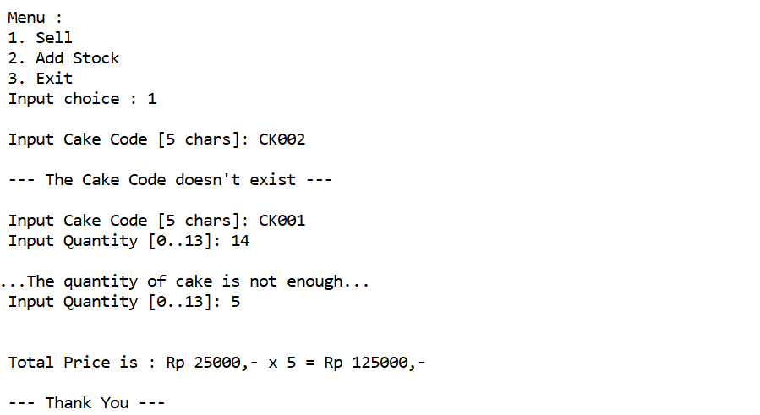

Figure 2. Sell Menu

* If user chooses **Add Stock** (**Menu 2**), then:
* Ask user to input **the** **cake code** he/she wants to add to the list. **Validate** the code must consist of **5 characters** and available in **the** **list of** **cakes**. If user inputs **the cake code** other than the one on the list, the program will show the message **“--- The Cake Code doesn’t exist ---”** and ask user to input again. The cake codeis **case-sensitive**.
* If the inputted cake code is **valid**, then ask user to input **the** **quantity**. Validate **the quantity of cake** must be **between 1 and 10**.
* If user succeeds to add stock, then show **“--- Adding Stock Success ---”**. Then add **the available cakes** with **the inputted quantity of cake**.

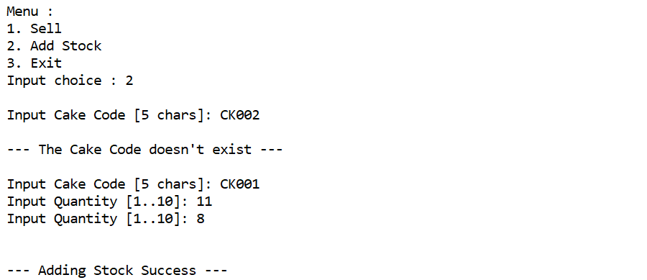

Figure 3. Add Stock Menu

* If user chooses **Exit**(**Menu 3**)**,** then the program will be terminated.

**Please run the EXE file to see the sample program**