1. Analyze daily news feeds in attempt to find patterns and correlate those with events happening in our society. This will serve as a base of further research I am planning on conducting at the end of the third class of the Data Science certification at UW.

2. Quiz 01b completed.

3. Data Flow Diagram (DFD) to support the description in Q1.

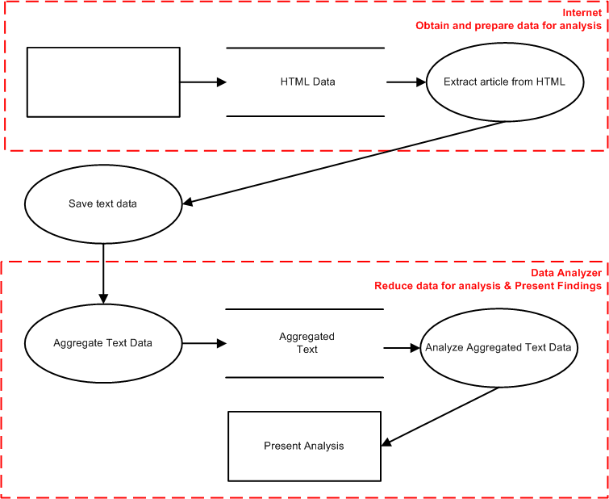

4. Screenshot of RStudio

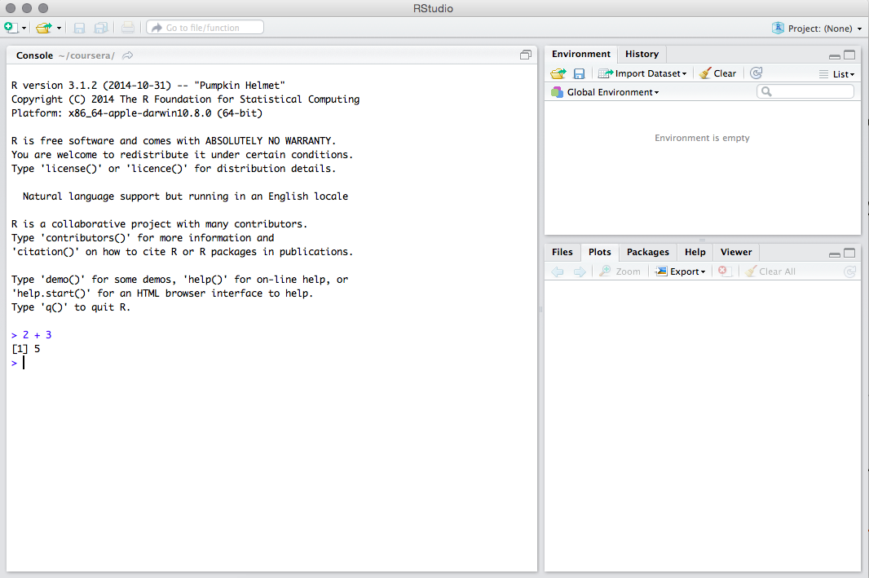

5. Screenshot of GNU Octave calculating 2 + 3.

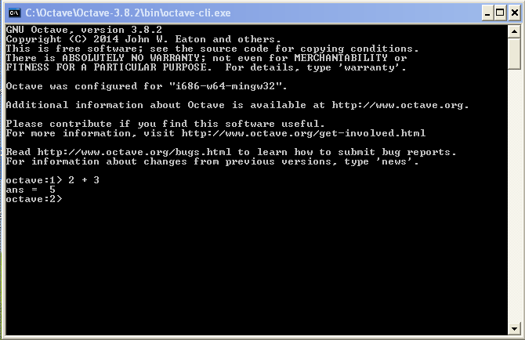

6. Virtual drive downloaded and unzipped

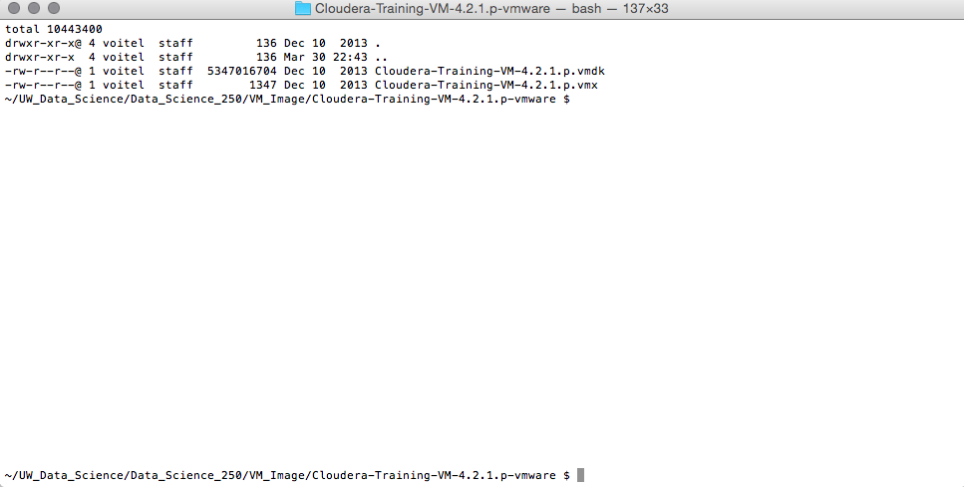

7. Baltimore City fixed speed cameras. Data set contains coordinates, intersections, and other attributes of location of fixed speed traffic cameras.

<https://data.baltimorecity.gov/api/views/dz54-2aru/rows.csv?accessType=DOWNLOAD>

8. LinkedIn group is joined (<https://www.linkedin.com/grp/home?gid=8269996>)