Model Selection

AMF

2/14/2021

## Slash pine Model Selection

SMA regression was used to determine the relationship between log(Age) and log(DBH).

## Call: smatr::sma(formula = log(slashpine$DIA) ~ log(slashpine$AGEDIA),   
## data = slashpine, method = "SMA")   
##   
## Fit using Standardized Major Axis   
##   
## ------------------------------------------------------------  
## Coefficients:  
## elevation slope  
## estimate 0.3440118 0.5783973  
## lower limit 0.2799281 0.5599690  
## upper limit 0.4080955 0.5974321  
##   
## H0 : variables uncorrelated  
## R-squared : 0.3770741   
## P-value : < 2.22e-16

## SMA regression line and residuals

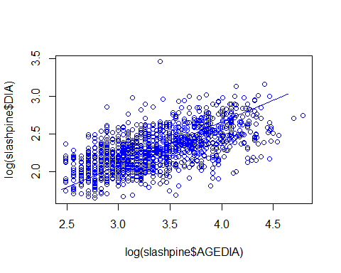 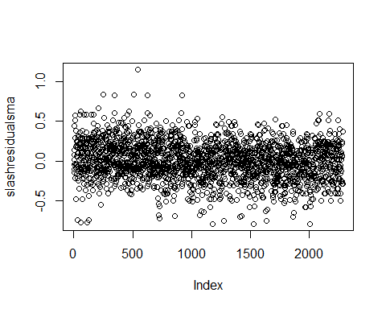

Int.model3 was selected based upon the following criteria: lowest predicted error sum of squares (PRESS), highest Adjusted R-squared, and lowest BIC score.

## Model PRESS Adj R-squared BIC  
## 1 full.model 117.2473 0.06016 -183.0376  
## 2 add.model 121.8596 0.06254 -174.4199  
## 3 notemp.model 122.7548 0.05519 -167.7221  
## 4 int.model2 121.7957 0.06339 -169.7606  
## 5 int.model3 116.8553 0.06364 -184.5131  
## 6 int.model4 117.4792 0.05821 -178.4704

This is the selected model and its coefficients.

##   
## Call:  
## lm(formula = slashresidualsma ~ ai_et0_NAD * SOILGRIDS_CN_SCALE +   
## slashpine$X30s_NAD, data = slashpine)  
##   
## Residuals:  
## Min 1Q Median 3Q Max   
## -0.81490 -0.14813 0.00403 0.15502 1.07311   
##   
## Coefficients:  
## Estimate Std. Error t value Pr(>|t|)   
## (Intercept) 1.759090 0.243248 7.232 6.55e-13 ***  
## ai_et0_NAD -1.374381 0.201575 -6.818 1.19e-11 ***  
## SOILGRIDS_CN_SCALE -0.009940 0.003129 -3.176 0.001512 **   
## slashpine$X30s_NAD -0.026373 0.007111 -3.709 0.000214 ***  
## ai_et0_NAD:SOILGRIDS_CN_SCALE 0.010618 0.003506 3.029 0.002485 **   
## ---  
## Signif. codes: 0 '***' 0.001 '**' 0.01 '*' 0.05 '.' 0.1 ' ' 1  
##   
## Residual standard error: 0.2299 on 2201 degrees of freedom  
## (80 observations deleted due to missingness)  
## Multiple R-squared: 0.06534, Adjusted R-squared: 0.06364   
## F-statistic: 38.46 on 4 and 2201 DF, p-value: < 2.2e-16

## Model Validation

Above-ground biomass (ABG) of 1 acre slash pine stands was simulated using individual-based growth and mortality model and compared to FIA remeasurement plots. 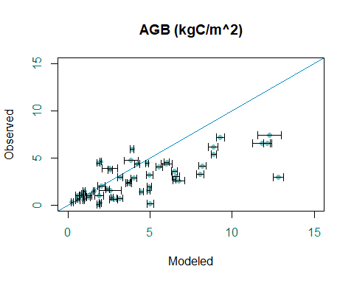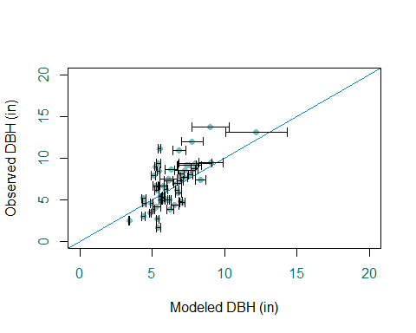

## Longleaf pine Model Selection

## Call: smatr::sma(formula = log(DIA) ~ log(AGEDIA), data = longleaf,   
## method = "SMA")   
##   
## Fit using Standardized Major Axis   
##   
## ------------------------------------------------------------  
## Coefficients:  
## elevation slope  
## estimate 0.2746847 0.5718692  
## lower limit 0.1565138 0.5415208  
## upper limit 0.3928557 0.6039184  
##   
## H0 : variables uncorrelated  
## R-squared : 0.4207783   
## P-value : < 2.22e-16

## SMA Model and Residuals

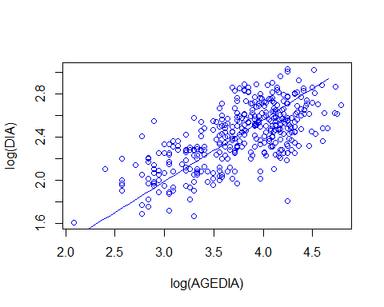 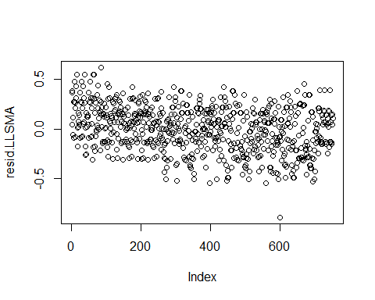

Int.model3 was selected based upon the following criteria: lowest predicted error sum of squares (PRESS), highest Adjusted R-squared, and lowest BIC score.

## Model PRESS Adj R-squared BIC  
## 1 full.model 35.60895 0.1145 -124.0053  
## 2 add.model 36.59297 0.07421 -117.941  
## 3 notemp.model 37.60718 0.0997 -102.5656  
## 4 int.model2 35.76112 0.1213 -130.626  
## 5 int.model3 34.99162 0.1306 -132.0229  
## 6 int.model4 35.77264 0.1106 -120.7723  
## 7 int.model5 36.35493 0.09551 -113.8396

This is the selected model and its coefficients.

##   
## Call:  
## lm(formula = resid.LLSMA ~ X30s_NAD + ai_et0_NAD * SOILGRIDS_CN_SCALE,   
## data = longleaf)  
##   
## Residuals:  
## Min 1Q Median 3Q Max   
## -0.87113 -0.15420 0.00179 0.16292 0.52278   
##   
## Coefficients:  
## Estimate Std. Error t value Pr(>|t|)   
## (Intercept) 3.810682 0.589630 6.463 1.86e-10 ***  
## X30s_NAD -0.078576 0.018543 -4.238 2.55e-05 ***  
## ai_et0_NAD -2.596493 0.344235 -7.543 1.35e-13 ***  
## SOILGRIDS_CN_SCALE -0.016985 0.004984 -3.408 0.000690 ***  
## ai_et0_NAD:SOILGRIDS_CN_SCALE 0.020275 0.005293 3.831 0.000139 ***  
## ---  
## Signif. codes: 0 '***' 0.001 '**' 0.01 '*' 0.05 '.' 0.1 ' ' 1  
##   
## Residual standard error: 0.2163 on 739 degrees of freedom  
## (8 observations deleted due to missingness)  
## Multiple R-squared: 0.1352, Adjusted R-squared: 0.1306   
## F-statistic: 28.89 on 4 and 739 DF, p-value: < 2.2e-16

## Model Diagnostics

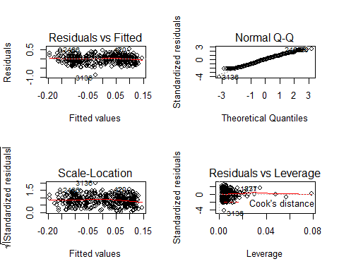

## Model Validation

Above-ground biomass (ABG) of 1 acre Longleaf pine stands was simulated using individual-based growth and mortality model and compared to FIA remeasurement plots. With probability of mortality by size class. 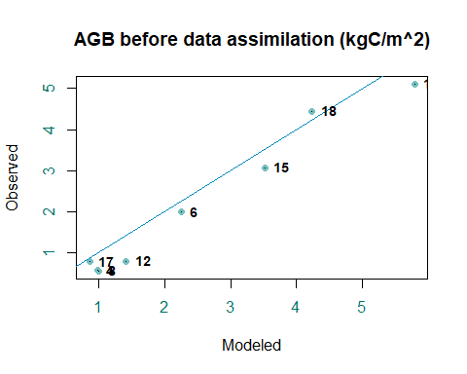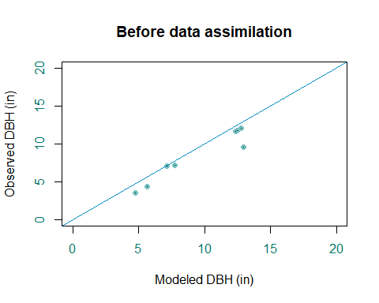 ## Longleaf after data assimilation Running 300 random parameter sets (after discarding burn-in) per site. Reporting site means with site sd

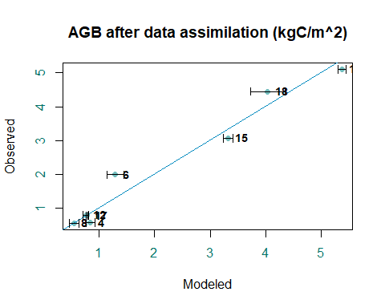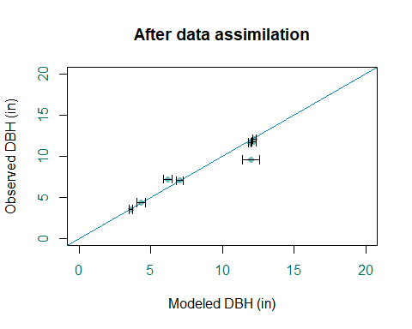 ## Model Validation Above-ground biomass (ABG) of 1 acre Longleaf pine stands was simulated using individual-based growth and mortality model and compared to FIA remeasurement plots. With continuous probability of mortality by size class. 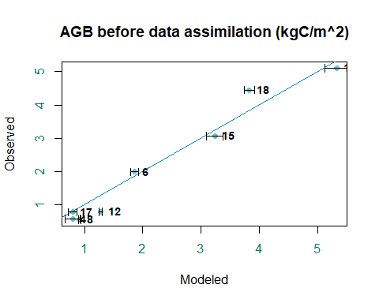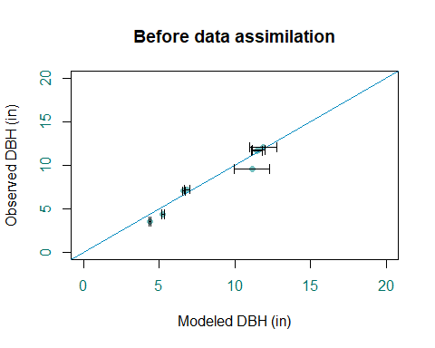

## Longleaf after data assimilation

Running 300 random parameter sets (after discarding burn-in) per site using >=mortality function and sd denominator 4. Reporting site means with site sd

