Tagging for Cost Allocation: Azure and AWS (KB Strawman)
Oct 22, 2026 · @Alfred Daluyaya
Draft v0.3 (strawman) for CLOUDCOE-17913. Phase 1 is Azure (this story). Phase 2 adds AWS and the Order Number management tool, drafted below for review. Links to CCoE wiki pages where they already exist. Items marked [CONFIRM] need a PG&E answer before this goes to the wiki. Azure is new at PG&E, so this page will change as the Azure setup and processes take shape. Check the change log at the bottom for what moved.

Purpose and audience
This guide shows teams how to keep cost tags current on Azure and AWS, so FinOps can split shared bills across the apps and teams that use them. On Azure, resource group tags are the key dependency for cost allocation inside a subscription.
It is for Azure subscription owners, AWS account owners, app teams, and FinOps practitioners. No deep Azure background is needed. Read the next section first if Azure is new to you.

Azure basics in two minutes
We tag at the resource group level. Cost data then reads each resource's owner from its resource group.
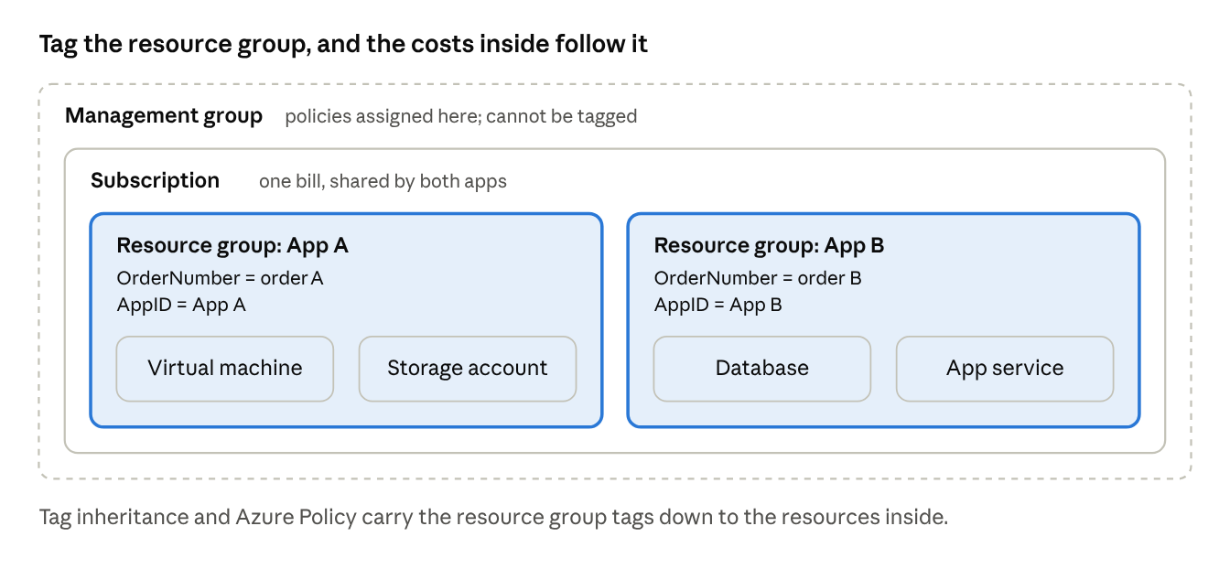
Azure hierarchy · where tags live
- Subscription: the billing container. Azure sends one bill per subscription.
- Resource group: a folder for the resources of one app or team. This is where we tag.
- Resource: one thing that costs money, such as a VM, database, or storage account.
- Tag: a name and value label, such as Environment = prod. Subscriptions, resource groups, and resources can be tagged. Management groups cannot.

Why tags matter
An Azure subscription or AWS account bill is one number. When several apps or teams share it, that number cannot say who spent what. Tags fix that.
FinOps groups cost by tag value, such as order number or app ID. Cost with a valid tag goes straight to its owner. Cost with no tag, or a wrong one, lands in a shared pool and is spread across everyone.
So good tags mean your showback is your actual spend. Missing tags mean you pay part of someone else's bill, and they pay part of yours.

Required tags
The same tags apply on both clouds: every Azure resource group and every AWS resource carries the tags below. Tag names and allowed values are [CONFIRM] against the PG&E tag standard; this table links to that standard once we have it. PG&E's Azure Terraform modules (azr/modules in the pge-terraform-modules repo) already validate approved AppID and order number combinations, so the module code is the first place to confirm tag names.
Tag name [CONFIRM] | What it holds | Example value | Used for
OrderNumber | The order number (charge code) that pays for this work | <order number> | Chargeback
AppID | The PG&E application ID | APP-XXXX | Showback by app
Environment | Where it runs | dev, test, prod | Split dev and prod spend
Owner | Team or person accountable for the spend | finops-team | Who to ask about a cost
Rules that apply to every tag:
- Use the exact tag names above. Names are not case-sensitive, but values are, so Prod and prod report as two groups.
- Put one value per tag. No lists, no free text.
- Never put sensitive data in a tag. Tags show up in cost reports, logs, and exported templates.
- A resource group can hold at most 50 tags.

Azure: add or update tags on a resource group
Use the same tool that created the resource group. If Terraform built it, change the tags in Terraform. A tag added by hand in the portal is wiped out on the next Terraform apply.
Terraform (preferred for anything deployed through Terraform Cloud)
Add or edit the tags block on the resource group, open a pull request, and let the normal plan and apply run.
resource "azurerm_resource_group" "app" {
name = "rg-myapp-dev"
location = "westus2"
tags = {
OrderNumber = "<order number>"
AppID = "APP-XXXX"
Environment = "dev"
Owner = "finops-team"
}
}
Azure portal (resource groups not managed by Terraform)
- Open Resource groups and select the resource group.
- Select Tags in the left menu.
- Add each required tag name and value.
- Select Apply.
Azure CLI (bulk updates or scripting)
The Merge operation adds or updates the tags you name and leaves the others alone.
RG_ID=$(az group show --name rg-myapp-dev --query id -o tsv)
az tag update --resource-id "$RG_ID" --operation Merge \
--tags OrderNumber=<order number> AppID=APP-XXXX Environment=dev Owner=finops-team

Azure: keep tags maintained
Tagging the resource group is not enough on its own. By default, Azure does not copy resource group tags onto the resources inside it, so their cost can show up untagged. Three controls close that gap.
Control | What it does | Who sets it up | PG&E status
Cost Management tag inheritance | Stamps subscription and resource group tags onto the cost records of every resource inside. Touches cost data only, not the resources. | Billing or subscription admin | [CONFIRM]
Azure Policy: require a tag on resource groups | Blocks a new resource group that is missing a required tag | Cloud platform team | [CONFIRM]
Azure Policy: inherit a tag from the resource group if missing | Copies the resource group's tag onto new or updated resources. A remediation task fixes existing ones. | Cloud platform team | [CONFIRM]
Tag inheritance is the fastest win for cost reporting. Once on, it updates the current month's cost records within about 8 to 24 hours. Earlier months are not rewritten.
What subscription owners do:
- Tag every new resource group before deploying into it. When you start allocating by resource group tags, email cloudenablement-finops@pge.com so FinOps picks up the right tag.
- Update tags the same day an owner, app, or order number changes.
- Check untagged spend once a month (next section) and fix anything new. Review cadence and fix window are [CONFIRM].

Azure: check it worked
If tagging is working, the untagged slice of your subscription's cost is small and shrinking.
- In the Azure portal, open Cost Management and select Cost analysis.
- Set the scope to your subscription.
- Group by tag and pick a required tag, such as OrderNumber.
- Look at the untagged group. Open it and group by resource group to see which ones need fixing.
- Repeat for each required tag.
Allow up to a day after a tag change before it shows in cost data. At PG&E, FinOps views Azure cost in Flexera Cloud Cost Management, which is moving to Power BI in late Q4 2026 or early Q1 2027.

Phase 2 draft — AWS: add, maintain, and check tags
AWS has no resource group layer for billing, so tags go on each resource. A tag shows up in cost reports only after two steps: the resource is tagged, and the tag key is activated as a cost allocation tag in the management (payer) account.
Terraform (preferred for anything deployed through Terraform Cloud)
Set default_tags on the AWS provider. Every resource in that configuration then gets the tags, so nothing is missed.
provider "aws" {
region = "us-west-2"
default_tags {
tags = {
OrderNumber = "<order number>"
AppID = "APP-XXXX"
Environment = "dev"
Owner = "finops-team"
}
}
}
AWS console (resources not managed by Terraform)
Open Resource Groups & Tag Editor, then Tag Editor. Search your account and region for resources, select them, and add or edit tags in bulk.
Keeping tags maintained
Control | What it does | Who sets it up | PG&E status
Cost allocation tag activation | Makes a tag key usable in Cost Explorer and cost reports. Only the management account can do this. Takes up to 24 hours. | Management account admin | [CONFIRM]
Cost allocation tag backfill | Applies activated tags to up to 12 months of past cost, where the resource was already tagged | Management account admin | [CONFIRM]
AWS Organizations tag policy | Keeps tag key spelling and allowed values consistent across accounts | Cloud platform team | [CONFIRM]
Check it worked
Open Cost Explorer, group by tag, and pick OrderNumber. The untagged slice shows which spend still needs a tag. Repeat for each required tag.

Phase 2 draft — Order Number management tool
The OrderNumber tag must match an active order number in the Order Number management tool. When an order number changes or closes, update the tool first, then update the tag on Azure and AWS to match.
To change the order number your cloud costs are charged to, email cloudenablement-finops@pge.com. FinOps does not accept allocation changes by Teams chat or verbally. Steps for the Order Number management tool itself: [link to add] [CONFIRM].
To confirm before v1.0:
- Who can update an order number in the tool?
- Does the tool push tags to Azure and AWS, or only record the order number?
- What happens to spend tagged with a closed order number?

Common pitfalls
- Tags added in the portal disappear. The resource group is managed by Terraform. Change the tags in code instead.
- Two groups for one team. A value is spelled two ways, such as Prod and prod. Pick one spelling and fix the other.
- Old months still show untagged. Tags and tag inheritance apply going forward, not to past months.
- One resource group, two owners. A resource group can carry only one value per tag. Split it into two resource groups, one per owner.
- Some resources don't take tags. A few Azure resource types do not support tags. Tag inheritance covers their cost records.

Open questions
These need an answer before v1.0 goes on the wiki.
- ☐ Is there an approved PG&E tag standard (names and allowed values)? Link it here instead of redefining it.
- ☐ Is Cost Management tag inheritance turned on for PG&E's Azure billing account or subscriptions?
- ☐ Which Azure Policy tag rules are already assigned, and at what scope?
- ☐ Who owns tag policy for Azure (cloud platform team or FinOps)?
- ☐ Is Flexera or Power BI the Azure cost view when this goes live?
- ☐ What review cadence and fix window do we ask of subscription owners?
- ☐ Are AWS cost allocation tags for our required keys activated in the management (payer) account?
- ☐ Is there an AWS Organizations tag policy for these keys?
- ☐ How does a team update an order number in the Order Number management tool, and does the tool push tags to Azure and AWS or only record them?

Related CCoE wiki pages
This KB links out instead of repeating what the CCoE wiki already covers. Links to add [CONFIRM]:
- PG&E tag standard
- Order Number management tool guide
- Azure Front Door & Subscription Vending (Azure subscription requests)
- AWS account request process
- FinOps for AI and Public Cloud (AWS and Azure): FinOps hub page and FAQ
- Azure Landing Zone: Commercial Cloud COE
- Azure Terraform Workspace creation

Change log
Version | Date | Change
v0.1 | Oct 22, 2026 | Strawman for CLOUDCOE-17913
v0.2 | Oct 22, 2026 | Scope widened per Bridget: AWS and the Order Number management tool added; links to CCoE wiki
v0.3 | Oct 22, 2026 | Added PG&E facts from the CCoE wiki: Flexera cost view, email FinOps when allocating by tag, order number change process, Terraform module validation, related page names

Sources
- Use tags to organize your Azure resources (Microsoft Learn)
- Group and allocate costs using tag inheritance (Microsoft Learn)
- Introduction to cost allocation (Microsoft Learn)
- Azure Policy pattern: tags (Microsoft Learn)
- Tutorial: Create and manage policies (Microsoft Learn)
- Backfill cost allocation tags (AWS docs)
- AWS Cost Allocation Tags now support retroactive application (AWS, Mar 2024)
- Cost allocation tags are managed at the payer account level (AWS re:Post)

