CLOUD AND AI FINOPS SERVICES

Cloud FinOps Platform High-Level Architecture
Item | Detail
Document owner | Alfred Daluyaya, FinOps Engineer (seller)
Version / status | v0.9 · Draft for discussion

1. Purpose and scope 2
2. Architecture principles 2
3. Target architecture overview 3
Figure 1. FinOps target architecture 4
3.1 Ingest 5
3.2 FinOps landing zone 5
3.3 Data product and reporting 5
3.4 Operate 5
3.5 Foundation 6
4. Optimization capability 6
4.1 Why it matters 6
4.2 Lifecycle 6
Figure 2. FinOps Optimization engine 8
4.3 Policies 9
4.4 Shared services 9
4.5 Exception model 10
4.6 Selection and enrollment 10
4.7 Optimization data model 11
4.8 Candidate lifecycle 12
4.9 AI seat policies 13
4.10 Optimization Center: the owner control plane 13
Figure 3. Optimization data model 14
Figure 4. Candidate lifecycle 15
Figure 5. Optimization Center 16
5. Double-click: shutdown automation 17
6. Ownership boundaries 18
7. Key design decisions 18
8. Phased roadmap 19
9. Glossary 19

1. Purpose and scope
This document describes the target high-level architecture for the CCOE Cloud FinOps platform.
In scope: the web app and its modules, order # update for chargeback, budgets and alerting, optimization, exception handling, notification, the data products and reporting, environments, and ownership boundaries with shared platforms.

2. Architecture principles
# | Principle | What it means
P1 | One capability, one owner | FinOps owns FinOps logic: allocation, chargeback rules, budgets, order numbers, exceptions and optimization policy. Same model as Finance owning its close process on SAP.
P2 | Build only the FinOps capability layer | Consume approved enterprise platforms (AWS, Azure, Portkey, Snowflake, Terraform Cloud, identity). Don't rebuild them.
P3 | Land once, use many | Every source lands once in the FinOps landing zone (S3 bucket). The FinOps data products and Operate both read from it.
P4 | Same contract per source | Each source has an adapter that writes the same output shape, partitioning and run manifest.
P5 | Same lifecycle per FinOps optimization capability | Every optimization policy runs identify, schedule, notify, opt-out, release.
P6 | One front door | People reach FinOps through one web app and look things up the way they already do: by AppID, LAN ID or order.
P7 | Metadata, not content | Exports collect usage metadata only. No sensitive payloads.
P8 | Opt-out by default | FinOps Optimization actions run unless the owner files an exception. Business Owner and app team will have the opportunity to review and opt-out. Exceptions carry a reason and expire.
P9 | Log every action | Every automated optimization action and its savings is recorded so realized savings can be reported.
P10 | Conservative by default | Long notice, repeated visibility and a reversible first step. An escalation caused by an unexpected shutdown or resize costs more than the savings, so when in doubt, FinOps doesn't act.

3. Target architecture overview
The FinOps capability has three lanes. Figure 1 on the next page shows the whole picture.
Lane | Question it answers | Main components
1 · Ingest | What was used? | Source adapters, FinOps S3 landing zone
2 · Data product & reporting (Data & Insights) | What happened? | FinOps data product (Snowflake silver → gold), reporting in Power BI, chargeback file to finance, forecasts and anomaly scores
3 · Operate | What do we do about it? | My PG&E FinOps web app (order # update, budgets, Optimization Center, exceptions), FinOps app DB, optimization engine, exception handling, FinOps notification service
Foundation | Where does it run? | FinOps dev → test → prod environment under APP-3967, Terraform Cloud, enterprise identity

Figure 1. FinOps target architecture
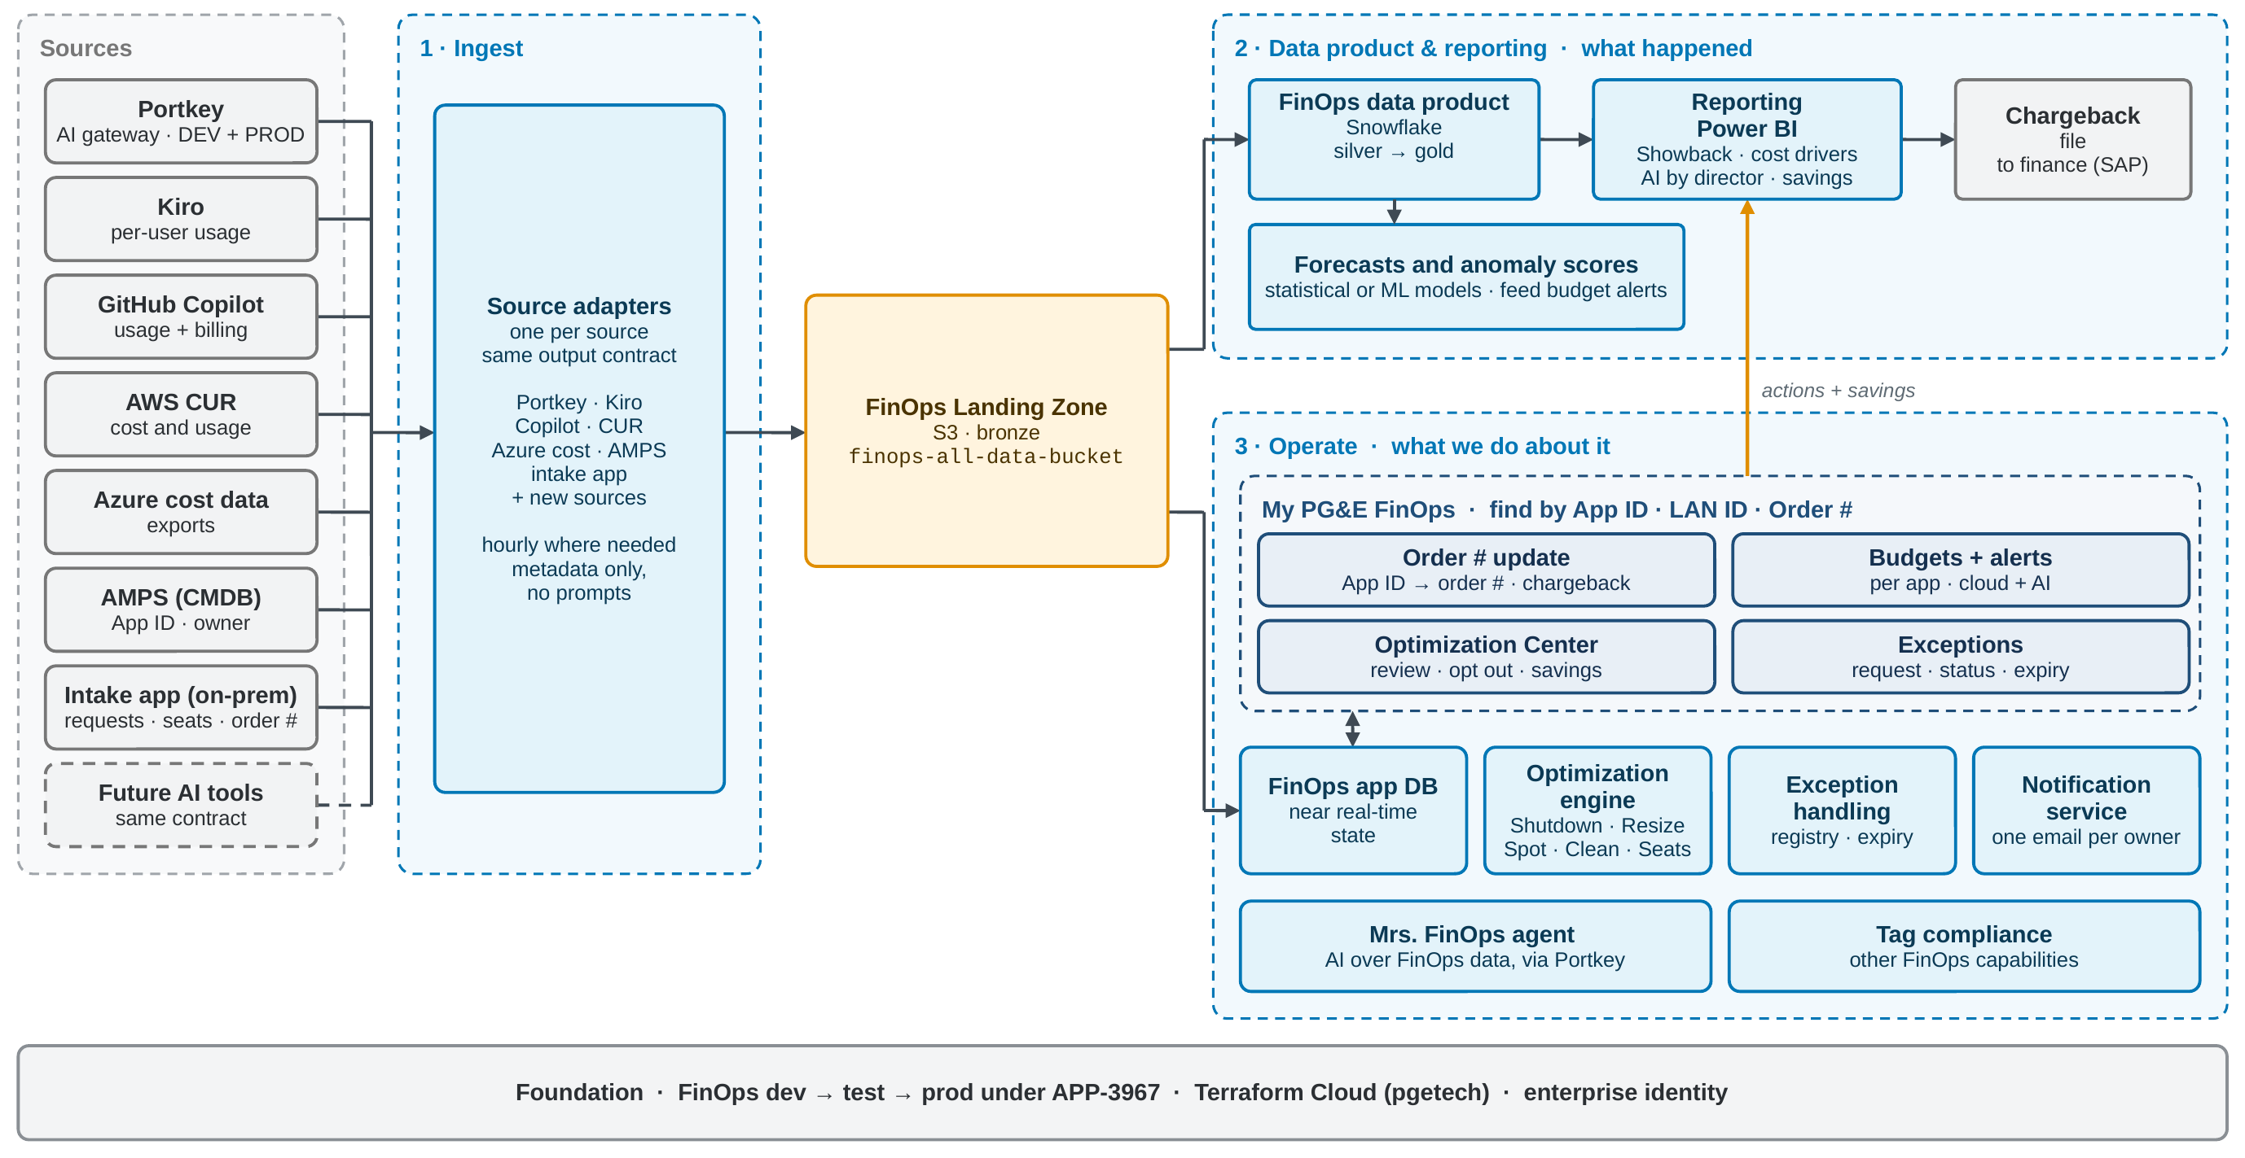

3.1 Ingest
Ingest collects usage and cost data from each source through an adapter. Each adapter:
- pulls from one source (Portkey DEV and PROD, Kiro, GitHub Copilot, AWS CUR, Azure cost data, AMPS reference data such as App IDs and owners, the on-prem intake app, and future AI tools);
- writes the same output contract: dataset layout, partitioning;
- runs on a schedule, hourly where cost can grow quickly.
- uses read-only credentials per environment and collects metadata only.
Adding a source means adding an adapter, not a new pipeline. The AI Consumption Data Export (Portkey first, then Kiro and Copilot) is the first set of adapters.
Intake app data. Intake is not a FinOps capability. The existing on-prem .NET intake app (CloudAutomation) is where people request access to tools such as GitHub Copilot, Kiro and Portkey, and it stays the system of record for those requests. FinOps only reads its data. FinOps lands a daily copy of requests, approvals and seat assignments, each with requester, App ID and order #, under intake/requests and intake/seats. That data is what ties a per-seat AI tool to a person and an order # for chargeback. Usage itself still comes from each tool's own adapter (the GitHub and Kiro exports), not through the intake app.
AMPS reference data. AMPS (Asset Management Platform and Services), PG&E's CMDB, holds App IDs and, for each platform or group, its IT SME, IT SME backup and FinOps practitioner.

3.2 FinOps landing zone
The landing zone is the bronze layer of the FinOps data product and the source of truth for raw usage data.
- Storage: S3, starting with the existing dev bucket dev-finops-all-data-bucket, with a folder per source (portkey, kiro, github, and so on).
- Layout: source/dataset/dt=YYYY-MM-DD/hr=HH.
- Read by the data product (into Snowflake) and by Operate (into the FinOps app DB).

3.3 Data product and reporting
- FinOps data product: landed data refined in Snowflake from silver (cleaned) to gold (business-ready, governed datasets).
- Reporting: Power BI reports in four families: showback and chargeback; cost drivers, meaning the biggest spenders such as VMs and disks; AI spend by director, including tokenomics and ROI; and savings, realized and forecast.
- Chargeback: the monthly file to finance (SAP).
- Forecasts: models read the landing zone and gold data and publish spend forecasts (by AppID, order # and budget). Models can be statistical or machine learning.
Reporting points optimization at what matters. Cost drivers show where the money goes, so they set the optimization priorities: VMs are the target of Shutdown and Resize, and disks the target of Clean. Savings reporting then shows whether it worked.

3.4 Operate
Operate is the transactional side of FinOps, where people and automation act on the data. It has two layers: the web app modules people use, and the shared services behind them.
Web app module | What it does
Order # update for Chargeback | A small mapping app, used for chargeback only. The IT SME or backup for an App ID sets the order # that App ID is charged to, and updates it when the order changes. Each change records who, when and the date it takes effect, so history is kept. The monthly chargeback file reads the mapping, and a missing or closed order # gets a notice before the file is built.
Budgets + alerts | Budget per App ID across AWS, Azure and AI tools, with threshold alerts and forecast-based alerts (forecasts from 3.3), sent through the notification service.
Optimization Center | The owner control plane: every upcoming optimization action for the owner's AppIDs, order #s or LAN ID, across all policies, with opt-out, approvals, history and savings (4.10).
Exceptions | Request an exception with a reason, see its status and expiry.

Shared service | Role
FinOps app DB | Operational state for the modules: the order # mapping, budgets, schedules, exceptions. Kept separate from Snowflake because apps need near real-time reads and writes.
Optimization engine | Runs the optimization policies in priority order: Shutdown and AI seat reclaim and right-size first, then Resize, Spot and Clean (section 4).
Exception handling | One exception registry for all policies (optimization today; budgets and tag compliance can reuse it). Every exception has a reason, an owner and an expiry date.
Notification service | One service for all FinOps notices: spend and budget alerts, missing or closed order #s before the chargeback file, and optimization notices. Every notice links back to the Optimization Center.
Other capabilities | Mrs. FinOps agent over FinOps data through Portkey; tag compliance.

3.5 Foundation
- Environments: FinOps dev → test → prod under APP-3967 (Cloud And AI FinOps Services).
- Deployment: Terraform Cloud in the pgetech org, with workspaces registered through pge-tfc-workspaces and code in pgetech GitHub repos.
- Identity: enterprise sign-in for the web app.

4. Optimization capability

4.1 Why it matters
Showback and chargeback tell people what they spent. Optimization acts on it, and it's where FinOps produces savings directly. Every optimization follows the same pattern: find candidates, schedule the action, tell the app owner, give them a window to opt out, then hand the remaining list to the tool that does the work. Building the pattern once lets FinOps add policies without building new apps.

4.2 Lifecycle
Stage | What happens | Owned by
1 Identify | A daily job applies each policy's rules to inventory, usage, tags and rightsizing recommendations to find candidates. | FinOps
2 Schedule | Each candidate is written to the optimization schedule with App ID, owner, action and action date. | FinOps
3 Notify | The action appears in the owner's FinOps email with a countdown until its date, linking to the Optimization Center (4.10). | FinOps
4 Opt-out window | The owner reviews the action in the Optimization Center and can file an exception with a reason. An exclusion job marks the resource exempt. | App owner, FinOps
5 Release | On the action date, the remaining list (minus exemptions) is handed to the executor. | FinOps
6 Execute | The executor performs the action. | Executor
7 Record | The outcome and savings are logged back to the landing zone for reporting. | FinOps

Figure 2. FinOps Optimization engine
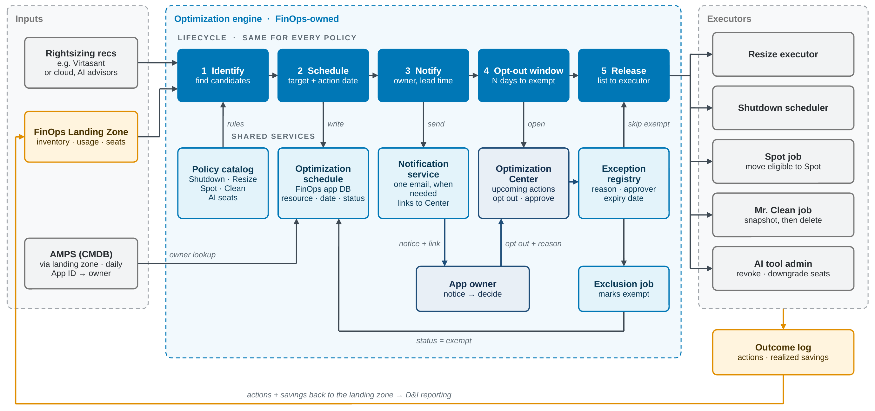
FinOps owns the policy, schedule, notice and exception. Executors only see the released list. Shutdown is detailed in section 5.

4.3 Policies
Policies are listed in priority order. Shutdown already has a story (CLOUDCOE-18928) and the AI seat data is already being exported, so they come first; Resize, Spot and Clean follow once owners know the program. Notice periods are deliberately long and are proposed starting points to confirm with the product owners.
Policy | What it finds | Executor | Owner notice | Typical exception
Shutdown | Non-prod VMs that can be off nights and weekends | Shutdown runners (section 5) | 60 days before the first shutdown schedule | Overnight batch or test runs
Seat reclaim | AI tool seats (Copilot, Kiro) unused for 45 days, or held by someone who left or changed roles | Tool admin API or console | Leavers: none, manager informed. Inactive: in the FinOps email when flagged, revoke after 30 more days | Planned leave, ramp-up after onboarding
Seat right-size | Premium seats (e.g. Kiro Power, $200/month) used at a lower tier's level | Tool admin API or console | 30 days before the downgrade | Work that needs the higher tier's limits
Resize | Over-provisioned VMs, from rightsizing recommendations | Resize executor (e.g. Virtasant) | 45 days before the resize date | Peak-season sizing, vendor-certified size
Spot | Interruption-tolerant workloads on on-demand | Spot job | 45 days before the move | Stateful, or can't take an interruption
Clean (Mr. Clean) | Unattached disks, old snapshots, idle IPs, orphaned resources | Mr. Clean job, snapshot first | 90 days, with countdown emails before delete | Held for audit, DR or a planned rebuild

Staying conservative. Utilities and other large enterprises are careful with shutdowns and resizing, and an escalation is never worth the savings. Every policy therefore follows the same safety rules:
- Long notice, without email overload: 30 to 90 days depending on the policy. There is no fixed email schedule: the FinOps email goes out only when something changes or comes due (an action enters its notice window, and again 30, 14, 7 and 1 days before it happens), combined into one email and never more than one a day. When nothing is new, nothing is sent. The IT SME and IT SME backup in AMPS receive it, with the group's FinOps practitioner copied.
- Critical apps excluded: apps marked critical or high availability in AMPS are excluded in every environment, including non-prod, unless the owner opts in (4.6).
- Reversible first: Clean takes a snapshot and stops or detaches first, and deletes only after a further hold period. Resize and Spot keep the previous configuration so they can be rolled back.
- Quiet periods: no actions during PG&E change freezes or emergency operations; actions due in those periods move to the next open window.
- Start small: each policy starts as a pilot on opt-in resources before anything is enrolled by default.

4.4 Shared services
- Policy catalog: the rules for each policy, such as thresholds, scope and notice period.
- Optimization schedule: the target list in the FinOps app DB, with resource, App ID, owner, action, date and status.
- Notification service: sends one consolidated FinOps email, only when something changes or comes due and at most one a day, plus failure alerts to FinOps.
- Optimization Center: the owner control plane in My PG&E FinOps (4.10).
- Exception registry and exclusion job: approved exceptions, and the job that marks resources exempt.
- Outcome log: actions taken and realized savings, written back to the landing zone.

4.5 Exception model
- An exception applies to one resource and one policy. Being exempt from Shutdown doesn't make a resource exempt from Clean.
- Each exception records the resource, App ID, policy, reason, requester (LAN ID), approver if one is required, start date and expiry date. Approvals happen in Approval Central (4.10).
- Expiring exceptions trigger a review notice, the same way order numbers are reviewed before they expire.
- Executors only receive the released list. Tag-aware executors can also honor an exempt tag that the exclusion job sets on the resource.

4.6 Selection and enrollment
Choosing which resources are in scope is the most important step in every policy. Each policy answers two separate questions:
- Eligibility: can this resource be acted on at all? Guardrails decide this (for example: non-prod only, not part of a scale group, has an owner, and its app is not marked critical or high availability in AMPS, even in non-prod). FinOps and the cloud admin team own these rules.
- Enrollment: is it in, and on which schedule? Ordered selection rules decide this.
Selection rules are kept per policy and evaluated in priority order. Each rule filters on cloud, account or subscription, resource group, environment, App ID, tag, name pattern, size or usage, and either enrolls the resource (with a schedule) or marks it never. A never rule always wins. The selection job re-evaluates every day and writes the result to the candidate list, recording which rule matched and how the resource was enrolled (rule, owner choice or tag).
The FinOps app DB is the master record. Tags are one input to the rules and can be mirrored back onto the resource for visibility, but they are not the only switch, because tag quality is still being improved (CLOUDCOE-17913). Pilots run opt-in (owners choose); at scale, eligible resources are enrolled by default and owners opt out through an exception.
Owner opt-in. Owners can also volunteer savings the rules didn't catch. In the Optimization Center they pick a resource or seat for their AppID and choose an action (add a shutdown window, request a resize, mark for cleanup, release a seat). The request becomes a candidate with enrolled_by = owner and its details in action_params. Guardrails still apply, but the notice period can be short because the owner asked, and the savings are credited to their app. Owners can also suggest a new rule, such as "all our -dev VMs can stop at night", which FinOps reviews and adds for everyone.
The same engine serves Spot with different rules: eligibility there means stateless, interruption-tolerant and managed by a scale group.
Prior art
Tool | How it selects resources | What we take from it
ParkMyCloud | Policy engine assigns schedules by name, tag or team; team-based access; SmartParking suggests schedules from usage; schedule override | Rules plus owner self-service. Its features are moving into IBM Turbonomic
IBM Turbonomic parking | Inventory of parkable VMs; policies scoped by cloud, account or Azure resource group with regex and tag filters, including an Unparkable rule; precedence levels; scope re-evaluated every 10 minutes | Separate eligibility from schedules; keep an explicit never rule
AWS Instance Scheduler | Instances carry the scheduler's tag; cross-account roles; EC2 and RDS | Simple tag enrollment, but no owner notice or exception flow
Azure Start/Stop VMs v2 | Scope by subscription, resource group (with exclusions) or VM list | In maintenance mode; don't build on it
Earlier custom Azure job | Tag-based selection (details to confirm with Scott) | Reuse tag conventions owners already know

4.7 Optimization data model
Figure 3 shows the transactional tables in the FinOps app DB. The shared core (application, person, cloud account, resource) is reused by every web app module, including budgets. The order # mapping (app_order_map) sits beside it: one active order # per App ID, with history, read by chargeback and by the App ID, LAN ID or order # lookup, and never by an optimization policy. Application and owner data come from AMPS, PG&E's CMDB; resources come from cloud inventory in the landing zone, joined to AMPS by App ID. The optimization tables are shared by every policy, VM or AI seat, so new policies reuse them and only the rules change.
Table | Holds | Written by
application, person | Reference data: App IDs, IT SME, IT SME backup and FinOps practitioner, app criticality | Sync from AMPS (the CMDB): LAN ID from the backend field (or parsed from "Last, First (LAN ID)"); email from AMPS or, by LAN ID, the enterprise directory
app_order_map | App ID to order # for chargeback: the order #, the dates it applies, and who changed it | Owners, in the Order # update module
cloud_account | Every AWS account and Azure subscription, with environment and in-scope flag | Sync; scope approved by the cloud admin team
resource | Everything a policy can act on: VMs across AWS and Azure, and AI tool seats, with owner keys and price | Inventory and seat sync from the landing zone
policy, schedule, selection_rule | What each policy does and how (action mode: auto, notify or approve), the standard windows, and the ordered rules | FinOps admins
optimization_candidate | The candidate list: one row per resource per policy, with status, matched rule or owner opt-in, schedule, next action and estimated savings | Selection job; runner; owner actions
candidate_event | Every status change, with who and when | Selection job; runner; owner actions
optimization_exception | Opt-outs with reason, approver and expiry | Owners (request); FinOps (approve)
action_log | Every stop, start and deallocate, with result, hours off and savings | Runners
notification | Every FinOps email and alert sent | Notification service

4.8 Candidate lifecycle
Figure 4 shows how a resource moves through the candidate list. Nothing is acted on before effective_from, which is the first notice plus the policy's notice period, so owners are never surprised even when a new rule brings in many resources at once.
Status | Meaning | Set by
identified | A selection rule matched, or the owner opted in | Selection job or owner
notified | The owner has been sent the notice | Notification service
scheduled | The notice period has ended; the runner acts on the window | Selection job
exempt | An approved exception covers it; returns to scheduled when the exception expires | Exception approval or expiry
removed | No rule matches any more, or the resource is gone | Selection job

4.9 AI seat policies
AI spend comes in two shapes: per-seat licenses for developer tools such as GitHub Copilot and Kiro, and per-token usage through Portkey. The industry treats both as FinOps scope. This architecture starts with seats, because the signal is clear (is the seat being used?), the action is simple, and owners understand it. Telling app owners which AI model to use is not in scope for now: reporting shows spend by app and model, and model choice stays with the app team and the AI platform team.
- Seat reclaim: the license version of Clean. A seat held by someone who has left PG&E is revoked with no notice period, and their manager is informed. A seat unused for 45 days appears in the holder's FinOps email and is revoked 30 days later if it is still unused, a more cautious version of GitHub's own guidance for Copilot.
- Seat right-size: the license version of Resize. A premium seat (for example Kiro Power at $200 a month) used at the level of a lower tier is downgraded after 14 days' notice, unless the owner files an exception.
Last activity and usage come from the Copilot and Kiro exports (CLOUDCOE-18969, CLOUDCOE-18835). Who holds which seat, and on which order #, comes from the intake app. Leavers and role changes need a people feed. Savings are the seat price times the months avoided, and a revoked or downgraded seat stops charging its order #.

4.10 Optimization Center: the owner control plane
Notifying owners takes more than email. When notices arrive only as separate emails, owners have to piece together what is coming and have no single place to act. The rule is one email and one page. Owners get one FinOps email covering all optimizations, not one email per action, and only when something changes or comes due, never more than once a day; when nothing is new, nothing is sent. It points to one owner control plane: the Optimization Center, a page in My PG&E FinOps rather than a separate app (Figure 5). Owners here are the contacts recorded in AMPS for each platform or group: the IT SME and IT SME backup decide on opt-outs and opt-ins, and the FinOps practitioner approves exceptions and is copied on the emails.
- See: every upcoming optimization action across all policies (shutdown, AI seats, resize, spot and clean), filtered by AppID, order # or LAN ID, with the action, date, estimated savings and status.
- Decide: opt in a resource or seat the rules missed, opt out with a reason and expiry, approve where a policy needs approval, change a shutdown window, Start now, or keep a seat or tier.
- Track: open exceptions and their expiry, every decision and action with who made it, and realized savings.
- Approve: Approval Central, a page in the Center where the FinOps practitioner for each platform or group (from AMPS), and FinOps, see exception requests and actions that need approval, and approve or reject them with a comment, one at a time or in bulk.
- Manage: contacts come from AMPS (IT SME, IT SME backup, FinOps practitioner); owners can add extra delegates.
Channel | Used for | How owners act
Email | One consolidated FinOps email, sent only when something changes or comes due and at most once a day, listing every upcoming optimization for their AppIDs with a countdown | Link to the Optimization Center
FinOps wiki page | The published policies, the calendar of upcoming optimizations, and how to opt out or opt in | Link to the Optimization Center
API | Teams that manage infrastructure as code | Create exceptions from their pipelines
Channels point; the Center decides. Whatever channel an owner uses, the decision lands in the same records (the exception registry and candidate_event), so there is one audit trail. For seats, the Center can start by linking to the existing GitHub Copilot license view in the on-prem intake app instead of rebuilding it.

Figure 3. Optimization data model
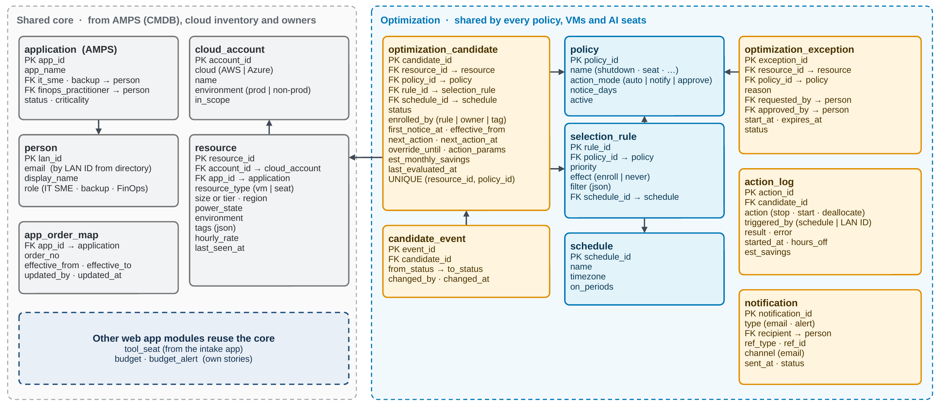
Gray: reference data. Blue: configuration. Yellow: transactions. Arrows point from a foreign key to its parent table.

Figure 4. Candidate lifecycle
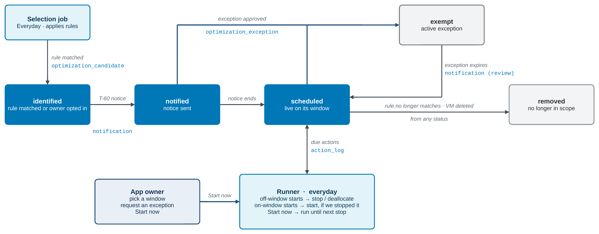
Italic labels are what triggers each move; monospace labels are the extra table written. Every status change also writes candidate_event.

Figure 5. Optimization Center
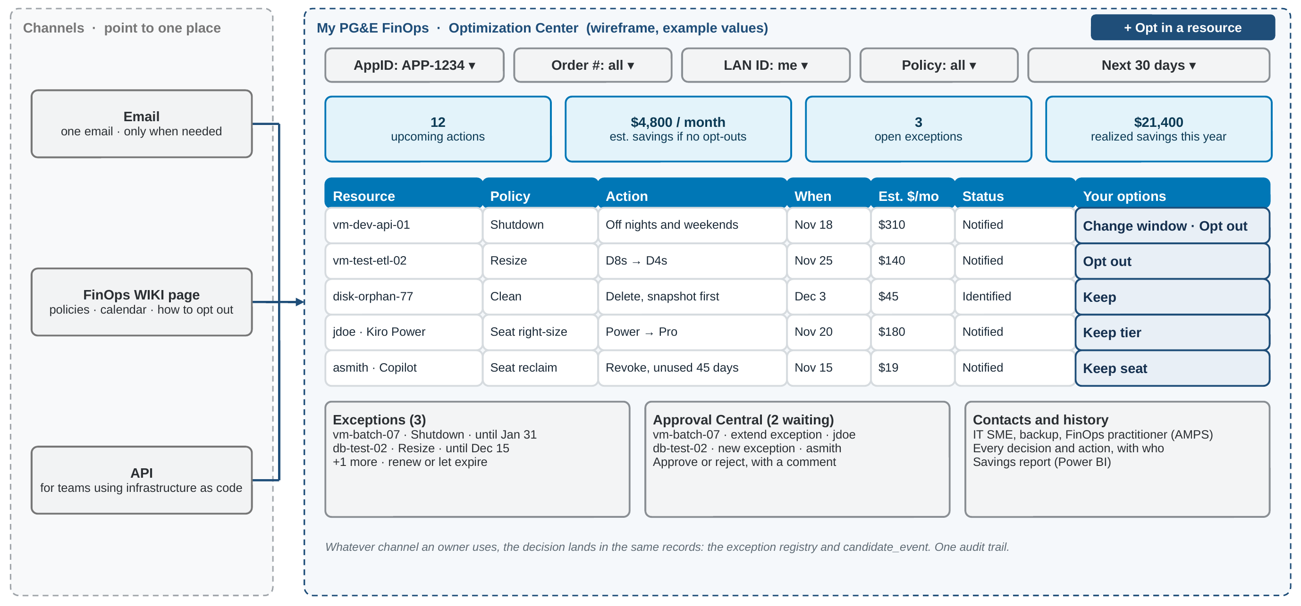
Wireframe with example values, not real data. Owners filter by AppID, order # or LAN ID; every channel links here.

5. Double-click: shutdown automation
Shutdown is the first optimization policy to be built end to end (CLOUDCOE-18928). Its detailed design is a separate companion document, the Shutdown Automation Design, so the cloud admin team can review and accept it on its own while this architecture keeps evolving.
In short. Selection rules pick non-prod VMs in AWS and Azure. Owners get 60 days' notice through the FinOps email and the Optimization Center. Thin FinOps runners stop or deallocate VMs at the start of each off-window and start them at the start of each on-window, using least-privilege roles that the cloud admin team deploys. Owners can opt out, change the window or press Start now, and every action is logged with its savings.
How the two documents stay aligned. The shutdown design uses the shared pieces defined here (the lifecycle, selection rules and candidate list, exception registry, notification service, Optimization Center and AMPS data) and doesn't redefine them. It names the version of this architecture it aligns with. When a change here affects one of those pieces, the shutdown design is updated in the same change; details that only matter to shutdown live only there.

6. Ownership boundaries
FinOps owns | FinOps consumes | FinOps never builds
Web app and its modules | Shared intake app | Identity and access
Source adapters and landing zone | Portkey AI gateway | AI gateway
Order # update and budgets | Snowflake and Power BI platforms | Enterprise data warehouse
Allocation and chargeback logic | Terraform Cloud | Cloud provider tooling

7. Key design decisions
ID | Decision | Rationale | Status
D1 | FinOps gets dedicated dev, test and prod under APP-3967 | Stop deploying into other platforms' accounts | Agreed in principle
D2 | The S3 landing zone is the FinOps source of truth for raw usage | Land once; both lanes read the same data | Agreed in principle
D3 | Operate uses its own app DB, separate from Snowflake | Transactional, near real-time needs differ from reporting | Agreed in principle
D4 | One web app front door, searchable by App ID, LAN ID (email) or order # | One place for order #, budgets, optimization and exceptions | Proposed
D5 | One notification service and one exception registry for all FinOps processes | Consistent behavior and one place to manage them | Proposed
D6 | Optimization is opt-out by default, with per-policy expiring exceptions | Savings get realized and exceptions stay current | Proposed
D7 | Shutdown runs through thin FinOps runners with roles deployed by the cloud admin team | FinOps owns the decision; the cloud admin team controls access | For cloud admin acceptance
D8 | Selection rules and the candidate list are shared by all policies; the app DB is the master record and tags are an input | One engine for shutdown, spot, resize and clean; tags alone are not reliable yet | Proposed
D9 | AI optimization starts with seats (reclaim and right-size) | Clear signal and simple action that owners accept | Proposed
D10 | One owner control plane, the Optimization Center in My PG&E FinOps, for every optimization action; all channels link to it and every decision lands in the same records | Owners see and manage everything in one place instead of piecing together emails | Proposed
D11 | Conservative by default: long notice, critical and high-availability apps excluded in every environment, reversible first steps, and no actions in change freezes | An escalation from an unexpected action costs more than the savings | Proposed
D14 | One email, one page: one consolidated FinOps email for all optimizations, sent only when something changes or comes due, and the Optimization Center, with Approval Central, as the one place to act | Too many emails is the most common complaint about optimization programs | Proposed

8. Phased roadmap
Phase | Scope
Now | FinOps environments under APP-3967. AI Consumption Data Export into the landing zone (Portkey, then Kiro and Copilot). This architecture. Notification design (CLOUDCOE-18933). Shutdown automation design and cloud admin acceptance (CLOUDCOE-18928).
Next | tbd

9. Glossary
- Landing zone (bronze): raw data exactly as each source provides it, partitioned by date and hour.
- Data product (silver / gold): cleaned, then business-ready datasets in Snowflake.
- Policy: the rules for one kind of optimization.
- Runner / executor: the code or tool that performs an optimization action.
- Window: the hours a VM is scheduled to be on.
- Exception: an owner's time-bound opt-out of one policy for one resource.
- Candidate list: the optimization_candidate table: which resources are in scope for which policy, and why.

