CLOUD AND AI FINOPS SERVICES

Shutdown Automation Design
Item | Detail
Document owner | Alfred Daluyaya, FinOps Engineer (seller)
Version / status | v0.1 · Draft for cloud admin team review
Aligned with | Cloud FinOps Platform High-Level Architecture v0.9

1. Purpose and scope

Non-prod VMs that run 24/7 are the most common avoidable cloud cost. Shutdown automation turns them off outside working hours and back on when the window opens, with notice to owners, an exception path, and an override when someone needs a VM after hours.

Scope
In | AWS EC2 instances (EBS-backed) and Azure VMs in accounts and subscriptions classified as non-prod.
Out | Production; Auto Scaling group and VM Scale Set members (handled through scheduled scaling instead); Kubernetes nodes (EKS, AKS); instance-store-backed instances; databases (RDS, Azure SQL) and other services, which are later candidates.

2. Alignment with the FinOps architecture
Shutdown is one policy of the FinOps optimization engine described in the Cloud FinOps Platform High-Level Architecture.
Shared piece | How shutdown uses it | Architecture
Optimization lifecycle | Identify, schedule, notify, opt-out window, release, then execute and record | 4.2
Selection rules and candidate list | The shutdown rules (3.2) write to the shared optimization_candidate table | 4.6, 4.7
Exception registry | Every opt-out has a reason and an expiry; approvals happen in Approval Central | 4.5
Notification service | The one consolidated FinOps email, starting 60 days before the first shutdown | 3.4, 4.10
Optimization Center | The shutdown view (3.3) where owners see, decide and Start now | 4.10
AMPS reference data | App ID, IT SME, IT SME backup, FinOps practitioner and criticality | 3.1, 4.7
Conservative defaults | Long notice, critical and high-availability apps excluded, reversible actions only | D11
FinOps environments | Runners deployed in FinOps dev, test and prod under APP-3967 through Terraform Cloud | 3.5, D1

3. Design

3.1 How it works
- Selection rules (3.2) decide which VMs are in scope and which window applies; the result is the shared candidate list. Owners can choose another standard window for their App ID.
- The schedule lives in the FinOps app DB: resource, App ID, owner, window, time zone and status.
- From sixty days before a VM's first shutdown, it appears in the owner's FinOps email with a countdown, linking to the FinOps Optimization Center.
- The owner can do nothing, pick a different window, or request an exception with a reason and expiry. Approved exceptions mark the VM exempt.
- Every day, at each window's start and end, the scheduler triggers the AWS and Azure runners for the VMs that are due.
- Each runner acts only at the start of an off-window (stop or deallocate) and at the start of an on-window (start, only for VMs it stopped). It doesn't keep enforcing all night, so a VM someone starts after hours stays up until the next scheduled stop.
- Owners can press Start now in the web app; the runner starts the VM and logs who asked and why.
- Every action is logged with hours off and estimated savings, then flows to the landing zone and reporting.

Figure 1. Shutdown automation
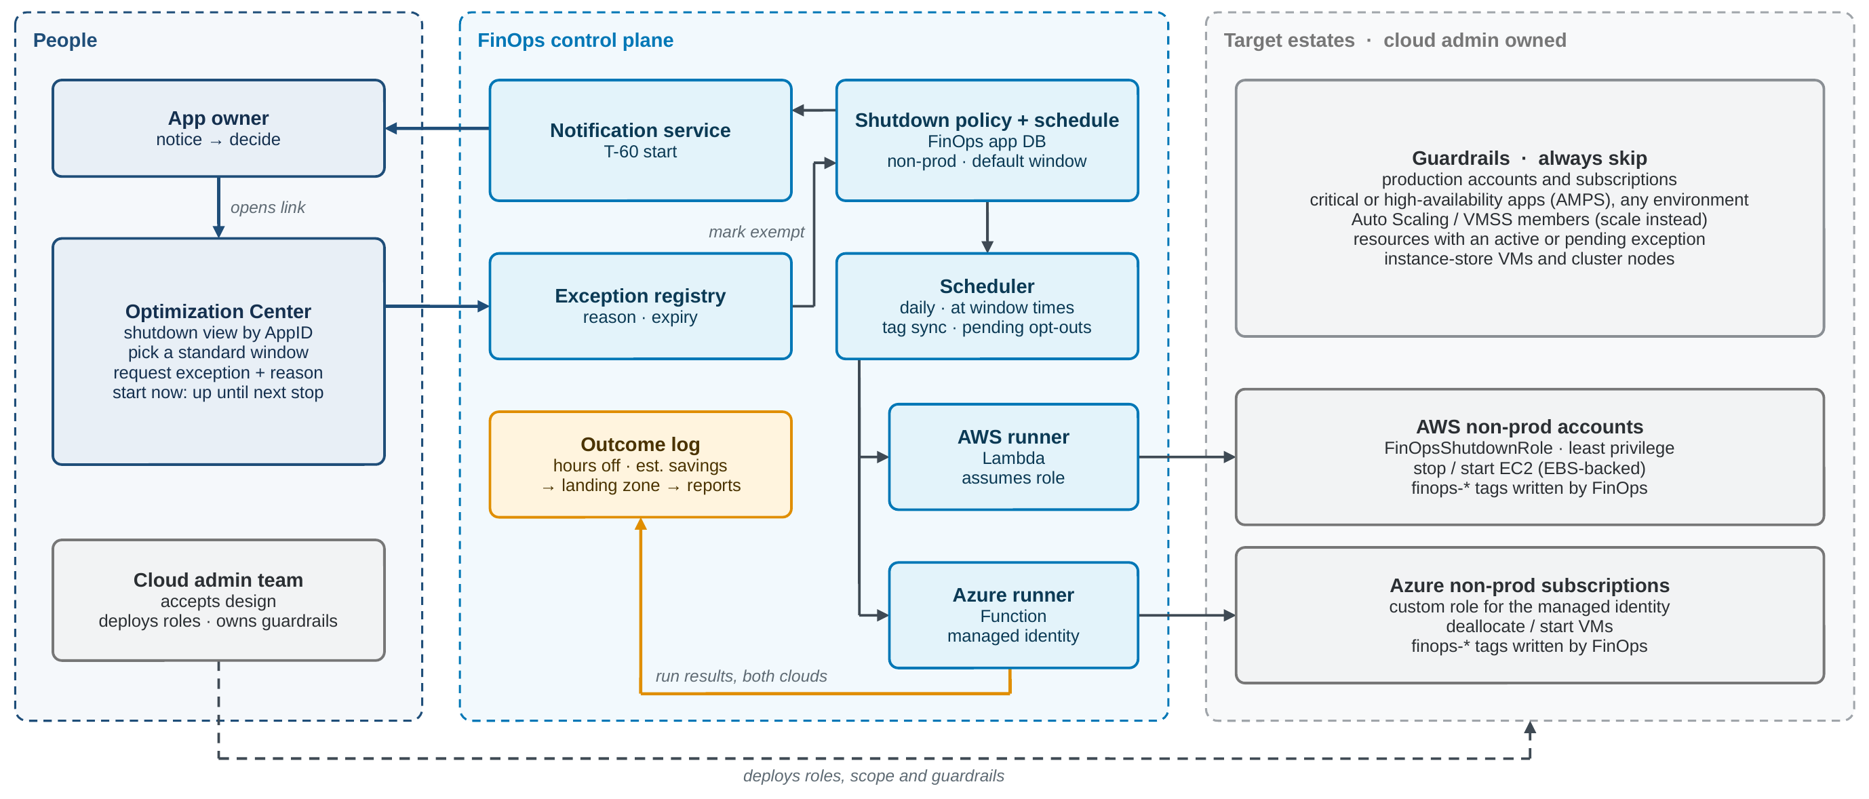
FinOps runs the schedule, notices, exceptions and runners. The cloud admin team deploys the roles into the target estates and owns the guardrails.

3.2 Shutdown selection rules
Proposed starting rules, evaluated top to bottom. The first never rule that matches wins.
Priority | Rule | Effect
1 | Production account or subscription, or environment = prod | Never
2 | App marked critical or high availability in AMPS, in any environment | Never, unless the owner opts in
3 | Auto Scaling group or VM Scale Set member, Kubernetes node, instance-store-backed | Never
4 | No App ID, or no IT SME in AMPS | Never; reported as a data gap
5 | Owner opted the VM in, or chose a window, in the Optimization Center | Enroll on the owner's window
6 | In a pilot account or subscription (phase 1), then any non-prod one (phase 2) | Enroll on the default window
Resources with an active or pending exception stay on the candidate list with status exempt, so the owner can still see them. Tags are not an input to these rules: the FinOps app DB decides, and the tags only show the result (3.5).

3.3 Shutdown view in the Optimization Center
The shutdown view is a lightweight view inside the Optimization Center. It gives owners one place to see and control shutdown for their VMs across AWS and Azure.
- Look up: by App ID, order # or LAN ID.
- See: each VM's cloud, account or subscription, environment, size, power state, schedule, how it was enrolled, next action and time, estimated monthly savings, and exception status.
- Act: opt in a VM that isn't scheduled yet; assign a standard window; remove a VM from its schedule, which files an exception with a reason and expiry; Start now; select many VMs at once.
- Admin view (FinOps): selection rules, standard windows, and savings.
- Who can change what: owners and their delegates for their own App IDs; FinOps admins for all.
- Not in phase 1: free-form schedules, resizing, and power control for VMs that aren't scheduled.

3.4 AWS and Azure implementation
Element | AWS | Azure
Trigger | EventBridge Scheduler, daily at each window start and end | Timer-triggered Azure Function (or Automation schedule), on the same times
Runner | Lambda in the FinOps account (APP-3967) | Azure Function or Automation runbook in a FinOps subscription
Access | Assumes FinOpsShutdownRole in each in-scope account | Managed identity with a custom role at subscription or management-group scope
Permissions | ec2:DescribeInstances, ec2:StopInstances, ec2:StartInstances, limited by tag and account. If EBS volumes use customer-managed KMS keys, the role also needs grant permission on those keys or starts can fail. Optional: ec2:CreateTags and ec2:DeleteTags, limited to the two finops-* keys with an aws:TagKeys condition (S7). | Microsoft.Compute/virtualMachines/read, /start/action and /deallocate/action. Optional: Microsoft.Resources/tags/write for the two FinOps tags (S7).
Action | Stop (EBS-backed only; EBS storage is still billed) | Deallocate (a stopped but still allocated VM keeps billing for compute)
Deployed by | Cloud admin team, through Terraform Cloud | Cloud admin team, through the agreed Azure deployment path
Audit | CloudTrail under the role, plus the FinOps outcome log | Activity Log under the identity, plus the FinOps outcome log
Packaged alternative | AWS Instance Scheduler | Start/Stop VMs v2

3.5 Schedules and tags
- Proposed default window: on weekdays 7:00 to 19:00 Pacific, off nights and weekends. That's 108 of 168 hours off, up to about 64% less compute cost for a VM on the default window.
- A short list of standard windows (for example extended hours 6:00 to 22:00), each with a time zone. No free-form schedules in phase 1.
Tags show the schedule; the app DB decides. Like commercial optimization tools, the design keeps a database record per VM as the master and stamps a tag on the VM so anyone can see in the console that it's managed. Only FinOps writes these two tags, and the daily sync keeps them matched to the app DB.
Tag | Meaning
finops-shutdown-schedule | The VM is enrolled; the value is its standard window name. Written by FinOps when the VM is scheduled, removed when it leaves the policy.
finops-shutdown-exempt | The VM has an approved or pending exception; the value is the expiry date. Written by FinOps from the exception registry.

Removing the schedule tag is a pending opt-out. Owners can pause shutdown from the console by removing the schedule tag. It's one process with two doors: every opt-out still ends in the exception registry.
- The daily sync sees that a FinOps-written schedule tag was removed from a VM that is still scheduled.
- Shutdown pauses for that VM right away. A pending exception is recorded and the exempt tag is stamped.
- The next FinOps email asks the IT SME to confirm the opt-out in the Optimization Center, with a reason and an expiry.
- If confirmed, the exception is approved and the VM stays exempt until it expires.
- If nobody confirms within 14 days, the VM is re-enrolled with a fresh 30-day notice, and only then is the schedule tag put back.
- A VM without the tag that was never enrolled isn't an opt-out; it just hasn't been scheduled. The app DB tells the two apart.
- Editing a tag's value by hand doesn't change the schedule; the sync restores it from the app DB and logs the drift. Window changes are made in the Optimization Center.
- Pipelines that deploy with code must ignore finops-* tags, so an apply doesn't strip them. This goes into the tagging standard.

3.6 Guardrails
- Production accounts and subscriptions are never in scope, even if a VM there carries a schedule tag.
- Apps marked critical or high availability in AMPS are skipped in every environment, unless the owner opts in.
- Skip Auto Scaling and VM Scale Set members, Kubernetes nodes and instance-store-backed instances.
- Skip VMs with no App ID or owner: report them instead, so nothing is shut down without someone being told.
- Stop and deallocate only. The automation never terminates or deletes anything.
- Dry-run mode, a global kill switch, and a cap on actions per run that alerts FinOps if exceeded.
- Idempotent actions with retries; failures alert FinOps through the notification service.
- Tag drift: if many FinOps tags disappear at once from one account or pipeline, it is treated as drift, not as opt-outs. Tags are restored from the app DB and FinOps is alerted.

4. Operating it

4.1 Owner experience
- The IT SME and IT SME backup get a FinOps email when the VM enters its 60-day notice and again 30, 14, 7 and 1 days before its first shutdown, combined with anything else due; nothing is sent in between.
- Self-service in the Optimization Center (3.3): see the schedule, pick a standard window, request an exception, or Start now.
- Remove the schedule tag in the console to pause shutdown at once; the next FinOps email asks to confirm the opt-out in the Optimization Center (3.5).
- Start now runs the VM until the next scheduled stop. The console works too, because the runner doesn't re-stop a VM mid-window.

4.2 Savings and audit
- Estimated savings per action: hours off × the VM's on-demand hourly rate (from CUR and Azure cost data). Storage costs continue and are excluded.
- Every action, override and failure is written to the outcome log and lands in the landing zone for realized-savings reporting.
- Cloud-native audit trails (CloudTrail, Activity Log) record every call made by the runner identities.

4.3 Responsibilities
Area | FinOps | Cloud admin team | App owner
Policy, windows, schedule | Owns | Reviews | Chooses a window
Scheduler, runners, app DB | Builds and runs | Reviews | —
Roles and permissions in target estates | Defines what's needed | Deploys and owns | —
Scope (which accounts and subscriptions) | Proposes | Approves | —
Guardrails | Implements in runners | Owns and approves | —
Exceptions and Start now | Runs the process | — | Requests
Incidents caused by a shutdown | First responder for the automation | Platform support | Reports the issue

4.4 Rollout
- Design acceptance by the cloud admin team (this story).
- Pilot in dry run: one or two non-prod accounts and subscriptions for two weeks. Owners get preview notices; nothing is stopped.
- Pilot live in the same accounts, with daily review of actions and failures.
- Expand to all non-prod accounts and subscriptions, opt-out by default, with realized savings reported.
- Later: scheduled scaling for Auto Scaling groups and scale sets, then databases.

5. Decisions with cloud admin team
# | Decision | FinOps proposal
S1 | Execution approach | Thin FinOps runners (Lambda, Azure Function) reading the FinOps schedule, so schedule, exceptions, notices and savings stay in one place. Alternative: packaged schedulers driven by tags FinOps writes.
S2 | Role deployment and permissions | FinOpsShutdownRole and the Azure custom role as listed in 3.4, deployed by the cloud admin team through Terraform Cloud.
S3 | Which accounts and subscriptions count as non-prod | Start from the cloud admin team's environment classification; pick one or two for the pilot.
S4 | Tag keys | finops-shutdown-schedule and finops-shutdown-exempt, written only by FinOps and aligned with the tagging standard; pipelines ignore finops-* tags.
S5 | Default window and time zone | Weekdays 7:00 to 19:00 Pacific.
S6 | Change management | Confirm whether turning shutdown on for an account needs a change record.
S7 | Tag write-back | Allow the FinOps sync to write and remove only the two FinOps tags, so anyone can see in the console which VMs are managed, and owners can pause shutdown by removing the schedule tag. Without it, the Optimization Center is the only view and the only way to opt out.
S8 | Tag removal as a pending opt-out | A removed schedule tag pauses shutdown and opens a pending exception for the IT SME to confirm within 14 days (3.5).

6. Glossary
- Policy: the rules for one kind of optimization; shutdown is one policy.
- Runner: the code that performs the action, here a Lambda or Azure Function.
- Window: the hours a VM is scheduled to be on; the rest is the off-window.
- Exception: an owner's time-bound opt-out of one policy for one resource.
- Candidate list: the optimization_candidate table: which resources are in scope for which policy, and why.
- Optimization Center: the page in My PG&E FinOps where owners see and act on every upcoming optimization.
- Start now: an owner override that starts a VM until its next scheduled stop.

