Portkey AI Cost Allocation and Estimate — Guide
Oct 21, 2026 · @Alfred Daluyaya
AWS is the source of truth for cost. Portkey gives the allocation percentage. Shared cost is a load on each dollar of inference.
Use this guide to build the Word document. Each section is one page in the Word document:
- Use case: how AI requests flow through Portkey to AWS.
- Terms: direct cost and shared cost.
- Allocation: Portkey gives each workspace its percentage of the direct cost.
- Example: the chargeback for three workspaces.
- Estimate: the cost of a new project.
Section 6 is a decision for the team: one bucket or two for DEV and PROD.
All numbers in this guide are examples. They are not PG&E data. All sections use the same example month, so the numbers agree from page to page.
Note on terms. "Shared Cost A" and "Shared Cost B" are labels for this guide only. They are not PG&E terms or FinOps Foundation terms. They divide the shared cost into two parts, by where the cost comes from:
- Shared Cost A (infrastructure): the cost to run the Portkey install in the gateway accounts. It directly supports the AI requests.
- Shared Cost B (foundation): the AI part of the base platform in the foundation accounts. It indirectly supports the AI requests.
In the three-layer AI cost model, the direct cost is layer 1 (inference), Shared Cost A is layer 2 (gateway infrastructure) and Shared Cost B is layer 3 (foundational).

1. The use case: how AI requests flow
Every AI request goes through Portkey before it reaches a model in AWS. Users, AI apps and tools such as Claude Code send their requests to a Portkey workspace. The Portkey gateway then sends each request to a model in Amazon Bedrock.
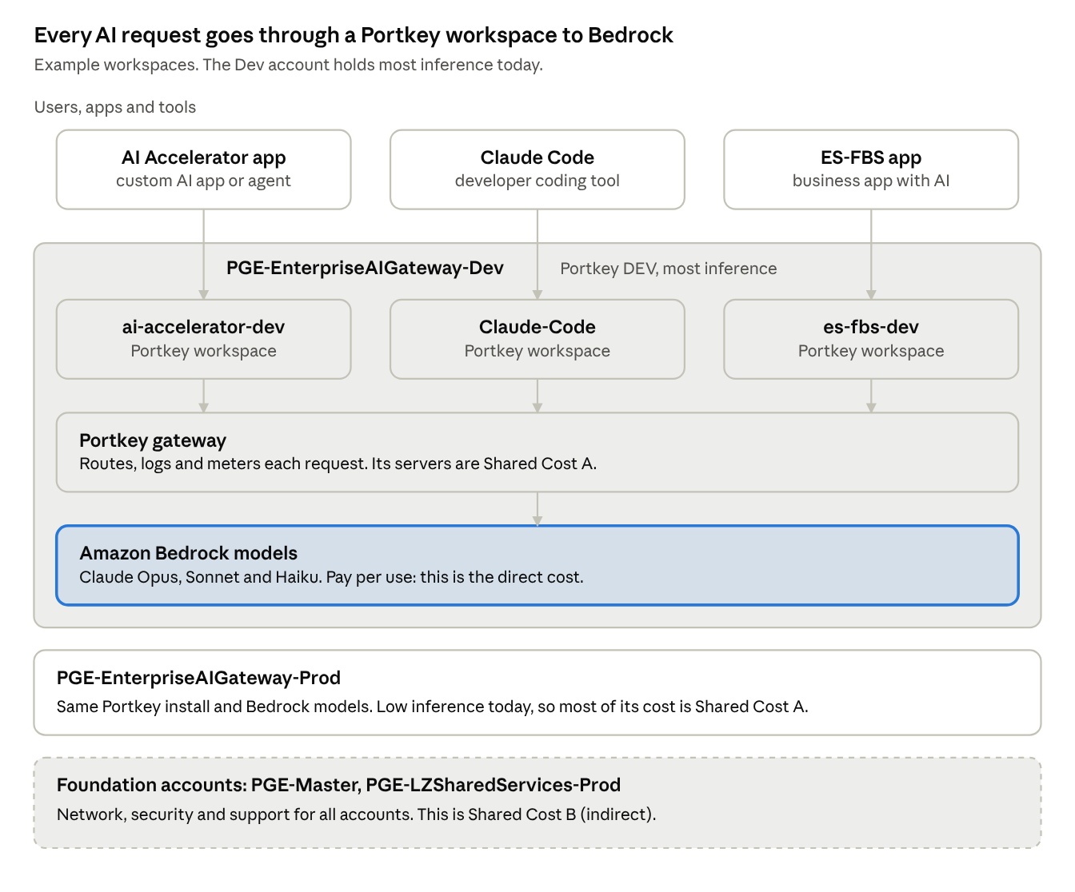
AI request flow · 3 callers, 3 workspaces, 4 AWS accounts
AWS account | What it holds | Cost part
PGE-EnterpriseAIGateway-Dev | Portkey install (DEV) and Bedrock models. Most inference is here today. | Direct cost and Shared Cost A
PGE-EnterpriseAIGateway-Prod | Portkey install (PROD) and Bedrock models. Inference is low today. | Direct cost and Shared Cost A
PGE-Master | Base services that support all accounts. | Shared Cost B (to confirm)
PGE-LZSharedServices-Prod | Landing zone shared services for all accounts. | Shared Cost B (to confirm)
Three facts make the rest of this guide work:
- A workspace is the entry point. Each app or tool sends its requests to its own workspace, for example ai-accelerator-dev, Claude-Code or es-fbs-dev.
- Portkey logs each request with its workspace, model and cost.
- AWS bills the account, not the workspace. AWS cannot show which workspace used a model. Section 3 shows how Portkey fills this gap.

2. Terms: direct cost and shared cost
The total AI cost has three parts: one direct cost and two shared costs. The three parts must add up to the billed amount. Nothing is added on top.
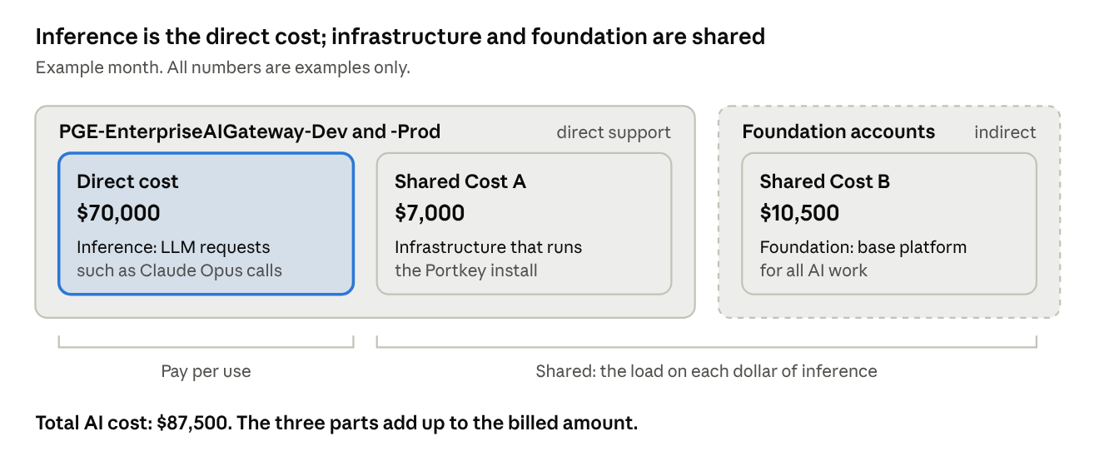
AI cost for one example month · 1 direct cost, 2 shared costs, 2 AWS accounts
Term | What it is | Where it comes from | How it is charged
Direct cost (inference) | The cost to run the LLM requests, such as Claude Opus calls on Amazon Bedrock. | PGE-EnterpriseAIGateway-Dev and -Prod | Pay per use. Each workspace pays for its own requests.
Shared Cost A (infrastructure) | The cost to run the Portkey install, such as compute, network, logs and storage. | PGE-EnterpriseAIGateway-Dev and -Prod | Shared. Each workspace pays a part, in proportion to its direct cost.
Shared Cost B (foundation) | The cost of the base platform that supports all AI work. It is not in the gateway accounts. | PGE-Master, PGE-LZSharedServices-Prod | Shared. Each workspace pays a part, in proportion to its direct cost.
The direct cost changes with use. If a workspace sends no requests, its direct cost is zero.
The shared cost does not change with each request. PG&E must pay it to keep the AI platform available. Think of the shared cost as a tax on each dollar of inference. Shared Cost A is a direct tax. Shared Cost B is an indirect tax.

Example: the bill for one month
The table shows the AWS Cost Explorer lines for each part. The service names are the names that Cost Explorer shows. The amounts are placeholders. Replace them with the real lines from the gateway accounts and the foundation accounts.
Part | Cost Explorer service | AWS account | Example amount (USD/month)
Direct cost | Claude Opus 5.5 (Amazon Bedrock Edition) | PGE-EnterpriseAIGateway-Dev | 38,000
Direct cost | Claude Sonnet 5.5 (Amazon Bedrock Edition) | PGE-EnterpriseAIGateway-Dev | 23,000
Direct cost | Claude Haiku 5.5 (Amazon Bedrock Edition) | PGE-EnterpriseAIGateway-Dev | 5,000
Direct cost | Amazon Bedrock (Amazon models, such as embeddings) | PGE-EnterpriseAIGateway-Dev | 3,000
Direct cost | Claude Sonnet 5.5 (Amazon Bedrock Edition) | PGE-EnterpriseAIGateway-Prod | 1,000
Direct cost total |  |  | 70,000
Shared Cost A | Amazon Elastic Compute Cloud - Compute (gateway nodes) | PGE-EnterpriseAIGateway-Dev | 2,000
Shared Cost A | EC2 - Other (NAT gateway, EBS volumes, data transfer) | PGE-EnterpriseAIGateway-Dev | 1,000
Shared Cost A | Amazon ElastiCache (gateway cache) | PGE-EnterpriseAIGateway-Dev | 600
Shared Cost A | AmazonCloudWatch (logs and metrics) | PGE-EnterpriseAIGateway-Dev | 600
Shared Cost A | Amazon Elastic Load Balancing | PGE-EnterpriseAIGateway-Dev | 400
Shared Cost A | Amazon Simple Storage Service (log export) | PGE-EnterpriseAIGateway-Dev | 400
Shared Cost A | Amazon Elastic Container Service for Kubernetes | PGE-EnterpriseAIGateway-Dev | 200
Shared Cost A | AWS Secrets Manager, AWS Key Management Service | PGE-EnterpriseAIGateway-Dev | 200
Shared Cost A | Gateway infrastructure (the same services as DEV) | PGE-EnterpriseAIGateway-Prod | 1,600
Shared Cost A total |  |  | 7,000
Shared Cost B | AWS Support (Enterprise) | PGE-Master | 4,500
Shared Cost B | Amazon GuardDuty, AWS Security Hub, AWS Config | PGE-Master | 3,000
Shared Cost B | AWS CloudTrail | PGE-Master | 1,000
Shared Cost B | AWS Transit Gateway, AWS Direct Connect | PGE-LZSharedServices-Prod | 2,000
Shared Cost B total |  |  | 10,500
The Shared Cost B amounts are only the part of each foundation account line that is assigned to AI. They are not the full line.
How to find the direct cost in Cost Explorer:
- AWS bills the Claude models through AWS Marketplace. Each Claude model is a separate service, and its name ends with "(Amazon Bedrock Edition)". source
- A filter on the service "Amazon Bedrock" shows only the Amazon models. It does not show Claude. source
- To get all of the direct cost, include each "(Amazon Bedrock Edition)" service and the "Amazon Bedrock" service.
- Since October 8, 2026, Cost Explorer can also group Bedrock cost by model attributes. Use this to check the model totals. source

3. Allocation: Portkey gives the percentage
AWS is the source of truth for cost, because AWS sends the invoice. Portkey is the source of truth for use, because each LLM request goes through a Portkey workspace.
AWS does not show which workspace used the LLM. Portkey shows this. We use Portkey only to find the percentage for each workspace. Then we apply that percentage to the AWS direct cost.
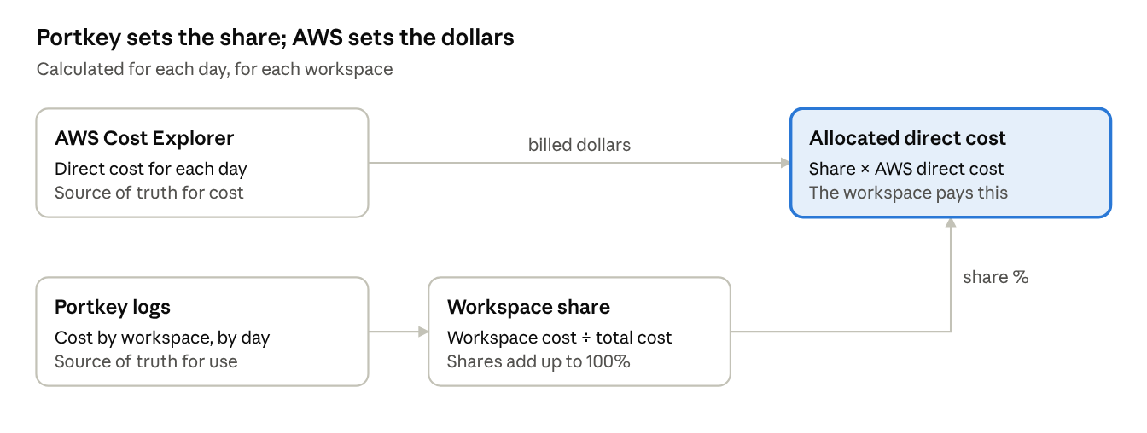
Direct cost allocation · 2 inputs, 1 share, 1 result
\begin{aligned}
\text{Workspace share} &= \frac{\text{Workspace Portkey cost for the day}}{\text{Total Portkey cost for the day}} \\
\text{Allocated direct cost} &= \text{Workspace share} \times \text{AWS direct cost for the day}
\end{aligned}
Rules:
- Calculate the share for each day. Then add the daily amounts to get the month.
- Use the Portkey cost, not the token count. A token for a large model costs more than a token for a small model. The Portkey cost includes this difference, so the model choice does not change the method.
- The shares for one day must add up to 100%.
- Do not bill the Portkey cost. Portkey shows list prices. AWS shows the billed cost.
Example for one day:
Workspace | Portkey cost (USD) | Share | Allocated AWS direct cost (USD)
Claude-Code | 900 | 45% | 1,035
ai-accelerator-dev | 500 | 25% | 575
es-fbs-dev | 100 | 5% | 115
All other workspaces | 500 | 25% | 575
Total | 2,000 | 100% | 2,300
On this day, Portkey shows $2,000 and AWS bills $2,300. Claude-Code used 45% in Portkey. Claude-Code pays 45% of $2,300, which is $1,035.

4. Example: the chargeback for three workspaces
Claude-Code pays $39,375 for the example month. ai-accelerator-dev pays $21,875 and es-fbs-dev pays $4,375. Each workspace pays the same share of the shared cost as its share of the direct cost.
This example uses the month from section 2: direct cost $70,000, Shared Cost A $7,000 and Shared Cost B $10,500.
Workspace | Share of direct cost | Direct cost (USD) | Shared Cost A (USD) | Shared Cost B (USD) | Total chargeback (USD)
Claude-Code | 45% | 31,500 | 3,150 | 4,725 | 39,375
ai-accelerator-dev | 25% | 17,500 | 1,750 | 2,625 | 21,875
es-fbs-dev | 5% | 3,500 | 350 | 525 | 4,375
All other workspaces | 25% | 17,500 | 1,750 | 2,625 | 21,875
Total | 100% | 70,000 | 7,000 | 10,500 | 87,500
How to calculate one row:
- Get the direct cost for the workspace. This is the sum of its daily allocations from section 3.
- Get the share of direct cost: workspace direct cost ÷ total direct cost.
- Multiply Shared Cost A by the share. Multiply Shared Cost B by the share.
- Add the three amounts. This is the total chargeback.
Check: the Total row must equal the amounts from section 2. The chargeback adds up to $87,500. Nothing is added on top, and nothing is left over.

5. Estimate: the cost of a new project
A new project asks one question: how much will it cost? This section gives the method. Sections 1 to 4 show where each number comes from.
An estimate has three steps:
- Estimate the inference cost from the project inputs.
- Adjust for the project features (optional).
- Add the load rate for the shared cost.

Step 1: Estimate the inference cost
Get these inputs from the project team:
Input | Example | Notes
Requests per minute (average) | 1 | At the busy hours.
Hours per day at this rate | 8
Days per month | 20 | Use workdays for business apps. Use 30 for apps that run all the time.
Input tokens per request | 150 | Include the system prompt, the conversation history and any documents.
Output tokens per request | 100
Model | Claude Sonnet 5 | Example price: $3 input and $15 output for each million tokens. Confirm with the current Bedrock price list.
\begin{aligned}
\text{Requests per month} &= 1 \times 60 \times 8 \times 20 = 9{,}600 \\
\text{Input cost} &= \frac{9{,}600 \times 150}{1{,}000{,}000} \times \$3 = \$4.32 \\
\text{Output cost} &= \frac{9{,}600 \times 100}{1{,}000{,}000} \times \$15 = \$14.40 \\
\text{Inference cost} &= \$4.32 + \$14.40 = \$18.72 \text{ per month}
\end{aligned}
The input tokens are the largest risk in an estimate. A chatbot sends its system prompt and the conversation history with each request. An agent makes many model calls for one task. When possible, measure the real tokens in Portkey for a similar workspace.

Step 2: Adjust for project features (optional)
Feature | Effect on cost | How to estimate
Agents | Each task makes many model calls. | Multiply the requests by the model calls for each task.
Documents (RAG) | Adds embedding cost and more input tokens. | Add the document text to the input tokens.
Images | Images add input tokens. | Add the image tokens to the input tokens.
Prompt caching | Decreases the cost of repeated input. | Decrease the input cost for the cached part.
Model mix | Large models cost more for each token. | Estimate each model separately. Then add the amounts.

Step 3: Add the load rate
For each $1.00 of inference, add $0.25 for shared cost. The 25% is the load rate from the example month: Shared Cost A gives 10% and Shared Cost B gives 15%.
\begin{aligned}
\text{Load rate} &= \frac{\text{Shared Cost A} + \text{Shared Cost B}}{\text{Direct cost}} = \frac{7{,}000 + 10{,}500}{70{,}000} = 25\% \\
\text{Estimated total cost} &= \text{Estimated inference cost} \times (1 + \text{Load rate})
\end{aligned}

Example: a new project
This example uses the inputs from step 1.
Line | Monthly (USD) | Annual (USD)
Claude Sonnet 5 (input tokens) | 4.32 | 51.84
Claude Sonnet 5 (output tokens) | 14.40 | 172.80
Inference subtotal | 18.72 | 224.64
Shared Cost A (10%) | 1.87 | 22.46
Shared Cost B (15%) | 2.81 | 33.70
Total | 23.40 | 280.80
The load is proportional. A small project pays a small load, and a large project pays a large load. All projects pay the same rate. This keeps the total of all estimates in line with the invoice.

Range: low, expected and high
Give a range, not one number. Change the inputs that are the least certain. In this table, the output tokens stay at 100 for each request.
Case | Requests per minute | Input tokens per request | Inference (USD/month) | Total with load (USD/month)
Low | 1 | 150 | 18.72 | 23.40
Expected | 2 | 1,000 | 86.40 | 108.00
High | 5 | 2,000 | 360.00 | 450.00

Build phase and run phase
Estimate two phases, and show both in the estimate:
- Build phase (development): the tokens that the team uses to build and test the app in DEV, for example with coding tools and test runs. This phase has a start and an end.
- Run phase (operation): the tokens that users use after go-live. This phase continues each month.
Apply the load rate to both phases.

Rules for the load rate
- Use an average of 3 months. One month can have a spike.
- Calculate the load rate again each month. When total inference goes up, the load rate goes down, because the shared cost does not grow with each request.
- The model choice changes step 1 only. The load rate is the same for all models.
- FinOps gives the load rate each month. The AI cost estimator, which is in development, can use it.

6. Decision: DEV and PROD buckets
The recommendation is to pool DEV and PROD in one bucket now, and to split them later. The final decision is for the FinOps product owner and finance.
The PROD gateway runs all the time, but it has little inference today. Its infrastructure must still be recovered. The question is who pays for it.
Option | How it works | DEV load rate | PROD load rate | Recovers PROD infrastructure | Trade-off
1. One bucket | Pool all gateway infrastructure and all inference from DEV and PROD. | 25% | 25% | Yes | DEV users pay for PROD before they use it.
2. Separate buckets | Each environment pays for its own infrastructure. | 23% | 175% | Yes, but only from PROD users | The first teams in PROD pay a very high rate.
3. Pool now, split later (recommended) | Charge back as one bucket. Show DEV and PROD separately in showback. Split when PROD reaches an agreed share of inference. | 25% | 25% until the split | Yes | The team must agree on the trigger and track it.
The load rates use the example month from section 2. Option 2 gives Shared Cost B to each environment in proportion to its direct cost.
Why option 3:
- It recovers the PROD infrastructure from the first month.
- It keeps one simple rate for chargeback.
- Showback shows the PROD part. In the example month, about 2 points of the 25% load (2.3%) are PROD infrastructure.
- The rule to split is agreed before it is needed.
Proposed trigger (to confirm): split the buckets when PROD inference is more than 25% of total inference for 3 months in a row.
Fallback: the AI platform order number pays for the PROD infrastructure as a central cost. This does not recover the cost from users. Use it only if the other options are not approved.

Open items
Confirm these items before the Word document goes out.
- ☐ Which AWS services go into Shared Cost A (for example: compute, network, logs and storage for the Portkey install).
- ☐ The Shared Cost B amount from the foundation accounts. Is it a fixed 15%, or a calculated amount?
- ☐ The billing level: workspace, AppID or order number.
- ☐ Scope: DEV first, then PROD. AWS first, then Azure.
- ☐ The AWS cost type: net amortized cost, after discounts and credits.
- ☐ Where to put inference that does not go through Portkey (for example, a separate unallocated line).
- ☐ Replace the example lines with the real Cost Explorer lines from the gateway accounts (DEV first) and the foundation accounts.
- ☐ Confirm which Claude models are in use, and how the gateway runs (EKS, ECS or EC2).
- ☐ Confirm the foundation accounts (PGE-Master, PGE-LZSharedServices-Prod or others) and the AI part of each.
- ☐ Decide the DEV and PROD buckets, and the trigger to split them (section 6).

Sources
- Bedrock billing classification in Cost Explorer (Classmethod)
- Bedrock product attributes in Cost Explorer (Classmethod)
- AWS Bedrock pricing and billing (Economize)

