在centos虚拟机安装kubernetes

1. kubernetes架构



1. 准备三台虚拟机，IP规划如下
   1. Kube-master :192.168.57.254/24
   2. Kube-minion1:192.168.57.253/24
   3. Kube-minion2:192.168.57.252/24
2. 安装kube-master
   1. 配置yum源

vim /etc/yum.repos.d/kubernetes.repo

[kubernetes-repo]

Baseurl=https://mirrors.aliyun.com

enabled=1

gpkcheck=1

* 1. 安装docker

yum install docker

* 1. 安装etcd

yum install

配置etcd

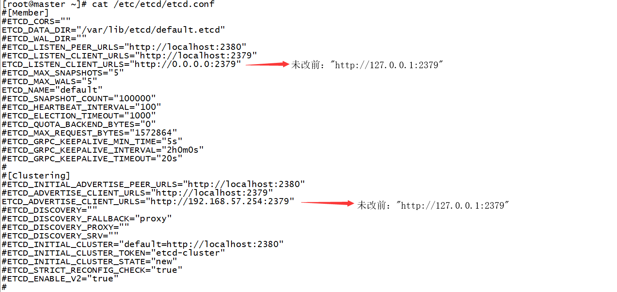

* 1. 安装kube-master

yum install kube-master

分别配置/etc/Kubernetes/config和/etc/Kubernetes/apiserver

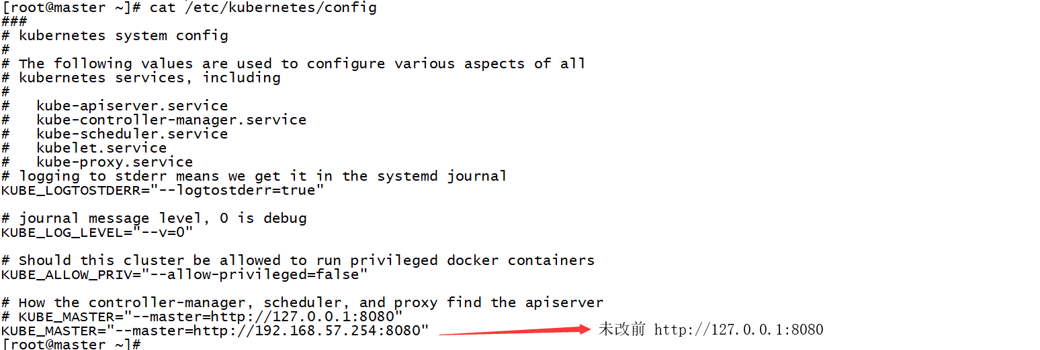

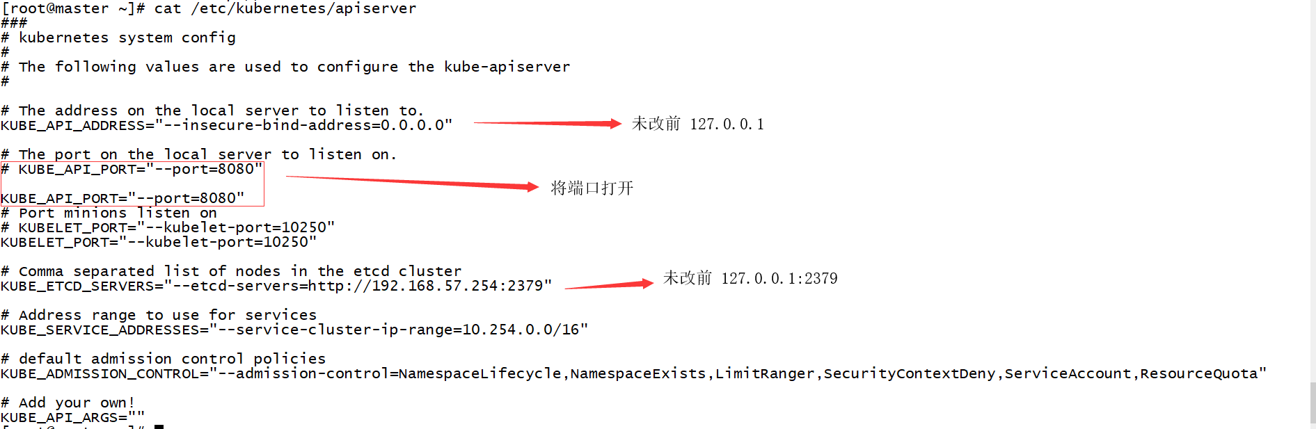

* 1. 启动kubernetes和etcd服务，并设置永久启动

for proc in kube-apiserver.service kube-controller-manager kube-scheduller ;

do systemctl enable $proc; systemctl start $proc;done

1. 安装kube-minion
   1. yum install kube-node

配置kube-node

v