TASK 1: Quadratic Function (Bungee Jumper)
Given:
h(t) = ${{-0.5^{2}}^{}}^{}$+ $v_{0}t$ + h0
Where:
- $v_{0}$ = 0 m/s
- $h_{0}$ = 210 m
So the function becomes:
h(t) = ${-0.5^{2}}^{}$+ 210

(i) Mathematical Understanding

(a) Domain and Range
Domain:
Time starts at t = 0 and ends when the jumper hits the river.
Solve for when h(t) = 0:
−0.5t² + 210 = 0
$t = \sqrt{420}$ $≈ 20.49 seconds$
Domain:
[0, 20.49]
Range:
Maximum height = 210 m
Minimum height = 0 m
[0, 210]
Physical Meaning:
- Domain → time during the jump
- Range → possible heights of the jumper

(b) Vertex
For quadratic ${h(t)at}^{2} + bt + c$
$t = -\frac{b}{2a}$
Here:
$a = -0.5, b = 0$
$t = 0$
$h(0) = 210$
Vertex:
$(0, 210)$
Meaning:
This is the starting point and maximum height.

(c) Maximum Height
Maximum occurs at vertex:
- Time = 0 seconds
- Height = 210 m
Explanation:
The jumper starts from rest (no upward motion), so the highest point is the starting position.

(d) When height = 11 m
${-0.5t}^{2} = 11$
${-0.5t}^{2} = -199$
$t^{2} = -398$
$t = \sqrt{398 }$ $≈ 19.95 seconds$

(e) Height after 20 seconds
${h(20) = -0.5(20)}^{2} + 210$
$=-0.5(400) + 210$
$=200 + 210 = 10m$
Meaning:
After 20 seconds, the jumper is very close to the river (10 m above).

(f) When does the jumper hit the river?
Already calculated:
$t ≈ 20.49 seconds$

(ii) Graphical Understanding

(a) Graph
Using GeoGebra:
Enter:
${h(t) = -0.5t}^{2} + 210$
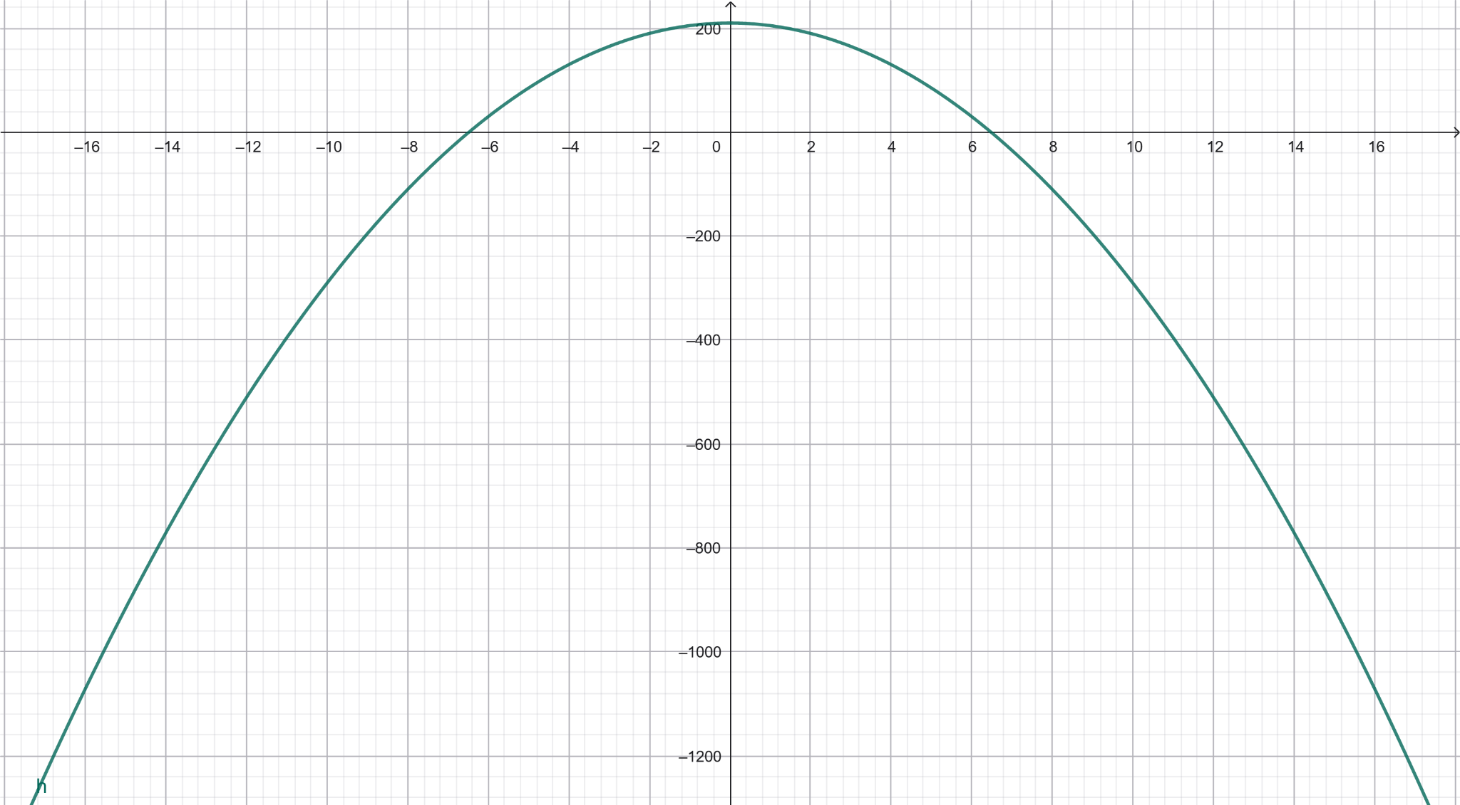

(b) Increasing/Decreasing Intervals
- Increasing: none (starts at maximum)
- Decreasing:
$\left(0, 20, 49\right)$
Meaning:
The jumper is continuously falling.

(c) Axis of Symmetry
$t = 0$
Explanation:
The motion is symmetric mathematically, but physically, only the right side (falling) is relevant.

(d) Intercepts
- t-intercept:
$\left(20, 49, 0\right)$
- h-intercept:
$\left(0, 210\right)$
→ starting height

TASK 2: Linear Function (Road Planning)
Points:
$A\left(5, 7\right), B\left(6, 5\right)$

(i) Equation of the Line
Slope:
$m = \frac{5 - 7}{6-7} = -2$
Using point-slope form:
$y = 7 = -2\left(x - 5\right)$
$y = -2x + 17$

(ii) Slope
$m = -2$
Meaning:
For every 1 unit increase in x, y decreases by 2.

(iii) Change in Elevation
$Δy=5-7 =-2$
Meaning:
The road slopes downward → important for drainage and safety.

(iv) Parallel and Perpendicular Lines
- Parallel: same slope = -2
Example:
$y=-2x+10$
- Perpendicular: slope = reciprocal opposite
$m=\frac{1}{2}$
Example:
$y=\frac{1}{2}x+3$

(v) Graph
Plot:
- Points A and B
- Line $y=-2x+17$
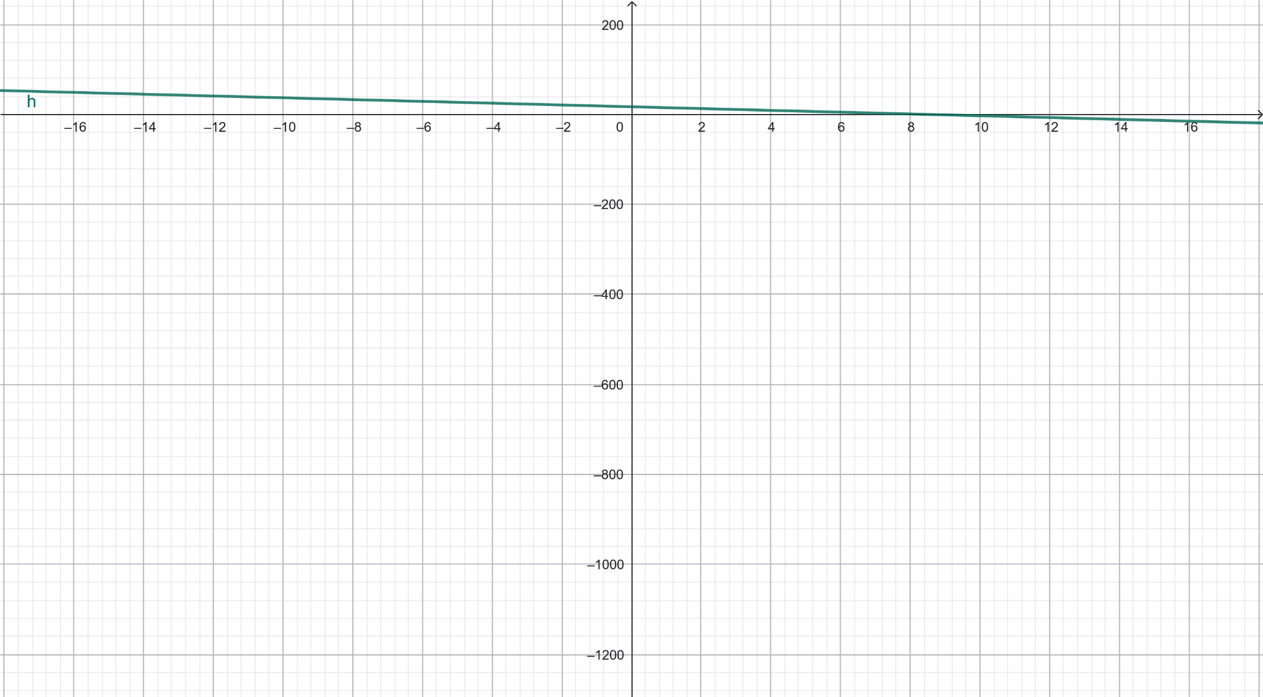

(vi) Intercepts
- y-intercept:
$\left(0, 17\right)$
- x-intercept:
$0=-2x+17⇒x=8.5$
$\left(8.5, 0\right)$

(vii) Number of Parallel/Perpendicular Lines
Infinite
Explanation:
- Infinite lines can have same slope (parallel)
- Infinite lines can have perpendicular slope

TASK 3: Linear Function (Electricity Pricing)

(i) Linear Function
Let:
- $C\left(x\right)=total cost$
- $x=units consumed$
Given:
- Fixed charge = 50
- Cost per unit = 0.78
$C\left(x\right)=0.78x + 50$

(ii) Average Rate of Change
Formula:
$\frac{{C(x}_{2}) -{C(x}_{1})}{x_{2}-x_{1}}$
For a linear function, this equals the slope:
=0.78
Meaning:
Each additional unit increases cost by $0.78.

Reference
Stitz, C., & Zeager, J. (2013). College algebra. Stitz Zeager Open Source Mathematics. https://stitz-zeager.com/szca07042013.pdf
Yoshiwara, K. (2020). Modeling, functions and graphs. American Institute of Mathematics. https://yoshiwarabooks.org/mfg/MFG.html

