Polynomial and Rational Functions Assignment

Task 1: Interpretation of Polynomial Graph

(i) Turning Points, Zeros, and x-intercepts
From the graph:
- Turning Points:
$A\left(-1.569, -3.124\right)$ → Local minimum
$B\left(0.319, 8.643\right)$ → Local maximum
- Zeros/x-intercepts:
$D\left(-2, 0\right)$
$E\left(-1, 0\right)$
$C\left(2, 0\right)$

(ii) Multiplicity of Zeros
- At $x=0:$
The graph touches and turns → even multiplicity (likely 2)
- At $x=-2$ and $x=-1$
The graph crosses the x-axis → multiplicity = 1
Explanation:
- Crossing → odd multiplicity
- Touching → even multiplicity

(iii) Degree and Increasing/Decreasing Intervals
- Number of turning points = 3
→ Minimum degree = 4
- End behavior: both ends go up
→ Even degree polynomial with positive leading coefficient

Increasing:
$\left(-1.569, 0.319\right)$

Decreasing:
$\left(-∞, -1.569\right)∪{}\left(0.319, ∞\right)$

(iv) Local Maximum and Minimum
- Local minimum:
$\left(-1.569, -3.124\right)$
- Local maximum:
$\left(0.319, 8.643\right)$

(v) Remainder when divided by $x-4$
Using Remainder Theorem:
$Remainder=f\left(4\right)$
From the graph, estimate:
$f(4)≈6 (approximate)$

Task 2: Polynomial Function
Given:
$f\left(x\right)=x^{4}-x^{3}-x^{2}+8x+7$

(i) Finding Zeros (Rational Root Theorem + Synthetic Division)
Possible rational roots:
$±1, ±7$

Test $x=1:$
$f\left(1\right)=1-8-8+8+7=0$
So, $x=1$ is a root.

Synthetic Division:
1 | 1 -8 -8 8 7
| 1 -7 -15 -7
-------------------
1 -7 -15 -7 0
So:
$f\left(x\right)=\left(x-1\right)\left(x^{3}-{7x}^{2}-15x-7\right)$

(ii) Graph
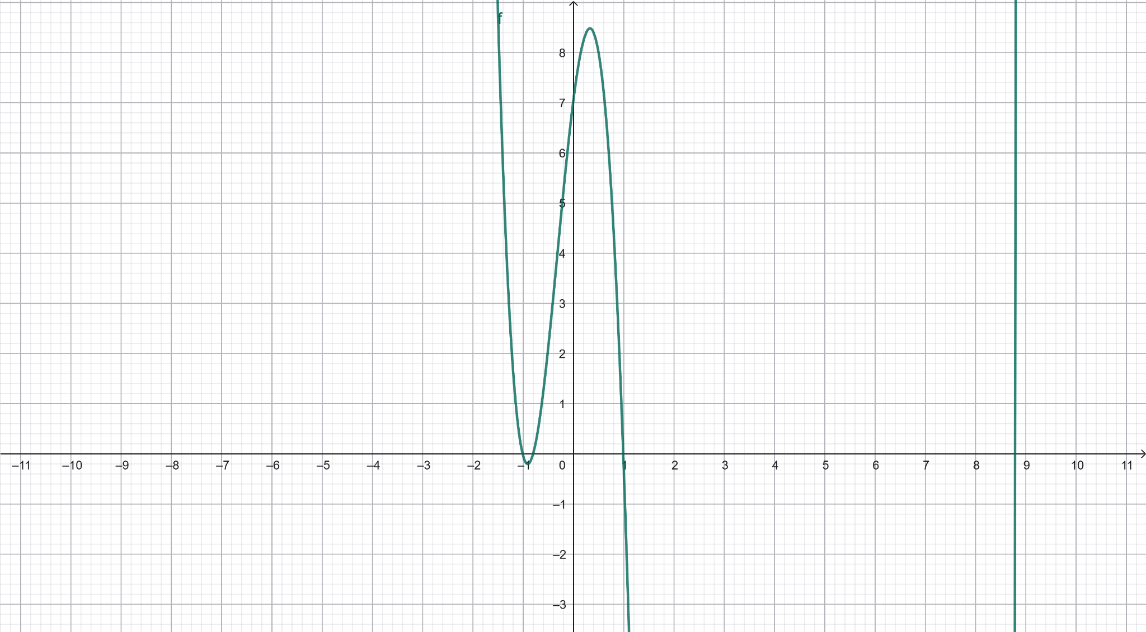

(iii) End Behavior
Leading term = $x^{4}$
As $x→±∞, f\left(x\right)→∞$

Task 3: Rational Function
Given:
$f\left(x\right)=\frac{{2x}^{2}-5x+3}{x^{2}+5x}$

(i) Asymptotes

Factor:
Numerator:
${2x}^{2}-5x=x(x+5)$
Denominator:
$x^{2}+5x=x(x+5)$

Vertical Asymptotes:
$x=0, x=-5$

Horizontal Asymptote:
Degrees are equal → ratio of leading coefficients:
$y=\frac{2}{1}=2$

(ii) Domain
Denominator ≠ 0:
$x≠0, x≠-5$
Domain:
$\left(-∞, -5\right)∩{}\left(0, ∞\right)$

Task 4: Rational Graph Interpretation

(i) Asymptotes
From graph:
- Vertical asymptotes:
$x=1, x=5$
- Horizontal asymptote:
$y=5$

General Method:
- Vertical → denominator = 0
- Horizontal → compare degrees

(ii) Zeros
From graph:
$x=2, 3, 4$

(iii) Rational Function
Based on zeros and asymptotes:
$f\left(x\right)=\frac{\left(x-2\right)\left(x-3\right)\left(x-4\right)}{\left(x-1\right)\left(x-5\right)}$

Task 5: Open Box Volume
Let width = $x$
Length = $3x$
After cutting 15 cm squares:
- New width = $x-30$
- New length = 3x-30
- Height = 15

(i) Volume Function
$V\left(x\right)=\left(x-30\right)\left(3x-30\right)\left(15\right)$
This is a polynomial function.

(ii) Domain
For valid dimensions:
$x-30>0⇒x>30$
So domain:
$\left(30, ∞\right)$

(iii) When Volume = 12500 cm³
$15\left(x-30\right)\left(3x-30\right)=12500$
Divide both sides by 15:
$\left(x-30\right)\left(3x-30\right)=833.33$
Expand:
${3x}^{2}-120x+900=833.33$
${3x}^{2}-120x+66.67=0$
Solve:
$x≈35cm$

References
Stitz, C., & Zeager, J. (2013). College algebra.
https://stitz-zeager.com/szca07042013.pdf
Yoshiwara, K. (2020). Modeling, functions and graphs.
https://yoshiwarabooks.org/mfg/MFG.html

