Basic Machine Learning with Scikit-Learn Course
Written Assessment (SAQ)

A: Trainee Information:

Trainee Name (as Per NRIC): _______________________________

Last 3 digits and alphabet of NRIC/FIN: _________________

Date: __________________

B: Instruction to Candidates

1. This is an individual exercise
2. This is an open book assessment
3. A total of 50 minutes is given to complete the written assessment
4. Submit your answers on the document provided

C: Short Answer Questions

Question 1:
Imagine you’re a data scientist working at Consta Company. You’re tasked with collecting data for machine learning applications. Some of these applications utilize supervised learning, while others use unsupervised learning.

What are some of the differences between supervised learning and unsupervised learning? (K1)

Question 2:
Imagine you're running a data-driven e-commerce business. To optimize your online store, you can leverage different machine learning techniques like classification and regression.

What are some of the differences between classification and regression? When should you choose one over the other? (K2)

Question 3:
Imagine you're a data analyst working for a law enforcement agency. You're tasked with understanding patterns in crime rates across different US states. You have a dataset containing arrest rates for various crimes and want to group states with similar crime profiles.

You've created a dendrogram (as shown below) to visualize the hierarchical clustering of US states based on arrest rates. Now, you need to determine the optimal number of clusters that best represent distinct groups of states with similar crime characteristics.
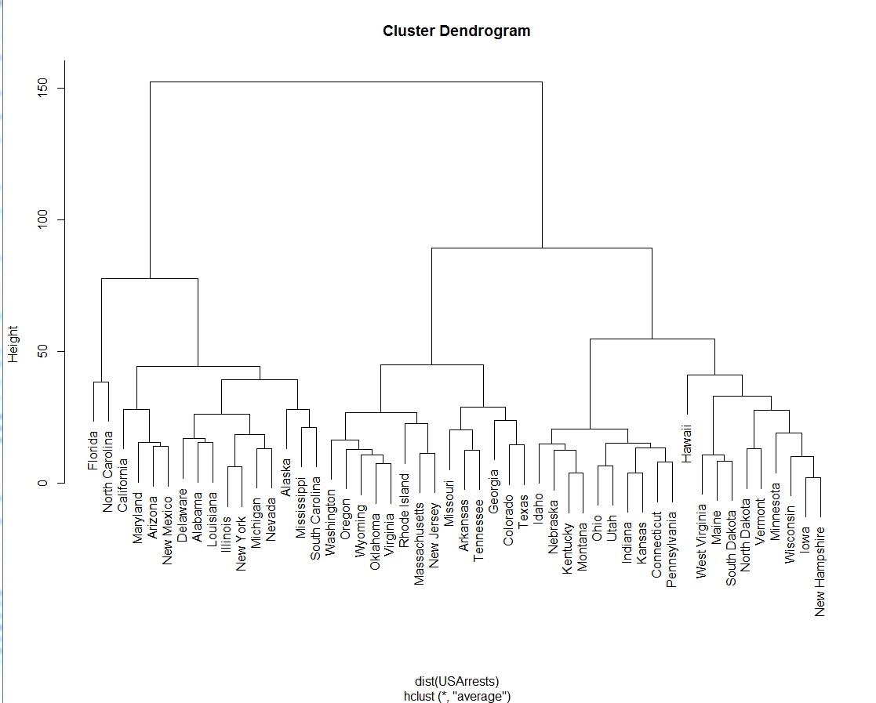

Suppose we want to have 3 clusters only. At which height should we cut? (K4)

Question 4:
Imagine you're a data scientist working for a retail analytics company. Your company has collected sales data from numerous stores across various regions. You're tasked with identifying underlying patterns and trends in this data to support strategic decision-making.
Study the scree plot below.
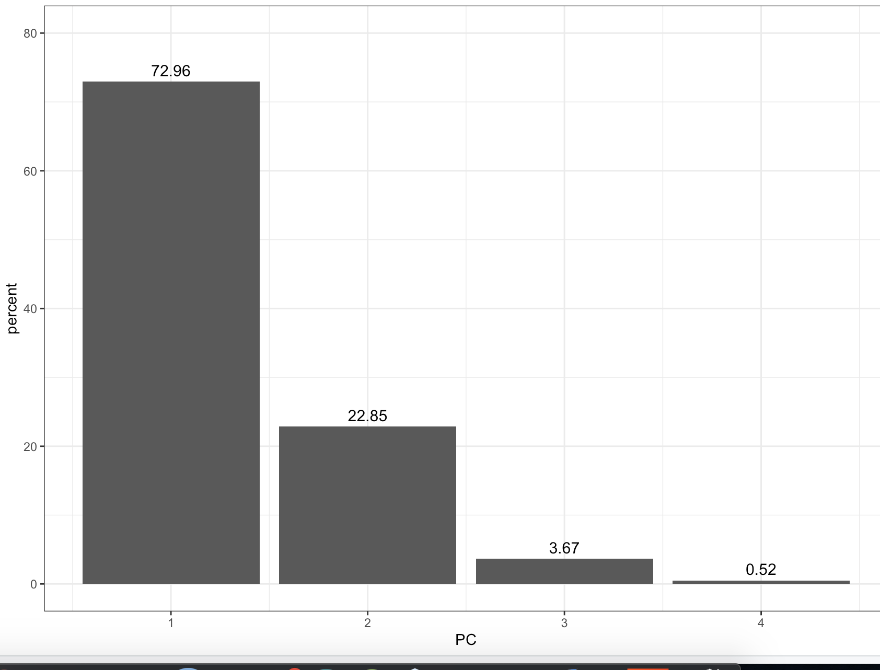

What is the percentage of variation that can be accounted for when using PC1 and PC2? (K5)

Question 5:
Imagine you're a data scientist tasked with evaluating the performance of a model that predicts whether a customer will churn or not. You have a confusion matrix that summarizes the model's predictions against the actual churn status of customers as shown below:

 |  | Predicted
 | n=192 | Positive | Negative
Actual | Positive | 118 | 12
 | Negative | 47 | 15
Compute the Precision, Recall, and F1 Score. Show your working and your answers below: (K6)

Question 6:
Imagine you're an ecologist studying a coral reef ecosystem. You want to group different coral species based on their characteristics like size, color, and water depth.

You decided to use the K-Means clustering algorithm. However, you encountered some issues along the way. What are two possible issues that you might face when using the K-Means clustering algorithm? (K7)

_____________________________________________________________________________
For Official Use Only

Grade: _____ (C / NYC)

Assessor Name: _______________ Assessor NRIC: _____________

Date: ________________________ Signature: _________________

Please create a subfolder named YYYY-MM-DD/DD_<<Trainer Name>> and upload all the learner's assessments to the respective Google Drive.
Please email erra@tertiaryinfotech.com after you have uploaded the assessment.

